Production of Pectinase Enzymes system in culture filtrates of Penicillium variabile Sopp

Akintobi AO¹, Oluitiola PO², Olawale AK³, Odu NN⁴, Okonko IO⁴

¹Department of Microbiology, Lead City University, Ibadan, Nigeria
²Department of Microbiology, Obafemi Awolowo University, Ile-Ife, Osun State, Nigeria;
³Department of Applied Sciences, Osun State Polytechnics, Iree, Osun State, Nigeria;
⁴Department of Microbiology, University of Port Harcourt, East-West Road, PMB 5323; Choba, Port Harcourt, Rivers State, Nigeria;
mac2finney@yahoo.com, iheanyi.okonko@uniport.edu.ng

ABSTRACT: Penicillum variabile Sopp produced enzymes with polygalacturonase, pectin transeliminase and pectin methylesterase activity when grown in liquid culture media containing pectic substances as sole carbon sources. The enzymes were also present in infected cocoa bean tissues. Production of pectinase enzymes by P. variabile was optimum at 30°C. Optimum pH for pectin methylesterase and pectin transelimiñase activities was best at pH 8.0 while polygalacturonase activity was at pH 5.0. When the cultures were agitated, less cellulase and pectinase enzymes were produced than when the cultures were stationary. Production of pectin methylesterase appeared, at least in part, to be constitutive, while polygalacturonase and pectin transeliminase were inducible. The pectinase complex was separated by molecular exclusion followed by ion exchange chromatography, into four components.
[Akintobi AO, Oluitiola PO, Olawale AK, Odu NN , Okonko IO. Production of Pectinase Enzymes system in culture filtrates of Penicillium variabile Sopp. Nat Sci 2012;10(7):99-109]. (ISSN: 1545-0740). http://www.sciencepub.net/nature. 15

Keywords: Penicillum variabile, cellulose, pectinase, enzymes, molecular exclusion

1. INTRODUCTION
It has been reported that Penicillium variabile Sopp was one of the Penicillium species responsible for both the internal mouldiness of cocoa beans (Theobroma cacao) (Oyeniran, 1970) and the root decay of sugar beet (Beta vulgaris) (Bugbee, 1975).
The primary cell wall of fruit is composed of approximately 10% proteins and 90% polysaccharides, which can be divided into three groups: cellulose, hemicellulose and pectin (Nathalie, 2006). Numerous cell wall degrading enzymes can be secreted by pathogens to breach and use the plant cell walls as nutrient sources that reduced post-harvest life and finally lead to develop inedible, undesirable quality and soft rot spoilage (Al-Hindi et al., 2011). A remarkable array of polysaccharide degrading enzymes including exo- and endo-polygalacturonases, pectin methylesterases, pectin lyases and pectate lyases, acetyl esterases, xylanases and a variety of endo-glucanases that cleave cellulose, xyloglucan and other glucans (Lebeda et al., 2001; Gordon et al., 2002; Raviyan et al., 2005; Netsanet et al., 2009; Al-Hindi et al., 2011).
Pectinases are the first enzymes to be secreted by fungal pathogens when they attack plant cell walls (Idnurm and Holett, 2001). Pectin degrading enzymes weaken the plant cell wall and expose other polymers to degradation by hemicellulases and cellulases. They are the first cell wall degrading enzymes that are secreted by pathogens and are important virulence factors (Tomassini et al., 2009).
Pectic enzymes had been implicated in cell maceration and cell death (Akintobi, 1978). The primary agents believed to be responsible for maceration process are pectic enzymes that hydrolyze, in a random manner, the α-1, 4 linkages in the uronic acid polymer of pectic substances (Bateman, 1968).
In the degradation of pectic substances three classes of enzymes were believed to be involved (Codner, 1971): 1) protopectinase (PP), this decomposes protopectin which is a water-insoluble constituent of the cell wall. The degradation product is soluble pectin. 2) Pectinmethylesterase (PME) which affects the hydrolysis of the methyl ester linkages of pectin (pectin is a polymer of galacturonic acid, containing methyl esters linkages) to yield pectic acid and methanol. PME shows a high degree of specificity and only partial methyl esters of galacturonic acid and, perhaps, protopectin are hydrolysed (Akintobi, 1978); and 3) Polygalacturonase (PG) which breaks the linkages of either pectin or preferentially pectic acid with the release of smaller chains and ultimately free galacturonic acid units. There are two types of polygalacturonase, the endopolygalacturonase and the exopolygalacturonase (Codner, 1971).
In this study, attention is being focused on the cell wall-degrading enzymes produced by phytopathogens of economic importance in Nigeria. The present study is an investigation into the production and activity of pectinolytic enzymes by Penicillium variabile, an area in which information is lacking. It has been shown by a number of workers that a major prerequisite for pathogenicity is the ability of the causal organism to produce enzymes necessary for the breakdown of the pectic components of the cell wall (Olutiola, 1976). Pectic enzymes are similarly involved in the reduction of the pectic substances into utilizable reducing sugars. Enzymes that degrade pectic substances of primary cell walls and middle lamellae area of major importance in the invasion of plant tissue by pathogenic fungi (Akintobi, 1978). If more were known about the production and properties of these enzymes produced by the respective pathogenic fungi, some means of blocking or delaying hyphal invasion of the host might be possible. Penicillium variabile is among the organisms associated with internal mouldiness of cocoa beans in Nigeria (Oyeniran, 1970). So far there has been no report about the ability of this organism to produce pectic enzymes.
Thus, the aim of this study was therefore to investigate production of pectic enzymes by Penicillium variabile and separation of the enzyme components by column chromatography and examination of the activity of the components resolved. Cultural conditions including depth of culture, pH, temperature, cations, type and concentration of substrates have been reported to affect production and activity of pectic enzymes from some pathogenic fungi. Some of these characteristics were therefore examined for pectic enzymes of Penicillium variabile.

2. MATERIALS AND METHODS
2.1. Inoculum and Culture Methods
The isolate (NSPRI.1l4) of Penicillium variabile employed in this work came from the culture collection of the Nigerian Stored Products Research Institute, Ibadan. It was isolated from moulding cocoa beans. Stock cultures were maintained on 1% malt-yeast extract agar slants. Cultures were grown in a basal medium containing NaNO₃ 2.5gm; KH₂P0₄ 1.0gm; MgSO₄ 7H₂0 0.25gm; CuSO₄ 5H₂0, 1mg; ZnSO₄ 7H₂0, 1mg; MnSO₄ 4H₂0, 3.5mg; CaSO₄ 2H₂0, 5.0mg; FeSO₄ 7H₂0, 5.0mg; Nicotinic acid, 0.5mg; Riboflavin, 0.05mg; Thiamine, 0.05mg and Biotin 0.005mg per 1 litre of distilled water. Pectin (Sigma Grade I), or any other carbon source used was autoclaved separately and added to the basal medium to give a final concentration of 1.0% carbon per each carbon source. When cocoa medium was used, it contained l0g of cocoa beans sliced into pieces plus 50ml distilled water per 250m1 of Erlenmeyer flask. When Whatman No. 1 filter paper was used as the sole carbon source, the medium contained l0g Whatman No. 1 plus 50ml of basal medium. Salts used were analytical grade. The media were adjusted to pH 5.5 after autoclaving as preliminary experiments indicated that this was the optimum growth pH for the organism. Each 250m1 experimental flask containing 50m1 of medium was inoculated with 1ml of an aqueous spore suspension prepared from 30day old cultures and aseptically diluted to contain approximately 8 x 10⁵ spores per ml. All experimental flasks were incubated at 30⁰c as preliminary experiments showed that this temperature supported optimum growth of Penicillim variabile.

2.1.1. Preparation of Culture Filtrates
After growth for seven days (except for growth weight, Figure 3), the contents of each flask were filtered through glass-fibre filter paper (Whatman, GF/A). The filtrate was labeled enzyme filtrate. The protein content of the filtrate was measured by the folin-phenol reagent of Lowry et al (1951), and the total reducing sugar content was measured by the dinitrosalicylic acid reagent of Miller (1959). The mycelium obtained following filtration was dried to constant weight at 80°C.

2.1.2. Preparation of Extracts From Mycelium and Diseased Tissues
Mycelium and diseased tissues (cocoa beans) were extracted separately by macerating in a cooled (4°C) 0.5M NaCl (1.3 w/v) solution for 2 minutes in a homogenizer (Gallenkamp) followed by centrifugation at l0,000g at 4°C for 30 minutes and labeled enzyme filtrate.

2.2. Assay Methods
2.2.1. Primary Screening for Pectinolysis
The media used for screening was the modified Czapek-Dox Agar (Nwodo-Chinedu et al, 2010) with sucrose replaced with equal quantity of citrus pectin to screen for pectinolysis or carboxymethylcellulose (CMC) to screen for cellulolysis. Streptomycin (100mg/l) was also added to each medium to prevent bacterial contamination. Screening was done at pH 5.4. To screen for pectinase-producing fungi, all the isolates were inoculated on petri dishes containing citrus pectin as the only carbon source and incubated at 37^{O}C for 24 h. At the end of the incubation period, plates were stained with 50mM iodine to view the clear zones around the colonies (Yogesh et al., 2009).

2.2.2. Pectinase
This was determined by measuring polygalacturonase (PG) activity, pectin methylesterase (PTE) activity and pectin trans-eliminase (PTE) activity.

2.2.3. Polygalacturonase (PG) activity
Polygalacturonase activity was determined by measuring the reduction in viscosity of 1.2% pectin (Sigma) and also by determining increase in reducing groups liberated at 30°C. Viscometric measurements were made at 30°C in standard U-tube viscometers (BS/U, size C) containing 5 ml of 1.2% pectin in 0.05M citrate phosphate buffer (pH 5.0) and 5ml enzyme filtrate (Appendix 3). Relative activity is expressed as the reciprocal of the time in minutes for 50% loss in viscosity multiplied by 10³ (Bateman, 1963). Reducing groups were determined by the modified dinitrosalicylic acid (DNSA) technique of Miller (1959). D-galacturonic acid (sigma) was used as standard. The reaction mixture containing l ml of 0.5% pectin in 0.05M citrate phosphate buffer at pH 5.0 and 0.5ml of crude enzyme filtrate, was incubated at 30°C for 3 h (Silva et al., 2002). One unit of PG is defined as that amount of enzyme under assay conditions that catalyses the release of 10μg D-gaiacturonic acid per hour. Enzyme preparations which have been boiled for 15 minutes served as controls in this and all other assays.

2.2.4. Pectin methylesterase activity
Pectin methylesterase activity was determined by a modification of Kertesz method. The reaction mixture contained 6ml of 1.2% pectin in 0.05mM NaN₃ and 1ml of enzyme filtrate in sterile MacCartney bottle. The pH was adjusted to pH 8.0 with O.02N NaOH. The experimental bottles were covered with their screw caps and placed in a waterbath at 30°C. At periodic intervals, reaction mixtures were readjusted to pH 8.0 by titration against 0.02N NaOH. One unit of PME activity is defined as the amount of enzyme that under assay conditions required the addition of 1 micro equivalent (Meq) of NaOH per mm to maintain the reaction at pH 8.0.

2.2.5. Pectin Trans-Eliminase (PTE) activity
Reaction products of the transeliminase reactions were detected by a modification of the thiobarbituric acid (TBA) procedure of Weissback and Hurwitz (1959 cited by Akintobi, 1978) and by a direct spectrophotometric measurement of increased absorbance at 235nm caused by unsaturated bonds formed during the degradation of pectic substances. The reaction mixture for the TEA test contained 3m1 of 1.2% pectin in O.05M Tris-H0l buffer (pH 8.0) and 2m1 of enzyme filtrate. The mixture was incubated for 3 hours at 30°C. After incubation, 1.5m1 of IN HCl and 3m1 of O.04M thiobarbituric acid (sigma) were added to the mixture and boiled at 100⁰C for 20 minutes. When the mixture had cooled, the optical density of the reaction mixture was measured at 550nm in Cecil (CE 202) spectrophotometer. One unit of PTE activity is defined as that amount of enzyme which caused an increase in absorbance of 0.01 per hour at 550nm under the specified assay conditions of the TBA test. The reaction mixture for the direct spectrophotometric measurement contained 1ml of 0.5% pectin in O.05M Tris-HCl buffer (pH 8.0) and O.5m1 of enzyme filtrate. The mixture was incubated at 30°C for three hours. To the mixture was added 4.5m1 of 0.01 HC1, mixed properly and optical density measured at 235nm in 1-cm fused silica cells with a cecil spectrophotometer against boiled enzyme filtrate. One unit of PTE activity is defined as the amount of enzyme which affected an increase in absorbance of 0.01 per hour at 235nm under the specified assay conditions of the direct spectrophotometric measurement of the end products of transeliminase reactions.

2.3. Effect of Cultural Conditions on Enzyme Activity
2.3.1. Effect of Temperature
Penicillium variabile was grown at different temperatures: 20, 25, 30 and 35°C respectively. Cultures were harvested as previously described and the filtrate analyzed for pectinase enzymes.

2.3.2. Effect of pH
Tris (tris-hydroxymethyl-aminomethane) - citrate buffer (0.5M) at various pH values was used to prepare pectin as substrates.

2.3.3. Effect of shaking
Some of the experimental flasks were continuously agitated in a flask shaker (95 strokes/minute stroke length = 3.8cm). Others were left stationary at the same temperature (30°C). Cultures were harvested for mycelial dry weight after 7 days of growth and their filtrates analyzed for pectinase activities and for protein content.

2.4. Preparation of Culture Filtrate for Gel-filtration
2.4.1. Concentration of Filtrate
The culture filtrate (l000ml) was precipitated with defined amounts of ammonium sulphate (NH₄)₂S0₄ (Analytical grade) between the limits of 40 and 90 percent saturation (Dixon and Webb 1971) as shown in Table 1. Preliminary experiments showed that precipitates obtained above 90% ammonium sulphate saturation had no appreciable pectinase activity. After the addition of each batch of ammonium sulphate, the filtrate was placed in a refrigerator (4°C). After 24 hours at this temperature each precipitate was separated from the supernatant by centrifuging at 15,000g for 15 minutes at 4°C. The precipitate was redissolved in Tris-HCl buffer to give a 10-fold concentration of the original culture filtrate.

Table 1: Preparation of Culture Filtrate for Gel-filtration
Initial Saturation of filtrate (%) | Ammonium Sulphate (g) added per litre of solution | Final Saturation (%)
0 | 243 | 40
40 | 132 | 60
60 | 143 | 80
80 | 77 | 90

2.4.2. Dialysis of the Enzyme Preparation
The enzyme concentrate was dialyzed for 24 hours at 4⁰C against a large volume (12 litre capacity) of Tris HCl buffer of pH 7.5 (for pectinase) using acetylated cellophane tubing prepared from Visking dialysis tubing (Gallenkamp). Low molecular weight substances and the ionic radicals of the ammonium sulphate were removed by this process. The dialyzed enzyme preparation was then sterilized by membrane filtration (Oxoid) before fractionation and assay procedures

2.5. Fractionation of the Culture Filtrate Concentrate on Sephadex G-75 Column
Sephadex G-75 (particle size. 40-l40μ was supplied by Pharmacia, Sweden. Ferritin (mol. wt 480,000), calf catalase (mol. wt. 240,000), aldolase (mol. wt. 450,000), bovine serum albumin (mol. wt. 67,000), egg albumin (mol. wt. 45,000), chymotrypsinogen A (mol. wt. 25,000) myoglobin (mol. wt. 17,800), cytochrome C (mol. wt. 12,400) and DNP-alanine (mol. wt. 55.2) were obtained from Serva-Feinbio-Chemical (D.-69 Heidelberg 1, Germany). The column, a vertical glass tube (2.5cm x 70cm, internal dimensions) equipped with a constant temperature water jacket was supplied by Pharmacia, Sweden.

2.5.1. Preparation of Sephadex G-75 for Column Chromatography
The column was prepared according to the methods of Olutiola and Cole (1976). The Sephadex was suspended in excess distilled water and stirred gently to expel trapped air bubbles. It was allowed to swell for three days after which the fine particles were removed by decantation. The gel suspension was de-aerated under low pressure. The particles were swollen further by suspension for three days in the eluting buffer containing 5mM NaN₃ (BDH) to prevent microbial contamination. The very fine particles still remaining were removed by decantation. The gel suspension was de-aerated as before and finally thin slurry of air-free gel particles was obtained, suspended in the eluting buffer. Next the vertical glass tube was partly filled with the buffer. The gel was then poured in to bring the liquid to the top of the glass tube, simultaneously allowing the buffer to flow through the growing bed of gel. More gel was added until the column was almost filled to the top. The top of the column was connected to the reservoir and the buffer allowed percolating through. The flow of the buffer through the column was continued even when the column was not in use. After five days, a constant bed height of 60cm was obtained. A sample applicator (Pharmacia Ltd.) was placed on top of the gel to prevent distortion of its top during sample application and by continuous flow of buffer through it. The column was checked for uniform packing before and after each experiment by observing the passage of ferritin, a coloured protein, through it. The eluting buffer (pH 7.5) consisted of Tris (hydroxymethyl) aminomethane 0.2M, HC1 0.1N, KC1 0.1M and NaN₃ 5mM.

2.5.2. Calibration of the Column
The column was calibrated with substances of known molecular weight in a manner similar to Olutiola and Cole (1976). The substances (5mg each) were dissolved in l0ml of the buffer and the solution was applied to the gel bed. The protein content of the eluted fractions was recorded by continuous measurement of the extinction at 280nm and fractions (5m1 per tube) were collected in an LKB automated fraction collector (7000 A Utra Rac). The relationship between the elution volume of each reference material and logarithm of its molecular weight was close to a straight line over the molecular weight range of 12,000 - 67,000. These observations are in agreement with that of Olutiola (1972).

2.5.3. Application of the Culture Filtrate to G-75 Column
Ten ml of the culture filtrate concentrate was applied to the column and the column eluates were collected for calibration of the column. The eluting buffer for pectinase was Tris-HCl buffer (pH 7.5) containing 0.1M KC1 and 5mM NaN₃ and NaN₃ 5mM (to prevent microbial contamination). Fractions (5ml per tube) were collected and measured for column calibration. Each fraction was examined for enzyme activity.

2.6. Further Fractionation of Pectic Enzymes by Ion-exchange Chromatography
After gel filtration, the groups of fractions in series, having high absorbance at 280nm and showing appreciable enzyme activity, were combined and low molecular weight substances were removed by mixing with dry, coarse Sephadex G-25 for 10min. (Olutiola, 1972). This process also helped to concentrate the enzyme fraction. The enzyme concentrate was made up to 15 ml in Tris-HCL buffer, pH 7.5 (containing 0.1M KC1 and 5mM NaN₃ and applied to a column (2.5 x 38cm) of CM-Sephadex C-50 surrounded by a water jacket at 20°C and equilibrated with Tris-HC1 buffer (pH 7.5). Fractions (5m1 per tube) were collected and measured for polygalacturonase, pectin methylesterase and pectin transeliminase activities.

2.7. Estimation of Tissue Maceration
Macerating enzyme activity was determined using potato tissue since this substrate seems preferred by Bateman (1968). Cores of potato tissue were made with a number 5 cork borer and then sliced into discs of tissue about 1.0mm thick. The potato discs were then subjected to constant agitation through three changes of distilled water at 10 minutes interval prior to use as substrate. This was necessary to free them of loose cell fragments and starch grains released during preparation. Course of tissue maceration can be assessed by determining the pectic substances released from the tissue during maceration. This principle was employed in the present work. Reaction mixtures consisted of six potato discs, 3ml 0.05M Tris-HCl buffer (pH 7.5) and 2m1 culture filtrate. Reaction mixtures were contained in MacCartney bottles and incubated at 30°C for 3 hours. Reaction mixture was then filtered through glass fibre (GF/A) and the pectic substances contained in filtrate were analysed by the Carbazole reagent of McCready and McComb (1952).

3. RESULTS ANALYSIS
3.1. Growth on Pectic Substrates
The culture filtrate of P. variabi1e grown in a medium containing a pectic substance as the sole carbon source, contained a complex of enzymes, capable of degrading the ∝-1, 4 glycosidic bonds of pectic substances (Figure 1). Degradation of pectin was also evident from an examination of the viscometric analysis of enzyme activity on pectin. During growth on pectin, there was an increase in the reducing power of the reaction mixture containing pectin and culture filtrate that paralleled the loss in viscosity of the filtrate.

3.2. Release of Enzymes during Growth Phase
In a medium containing pectin as the sole carbon source, there was a gradual increase in pH of the medium from an initial pH of 5.5 to a final pH of 8.0 on the seventh day. Growth increased slightly rapidly at first until the sixth day after which the increase was only slight (Figure 1). The reducing sugar content of the medium also increased gradually until after the fifth day when the amount of reducing sugars started to decline. Polygatacturonase, pectin methylesterase and pectin-transeliminase activities increased gradually until the fifth day after which enzyme activity started to fall (Figure 1).

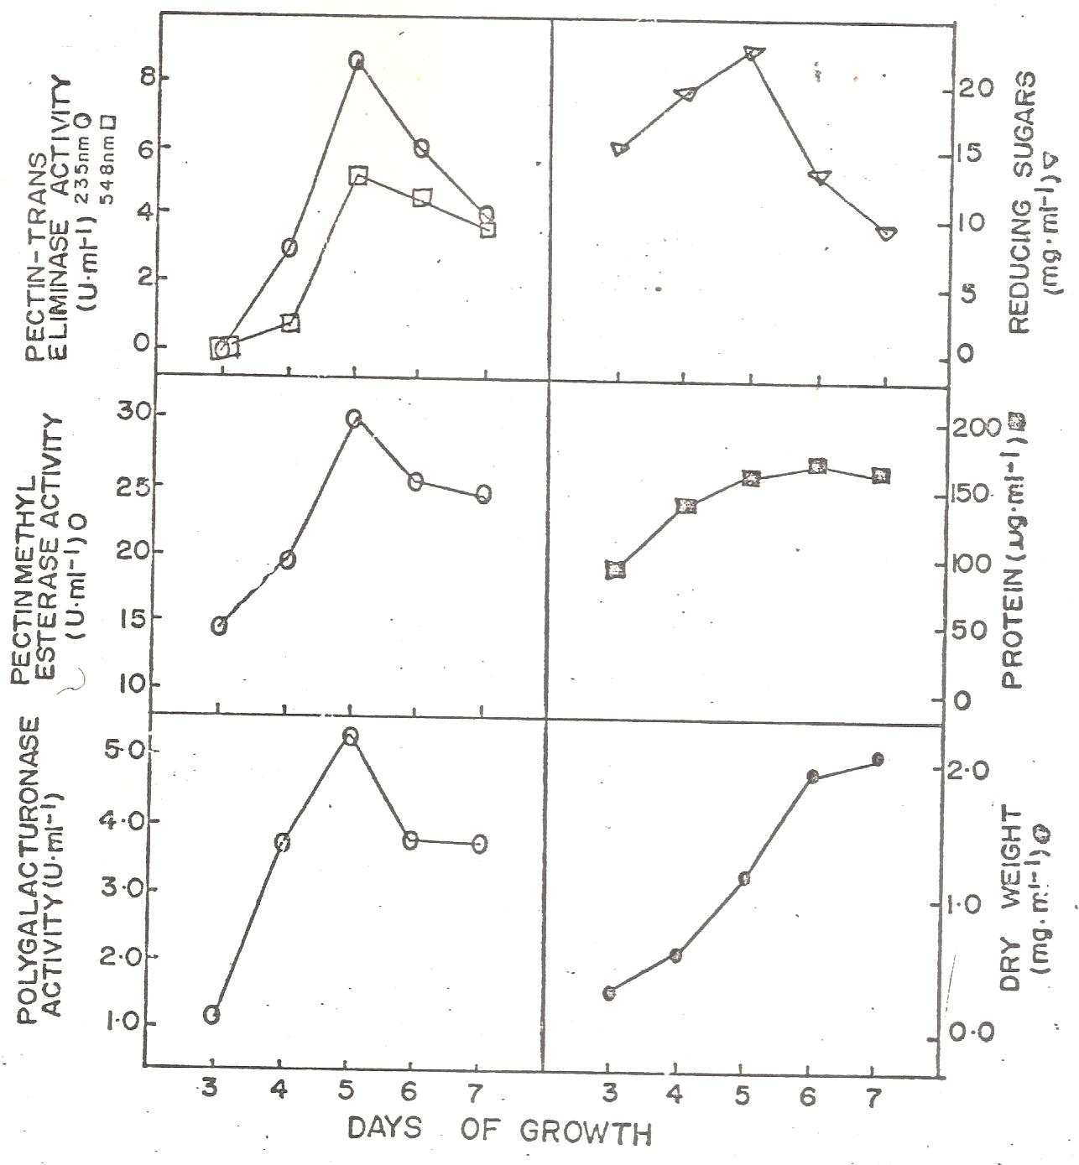
Figure 1: Growth of P. variabile on pectin as carbon source and production of pectic enzymes.

3.3. Growth and Production of Enzymes on Different Carbon Sources
Experiments were carried out to examine the constitutive or inductive nature of the pectic enzymes produced by P. variabile. The organism was grown in a medium containing glucose, cocoa or pectin as the sole source of carbon. P. variabile was able to grow on each of these carbon sources when employed as the sole carbon source (Table 2). During this process proteins were released into the medium. Growth was best on cocoa, followed by glucose and pectin respectively. The amount of proteins released into the medium paralleled the growth attained on each carbon source. Polygalacturonase and pectin-transeliminase were produced when the carbon source was cocoa or pectin.

Table 2: Effect of Source of Carbon on Growth and Production of Enzymes by P. variabile
Carbon source | Mycelial dry weight (mg/ml) | Protein (µg/ml) | polygalacturonase (PG) relative activity | pectin methylesterase (PTE) activity (µg/ml) | pectin trans-eliminase (PTE) activity (µg/ml)
Glucose | 5.52 | 195 | 0.0 | 19.46 | 0.0
CM-Cellulose | 2.50 | 165 | 0.0 | 23.58 | 0.0
Cocoa | 8.60 | 298 | 15.45 | 35.58 | 3.37
Pectin | 4.35 | 186 | 7.33 | 33.92 | 3.27

3.4. Enzyme Activity in Extracts of Diseased Cocoa Beans and Fungal Mycelium
The dialysed extract of healthy cocoa beans contained no pectin-transeliminase activity, although occasionally, traces of pectin methylesterase were detected. On the other hand the dialysed extracts of cocoa beans infected with P. variabile possessed cellulase, polygalacturonase and exhibited high pectin methyl esterase activity when incubated with pectin. The absorption spectrum of reaction products which contained pectin and extracts from diseased tissue revealed an absorption maximum at 235nm. The absorption spectrum of reaction products with thiobarbituric acid (TBA) also revealed an absorption maximum at 550nm. These are characteristics of pectin-transeliminase activity and confirmed presence of pectin-transeliminase in tissues infected with P. variabile.

3.5. Effect of Shaking, Temperature and PH on Enzyme Activity
During growth in shaken cultures P. variabile grown on pectin as the sole carbon source caused less observable reduction in the viscosity of the growth medium than in stationary cultures. The protein content of stationary cultures was higher than those of shaken cultures and the ability of the culture filtrate to reduce the viscosity of buffered pectin was greater in stationary cultures (Figure 2). Thus, the production of pectic enzymes was less in agitated than in stationary cultures. Codner (1971) further believed that this maceration involves mainly pectinolytic enzymes since the cell walls of the tissue maintain their rigidity so long as the component of the cell wall remains intact.

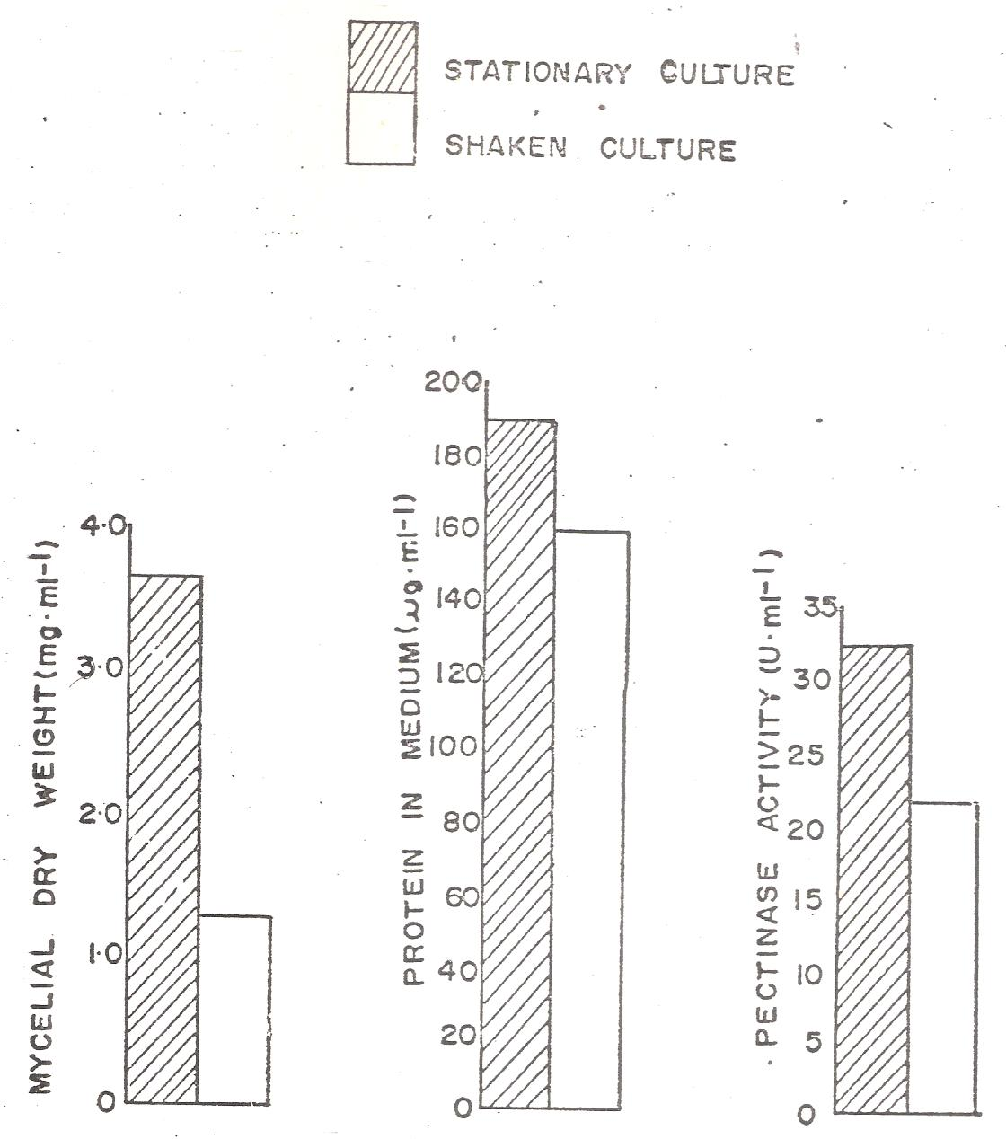
Figure 2: Effect of shaking on pectinase production by P. variabile

The temperature of the medium also affected both growth and enzyme production by P. variabile. Growth of the organism and production of pectinclytic enzymes were optimum at 30°C. Release of proteins into the medium was also optimum at 30°C, Growth and production of enzymes were least supported at 20⁰C and 35°C (Figure 3).
When the sole carbon source was a pectic substance, the culture filtrate exhibited polygalacturonase activity at an optimum pH of 5, and the activity decreased as pH of the reaction mixture increased beyond 5 (Figure 4). At pH below 6, pectin-transeliminase activity was poor, the optimum activity occurring at pH 8. No pectin methyl esterase activity occurred between pH 3 and pH 6. Maximum pectin methyl esterase activity occurred at pH 8 as shown in Figure 4.

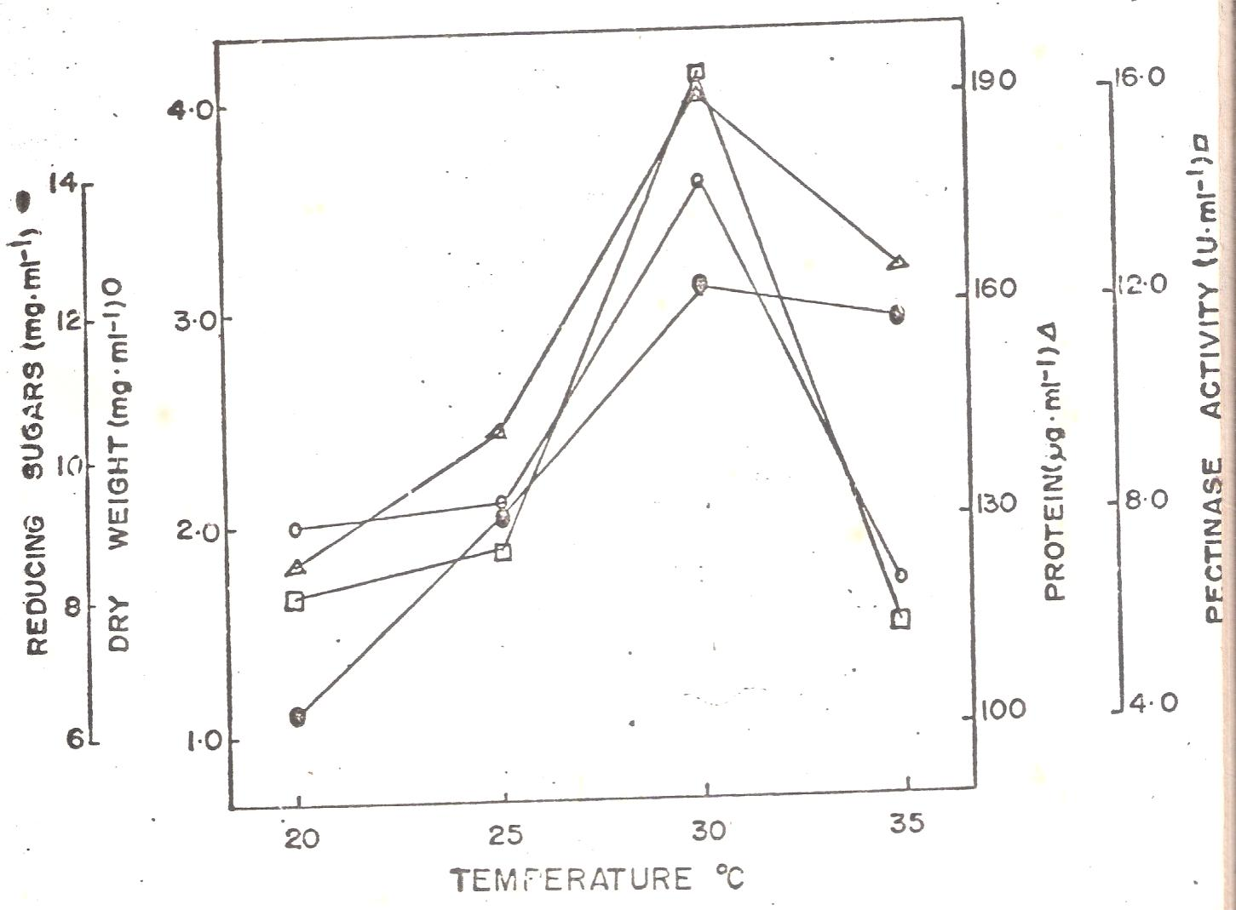
Figure 3: Effect of Temperature on pectinase production by P. variabile

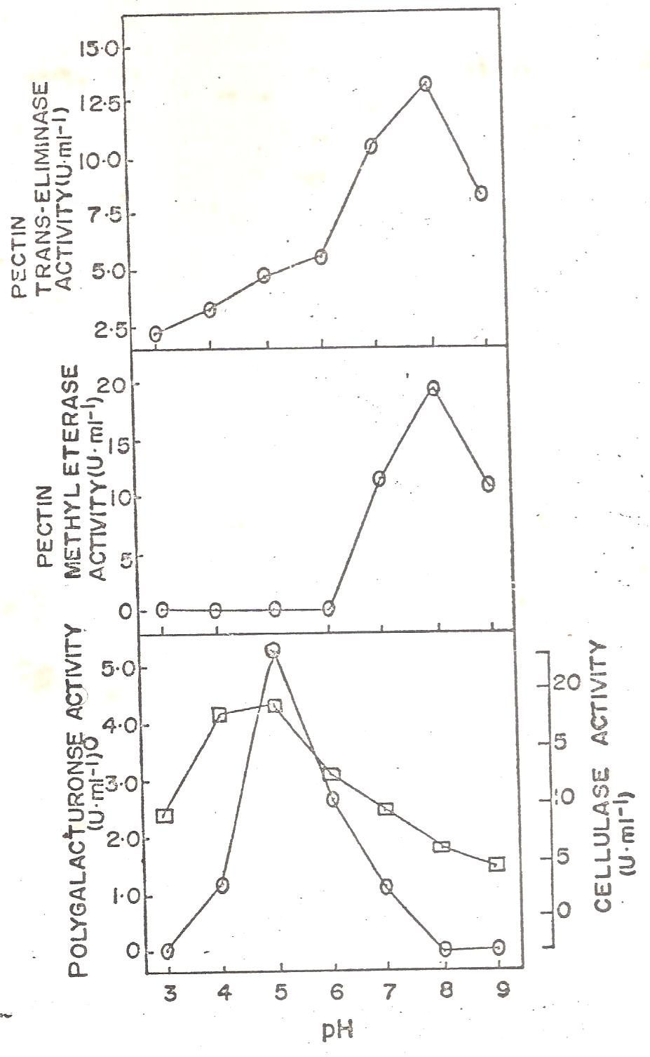
Figure 4: Effect of pH on pectinase production by P. variabile

3.6. Fractionation of Pectic Enzyme on Sephadex G-75 and Sephadex C-50 Columns
Fractionation of the enzyme concentrate (obtained from culture filtrate of P. variabile grown on pectin medium) gave only one absorption peak with a molecular weight of approximately 63100 (Figure 5).
Further separation of these components was therefore attempted on Sephadex C-50. Separation on Sephadex C-5O gave four absorption peaks designated Aa, Ab, Ac and Ad respectively (Figure 6). Component Aa possessed polygalacturonase, pectin methylesterase and pectin trans-eliminase activity. Component Ab and Ac possessed polygalacturonase and pectin trans-eliminase activity but lacked pectin methylesterase activity. Component Ad lacked both polygalaëturonase and pectin methylesterase activity and possessed only pectin trans-eliminase activity.

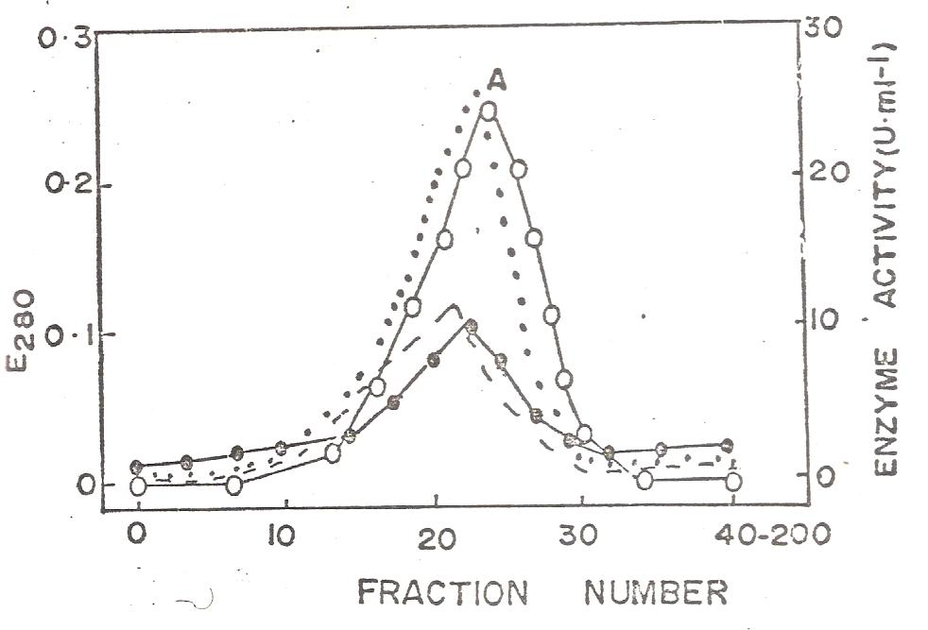
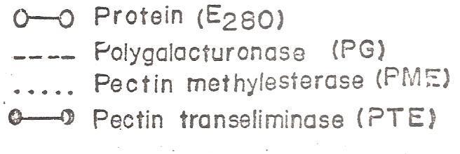

Figure 5: Separation by gel-filtration of proteins in concentrated culture filtrate of P. variabile.

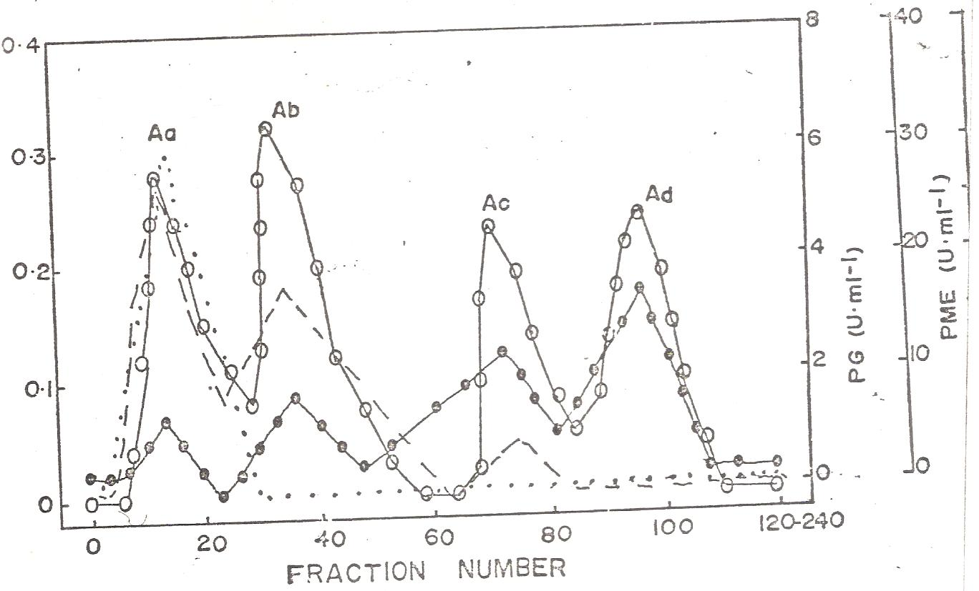

Figure 6: Separation by ion exchange chromatography of proteins previously separated from culture filtrates of P. variabile by gel filtration.

4. DISCUSSION
In this study, Penicillium variabile was able to grow in culture media containing pectic substrate as a carbon source and released into the medium, proteins and a complex of enzymes capable of degrading the ∝-l, 4 glycosidic bonds of pectic substances hydrolytically as well as by a transeliminative mechanism. Increase in quantity of proteins was directly related to mycelial dry weight. Similar observations have been reported by other workers (Norkrans, 1963a,b). This reaction is of importance especially as regards the ability of phytopathogens to split pectic substances by the alternative pathway of non-hydrolytic action in addition to the conventional hydrolytic degradation of these substances (Akintobi, 1978). Penicillium and Aspergillus are among the most studied cellulolytic and pectinolytic fungi (Sukumaran et al., 2005; Favela-Torres et al., 2006; Adeleke et al., 2012). Though strains of Penicillium sp. are perhaps best known for their use in pharmaceutical industry for the synthesis of penicillin and griseofulvin (Adeleke et al., 2012), Fawole and Odunfa (1992) previously showed that Aspergillus, Fusarium, Penicillium and Rhizopus showed high pectolytic activities.
Adeleke et al. (2012) evaluated the potentials of fungi to produce pectinase and cellulase using orange peels as substrate. Mixture of orange bagasse and wheat bran was the best substrate for the production of pectinase in solid state fermentation using a Penicillium sp. (Silva et al., 2002; Adeleke et al., 2012). Industrially, use of orange peel powder can be highly economical. Dhillon et al. (2004) reported the use of citrus peel in semisolid fermentation for pectinase production.
In a study by Spalding et al. (1973 cited by Akintobi, 1978), Penicillium expansum, the causal agent of blue mould rot in apples, was shown to produce polygalacturonase in artificial media and when attacking apples. Bateman (1963) worked on macerating enzyme of Rhizoctonia solani and observed that PG from Rhizoctonia solani-infected bean tissue could macerate potato tissue but pectin methylesterase (PME) appeared not to be necessary for this process. However, the primary components of macerating enzyme of Rhizoctonia solani filtrates he obtained from the bean stem medium, admittedly, were apparently polygalacturonase (Bateman, 1963).
Pectin trans-eliminase and polygalacturonase activities occurred in Penicillium-infected cocoa beans but could not be demonstrated in healthy tissues. On the other hand traces of pectin methylesterase were occasionally demonstrable in healthy and in uninoculated tissue extracts, although comparatively higher amounts occurred in infected tissue. The greater amount of pectin methylesterase in diseased tissue extracts could therefore have resulted from a release or perhaps due to increased synthesis, of the enzyme on the part of the host rather than production of the enzyme by the pathogen. However, the fact that pectin methyl esterase activity was demonstrable in culture filtrate of P. variabile indicated that the organism could secrete the enzyme and will therefore be contributive to the overall quantity of pectin methyl esterase present in diseased tissue extracts. Alabi and Naqvi (1977) observations noted that the pectolytic and celluloytic enzymes could act jointly to disintegrate host tissues. Other studies have shown that pectinolytic enzymes are involved in the degradation of pectin constituents of cell walls and middle lamellae in leaf spots (Hancock et al., 1964) while polygalacturonases have been reported to be important for successful pathogenesis by fungi (Albersheim et al., 1969).
In this present study, pectin methyl esterase was produced in media either containing or lacking a pectic substance. On the other hand polygalacturonase and pectin transeliminase were not produced whenever the medium lacked a pectic substance, thus production of pectin methylesterase by P. variabile is constitutive whereas the production of polygalacturonase and pectin transeliminase is inductive. However, for each type of enzyme more was produced whenever the medium contained a pectic substance. Synthesis of even a small amount of constitutive enzyme could be distinctly advantageous for pathogenicity. Some constitutive synthesis of pectic enzymes would allow an organism to begin an attack on exposed pectic materials immediately and prior to formation of the protective layer. Also if smaller degradation products rather than large pectin molecules are the actual inducers of pectic enzyme synthesis, a small amount of constitutive enzyme could also form a supply of inducer quickly and trigger synthesis of inducible enzyme (Akintobi, 1978).
Although relatively large quantities of proteins were produced in media lacking pectin, culture filtrates from such media possessed less pectinase activity than pectin-containing media. Two possibilities are suggested to explain the phenomenon. Firstly, the extra protein present in non-pectin media was not necessarily pectic enzymes and possibly consists of other types of enzymes which are involved in the metabolism of sugars by P. variabile. Secondly, the extra proteins could as well be pectic enzymes but whose activities are somehow inhibited by the presence of sugars, thus an example of catabolite repression of pectic enzyme synthesis (Akintobi, 1978).
Cultural conditions greatly influenced the activity of pectinolytic enzymes produced by P. variabile and the nature or pattern of the effect was somehow dependent on the type of enzyme. For example, production and activity of pectin methyesterase and pectin transeliminase activities were favoured by alkaline condition. Similar results have been reported by other workers (Olutiola, 1972, 1976). The effect of hydrogen ion concentration on activity of the enzyme may be explained in part in terms of the relative molecular stability of the enzyme itself and in part on the ionizable groups (COO^{-,} OH⁻) of the tertiary protein structure of the enzyme complex (Lehninger, 1973).
In this study, production of pectinase enzymes by P. variabile was optimum at 30°C. Optimum pH for pectin methylesterase and pectin transelimiñase activities was best at pH 8.0 while polygalacturonase activity was at pH 5.0. In previous studies, fungal endo-polygalacturonase pH optimum was recorded in extracts of diseased leaves as between pH 4 and 5 (Hancock et al., 1964). Earlier on, it was found to be most active under acid condition (Bateman, 1963). In a study by Adeleke et al. (2012), Penicillium atrovenetum, Aspergillus flavus and Aspergillus oryzae produced polygalacturonase optimally on the 5th day while endoglucanase was produced optimally on the 7th day. Highest production of polygalacturonase and endoglucanase by Penicillium atrovenetum was observed at pH 5, 40^{O}C and at 0.2% ammonium persulfate. Banu et al. (2010) presented similar observations for polygalacturonase production by Penicillium viridicatum on day 7, pH 5 and at 45^{O}C. Mrudula and Anitharaj (2011) reported an optimum production of pectinase on orange peels by Aspergillus niger at 50^{O}C, pH 5, 96th hour, 1:2(v/w) moisture, 2.5ml inoculums size and in the presence of sucrose and triton-X-100. Varying times of optimum incubation time can be justified by the submission of Patil and Dayanand (2006) and Adeleke et al. (2012) that the period of fermentation depends upon the nature of medium, fermenting organisms, concentration of nutrients and the process physiological conditions.
Temperature of incubation also affected the release into the medium and activity of pectinolytic enzymes of P. variabile, temperature of 20°C being particularly unfavourable to both enzymes. In general, temperature is believed to be the most important physical factor affecting enzyme activity (Dixon and Webb, 1971). The effect of temperature on activity of enzyme reactions may be due to several causes including an effect on the stability of the enzyme itself or to an effect on the enzyme-substrate affinity (Lehninger, 1973). In nearly all cases the enzyme protein is irreversibly denatured (Akintobi, 1978).
Agitation of the culture also exerted considerable influence on the activity of pectic enzymes produced by P. variabile. Agitated cultures released fewer proteins into the medium than stationary cultures. Also in agreement with this observation is the fact that measured mycelial dry weight and enzyme activity were less in shaken than in unshaken cultures. These results agree with those of earlier workers (Norkrans, 1963a, Olutiola, 1972).

Most of the fungi investigated for pectinase production showed optimum growth in the range of 45 to 60^{O}C (Rubinder et al., 2002; Freitas et al., 2006). The pH of the medium will also limit the growth of the culture or exert influence upon catalytic activity of the enzyme. Maximum polygalacturonase production was observed in the medium with the acidic initial pH values within a range of 4 to 6 (Aminzadeh et al., 2007). Observation in the study by Adeleke et al. (2012) showed optimum pH for enzymes production within 5 to 5.5.
Several methods have been employed for the determination of the molecular weight of proteins, but gel filtration is probably the most useful because of its simplicity in operation, wide application and equivalence with preparatory procedure (Olutiola, 1972). The use of sephadex gel filtration has been highly recommended for the separation of protein components (Andrews, 1964). In this study, gel filtration was able to separate cellulase enzyme of P. variabile into five components, four of which exhibited cellulase activity. Thus when separated on the column of sephadex G-75 the cellulase of P. variabile possessed five components. However, when gel filtration was employed for the pectic enzyme of P. variabile only one absorption peak was obtained. On further separation by ion-exchange chromatography, the single component was resolved into four components, one of which (component Ad) appeared unique, representing a PG- and PME-free form of pectin trans-eliminase, A similar pectin trans-eliminase enzyme has been reported by other workers.
A number of the separated components are relatively low molecular weight enzymes ranging from approximately 20000 to 35000. Enzymes and macromolecules have been reported to penetrate plant cell membranes. Therefore the small sizes of the enzymes could be of advantage to a phytopathogen because such enzymes will be able to diffuse more readily through membranes and fungal cell walls, thus contacting substrates faster than larger enzymes. In addition, the amount of energy expended by the fungal cell to synthesize a small molecule will be less than for a larger enzyme, and there will be less active (charged) sites on the enzyme, thus making them less susceptible to reactions with inhibitors (Dixon and Webb, 1971).
Polygalacturonase, pectin transeliminase and pectin methylesterase were detected in the cell-free broth of P. variabile. This is consistent with several papers which suggested that polygalacturonases are important pathogenecity factors for spoilage fungi (Dimatteo et al., 2006; Al-Hindi et al., 2011). The secretion of pectin degrading enzymes during infection to the plants has been reported from various plant pathogenic fungi such as F. oxysporum, Botrytis cinerea, Sclerotinia sclerotiorum (TenHave et al., 2001; De Las Heras et al., 2003; Li et al., 2004; Al-Hindi et al., 2011).
Previous studies reported that fungi have been produced from several plant cell wall degrading enzymes (Al-Hindi et al., 2011). Genus Fusarium was able to secrete several cell wall degrading enzymes such as pectinase (Di Pietro et al., 2003; Al-Hindi et al., 2011). Tissues infected by F. oxysporum produced the highest pectolytic enzyme activity among the fungi studied in as study by Bahkali et al. (1997) and Al-Hindi et al. (2011).
In several studies, induction of polygalacturonases from A. oryzae by pectin was significantly higher than when rinds of citrus fruits were used as inducer (Malvessi and da Silveira, 2004; Al-Hindi et al., 2011). A. oryzae produced polygalacturonase in solid-state and submerged cultures (Oda et al., 2006; Al-Hindi et al., 2011). A. tubingensis produced polygalacturonase (Kester et al., 1996) when synthetic media used as substrates under submerged culture cultivation (Al-Hindi et al., 2011).

5. CONCLUSION
Enzymes are currently used in several different industrial products and processes and there is ever increasing demand to replace traditional chemical processes with advanced biotechnological processes involving microorganisms and enzymes. Hence, new areas of application are constantly being
researched into (Adeleke et al., 2012).
In this study, the extracts obtained from Penicillium-infected cocoa beans exhibited polygalacturonase, pectin-methylesterate and pectin transeliminase activities. The culture filtrates also possessed similar enzyme activities. Thus, besides producing pectinolytic enzymes in vitro, P. variabile also produces these enzymes in vivo. The results also show that the pectinolytic enzymes produced by P. variabile were able to cause maceration of plant tissue, indicating production of a macerating “factor” by P. variabile (Mount et al, 1970). Thus, in its infection process, P. variabile will be equipped with a complex of enzymes capable of degrading pectic components of the host cell wall. It is therefore suggested that pectinolytic enzymes may play an important role in the infection of cocoa beans by P. variabile. The possible role of pectinolytic enzymes in pathogenicity have been indicated (Ayesu-Offei and Clare, 1970; Hunter and Elkan, 1975).

Acknowledgement
The authors thank the management and staff of the Nigerian Stored Products Research Institute (NSPRI), Ibadan for their immense assistance and for the culture collection of the isolates (Penicillium variabile NSPRI.1l4) employed in this study.
Correspondence to:
Iheanyi O. Okonko
Department of Microbiology,
University of Port Harcourt, Choba,
East-West Road, P.M.B. 5323, Choba,
Port Harcourt, Rivers State, Nigeria;
Tel.: +2348035380891
Email: mac2finney@yahoo.com;
Iheanyi.okonko@uniport.edu.ng

References
- Adeleke AJ, SA Odunfa, A Olanbiwonninu, MC Owoseni. Production of Cellulase and Pectinase from Orange Peels by Fungi. Nature and Science 2012;10(5):107-112
- Alabi, R.O. and Naqvi, S.H.Z. 1977. Production of cellulolytic and pectolytic enzymes by Cercospora arachnidicola. Trans. Br. Mycol. Soc. 68 (2): 296-298.
- Albersheim, P. Jones, T.M. and English, P.D. 1969. Biochemistry of the cellwall in relation to infective process. Ann. Rev. Phytopathol 7:171-194.
- Al-Hindi RR, Al-Najada AR, Mohamed SA. Isolation and identification of some fruit spoilage fungi: Screening of plant cell wall degrading enzymes. African Journal of Microbiology Research, 2011; 5(4): 443-448.
- Aminzadeh S., Naderi-Manesh H. and Khadesh K. (2007). Isolation and characterization of polygalacturonase produced by Tetracoccosporium sp. Iran J. Chem. Eng. 26(1): 47 – 54.
- Andrews, P. 1964. Estimation of the Molecular Weights of Proteins by Sephadex Gel-Filtration. Biochemical Journal 91: 222-233.
- Ayesu-Offei, E.C. and Clare, B.G. 1970. Processes in the Infection of Barley Leaves by Rhynchosporium secalis. Australian Journal of Biological Science 23:299-307.
- Bahkali AR, A1-Khaliel, AS Elkhider KA (1997). In vitro and In vivo production of pectolytic enzymes by some phytopathogenic fungi isolated front southwest Saudi Arabia. King Saud Univ., 9: 125-137.
- Banu A.R., Devi M.K., Gnanaprabhal G.R., Pradeep B.V. and Palaniswamy M. (2010). Production and characterization of pectinase enzyme from Penicillium chysogenum. Indian Journal of Science and Technology, 3(4): 377 – 381.
- Bateman, D.F. 1963. The “Macerating Enzyme” of Rhizoctonia solani. Phytopathology 53:1178-1186.
- Bateman, D.F. 1968. The Enzymic Maceration of Plant Tissue. Nether J. PL. Pathol. 74: 67-80.
- Bugbee, W.M. 1975, Penicillium claviforme and P. variabile: Pathogens of Stored Sugar Beets. Phytopathology 65(8): 926-987.
- Codner, R.C. 1971. Pectinolytic and Cellulolytic Enzymes in the Microbial Modification of Plant Tissues. Journal of Applied Bacteriology 34(1): 47-160.
- De Las Heras A, Patino B, Posada, ML, Martinez MJ, Vazquez C, Gonzalez Jean MT (2003). Characterization and in vitro expression patterns of an exo-polygalacturonas encoding gene from Fusarium oxysporum f.sp. radicis lycopersici. J. Appl. Microbiol., 94: 856-864.
- Dhillon S.S., Gill R.K., Gill S.S. and Singh M. (2004). Studies on the utilization of citrus peel for pectinase production using Aspergillus niger. Inter. J. Environ., 61: 199 – 210.
- Di Matteo A, Bonivento D, Tsernoglou D, Federici L, Cervone F (2006). Polygalacturonase-inhibiting protein (PGIP) in plant defence: a structural view. Phytochem., 67: 528-533.
- Di Pietro A, Madrid MP, Caracuel Z, Delgado-Jarana J, Roncero MIG (2003). Fusarium oxysporum: exploring the molecular arsenal of a vascular wilt fungus. Mol. Plant Pathol., 4: 315-326.
- Dixon, M. and Webb, E.C. 1971 Enzymes (2nd ed.) Longmans, London.
- Favela-Torres E., Volke-Sepulveda T. and Viniegra- Gonzalez G. (2006). Production of hydrolytic depolymerising pectinases. Food Technol. Biotechnol., 44(2): 221 – 227.
- Fawole O.B. and Odunfa S.A. (1992). Pectolytic moulds in Nigeria. Letters in Applied Microbiology, 15: 266 – 268.
- Freitas P.M.N., Martin D., Silva R. and Gomes E. (2006). Production and partial characterization of polygalacturonase production by thermophilic Monascus sp. N8 and by thermotolerant Aspergillus sp. N12 on solid state fermentation. Brazilian Journal of Microbiology, 37: 302 –306.
- Gordon E, Anthon, Yukio Sekine, Nobuo Watanabe, Diane M (2002). Thermal inactivation of pectin methylesterase, polygalacturonase, and peroxidase in tomato juice. J. Agric. Food Chem., 50: 6153-6159.
- Hancock, J.G. Millar, R.L. & Lorbeer, J.W. 1964. Role of Pectolytic and Celluloltytic Enzymes in Botrytis Leaf Blight of Onion. Phytopathology 54: 932-935.
- Hunter, W.J. & Elkan, G.H. 1975. Role of Pectic and Cellulolytic Enzymes in the Invasion of the Soybean by Rhizobium japonicum. Can. J. Microbiol. 21: 1254-1258.
- Idnurm A, Howlett BJ (2001). Pathogenicity genes of phyto-pathogenic fungi. Mol. Plant Pathol., 2: 241-255.
- Kester HCM, Kusters-van Someren MA, Müller Y, Visser J (1996). Primary structure and characterization of an exopolygalacturonase from Aspergillus tubingensis. Eur. J. Biochem., 240: 738-746.
- Lebeda A, Luhová L, Sedláková D, Janková D (2001). The role of enzymes in plant–fungal pathogens interactions. J. Plant Dis. Prot., 108: 89-111.
- Lehninger, A.L. 1973. A short Course in Biochemistry Worth Publisher, Inc. New York.
- Li R, Rimmer R, Buchwaldt L, Sharpe AG, Seguin-Swartz G, Hegedus DD (2004). Interaction of Sclerotinia sclerotiorum with Brassica napus: Cloning and characterization of endo- and exopolygalacturonases expressed during saprophytic and parasitic modes, Fungal. Gen. Boil., 41: 754-765.
- Lowry, O.H. Rosebrough, N.J. Parr, A.L. & Randal, R.J. 1951. Protein Measurement with the Folin-Phenol Reagent. J. Biol. Chem. 193: 265-275.
- Malvessi E, Silveira MM (2004). Influence of medium composition and pH on the production of polygalacturonases by Aspergillus oryzae. Braz. Arch. Biol. Technol., 47: 693-702.
- McCledon, J.H. 1964. Evidence for the Pectic Nature of the Middle Lamella of Potato Tube Cellwalls Based on the Chromatography of Macerating Enzymes. Am. J. Bot. 51: 628-633.
- Meyer, J.A. 1964, The Production of Pectolytic and Cellulolytic Enzymes by Formae of Fusarium oxysporum. Overdruk Uit de Mededelingen Vande Land Bouwhoge School Ende Opzoekings Stations Van de Stoat to Gent Deel XXIX, No. 3: 875-883.
- Miller, G.L. 1959. Use of Dinitrosalicylic Acid Reagent for Determination of Reducing Sugar. Anal. Chem. 31. 426-428.
- Mount, M.S. Bateman, D.F. & Basham, H.G. 1970. Induction of Electrolyte Loss, Tissue Maceration and Cellular Death of Potato Tissue by an Rnfopoly hslsvyutonsyr ytsnd-rliminsdr. Phytopathology 60: 924-931.
- Mrudula S. and Anitharaj R. (2011). Pectinase production in solid state fermentation by Aspergillus niger using orange peel as substrate. Global Journal of Biotechnology & Biochemistry, 6(2): 64 – 71.
- Nathalie J (2006). Plant protein inhibitors of cell wall degrading enzymes. Trends Plant Sci., 11: 359-367.
- Netsanet ST, Gamage M, Vilkhu K, Simons L (2009). The kinetics of inactivation of pectin methylesterase and polygalacturonase in tomato juice by thermosonication Raymond Mawson, Cornelis Versteeg. Food Chem., 117: 20-27.
- Norkrans, B. 1963a. Influence of some Cultural Conditions on Fungal Cellulase Production. Physiol. Planta. 16: 11-19.
- Norkrans, B. 1963b. Degradation of Cellulose. Ann. Rev. Phytopathology 1: 325-342
- Nwodu-Chinedu S., Eni A.O., Adeniyi A.I. and Ayangbemi J.A. (2010). Assessment of growth and cellulase production of wild-type microfungi isolated from Ota, Nigeria. Asian Journal of Plant Sciences, 9(3): 118 – 125.
- Oda K, Kakizono D, Yamada O, Iefuji H, Akita O, Iwashita K (2006). Proteomic analysis of extracellular proteins from Aspergillus oryzae grown under submerged and solid-state culture conditions. Appl. Environ. Microbiol., 72: 3448-3457.
- Olutiola, P.O. & Ayres, P.G. 1973. A Cellulase Complex in Culture Filtrates of Rhynchosporium secalis. (Barley Leaf Blotch). Trans. Br. Mycol. Soc. 60: 273-282.
- Olutiola, P.O. 1972. Aspects of the Carbohydrate Physiology of Rhynchosporium secalis (Oudem). Ph.D. Thesis, University of Lancaster.
- Olutiola, P.O. 1976. A Cellulase Complex in the Culture Filtrates of Penicillium citrinum. Can. J. Microbiol. 22: 1153-1159.
- Olutiola, P.O. and Cole, O.O. 1976. Production of Cellulase Complex in the Culture Filtrates of Aspergillu tamari Associated with Mouldy Cocoa Beans in Nigeria. Physiol. Planta. 37: 313-316.
- Oyeniran, J.O. 1970. Internal Mouldiness of Commercial Cocoa in Ibadan, Western State, Nigeria. Rep. Niger. Stored Prod. Res. Inst. Tech. Rep. No. 2:19-27.
- Patil S.R. and Dayanand A. (2006). Exploration of regional agrowastes for the production of pectinase by Aspergillus niger. Food Technol. Biotechnol., 44(2): 289 – 292.
- Raviyan P, Zhang Z, Feng H (2005). Ultrasonication for tomato pectinmethylesterase inactivation: Effect of cavitation intensity and temperature on inactivation. J. Food Eng., 70: 189–196.
- Rubinder K., Chandha B.S., Singh S. and Saini H.S. (2002). Amylase hyper production by deregulated mutants of the thermophilic fungus Thermomyces lanuginosus. J. Ind. Microbiol. Biotechnol., 29: 70 – 74.
- Silva D., Martins E. Da Silva. and Da Silva R., Gomes E. (2002). Pectinase production by Penicillium viridictum RFC3 by solid state fermentation using agricultural waste and agroindustrial by-products. Brazilian Journal of Microbiology, 33: 318 – 324.
- Sukumaran R.K., Singhania R.R. and Pandey A. (2005). Microbial Cellulases --- Production, application and challenges. Journal of Scientific & Industrial Research, 64: 832 – 844.
- Ten Have A, Breuil WO, Wubben JP, Visser J, van Kan JA (2001). Botrytis cinerea endopolygalacturonase genes are differentially expressed in various plant tissues. Fungal Gen. Biol., 33: 97-105.
- Tomassini A, Sella L, Raiola A, D'Ovidio R, Favaron F (2009). Characterization and expression of Fusarium graminearum endopolygalacturonases in vitro and during wheat infection. Plant Pathol., 58: 556-564.
- Yogesh K., Vamsi K., Amal B., Nikhil G., Soham T., Prasad P., Girish G., Mayank G, Amol J., Adarsh M., Joshi B. And Mishra D. (2009). Study of pectinase production in submerged fermentation using different strains of Aspergillus niger. International Journal of Microbiology Research, 1(2): 13 – 17.

5/5/2012

