Development of Disease Forecasting Model for Leaf rust of Mulberry ( Morus alba L.) of Dimapur of North East India

S. K. DUTTA¹, M.K.GHOSH¹, A.BORAH², B.B.BINDROO¹

¹Central Sericultural Research and Training Institute, Central Silk Board, Berhampore, WB, India
²Research Extension Centre,CSR&TI, Dimapur (Nagaland), India
dutta_sandipkumar@yahoo.in

Abstract: Dimapur ( 25.55˚N / 93.44˚E ), the capital of Nagaland is located at 190 meter above sea level (MSL) in the North East zone of India. Sericulture is one of the primary occupations for livelihood of rural population of Eastern and North Eastern India. The tradition of silkworm rearing has become a part of culture of rural masses of different states of India viz., West Bengal, Assam, Manipur, Bihar, Jharkhand and Odisha. Presently, the Eastern and North Eastern region generates about 3,254 ton of raw silk per annum and contributes to nearly 50% of total production of India. Mulberry (Morus alba, L.) belongs to family Moraceae is the sole food plant of silkworm (Bombyx mori L.). Disease incidence is one of the major hindrance for sericulture activity in India. Mulberry can be grown under various agro climatic conditions. In Dimapur climatic vagaries and fluctuating environmental situations have significantly adverse impact on congeniality for successful silkworm rearing. Despite of the hurdles, this state (Nagaland) possess great potential for sericulture development which ultimately contributes towards overall prosperity and remunerative employment generation. Among the commercially exploited mulberry varieties viz, S1 and S1635 of Dimapur, incidence of leaf rust (Peridiopsora mori) is very common. The disease severity data ( PDI) of leaf rust (LR) in different areas of Dimapur district viz., Samaguri, Jalukie, and Maimansi were collected along with the meteorological parameters viz., maximum temperature, minimum temperature, maximum RH, minimum RH and rainfall for prediction of disease severity through regression analysis, when coefficient of determination R² = 0.255 Maximum severity of Leaf rust was observed during November ( 16.89 PDI).
[S. K. DUTTA, M.K.GHOSH, A.BORAH, B.B.BINDROO. Development of Disease Forecasting Model for Leaf rust of Mulberry ( Morus alba L.) of Dimapur of North East India. Nat Sci 2012;10(8):66-69]. (ISSN: 1545-0740). http://www.sciencepub.net/nature. 11

Key words: Leaf rust (LR) , Regression analysis, Coefficient of determination.

1. Introduction:
Mulberry varieties ( S1 and S 1635) are cultivated in Dimapur of N. E. India as bush or as dwarf tree forms. Among the different diseases of mulberry of this locality, Leaf rust (LR) is predominant. Disease appears in the ventral surface of leaves as brown pustules, gradually spreads brown pin head structure through ventral surface. Feeding of diseased leaves results poor cocoon crop and causes reduction in the income of the rearers, therefore timely management for control of disease is the prerequisite for harvesting healthy and nutritious leaves. Disease not only reduces leaf yield but also causes degradation in the quality (Quadri et al 1999a & 1999b) and feeding of diseased leaves prolongs larval period (Noamani et al,1970 and Umesh Kumar et al, 1993).

2. Material and Methods:

The study was carried at Samaguri, Jalukie and Maimansi area of Dimapur district of Nagaland.

For occurrence of Leaf rust (Fig.I) in mulberry field of S1 variety, weekly disease severity data (PDI) and day wise meteorological data viz. maximum temperature, minimum temperature, maximum relative humidity (%), minimum relative humidity (%) and rainfall were collected and recorded during 2009-2012.

During collection of disease data, five plants are selected from a plot of 20 / 20 meter area , then four plants from four corners and one from the centre was selected. Three branches are randomly selected per plant and tagged from one-one plants. To measure the disease incidence, the total number of leaves and the number of leaves infected with disease are counted on the selected branches. For measuring the percentage of disease index (PDI), all infected leaves are categorized into different grades of infection using the following 0 – 5 grading scale (FAO 1967).

GRADING SCALE:

Grade -0= No infection

Grade -1= 0-5% leaf lamina covered by the symptom

Grade -2= 6-10% leaf lamina covered by the symptom

Grade -3= 11-25% leaf lamina covered by the symptom

Grade -4= 26-50% leaf lamina covered by the symptom

Grade =5 = 50% and above leaf lamina covered by the symptom

Sum of all individual rating

Percent disease index (PDI) = ----------------------------------------------------- X 100

Total no. of leaves observed X Maximum grade (5)

3. Results and discussion:
Present observation ( Avg. of three years) shows that maximum severity of leaf rust (Fig – II) was observed during November ( 16.89 PDI) and minimum severity during September (1.47 PDI).
Fig. - I
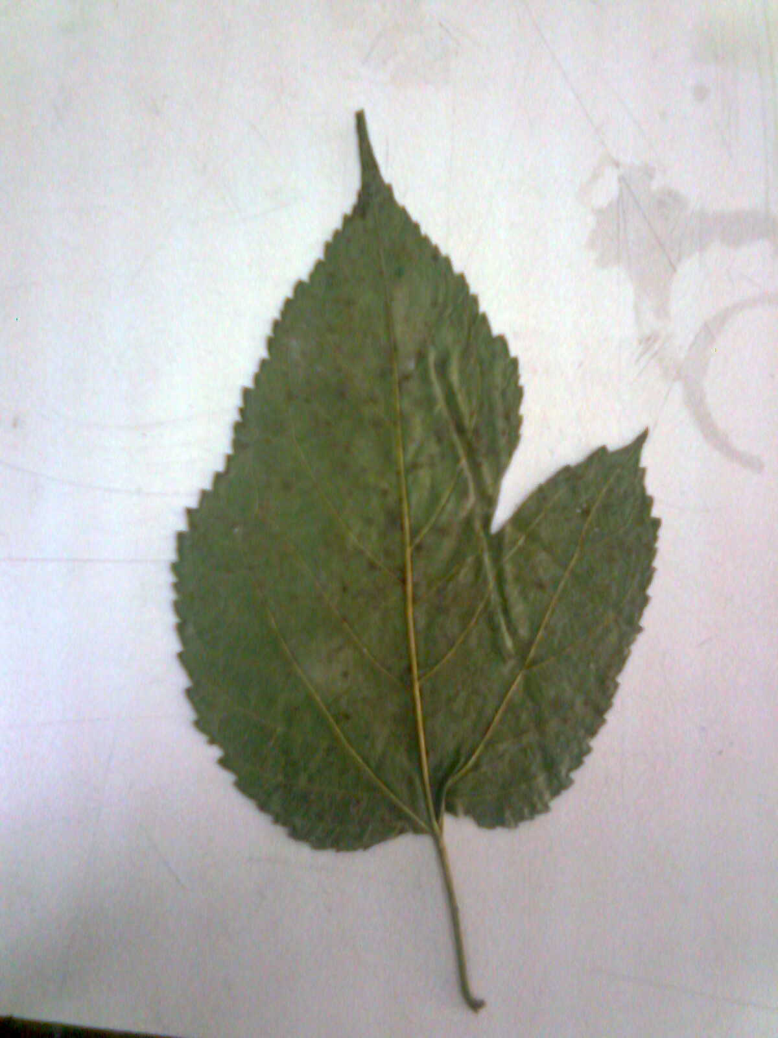
Leaf rust ( Peridiopsora mori)

Fig. - II

Fig. - III

Fig. - IV

Fig. - V

Climatic condition of Dimapur shows (Fig. III) maximum temperature ( 37˚C) during August and minimum temperature (11˚C) during January. Maximum RH (89%) during June and minimum RH (61%) during August (Fig. IV). Maximum rainfall (487 mm) during June was recorded (Fig. V ).
Different scientists were worked regarding meteorological factors related to disease severity in different plants (Singh, 1984).
Prediction of disease severity through input of disease and meteorological data was done by regression analysis Y = a₁ + b₁X₁ + b₂X₂ + b₃X₃ + b₄X₄ + b₅X_{5,} when X ₁ = Maximum temperature , X ₂ = Minimum temperature X ₃ = Maximum relative humidity X ₄ = Minimum relative humidity X ₅ = Rainfall, Y = Predicted disease severity, a₁ = Intercept and b₁ – b₅ = Partial regression coefficient for weather factors. Regression equation analysis for leaf rust of Dimapur shows Y = - 34.899 – 0.012 X₁ + 0.492 X₂ – 0.420 X₃ + 0.807 X₄ - 0.013 X₅, when coefficient of determination, R² = 0.255. Here predicted disease severity is very close to actual disease severity hence, the model can be exploited by application recommended fungicide ( 0.1% Mancozeb @180 litre/acre) for cost effective management of leaf rust disease of Dimapur (Nagaland).

References
- F.A.O. 1967 Crop loss due to diseases and pests. Food and Agricultural Organization. Rome.
- Noamani, M.K.R., Mukherjee, P.K. and Krishnaswami,S. 1970 Studies on the effect of feeding multivoltine silkworm (Bombyx mori. L.) larvae with mildew effected leaves. Indian.J.Sericulture, 9: 4 – 52.
- Qadri, S.M.H., Gangwar, S. K., Pratheesh Kumar, P.M., Elangavon, C., Maji, M. D and Saratchadra, B. (1999a) Crop loss assessment due to leaf spot disease of mulberry Indian J. Sericulture,38 (1) : 35-39
- Qadri, S.M.H., Pratheesh Kumar, P.M., Gangwar, S. K., Elangavon, C., Das, N. K., Maji, M.D and Saratchadra, B. (1999b) Crop loss assessment due to powdery mildew in mulberry, Bull. Sericulture. Res.9: 31-35
- Singh,R.S. (1984) Introduction to principles of Plant Pathology, 3rd Ed. Oxford and INH publishing co., New Delhi, 534 pp.
- Umesh Kumar, N.N., Sharma, D.D. and Shree,M.P., 1993 Effect of feeding fungus infected leaves on commercial characters of silkworm (Bombyx mori. L.) Indian. J. Sericulture, 32 (1):107-109.

6/6/2012

