Assessment of the Effect of Different Preservatives on the Physico-chemical Quality of Soy milk Stored at Different Temperatures

Odu NN and Egbo NN

Department of Microbiology, University of Port Harcourt, Choba, P.M.B. 5323, Port Harcourt, Rivers State, Nigeria; odungozi@yahoo.com

ABSTRACT: The aim of this study was to assess the effect of different preservatives on the physico-chemical quality of Soy milk stored at different temperatures. The utilization of soy bean for the production of soy milk was evaluated. Soy milk was extracted from whole and dehulled seed, pasteurized and fermented. Physicochemical qualities of the soy milk samples were evaluated to determine the physical and chemical quality of the products. All the samples were treated with potassium sorbate and sodium benzoate (in combination) with propyl gallate and Ascorbyl palmitate (singly and in combination), organoleptically evaluated and stored at ambient temperature and 4 ± 2^{O}C for 16 days and were subjected to physical examination and chemical analyses such as pH and titratable acidity (TTA). There was a gradual decrease in the pH and an increase in the total titratable acidity of the samples. For both pH and TTA, there was significant difference (P<0.05) between all the treatments and the length of storage. At ambient temperature, a rapid decline in pH was dominant especially for samples treated with NaHCO₃. Samples treated with Na₂CO₃ had a higher pH stability compared to its counterpart. At refrigeration temperature, there was a slow decrease in pH over time. Samples treated with Na2CO₃ also had a stable pH during the first few days of storage (4-10). For TTA, samples treated with NaHCO₃ had the highest increase in TTA value compared to samples treated with Na₂CO₃ at ambient temperature. The control showed least increase (from 0.026-0.036) for samples treated with Na₂CO₃ and 0.027-0.037 for sample treated with NaHCO₃. At refrigeration, due to longer storage time, there was a higher value for TTA. Ascorbyl Palmitate treated samples showed marked increase in TTA values in comparison with those treated in combination and singly. However, in all the samples, the control showed the least increase (for Na₂CO₃ 0.026-0.039 and 0.027-0.037 for NaHCO₃). No direct relationship was observed between pH values and titratable acidity. The study showed that the overall changes in pH and TTA observed for all the stored soy milk samples in the study may be suggesting that the fermentative activities of the soy milk starters still continued in storage. Generally, improved combined preserving techniques can in particular improve keeping quality; lessen the risk of microbial food poisoning.
[Odu NN and Egbo NN. Assessment of the Effect of Different Preservatives on the Physico-chemical Quality of Soy milk Stored at Different Temperatures. Nat Sci 2012;10(8):77-84]. (ISSN: 1545-0740). http://www.sciencepub.net/nature. 13

Keywords: Soybean, soy milk, pH, temperature, physicochemical quality, total titratable acidity (TTA)

1. INTRODUCTION
Grain legumes serve as a cheap source of protein to a large proportion of the population in poor countries of the tropics (Massawe et al, 2005). In recent years, different edible varieties of legumes have been identified that have high nutritional value and therefore could help to address a number of diet related problem globally (Kolapo and Oladimeji, 2008). Development of milk substitutes extracted from legumes serves as an alternative way of producing an acceptable nutritious food based on vegetable. Soybean (Glycine max) is recognized as one of the crops with huge potential the world over. This plant has been exploited for the manufacture of food products such as soybean fortified garri and tapioca and cereals-based traditional foods (Kolapo and Oladimeji, 2008; Iwe, 2003; Ikpeme et al, 2009).
Soymilk yoghurt serves as a very good alternative to the expensive cowmilk yoghurt (Nsofor and Maduako, 1992; Ashaye et al., 2001; Jimoh and Kolapo, 2007; Osundahunsi et al., 2007; Farinde et al., 2008, 2009, 2010). Soymilk has a characteristic beany flavour and this offflavour has often made it less acceptable than cow milk, but this has reportedly been reduced by lactic acid fermentation (Mital et al., 1974; Pithang et al., 1980; Farinde et al., 2010). Lee et al. (1990) reported the health benefit of lactic acid fermentation of soymilk to include reduced level of cholesterol. Chang et al. (2005) also reported that intake of fermented soymilk improves the ecosystem intestinal tract by increasing the amount of probiotics. Various processing methods have been developed to reduce syneresis in soy-yoghurt and improve its acceptability (Moor, 1985; Lee et al., 1990; Collins et al., 1991; Jimoh and Kolapo, 2007; Farinde et al., 2010).
The physicochemical characteristics of soymilk are the ones which affect the behavior of proteins in foods and such properties includes the protein content, viscosity, and pH content in the soymilk. Soymilk and cows milk contain approximately the same protein content (Smith and Circle, 1972, Piper and Morse, 1943). The degree of acidity or alkalinity of foods is also a very important factor in the properties and value of food and soymilk is not an exception to this. Studies show that the pH of soymilk produced by traditional oriental method is slightly acidic (5.38%) and lower in concentration when compared to the pH of normal cow’s milk (Onuorah et al; 2007).
The aim of this study was to assess the effect of different preservatives on the physico-chemical quality of Soy milk stored at different temperatures.

2. MATERIALS AND METHODS
Soymilk was prepared using two methods modified from Illinois method.
2.1. Method 1: soybean was sorted to remove stones and damaged, deformed seeds. The soybean was washed and soaked in water (500g in 1 Liter) for 12 hours. It was rinsed and blanched in 1.25% NaHCO₃ for 30 minutes. The soybean was washed, manually dehulled and rinsed. The soybean seeds were ground in blender (kenwood) and expressed in the ratio of 3:1 to remove the okra. The resultant slurry was formulated by adding 0.1% of sodium benzoate and 0.1% potassium sorbate, 2% sucrose and propy gallate and Ascorbic pamitate at this ratios: 100ppm Ascorbic palmitate and 100ppm propyl gallate, 200ppm Ascorbic palmitate, 200ppm propyl gallate and Control (without preservative and antioxidant). The milk was heated at 71ºC for 15 seconds and subsequently bottled and stored at ambient and refrigeration temperature.

2.2. Method 2: soybean was sorted to remove stones and damaged, deformed seeds. The soybean was washed and soaked in water (500g in 1 Liter) for 12 hours. It was rinsed and blanched in 1.25% Na₂CO₃ for 30 minutes. The soybean was washed, manually dehulled and rinsed. The soybean seeds were ground in blender (kenwood) and expressed in the ratio of 3:1 to remove the okra. The resultant slurry was formulated by adding 0.1% of sodium benzoate and 0.1% potassium sorbate, 2% sucrose and propy gallate and Ascorbic pamitate at this ratios: 100ppm Ascorbic palmitate and 100ppm propyl gallate, 200ppm Ascorbic palmitate, 200ppm propyl gallate and Control (without preservative and antioxidant). The milk was heated at 71ºC for 15 seconds and subsequently bottled and stored at ambient and refrigeration temperature.

2.3. PHYSIOCHEMICAL ANALYSIS
The chemical composition of the sample was determined by standard methods in triplicate. pH and tritrable acidity were determined as described by Aderibigbe and Osegboun (2006), Olubamiwa et al. (2006) and Njoku et al. (1991) respectively.

2.3.1. pH
The pH was determined by the use of a pH meter every 2 days interval. The pH value was done by taking 10ml of soymilk from each of the sample into a beaker. The pH meter was then standardized using a buffer solution. The electrode of the pH meter was then washed with distilled water and dipped into each beaker with d samples (rinsing out the electrode with distilled water before introducing it into a new beaker). The pH value of each sample was read off.

2.3.2. TOTAL ACIDITY
It was determined by titrating suitable aliquots of the diluted sample against a 0.01N NAOH solution and was expressed as a percentage of lactic acid.

2.3.3. TITRATABLE ACIDITY
It was determined by titrating 1.0ml of sample against 0.1N NAOH using phenolphthalein as the indicator. The appearance of a pink colour marked the end point of titration. The titratable acidity (expressed as percent lctic acid) was determined using: 1ml 0.1N NaOH = 0.009008ml lactic acid (ACID FACTOR); TA=Normality Of Base X Volume Of Base X Acid Factorx100/Volume Of Sample.

2.3.4. TOTAL SOLID
The samples were filtered and the filtrate evaporated to dryness in a weighing dish and was dried to constant weight at 180ºC. The increase in dish weight represent total dissolve solid. It was calculated as:
Weight of the dried residue + dish, mg – weight of the dish x 1000.

2.4. DATA ANALYSES
The data obtained were subjected to analysis of variance (ANOVA) using Graph Pad Prism Software, version 5.01. Significant difference between means were determined at p<0.05. The result of the study collated at the end of the storage was analyzed using statistical means to determine if there were any significant differences among their means. T-test was used to determine the relationship (difference) between the different temperatures of storage for both the market and sample soymilk. This was because t-test measure’s the differences between the means of two variables. Also t-test was used to analyze if significant differences exist between the soymilk treated with acid salt (NaHCO₃) and the soymilk treated with alkaline salt (Na₂CO₃). Two way ANOVA was also used to determine if differences among the individual samples, in terms of pH and TTA.

3. RESULTS ANALYSIS
In this study, sample A was NaHCO₃ Soymilk treated with Propyl Gallate, sample B was NaHCO₃ Soymilk treated with Ascorbyl Palmitate, sample C was NaHCO₃ Soymilk treated with both Propyl Gallate and Ascorbyl Palmitate, sample D was NaHCO₃ Control, sample E was Na₂CO₃ Soymilk treated with Propyl Gallate, sample F was Na₂CO₃ Soymilk treated with Ascorbyl Palmitate, sample G was Na₂CO₃ Soymilk treated with both Propyl Gallate and Ascorbyl Palmitate while sample H was Na₂CO₃ Control.

3.1. changes in pH
The pH of the entire sample followed the same decreasing pattern as storage progressed (Table 1). At ambient temperature, a rapid decline in pH was dominant especially for samples treated with NaHCO₃. In all samples the control has the most significant decrease. Samples treated with Na₂CO₃ had a higher pH stability compared to its counterpart. In all, there were no significant variations (P<0.05) in the individual samples treated with propyl gallate and asorbyl palmitate.

Table 1: pH of sample soymilk at ambient temperature
pH values
 | Samples
Days | A | B | C | D | E | F | G | H
0 | 7.02 | 7.01 | 7.02 | 7.00 | 7.22 | 7.22 | 7.21 | 7.21
2 | 6.52 | 6.55 | 6.53 | 6.50 | 6.43 | 6.46 | 6.41 | 6.44
4 | 5.43 | 5.42 | 5.30 | 4.82 | 5.65 | 5.64 | 5.65 | 5.60
6 | 4.82 | 4.85 | 4.82 | 4.75 | 4.96 | 4.94 | 4.97 | 4.00
8 | 3.75 | 3.73 | 3.72 | 3.10 | 3.97 | 3.98 | 3.98 | 3.10
10 | 3.63 | 3.63 | 3.62 | 3.00 | 3.85 | 3.84 | 3.84 | 3.02

At refrigeration temperature (Table 2), there was a slow decrease in pH over time. Samples treated with Na2CO₃ also had a stable pH during the first few days of storage (4-10). Samples treated with NaHCO₃ had a slow decrease but with lower values.
Figure 1 illustrates changes in sample pH at ambient temperature. Figure 2 shows variations of pH values in the individual samples and changes in pH over time (storage). However, the control samples showed marked decrease with that treated with NaHCO₃ only being most apparent. These changes in pH seem to be stabilized at day 8 and 10 (where pH values ranged from 3.9-3.02) for both Na₂CO₃ and NaHCO₃. The individual sample that showed the least decrease (7.01-3.84) was sample F (soymilk treated with Ascorbyl Palmitate).
Table 2: pH of sample soymilk at refrigeration temperature
pH-refrigeration
 | Samples
days | A | B | C | D | E | F | G | H
0 | 7.02 | 7.01 | 7.02 | 7.00 | 7.22 | 7.22 | 7.21 | 7.21
4 | 6.12 | 6.18 | 6.18 | 6.10 | 6.33 | 6.32 | 6.35 | 6.30
6 | 6.02 | 6.01 | 6.05 | 6.00 | 6.24 | 6.28 | 6.24 | 6.10
8 | 6.04 | 6.02 | 6.03 | 5.90 | 6.19 | 6.18 | 6.19 | 6.00
10 | 6.00 | 6.00 | 6.00 | 5.60 | 6.02 | 6.01 | 6.02 | 5.98
12 | 5.75 | 5.76 | 5.75 | 4.00 | 5.94 | 5.94 | 5.92 | 4.50
14 | 5.64 | 5.64 | 5.65 | 3.61 | 5.87 | 5.86 | 5.83 | 3.80
16 | 4.56 | 4.56 | 4.54 | 3.39 | 4.77 | 4.76 | 4.77 | 3.50

`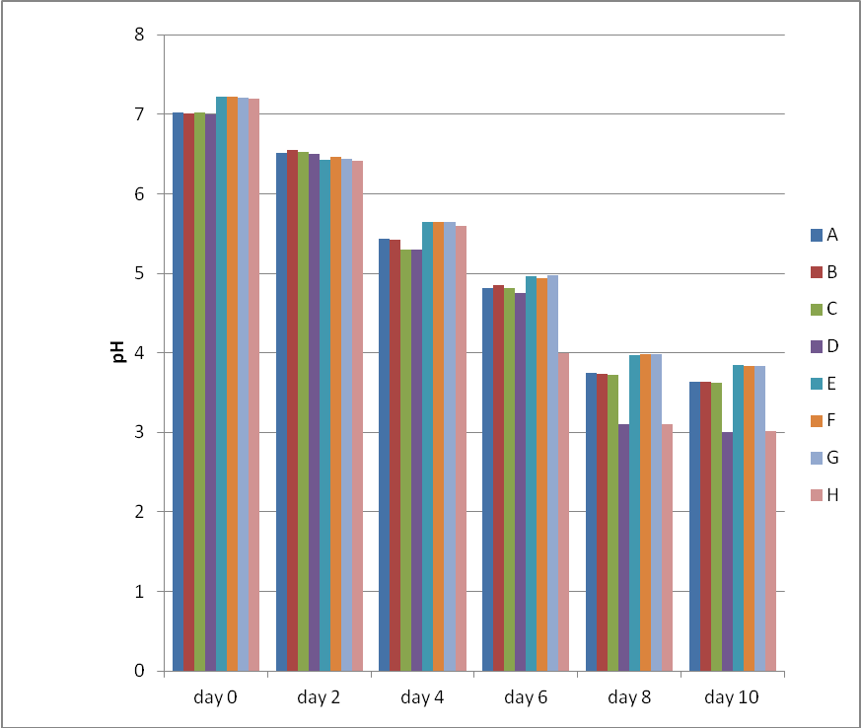
Figure 1: pH of sample soymilk at ambient temperature
Figure 2 illustrates changes in sample pH at refrigeration temperature. It showed that there was a slow decrease in pH over time.
`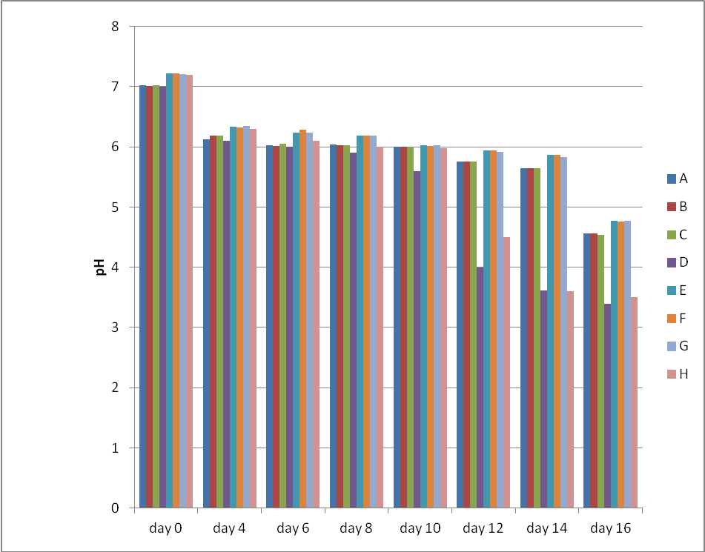
Figure 2: pH of sample soymilk at refrigeration temperature
3.2. Changes in titratable acidity
The changes in titratable acidity showed similar increase in acidity with storage time (Table 3). At ambient temperature, samples treated with NaHCO₃ had the highest increase in titratable acidity value compared to samples treated with Na₂CO₃. Individually, samples treated with Ascorbyl Palmitate had a higher increase in titratable acidity values in comparison with those treated propyl gallate, in combination. The control showed least increase (from 0.026-0.036) for sample control treated with Na₂CO₃ and for sample treated with NaHCO₃ (0.027-0.037).

Table 3: Titratable Acidity (TTA) of sample soymilk at ambient temperature
Titratable Acidity (TTA) - ambient
 | Sample code
days | A | B | C | D | E | F | G | H
0 | 0.033 | 0.033 | 0.033 | 0.027 | 0.030 | 0.030 | 0.030 | 0.026
2 | 0.032 | 0.033 | 0.033 | 0.030 | 0.031 | 0.032 | 0.031 | 0.028
4 | 0.035 | 0.036 | 0.035 | 0.032 | 0.034 | 0.034 | 0.034 | 0.030
6 | 0.037 | 0.037 | 0.037 | 0.033 | 0.036 | 0.036 | 0.035 | 0.031
8 | 0.038 | 0.039 | 0.035 | 0.039 | 0.037 | 0.038 | 0.037 | 0.035
10 | 0.039 | 0.039 | 0.039 | 0.037 | 0.039 | 0.039 | 0.038 | 0.036

Figure 3 illustrates the variations in the titratable acidity of produced soymilk at ambient temperature. The study also showed variations in the individual samples titratable acidity values were negligible (they have close values).
Table 4 shows the values of the titratable acidity (TTA) of sampled soymilk at refrigeration temperature. At refrigeration temperature (Table 4), due to longer storage time, there was a higher value for titratable acidity. Ascorbyl Palmitate treated samples showed marked increase in titratable acidity values in comparison with those treated in combination and singly. However, in all the samples, the control showed the least increase (for Na₂CO₃ 0.026-0.039 and for NaHCO₃ 0.027-0.037).
Figure 4 illustrates the variations in the titratable acidity of produced soymilk at refrigeration temperature. Here also the variations in titratable acidity values of the individual samples were negligible. It showed changes in titratable acidity as storage progressed.

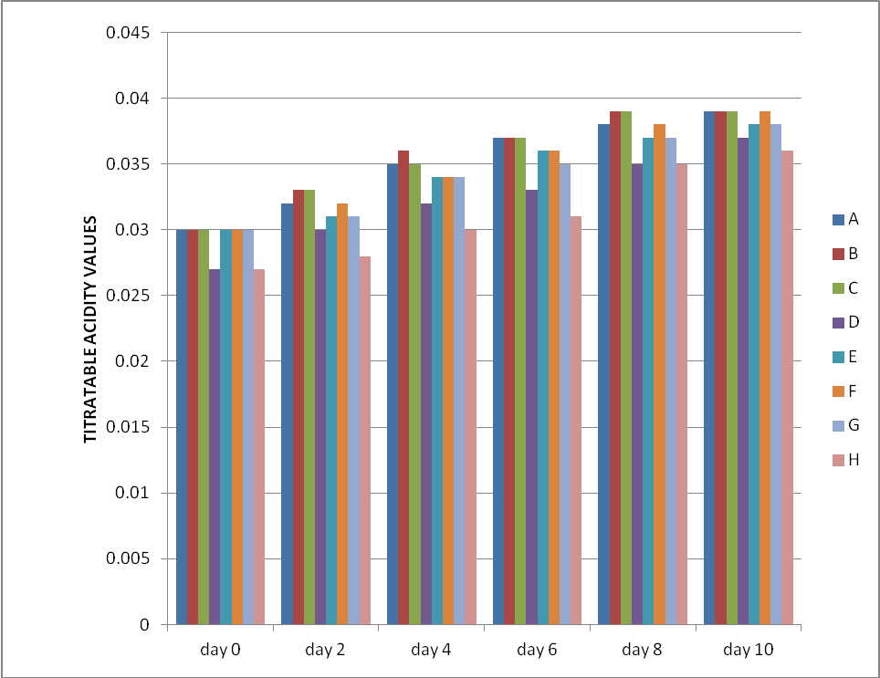Figure 3: TTA of sample soymilk at ambient temperature

Table 4: TTA of sample soymilk at refrigeration temperature
TTA-refrigeration
 | Sample code
days | A | B | C | D | E | F | G | H
0 | 0.030 | 0.030 | 0.030 | 0.027 | 0.030 | 0.030 | 0.030 | 0.026
4 | 0.033 | 0.033 | 0.032 | 0.029 | 0.031 | 0.032 | 0.031 | 0.028
6 | 0.035 | 0.034 | 0.035 | 0.030 | 0.033 | 0.034 | 0.034 | 0.030
8 | 0.037 | 0.037 | 0.037 | 0.032 | 0.035 | 0.035 | 0.035 | 0.031
10 | 0.038 | 0.039 | 0.038 | 0.033 | 0.037 | 0.038 | 0.037 | 0.036
12 | 0.039 | 0.040 | 0.039 | 0.034 | 0.038 | 0.038 | 0.038 | 0.036
14 | 0.040 | 0.040 | 0.040 | 0.035 | 0.039 | 0.039 | 0.039 | 0.037
16 | 0.041 | 0.042 | 0.041 | 0.037 | 0.040 | 0.041 | 0.040 | 0.039

Figure 4: TTA of sample soymilk at refrigeration temperature

4. DISCUSSION
The physicochemical quality of produced soymilk during storage at ambient temperature and at refrigeration temperature was evaluated. There was a significant difference (p<0.05) in pH of soymilk stored at ambient temperature and those stored at refrigeration temperature. The average value of pH of “soy milk” at day 0 was 7.11. The pH values being neutrality, which agrees with the reports of several other workers (Fraizer and Westhoff, 1985; Gesinde et al., 2008), may account for the growth of bacterial cells observed since bacteria thrive best on such media (Gesinde et al., 2008).
The difference in pH and titratable acidity levels during storage at refrigeration temperature were not significant for those treated with different preservatives and the controls. As can be deduced from the physical assessment, colour change did not occur until after day 2 and gas production did not occur until day 6. Watery texture and curdling occurred on day 8. This show a much better report than that of Iwe (2003) and Lo et al. (1968), where they indicated that whey separation, curdling and production of gas occurred after 48 hours (2 days) at ambient temperature. Therefore, it can be deduced from this study that the combined use of potassium sorbate and sodium benzoate (in combination) with propyl gallate and Ascorbyl palmitate (singly and in combination) has demonstrated the benefits of preservatives treatment. This was evident in the slight gradual decrease in pH and gradual increase in TTA, unlike other reports of Lo et al. (1968), where it was reported that Lactobacillus and Streptococcus spp brought about rapid/drastic increase in acidity and decrease in pH. The pH values of the samples were reasonably justified and suitable for soy milk marketed in tropical areas because of the expected effect of bad storage conditions such as high temperatures encountering in some zones in Nigeria which can affect the acidity of yoghurt (Olugbuyiro and Oseh, 2011).
There is an agreement between the result of the physical examination, pH and TTA changes of the stored soy yoghurt samples. The non significant changes in pH and TTA of the stored products within the first four day of storage might be responsible for the shelf stability of the stored soy milk within four days of storage; thus lending credence to the widely held opinion that chemical changes in foods grossly affect their shelf stability and consumer acceptability (Tomassi, 1988; Jimoh and Kolapo, 2007). The overall changes in pH and TTA observed for all the stored soy milk samples in the study may be suggesting that the fermentative activities of the soy milk starters still continued in storage (Jimoh and Kolapo, 2007). The simultaneous increase in pH and TTA in the present study is similar to that reported for another soyfood- soybean daddawa (Popoola et al., 2007), wherein the production of acid and ammonia were found to be superimposed in the course of storage; the balance between the two being responsible for the over all pH (Jimoh and Kolapo, 2007). The production of ammonia (which could increase the pH) in the present study becomes more probable as some yoghurt starter could produce ammonia from arginine (Collado et al., 1994; Jimoh and Kolapo, 2007).
The variation in the pH of soy mik stored at ambient temperature when compared with other samples stored at refrigeration could be due to its composition during production. The pH values observed in this study are comparable to other workers (Dublin-Green and Ibe, 2005; Hassan and Amjad, 2010; Jimoh and Kolapo, 2007; Olugbuyiro and Oseh, 2011). All the same, the pH results are in accordance with FDA specifications for the pH of yoghurt (4.6 or lower) (Olugbuyiro and Oseh, 2011). The pH obtained in this study is similar to values reported for soy yoghurt (Sugimoto and Van Buren, 1970; Buono, 1988) which range between 5 and 6. The difference in the rate of decrease in pH during production of yoghurt and soy milk is due to production of lactic acid by Lactobacillus (Adams and Moss, 1995) and other lactic acid bacteria. Related research carried out by Njoku et al. (1991) reported similar result. This could be attributed to metabolic activity of the fungi. In a study by Maduka et al. (2012), it was reported that the reduction in p^{H} during fermentation might be as a result of acidification by acetic acid fermentation of breadfruit which reduces the chance of microbial spoilage.
The values obtained for titratable acidity are generally below the standard which is 0.7% (FDA, 2009; Olugbuyiro and Oseh, 2011). No direct relationship was observed between pH values and titratable acidity as has been previously reported (Dublin-Green and Ibe, 2005; Olugbuyiro and Oseh, 2011). The gradual increase in titratable acidity during storage was also observed in Sudanese yoghurt (Manhal and Kamal, 2010). The titratable acidity values obtained during storage at refrigeration temperature is comparable to the values obtained by Davis and Mclachian (1974) and Younua et al. (2002), who reported mean values of titratable acidity in the range of 0.87 to 1.13. This was different from the values of 2.5 to 2.07 reported by Muhammed et al. (2009) for soy milk stored at refrigeration temperature.
The production of lactic acid after fermentation has the effect of lowering pH and thereby arresting any further development of pathogens and other toxic microorganisms, apart from having lethal and destructive effect on bacteria and arresting bacterial multiplication (Jayeola et al., 2010). There was however no direct relationship observed between pH values and titratable acidity as has been reported by other workers (Robinson and Tamime, 1975) and this has been attributed to the presence of milk powder which increases the buffering capacity of the product. In a study by Saidu (2005), there was a substantial increase in the concentrations of lactic acid. This was attributed to production of these acids by microorganisms in the soak water and their subsequent diffusion into the beans (Saidu, 2005). There was also a decrease in pH of both the soak water and the beans due to the production of the organic acid. The changes that occurred in the organic acid and pH levels resulted in flavor alterations, since many of the organisms showed different patterns of growth ad survival (Saidu, 2005).

5. CONCLUSION
The study showed that the overall changes in pH and TTA observed for all the stored soy milk samples in the study may be suggesting that the fermentative activities of the soy milk starters still continued in storage. Generally, improved combined preserving techniques can in particular improve keeping quality; lessen the risk of microbial food poisoning.

Correspondence to:
Dr. NN Odu
Department of Microbiology, University of Port Harcourt, Choba, PMB 5323 Port Harcourt, Rivers State, Nigeria; E-mail:odungozi@yahoo.com

REFERENCES
- Adams M. R. and Moss M. O., 1995. Food Microbiology. Royal Society Of Chemistry, Cambridge, pp 201.
- Aderibigbe, E. Y. and Osegboun, A. O. (2006). Acceptobility of tempeh among health workers in Ado-ekiti Nigeria. Pak. J. Nutrition pp 122 –124.
- Ashaye OA, Taiwo LB, Fasiyiro SB and Akinnagbe CA (2001).Compositional and shelf life properties of soy yoghurt using two starter cultures. Nutr. and Food Sci. 31(5): 247-250.
- Buono, M. A., Setser, C., Erikson, L. E. and Fung, D. Y. C. (1990).Soymilk yoghurt: Sensory evaluation and chemical measurement. Journal of Food Science 55: 528-551.
- Chang IC, Shang HF Lin T, Wang TH and Lin SH (2005). Effect of fermented soymilk in the intestinal bacteria ecosystem. World J.Gastro enterol 1225-1227.
- Collado LS, Mabesa RC, Sumague MJV, Mok CK (1994). Yoghurt-like Products from Riceflour and Soymilk The Philippine Agriculturist 77(3): 307-319.
- Collins JL, Ebah CB, Mount JR, Demott BJ and Draughon FA (1991). Production and evaluation of milk sweet potato mixtures fermented with yoghurt bacteria .J. Food Sci. 56(3): 685-688.
- Davis, J.G. and McLachian, T. (1974). Yoghurt in the United Kingdom: Chemical and Microbiological analysis. Dairy Industry 1: 149 -177.
- Dublin-Green, M. and S.N. Ibe, 2005. Quality evaluation of yogurts produced commercially in Lagos, Nigeria. Afr. J. Applied Zool. Environ. Biol., 7: 78-82.
- Farinde E.O., Obatolu, V.A., Oyarekua, M.A., Adeniran, H. A., Ejoh, S. I. and Olanipekun, O.T. 2010. Physical and microbial properties of fruit flavoured fermented cowmilk and soy milk (yoghurt-like) under different temperature of storage. African Journal of Food Science and Technology (ISSN: 2141-5455) Vol. 1(5) pp. 120-127
- Farinde EO, Adesetan TO, Obatolu VA and Oladapo MO (2009). Chemical and microbial properties of yoghurt processed from cow milk and soymilk. J.Food Processing and Preservation. 33: 245 –259.
- Farinde EO, Obatolu VA, Fasoyiro SB, Adeniran AH and Agboola ER (2008). Use of Alternative raw materials for yoghurt production. Afri. J. Biotechnol 7 (33): 3339-3345.
- FDA, 2009. Milk and cream products and yogurt products. Food and Drug Administration Federal Register, 74: 2448.
- Fraizer, W.C. and D.C. Westhoff, 1985. Food Microbiology. McGrawHill Inc. United States of America, pp: 278.
- Gesinde A.F., O.M. Oyawoye and A. Adebisi. 2008. Comparative Studies on the Quality and Quantity of Soymilk from Different Varieties of Soybean. Pakistan Journal of Nutrition 7 (1): 157-160
- Hassan Ammara and Amjad Imran, 2010. Nutritional evaluation of yoghurt prepared by different starter cultures and their physiochemical analysis during storage. Afr. J. Biotech., 9: 2913-2917.
- Ikpeme-Emmanuel, C. A., Okoi, J., and Osuchukwu, N. C. (2009). Functional, antinutritional and sensory acceptability of taro and soybean based weaning food. African Journal of Food Sci, 3 (11), 372-377.
- Iwe, M.O. (2003). The science and technology of soybean. Rejoint communication Services Ltd pp 145
- Jayeola, C. O., Yahaya, L. E. and Igbinadolor, R. O. (2010). Cocoa powder supplementation in yoghurt production. Journal of Food Technology 3: 82 – 85.
- Jimoh, KO and Kolapo, AC (2007). Effect of different stabilizers on acceptability and shelf stability of soy-yoghurt. African Journal of Biotechnology. Vol. 6(8) Pp 1000-1003.
- Kolapo A.L and G.R. Oladimeji (2008). Production and quality evaluation of soy-corn milk. Journal of Applied Biosciences, 1(2): 40 - 45.
- Lee SY, Marr CV and Seo, A (1990). Comparison of milk-based and soymilk based yoghurt. J. Food Sci. 55: 532-536.
- Lo, W.Y, K.H Steinkarus and D.B Hand. (1968). Heat sterilization of bottled soymilk. Journal of Food Science, 40; 114-118
- Maduka N, H. O. Njoku and N.N. Odu. The Production Of Tempeh-Like Food Product Using African Breadfruit Seeds (Terculia africana). Academia Arena, 2012;4(4):39-43
- Manhal, M.D.O. and Kamal, A.A.R. (2010). Quality attributes of soy yoghurt during storage periods. Pakistan journal o. Nutrition 11: 1088 – 1093.
- Massawe, F.J., Mwale, S.S., Azam-Ali, S.N. and Roberts, J.A. (2005) Breeding in bambara groundnut (Vigna subterranea (L.) Verdc.): strategic considerations. African Journal of Biotechnology. 4 (6). 463-471.
- Mital BK, Steinkraus KH and Naylor HB (1974). Growth of lactic acid bacteria in soymilik. J. Food Sci. 39: 1018.
- Moor CV (1985). Functionality of heated milk proteins in dairy and related foods. J. Dairy Sci. 66: 2773.
- Muhammad BF and Abubakar MM (2001). Household yoghurt production techniques. In: Research Report Proceedings of AESON. Pp. 91-96.
- Muhammad, B. F., Abubakar, M.M. and Adegbola, T. A. (2009). Effect of period and condition of storage on properties of yoghurt produced from cow milk and soymilk materials. Research Journal of Dairy Scence2: 18 – 24.
- Njoku, H. O., Ofuya, C. O. and Ogbulie, J. N. (1991). Production of tempeh from the African yam bean (Sphenostylis stenocarpa Hams) J. Food Microbiol. (8): 1-6.
- Nsofor LM and Maduako O 1992. Stabilized soymilk for ambient tropical storage: A preliminary report .Int. J. Food Sci. Technol. 27: 573-576.
- Olubamiwa AO, Kolapo AL, Odetoyinbo BB (2006). Effect of different starter cultures on the chemical compositions and acceptability of soy-yoghurt. Being a paper delivered at the 37th Annual Conference of Nutrition Society of Nigeria. Abeokuta. Nigeria. pp. 8-11.
- Olugbuyiro JAO and Oseh JE. 2011. Physico-chemical and Sensory Evaluation of Market Yoghurt in Nigeria. Pakistan Journal of Nutrition 10 (10): 914-918
- Onuorah C. E., Adejare A. O., and Uhiara N. S., 1997. Comparative physico-chemical evaluation of soymilk and soya cake produced by three different methods. Nig. Food Journal, Vol. 25, No. 2, 2007 (www.ajol.info/journals/nifoj) ISSN 0189-7241. Html version http://www.bioline.org.br/request?nf07023
- Oshundahunsi OF, Amosu D, Ifesan BOT (2007). Quality Evaluation and Acceptability of soy- yoghurt with different colours and fruit flavours. American J. Food Technol 2(4) 273-280.
- Piper C.V and Morse W.J (1923): The Soybean; M.C Grawhhill book Co. Inc New York: Pp 21-23.
- Pithong R, Macrae R, Rothwell J (1980). The development of a soybased yoghurt part II: Sensory evaluation and analysis of volatiles. J. Food Sci. Technol. 32: 313-324
- Popoola TOS, Kolapo AL, Afolabi OR (2007). Biochemical deterioration of soybean daddawa- A condiment. J. Food Agric. Environ. 5(1): 67- 70.
- Robinson, R. K. and Tamime, A. Y. (1975). Yoghurt- a review of the product and its manufacture. Journal of Social Diary Technology 28: 149-163.
- Saidu Janette Ethel Pessi. 2005. Development, Evaluation And Characterization Of Protein-Isoflavone Enriched Soymilk. Ph.D. Thesis in The Department of Food Science, Graduate Faculty of the Louisiana State University and Agricultural and Mechanical College, pp 232
- Smith A.K and Circle S.J (1978). Protein products as food ingredients. In: Liu, K. 1997. Soybeans: Chemistry, Technology and Utilization. Chapman and Hall, New York.
- Sugimoto, H. and Van Buren, J. P. (1970). Removal of oligosaccharides from soy milk by an enzyme from Aspergillus saitoi. Journal of Food Science 35: 655 -660.
- Tomassi G (1988) Nutritional and safety aspect of Natural antioxidants. In: Walker R, Quattruci E (Eds). Nutritional and Toxicological Aspects of Food processing. Taylor and Francis. Basingstoke pp. 1-13.
- Younua, S., Masud, T. and Aziz, T. (2002). Quality evaluation of market yoghurt/Dahi. Pakistan Journal of Nutrition 5 : 226 – 230.

6/15/2012

