Smart System For Teaching Stiffness Method For Structural Analysis Of Truss

A.E. Bakeri

Department of Structural Eng., Faculty of Eng., Zagazig University, Zagazig, Egypt
aebakeri@zu.edu.eg

Abstract: This research is the first block in Learning Structural Analysis Project (LSAP) that aims to produce a software package offers a detailed solution of the structural analysis problems. This research presents an educational program designed to understand the stiffness structural analysis theory of plan trussed structures. The program is written using Matlab©. The program is designed to be user friendly, where students can input any truss problem easily. The program offers also theoretical basic concepts of the method, and arranges the solution in steps.
[A.E. Bakeri. Smart System For Teaching Stiffness Method For Structural Analysis Of Truss. Nat Sci 2012;10(8):106-113]. (ISSN: 1545-0740). http://www.sciencepub.net/nature. 18

Keywords : matrix structural analysis; Assembly stiffness method; matlab; Smart system

1. Introduction
Matrix Structural Analysis and Finite Element methods are an important courses at the undergraduate and graduate levels. The stiffness matrix structural analysis theory has been a difficult subject to understand by civil engineering students. Many packages have been developed focused in spreading abilities in students to manage the structural behavior in different kind of structures by solving quickly a large number of problems with different load conditions or supports [1-5].
However, students still have problems in understanding the matrix structural analysis theory underneath the structural analysis packages they use. When students try to solve any problem by hand and the obtained results don't match that obtained from the ready packages, they cannot detect the location of the wrong step especially when the problems are very complicated as in the stiffness method problems. Many trails were made to cover this need with primordial software [6-15]. Students need friendly software to solve any problem and show the solution step by step. Then students can compare their solution with the exact solution and determine the location of mistakes.
This research is the first step of a huge project in structural analysis education prepared by the author that aims to cover all structural analysis methods with software that provides a detailed solution of structural analysis problems. This research introduces the software that was developed to produce a detailed solution of truss structural analysis using stiffness method. The software is prepared by Matlab©. Students can enter any truss problem on the prepared package easily, and the software offers detailed sheets for the solution. In this paper, an indeterminate truss problem is solved on this software to show the method of inputting the problem on the software. Stiffness method solves the structure problems using the assembly or direct methods. This research is concerned on the solution using assembly method.

Theory
Solution of trussed structure using stiffness method passes through many steps:
The first step is modeling. Modeling means numbering the degrees of freedom (DOFs). In the direct stiffness method the unrestrained DOFs only are numbered, while in the assembly method all degrees of freedom are numbered as followed in this research.
The Second step is the construction of the global stiffness matrix for each element. The construction of the global stiffness matrix can be obtained from the local stiffness matrix and the transformation matrices of each element as stated in Equations 1, 2 and 3. The global stiffness matrix can also be constructed by applying the derivation of the global stiffness matrix symbolically as stated in Equation 4, and then substitute directly on it for each element. The second approach is followed in this research.
The third step is the assembly of the structure stiffness matrix from the elements global stiffness matrices. There are two methods to perform the assembly. The first way is performed by assembling only the unrestrained DOFs. While in the second method, the assembly is performed on all degrees of freedom and then eliminates the restrained ones. The second method is followed in this research.
The fourth step is the construction of the force vector that accommodates the structure degrees of freedom. The fifth step is the construction of the unconstrained equation of motion as stated in Equation 5. The Sixth step is solving the stiffness equation to obtain the values of the degrees of freedom. Finally, the internal forces for each element are calculated using Equation 6. [16]
$\begin{aligned} \\ \left[K_{m}^{g}\right]=\left[T\right] \left[K_{m}^{ℓ}\right] {\left[T\right]}^{T}\end{aligned}$ (1)
$\left[K_{m}^{ℓ}\right]=\frac{\text{EA}}{L}\left[\begin{matrix}1 & 0 & −1 & 0 \\ 0 & 0 & 0 & 0 \\ −1 & 0 & 1 & 0 \\ 0 & 0 & 0 & 0\end{matrix}\right]$ (2)
$\left[T\right]=\left[\begin{matrix}\text{cos} θ & − \text{sin} θ & 0 & 0 \\ \text{sin} θ & \text{cos} θ & 0 & 0 \\ 0 & 0 & \text{cos} θ & − \text{sin} θ \\ 0 & 0 & \text{sin} θ & \text{cos} θ\end{matrix}\right]$ (3)

$\left[K_{m}^{g}\right]=\frac{\text{EA}}{L}\left[\begin{matrix}c^{2} & \text{cs} & −c^{2} & −\text{cs} \\ \text{cs} & s^{2} & −\text{cs} & −s^{2} \\ −c^{2} & −\text{cs} & c^{2} & \text{cs} \\ −\text{cs} & −s^{2} & \text{cs} & s^{2}\end{matrix}\right]$ (4)
$\left[F\right]=\left[K\right] \left[D\right]$ (5)
$\begin{aligned} \\ \left[F_{m}^{ℓ}\right]= \left[K_{m}^{ℓ}\right] {\left[T\right]}^{T} \left[D_{m}^{ℓ}\right] \end{aligned}$ (6)

Program description
The prepared package is divided into two main parts. The first part is the structure information data input which includes the construction of the truss geometry by defining the joint coordinates, the element connectivity, supports. It also includes the properties of the element sections and the applied forces on the truss. The second part is solving the structural analysis problem which includes the construction of the elements global stiffness matrices and assembling them to obtain the structure stiffness matrix. It also includes the construction of the force vector, then the stiffness equation and solving it to obtain the structure deformations that are used in calculating the internal forces in the truss elements. These steps are presented in Fig. 1
Input Stage:
The procedures of the package are explained on a trussed structure shown in Fig. 2. The first interface form is an introduction states the main information about the project as shown in Fig. 3. By pressing the start button the program goes to the second form (Fig. 4 a) which asks the user to input the main structure information as the number of joints, number of elements and the units used in the problem which is selected from a dropdown list (Fig. 4 b). This form contains also a checkbox for constant cross sectional area for all elements. After entering this information, and pressing the next button, the program goes to the third form shown in Fig. 5 a. This form allows the student to input the coordinates of the truss joints in the previously stated units, as shown in Fig. 5 b. The following form (Fig. 6) asks the user to input the number of the start and end joints for each element. The next form (Fig. 7) shows the geometry of the structure to check the validity of the entered data, and the previous button allows the user to go back into the previous forms to correct any false data. The next form (Fig. 8 a) shows a table for the structure supports, where the number of all joints is shown and opposite to each joint a dropdown list to select the support type as shown in Fig. 8 b. The following step is to apply the joint loads in the x and y directions, using form presented in Fig. 9. The four joint loads are entered as shown in Fig. 9. The next form (Fig. 10) asks the user two questions, the modulus of elasticity and the constant cross sectional area. It is noticed that the program asks on the cross sectional area once, because the user have already checked the checkbox in the second form (as shown in Figure 4 a). If the user had not checked out this checkbox, the program shows a table of cross sectional areas for each element as shown in Fig. 11.
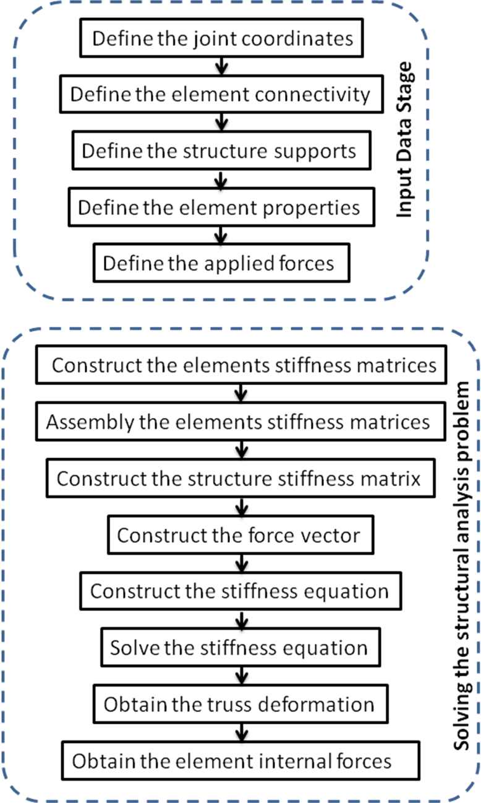
Fig. 1: Flow chart of the structural analysis education program
Fig. 12 shows the final form in the input data stage. The form shows the trussed structure with supports and joint loads. Until this form the user can go back to change any information. The next button is replaced by solve button to alert the user that this button will go to a new stage.
Solving Stage
Pressing the solve button go to the first form of the solving stage as shown in Fig. 13, which shows the main steps of the solution. The next form shows the modeling of the truss where a two degrees of freedom is added to each joint in the horizontal and vertical direction respectively as shown in Fig 14. Figures 15 a and 15 b show the derivation of the element global stiffness matrix from the local stiffness and transformation matrices. The next button shows many forms (Fig. 16), each of them show the global stiffness matrix of element after calculation of the element length, inclination angle cosine and sine. The next forms (Fig. 17 a, b, and c) show the assembly steps where each global stiffness matrix is placed in the corresponding degrees of freedom in the structure stiffness matrix. As the user goes ahead, the assembly matrix is filled with the rest stiffness matrices. When the user go to the last element assembly, the obtained assembled matrix is the structure stiffness matrix as shown in Fig. 17 c. The next form (Fig. 18) shows the construction of the force vector. A table is constructed to show the forces at each point corresponding to the degrees of freedom. The construction of the stiffness equation becomes very easy because the structure stiffness matrix and the force vector were obtained previously, as shown in Fig. 19. As a result to the structure stiffness matrix is corresponding to all degrees of freedom, it is required to eliminate the rows and columns that accommodate the restrained degrees of freedom as shown in Fig. 20. After elimination of restrained degrees of freedom, the unrestrained stiffness equation is reduced as shown in Fig. 21. To solve the stiffness equation, the equation is recasted in the inverse form as shown in Fig. 22. The inverse of the stiffness matrix is shown in Fig. 23 to allow the student to check their calculations. After substitution of the stiffness matrix equation, the equation become as show in Fig 24. The values of the unrestrained displacements are obtained as shown in Fig. 25.
To obtain the elements internal forces, it is required to derive a rule from the principal of the element stiffness equation which illustrated in Figures 26 a, b, c and d. The obtained rule is used for each element after substitution of the corresponding displacement and element information as shown in Fig. 27 as a sample. The last form is a review for the final results of the elements internal forces, as presented in Figure 28. The next button is replaced by finish button to inform the user that pressing this button will leave the solving program.
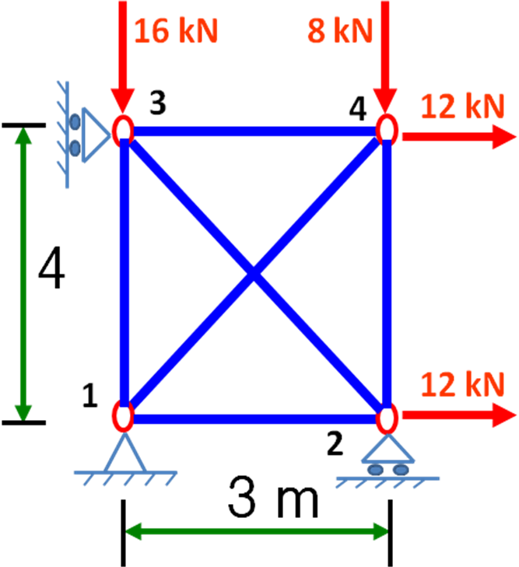
Fig. 2: Trussed Structure Example
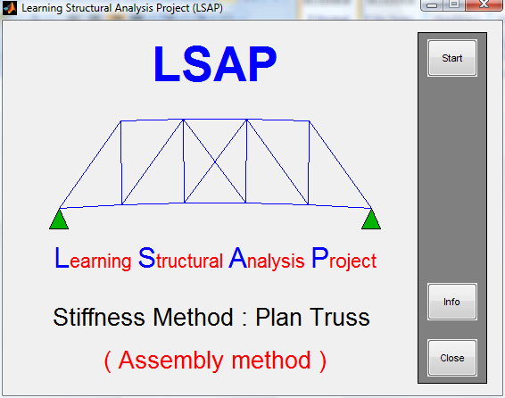
Fig. 3: Introduction Form
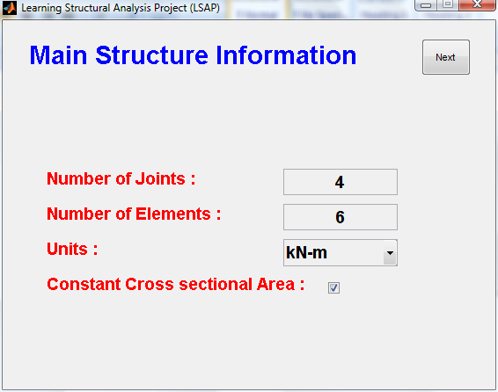
Fig.4a : Main Structure Information form
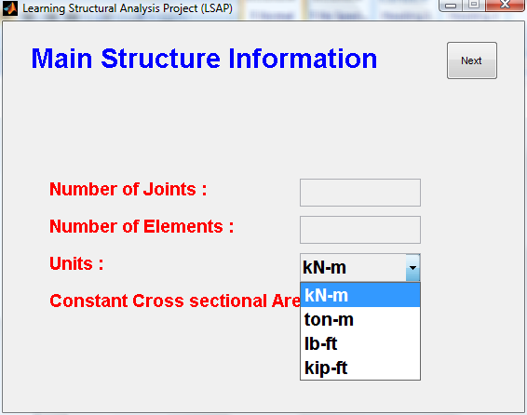
Fig.4 b: Units selection dropdown list

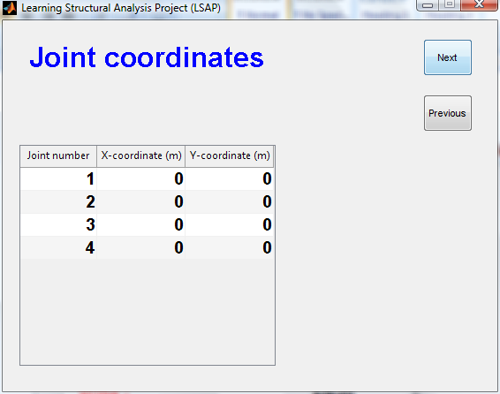
Fig.5 a: Joint coordinates form
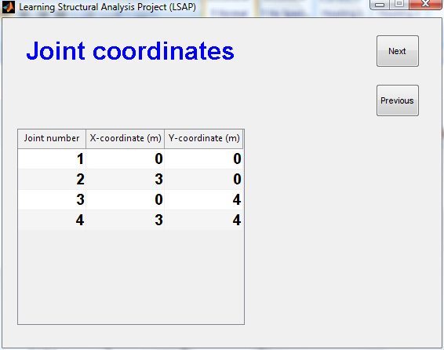
Fig.5 b: Joint coordinates form (Filled)
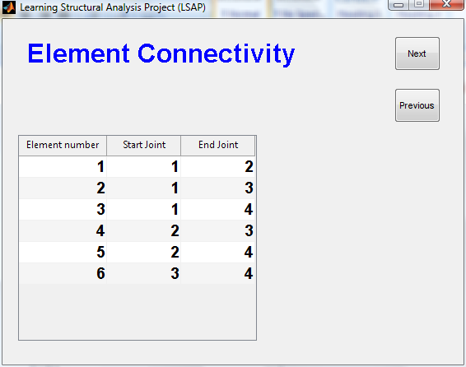
Fig.6: Element connectivity form
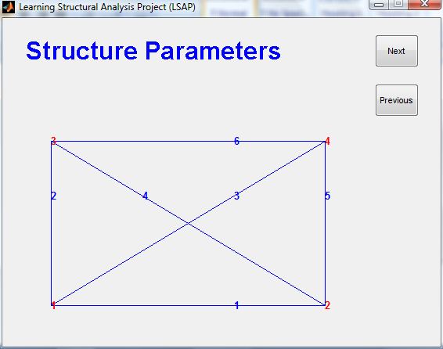
Fig. 7: Structure geometry form

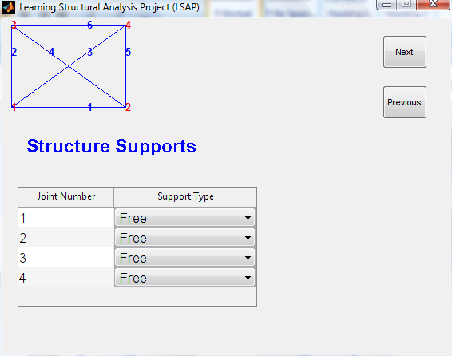
Fig. 8 a: Structure supports form
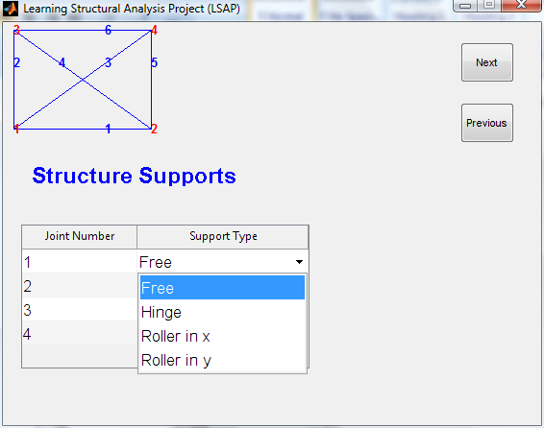
Fig.8 b: Supports dropdown list
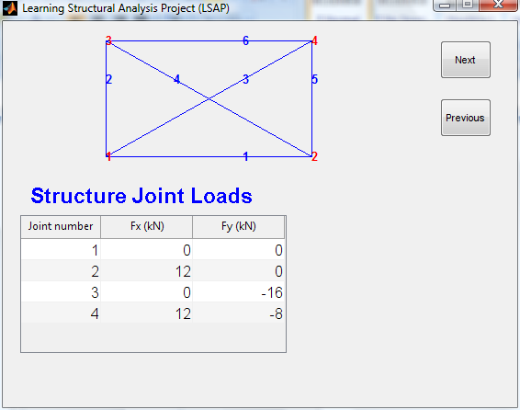
Fig.9: Joint Loads form
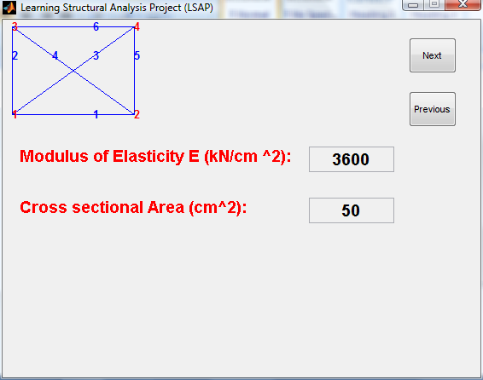
Fig.10: Modulus of Elasticity and Elements Area Form (for constant cross sectional area)
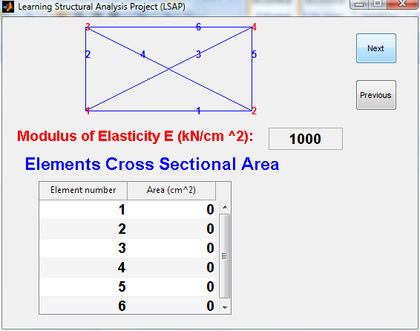
Fig.11: Modulus of Elasticity and Elements Area Form (for varied cross sectional area)
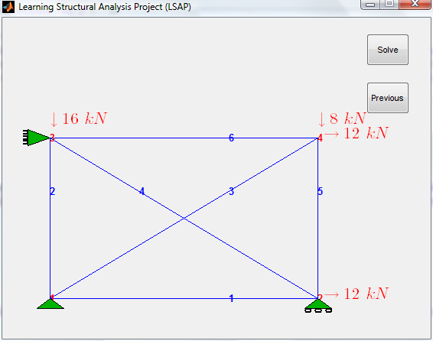
Fig.12: Structure All Information Form
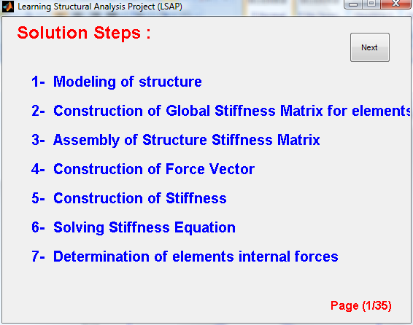
Fig.13: Solution steps form
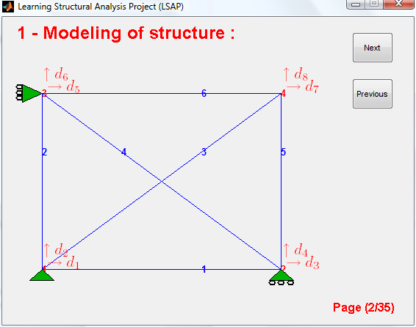
Fig.14: Modeling form
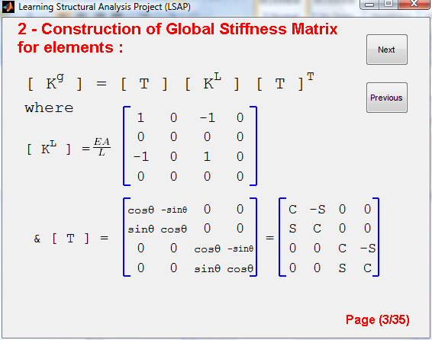
Fig. 15 a: Derivation of element global stiffness matrix form (Form 1)
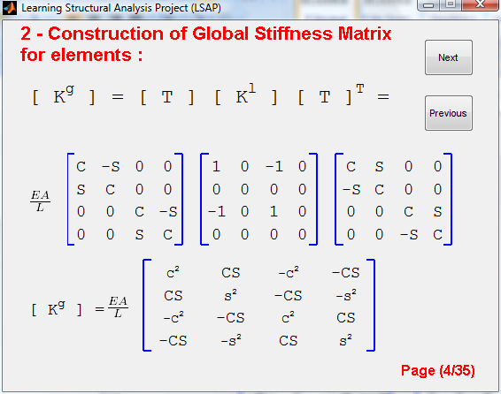
Fig. 15 b: Derivation of element global stiffness matrix form (Form 2)
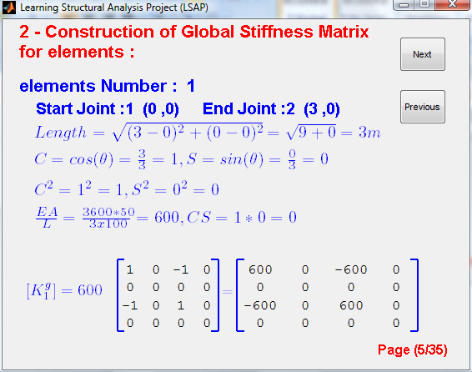
Fig. 16: Construction of element global stiffness matrix form
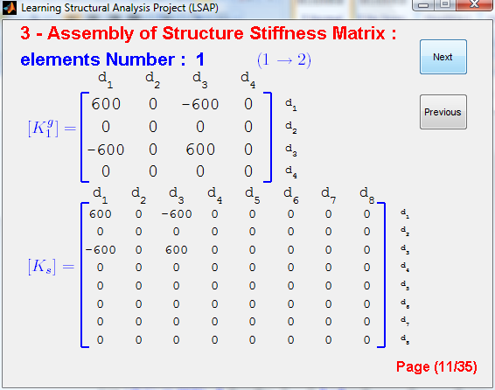
Fig.17 a: Assembly of element global stiffness matrix form (Form 1)
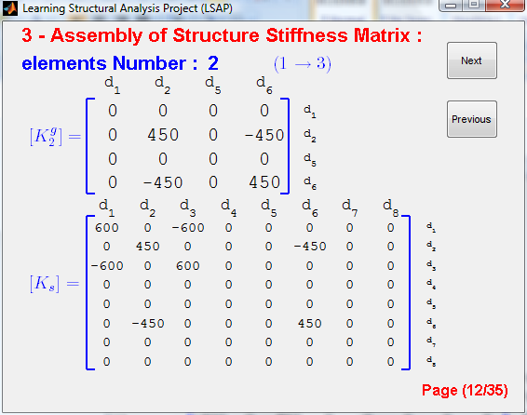
Fig.17 b: Assembly of element global stiffness matrix form (Form 2)
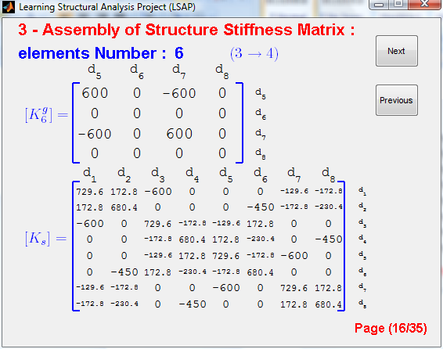
Fig.17 c: Assembly of element global stiffness matrix form (Form 3)
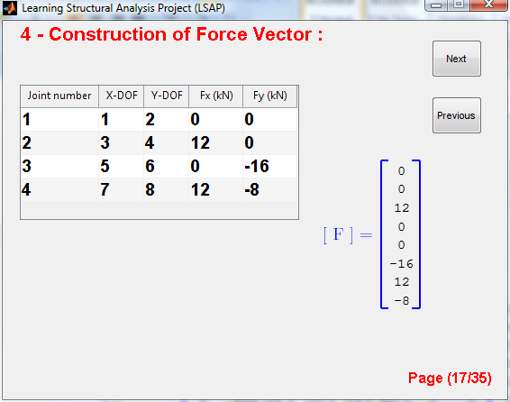
Fig.18: Construction of force vector form
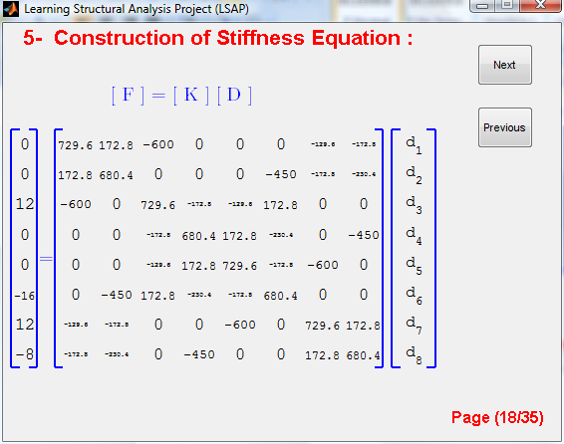
Fig.19: Construction of Structure Stiffness equation
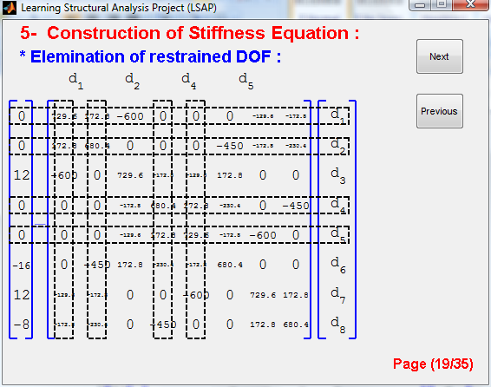
Fig.20: Elimination of restrained degrees of freedom from the stiffness equation
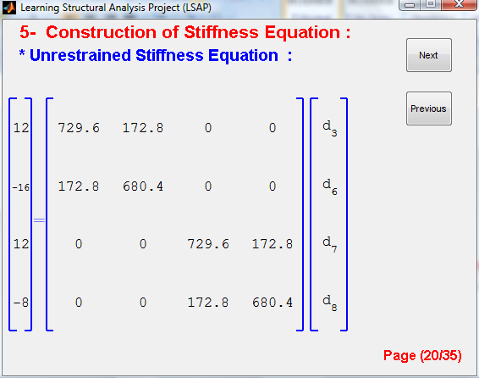
Fig.21: Construction of Unrestrained Structure Stiffness equation form
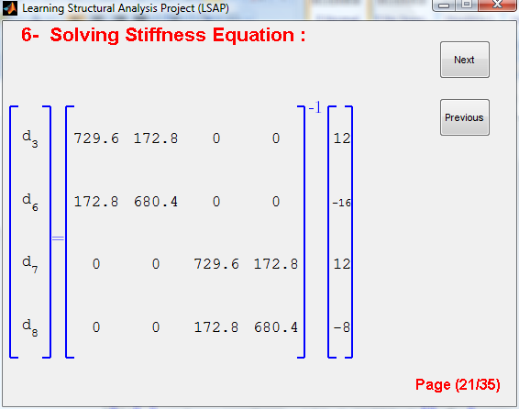
Fig. 22: Solving Stiffness equation form (Form1)
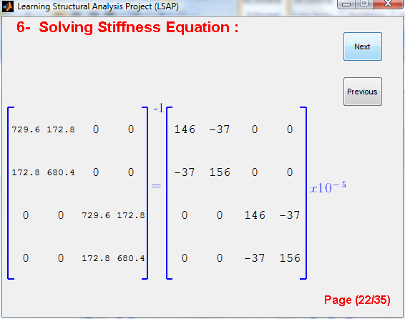
Fig. 23: Inverse of stiffness matrix form
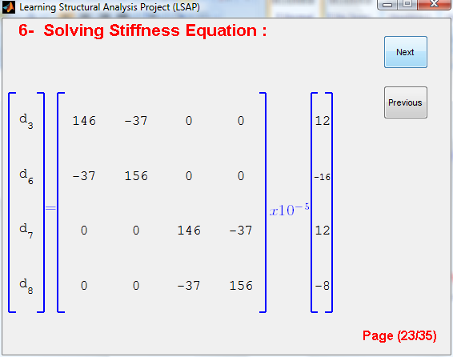
Fig. 24: Solving Stiffness equation form (Form2)
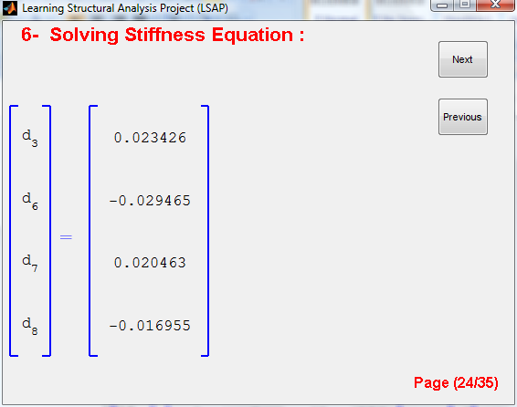
Fig.25: Structure deformation form
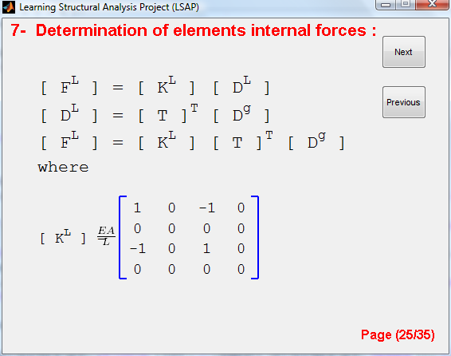
Fig.26 a: Derivation of internal forces rule form (Form1)
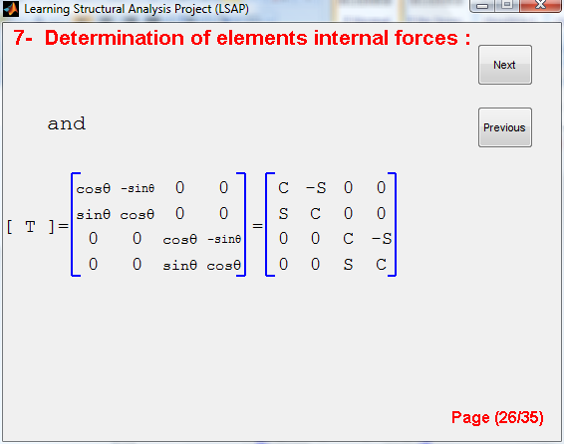
Fig.26 b: Derivation of internal forces rule form (Form2)
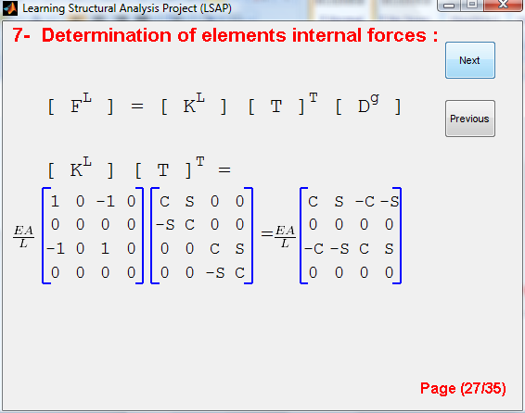
Fig.26 c: Derivation of internal forces rule form (Form3)
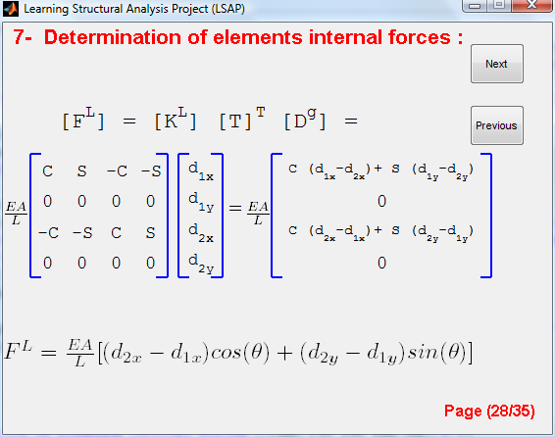
Fig.26 d: Derivation of internal forces rule form (Form4)
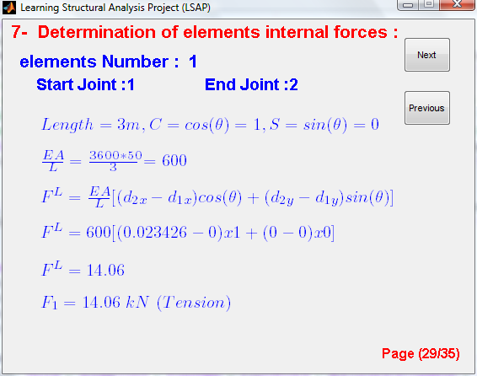
Fig.27: Determination of elements internal forces form
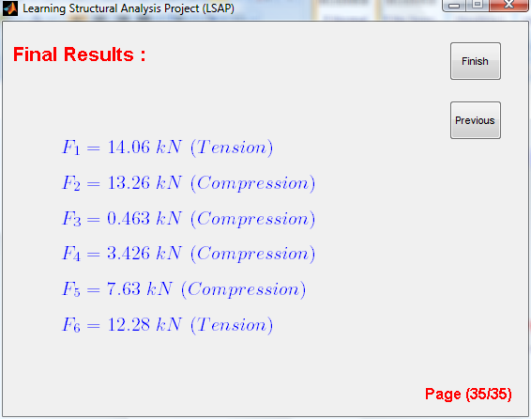
Fig.28: Revision of the elements internal forces form
Conclusion
This research is the first block in Learning Structural Analysis Project (LSAP) that aims to produce a software package that offers a detailed solution of the structural analysis problems. This research presents an educational program designed to understand the stiffness structural analysis theory of plan trussed structures. The program is designed to be user friendly, where students can input any truss problem easily. The program offers detailed solution of the truss problems and offers also theoretical basic concepts of the method, and arranges the solution in clear and organized steps.

Corresponding author
A.E. Bakeri
Department of Structural Eng., Faculty of Eng., Zagazig University, Zagazig, Egypt,
aebakeri@zu.edu.eg

References
[1] Dr. Beam Pro and Dr. Frame, URL: http://www.disoftware-home.com.
[2] Ftool, URL: http://www.tecgraf.puc-rio.br/
_lfm/ftool/ftool.html.
[3] Yuan, X. F. and J. G. Teng, (2002). Interactive web-based package for computer aided learning of structural behavior, Computer Application in Engineering Education 10: 121-136.
[4] Almeida, S. F., R. Piazzalunga, and V. G. Ribero (2003). A web-based 2D structural analysis educational software, Computer Application in Engineering Education 11: 83-92.
[5] ROSETE, R. C., (2007). Stiffness Matrix Structural Analysis Educational Package by Mathcad, Computer Application in Engineering Education 15: 107-113.
[6] Lee, J. Y., (2006). Visual FEA User’s Manual, Intuition Software, Jeonju, Korea, 503.
[7] Lee, J. Y., (2002). Visual FEA/CBT, computer-based training of finite element method (CD), John Wiley and Sons, New York.
[8] Abel J. F. (1990). Interactive graphics as a stimulus to creative play in engineering education, Proceedings of the International Conference on Computer Aided Training in Science and Technology, Barcelona : 66–72.
[9] Lee J. Y. and S. Y. Ahn (2008). Finite element implementation for computer-aided instruction of structural mechanics, Sixth International Conference on Computation of Shell & Spatial Structures, Ithaca, New York.
[10] Lee J. Y. (1999). Development of a computer-based training system for finite element method, J Comput Struct Eng Inst Korea 12: 607–618.
[11] Libby D. H. (1982). GISMO, A graphical interpreter for structural matrix operations, Department of Structural Engineering Report No. 82-2, Cornell University.
[12] Maiorana C., L. Sgarbossa, and V. Salomoni, (2008). New methodologies in teaching e-structural mechanics using www, Computer Application in Engineering Education 16: 189–210.
[13] El-Rimawi J. and A. El-Hamalawi (2002). Dynamic strategy for teaching structural analysis, Comput Appl Eng Educ 10: 194–203.
[14] Barretto S. F. A., R. Piazzalunga, and V. G. Ribeiro (2003). A web-based 2D structural analysis educational software, Computer Application in Engineering Education 11: 83–92.
[15] Romeo F., G. Padoan, and J. Truss (2008). A CAD-oriented educational open-source software for static analysis of truss-type structures, Computer Application in Engineering Education 16: 280–288.
[16] Felippa C. A., (2001). A historical outline of matrix structural analysis: a play in three acts, Computers & Structures 79 (14): 1313–1324

5/2/2012

