Potential Longevity of Maize Seeds under Storage in Humid Tropical Seed Stores

Oyekale, K. O.¹; Daniel, I. O.²; Ajala, M. O.² and Sanni, L. O.³

¹Department of Agriculture and Industrial Technology, Babcock University, Ilishan-Remo, Nigeria
²Department of Plant Breeding and Seed Technology, University of Agriculture, Abeokuta, Nigeria
³Department of Food Science and Technology, University of Agriculture, Abeokuta, Nigeria
kenoye3@yahoo.com

Abstract: This study was undertaken to calibrate open seed warehouse storage environments in the humid tropics and model maize seed deterioration under them. Five maize varieties (TZPBSR, DMR-ESR-Y, Oba Super-2, Suwan-1-SRY, and ART-98-SW1) were used for the study. The seeds were cleaned and their initial quality determined by recommended methods. One kilogramme of seeds of the five maize varieties were packaged in separate moisture-proof polythene bags (with automatic thermohygrometers inserted to monitor changes in temperature and RH) and placed in the seed stores at the University of Agriculture, Abeokuta (UNAAB) and the Institute of Agricultural Research and Training, Ibadan (IAR&T) from 2005-2007. Seed samples were taken at 3-month interval and evaluated for seed viability and seedling vigour attributes. Probit analysis was used to estimate seed deterioration and potential longevity. PROC GLM statement of SAS was used to separate means of variables evaluated in both environments. The seed survival curves under the humid tropical conditions fitted the normal distribution curve well (p {χ²}>0.05); with UNAAB seed storage environment extending the longevity of stored seeds far better than the IAR&T seed store. Overall, results showed that effective seed storage under humid tropical conditions is possible, though effectiveness may differ from one environment to the other.
[Oyekale, K. O.; Daniel, I. O.; Ajala, M. O. and Sanni, L. O. Potential longevity of maize seeds under storage in humid tropical seed stores. Nat Sci 2012;10(8):114-124]. (ISSN: 1545-0740). http://www.sciencepub.net/nature. 19

Keywords: Seed storage, Longevity, Storage environment, Probit modeling.

- Introduction
In the humid tropics, long-term storage of seeds has continued to pose a major problem for maize germplasm conservation because ambient temperature and relative humidity (RH) could be more than 33°C and 75% respectively. Under such conditions, it is difficult to dry seed to moisture levels below 12%. Seeds are often stored in cold rooms to prolong their lifespan, but this adds extra cost to seed production. With mechanical drying, it may be easy to dry seeds from high levels (17-22%) down to 12% because seed moisture is freely located in the mass of the seed (Asiedu et al., 1999). Below 12%, moisture may be chemically bound to the internal structure of the seed, thus making it difficult to remove. It takes longer period and costs more to dry seed mechanically from 12 to 8-9%. This could however be achieved easily and more economically with dehumidifying drying, which is regarded as a viable option for long-term seed storage in the humid tropics.
Seeds stored in humid and warm environments tend to absorb moisture from the surroundings, leading to increased seed moisture content until equilibrium is established. As seed moisture increases, the rate of deterioration increases (Roberts, 1972). High temperatures plus high relative humidity makes seed storage much more difficult. One of the two main factors influencing seed longevity is seed moisture content. Within limits, the higher the seed moisture content, the faster the decrease in germination capacity and ultimately a reduction in the overall quality of the seed.
Maximizing the longevity of seeds thus requires a good seed store and knowledge of the principles of seed preservation (Ng, 1996). Grain must be protected from weather, insects and growth of micro-organisms to maintain high grain quality during storage. Seasonal changes in air temperature and solar radiation create temperature gradients in the stored grain. Moisture tends to migrate from warmer to cooler portions of the grain mass; and the accumulation of moisture in a localized area of the grain mass stimulates the growth of micro-organisms which ultimately affect grain quality (Bonner, 1990).
This study was designed to calibrate open (unconditioned) maize seed warehouse storage environments in the humid tropics and model maize seed deterioration under them.
- Materials and Methods
A Commercial hybrid and 4 different Open-Pollinated Varieties (OPVs) of maize (Zea mays L.) were used for this work. The hybrid variety used was Oba Super-2 from Premier Seeds, Zaria while the four OPVs (TZPBSR, DMR-ESR-Y, Suwan-1-SRY and ART-98-SW1) were obtained from the Institute of Agricultural Research and Training (IAR&T), Ibadan (Table 1).

Table 1. List of Five Maize Genotypes used for the Experiments.
Variety Type Source Description

Oba Super-2 Hybrid Premier Seeds yellow, round-shaped
Ltd, Zaria

TZPBSR OPV IAR&T, Ibadan white, oval-shaped

DMR-ESR-Y OPV IAR&T, Ibadan yellow, round-shaped

Suwan-1-SRY OPV IAR&T, Ibadan yellow, round-shaped
ART-98-SW1 OPV IAR&T, Ibadan yellow, round-shaped
OPV = Open Pollinated Variety, IAR&T = Institute of Agricultural Research and Training.

Seed Moisture Determination
Initial seed moisture content (SMC) of the seed lots was determined by gravimetric (forced air) oven method. Empty cans were weighed and heated in the oven at 130ºC to constant weight to remove moisture on can due to high humidity which may constitute errors in the SMC estimates. Two replicates of 5g of fresh seeds were then placed in dried cans. The fresh seeds were dried at 130ºC. Reduction in weight of drying seeds was monitored for 3 hours when constant weight has been achieved. The seed dry weight was taken thereafter.
Seed Viability Evaluation
Initial seed viability and vigour were estimated by germination on trays filled with 2-4mm top - soil. The trays used for germination were a plastic type of about 60cm x 30cm dimensions, with well-spaced pores at the bottom layer. Three replicates (three rows) each containing 10 seeds was planted for each treatment. Germination counts at specified interval were recorded until germination became constant. Germination percentage was afterward calculated. Germination count and Germination percent were expressed as follow:
Germination count = No of seed germinated / No of seeds sowed
Germination percent = (No of seeds germinated / No of seeds sowed) x 100
Seed Storage in Humid Tropical Seed Stores
This was carried out at two commercial seed stores located in the humid tropical region of Southwestern Nigeria namely: University of Agriculture, Abeokuta (UNAAB) and Institute of Agricultural Research and Training (IAR&T), Ibadan. Average monthly agro-meteorological conditions of these two environments during seed storage period are shown in tables 3 and 4.
One kilogramme of seed lots of the five maize genotypes was weighed and packaged in transparent moisture-proof polythene bags. Packaged seeds were stored in UNAAB seed store for 24 months (May 2005 – April 2007) and 12 months (May 2006 – April 2007). Seeds were stored at the IAR&T seed store for 12 months (May 2006 – April 2007). Seed packs were arranged on wooden pallets placed at the centre of the seed store. Temperature and RH changes in the stores were monitored with the aid of automatic thermo-hygrometers (Plate 1).
Data Collection: Serial germination data were collected on the seeds stored at both locations at specified intervals. The procedure is as in the initial evaluation before storage.
Statistical Analyses: The design used for this experiment was Completely Randomized Design (CRD). The serial germination data collected were subjected to probit analysis to estimate the seed deterioration rates and longevity of the maize genotypes under the two storage environments. The parameters estimated from this procedure The parameters estimated from the procedure were Intercept (Ki), an estimate of the probit value of initial seed viability at the start of storage, slope (1/σ), an estimate of rate of seed deterioration, sigma (σ), the standard deviation of seed survival curve and an estimate of time taken to loose 1 probit seed viability and P₅₀, a measure of time taken for a seed lot to loose 50% viability and estimate of absolute seed longevity. The PROBIT analysis further provided goodness-of-fit for the survival data; to be able to test the conformity of the seed deterioration data to the probit viability model.


Plate 1. Seeds in Thick Polythene Bags arranged on Wooden Pallets under Humid Tropical Storage Condition.

- Results and Discussion
Average condition in the main store was 31°C, 71%RH (for UNAAB seed store) and 32.2°C, 68% RH (for IAR&T seed store) throughout the storage period.
Results of initial germination test and seed moisture content determination of the maize genotypes used for this experiment are presented in Table 2. Percentage seed germination of the 2005 seed lot ranged from 83% in DMR-ESR-Y to 100% in Oba Super-2 varieties while seed moisture content ranged from 8.2 to 11.3%. Percentage seed germination of the 2006 seed lot ranged from 58% in TZPBSR to 75% in ART-98-SW1 varieties while seed moisture content ranged from 9.9 in Oba Super-2 to 12% in TZPBSR. The differences between the 2005 and 2006 seed lots with respect to % germination and MC could be due to variations in production environments during each year as well as seasonal fluctuations during the seed production and multiplication seasons. This is expressed by the germination capacity of the seed as well as the seed moisture status occasioned by prevailing environmental conditions.
Environmental differences (average temperature and RH) across the two locations used for this work (Tables 3 and 4) confirm the fact that minor differences in environmental conditions could occur in areas within the same geographical region (Ola, 2008). Thus, climatic variations observed in these locations is germane in determining the performance of seeds stored at the two separate environments. Materials used for this study also presented varying biological characteristics across years of experiments, and this was fundamental in determining their subsequent performance in storage and during tests.

Table 2. Initial Quality of Seed lots of the Maize Genotypes.
Variety 2005 ` 2006
% Germination % MC % Germination % MC

ART-98-SW1 95 11.3 75 11.4
(AR)

DMR-ESR-Y 83 10.9 63 10.5
(DM)

Oba Super-2 100 8.2 72 9.9
(OB)

Suwan-1-SRY 97 9.6 80 11.2
(SU)

TZPBSR 97 10.0 58 12.0
(TZ)
(S.E., N = 15) 6.61 1.21 8.96 0.86
MC = Seed Moisture Content, S.E. = Standard Error.

Table 3. Average Monthly Agro-meteorological Data of IAR&T Environment for 2006 and 2007 Seed Storage Periods.
________________________________________________________________________
Year Month Rainfall Min. Temp. Max. Temp. Rel. Hum.
(mm) (°C) (°C) (%)
2006 JAN. 19.7 22.45 32.03 80.71
FEB. 21.6 23.18 33.68 90.68
MAR. 127.4 21.65 32.23 91.74
APR. 114.0 22.37 32.53 91.70
MAY 91.6 21.19 30.52 87.26
JUN. 210.9 20.50 29.60 90.40
JUL. 169.8 21.07 28.03 91.13
AUG. 176.0 20.68 26.81 92.19
SEP. 375.5 20.50 27.03 92.37
OCT. 206.1 21.03 29.48 90.13
NOV. 13.4 19.10 31.67 86.80
DEC. 0 18.87 32.71 80.77
2007 JAN. 0 26.19 33.36 57.16
FEB. 0 29.14 35.71 81.36
MAR. 12.2 30.83 37.00 82.52
APR. 36.4 30.04 35.44 80.00
MAY 143.8 30.66 33.26 86.13
JUN. 182.2 28.85 31.13 88.33
JUL. 184.7 28.66 29.26 91.61
AUG. 111.4 27.49 28.62 87.32
SEP. 245.8 29.06 30.00 88.14
OCT. 256.6 29.87 30.65 84.81
NOV. 39.5 31.46 32.53 83.00
DEC. 11.5 27.43 32.97 75.00
Source: Statistics Unit, Institute of Agricultural Research & Training (IAR&T), Ibadan.

Table 4. Average Monthly Agro-meteorological Data of UNAAB Environment for 2006 and 2007 Seed Storage Periods.
________________________________________________________________________
Year Month Rainfall Min. Temp. Max. Temp. Rel. Hum.
(mm) (°C) (°C) (%)
2006 JAN. 0 13.5 34.8 59.6
FEB. 34.4 15.0 35.6 67.2
MAR. 68.2 33.3 38.8 78.7
APR. 37.4 31.4 37.5 67.0
MAY 127.7 33.2 35.2 59.5
JUN. 130.4 27.5 30.8 88.3
JUL. 314.0 26.2 30.1 78.7
AUG. 200.0 25.5 26.5 83.5
SEP. 280.3 25.5 26.4 84.2
OCT. 96.0 25.0 26.0 86.3
NOV. 62.8 25.5 26.4 85.0
DEC. 0 25.0 26.5 80.2
2007 JAN. 0 25.4 26.8 85.5
FEB. 0 28.0 29.0 54.5
MAR. 69.5 28.7 29.5 53.0
APR. 71.4 26.4 30.5 73.0
MAY 231.2 24.1 27.4 78.0
JUN. 163.5 23.7 28.7 77.2
JUL. 300.7 24.4 29.5 80.7
AUG. 777.6 27.1 35.9 78.9
SEP. 212.1 25.1 32.2 81.5
OCT. 103.5 26.6 26.8 76.0
NOV. 16.4 26.7 27.0 65.9
DEC. 0 25.6 26.1 69.2
Source: Hydrology Dept, Ogun-Osun River Basin Devpt Authority (ORBDA), Abeokuta.

Figures 1 and 2 shows the plots of percentage germination against storage time at different seed storage locations. Seeds stored in both environments deteriorated progressively from the beginning to the end of storage. Seeds in storage attained 0% viability at 18 months of storage for TZPBSR, Oba Super-2 and ART-98-SW1, while germination was zero for DMR-ESR-Y from the 7th month of storage for seeds stored in UNAAB from 2005-2007 (Fig. 1). Seed deterioration over a period of 12 months in storage at UNAAB and IAR&T is shown in Fig. 2. Seed viability declined to 0% at 8 months for TZPBSR, while 0% viability was obtained only at 12 months in DMR-ESR-Y, Oba Super-2, Suwan-1-SRY and ART-98-SW1 (Fig. 2). Seeds stored in IAR&T seed store also deteriorated over the storage period of 12 months, but more rapidly than at UNAAB seed store (Fig. 2). Oba Super-2 declined to 0% germination at 12 months of storage, while for TZPBSR and DMR-ESR-Y seed germinability dropped to zero from 8 months after storage. Suwan-1-SRY and ART98-SW1 however declined to 0% viability at the 10th month (Fig. 2). Miles (1985) proposed that the acquisition of events defining viability, germination and vigour during seed storage is the inverse of the loss of this same process during seed deterioration, thus seed survival curves are negative.
Estimates of probit parameters of potential seed longevity for seeds stored in UNAAB seed store between 2005 and 2007 (24 months) are given in Table 5. Suwan-1-SRY had significantly highest value of initial seed viability, Ki (2.200); with DMR-ESR-Y having the least value for same parameter (0.149). Seed deterioration parameter 1/σ was significantly different among all the five maize genotypes evaluated, with DMR-ESR-Y having significantly highest estimate (Table 5). Estimates of seed half viability period in days (P₅₀) were also different in all the maize genotypes; with Suwan-1-SRY having significantly highest value (368 days) for the parameter.

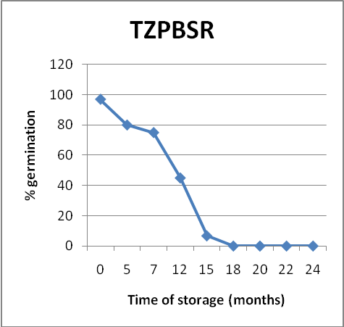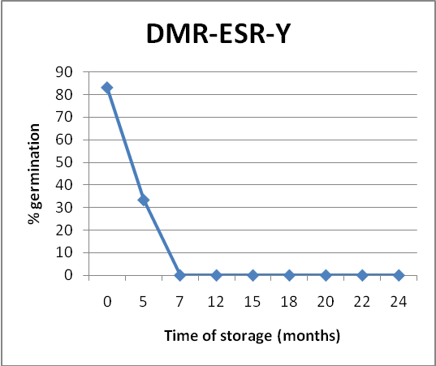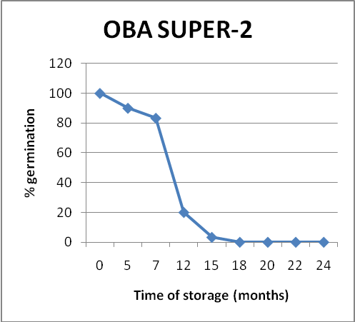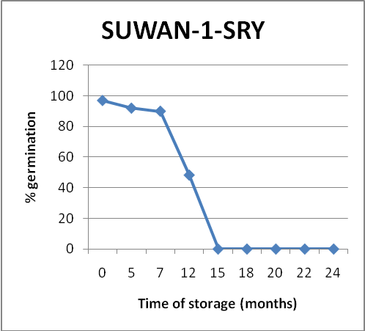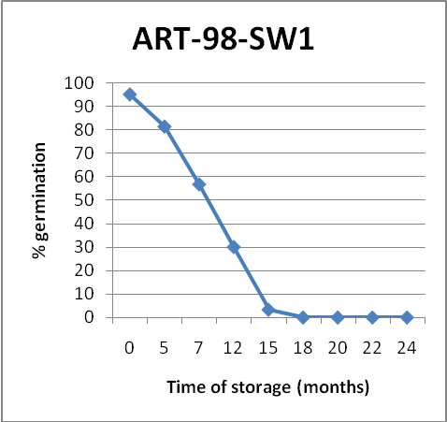

Fig. 1. Percentage Seed Germination over Time for Maize Genotypes within 24 Months (2005-2007) of Storage in UNAAB Seed Store, Abeokuta.

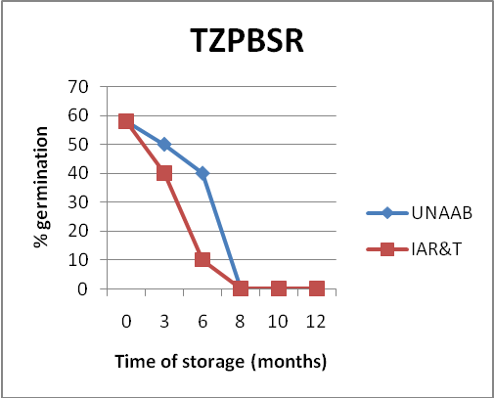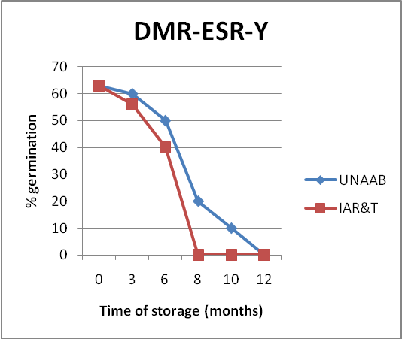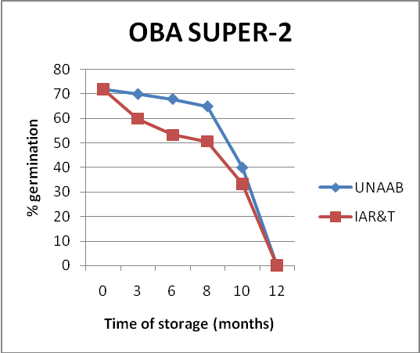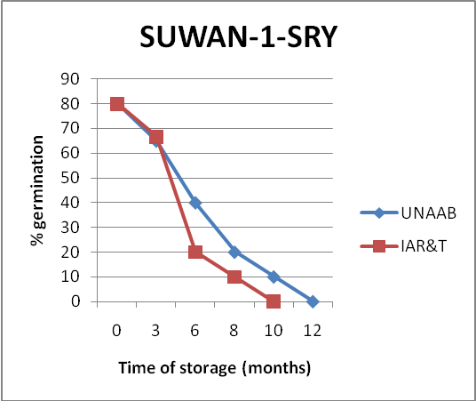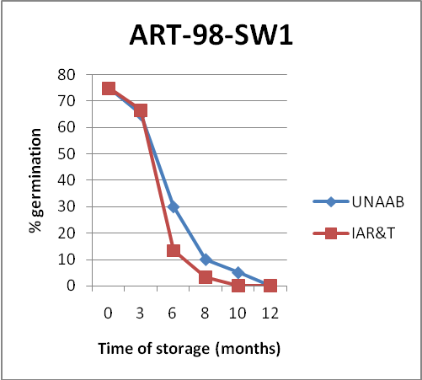
Oba Super-2
Suwan-1-SRY

Fig. 2. Percentage Seed Germination over Time for Maize Genotypes within 12 Months (2006-2007) of Storage in UNAAB, Abeokuta and IAR&T, Ibadan Seed Stores.

Table 5. Estimates of Probit Parameters of Potential Seed Longevity for 5 Varieties of Maize Seeds stored in UNAAB Seed Store for 24 Months.
Probit Parameters
Maize Genotypes Ki 1/σ σ P₅₀ (in days)
TZPBSR 1.882 0.196 5.137 288.0
(0.317) (0.034) (1.217) (24.7)
DMR-ESR-Y 0.149 0.225 4.500 19.7
(0.317) (0.034) (1.217) (24.7)
Oba Super-2 1.139 0.144 7.204 239.0
(0.317) (0.034) (1.217) (24.7)
Suwan-1-SRY 2.200 0.183 6.886 368.0
(0.317) (0.034) (1.217) (24.7)
ART-98-SW1 1.882 0.133 8.372 284.1
(0.317) (0.034) (1.217) (24.7)
*Values are means and standard error of means (in parenthesis).
Ki = Probit value of initial seed viability, 1/σ = Slope (measure of seed deterioration in storage), σ = Standard deviation of seed death in storage, P₅₀ = Seed half life or measure of time to 50% seed viability in storage.

Table 6 shows the goodness-of-fit test statistics for maize seed survival that fits to the probit model (v=ki-p/σ) during storage in UNAAB seed store for 24 months. Probability of chi square was significant (p≤0.05) in TZPBSR and Oba Super-2 but not significant in other seed lots (p>0.05). Estimate of chi square was highest (12.7919) for Oba Super-2 and lowest value obtained in ART-98-SW1 (1.4770). Heterogeneity factor (H) was nil for DME-ESR-Y, Suwan-1-SRY and ART-98-SW1. However, TZPBSR and Oba Super-2 had ‘H’ values of 4.0 and 6.4 respectively (Table 6).

Table 6. Goodness – of – fit Test Statistics for Maize Seed Survival that fits to the Probit Model (v=ki-p/σ) during Storage in UNAAB Seed Store for 24 Months.

Maize
Genotypes
χ P(χ²) H
TZPBSR 8.0418 0.0179 4.0

DMR-ESR-Y 2.8916 0.2356 -

Oba Super-2 12.7919 0.0017 6.4

Suwan-1-SRY 3.3551 0.1868 -

ART-98-SW1 1.4770 0.4778 -

χ² = Estimate of chi square, P(χ²) = Probability of chi square, H = Heterogeneity factor.

Estimates of probit parameters of potential seed longevity for the 5 varieties of maize stored in UNAAB and IAR&T seed stores between 2006 and 2007 (12 months) are also presented in Table 7. Under UNAAB seed storage environment, Oba Super-2 had significantly highest Ki value (2.811) and ART-98-SW1 had significantly least value (1.230) for same parameter. Half seed viability period (P₅₀) was correspondingly and significantly highest in Oba Super-2 (278.2 days), but lowest (117 days) in TZPBSR. Estimates of P₅₀ for TZPBSR and ART-98-SW1 were not different from each other (Table 7). In IAR&T seed store however, ART-98-SW1 had significantly highest estimate of Ki (3.689), while least significant estimate (1.495) of same parameter was recorded for Suwan-1-SRY (Table 7). Seed deterioration rate (1/σ) was lowest in Oba Super-2 (0.223) while DMR-ESR-Y had significantly highest value (0.605) for same parameter. Estimate of P₅₀ was significantly different in all the maize genotypes with Oba Super-2 having significantly highest estimate (250 days; Table 7).

Table 7. Estimates of Probit Parameters of Potential Seed Longevity for Seeds stored in UNAAB and IAR&T Seed Stores for 12 Months.

Storage Locations
UNAAB IAR&T
Maize Genotypes
Ki 1/σ σ P₅₀ (days) Ki 1/σ σ P₅₀ (days)
TZPBSR 1.600 0.402 2.587 117.0 1.627 0.507 1.992 92.82
(0.77) (0.05) (0.32) (10.50) (0.77) (0.05) (0.32) (10.5)
DMR-ESR-Y 1.893 0.311 3.266 184.1 2.886 0.605 1.792 144.6
(0.77) (0.05) (0.32) (10.50) (0.77) (0.05) (0.32) (10.5)
Oba Super-2 2.811 0.302 3.328 278.2 1.857 0.223 4.494 250.0
(0.77) (0.05) (0.32) (10.50) (0.77) (0.05) (0.32) (10.5)
Suwan-1-SRY 2.230 0.366 2.833 184.5 1.495 0.401 2.519 111.9
(0.77) (0.05) (0.32) (10.50) (0.77) (0.05) (0.32) (10.5)
ART-98-SW1 1.230 0.286 3.522 128.5 3.689 0.442 0.318 106.6
(0.77) (0.05) (0.32) (10.50) (0.77) (0.05) (0.32) (10.5)
*Values are means and standard error of means (in parenthesis).
Ki = Probit value of initial seed viability, 1/σ = Slope (measure of seed deterioration in storage), σ = Standard deviation of seed death in storage, P₅₀ = Seed half life or measure of time to 50% seed viability in storage.

Table 8 shows the Goodness-of-fit test statistics of the maize genotypes that fits to the probit model (V = Ki-P/σ) during storage in UNAAB and IAR&T seed stores. Probability of chi square was not significant for all the maize genotypes evaluated in both UNAAB and IAR&T seed stores (P>0.01). Suwan-1-SRY had highest chi square estimate (7.6369) under UNAAB storage condition; while highest estimate of chi square (5.2538) was recorded for DMR-ESR-Y in IAR&T seed store. ART-98-SW1 however had least estimates of chi square in both UNAAB (2.30) and IAR&T (0.63) seed storage environments. Statistics computed for both seed storage locations indicates conformity of the seed survival data to the seed viability model. The fact that seed-survival curves conform to a normal distribution has been confirmed for many crops by visual examination of seed survival curves (Ellis and Roberts, 1980b, 1981; Ellis et al.; 1982) and by statistical tests for hybrid corn seed (Tang et al., 1999a). Seed deaths during storage can be described by constructing seed survival curves that could follow a normal or logistic distribution (Finney, 1971). Other distributions, such as the Weibull Curve, had also been used (Moore and Jolliffe, 1987). Regardless of the distribution underlying seed-survival curve, the viability period indices (P₈₀, P₅₀, and P₃₀) can be estimated (Moore and Jolliffe, 1987).

Table 8. Goodness-of-fit Test Statistics for Maize Seed Survival that fits to the Probit Model (V = Ki – P/σ) during Storage in Humid Tropical Seed Stores.

Storage Locations
UNAAB IAR&T
Maize Genotypes
χ² P(χ²) H χ² P(χ²) H
TZPBSR 5.29 0.1519 - 2.10 0.5529 -

DMR-ESR-Y 3.82 0.2821 - 5.25 0.1541 -

Oba Super-2 6.91 0.0748 - 3.35 0.3413 -

Suwan-1-SRY 7.62 0.0541 - 1.12 0.7721 -

ART-98-SW1 2.30 0.5129 - 0.63 0.8902 -

χ² = Estimate of chi square, P(χ²) = Probability of chi square, H = Heterogeneity factor.

From the probit model estimation of longevity parameters of seeds stored in the two environments, there were differences in estimates across the maize genotypes used, and seeds with high initial probit value of seed viability (Ki) had corresponding lower deterioration rates (1/σ) and high seed half-life (P₅₀). Differences in estimates of Ki establish reports of varieties and seed lot differences in potential longevity of maize. This is in agreement with the reports of Zanakis et al. (1993) and Adebisi et al. (2003) in soybean varieties. However, since the intercept parameter is a seed lot parameter, varietal superiority may not be the major factor. Also, differences in the seed deterioration rates of maize genotypes showed that initial seed germination before storage influenced seed deterioration parameters. Probit modeling had been widely applied in evaluation of seed quality i.e potential longevity (Pieta-Filho, 1992), seed deterioration (Daniel et al., 1999; Tang et al., 1999a) and predicting seed viability in storage under constant conditions for different species under different storage environments (Daniel et al., 2003; Daniel and Ajala, 2006). A study carried out by Ola (2008), using UNAAB (Abeokuta) and BABCOCK (Ijebu) locations for sesame seed storage reported differences in the estimates of probit parameters for viability and vigour of 10 sesame genotypes stored in the two locations. He concluded that UNAAB storage environment was more favourable and ultimately enhanced seed longevity of sesame seeds, but that open seed storage under humid tropical climate is not generally ideal for long-term seed storage.
Probability of chi square {p(χ²)} of the fits of seed survival data to the probit model for some of the seed lots were not significant (p > 0.05). The significant ones had very low heterogeneity factor. This signifies conformity of the deterioration data of all the seed lots to the normal distribution models of Ellis and Roberts (1980a) seed viability equation. However, there are several reports in which the χ² test for normality indicated that seed survival curves deviated from the normal distribution (Moore and Roos, 1982; Moore and Jollife, 1987; Tang et al., 1999a). Wilson et al. (1989) also reported that the analysis of survival curves of Phaseolus vulgaris seed lots with low initial germination always resulted in insignificant χ²; while Tang et al. (1999a) reported large χ² in corn seed lots that had high germination percentages above 95% when percentage germination dropped below 5%. For some of the goodness-of-fit statistics that shows significant chi square but low heterogeneity factor, Tang et al. (1999b) argued that a significant chi square does not necessarily mean that the distribution is not normal. Insufficient or unbalanced samplings do contribute to disparity in test results of seed storage data (Ellis et al., 1990; Fabrizius et al., 1999), because they increase the deviation of observations from the expectation. Also, variations in germination test results can contribute to a significant chi square, so an increase in the number of seed tested may reduce the variation (Tang et al., 1999a).

Conclusion
Overall, the seed survival pattern under the humid tropical conditions fitted the normal distribution curve well, and the initial seed quality (germination, vigour and seed MC) enhanced seed storability under the different storage conditions. This shows that the probit model can be used to characterize the survival pattern of maize seeds during storage under ambient tropical conditions.

REFERENCES
- Adebisi M. A.; Daniel I. O. and Ajala M. O. (2003). Storage life of soybean seed dressing. Journal of Tropical Agriculture 42:3-7.
- Asiedu, E. A.; Van Gastel, A. J. G.; Greg, B. and Ebert, A. (1999). Dehumidifying drying: A viable option for long-term seed storage in the humid tropics. In: Impact, challenges and prospects of maize research and development in West and Central Africa. Proceedings of a Regional maize Workshop, 4-7 May, 1999. IITA COTONOU, Benin Republic. Pp 59-67.
- Bonner, F. T. (1990). Storage of seeds. Potential and limitation for germplasm conservation. CAB Seed Abstract (1991). 14 (6): 255.
- Daniel, I. O. and Ajala M. O. (2006). Probit modeling of seed physiological deterioration in humid tropical seed stores. ASSET A 4(3): 45-50.
- Daniel, I. O.; Ng, N. Q.; Tayo T. O. and Togun A. O. (2003). Storage of West African Yam (Dioscorea spp.) seeds: modeling seed survival under controlled storage environments. Seed Science and Technology 31: 139-147.
- Daniel, I. O.; Ng, N. Q.; Tayo, T. O. and Togun A. O. (1999). West African yam seeds stored under desiccated and cold storage conditions are orthodox. Seed Science and Technology, 27: 969-975.
- Ellis, R. H. and Roberts, E. H. (1980a). Improved equations for the prediction of seed longevity. Annals of Botany 45: 13-30.
- Ellis, R. H. and Roberts, E. H. (1980b). The influence of temperature and moisture on seed viability period in barley (Hordeum distichicuml). Annals of Botany 45: 31-37.
- Ellis, R. H. and Roberts, E. H. (1981). The quantification of ageing and survival in orthodox seeds. Seed Sci. and Tech. 9: 373-409.
- Ellis, R. H.; Hong, T. D. and Roberts, E. H. (1990). Moisture contents and the longevity of seeds of Phaseolus vulgaris. Annals of Botany 66: 341-348.
- Ellis, R. H.; Osei-Bonsu, K. and Roberts, E. H. (1982). The influence of genotye, temperature and moisture on seed longevity in chickpea, cowpes and soyabean. Annals of Botany 50: 69-82.
- Fabrizius, E.; Tekrony, D. M.; Egli, D. B. and Rucker, M. (1999). Evaluation of a viability model for predicting soyabean germination during warehouse storage. Crop Science 39: 194-201.
- Finney, D. J. (1971). Probit Analysis, 1st edition, Cambridge University Press, London. 333pp.
- Miles, D. F. (1985). Effect of storage of development and the desiccation environment on soyabean seed quality and respiration during germination. Ph.D. Dissertation, University of Kentucky, Lexington, KY, USA. 165pp.
- Moore, F. D. and Jolliffe, P. A. (1987). Mathematical characterization of seed mortality in storage. Journal of America Society of Horticultural Science 112: 687-686.
- Moore, F. D. and Roos, E. E. (1982). Determining differences in viability loss rates during seed storage. Seed Science and Technology 10: 283-300.
- Ng, N. Q. (1996). Preservation of genetic resources by seed storage. IITA Research Guide 52. International Institute of Tropical Agriculture (IITA), Ibadan, Nigeria. 36Pp.
- Ola, J. A. (2008). Storage life of sesame (Sesamum indicum L.) seeds under tropical conditions. M.Agric. Dissertation. University of Agriculture, Abeokuta, Nigeria. 120pp.
- Pieta-Filho, C. (1992). Estimating the value of the seed lot constant of the seed viability equation in barley and wheat. Seed Science and Technology 20: 93-99.
- Roberts, E. H. (1972). Cytological, genetic and metabolic changes associated with loss of viability. Pp. 253-306. In: E. H. Roberts (ed.) Viability of seeds. Chapman and Hall limited, London.
- Tang Shande; Dennis M. TeKrony; Dennis B. Egli; Paul L. Cornelius and Marcy Rucker (1999a). Survival Characteristics of Corn Seed during Storage: I. Normal Distribution of Seed Survival. Crop Sci. 39: 1394 - 1400.
- Tang, S; Tekrony, D. M.; Egli, D. B. and Cornelius, P. L. (1999b). Survival characteristics of corn seed during storage: II. Rate of seed deterioration. Crop Science 39: 1400-1406.
- Wilson, D. O.; McDonald, M. B. and St. Martin, S. R. (1989). A probit planes method for analyzing seed deterioration data. Crop Sci. 29: 471-476.
- Zanakis, G. N.; Ellis, R. H. and Summerfield, R. J. (1993). Response of seed longevity to moisture content in three genotypes of soyabean (Glycine max). Experimental Agriculture 29: 449-459.

7/1/2012

