Investigating heavy metal composition in medicinal tree barks

*Taiye R. Fasola and O.I Shittu

*Department of Botany, University of Ibadan, Ibadan, Nigeria
Department of Statistics, University of Ibadan, Ibadan, Nigeria
*Correspondence: fasolatr@yahoo.com

Abstract: Plant barks have been documented as the mostly used plant part in most parts of the World. The use of bark of plants in parts or as a whole in ethnomedicinal preparations is popular as a major form of medicine by 80% of the world’s population. This study therefore investigates the heavy metal level of trees outer bark as compared to the inner bark of some medicinal trees with a view to ascertaining their fitness for consumption when used in phytomedicinal preparations and to know if any of the barks constitute health hazards. Six heavy metals (Zn, Cu, Fe, Pb, Cd and Cr) from nine different plants: Mangifera indica, Alstonia boonei, Khaya ivorensis, Enantia chlorantha, Newbouldia laevis, Azadirachta indica, Morinda lucida, Nauclea diderrichii, Lannae welwitschii were identified for this study. The result shows that metal content of the outer bark of plants is about twice of the content of the inner bark. The heavy metal content in the outer bark of the trees studied outweighs that of the inner bark and is suggestive why the outer bark is scrapped off as a way known or unknown to some users in other to reduce consumption of heavy metals in ethnomedicine. For the purpose of forecasting, the inner bark content is regressed on the outer bark content with the equation error with the error term assumed to be normally distributed.
[Taiye R. Fasola and OI Shittu. Investigating heavy metal composition in medicinal tree barks. Nature and Science 2012; 10(8):149-153]. (ISSN: 1545-0740). http://www.sciencepub.net. 23

Keywords: Plant barks; Metal content; Ethnomedicne; Outer bark; Inner bark

Introduction
The role of a tree bark basically is to protect the plant from desiccation, injury and attack of microbes. Tree barks are most times used as spices, tannins, resins, latexes, fibres and other purposes including herbal preparations. They constitute both the outer and inner barks. The inner bark constitutes living cells while the outer bark is known to consist of dead cells with band of cork technically called rhytidome (Fahn, 1990). Metallic constituent concentration accumulation in plants is indeed worrisome to health scientists and botanists because concentration of heavy metals accumulates in vital organs of humans.
Tree barks have been proposed as biomonitors of heavy metal pollution in Netherlands (Kuik and Wolterbeer, 1994). They are indicated in long term air pollution as they are exposed to air pollutants directly or through stem flow. Buszewski et al (2000) observed that plants demonstrate morphological and physiological responses to heavy metals pollution; some of which may be utilized as bioindicators. The use of pesticides and fertilizers in agricultural practices, exhaust pipes of automobiles, industrial wastes and many other anthropogenic activities have resulted in increased heavy metal accumulation in plants (Hutton and Symon, 1986 and Nriagu, 1988). Though Farago (1994) studied a selection of plant species as biomonitors of mineralization and pollution, they however reported that higher concentrations of these metals can lead to poisoning. Studies on atmospheric pollution monitoring involving the use of tree barks have been carried out in Europe and USA, where the levels of metals in tree barks and tree rings have been correlated with the actual levels present in the atmosphere (Barnes et al 1971 and Berthelsen et al 1995). Similarly, in Ibadan, Nigeria; Osibanjo and Ajayi (1980) reported that lead concentration shared a marked correlation with traffic movement.
Threats posed by heavy metals are numerous. Among such is an indication that levels of lead as low as 25-50g/l caused drops in intelligence quotient. It was reported that Juvenile delinquency rates are higher for children exposed to high levels of lead (ATSDR, 1999). In the same report, adults clinically exposed to lead can suffer from seizure, anorexis, abdominal upset etc. Mercury has long been known to cause severe mental problems. Though living things require trace amount of heavy metals, the threats associated to their excess in human have been documented (United Nations System, 2003).
The use of medicinal plants in parts or as whole is on the increase as herbal medicine is popular as a major form of medicine used by 80% of the world’s population (Nana, 2007). Plant barks have been documented as the mostly used plant part in a study carried out in Uganda by Wild and Mutebi (1996). The harvested bark portions of tree barks used in these studies have varied uses in phytomedicine. The uses ranged from malaria which is prevalence in Africa to inflammation, blood tonic and dermatitis. Fasola and Egunyomi (2002) expressed two schools of thought in the use of tree barks in phytomedicine. A school of thought used the entire bark while the other scrapped off the outer bark before use. In their studies, the outer bark thought to be dead, revealed having phytochemicals. However, the fear of the outer barks accumulating heavy metals was not expressed. It was therefore the aim of this study to investigate the heavy metal levels of trees outer bark as compared to the inner barks of some medicinal trees. This was with a view to ascertain if they are fit for consumption when used in phytomedicinal preparations.

Material and methods
The plants used in this study are long standing trees of Mangifera indica, Alstonia boonei, Khaya ivorensis, Enantia chlorantha, Newbouldia laevis, Azadirachta indica, Morinda lucida, Nauclea diderrichii, Lannae welwitschii located in various areas of Ibadan, Oyo state, Nigeria. Ibadan lies at latitude 07°22'N and longitude 03°58'E. Ten grams of separated powdered outer and inner barks of each tree were accurately weighed into properly cleaned, oven dried vitrosil crucibles and ashed at about 500ºC. The ash made up with distilled water to 100ml volumetric flask.
The samples were analyzed for heavy metals (Zn, Cu, Fe, Pb, Cd and Cr) by Atomic Absorption Spectrophotometer using a Perkin-Elmer model 200 coupled to a Perkin-Elmer recorder operated
as per the instrument’s hand book. Air acetylene flame was used and the instrument calibrated using mixed calibration standard solutions prepared as required from stock standard solution from nitrate of the metals (Osibanjo and Ajayi, 1980).
The computed statistics and summaries were presented graphically using the boxplot, histogram and pie-chart. The resulting model is examined for adequacy from the histogram of the residuals of the model. The analysis of variance (ANOVA) test is used to test the null hypothesis of no difference in the mean contents of heavy metals in the inner and outer bark of the plants as:
at level of significance. The decision to reject H₀ or otherwise is taken by comparing the

calculated with the critical value at level of significance with
k-1 and n-k-1 degrees of freedom,( Weisberg 1985).

Results and Discussion
Six heavy metals from nine different plants were considered in this study. The preliminary analysis showed varying quantities of heavy metals in plants. A few outliers were noticed in Ni for both inner and outer barks as shown in figs 1 and 2. Table 1 shows the mean quantity of heavy metal content, the standard deviation and the 95% confidence interval for the mean heavy metal content for the inner and outer bark of plants. It can be observed that Fe (34%) is highest, followed by Zn (24%), Cu (18%), Pb (17%) and Cr (9%). The least is Cd (1%).

Table 1: Showing Summary Statistics for Heavy Metals
 | Inner B |  |  | Outer B
Heavy Metals | Mean(S.E) | Std. Dev. | 95% C. I. | Mean (S.E) | Std. Dev. | 95% C. I.
Zn | 33.43  (2.075) | 10.78 | (29.16-37.69) | 66.08  (2.986) | 15.517 | (59.94-72.22)
Cu | 25.35  (2.026) | 10.526 | (21.18-29.51) | 48.72  (4.037) | 20.980 | (40.42-57.02)
Fe | 45.18  (2.690) | 10.979 | (39.65-50.71) | 92.55  (4.78) | 24.848 | (82.72-102.38)
Pb | 22.37  (1.798) | 9.343 | (18.67-26.07) | 47.34  (3.475) | 24.847 | (40.20-54.48)
Cd | 0.750  (0.069) | 0.358 | (0.61- 0.89) | 1.638  (0.167) | 0.8694 | (1.294- 1.982)
Cr | 12.836  (0.441) | 2.293 | (11.93-13.74) | 17.791  (0.732) | 3.801 | (16.28-19.29)
Table 2 also shows the mean quantity; standard error of metal content in plants and the 95% confidence interval for the means for the inner and outer barks of the plants. Though there are slight variations in the heavy metal content of the plant as shown in figure 3.

Table 2: Showing Metal content in Plants
 | Inner B |  |  | Outer B
Plants | Mean  (S.E) | Std. Dev. | 95% C. I. | Mean (S.E) | Std. Dev. | 95% C. I.
Mangifera indica | 25.30  (5.24) | 24.75 | (12.99-37.61) | 44.45  (11.41) | 48.42 | (25.37-73.53)
Alstonia boonei | 21.88  (3.74) | 15.88 | (13.98-29.98) | 44.77  (8.39) | 35.63 | (27.05-62.49)
Khaya ivorensis | 25.92  (3.66) | 15.55 | (18.19-33.66) | 42.50  (7.58) | 32.18 | (32.33-64.34)
Enantia chlorantha | 22.64  (3.24) | 13.759 | (15.79-29.48) | 42.50  (6.37) | 27.03 | (29.06-55.94)
Newbouldia laevis | 21.88  (5.63) | 23.88 | (9.99-33.75) | 43.51  (10.50) | 44.56 | (21.35-65.67)
Azadirachta indica  Morinda lucida  Nauclea diderrichii  Lannae welwitschii | 18.95  (3.24)  26.08  (3.74)  23.21  (3.04)  24.02  (3.13) | 13.75  15.85  13.14  13.25 | (12.11-25.79)  (18.20-33.96)  (16.67-29.74)  (17.43-30.61) | 38.14  (6.61)  51.42  (7.70)  46.34  (6.91)  46.71  (6.57) | 28.04  32.68  29.33  27.89 | (24.21-52.09)  (35.16-67.67)  (31.76-60.92)  (32.84-60.58)

The analysis of variance (ANOVA) test showed a significant difference in the heavy metals in plant at (P=0.002).
The multiple comparison test using the Turkeys HSD test, Scheffe test and LSD test all show that heavy metals for both inner and outer bark were scientifically different except for Cu and Pb at 5% level of significance. The analysis also shows an insignificant difference in the metal content in plants at (P=0.983). This is presented graphically in Figure 2.
The paired comparison test of heavy metals in the outer and inner barks of plant at 5% level of significant confirms our findings that the metal contents in the outer bark is greater than that of the inner bark. The degree of correlation between the metal content in outer and inner back is calculated as r = 0.955. This indicates a strong positive association metal content of outer bark on that of inner bark. The outer bark content can be predicted using the regression model:

error ;

The plot of the residuals of the model did not show any sign of model inadequacy. Hence, given a value of the outer bark content, the inner bark content can be predicated with reasonable degree of reliability.

Fig.1a: Box plot showing Metal Content Fig.1a: Box plot showing Metal Content
in Outer bark in Inner bark

Key: Mangifera indica(Mi), Alstonia boonei(Ab), Khaya ivorensis(Ki), Enantia chlorantha(Ec), Newbouldia laevis(Nl), Azadirachta indica(Ai), Morinda lucida(Ml), Nauclea diderrichii(Nd), Lannae welwitschii(Lw)

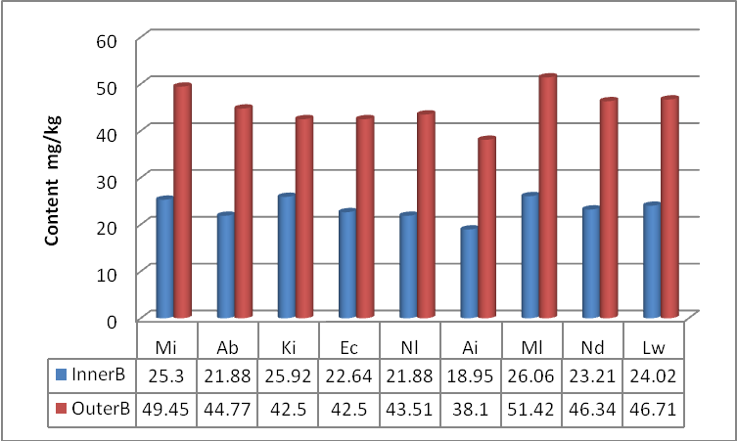
Figure 2: Mean Metal Content of Inner and Outer Bark by Plants

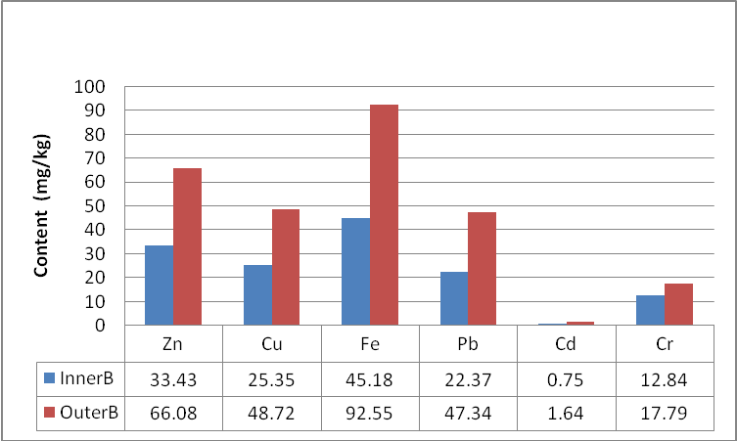
Figure 3: Mean Content of Inner and Outer Bark by Metals

In view of the above findings, that the heavy metal content in the outer bark of the trees studied outweighs that of the inner bark is suggestive that the school of thought discarding the use of outer bark in phytomedicinal preparation could in a way have reduce the consumption of heavy metals. More also that the outer bark of plants have immediate contact with the atmosphere is supportive of higher accumulation of heavy metals. This finding is in line with other studies on atmospheric pollution monitoring involving the use of tree outer bark that have been carried out by several workers.

References
- Agency for Toxic Substances and Diseases Registry (AESDR).Toxicology profile for Lead Atlanta, GA: US Department of Health and Human Services, Public Health Services. 1999.
- Barnes D., Hammabah MA, Ottaway JM. The lead, copper and zinc contents of tree rings and bark, a measure of local metallic pollution. Sci.Total Environ.1976; 5: 63.
- Berthelsen BO, Steinnese E, Solberg W, Jingsen L. Heavy metals concentrations in plants relation to atmospheric heavy metals deposition. J. Environ. Qual., 1995; 24: 1081.
- Buszewski B, Jastrzebska A, Kowalkowski T, Gorna-Binkul A. Monitoring of selected heavy metals uptake by plants and soils in the area of Torun´, Poland. Polish Journal of Environmental Studies 2000; 9(6): 511 – 515.
- Fahn A. Plant Anatomy, Pergamon Press, Oxford 1990.
- Farago ME. Plants as indicators of mineralization and pollution, in: Plants and the chemical elements, VCH Wienheim. 1994.
- Fasola TR, Egunyomi A. Bark Extractivism and uses of some medicinal plants. Nigeria Journal of Botany 2002; 15: 26 – 36.
- Hutton M, Symon C. Quantities of cadmum, lead, mercury and arsenc entering the environment from Human Activities. Sci. Total Environ. 1986; 57:129 – 150.
- Kisamo DS. Environmental hazards associated with heavy metals in lake Victoria Basn (East Africa), Tanzania. Afric. Newslett. in occup. Health and Safety 2003; 13: 67 – 69.
- Kuik P, Wolterbeek HT. Factor analysis of trace-element data from tree-bark samples in the Netherlands. Environ. Monit. Assess 1994; 32: 207-226.
- Nana W. Cameroon: 80 Percent of World's Population Depend On Traditional Medicine. The postnewsline.com of 6th September, 2007.
- Nriagu JO. A silent epidemic of environmental metal poisoning. Environmental Pollution 1988; 50: 139 -161.
- Osibanjo O, Ajayi SO. Trace metal level in tree barks as indicators of atmospheric pollution. Envron. Int. 1980; 4: 239 – 244.
- United Nations Systems. Wide Earth Watch. Unepinet/toxic chem./heavy metals.ph.2003
- Wiesberg S. Applied Linear Regression. 2nd edition; John Wiley & Sons Inc. 1985.

7/30/2012

