EFFECTS OF A CARBONACEOUS BOTTLING PLANT EFFLUENT ON ALBINO MICE SPERM MORPHOLOGY AND TESTES HISTOPATHOLOGY

¹Agunbiade SO, ²Okonko IO, ¹Alimba CG, ¹Folarin AC, ³Anugweje KC

¹Department of Biochemistry, Lead City University, Ibadan, Nigeria; ²Department of Microbiology, University of Port Harcourt, East-West Road, P.M.B. 5323, Choba, Port Harcourt, Rivers State, Nigeria; ³Department of Health Services, Lulu Briggs Health Centre, University of Port Harcourt, East-West Road, P.M.B. 5323, Choba, Port Harcourt, Rivers State, Nigeria; mac2finney@yahoo.com, iheanyi.okonko@uniport.edu.ng

ABSTRACT:This study seeks to examine the genotoxic effects of an industrial effluent from a carbonaceous bottling plant in Lagos state Nigeria using sperm head abnormality assay and assessment of testicular histopathology of albino mice. Samples of the effluent were administered orally to mice at test concentrations of 1%, 2.5%, 5%, 10% and 25%. Mice were given 0.3ml daily for 25 days by oral dosage. Each dose group comprised of 5 mice; positive and negative control groups also had 5 mice each. The result data shows that the test sample induced a dose-dependent, statistically significant increase (p<0.05) in the number of sperm with abnormal morphology, as well as diverse histopathological changes in the testes. Physicochemical analysis of the test samples showed that they contain constituents that are capable of inducing mutation in the biological system. The interaction of some of these constituents with the genetic material in the differentiating cells during spermatogenesis may be responsible for these observations. This study is relevant in environmental waste management, and for the assessment of the hazardous effects of chemicals in waste effluents.
[Agunbiade SO, Okonko IO, Alimba CG, Folarin AC, Anugweje KC. EFFECTS OF A CARBONACEOUS BOTTLING PLANT EFFLUENT ON ALBINO MICE SPERM MORPHOLOGY AND TESTES HISTOPATHOLOGY. Nat Sci 2012; 10(8):154-160]. (ISSN: 1545-0740). http://www.sciencepub.net. 24

Keywords: Plant Effluent, Albino Mice, Sperm, Morphology, Testes, Histopathology

1.0. INTRODUCTION
Waste pollution is a characteristic feature of urbanisation, industrialization and population increase in most developing and developed countries. They may exist in different forms which include solid waste, sludge and effluents. Indiscriminate discharge of untreated or partially treated wastewaters directly or indirectly into aquatic bodies may render water resources unwholesome and hazardous to man and other living systems (Bakare et al., 2003a,b, 2009; Fawole et al., 2008; Kumar, 2008). This method has been reported to have a significant relative risk of contracting diseases, especially gastrointestinal symptoms, related to the number of indicator organisms present in the polluted water bodies (Bakare et al., 1999a,b). Apart from this direct health risk, pollutants present in the water bodies may be mutagenic or toxic and may lead to many human health problems like cancer, cardiovascular diseases and premature ageing. Bakare et al. (2003a,b) reported that most industrial waste water can be regarded as complex mixtures of numerous inorganic and organic compounds. These chemicals may be bioaccummulated and biomagnified in the ecosystem and may get to a threshold level that may be deleterious to man.
Several reports have demonstrated acute toxicity of industrial effluents to microalgae, fishes and bacteria. However reports on the genotoxicity are few and are mostly with microbial assays. More often than not, landfills of these effluents neither have a synthetic membrane liner at the bottom, nor a natural layer of compacted soil with the desired hydraulic conductivity, nor a run-off control system. This is a potential source of leechates which ultimately find their way into municipal and local water supplies, adding to the toxic components of domestic water we use every day. An imperative need has been suggested to examine the toxic and genotoxic effects of these waste waters in order to generate information that will be useful to the environmental authorities for promulgating laws that will guide the proper management of these waste waters (Bakare et al., 2003a,b, 2006, 2009; Bakare and Wale-Adeyemo, 2004).
Although several reports have demonstrated the acutely toxic and genotoxic effects of industrial effluents in microbial organisms, plants and aquatic animals, the effects of pollutants present in these effluents have not been clarified in terrestrial animals. There is paucity of data on its effect and mechanism of action on the male reproductive system. The objective of this study was to examine the genotoxic effects of industrial effluents from a carbonaceous bottling plant in Lagos state, Nigeria, using sperm-head abnormality assay. These findings may be used in the assessment of the toxic effects of chemicals present in the waste water samples on the environment if dumped indiscriminately.
2.0 MATERIALS AND METHODS
2.1. Laboratory mice
Thirty five male albino mice were obtained from the animal breeding unit at the Institute for Advanced Medical Research and Training, IMRAT, Ibadan. The mice were quarantined for three weeks in a pathogen free, well ventilated room in order to enable them to acclimatize to their environment and also to avoid the transiting increases in abnormal sperm occurring at the onset of mouse spermatogenesis in young mice. During the period of acclimatization, the animals were supplied with food pellets and drinking water on daily basis and their beddings were changed, discarded and disinfected. The mice were maintained in the departmental animal breeding unit at IMRAT in cages containing 5 animals each.
2.2. Waste effluent
The waste water sample was sourced from drainage pipes of the Effluent Treatment Plant of a well known beverage producing company in Lagos state, Nigeria.
2.3. Storage of Effluent
The collected effluents were stored in labelled plastic bottles and refrigerated at 4°C until when needed. They were then brought out and diluted to various concentrations at room temperature. The various concentrations were in-turn stored in plastic bottles and refrigerated all through the experiment.
2.4. Dilution from the stock
The required dilutions were 25%, 10%, 5%, 2.5%, and 1%. They were obtained using the formula, C₁V₁ = C₂V₂ where C₁ = Original concentration, V₁ = Initial Volume, C₂ = Required concentration and V₂ = Final Volume. 0.3ml of the various dilutions – including the controls - was administered orally to each mouse for 35days.
2.5. Positive control
The drug cyclophoshamide was used. Administered dosage depends on the average body mass of the animal per kg, which is 40mg/kg as stipulated by Krishna Gopala and Hayashi Makoto, 2000. The value in mg provided by the manufacture was taken into consideration when making the calculation. Average body weight of animal for positive control per kg is 24.5g. 40mg = 1000g; X = 24.5g; X = 40 x 24.5/1000 = 0.98mg of cyclophosphamide dissolved in 1000ml distilled water and administered orally for 35days.
2.6. Physical and chemical characteristics of the effluent
Tests and methodology, pH determination, alkalinity, colour, total sulphate, total chloride, total hardness, total dissolved solids, total suspended solids, biochemical oxygen demand (BOD), chemical oxygen demand (COD), determination of metals was carried out by the methods of FAO (1997) and Ademoroti (1996).
2.7. Testis Histopathology
The testes were rinsed in normal saline (0.85g NaCl + 100ml water), hypotonic solution, and then placed in formalin until further cold storage. Cross-sections were obtained and slides were made from them. They were then stained with Hematoxylin (H & E) and viewed under the microscope. Photomicrographs were taken and studied.
2.8. Administration of Dosage Concentrations
The animals were randomly divided into s even groups. Each group made up of five individuals. Five groups were each dosed with different dilutions of the effluent. One group was administered a positive control sample while another group the negative control sample. 0.3ml of the sample was administered orally to each animal for a period of thirty five consecutive days. This dosage period is necessary to allow spermatogenesis in males to be completed before sacrificing the animals.
2.9. Sacrificing the Animals
After the 35days period the animals were sacrificed by cervical dislocation and dissected to obtain the cauda epididymis from the testes for subsequent staining in accordance with procedures stipulated by Wyrobek et al. (1983). The cauda epididymes were minced with fine needles into a Petri-dish containing isotonic medium. Large tissue fragments were removed by filtering with a stainless steel mesh to make clear filtrate containing suspended sperm cells.
2.10. Sperm staining; preparation of slides
The collected sperm cells in the Petri dish were stained with a mixture of normal saline and 1% Eosin-Y stain in allows the cell to absorb the stain.
2.11. Cytological Studies
Cytological evaluation of sperm head abnormalities and any other sperm aberration was carried out using a light microscope under 100x magnification sperm cells. 600 sperm cells were counted per animal and were assessed for morphological damages.
2.12. Statistical Analysis
The SPSS 10.0 statistical package was applied to evaluate the distribution of abnormal spermatozoa. Difference between the negative control and the individual dose groups was analysed by means of the students’ t-test of significance at the P<0.05 level. The mean standard error was calculated. The assay result was considered positive when the frequency of abnormal sperm-heads was at least twice the negative control level; when statistically significant increments were seen at least two consecutive dose levels, and when there was evidence of a dose-related increase in abnormalities.

3.0. RESULTS AND DATA ANALYSIS
3.1. Physicochemical Analysis
Table 1 shows the physicochemical parameters determined in the effluent sample and tap water. The values obtained for the effluent sample were much higher for most of the parameters compared with the values for tap water, and higher than the maximum allowable levels in drinking water (WHO, 1985; FEPA, 1991). Most of the identified constituents are considered toxic to drinking water and ions such as iron, magnesium, cadmium, nickel (Loizidou et al., 1993).
3.2. Sperm Analysis
Analysis of sperm-head abnormalities was made immediately after the 35 days exposure of the animals to the test effluent. Sperm cells observed at this time were presumably exposed to the effluents constituents while they were early primary spermatocytes and spermatogonia. Table 2 shows the effect of different concentrations of the effluent sample on sperm-head morphology. The negative controls showed 3.8% abnormalities, while the positive control gave a statistically significant elevation of abnormal sperm heads (19.89%). Different types of abnormal heads were observed at the test concentrations; the induction was concentration-dependent for all samples. The total percentage abnormality was 9.9%. This value was statistically significant (p<0.05) at all doses except at the 1% and 2.5% concentrations.

Table 1: Physical and chemical characteristics of the effluent samples and Tap water
PARAMETERS | SAMPLE | TAP WATER | FEPA* | USEPA*
pH | 7.80 | 7.8 | 6.9 | 6.5-8.5
Colour | Light Brown | Colourless | - | -
BOD | 2.50 | - | 50
COD | 55.01 | -
Total Suspended Solid | 0.50 | 288.63
Total Dissolved Solid | 0.01 | 100 | 2000 | 500
Total Hardness | 100 | 3.0 |  | 0.75
Total Alkalinity | 3.20 | 22.5 | 250 | 20
Chlorides | 3.0 | 232.0 |  | 250
Sulphates | 2.70 | 41.0 | 20 | 250
Nitrates | 7.29 | 0.08 |  | 10
Ammonium | 6.91 | 0.18
Magnesium | 24.06 | 0.49
Copper | 2.81 | 0.0000091 | 0.30 | 1.00
Iron | 2.99 | 0.00014 | 0.05 | 0.30
Lead | 0.01 | 0.00037 | 0.01 | 0.015
Cadmium | 0.003 | 0.000018 | 0.05 | 0.05
Silver | 0.099 | 0.000047
Nickel | 0.062 | 0.188
Manganese | 11.25 | 0.0689 | 0.05 | 0.05
Note: All values are in mg/l except pH with no unit. Cyanogenic potential is expressed as μg HCl mLG¹ (ppm). COD: Chemical oxygen demand, BOD: Biochemical oxygen demand, TDS: Total dissolved solids, ªFederal Environmental Protection Agency (FEPA, 1991) Permissible limits for drinking water.

Table 2: Effects of effluents on sperm morphology after 35 days exposure
Concentration (%) | Total Abnormal Sperm (%) | Mean ± S. E
Negative control | 66(3.80) | 3.20 ± 1.07
1 | 101(5.82) | 20.20 ± 1.36
2.5 | 167(9.63)* | 33.40 ± 2.09
5.0 | 246(14.18)* | 49.20 ± 2.96
10.0 | 278(16.0)* | 55.60 ± 3.74
25.0 | 327(18.85)* | 65.40 ± 3.08

The percentages and the means are for groups of five mice for each dose. Positive control value (% abnormal sperm) = 19.89%; 2,500 sperms were assessed for morphological damage per concentration, and controls. Total abnormal sperm counted was 1733, having an overall percentage abnormality of 9.90%; *= Significantly higher (p<0.05) than control.

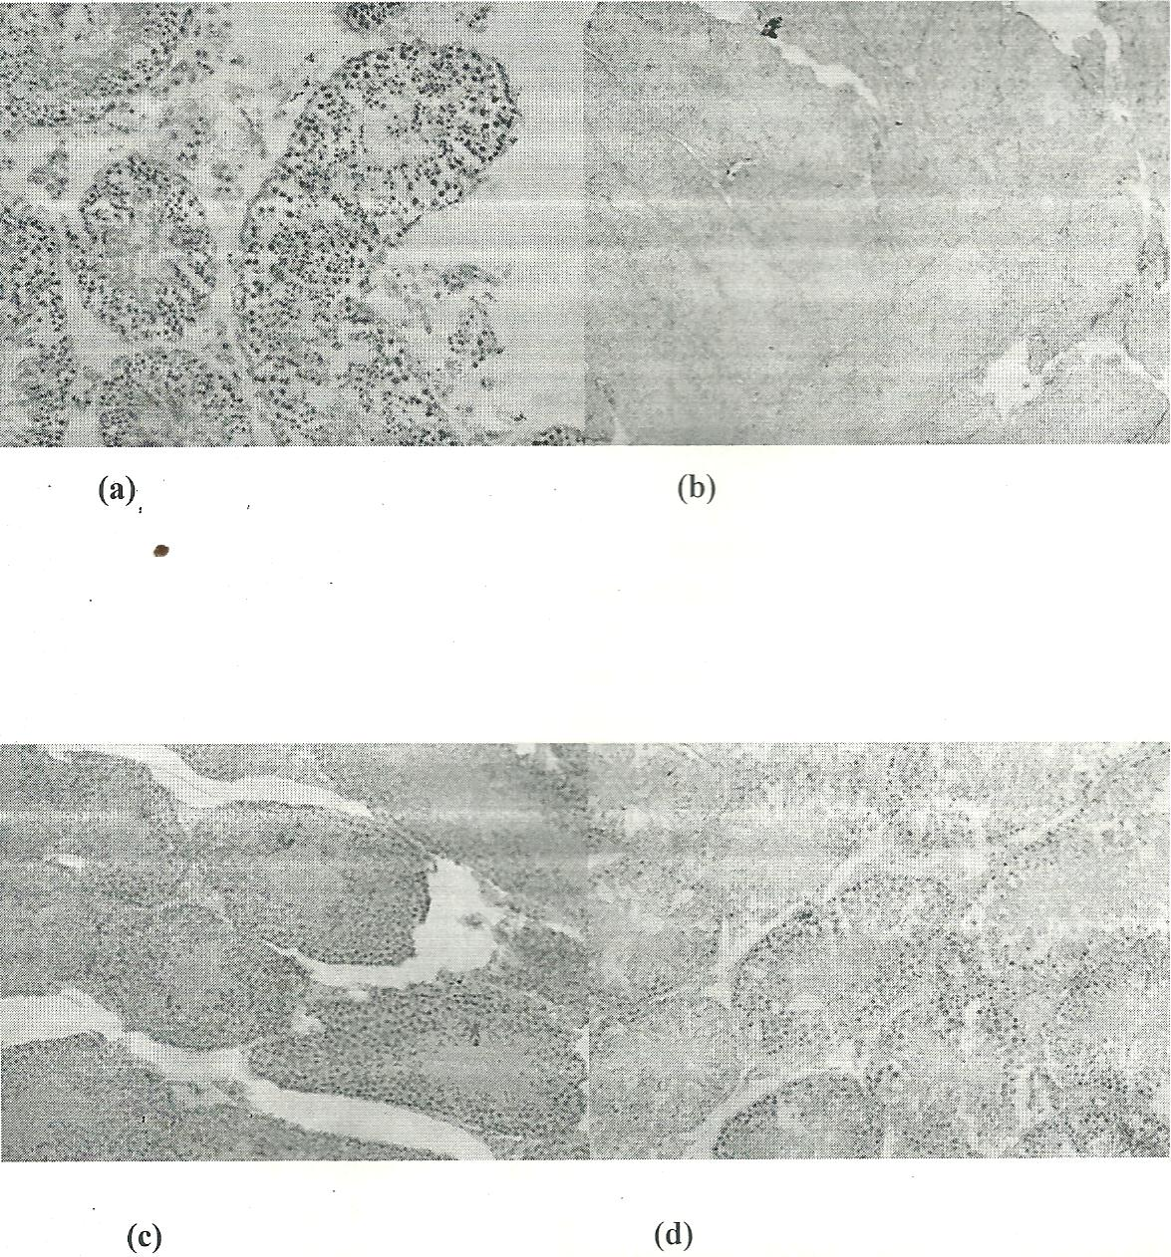
Figure 1: Specific morphological aberrations amongst healthy sperm cells

3.3. Testes histopathology
Figure 1 shows specific morphological aberrations amongst healthy sperm cells. The test sample may therefore be active in inducing sperm-head abnormalities and may be genotoxic. This is because the criteria for positive response were satisfied. There was no recorded death during treatment. Thus it can be safely assumed that the increase in the frequency of the sperm morphology aberrations seen in the treated mice was due to the effluent tested. The photomicrographs in Figure 2 and 3 illustrate different histopathologic changes that were observed in the testes of the animals. Administration of the effluent caused severe histopathologic lesions such as congestion of the interstitium, and severe congestion of the interstitial blood vessels. Figure 2 shows the photomicrographs of different histopathologic changes in the testes of test animal while Figure 3 shows photomicrographs of different histopathologic changes in the testes of test animal.

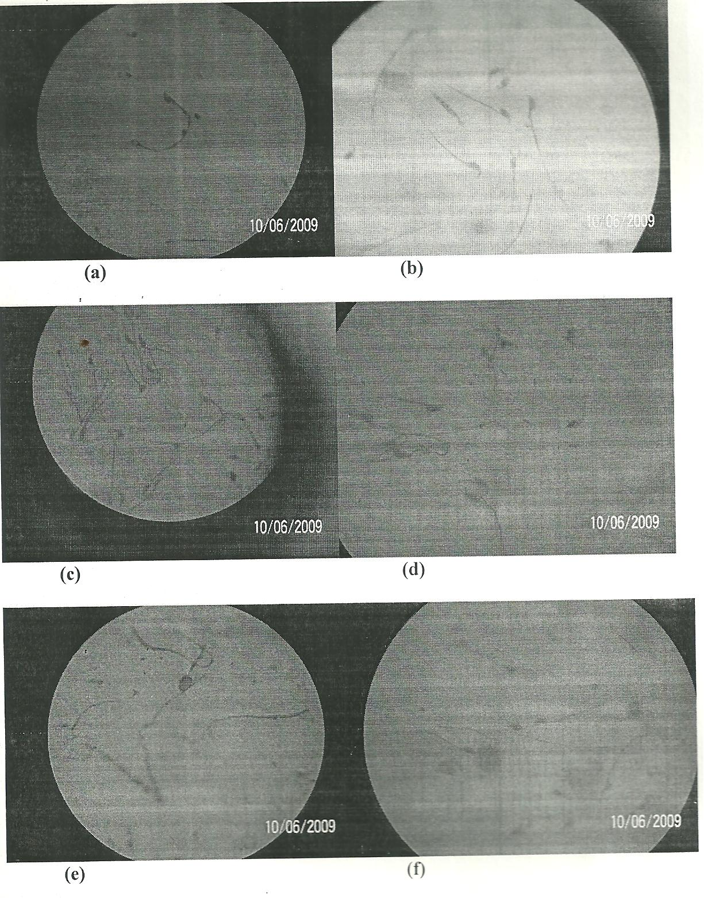
Figure 2: Photomicrographs of different histopathologic changes in the testes of test animal

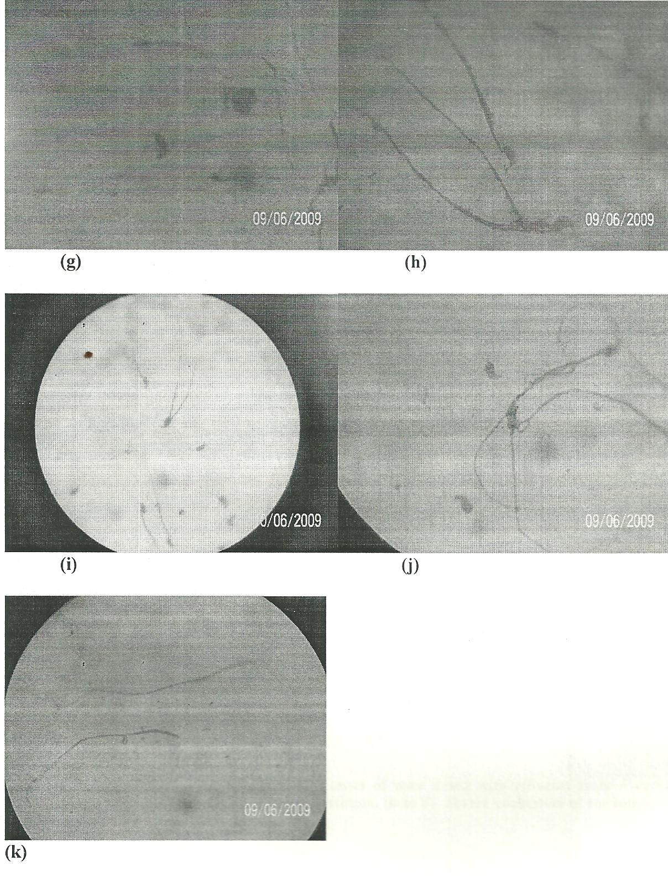
Figure 3: Photomicrographs of different histopathologic changes in the testes of test animal

4.0 DISCUSSION
This study this study examined the genotoxic effects of industrial effluents from a carbonaceous bottling plant on sperm of albino mice. It showed that heavy metals concentrations were on the high side. This finding is therefore useful in further assessment of the toxic effects of chemicals present in the wastewater samples on the environment if dumped indiscriminately. Compared to the allowable limits (FEPA, 1991; USEPA, 1988; UNESCO/WHO/UNEP, 1992) most of the parameters analyzed, especially the heavy metals were present in high concentrations. This is comparable to the findings of previous studies (Ubalua, 2007; Bakare et al., 2009; Olorunfemi et al., 2007, 2008, 2011). Ubalua (2007) stated that the claim that cassava wastewater can cause problems in some crops is based on anecdotal information. Macroscopic and microscopic results obtained from the sperm test in this study with the industrial effluents from a carbonaceous bottling plant clearly show that they are cytotoxic and genotoxic. The effluents induced sperm abnormally in line other workers (Fiskesjo, 1988; Odeigah et al., 1997; Seetharaman et al., 2004; Babatunde and Bakare, 2006; Bakare and Wale-Adeyemo, 2004, 2009; Olorunfemi et al., 2011) have shown to be useful signs of cytotoxicity and genotoxicity. Ivanova et al. (2002) and Staykova et al. (2005) have established the genotoxic and mutagenic effects of open water contaminated with heavy metals and cyanide, further confirming the results of the inhibitory effects of these effluents in previous studies (Olorunfemi et al., 2007, 2008, 2011).
The mouse sperm morphology assay was developed by Wyrobek and its relevance in evaluating mammalian germ cell mutagens is well accepted (Wyrobek and Bruce, 1975; Wyrobek et al., 1983). Presence of abnormal sperm head suggests induction of genetic damage in the male germ cells. Sperm head abnormalities may arise due to small deletions or point mutations. Abnormalities in sperm head may occur by physiological, cytotoxic or genetic mechanisms, alteration in testicular DNA which in turn disrupts the process of differentiation of spermatozoa (Odeigha, 1997).
The formation of normal sperm head involves a series of intricate, synchronous, morphological and biochemical steps. The nuclei that result from these processes are normally very homogenous and have a marked strain specific structural definition (Beatty, 1970). Chromosomes appear to be arranged in specific location in the nuclei (Beatty, 1970). The reason for sperm of abnormal head shape is not clear. Perhaps they are the results of naturally occurring levels of mistakes in the differentiation process. Genotoxic chemicals might increase the frequency of these mistakes. If this were the case, then sperm with abnormal head shapes might well contain an intact, normal chromosome complement or perhaps there are very few mistakes made in the packaging of genetic material in the head. Perhaps, the abnormal shape is a consequence of an abnormal chromosome complement. For instance, a spermatid which has a translocation may not form a normal-looking head. If this were the case, then sperm with abnormal shapes would contain abnormal genetic material. Although several reports have demonstrated the acute toxicity and genotoxic effects of substances such as tetracycline on sperm morphology; induction of sperm abnormality in mice by landfill leachates, the effects of pollutants such as effluents from heavy industries in municipal water content has not yet been clarified in terrestrial animals (Bakare et al., 2006).
In this study, the tested effluents induced abnormal sperm-head morphology and the induction was dose-dependent. Based on the total percentage abnormalities at the end of the 5-week exposure period, the order of induction abnormal sperm head was 25% > 10% > 5%> 2.5% > 1%. None of the dosage groups however, induced any specific type of abnormality but rather a variety of abnormalities (Figure 2). The photomicrographs shown in Figure 3 illustrate the sperm morphological aberrations observed. The abnormalities show no proportionality in occurrence and seem to occur randomly. The observed abnormalities indicate that the sample constituents had an effect on sperm that had risen in treated spermatogonial cells. They may have caused damage to the pre-meiotic stages of spermatogenesis since during spermatogenesis, DNA synthesis occurs before the pre-meiotic phase and no further DNA synthesis occurs throughout sprermatogenesis in the cell cycle (Monesi, 1962). Moreover the nuclei of the mammalian gamete resulting from spermiogenesis are usually every homogenous, and have a marked strain-specific structural definition. Therefore any abnormalities observed in the sperm heads presumably occurred during spermatogenesis since once the head develops its shape, it is extremely stable.
Some constituents of the test samples shown in Table 1 might have acted individually, synergistically, and/or antagonistically by increasing the frequency of these mistakes during the differentiation process. Individually, some of the constituent elements are mutagens and carcinogens. For example, lead was reported to be a strong clastogen that breaks chromosome in Chinese Hamster Ovary Cells (Bauchinger et al., 1972), bone-marrow erythrocytes of rats (Kharchenko and Andreera, 1987) and in workers occupationally exposed to lead, as well as in human lymphocytes tested in vitro (Forni et al., 1980). In addition, lead inhibits spermatogenesis and contributes to reduction of fertility and induction on congenital malformation in rats (Muro et al., 1969; Kharchenko and Andreera, 1987). Nickel is known to produce a highly selective damage to heterochromatin (Costa et al., 1994). Likewise cadmium exerts embryonic effects and inhibits spermatogenesis in some strains of mice (Dalton, 1996). A number of epidemiological studies in experimental animals have also demonstrated the carcinogenicity of lead (Fowler et al., 1994), nickel (Haugen, 1994) and cadmium (Elinder, 1996) compounds.
The observation reported here is in accordance with previous reports on the microbial mutagenicity of related effluents/chemical dumps (USEPA, 1980). There are some reports on the use of a mammalian in vivo assay to evaluate possible genotoxic effects of related waste materials. Currently there is only a small database on the use of mammalian cell assays with complex mixtures, let alone, with relatively hazardous wastes. Perhaps this isbecause mammalian cell assays are difficult to conduct with toxic, complex mixtures and are more costly and time-consuming than microbial assays (Demarini et al., 1988). Substances such as tetracycline have been shown to induce a number of biochemical disorders (Forni et al., 1980) and also suspected to cause testicular dysfunction and impairment of spermatogenesis in animals and humans (Houk, 1992). This study appears to be the first report of the ability of effluents from a carbonaceous bottling plant to cause oxidative damage to mice cells.
In this study, administration of the sample did not seem to significantly affect the body weight of the animals, but it did cause an apparent reduction in the weight of the testes. The weight of the testes is largely dependent on the mass of the differentiated spermatogonic cells; the apparent reduction in the weight of the testes may be due to decreased number of germ cells, inhibition of spermatogenesis and steroidogenic enzyme activity (Forni et al., 1980). The photomicrographs shown in Figure 3 illustrate some of the various histopathologic changes that were observed in testes of animals that were given varying dosages in this work. Administration of the effluents caused severe histopathologic lesions such as; marked congestion of the interstitium, presence of immature spermatic stages in the lumen of seminiferous tubules, sever congestion of interstitial blood vessels, tubular degeneration and coagulative necrosis of spermatozoa. In a related study, Olorunfemi et al. (2011) reported that heavy metals-cyanide interaction in the cassava waste waters was responsible for the anomalies in cell division process and chromosome aberration induction in the Allium cepa root meristem. Also in another related study conducted by Adeyemo (2005) to assess the haematological and histopathological effects of cassava effluent on adult female African catfish, Clarias gariepinus, the fish was found to show signs of gill and liver damage. Similarly, histopathological examination of the kidney, gill and liver of the fingerlings of the Nile Tilapia, Oreochromis niloticus treated with cassava effluent indicated damage (Wade et al., 2002).
Considering the high correlation between mutagenicity and carcinogenicity, it may be pertinent to mention that humans predisposed to cancer and exposed sewage systems which are heavy laden with improperly treated waste effluents may be at a very high risk for developing the disease. This is because of the chemical content of industrial effluents that are active in initiation, promotion and progression and may work in concert to bring about neoplastic transformation (Fowler et al., 1994; Haugen, 1994; Elinder, 1996). Thus, there are substances in the test sample that are capable of inducing genetic effects in mice which is relevant to human health because the toxicological target is DNA, which exists in all cellular forms (Houk, 1992).
5.0 CONCLUSION
The results from this study suggest that anomalies in cell division process and chromosome aberration induction in the sperm of albino mice could be as a result of heavy metals interaction in the effluents from carbonaceous bottling plant. The genotoxic and histopathological effects of the effluents from carbonaceous bottling plant established in this study indicates that the effluents contain toxic substances which may constitute a risk to the environment and human health, more especially as the waste generated from effluents from carbonaceous bottling processing plant is not properly managed. This study may be significant for Nigeria and other countries where extensive exposure to hazardous chemicals from manufacturing industries via underground municipal water supplies is a possibility. This is because most Nigerians depend on surface water and well water for drinking and other domestic purposes. It should be noted that underground sewage systems are poorly constructed in public places and are surrounded by residential quarters. These chemical effluents can cause taste and odour problems if they seep into the ground or surface water. The chemical constituents may also induce genotoxic effects in somatic or germ cells if there is sufficient exposure. However, proper effluents management is therefore advocated.

CORRESPONDENCE TO:
Iheanyi O. Okonko;
Department of Microbiology, University of Port Harcourt, East/West Road, P.M.B 5323, Choba, Port Harcourt, Rivers State, Nigeria; E-Mail: mac2finney@yahoo.com; iheanyi.okonko@yahoo.com; Tel: +234-080-3538-0891

REFERENCES
- Ademoroti CMA. ‘Standard method for water and effluent analysis’ March prints and Consultancy, Foludex press Ltd. Ibadan. 1996; pp182.
- Adeyemo, O.K., 2005. Haematological and histopathological effects of cassava mill effluent in Clarias gariepinus. Afr. J. Biomed. Res., 8: 179-183.
- Babatunde, B.B. and A.A. Bakare, 2006. Genotoxicity screening of wastewaters from Agbara industrial estate, Nigeria evaluated with the Allium test. Pollut. Res., 25: 227-234.
- Bakare AA, Mosuro AA, Osibanjo O. Cytotoxic effect of landfill Leechate on Chromosomes and Mitosis in Root of Allium cepa (L.). Bios. Research Communication, 1999a; 11(3), 1-13
- Bakare AA, Mosuro AA, Osibanjo O. Effect of Stimulated Leechate on Chromosomes and Mitosis in Root of Allium cepa (L.). J. Environ. Biol., 1999b; 21(3), 263-271.
- Bakare AA, Mosuro AA, Osibanjo O. Landfill Leechate Induced Toxicity in Mice. J. Environ. Biol., 2003a; 24(4), 429-435.
- Bakare AA, Lateef A, Amuda OS, Afolabi RO. The aquatic toxicity and characterization of chemical and microbiological constituents of water samples from Oba River, Odo-Oba, Nigeria. Asian J. Microbiol. Biotechnol. Environ. Sci., 2003b, 5: 11-17.
- Bakare AA, Wale-Adeyemo AR. The mutagenic and cytotoxic effects of leacheates from domestic solid wastes and Aba-Eku landfill, Nigeria on Allium cepa. Nat. Environ. Pollut. Technol., 2004; 3: 455-462.
- Bakare AA, Okunola AA, Adetunji OA, Jenmi HB. Genotoxicity assessment of a pharmaceutical effluent using four bioassays. Genet. Mol. Biol., 2009; 32: 373-381.
- Bauchinger M, Schmid E. Chromosome analysis in Chinese hamster cell cultures treated with lead acetate. Mut. Research, 1972; 14:95-100.
- Beatty RA. The genetics of the mammalian gamete. Biological Review, 1970; 45:3 119.
- Costa M, Salnikow K, Consentino S, Klein CB, Huang X, Zhuang Z. Molecular mechanism of Nickel carcinogenesis. Environmental Health Perspective, 1994; 102: 127-130.
- Dalton T, Fu K, Enders GC, Palmiter RD, Andrews GK. Analysis of the effects of over-expression of Metallothioneine in Transgenic Mice on the Reproductive Toxicology of Cadmium. Environmental Health Perspectives, 1996; 104:68-76.
- Elinder CG, Jarup L. Cadmium exposure and health risks: recent findings. Ambio, 1996; 25(5): 370-373.
- Demarini DM, Houk VS. Assessment of hazardous wastes for genotoxicity. In: Abbou R. (ed.), Hazardous waste: Detection, control, treatment Part B. Elsevier Science Publishers, BV, Amsterdam, pp1107-1115.
- Fawole, O.O., T.A. Yekeen, A.A. Ayandele, A. Akinboro, M.A. Azeez and S.O. Adewoye, 2008. Polluted Alamuyo River: Impacts on surrounding wells, microbial attributes and toxic effects on Allium cepa root cells. Asian J. Biotechnol., 7: 450-458.
- FEPA, 1991. S1.8 National Environmental Protection (Effluent Limitations) Regulations 1991 as Cited by Odiete. In: Environmental Physiology of Animals and Pollution, Okoye, B.C.O. (Ed.). Diversified Resources Ltd., Lagos, Nigeria, pp: 157-219.
- Federal Environmental Protection Agency. SI.8 National Environmental Protection (Effluent limitations) regulations 1991 as cited by Odiete (1999), in: Environmental Physiology of Animals and Pollution, published by Diversified Resources Limited., Lagos, Nigeria. 1991. Pp. 157-219.
- Fiskesj, G., 1997. Allium Test for Screening Chemicals: Evaluation of Cytologic Parameters. In: Plants for Environmental Studies, Wang, W., J.W. Gorsuch and J.S. Hughes (Eds.). CRC Lewis Publishers, Boca, Raton, New York pp: 308-333.
- Food and Agriculture Organization (FAO). 1997. Chemical analysis manual for food and water, 5th Ed, FAO ROME 1: 20-26.
- Forni A, Sciame A, Bertazzi PA, Allessio L. Chromosome and biochemical studies in women occupationally to lead. Arch. Environ. Health, 1980; 35:139-145.
- Fowler BA, Maehle L, Mollerup S, Rivedal E, Ryberg D. Role of lead binding proteins in renal cancer. Environmental Health Perceptive, 1994; 102: 115-116.
- Haugen A, Maehle L, Mollerup S, Rivedal E, Ryberg D. Nickel-induced alterations in human renal epithelial cells. Environmental Health Perceptive, 1994; 102: 117-118.
- Houk VS. The genotoxicity of industrial wastes and effluents: A review. Mut. Res., 1992; 277:91-138.
- Ivanova, E., T. Staikova and I. Velcheva, 2002. Mutagenic effect of water polluted with heavy metals and cyanides on Pisum sativum plant in vivo. J. Balkan Ecol., 3: 307-310.
- Kharchenko TI, Andreera S. Genotoxic effect of lead acetate on albino rats in an experiment. Dolk. Acad. Nauk. UKR, SSR, Ser. B. Geol. Khim. Biol. Nauki, 1987; pp81-84.
- Krzanowska H. Sperm-head abnormalities in relation to the age and strain of mice. Journal of Reprod. Ferti., 1981; 62:385-392.
- Kumar ARG. Anaphase-telophase aberration assay of fertilizer factory effluent in Allium cepa L. J. Cytol. Genet., 2008; 9: 131-135.
- Loidizou M, Kapentanios EG. Effect of Leechate from Landfills on Underground Water Quality. Sci. Total Environ., 1993; 128. 69-81.
- Monesi V. Autoradiographic study of DNA synthesis and the cell cycle in spermatogonia and spermatocytes of mouse tests using titrated thymidine. Journal of Cell Biology, 1962; 14:1-18
- Muro LA, Goyer RA. 1969. Chromosome damage in experimental lead poisoning. Arch. Pathol. 1969; 87:660-663.
- Odeigah PGC, Nurudeen O, Amund OO. 1997. Genotoxicity of oil field wastewater in Nigeria. Hereditas, 126: 161-168.
- Olorunfemi D, Obiaigwe H, Okieimen E. Effect of cassava processing effluent on the germination of some cereals. Res. J. Environ. Sci., 2007; 1: 166-172.
- Olorunfemi DI, Emoefe EO, Okieimen FE. Effect of cassava processing effluent on seedling height, biomass and chlorophyll content of some cereals. Res. J. Environ. Sci., 2008; 2: 221-227.
- Olorunfemi DI, Okoloko GE, Bakare AA, Akinboro A. Cytotoxic and Genotoxic Effects of Cassava Effluents using the Allium cepa Assay. Research Journal of Mutagenesis, 2011; 1: 1-9.
- Seetharaman N, Dhanavel D, Vembu B. Effects of induced heavy metal, nickel on somatic chromosomes of Allium cepa. Nat. Environ. Pollut. Technol., 2004; 3: 481-484.
- Staykova TA, Ivanova EN, Velcheva IG. Cytogenetic effect of heavy-metal and cyanide in contaminated waters from the region of southwest Bulgaria. J. Cell Mol. Biol., 2005; 4: 41-46.
- Ubalua AO. Cassava wastes: Treatment options and value addition alternatives. Afr. J. Biotechnol., 2007; 6: 2065-2073.
- United States Environmental Protection Agency. Toxicity of leachates. EPA office of research and development, municipal environmental research lab, EPA-600/2-80-057, 1980; pp1-93.
- UNESCO/WHO/UNEP. The Selection of Water Quality Variables. In: Water Quality Assessments, A Guide to the Use of Biota, Sediments and Water in Environmental Monitoring, Chapman, D.V. (Ed.). 2nd Edn., Chapman and Hall Ltd., London, 1992; pp: 51-119.
- USEPA. EPA report to congress: Solid waste disposal in the United States. EPA Office of Solid Waste and Emergency Response, Volume 1. EPA/530-SW-8-011, Washington D.C., 1988.
- Wade JM, Omoregie E, Ezenwaka I. Toxicity of cassava (Manihot esculenta Crantz) effluent on the Nile tilapia, Oreochromis niloticus (L.) under laboratory conditions. J. Aquat. Sci., 2002; 17: 89-94.
- World Health Organisation. Guidelines for Drinking Water Quality, Geneva Conference Records 3, 1985.
- Wyrobek AJ, Bruce WR. Chemical Induction of Sperm Abnormalities in Mice. Proc. Natl. Acad. Sci. U.S.A., 1975; 72, 4425-4429.
- Wyrobek AJ, Gordon LA, Burkhart JG, Francis MW, Kapp RW Jr, Letz G, Malling HG, Topham JC, Whorton MD. An Evaluation of the Mouse Sperm Morphology Test and other Sperm Tests in Non-human mammals. A Report of the United States Environmental Protection Agency Gene-Tox Programme. Mut. Res., 1983; 115, 1-72.

7/30/2012

