Performance Evaluation for New OLSR versus Variant MANET Routing Protocols

¹Ashraf Diaa El-Den; ²Hosny Ahmed Motaafy, ³Ibrahim Fathy Torad; ¹Atef Lofty Salama and ²Adel Fouad El-Kabbany

¹Military Technical College, ²Higher technology Institute ³Faculty of Engineering, Al Azhar University,
kabany_2008@yahoo.com

Abstract:: The provision of quality-of-service (QoS) on the network layer is a major challenge in communication networks. This applies particularly to mobile ad-hoc networks (MANETs) especially with the increasing use of delay and bandwidth sensitive applications. The focus of this survey lies on the classification and analysis of selected QoS routing protocols in the domain of mobile ad-hoc networks.
[Ashraf Diaa El-Den; Hosny Ahmed Motaafy, Ibrahim Fathy Torad; Atef Lofty Salama and Adel Fouad El-Kabbany Performance Evaluation for New OLSR versus Variant MANET Routing Protocols. Nature and Science 2012; 10(8): 168-176]. (ISSN: 1545-0740). http://www.sciencepub.net. 26

Keywords: quality-of-service (QoS); network layer; communication; mobile

1. Introduction
Mobile ad-hoc networks (MANETs) denote wireless networks that can form spontaneously as soon as multiple wireless nodes are in transmission range. Mobile nodes can join and Leave or change their position inside the network, so its topology can change anytime in Unpredictable ways. Another fundamental property is the absence of a centralized control to manage and assign resources. In addition, routing protocols in wireless networks have to cope with problems like the exposed and hidden terminal problem or the usage of a shared medium. Routing is one of the core problems for data exchange between nodes in networks. In recent years, both the areas of providing quality-of-service and routing in mobile ad-hoc networks have massively increased in importance Many routing protocols for wireless networks, e.g. AODV , DSR, GRP and OLSR, use best-effort routing, where all nodes within range compete for the shared medium. No guarantees or predictions can be given here on when a node is allowed to send. For quality-of-service (QoS) routing, it is not sufficient to only one or more QoS constraints, mostly, but not limited to, bandwidth or delay To guarantee one or more QoS constraints, mostly, but not limited to, bandwidth or delay these constraints after a route was found, resource reservations on the participating nodes are made. In many cases nodes in these networks can only be connected wirelessly because of their mobile character wearable sensors, computers embedded in objects of everyday life.
Delay and bandwidth sensitive applications (e.g. voice or video streams) increases, so does the need for QoS routing protocols in MANETs Providing QoS in mobile ad-hoc networks is much more difficult than in most other types of network. First of all, because of the nature of radio links, reservations on links can influence each other in a 2- hop range.

2. Classification
To compare different routing protocols, to show their strengths and weaknesses, common .Criteria have to be chosen. The protocols are then classified on the basis of these criteria [2].
2.1 Addressing: defines what destination nodes will receive a packet sent out by a source node. Unicast means that exactly one destination node is addressed from a source node. To support unicast, a routing protocol discovers a path or multi-path between two nodes. With multicast, multiple nodes may be addressed .Broadcast means that a packet is addressed to all the nodes in a network, often realized flooding where each node repeats the packet. In wireless networks, this often leads to frame collisions and many unnecessary transmissions.
2.2 Prerequisites while the specification of some routing protocols also includes certain functionality like resource reservation, others assume the existence of mechanisms to handle tasks.
2.3 Quality-of-Service (QoS) in computer networks refers to the provision of guaranteed service on the networking layer.
2.4 Metrics To specify QoS requirements, metrics are needed. In networking, a metric coding, where each node repeats the packet p = (n1, n2, . . . , nm) be a path between nodes n1 and nm. Then the named metrics are defined as follows:
Additive: d(p) = d(n1, n2) + d(n2, n3) + . . . + d(nm−1, nm) (1)
Multiplicative: d(p) = d(n1, n2) × d(n2, n3) × . . . × d(nm−1, nm) (2)
Concave: d(p) = min (d(n1, n2), d(n2, n3), . . . , d(nm−1, nm)) (3)
The most commonly used metrics in QoS networks are bandwidth and delay. Bandwidth concave) denotes the bandwidth along a certain path. Delay (additive) indicates the time between sending out a packet from the source node and reception of this packet at the destination node.
2.5 Constraints A QoS constraint is a lower or upper numerical bound referring to aQoS metric.
2.6 Reservations: Guarantees for satisfaction of QoS constraints along a route can only be given if resources are reserved along this route.
Link properties: some routing protocols require bidirectional links. Two nodes a and2.7 b are linked bi-directionally, if there exist two unidirectional links between them, (a, b and (b, a).
2.8Communication complexity: The communication complexity relates to the number of messages that need to be exchanged in a network consisting of n nodes in a worst case scenario.
2.9 Packet size: this denotes the amount of information that is exchanged per packet to update other nodes in a worst case scenario.
2.10 Storage Complexity: this denotes the amount of memory necessary to store net state information in a worst case scenario.
2.11 Route discovery: A route between two nodes consists of a list of nodes n1, n2, . . . , nm, m ≥ 2 where n1 denotes the source node, nm denotes the destination node, and a link exists between each two adjacent nodes in the list.
2.12 Routing Type: There exist different strategies for route discovery in routing protocol for source routing, the source node determines the route a packet will take on its own; for that the node needs sufficient knowledge about the network's topology.

Figure 1: Example for multi-path routing with split up bandwidth requirement of 4

2.13 Scalability: This indicates whether a routing protocol can still be used efficiently with increased network size
2.14 Suitable for ad-hoc: Each of the surveyed protocols is given a rating on whether it is suitable for application in mobile ad-hoc networks or not.
2.15 Performance Assessments: To assess a routing protocol, additional information beyond the protocols description and its algorithms is needed.
3 Survey and classification of QoS routing protocols
In this section, selected QoS routing protocols for MANETs are surveyed. For each protocol the functionality and main features are described briefly, followed by an assessment. The results are summarized in Tables 1-3.

3.1 Table 1: Capability and prerequisites
3.2 Table 2: Complicity

3.3 Table 3: Analysis of routing protocols

4 Simulations and Performance Analysis Evaluation
First, we classify the most popular routing protocols, and second a mobile ad hoc network (MANET) which consists of set mobile wireless nodes (25, 50, 75, and 100) and one fixed wireless server are design using OPNET Modeler 17.1 [4]. The performance of this network under different routing protocol is analyzed by three metrics: delay, network load and throughput. The comparison analysis will carry out about these protocols and in the last the conclusion shows which routing protocol is the best one for mobile ad hoc network.
4.1 Dynamic Source Routing (DSR):
DSR is an entirely on-demand ad hoc network routing protocol composed of two parts: Route
Discovery and Route Maintenance Dynamic Source Routing (DSR) is a reactive protocol that discovers and maintains routes between nodes on demand. It relies on two main, mechanisms Route Discovery and Route Maintenance
4.2 Optimized Link State Routing (OLSR)
OLSR is a proactive routing protocol and is also called a table driven protocol because it permanently stores and updates its routing table. OLSR keeps track of its routing table in order to provide a route if needed. OLSR can be implemented in any ad hoc network. Due to its nature, OLSR is called a proactive routing protocol.
4.3 Ad Hoc on-Demand Distance Vector Routing (AODV)
AODV provides on-demand route discovery in mobile ad hoc networks .Like most reactive routing protocols; route finding is based on a route discovery cycle involving a broadcast network search and a uncast reply containing discovered paths.
4.4Temporally Ordered Routing Algorithm (TORA)
TORA is another source-initiated on-demand routing protocol, built on the concept of link reversal of Directed Acyclic Graph (ACG). In addition to being loop-free and bandwidth-efficient
5. A Performance Parameters
OPNET modeler (Optimized Network Engineering Tool) supports different parameters for the measurement performance evaluation of the MANET network under different routing protocols. These parameters have different behaviors for overall network performance [3].
We evaluate three parameters in our study on overall network performance.
These parameters are delay, network load, and throughput
5. A. 1 Delay
The packet end-to-end delay is the time from the generation of a packet by the source up to the destination reception. This time expressed in seconds (sec).
. 5. A. 2 Network Load
Network load represents the total load in bit/sec submitted to wireless LAN layers by all higher layers in all WLAN nodes of the network. When there is more traffic coming into the network and it is difficult for the network to handle all this traffic, it is called the network load
5.A. 3 Throughput
Representing the total data traffic in bits/sec successfully received and forwarded to the higher layer by the WLAN MAC.
5. B The Simulation Methodology
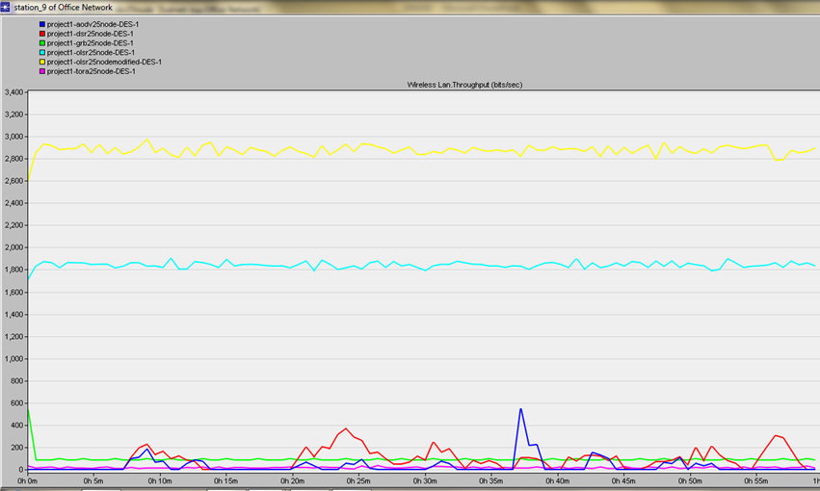
The optimized network engineering tool (OPNET version 17.1 software used for the simulations implemented in this paper . the first step is to create and design the network . figure (1) shows the simulation environment of one scenario containing 25 mobile nodes and one fixed WLAN server running GPR . we used the MANET model library provided by version 17.1 , the wlan _ wkstn _ adv node model which represents a workstation with client-server applications running over TCP/IP and UDP/IP. The workstation supports one underlying WLAN connection at 1 Mbps, 2 Mbps, 5.5Mbps, and 11Mpbs. we configure the entire node in the scenario to work with 5.5 mbps. The network size is of 1500 x 1500 meters. after that IPv4 addressing was assigned to all the nodes .We use the "Rx group configuration" node to speed up the simulation time. This scenario is used to compute the set of possible receivers that a node can communicate with, so all possible receivers that have a channel match with a transmitter channel(s) , and fall within the distance and path loss thresholds are receivers that a node can communicate with . it is configured to eliminate all receivers that are over 1500meters away . The "application configuration." node is used to specify applications using available application types. FTP application type was chosen to all nodes in the network with multiple FTP sessions, and the FTP was selected as traffic high load. We ran four scenarios, for each type of routing protocol, in every scenario there were 25,50,75 and 100 mobile nodes . All the attributes remained the same except for the number of nodes, which was increased. The routing protocol of the network also changed. Each scenario was run for the 30 minutes (simulation time). The MANET network under AODV, DSR, OLSR, GPR and TORA were tested against three parameters i.e. delay, network load and throughput.

6 Results:
*It is obviously from figures (2 -13) that OLSR routing protocol has the best performance than the other routing protocols (AODV, DSR, GRP and TORA),
*OSLR routing protocol has the peak value of throughput, the smallest value of delay and the largest value of load.
* So, we'll compare between the Modified OLSR routing protocol (the proposed) and the OLSR routing protocol.
6.1The First scenario for MANET 25 nodes:
6.1.1Throughput
A. Figure (2) shows WLAN throughput for the first scenario. The peak value of the throughput when the number of nodes is 25 under OLSR is equal to 1900 bit/sec and it remains constant along the simulation period.
B. Under modified OLSR, throughput is equal to 2900 bit/sec and remain constant along the simulation period. Figure (2) shows a good stable throughput for MANET running modified OLSR as the routing protocol of the network.

Fig.2 Wireless LAN Throughput in bit/sec for MANET 25 Nodes

6.1.2 Delay
A. Figure (3) shows the delay of the WLAN for the first scenario. The value of the delay when the number of nodes is 25 under OLSR is equal to 0.00095 seconds and remains constant along the simulation period.
B. Under Modified OLSR, the delay is smallest and equal to 0.00090 seconds and remain constant along the simulation period.
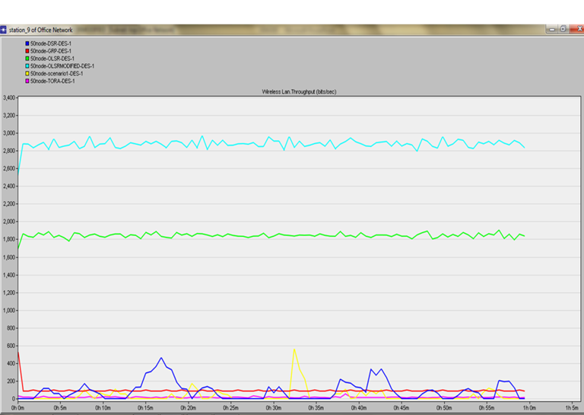
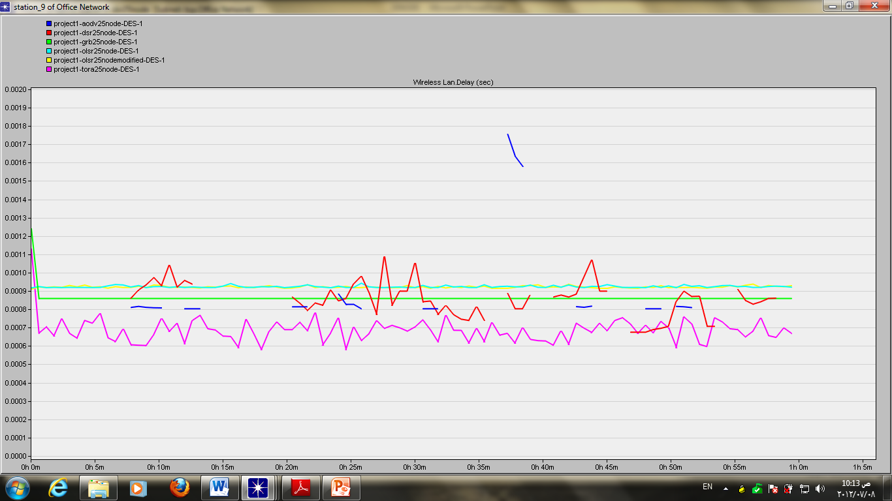

Fig. 3. Time Average in Wireless LAN Delay in sec for MANET 25 Nodes
6.1.3 Load
A. Figure (4) shows the load of the WLAN for the first scenario. The value of the load when the number of nodes is 25 under OLSR start with 240 and reach the peak value equal to 260 bit / sec and remaining constant along the simulation period.
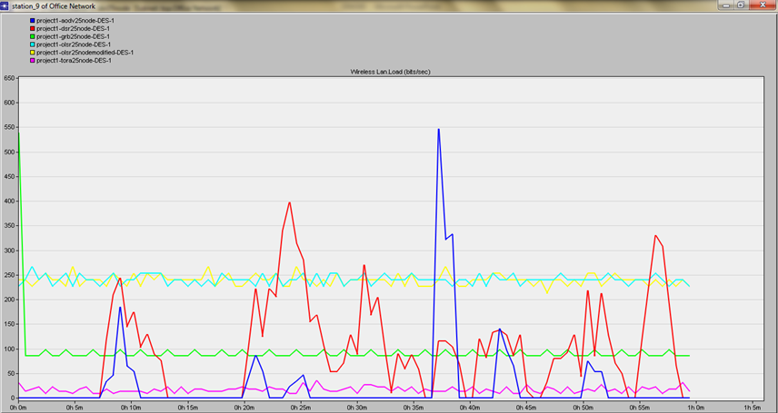
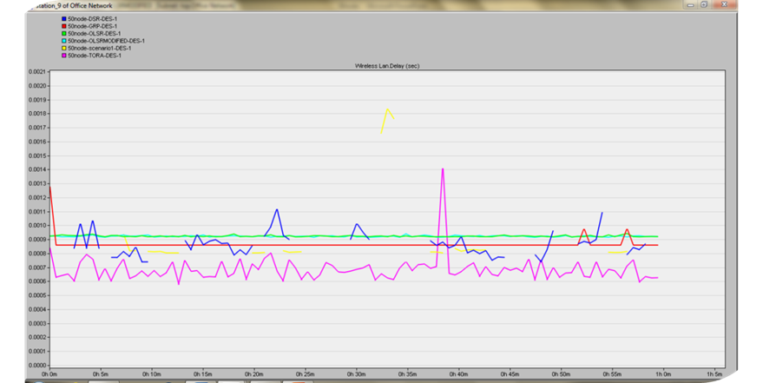
B. under Modified OLSR, the value of the load starts with 250 and reaches a peak value equal to 265 bit/sec.

Fig. 4 Time Average in Wireless LAN Load in bit/sec for MANET 25 Nodes

6.2 The Second scenario for MANET 50 Nodes:
6.2.1 Throughput
A. Figure (5) shows WLAN throughput for the second scenario.it starts with 1700 bit/sec and reach the peak value of the throughput when the number of nodes is 50 under OLSR is equal to 1850 bit/sec and remains constant along the simulation period.
B. Under modified OLSR, the throughput starts with value 2600 bit/sec and then reaches the peak value 2900 bit/sec and remains constants along the simulation period.

Fig. 5.WLAN Throughput in bit/sec for MANET 50 Nodes

6.2.2Delay
A. Figure (6) shows the delay metric of the WLAN for the second scenario. The value of the delay when the number of nodes is 50 under OLSR is equal to 0.00095 seconds and remains constant along the simulation period.
B. The two curves (OLSR and OLSR MODIFIED) are cons ides.

Fig. 6. Time Average in Wireless LAN Delay in sec for MANET 50 Nodes

6.2.3 Load
A. Fig. (7) Shows the load of the WLAN for the second scenario. The value of the load when the Number of nodes is 50 nodes under OLSR with a peak value equal to 250 bit/sec and remaining constant for the simulation period.
B. Under Modified OLSR, the peak value of the load equal to 255 bit/sec and remaining constant for the simulation period.

Fig. 7 Time Average in WLAN Load in bit/sec for MANET 50 Nodes

6.3 The third scenario for MANET 75 Nodes:
6.3.1 Throughput
A. Figure (8) shows WLAN throughput for the third scenario. The peak value of the throughput when the number of nodes is 75 under OLSER and is equal to 6500 bit/sec (starting with the value 6000 bit/sec) and remaining constant along the simulation period
B. Under Modified OLSR, the peak value of the throughput is equal 10.000 bit/sec.
This figure showed a good stable throughput for MANET running Modified OLSR as a routing period protocol for the network.
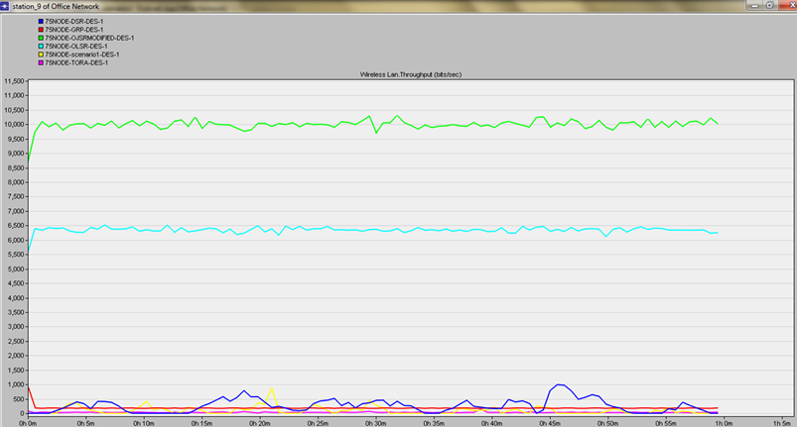
Figure 8 WLAN THROUPUT IN BIT/SEC FOR MANET75 NODES

6.3.2 Delay
A. Figure (9) shows the delay of the WLAN for the third scenario. The value of the delay when the number of nodes is 75 under OLSR is equal to 0.0010 seconds and remains constant along the simulation period
B. under Modified OLSR, the value of the delay is equal to 0.0009 seconds.

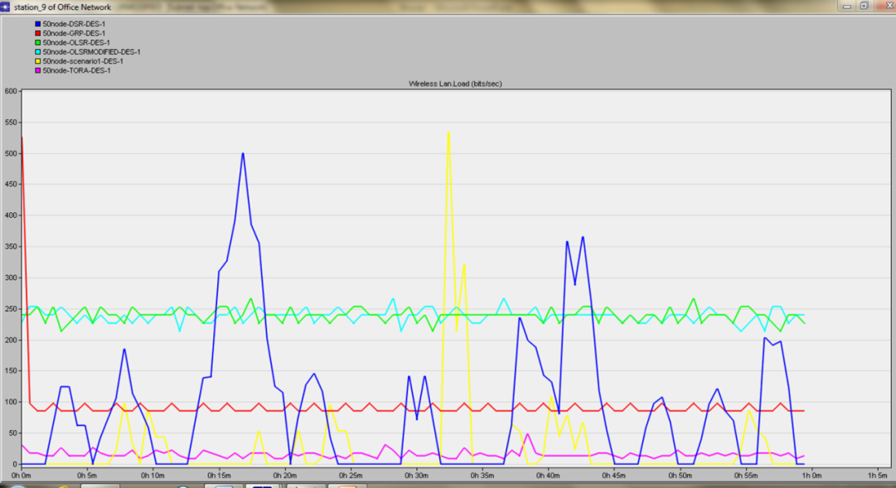
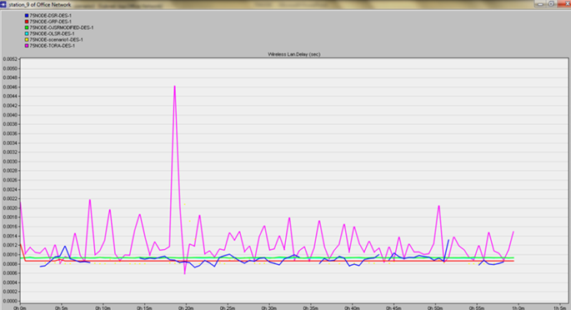
Fig . (9)TIME AVERAGE IN WLAN DELAY IN SEC FOR MANET 75 NODES

6.3.3. Load
A. Figure (10) shows the load of the WLAN for the scenario. The value of the load when the number of nodes is 75 under OLSR is 250 bit/sec and remaining constant along the simulation period.
B. under Modified OLSR, the value of the load is 260 bit/sec.

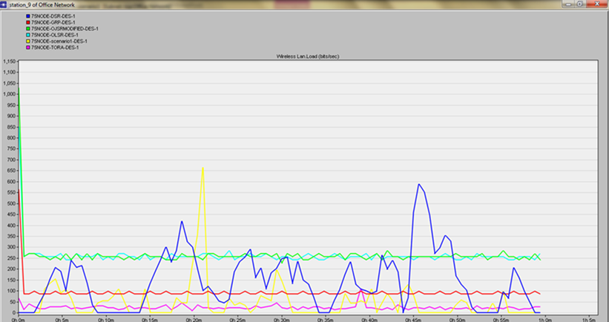
Fig. 10 TIME AVERAGE IN WLAN LOAD IN BIT/SEC FOR MANET 75 NODES

6.4. The Fourth scenario for MANET 100 nodes:
6.4.1. Throughput
A. Figure (11) shows WLAN throughput for the fourth scenario. The peak value of the throughput when the number of nodes is 100 under OLSR is equal 26000 bit /sec (starting with the value bit/sec) and remains constant along the simulation period. Comparing this value of throughput for 75 nodes, we notice a difference between the two values. Throughput value for 100 nodes is higher than the throughput for 75 nodes. This is because of the increase in the number of nodes.
B. under Modified OLSR, the peak value of the throughput is equal 26.000 bit/sec (the same as OLSR, the two curves are consides. This figure showed a good stable throughput for MANET running Modified OLSR as a routing period protocol for the network.
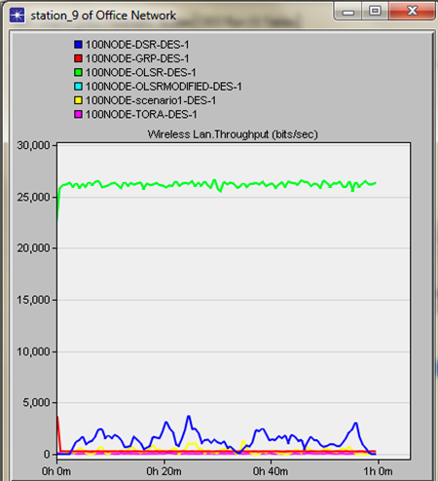
Fig 11 WIRELESS LAN THROUGHPUT IN BIT/SEC FOR MANET 100 NODES

6.4.2. Delay
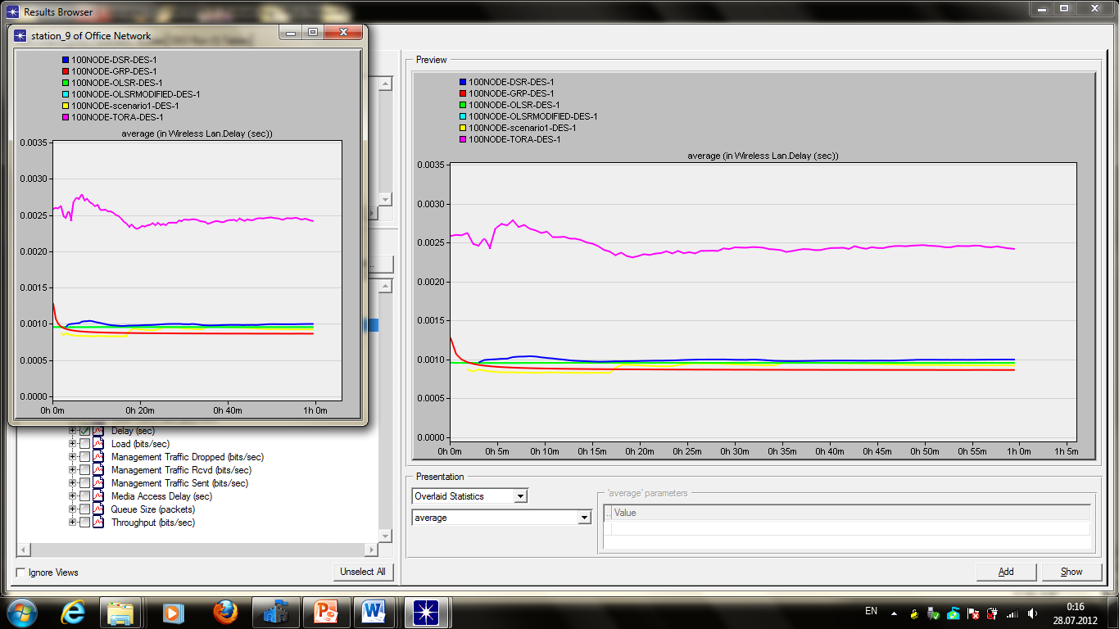
Figure (12) shows delay of the WLAN for the fourth scenario. The value of the delay when the number of nodes is 100 under OLSR is the smallest value and 0.0010 second and remains constant along the simulation period. The two curves (OLSR and OLSR MODIFIED) are cons ides.

FIGURE 12 TIME AVERAGE IN WLAN DELAY IN SEC FOR MANET 100 NODES

6.4.3. Load
Figure (13) shows the load of the WLAN for the fourth scenario. The value of the load when the number of nodes is 100 under OLSR or OLSR MODIFIED are the largest value (9000 bit/sec), the two curves are cons ides, and remaining constant along the simulation period.
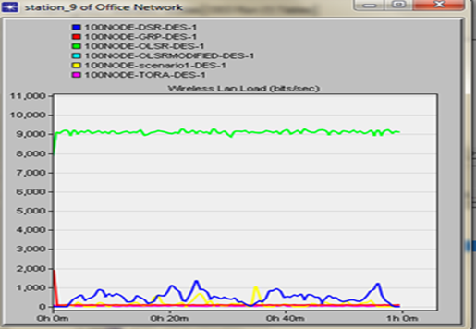
Fig.13 TIME AVERAGE IN WIRELESS LAN LOAD IN BIT/SEC FOR MANET 100 NODES
7. A comparison of MAC layer protocol used in QoS:

Table 3: A comparison of MAC Layer protocol used in QoS provisioning [5]
SUMMARY OF QOS ROUTING PROTOCOLS: [1] .8

To facilitate a comparison among the different QoS - aware routing protocols, the salient features of the QoS routing protocols is described in a table, the table lists the design constraints listed earlier such as Route discovery, Resource reservation, Route maintenance, QoS metrics constrained, Network architecture and routing overhead and discussing how each protocol addresses.

Table 5: QOS ROUTING PROTOCOLS COMPARISON
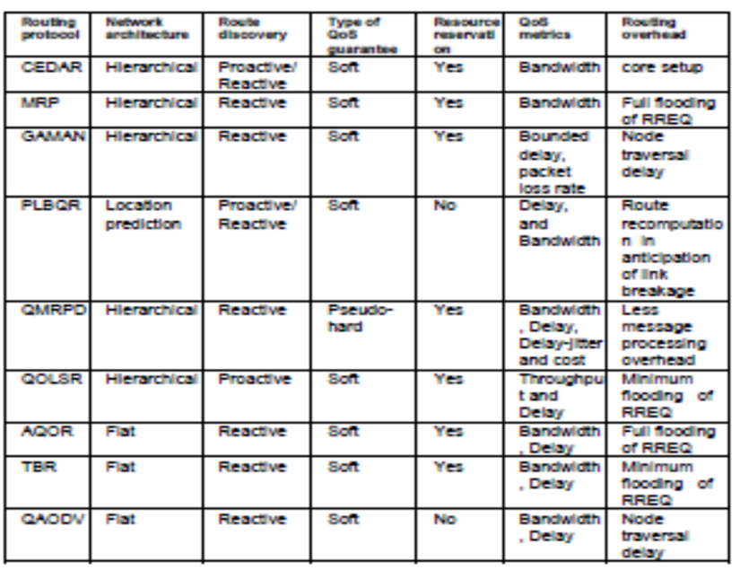
9. Conclusions
The simulation study of our paper for MANET network under five routing protocols AODV, DSR, OLSR, TORA and GPR were deployed using FTP traffic analyzing. We checked the behavior of these protocols with respect to three performance metrics: delay, network load and throughput. Figures (from 2 to 13 shows the behavior of the MANET under all the routing protocols for different numbers of mobile nodes. Obviously some routing protocols performed better than the others. From the above analysis of routing protocols, the modified OLSR outperforms, the fourth, DSR, GPR, OLSR, OLSR MODIFIED, AODV and TORA is the best in Throughput, Delay and Load.

Corresponding author
Adel Fouad El-Kabbany
Higher technology Institute
kabany_2008@yahoo.com

10 References:
1- SANJEEV GANGWAR , DR. SAURABH PAL and DR. KRISHAN, KUMAR JCSET, :" Mobile Ad Hoc Networks: A Comparative Study of QoS Routing Protocols", Vol. 2, Issue 1: January 2012.
2-Philipp Becker: "QoS Routing Protocols for Mobile Ad-hoc Networks – A Survey", A publication by University of Kaiserslautern, 6 August 2007.
3- Razan Al-Ani, Simulation and Performance Analysis Evaluation for Variant MANET Routing Protocol, Volume3, NO.1, Feb.2011, International Journal of Advancements in Computing Technology.
4- Opnet 17.1, Authorized by NTI.
5- Ash Mohammad Abbas and Øivind Kur, Quality of Service in mobile ad hoc net. :
"a survey, Center for Quantifiable Quality of Service in Communication System",
Norwegian University of Science and Technology.

8/10/2012

