Assessment of the Effect of Different Preservatives on the Keeping Quality of Soymilk Stored at Different Temperatures

Odu NN and Egbo NN

Department of Microbiology, University of Port Harcourt, Choba, P.M.B. 5323, Port Harcourt, Rivers State, Nigeria; odungozi@yahoo.com

ABSTRACT: The aim of this study is to evaluate the effect of preservation on the keeping quality of soymilk preserved by different methods under ambient and refrigeration temperatures and to identify an extraction process for the effective reduction of microbial growth in soymilk. The utilization of soybean for the production of soymilk was also studied. The soybean was washed and soaked in water (500g in 1 Liter) for 12 hours. It was rinsed and blanched in 1.25% Na₂CO₃ and NaHCO₃ for 30 minutes. The soybean seeds were ground in blender (kenwood) and expressed in the ratio of 3:1 to remove the okra. The resultant slurry was formulated by adding 0.1% of sodium benzoate and 0.1% potassium sorbate, 2% sucrose and propy gallate and Ascorbic pamitate at this ratios: 100ppm Ascorbic palmitate and 100ppm propyl gallate, 200ppm Ascorbic palmitate, 200ppm propyl gallate and Control (without preservative and antioxidant). The milk was heated at 71ºC for 15 seconds and subsequently bottled and stored at ambient and refrigeration temperature. Microbial qualities of the soymilk samples were evaluated to determine the microbiological quality of the products. Bacterial species isolated from the soymilk samples were Lactobacillus sp, Streptococcus sp, Micrococcus sp, Saccharomyces cerevisae and Aspergillus sp. There was increase in microbial population with storage time in both treated and untreated soymilk samples. There was significant difference (P<0.05) among the individual samples treated with NaHCO₃ and Na₂CO_{3.} The highest number of aerobic count at the end of storage occurred in the control sample (1.15x10⁶) at ambient temperature. There was a significant difference (P<0.05) in the aerobic count between the NaHCO₃ treated soymilk and Na₂CO₃ treated soymilk. Also, similar comparable trends occurred in fungal population in all the samples. Both samples treated with Na₂CO₃ and NaHCO₃, had similar counts. Growth of S. typhi and Staph. aureus was absent in all the samples. At refrigeration temperature, there was no growth in aerobic population from day 0 to day 6 in all the samples. The same trend was observed in fungal count except that growth started on day 12 and the controls that started on day 8. The same individual samples treated with propyl gallate and in combination (A, C, E and G) had the least count while the control had the highest count. There was no coliform, S. typhi and S. aureus growth throughout the refrigeration storage. The results obtained in this study shows that soymilk can keep for up to 16 days at refrigeration temperature, during which no reasonable multiplication of mesophilic aerobes above 3x10⁴ CFU/ml was observed and total inhibition of yeast and molds were achieved up till day 12. In addition, they exhibited lower microbial count at both temperatures than the controls. The study has shown that the use of Na₂CO₃ and NaHCO₃ could therefore be an additional/complementary method of soymilk preservation, since potassium sorbate and sodium benzoate are known to act at lower pH.
[Odu NN and Egbo NN. Assessment of the Effect of Different Preservatives on the Keeping Quality of Soymilk Stored at Different Temperatures. Nat Sci 2012;10(9):1-9]. (ISSN: 1545-0740). http://www.sciencepub.net/nature. 1

Keywords: Soybean, soy milk, Streptococcus sp, Lactobacillus sp, Micrococcus sp, Saccharomyces cerevisae and Aspergillus sp, microbial quality

1. INTRODUCTION
Soymilk is a traditional oriental food beverage that is growing in popularity in the United States and the world (Jimoh and Kolapo, 2007). Soymilk which is a watery extract of whole soybean is rich in water soluble protein, carbohydrate and oil (Adebayo-Tayo et al, 2008). Soymilk is made by soaking soybeans in water before grinding and straining. The milk is a white or creamy emulsion which resembles cow milk (conventional milk) in both appearance and consistency (Iwe, 2003; Kolapo and Oladimeji, 2008). It is commonly characterized as having a beany, grassy or soy flavor, which reportedly can be improved by lactic acid fermentation, as in yoghurt- like products (Jimoh and Kolpo, 2007). The increasing popularity of soymilk as a beverage worldwide is credited to health benefits e.g. low cholesterol and lactose, its ability to reduce bone loss and menopausal symptoms, prevention and reduction of heart diseases and certain cancers (Iwe, 2003; Kolapo and Oladimeji, 2008; Adebayo-Tayo et al, 2008).
Soybean is used in various forms in many parts of the world. Soybeans and products derived from them have served as an important source of protein in the diet of millions of oriental people for nearly 5,000 years (Hackler et al, 1962). The diets of people in many developing countries comprise mainly starchy roots and cereals and few legumes. Unfortunately, animal sources of proteins such as milk, which are used to complement the starchy diets are expensive and out of reach for low income families (Kolapo and Oladimeji, 2008). Milk is an excellent source of all nutrients except iron and ascorbate (Onweluzo and Nwakalor, 2009). Adults who consume milk at all in Nigeria, do so by adding small amounts of evaporated milk or milk powder to breakfast cereals, beverage, porridge, coffee or tea because of its exorbitant cost and exceptional scarcity in Nigeria. The scarcity of milk supply in developing countries perhaps led to the development of alternative milk from vegetable sources (Onweluzo and Nwakalor, 2009).
The aim of this study is to evaluate the effect of preservation on the keeping quality of soymilk preserved by different methods under ambient and refrigeration temperatures and to identify an extraction process for the effective reduction of microbial growth in soymilk.

2. MATERIALS AND METHODS
2.1. SOURCE OF SOYBEAN
Soybean was purchased from mile 1 market and kept at ambient temperature prior to usage. They were analyzed within a day of purchase.

2.2. PRODUCTION OF SOY MILK
Soymilk was prepared using two methods modified from Illinois method.

2.2.1. Method 1:
Soybean was sorted to remove stones and damaged, deformed seeds. The soybean was washed and soaked in water (500g in 1 Liter) for 12 hours. It was rinsed and blanched in 1.25% NaHCO₃ for 30 minutes. The soybean was washed, manually dehulled and rinsed. The soybean seeds were ground in blender (kenwood) and expressed in the ratio of 3:1 to remove the okra. The resultant slurry was formulated by adding 0.1% of sodium benzoate and 0.1% potassium sorbate, 2% sucrose and propy gallate and Ascorbic pamitate at this ratios: 100ppm Ascorbic palmitate and 100ppm propyl gallate, 200ppm Ascorbic palmitate, 200ppm propyl gallate and Control (without preservative and antioxidant). The milk was heated at 71ºC for 15 seconds and subsequently bottled and stored at ambient and refrigeration temperature.

2.2.2. Method 2:
Soybean was sorted to remove stones and damaged, deformed seeds. The soybean was washed and soaked in water (500g in 1 Liter) for 12 hours. It was rinsed and blanched in 1.25% Na₂CO₃ for 30 minutes. The soybean was washed, manually dehulled and rinsed. The soybean seeds were ground in blender (kenwood) and expressed in the ratio of 3:1 to remove the okra. The resultant slurry was formulated by adding 0.1% of sodium benzoate and 0.1% potassium sorbate, 2% sucrose and propy gallate and Ascorbic pamitate at this ratios: 100ppm Ascorbic palmitate and 100ppm propyl gallate, 200ppm Ascorbic palmitate, 200ppm propyl gallate and Control (without preservative and antioxidant). The milk was heated at 71ºC for 15 seconds and subsequently bottled and stored at ambient and refrigeration temperature. Figure 1 shows the processing of soybean to soymilk.

Method 1 | Method 2
Soya bean  Soaking in water  12 hours  Blanching in 1.25% NaHCO₃  (30 mins)  Grind and express  (Ratio 1:3)  Milk  Formulating  (anti-oxidants and preservatives)  Pasteurization  Bottling  Store | Soya bean  Soaking in water  12 hours  Blanching in 1.25% Na₂CO₃  (30 mins)  Grind and express  (Ratio 1:3)  Milk  Formulating  (anti-oxidants and preservatives)  Pasteurization  Bottling  Store
Figure 1: Flowchart illustrating the production sequence of shelf stable milk

2.3. STORAGE
The soy milk samples were stored at ambient temperature (27°C ± 2⁰C) for 10 days and refrigerated temperature (4 ± 2 °C) for 16 days.

2.4. MICROBIOLOGICAL ANALYSIS
Following sterilization, each sample was swirled and 10ml aseptically introduced into 90ml of sterile peptone water and was homogenized; further decimal dilutions to 10⁻⁶ concentration. A 0.1ml quantity of appropriately diluted sample was used to inoculate freshly prepared media by spread plate method. Media employed for the isolation and enumeration of the organism include:- Mannitol salt agar (MSA) for S. aureus, Eosin methylene blue agar for E. coli , Desoxycholate agar (DCA) for Salmonella and Shigella sp, Sabroud dextrose agar (SDA) for moulds and fungi, MaConkey broth for colifrom count, Buffered peptone water for pre-enrichment, Nutrient agar for viable count. Media was sterilized by autoclaving at 121ºC for 15 minutes except DCA which involved only boiling over gauze. In all cases of colony counts, the resulting colonies following inoculation and incubation were counted.

2.4.1. ISOLATION AND ENUMERATION OF E. coli
Mackonkey broth was prepared according to manufactures’ instruction using the 3 tubes MPN method for each protocol. 10ml of each sample was added to sterile 90ml MB, 1ml of each sample into 9ml MB and 0.1ml into 0.9ml of MB and incubated at 37ºC for 24hours after which positive tubes (those with colour change and gas production in durham tubes) where streaked onto EMB plates with sterile wire loop and incubated at 37ºC for 48 hours after which typical colonies with greenish metallic sheen were subjected to biochemical tests for E. coli.

2.4.2. ISOLATION AND ENUMERATION OF S. aureus
Mannitol salt agar was prepared according to manufacturer’s instruction and inoculated as previously described and incubated at 37ºC for 24 hours. Golden yellow colonies were presumptively identified as S. aureus and coagulase test was carried out to further characterize S. aureus.

2.4.3. ISOLATION AND ENUMERATION OF Salmonella and Shigella Species
About 1ml quantity of each of the soymilk sample was inoculated into 9ml of pre-enrichment buffered peptone water and incubated at 37ºC for 6 hours. Desoxycholate agar was prepared according to manufacturer’s instruction and inoculated by transferring 0.1ml from the pre-enrichment broth and incubated at 37ºC for 24 hours. Typical colonies of Salmonella sp were identified as such according to Macfaddin methods (1977). They were subjected to further biochemical tests.

2.4.4. TOTAL VIABLE COUNT
Nutrient agar was prepared according to manufacturer’s instruction and inoculated with a 0.1ml of appropriately diluted soymilk sample by spread plating techniques and incubated at 37ºC for 24 hours. Colonies were counted and multiplied by the dilution factor. They were subjected to further biochemical tests.

2.4.5. ISOLATION AND ENUMERATION OF MOULDS AND FUNGI
Sabround dextrose agar was prepared according to manufacturer’s instruction and inoculated with a 0.1ml of appropriately diluted soymilk sample by spread plating techniques and incubated at 35ºC for 48 hours. They were subjected to further biochemical tests.

2.4.6. IDENTIFICATION OF BACTERIA AND FUNGI
All individual colonies on each medium was counted and sub cultured to nutrient agar plate and incubated for 24 hours at 37ºC and subsequently streaked in agar slant for biochemical tests. This was done to obtain pure bacteria isolates. They were identified their microscopic characteristics. Biochemical tests for the identification of the isolates were: - citrate utilization, indole production, methyl red, vogues-p test, oxidase catalase, coagulase, sugar fermentation, triple sugar test (TSI), motility, and starch utilization. Representative colonies were picked from the NA and PDA plates, subcultured and transferred to NA and PDA slants and incubated at 37⁰C and 30⁰C respectively. Morphological and biochemical tests were done for each isolates and characterized using the schemes of Treagan and Pulliam (1982) and Bergey’s Manual of Determinative Bacteriology (Bergey and Holt, 1994). Fungal isolates were identified by their colonial, morphological and microscopic characteristics (John and Arandhati, 1995).

2.5. DATA ANALYSIS
The result of the experiment collated at the end of the storage was analyzed using statistical means to determine if there were any significant differences among their means. T-test was used to determine the relationship (difference) between the different temperatures of storage for both the market and sample soymilk. This was because t-test measure’s the differences between the means of two variables. Also t-test was used to analyze if significant differences exist between the soymilk treated with acid salt (NaHCO₃) and the soymilk treated with alkaline salt (Na₂CO₃). Two way ANOVA was also used to determine if differences among the individual samples, in terms of microbial load (S.typhi, S. aureus, Lactobacillus sp, fungal and viable counts). The data obtained were subjected to analysis of variance (ANOVA) using Graph Pad Prism Software, version 5.01. Significant difference between means were determined at p<0.05.

3. RESULTS ANALYSIS
3.1. Microbial changes in samples soymilk as affected by different chemicals
There was increase in microbial population with storage time in both treated and untreated soymilk samples. Statistically, it was shown that there was significant difference among the individual samples treated with NaHCO₃ and Na₂CO_{3.}

3.1.1. At ambient temperature
At ambient temperature (Figure 2), for samples treated with NaHCO₃, the highest number of aerobic count at the end of storage occurred in the control sample (1.15x10⁶). These samples showed the maximum population as from the 2nd day of storage. On day 0, there was no growth. Individually, sample B (treated with Ascorbyl Palmitate) had the highest increase in population. The individual sample with the least population was simple A and C (treated with propyl gallate and in combination). Statistically, there was a significant difference (P<0.05) between the NaHCO₃ treated soymilk and Na₂CO₃ treated soymilk with NaHCO₃ being higher.

Figure 2: Total viable count of sample soymilk at ambient temperature
Keys: A=NaHCO₃ Soymilk treated with Propyl Gallate; B= NaHCO₃ Soymilk treated with Ascorbyl Palmitate; C= NaHCO₃ Soymilk treated with both Propyl Gallate and Ascorbyl Palmitate; D= NaHCO₃ Control; E= Na₂CO₃ Soymilk treated with Propyl Gallate; F= Na₂CO₃ Soymilk treated with Ascorbyl Palmitate; G= Na₂CO₃ Soymilk treated with both Propyl Gallate and Ascorbyl Palmitate; H= Na₂CO₃ Control

The pattern of aerobic population in Na₂CO₃ were comparable with the same individual samples (E and G) showing highest and lowest count. The only difference was that the aerobic count for samples treated with Na₂CO₃ was higher than those treated with NaHCO₃. Also similar comparable trends occurred in fungal population in all the samples (Figure 3). Throughout day 0 to day 2, there was no fungal growth. Fungal growth proceeded from day 4 and steadily increased up to day 10. Also, the control sample had the highest population. Samples treated with NaHCO₃ had lower fungal count in comparison with sample treated with Na2CO₃. But in all samples (both Na₂CO₃ and NaHCO₃) the individual sample with the lowest count was A, C, E and G while the control had the highest population.

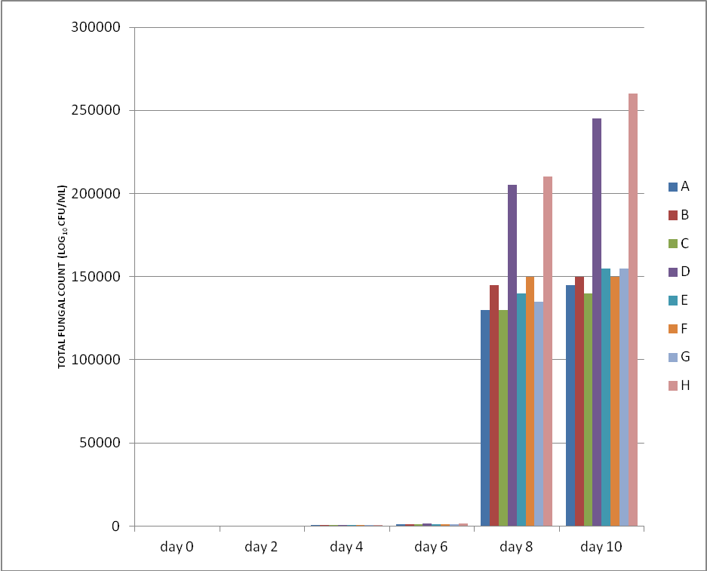
Figure 3: Total fungal count of sample soymilk at ambient temperature
Keys: A=NaHCO₃ Soymilk treated with Propyl Gallate; B= NaHCO₃ Soymilk treated with Ascorbyl Palmitate; C= NaHCO₃ Soymilk treated with both Propyl Gallate and Ascorbyl Palmitate; D= NaHCO₃ Control; E= Na₂CO₃ Soymilk treated with Propyl Gallate; F= Na₂CO₃ Soymilk treated with Ascorbyl Palmitate; G= Na₂CO₃ Soymilk treated with both Propyl Gallate and Ascorbyl Palmitate; H= Na₂CO₃ Control

Similar trend was also observed in coliform count, there was no growth in all the samples (Na₂CO₃ and NaHCO₃) from day 0-day 8 except in the control samples that had growth from day 6. Both samples treated with Na₂CO₃ and NaHCO₃, had similar counts. S. typhi and Staph. aureus growth was absent from day 0 to day 8 in all the samples (Na₂CO₃ and NaHCO₃). All the individual samples had similar counts except the controls that had higher counts (Figure 4 and 5).

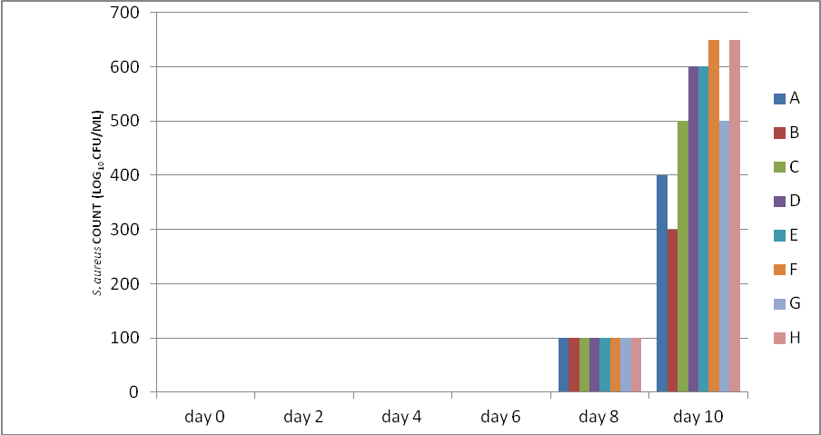

Figure 4: Total S. aureus count of sample soymilk at ambient temperature
Keys: A=NaHCO₃ Soymilk treated with Propyl Gallate; B= NaHCO₃ Soymilk treated with Ascorbyl Palmitate; C= NaHCO₃ Soymilk treated with both Propyl Gallate and Ascorbyl Palmitate; D= NaHCO₃ Control; E= Na₂CO₃ Soymilk treated with Propyl Gallate; F= Na₂CO₃ Soymilk treated with Ascorbyl Palmitate; G= Na₂CO₃ Soymilk treated with both Propyl Gallate and Ascorbyl Palmitate; H= Na₂CO₃ Control

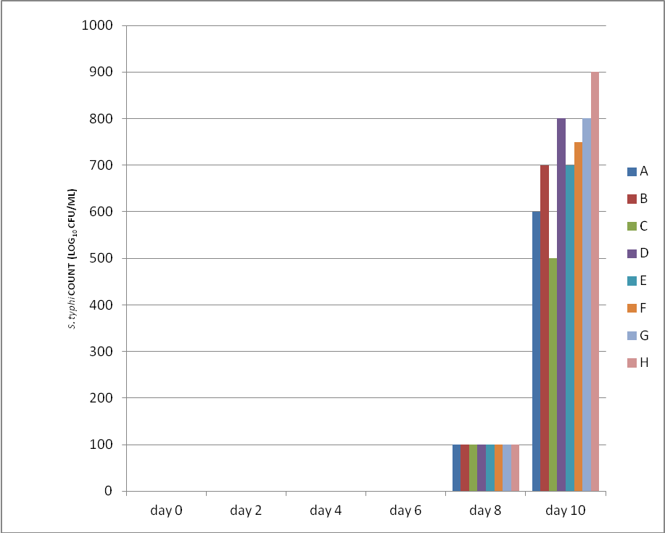
Figure 5: Total S. typhi count of sample soymilk at ambient temperature
Keys: A=NaHCO₃ Soymilk treated with Propyl Gallate; B= NaHCO₃ Soymilk treated with Ascorbyl Palmitate; C= NaHCO₃ Soymilk treated with both Propyl Gallate and Ascorbyl Palmitate; D= NaHCO₃ Control; E= Na₂CO₃ Soymilk treated with Propyl Gallate; F= Na₂CO₃ Soymilk treated with Ascorbyl Palmitate; G= Na₂CO₃ Soymilk treated with both Propyl Gallate and Ascorbyl Palmitate; H= Na₂CO₃ Control

3.1.2. At refrigeration temperature
At refrigeration temperature, there was no growth in aerobic population from day 0 to day 6 in all the samples (Na₂CO₃ and NaHCO₃). The individual sample with the lowest count was samples treated with propyl gallate and in combination (A, C, E and G). The controls had the highest count (Figure 6).

`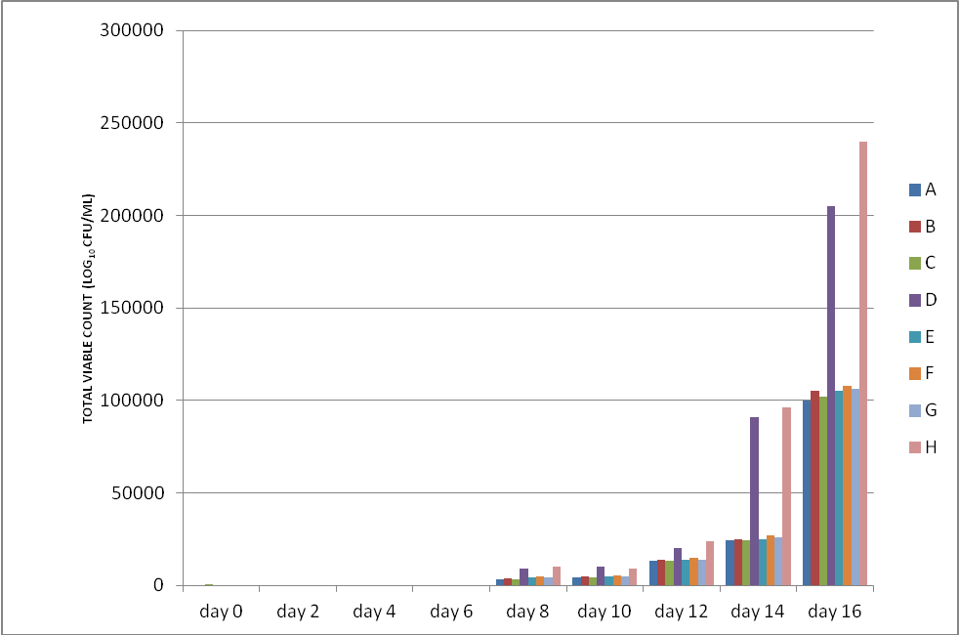
Figure 6: Total viable count of sample soymilk at refrigeration temperature
Keys: A=NaHCO₃ Soymilk treated with Propyl Gallate; B= NaHCO₃ Soymilk treated with Ascorbyl Palmitate; C= NaHCO₃ Soymilk treated with both Propyl Gallate and Ascorbyl Palmitate; D= NaHCO₃ Control; E= Na₂CO₃ Soymilk treated with Propyl Gallate; F= Na₂CO₃ Soymilk treated with Ascorbyl Palmitate; G= Na₂CO₃ Soymilk treated with both Propyl Gallate and Ascorbyl Palmitate; H= Na₂CO₃ Control

The same trend was observed in fungal count except that growth started on day 12 and the controls that started on day 8. The same individual samples treated with propyl gallate and in combination (A, C, E and G) had the least count while the control had the highest count (Figure 7). There was no coliform, S. typhi and S. aureus growth throughout the refrigeration storage.

3.2. CULTURAL CHARACTERISTICS OF ISOLATES FROM PRODUCED SOY MILK
The pattern of growth, colour and size of colonies on media, were observed and recorded at the end of the incubation (Table 1). On EMB, the surface of growth was smooth and some of them had flat elevation, while some had low elevation. The major colors identified were- colonies with dark centers and brown-pink colonies. Each colony was selected. When subjected to microscope at different magnification (x100, x240), the colonies with dark centers were found to be gram positive cocci in chains and without the presence of spores and were identified as Streptococcus sp. The brown pink colonies were gram positive cocci but in clusters and non-sporing and were identified as Micrococcus sp. On SDA, most surfaces were also smooth while some were fluffy (interwoven) growing into the agar, dull and some moist and glistering with flat elevation. The dominant colony colors where white, pale olive and cream. When observed under the microscope, one isolate was having straight branches-like shape with a rod shaped end, others were found to be oval to round cells with multilateral buds and, while some where rods in chain formation and non-sporing. The latter was Saccharomyces cerevisae and the first as Aspergillus spp. On MRS, the surface was feathery like (not smooth). The colony colours that dominated the plate were cream and pale with raised elevation. When observed under the microscope, they were gram positive rods in chain formation and non-sporing. They were identified as Lactobacillus sp. On, MSA, the surface of growth was smooth with convex elevation and the dominant colony colour was red. When observed under the microscope they were found to be gram positive cocci in clusters and non-sporing and were identified as Micrococcus sp (Table 1).

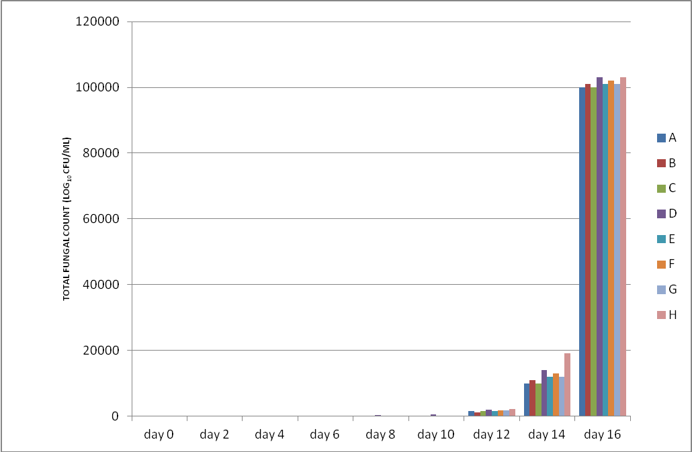Figure 7: Total fungal count of sample soymilk at refrigeration temperature
Keys: A=NaHCO₃ Soymilk treated with Propyl Gallate; B= NaHCO₃ Soymilk treated with Ascorbyl Palmitate; C= NaHCO₃ Soymilk treated with both Propyl Gallate and Ascorbyl Palmitate; D= NaHCO₃ Control; E= Na₂CO₃ Soymilk treated with Propyl Gallate; F= Na₂CO₃ Soymilk treated with Ascorbyl Palmitate; G= Na₂CO₃ Soymilk treated with both Propyl Gallate and Ascorbyl Palmitate; H= Na₂CO₃ Control.

Table 1: Cultural/ Microscopy Characteristics of Isolates of Sample Soymilk
Culture Media | Shape | Colour | Gram Reaction | Arrangement | Spores | organism
NA | Cocci | Purple | + | Clusters | - | Micrococcus spp
 | Cocci | Purple | + | Chain | - | Micrococcus spp
 | rods | Purple | + | Chain | - | Micrococcus spp
SDA | Rods | White | + | Chain | - | Saccharomyces cerevisae
 | Oval | Pale olive | + | Cluster | - | Aspergillus spp
MSA | Cocci | Red | + | Chain | - | Micrococcus spp
EMB | Cocci | Dark centers | + | Chain | - | Streptococcus spp
 | Cocci | Brown-pink | + | Clusters | - | Micrococcus spp.
MRS | Rods | Creamy & Pale | + | Chain | - | Lactobacillus spp
DCA | cocci | Purple | + | Clusters | - | Micrococcus spp

3.3. BIOCHEMICAL CHARCTERISTICS OF ISOLATES FROM PRODUCED SOY MILK
Some of the organisms isolated from soymilk samples were gram-positive cocci in pairs and chains, non- sporing, non- motile, aerobic, catalase-negative and oxidase-negative as can be seen on Table 2. On further subjection to tests, they were found to be Streptococcus sp. Streptococcus sp have a fermentative metabolism, with lactic acid as one of its end products and thereby bringing about the souring and curdling of the milk. Another organisms isolated was Micrococcus sp, with gram positive cocci but in small and large custers, which were non-motile when grown on semi-solid agar, catalase positive and non-sporing. Another isolate that was identified was Lactobacillus sp. They were gram-positive rods in with chain formation, non-motile and non-sporing, requiring small amount of oxygen for growth, catalase negative and oxidase negative (Table 2). Saccharomyces cerevisae and Aspergillus sp were also identified.

Table 2: Biochemical Characteristics of Identified Isolates of Sample Soymilk
Glucose | Lactose | Sucrose | Mannitol | Maltose | Catalase | Oxidase | Coagulase | Citrate | Methyl Red | Starch | Motiliy | Vp | Organism
A | A | A | - | A | - | - | - | - |  | + | - | - | Streptococcus sp
A | A | AG | - | - | - | - | - | - |  | + | - | - | Lactobacillus sp
A | AG | AG | A | AG | + | - | - | - |  | + | - | - | Micrococcus sp
AG | - | AG | A | AG |  |  |  |  |  |  |  |  | Saccharomyces sp
Pale/olive colour in SDA |  |  |  |  |  |  |  |  |  |  |  |  | Aspergillus sp
Keys: AG = Acid & Gas production, A = Acid production, - = non reactive, + = Reactive

4. DISCUSSION
The greatest problem consumers’ encounter with soymilk remains its very short shelf life due to microbial activity. The combination of different preservation methods may just be the solution to the problem. The effect of certain preservatives at various concentrations within their maximum permissible levels along with pasteurization and refrigeration storage on the microbial keeping quality of soymilk was used with the intention of determining which combination is best for a prolonged shelf life. Pasteurization treatment is not sufficient to extend the shelf life by inactivate the bacterial spores in it which grow and cause coagulation by acid precipitation of soy protein (Osuji and Anyaiwe, 2010). Also, Gandhi (2009) has specified the need for use of HACCP protocols (Hygienic conditions) to eliminate microbial flora to the barest minimum, this will in turn reduce the bulk of the shelf life being hinged on preservative and temperature. From these it can be seen that control of microbial growth and spoilage of soymilk is achieved by restricting and controlling microorganisms from contaminating the products through good manufacture and handling practice.
Bacterial species isolated from the soymilk samples were Lactobacillus sp, Streptococcus sp, Micrococcus sp, Saccharomyces cerevisae and Aspergillus sp. As can be seen from the present study, soymilk is highly predisposed to microbial spoilage because it is a good substrate for microbial growth. The occurrence of initial marginal changes (day 0) in the microbial population, especially at refrigeration temperature, can be attributed to the hygienic method of preparation (i.e.) less volume of inoculums present, extension of lag phase due to presence of preservatives. There it can be said that, to be an indication of less adaptive changes and recovery by the microorganisms. Sodium benzoate is known to inhibit the metabolism of microorganisms (Jay, 2000). At ambient temperature, the organisms where able to adapt fast due to the conducive temperature of storage, therefore they were able to proliferate easily but it was also noticed that as storage progressed to day 2, there was significant microbial population but the product was still acceptable. This may be due to the fact that the organisms have not been able to produce metabolites that will spoil the product. But the gradual increase in population as storage progressed shows that soymilk is a good microbial substrate. However, it was observed that samples treated with NaHCO₃ had lower counts in comparison with samples treated with Na₂CO₃. This may be because NaHCO₃ confers acidic properties to the soymilk. But the parameter results obtained where similar for the individual samples.
Throughout the period of storage there was no growth for S. typhi, S. aureus and coliform for both acid and alkaline treated milk until Day 8. It can be conveniently said that this could have been possible due to no initial inoculums prior to storage. The growth seen on day 8 could have been due to contamination by opportunistic organisms (Jay, 2000). As can be seen from refrigeration temperature, there was no growth of the three organisms thru out the period of storage. Even at that, lower levels were obtained with samples treated with acid salt (NaHCO₃). This occurrence may be also be related to their poor growth under acidic conditions (optimal being 6.5-7.5). Had it being there were members of the initial microbial population, they would have flourished at the start-up pH. This is evident in the market soymilk where they were present in the milk and thus being able to proliferate fast. In all, the population of S. aureus was reduced lower than the critical level of 10⁶CFu/ml usually associated with production of Staphylococcal enterotoxin. This further illustrates the venerability of the market soymilk which had higher counts just at day 2 of storage at ambient temperature. Oyeleke (2009) isolated C. albicans from nice yoghurt. The successive decrease in microbial load of yoghurt during refrigeration storage has been reported earlier by Laye et al. (1993). According to this author gradual decrease in Lactobacillus in plain nonfat yoghurt and this reduces fat oxidation and hydration of protein constituents. Aminigo et al. (2009) also reported a decrease in the lactic acid bacteria count in AYB yoghurt stored at refrigeration temperature for 4 weeks respectively.
Individually, there was slight variation among the samples. It was noticed that samples treated with propyl gallate and in combination had lower counts compared to that treated with Ascorbyl palmitate only. This might be attributed to the fact propyl gallate acts as a free radical terminator, which interferes with the metabolism of microorganisms (Cottone, 2009). Ascorbyl palmitate acts as a reducing agent and it has been reported by Vijayvaragiy and Pai, 2003 that it works best in foods when combined with propyl gallate, than other antioxidants. The same effect was noticed at refrigeration temperature. Other factors have also being linked to be responsible for this. Benzoates act against microorganisms by inhibiting the cellular uptake of substrate molecules. It counterpart used in this study, potassium sorbate are similar in mechanism and action. Therefore, it can be deduced from their mechanism of action that the low generation time/extended lag phase of the inherent microorganisms in the milk was due to the preservatives serving as carbon sources rather than the milk constituent, thereby preserving the milk (Cottone, 2009).
Although antioxidants are used primarily in foods to prevent auto oxidation of lipids, they have been shown to posses’ antimicrobial activity, when used in combination with other preservatives (Jay, 2000). At refrigeration temperature, appreciable difference was noticed in the samples. Preservatives in combination with low temperature was able to inhibit and retard microbial growth up until day 6, for viable count for both acid and alkaline treated milk and up till day 12 for fungal growth except the control which already had growth from day 8. From the physical analysis, colour change was observed on day 12 (white to creamy), these may be because the microbial population is still small and therefore haven’t produced enough metabolites to effect deterioration (Akpan et al., 2007).
Results obtained in this study shows that soymilk can keep for up to 16 days at refrigeration temperature, during which no reasonable multiplication of mesophilic aerobes above 3x10⁴ CFU/ml was observed (except in control 9.1x10⁴ and 9.6x10⁴) and total inhibition of yeast and molds were achieved up till day 12. Moulds and yeast are the primary contaminants in yoghurt (Dublin-Green and Ibe, 2005). The acceptable microbial population of cow milk is 3x10⁴ (Jay, 2000), therefore the values obtained at ambient temperature after 4 days of storage and at refrigeration after 14 days of storage indicate the storage limit of the samples. However, at refrigeration temperature, the controls have all spoilt on the 14th day of storage, demonstrating the benefits of use of antioxidants. Thus antioxidants were able to retard microbial growth especially in combination. Evidently, from physical assessment curdling and gas production which are factors in rancidity was subdued in all samples subjected to antioxidant treatment except the controls which was already watery and brownish on day 14 at refrigeration temperature. In addition, they exhibited lower microbial count at both temperatures than the controls. This therefore could be an additional/complementary method of soymilk preservation, since potassium sorbate and sodium benzoate are known to act at lower pH.

5. CONCLUSION
In this study, contamination by yeast and Aspergillus characterized the samples stored at room temperature. More work should be carried out on how to extend the shelf life of the product stored at room temperature using chemical preservatives as most families either do not have refrigerators or do not have constant power supply. The effect of certain preservatives at various concentrations within their maximum permissible levels along with pasteurization and refrigeration storage on the microbial keeping quality of soymilk used showed that soymilk samples blanched in NaHCO₃, pasteurized at 75ºC for 15 seconds and then formulated with 0.1%potassium sorbate and sodium benzoate in addition with either 200ppm propyl gallate or 100ppm propyl gallate and ascorbyl palmitate, gave soymilk of high microbial quality and shelf life stability. Results of the study highlight the laxity in hygiene on the part of the producers of the market soymilk since majority of the isolates are members of the human body flora (Eze et al, 2008). Generally improved combined preserving techniques can in particular improve keeping quality, lessen the risk of microbial food poisoning. The use of clean water, clean processing equipment followed by storage in clean container and environment should be seriously practiced. This will reduce the introduction of contaminants into the milk. As can be seen from the study, no pathogenic organisms were isolated, therefore, even if preservatives were not used, the product will not pose a serious hazard to health. This is to say, that in order to achieve soymilk of high quality and storage-stability, good manufacturing practices should not be compromised regardless of the types of preservatives used.

Correspondence to:
Dr. NN Odu
Department of Microbiology,
University of Port Harcourt, Choba,
PMB 5323 Port Harcourt, Rivers State, Nigeria;
E-mail: odungozi@yahoo.com

REFERENCES
- Adebayo-Tayo, B. C., A. A. Adegoke and O. J. Akinjogunla (2008). Microbial and physico-chemical quality of powdered soymilk samples in Akwa Ibom, South Southern Nigeria. African Journal of Biotechnology Vol. 8 (13), pp. 3066-3071.
- Akpan UG, Mohammed AD, Aminu I. (2007). Effect of preservative on the Shelf Life of Yoghurt Produced from Soya Beans Milk. Leonardo Electron Journal of Practices and Technologies, 11: 131–142.
- Aminigo, E. R., Metzger, L. and Lehtola, P. S. (2009). Biochemical composition and storage of a yoghurt – like product from African yam bean (Sphenostylis stenocarpa). International Journal of Food Science and Technology 44:560 – 566.
- Bergey, D. H., and Holt, J. G. (1994). Bergey’s Manual of Determinative Bacteriology. 9th edn.
- Cottone Elyse (2009.) Use of natural antioxidants in dairy and meat products: a review of sensory and instrumental analyses. M.Sc project, Kansas State University.
- Dublin-Green, M. and S.N. Ibe, 2005. Quality evaluation of yogurts produced commercially in Lagos, Nigeria. Afr. J. Applied Zool. Environ. Biol., 7: 78-82.
- Eze, C.N, E.A Eze, E.C Agbo, (2008). Isolation And Characterization Of The Bacterial Flora Of Soy Milk Sold In Nsukka Market. Plant Product Research Journal Vol. 12 2008: pp. 23-26.
- Gandhi, A. P (2009). Application of HACCP Protocols for the Production of Soy milk. Internet Journal of Food Safety, Vol.11, 2009, p. 67-80.
- Hackler, L. R., D. B Hand, K. H. Steinkraus and J. P. Van Buren, (1962). A Comparison of the Nutritional Value of Protein from Several Soybean Fractions. Journal of nutrition, Vol 80, p 63.
- Iwe, M.O. (2003). The science and technology of soybean. Rejoint communication Services Ltd pp 145.
- Jay, M. J (2000), Modern Food Microbiology, Sixth Edition. Aspen Publishers, Inc. pp 66.
- Jimoh, K.O. and A.L. Kolapo. (2007). Effect of different stabilizers on acceptability and shelf stability of soy-yoghurt. African Journal of Biotechnology, 6: 1000-1003.
- John, O. O. And Arandhati, K. A. (1995). Medical Laboratory Science, Theory and Practical. Tata McGraw Hill Publishing Company Ltd., India pp32-34.
- Kolapo A.L and G.R. Oladimeji (2008). Production and quality evaluation of soy-corn milk. Journal of Applied Biosciences. Vol.1 (2): 40 - 45.
- Laye, I., Karleskino, D. and Morr, C.V. (1993). Chemical, Microbial and sensory properties of plain non-fat yoghurt. Journal of Food Science 58: 991 – 995.
- MacFaddin JF (1977). Biochemical tests for identification of medical bacteria. Williams & Wilkins Company, Baltimore, pp. 69-75.
- Onweluzo, J.C. and Nwakalor, C (2009). Development and evaluation of vegetable milk from Treculia Africana (decne) seeds. Pakistan Journal of Nutrition 8 (3): 233-238, 2009.
- Osuji, C.M. and U. C Anyaiwe, (2010). Stability, yield and chemical properties of soymilk whey from soybean (glycine max) varieties. Nigerian food journal, Vol. 28.
- Oyeleke, S.B. (2009). Microbial assessment of some commercially prepared yoghurt retailed in Minna, Niger State. African Journal of Microbiology Research 3:245-248.
- Treagan, L. and Pulliam, L. (1982). Medical microbiology laboratory procedures.9th ed. W. B. Saunders Philadelphia pp318.

6/15/2012

