FORENSIC TRICHOLOGY AND ITS IMPORTANCE IN CRIME CASES.

V. Vinayak¹*,Chitralekha², S.Kaur³,. A. Kadyan⁴ and A.Rai⁵

¹Senior Scientific Officer(Biology) ² Scientific Assistant(Biology) ³ Senior Scientific Assistant(Biology) ⁴ Assistant Director(Biology) ⁵ Scientific Assistant (D.N.A).Forensic Science Laboratory, Haryana, Madhuban. 132037
¹kapilvinayak@gmail.com

Abstract: Forensic trichology has played an important role in criminal justice delivery system. Hair is encountered as physical evidence in many crime cases. If hair is properly collected at scene of crime it can provide as a strong corroborative evidence to place an individual to crime scene. A microscopic examination of hair distinguishes human hair from or animal hair or a fiber. Scale structure, medullary index, shape, colour, ends of hair help in judging whether hair belongs to an individual have been cut , pulled , thrashed or artificially coloured. If hair is forcibly removed in such a way that it leaves some blood or skin with the root, then DNA typing can be performed. With the exception of mitochondrial DNA, it is not possible to extract DNA from a single hair without blood or skin attached.
[V. Vinayak, Chitralekha, S. Kaur, A. Kadyan and A. Rai. FORENSIC TRICHOLOGY AND ITS IMPORTANCE IN CRIME CASES. Nat Sci 2012;10(9):116-120]. (ISSN: 1545-0740). http://www.sciencepub.net/nature. 16

Keywords:. Trichology, crime scene, Microscopy

Introduction:
The scientific study of hair is called trichology. Forensic scientists perform three types of hair analysis. Microscopic comparison of hair collected from two different places is used to determine if hairs are from same person or animal. The root cells of hair contain DNA that can be used for DNA analysis. Chemical assays are used to assess the use of drugs by the presence of metals in the body and to test for nutritional deficiencies. Hair can be moved from one place to another by mere physical contact, the presence of a specific person’s hair can link a suspect or a victim to a crime scene. If hair is transferred from the region of the body from which it originates it is considered a primary transfer. Approximately 100 head hairs are lost per day. These hairs are usually find on clothing, furniture, flooring, walls etc. Transfer of hairs from these items is called secondary transfer. This type of transfer is very common with animal hairs thus hairs can be used to link suspects to crime scene.
Structure
Hair is an appendage of skin that grows out of a structure known as hair follicle. The length of a hair extends from root embedded in the follicle, continues into shaft and terminates at tip. Hair shaft is made up of three layers: medulla, cortex and cuticle [1] The medulla is the innermost canal that extends through the hair, surrounding the medulla is the cortex which makes up the major part of the hair. The outermost layer is the cuticle which is a single layer of scales. Pigments are found in both cortex and medulla but are absent in cuticle.
Though there are similar morphological features, the scale pattern provides distinguishing characteristics between animal and human hairs. The scales of an animal’s hair show many distinctions such as coronal (crown-like) and spinuous patterns, whereas in the case of humans the scale patterns are of the ‘imbricate’ type (flattened) [2,3]. Besides, the medullary index, which is the ratio of the medulla’s width to the diameter of the hair, is 1/3 and below in humans compared to greater than 1/3 in animal hairs, due to the greater width of the medulla in animals (2,3). Hair root is anchored in a follicle, the cells of the follicle actively divide and the hair grow upwards. In human hair medulla is narrow less than a third of the diameter of the entire shaft but in animals medulla is broader than half the diameter of entire shaft. Using morphological features forensic scientists classify six different types of hair on human body: head hair, eyebrow and eyelash hair, beard and moustaches hair, body hair, pubic hair and axillary hair. Animals also produce different types of hair. They also produce whiskers and longer hairs in such places as the tail and mane. In humans, hair undergoes cyclical phases of growth (anagen), transition (catagen), and resting (telogen). The average anagen phase lasts about 1,000 days and usually lasts for 100 days. At any time, between 10 and 18% of all the hairs on a human head are in the telogen phase; about 2% are in the catagen phase and the rest, between 80 and 90% are actively growing.
Collection of hair
In particular, the hair in question may be collected as evidence from a crime scene and the known hair may be collected from a suspect or from a suspect's possessions.
Microscopic analysis of hair
In forensic laboratories microscopic hair comparison involves the use of two compound microscopes that are optically connected so that the hair in question and the hair from a known origin are in the field of view. The hair is usually magnified between 40x and 400x[4].
Examination of hair
The first step of the examination involves verifying whether the hair in question is that of a human or an animal. If the hair is from an animal, the examiner potentially identifies the species from which it originated. If the hair is from a human, the examiner will determine the part of the body from which it originated. The majority of hairs examined in forensic investigations originate from the head and the pubic areas [5-11]. The features which are used in examination of hair are length, shape, size, colour, stiffness, curliness, pigmentation and the appearance of the medulla. Hairs of infants are usually fine and contain few racial indicators. Hair of the elderly shows signs of pigment loss and often has variable diameter.
Examination of the roots can provide information about the nature of crime, especially if violence is suspected. If hairs fall out naturally during the telogen (resting) phase, the root will have a club shape. If hair is pulled out with force, the root will be stretched or broken and may have tissue attached. Examiners can also determine if hair has been burned, cut, or crushed. Microscopic analysis of hair influenced by the experience of the examiner because it is a subjective, no statistics can be assigned to the probability that a hair belongs to an individual.
The analogy referred to is that an individual can recognize the face of a friend among a group of people even though all of them have the same features: eyes, nose, and mouth. In the same way, an experienced hair examiner can recognize those features of hair that determine whether or not it belongs to a specific individual.
DNA from cells associated with the root can be extracted and used for DNA analysis. Analysis of the DNA in the nucleus of the cell can be used for determining identity and DNA from the y-chromosome focuses on questions of paternity. Mitochondrial DNA is useful for establishing maternity.

Material and Methods
Materials:
Slides, cover slip, distilled water, soft tissue roll, soft painting brushes, forceps, Glycerine, Microscope with camera.
Method (Mounting):
10% Glycerin with a refractive index in the range of 1.50 to 1.60 was used to view hairs in transmitted light. Hair were washed, soaked and dried and then mounted on 10% of glycerin. One hair or multiple hairs from the same source were mounted on a glass microscope slide with an appropriate cover slip. Each mounted hair must be clearly visible. Each slide was labeled as to the source of the hairs.

A Case of Arson in depth study:
A women aged appx. 25 years belonging to district Yamunanagar of Haryana state was married since 3 years and had one child and was 27+ 5 weeks pregnant. She had frequent conflicts with her husband, mother in law, sister in law and brother in law. One night on 19.9.2011 at 11.p.m the conflicts rose to this height that her brother in law set her aflame by putting kerosene oil on her. Later her husband informed her brother that their sister has caught fire while working in the kitchen. Women’s brother and cousin immediately rushed her to local Government hospital at Yamunanagar. Her condition was serious and was later referred to PGI, Chandigarh Burn ward.
Upon police investigation the in laws family was interrogated. Upon investigation a bottle of kerosene oil along with match box, a bed sheet, soil smelling kerosene oil, burnt cloth pieces and a towel hidden with hair, skin and burnt cloth on it were recovered in the house. The in laws family was taken into custody who still refused to admit the crime. Later Judicial Magistrate in the presence of police and medical officer took the statement of the victim who in her statement told that her in laws had put kerosene oil on her and set her on flames on account of bringing insufficient dowry. The victim however died within 5-6 days and gave birth to a dead baby boy who had died due to maternal burns leading to foetal hypoxia. A case against dowry and murder was registered against the in laws family U/S 307/148/149/316/302 IPC.
Post mortem examination revealed dead body of moderately built adult female appx.165cm wrapped in white sheet with white bandage wrapped around trunk and limbs. Rigor mortis present. Post mortem staining can’t be commented due to burnt areas. Eyes closed, cornea was hazy, epidermis to dermo epidermal burns present over body over face back of neck front of chest back of chest abdomen both flanks, both upper limbs (anterior and posterior aspects). Yellowish foul smelling slough present over burnt areas peeling of skin present at places, blisters present at places over the body. Red line of demarcation present between burnt and unburnt areas. Scalp hair, perineal hair, axillary hair burnt and singed. Approximate area of burn is 90% of total body. Cause of death in this case is septicemia, consequent upon infected burn injuries. All burnt injuries were ante mortem in nature.
Police had sent the burnt remains of the victim and the towel recovered from the spot for hair and fibre detection if any and their further comparison and origin at Forensic science laboratory Haryana. The hair and fibres were detected in both the burnt cloth of victim(Fig. 1(A)) and the towel recovered from the spot (Fig.1(B))and were compared morphologically and microscopically. The hair were found to be human in origin and were compared with a sample of animal hair to rule out any possibility of animal hair (Fig.2). The hair on the burnt clothes had Medullary index less than 1/3, medulla was fragmentary, cortex dark brown in pigmentation and the ends were found to be singed a characteristic of hair being burnt (Fig3). The hairs on the burnt cloth were found to be similar to that found stuck on the towel and were human in origin (Fig.4). Fibers of burnt cloth piece were found stuck on the towel and were also found to be of similar type (Fig.5). Further skin was also detected in the burnt cloth pieces. The bottle, the bed sheet and soil showed the presence of Kerosene oil. All these evidences clearly indicate and link the victim with the scene of crime.

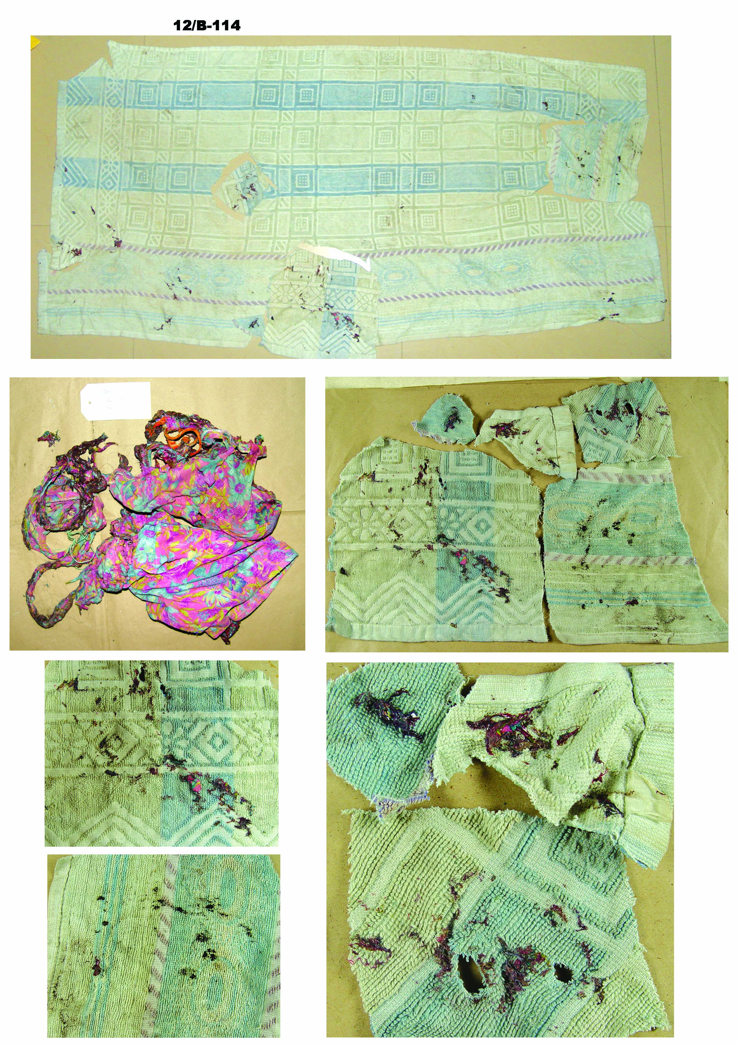  Burnt clothes of the victim (A)  Hair present  Hair and Fibres of burnt clothes on towel  Hair present | 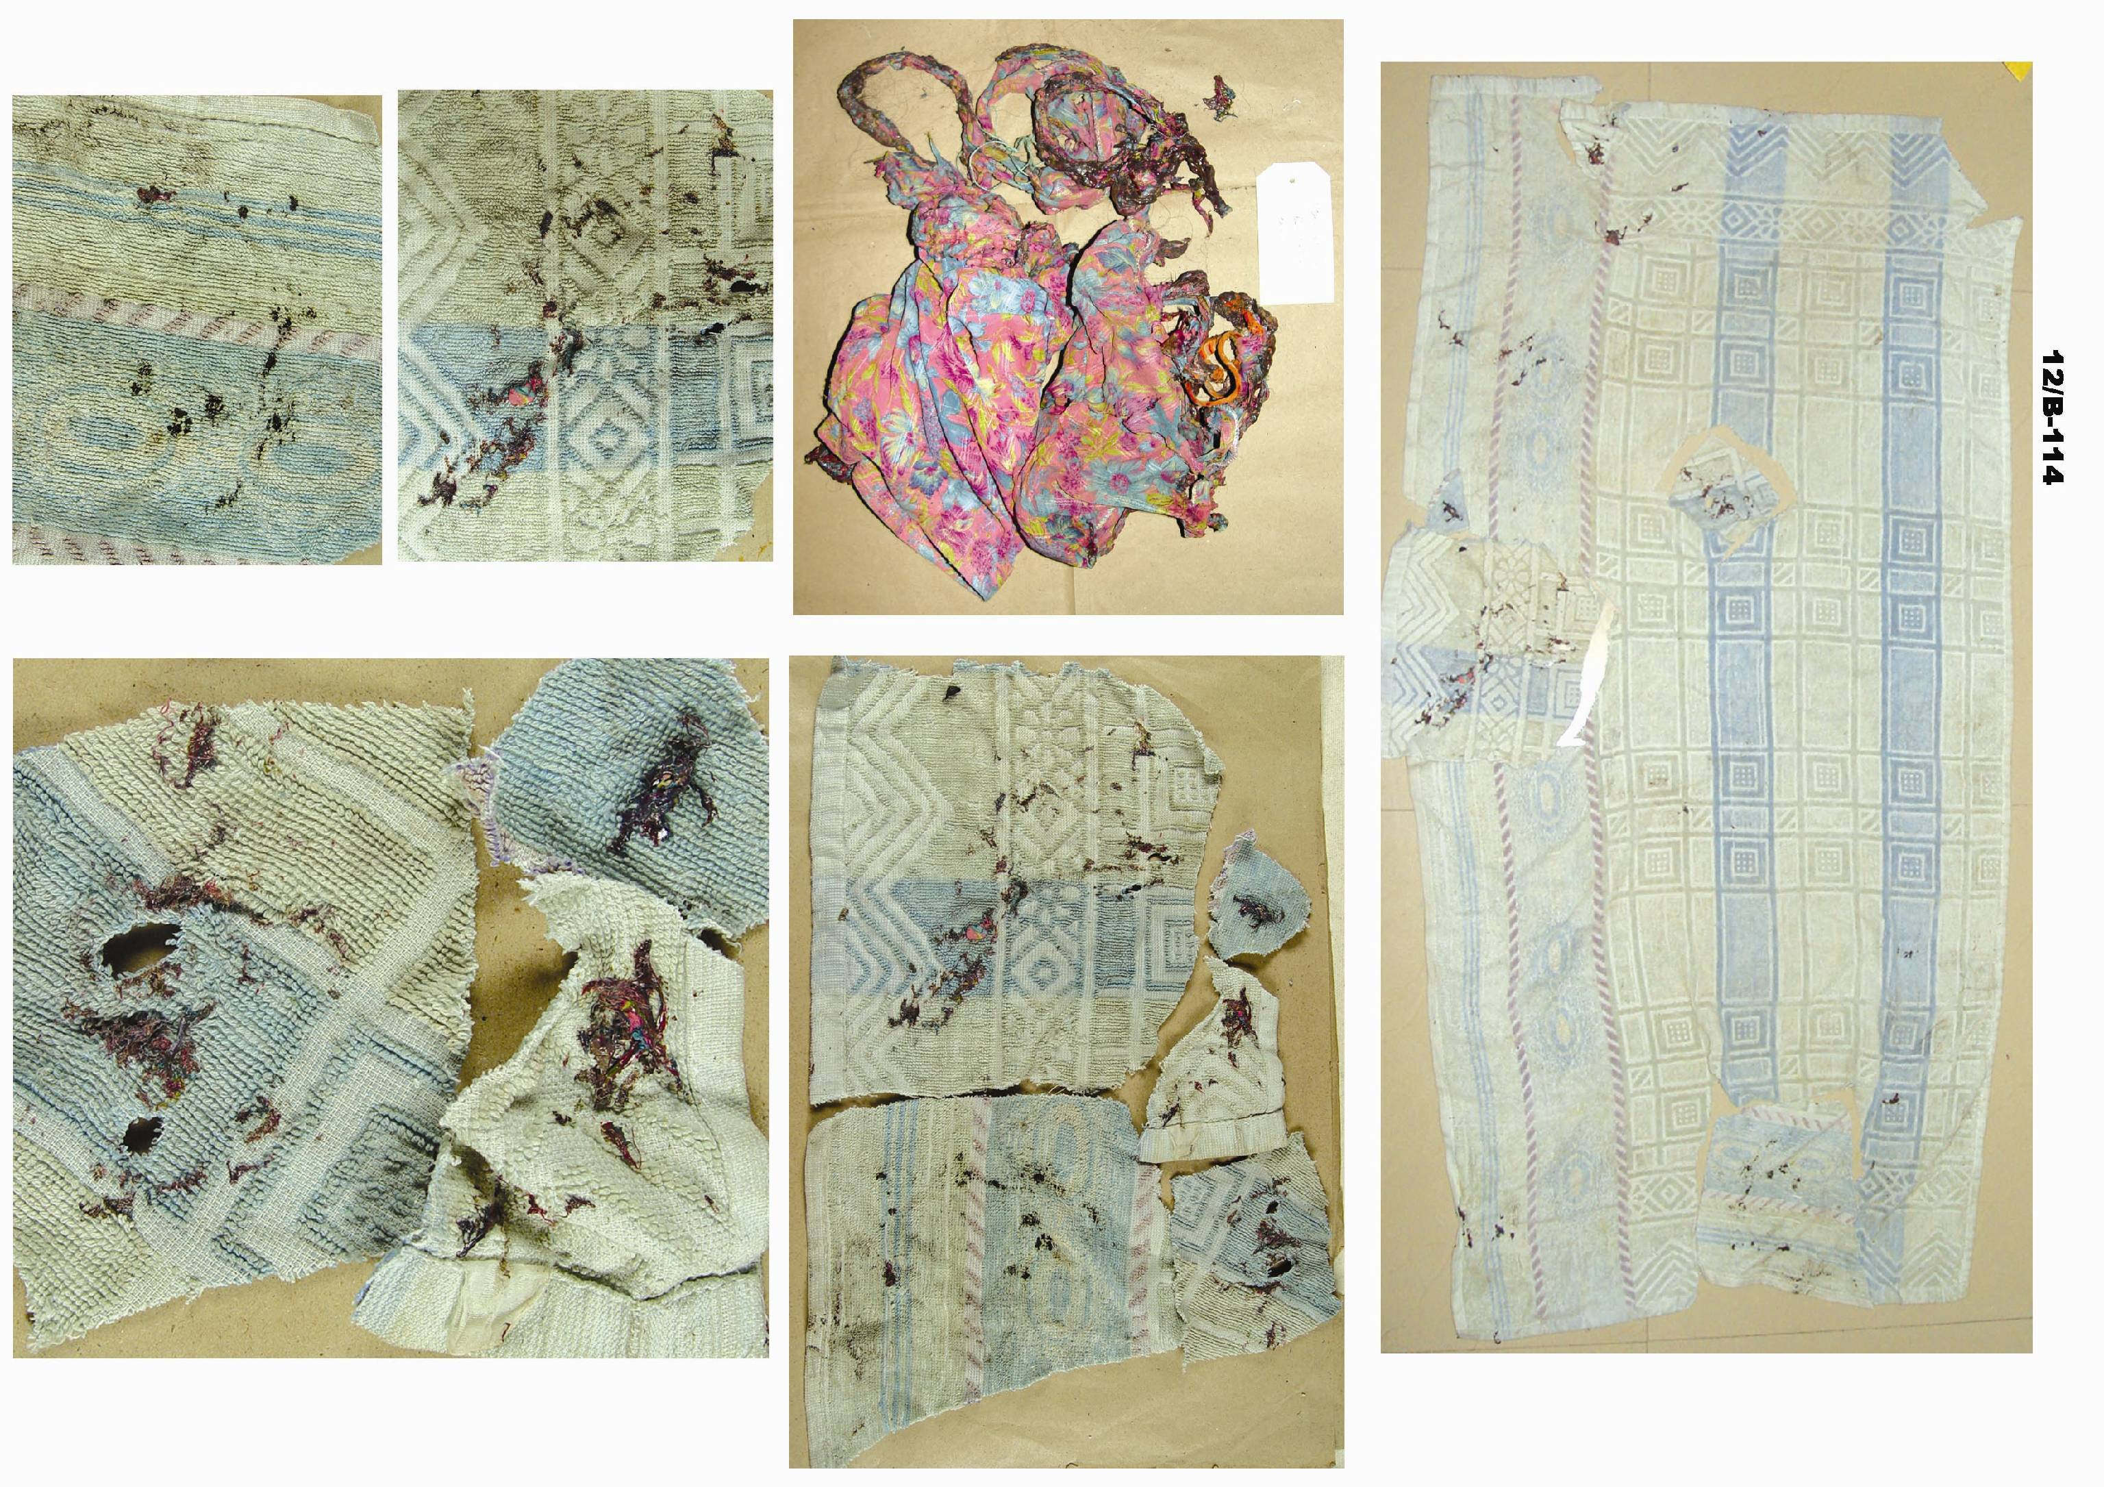  Towel recovered from the spot (B)
Fig. 1 Burnt clothes of the victim (A) and Towel recovered from the spot (B)

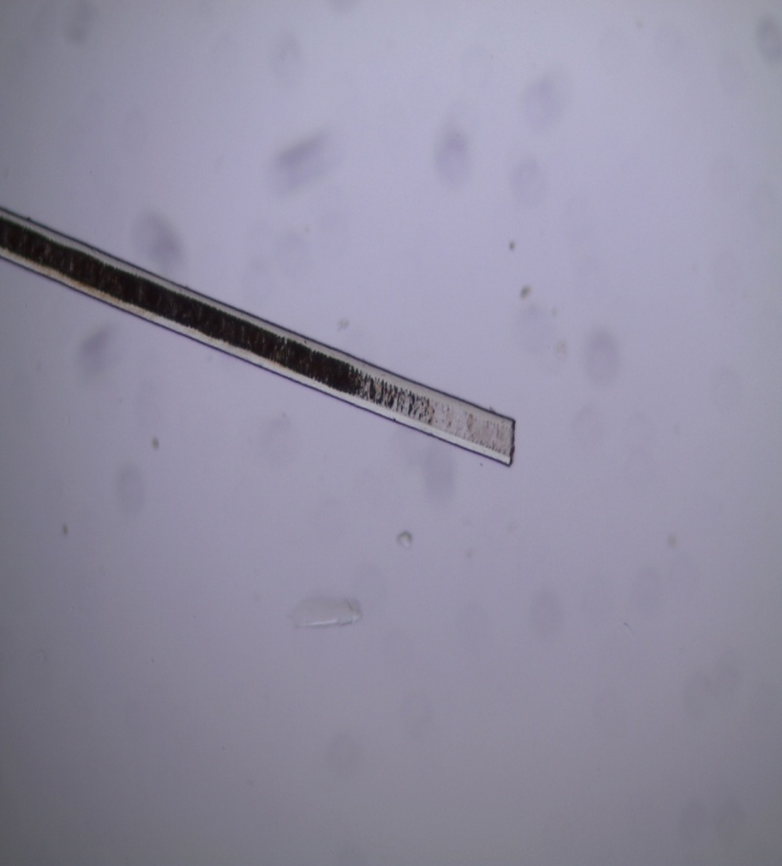  Cat Hair | 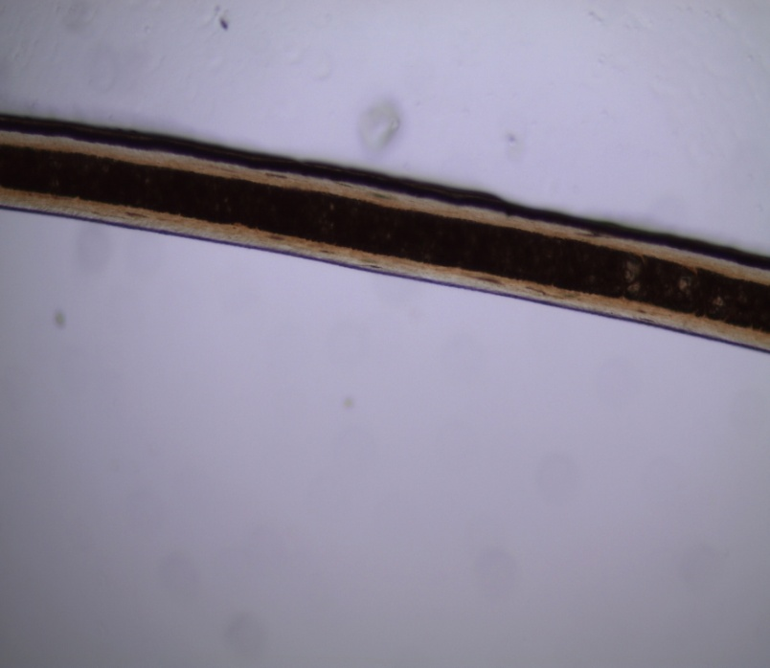  Dog Hair
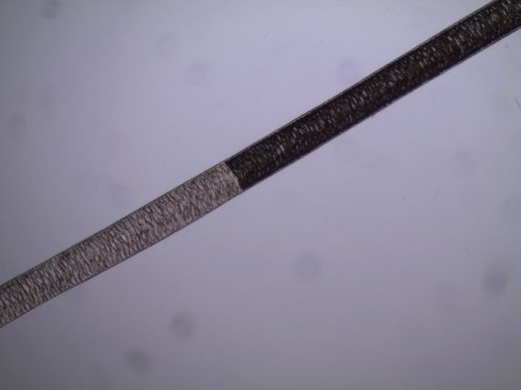  Guinea Pig Hair | 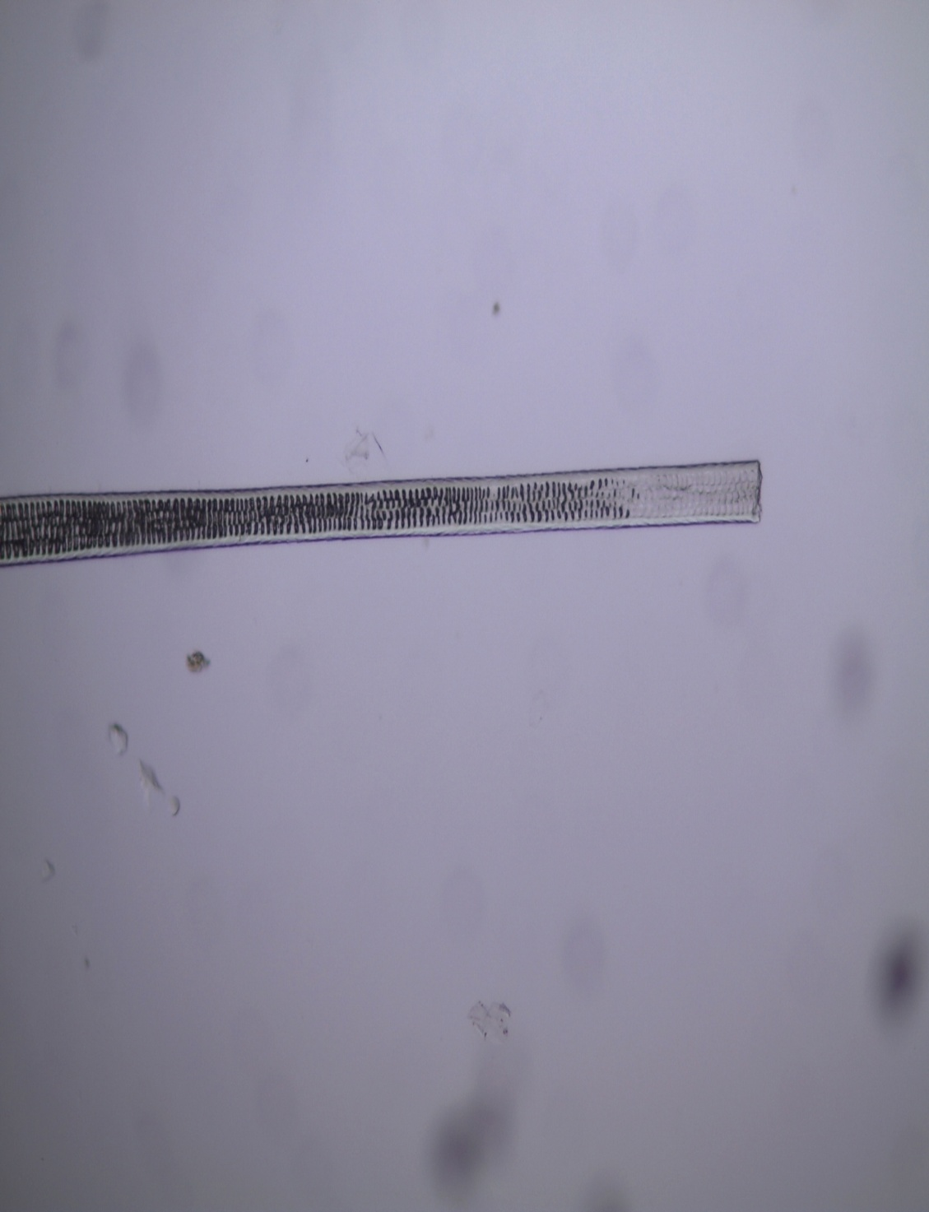  Rabbit Hair
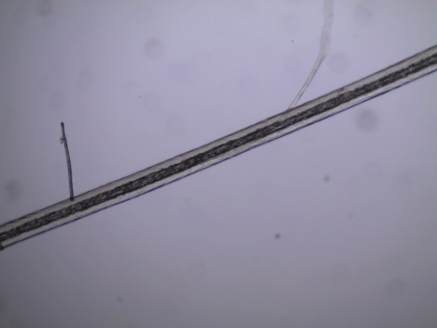  Rat Hair | 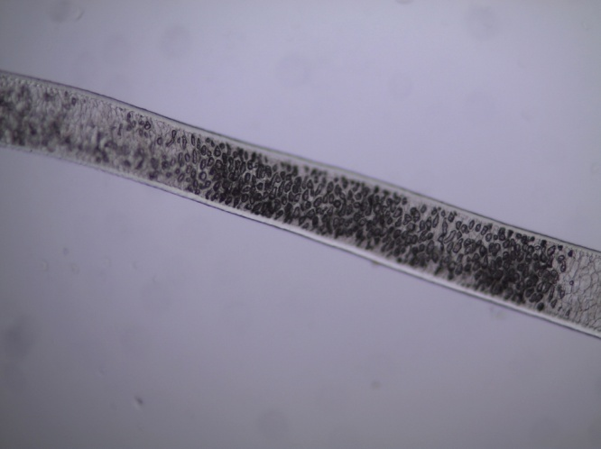  Sheep hair

Fig.2 Plate showing hair from different animal fur collected from animal house of Kurukshetra university.

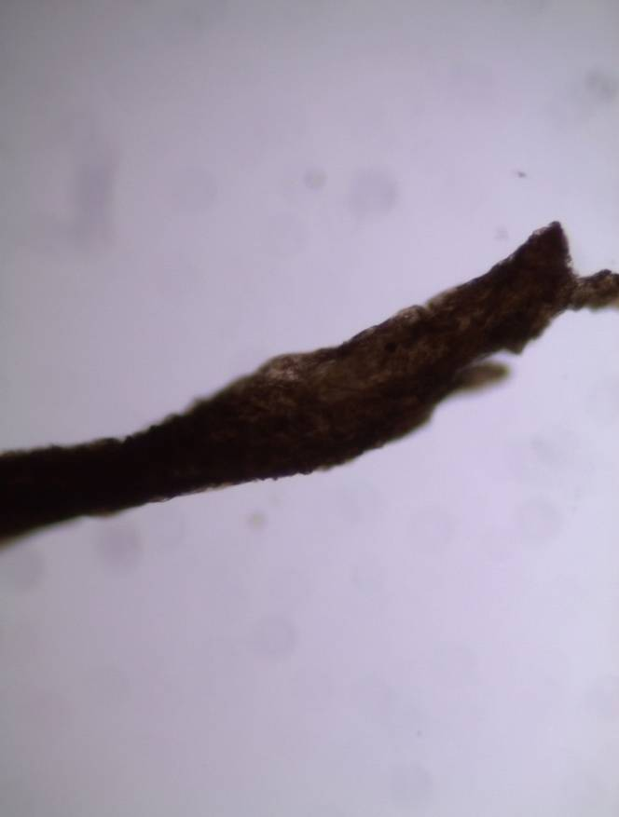  One end | 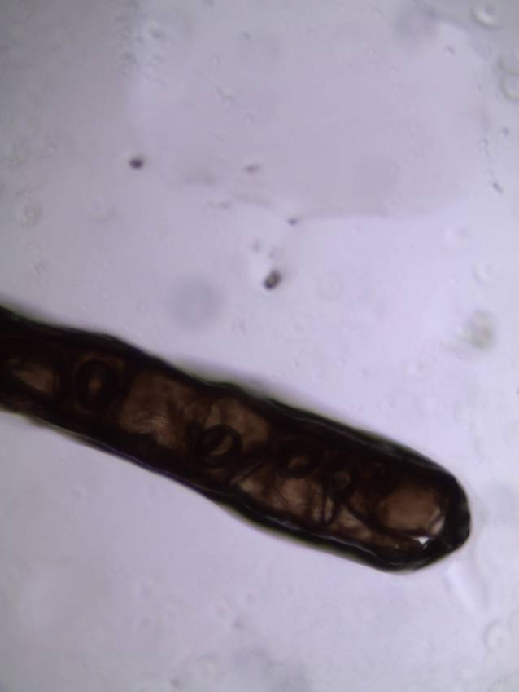  Other end
Fig. 3 Microscopic view of Hair and its Ends detected on burnt clothes of the victim(A)
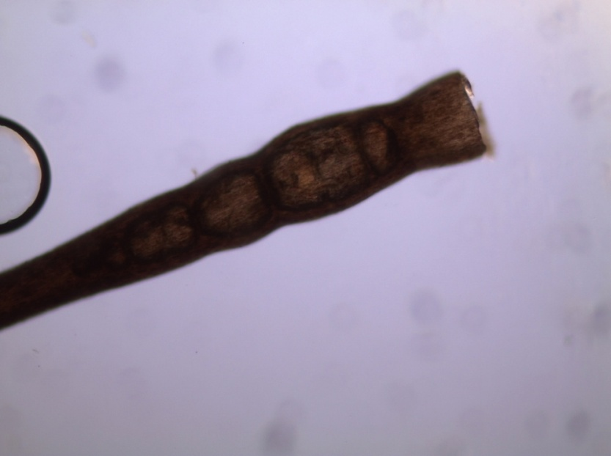  One end |  |  | 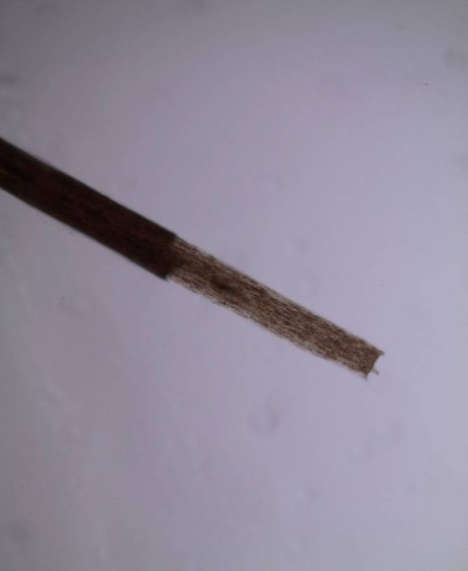  Other end
Fig 4 Microscopic examination of hair and its Ends detected on towel recovered from the spot(B).
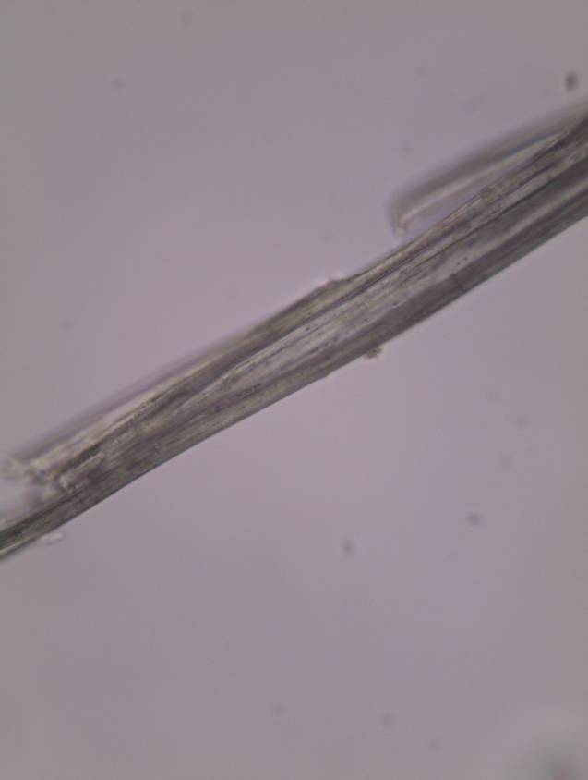  (A) |  | 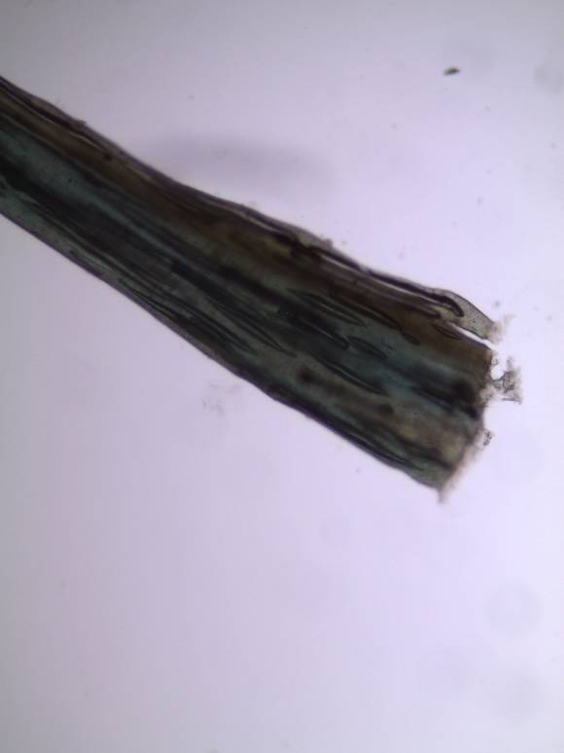  (B)
Fig.5 Fibres of burnt clothe (A) found to be similar to that found on the towel recovered from the spot(B).

Acknowledgement:
Author is thankful to Ms Chitralekha and Ms Sumandeep Kaur Virk for assisting in conducting the case, Dr Anita Kadyan for her sincere suggestions and Mr. Anshuman Rai for critically editing the manuscript and Ms Mamta (M.Sc Final Student of K.U) for collecting animal hair from Animal house Kurukshetra University.

Corresponding Author:
Dr. Vandana Vinayak, Senior Scientific Officer (Biology), Forensic Science Laboratory, Haryana,Madhuban, Karnal 132037. Email: kapilvinayak@gmail.com

Bibliography
- Miller, L. S., Bass, W. M., & Miller, R. L. (1985). Human evidence in criminal justice (2d ed.). Cincinnati: Anderson Publishing.
- Deedrick DW, Koch SL. Microscopy of hair Part I: A practical guide and manual for human hairs. Forensic Science Communications. July 2004 Volume 6 – Number 1. [cited 05/06/2009]/.
- Deedrick DW and Koch, S. L. Microscopy of hair Part II: A practical guide and manual for animal hairs. Forensic Science Communications. July 2004 Volume 6 – Number 1 [cited 05/06/2009 ]
- Robertson J. Forensic and microscopic examination of human hair. In: Forensic Examination of Hair. Taylor and Francis, London, 1999; p.79–154.
- Bisbing RE. Human hair in a forensic perspective. In: Proceedings of the International Symposium on Forensic Hair Comparisons; 1985 June 25–27; Quantico, VA: FBI Academy, 1985.
- Gaensslen RE. Unit IX: translations of selected contributions. In: Sourcebook in forensic serology, immunology, and biochemistry. Washington, DC: National Institute of Justice, 1983.
- Adorjon AS, Kolenosky GB. A manual for the identification of hairs of selected Ontario mammals. Ontario Department of Lands and Forests.Research, 1969, Report 90.
- Brown FM. The study of mammalian hair for anthropologists. Proc Am Philos Soc 1942;85:250– 74.
- Brunner H, Coman BJ. The identification of mammalian hair. Melbourne: Inkata Press, 1974.
- Hicks JW. Microscopy of hairs. Washington, DC: Federal Bureau of Investigation, 1977.
- McCrone WC. Characterization of human hair by light microscopy. Microscope 1977;25:15–30.
- Robertson J, editor. Forensic and microscopic examination of human hairs. In: Forensic examination of hair. Philadelphia: Taylor and Francis, 1999.

7/25/2012

