Tobacco rattle Tobravirus: Occurrence in Flax Plants (Linum usitatissimum L.) in Egypt

Salwa N. Zein¹, A. H. Hamed¹and Hanaa S. Zawam²

¹Virus and Phytoplasma Res. Dept., Plant Patho .Res. Inst., ARC., Giza, Egypt
²Nematode Res. Dept., Plant Patho. Res. Inst., ARC., Giza, Egypt
salwaelhiti2006@yahoo.com, ali_hamed65@yahoo.com and hn_zawam@yahoo.com

Abstract: This is the first report of Tobacco rattle virus (TRV) isolated from naturally infected flax (Linum usitatissimum ) crop growing in the Agriculture Research Experimental Station (ARES) in Egypt. Naturally infected flax plants showed symptoms of TRV i.e. yellowing, systemic mosaic and leaf deformation. Symptoms were collected and subjected to isolation and identification by indirect ELISA. Presence of the virus isolate in different cultivars, all florets, flower parts was confirmed by using DAS- ELISA. ELISA was also used to confirm the modes of transmission (mechanical inoculation, seed and nematodes transmission). The obtained results indicated that DBIA test was useful to confirm the identification of the virus isolated from flax crop. The percentages of seeds transmission ranged between 2.8 - 19.7 %. Paratrichodorus nematodes was successfully transmitted TRV by16.6%.
[Salwa N. Zein, A. H. Hamed and Hanaa S. Zawam. Tobacco rattle Tobravirus: Occurrence in Flax Plants (Linum usitatissimum L.) in Egypt. Nat Sci 2012;10(10):14-20]. (ISSN: 1545-0740). http://www.sciencepub.net. 2

Keywords: flax, Tobacco rattle virus (TRV), Paratrichodorus, production, Mechanical, seed and Nematodes transmission, Serological detection and DBIA.

1. Introduction
Flax (Linum usitatissimum L.) known as common flax or linseed, is a member of the genus Linum in the family Linaceae. It is an erect annual herb plant. Flax is native to the region extending from the eastern Mediterranean to India and was probably first domesticated in the Fertile Crescent. In Egypt, Flax is an old economic crop owing to export beside local industry grown as a dual purpose crop for seeds and fibers which is used for the manufacture of linen. The oil is edible and also is used for the preparation of paints, varnishes, printing ink and soap.
Tobacco rattle virus has been found throughout Europe, New Zealand, in North America and in Japan (Visser et al., 1999). TRV Infected potato, tomato, tobacco, spinach, artichoke, celery, pepper and lettuce (Sudarshana & Berger, 1998; Visser et al., 1999). Also, TRV infected gladiolus (Sabek, 1973), henbane [Hyoscyamus muticus L.], (Shafie, 1978), Kaki (Zein, 2004), sugar beet (Dikova, 2005), Paeonia (Samuitienė et al., 2009) and onion (Hamed et al., 2012).
TRV occurred in percentages of 1-6% in some weeds such as Capsella bursa-pastoris and Myosotis arvensis. The percentage of seed transmission was up to 40% in Nicotiana tabacum and Viola arvensis and 1% in Capsella bursa pastoris (Murant and Lister, 1967).
Tobacco rattle virus could be transmitted by a nematode vector Paratrichodorus allius, P. anemones, P. christiei, P. nanus P. pachydermus, P. teres, Trichodorus minor and T. primitives Trichotoridae. (Ploeg et al., 1992; Hernandez et al., 1995; Mojtahedi et al., 2007 and Boydston et al., 2008).
The aim of our study to confirm that TRV infected flax in Egypt, evaluate DBIA dot blot immunobinding assay test in identification and estimate the ratio of transmission by Paratrichodorus

2. Materials and Methods
2.1. Virus source and symptoms:
Samples of flax plants collected from Agriculture Research Experimental Station (ARES) showed systemic mosaic, yellowing, and curling symptoms of TRV.
2.2. Virus isolation and propagation:
The virus isolate was biologically purified through a single local lesion technique on Chenopodium amaranticolor Coste & Reyn plants (Kuhn, 1964). The virus was then transmitted mechanically to Nicotiana rustica L. which was used as a source for virus propagation.
2.3. Source of antiserum used for TRV detection:
Antiserum was previously performed for Tobacco rattle virus (Zein, 2004). Inoculated and healthy plants were serologically tested by ELISA and dot blot immunobinding assay method using the induced antiserum against TRV. This technique was applied for TRV detection in infected and healthy flax leaves for different cultivars (Giza 4, Giza 7, Giza 8, Giza 9, Sakha 2, Sakha 3 and Sakha 10) according to the methods described by Hsu and Lawson (1991).

2.4. Transmission studies:
2.4.1. Mechanical transmission:
Mechanical transmission tests was made by homogenized samples of TRV- infected plants separately in distilled water or 0.01m sodium phosphate buffer, pH 7.0, containing, 0.1 % sodium sulfite. The sap was used to inoculate N. rustica predusted with carborundum. Plants were kept under greenhouse conditions, observed for symptom expression, and assayed by enzyme linked immunosorbent assay (ELISA) and DBIA techniques.

2.4.2. Seed transmission
a. Percentage of transmission
Flax seed sample (twenty one) of the cultivars tested seeds (Giza 4, Giza 7, Giza 8, Giza 9, Sakha 2, Sakha 3 and Sakha 10) collected from commercial available seed lots were used in this study to detect TRV infection twenty groups of seeds per cultivar tested were randomly picked for virus detection The presence of TRV in plants growing from infected seeds were confirmed by DAS- ELISA. Healthy seeds of flax were used as a control. Healthy and infected seeds were washed in running tap water and placed for 48 hr. in Petri dishes with wet cotton before homogenized and assayed by DAS- ELISA Fig. (1). Seed infection rates were estimates calculated by formula P= {1- (^{H}/_{N}) ¹/_{n}} ×100 (Maury et al., 1985 and Fegla et al., 2009).
P= percentage of seed infection,
H= number of virus –free group,
N= total number of groups tested,
n=number of seeds per group
b. Presence of the virus isolate in leaves and all florets and flower parts:
The leaves and flowers of cultivars Giza 4, Giza 7, Giza 8, Giza 9 and Sakha 3 and also, the flowers parts (Stamens, sepals and petals) were removed separately from fifty florets of each infected and healthy flax plant cultivar, Giza 9 according to Sleper and Poehlman( 2006). Samples were ground by pestle in 100 μl from saline phosphate buffer (PBS). The level of resistance in flax cultivars were determined by enzyme-linked immunosorbent assay (ELISA), which showed that the titer of the TRV. Leaves, flowers and florets parts were prepared for DAS- ELISA, according to the method described by Clark and Adams (1977).

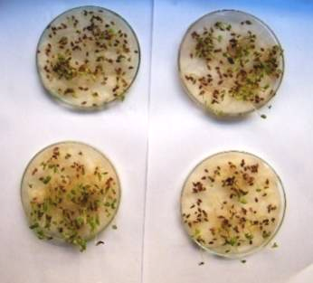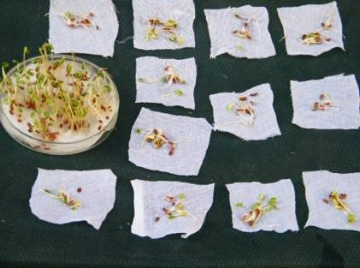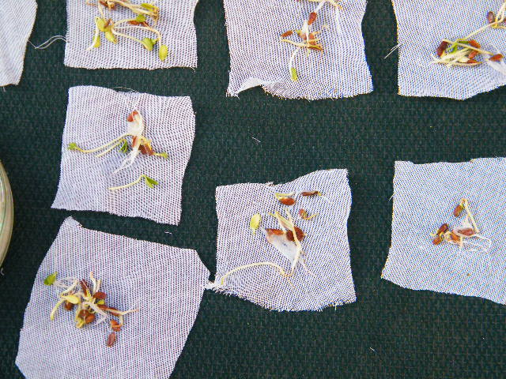
Figure 1. Seed flax cultivars is growing in petri dishes with wet cotton (A), groups tested of flax seed (B).

2.4.3. Nematodes transmission:
a. Nematode associated flax plant
The nematodes were extracted from soil samples collected from rhizosphere of flax field growing in the Agriculture Research Experimental Station (ARES) at the end of the season. The soil was naturally infested with Ditylenchus, Aphelenchus, Helichotylenchus, Pratylenchus, Paratrichodorus and Tylenchorhynchus. Experiments were conducted using nematodes from soil extracted by wet-sieving method and decanting method (Seinhorst, 1988).

b. Nematode transmission
Population of Paratrichodorus was selected for this study. This population was collected from rhizosphere associated with TRV-infected and free plants.
Flax seeds of the cultivars Sakha 10 were sown in sterilized soil 25 cm-diam pots. Twenty pots were used. Fifteen days later the emerged seedlings were mechanically inoculated with TRV. Nematodes (Paratrichodorus) were added to the soil of each pot by means of about 1250 adults/1 ml as illustrated in Fig. 2 (A, B and C). The nematodes then removed, three week later, from the pots of infected plants by hand-picking to 32 pots contains healthy flax seedlings which were observed for symptoms appearance. ELISA tests were always used in each stage to insure the presence of TRV either in flax plants or in nematodes.

3. Results and Discussion
3.1. Isolation:
TRV was isolated from infected flax plants as described (Brunt et al., 1996). After biological purification through single lesion transfers on C. amaranticolor, the resulting viruses were propagated on N. rustica for TRV. Infection was confirmed by back inoculation and /or by ELISA.

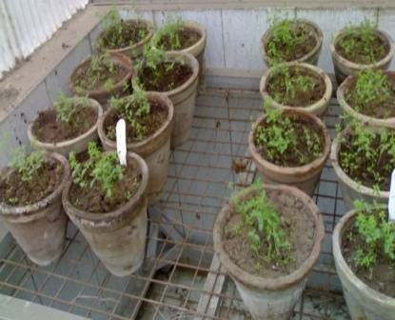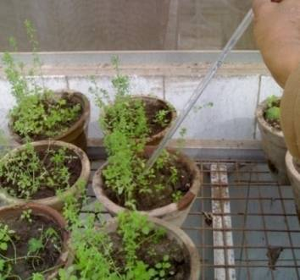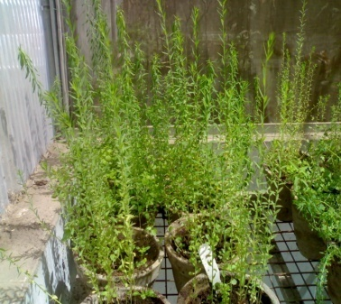
B
C
A
Figure 2. Nematodes Paratrichodorus were added to the soil of each pot by means of about 1250 adults/1 ml (A, B and C).

3.2. Identification by serological testes:
TRV was identified in different flax cultivars (Giza 4, Giza 7, Giza 8, Giza 9, Sakha 2, Sakha 3 and Sakha 10) according to serological reactions using direct, indirect ELISA and DBIA techniques. TRV was identified in flax (Giza 4, Sakha 2) cultivars by DBIA test using polyclonal antiserum and positive reaction were obtained as shown in Fig. (3). Dijkstra and De-Jager (1998) mentioned that the advantages of DBIA for detection of small amounts of antigen over standard ELISA. The technique involves stamping freshly cut surfaces of plant parts on a nitrocellulose or nylon membrane, which is then processed in the same way as in DBIA. Hamed et al. (2012) used by both TBIA and DBIA and their results were compared with ELISA readings of the diseased onion leaves.
3.3. Modes of transmission
3.3.1. Mechanical transmission
TRV was transmitted mechanically to flax as described by Brunt et al. (1996). Healthy flax plants mechanically inoculated with fresh sap from infected plants showed mosaic symptoms 3 weeks after inoculation. Symptoms in inoculated plants included mosaic and yellowing followed by systemic mosaic and leaf deformation. These symptoms were similar to those described and observed in field plants (Fig. 4). No symptoms were observed in non-inoculated plants.

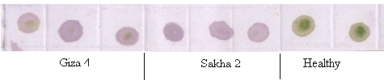
Figure 3. TRV was identified by DBIA test using polyclonal antibodies for (Giza 4, Sakha 2) flax cultivars
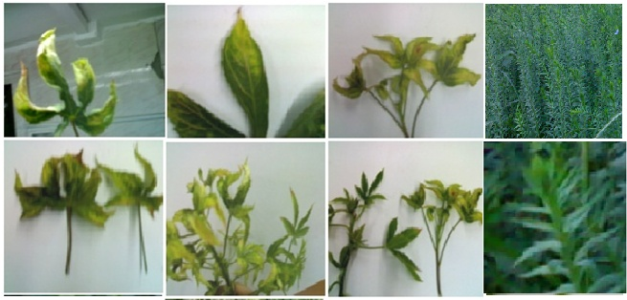
A
B
C
D
E
F
G
H
Figure 4. Symptoms induced by TRV in the leaves of flax plants naturally infected in the field. Leaf symptoms include yellowing (A, B), systemic mosaic (C, D) and leaf deformation (E, F) and healthy (H).

3.3.2. Seed transmission
Transmission through seed has been described for 108 plant viruses in one or more of their hosts. For all these, except Tobacco mosaic virus, successful seed transmission depends on the virus entering and surviving in the embryo (Mink, 1993).
Results in Table (1) indicated that TRV was found to be seed- transmitted through seeds harvested from commercial infected flax plants when tested using DAS- ELISA technique as described by Clark and Adams (1977). Seed transmission rate was evaluated in the following flax cultivars: Giza 4, Giza 7, Giza 8, Giza 9, Sakha 2, Sakha 3 and Sakha 10 (Table 1). The percentage of seed transmission calculated by the formula P= {1- (^{H}/_{N}) ¹/_{n}} ×100 of Maury et al. (1985) raged between (2.82% -19.73%). Fegla et al. (2009) mentioned that the formula gave constant estimation when the expected transmission rate was 1.0% or less. Under such conditions clustering or dilution of infected samples could not be occurred.
High efficiency was observed in cultivars Sakha 10 (19.73%), Sakha 2 (16.74%) and Sakha 3 (6.01%), but the lowest percentage was in cultivars Giza 4 (4.36%), Giza 9 (3.58 %) and Giza10 (2.82%). On the other hand, no infection was observed in Giza 7 and Giza 8 .The occurrence and extent of seed-transmission depended on both the virus and the host plant. So, proportion of virus transmission from host to the other was studied by Dikova (2005). This study involves TRV detection in racemes of two-year beet plants, seedlings, grown from seeds of these plants and seedlings from commercially available sugar beet seeds. Also, Hamed et al. (2012) showed that, TRV could be transmitted through onion seeds of the three tested onion cultivars (Giza 6, Giza 20 and Behery) with different transmission percentages. Maule and wang, (1996) reported that seed transmission is precluded when the virus is unable to infect the gametes prior to fertization, unable to enter the embryo during development, or when the virus is inactivated in the embryo during seed transmission and storage. In virus- host combination with potential for seed transmission, the frequency of seed transmission depends on both host and virus genotype and may range from 0% to almost 100% (Mink, 1993).

Table 1. Percentages of seed transmission in different flax cultivars .
Cultivars | H | N | (^{H}/_{N}) | ¹/_{n} | (^{H}/_{N}) ¹/_{n} | Percentage %
Giza 4 | 12 | 15 | 0.80 | 0.2 | 0.96 | 4.36
Giza 7 | - | - | - | - | - | -
Giza 8 | - | - | - | - | - | -
Giza 9 | 5 | 6 | 0.83 | 0.20 | 0.96 | 3.58
Giza 10 | 13 | 15 | 0.87 | 0.2 | 0.97 | 2.82
Sakha 2 | 6 | 15 | 0.40 | 0.2 | 0.83 | 16.74
Sakha 3 | 11 | 15 | 0.73 | 0.2 | 0.94 | 6.01
Sakha 10 | 5 | 15 | 0.33 | 0.2 | 0.80 | 19.73
H= number of virus –free group N= total number of groups tested, and
n= number of seeds per group Each group = 5 seedlings
- = no infection

3.3.3. Nematode transmission
a. Nematode associated flax plants
Data in Table (3) showed the averages of population density of the recovered species of nematodes Ditylenchus, Aphelenchus, Helichotylenchus, Pratylenchus, Paratrichodorus and Tylenchorhynchus which infested the soil soil samples associated with roots of flax plants which collected as mentioned before.
b. Transmission of TRV by Paratrichodorus
Population of Paratrichodorus sp. was used for this study. This nematode species was collected from the rhizosphere associated with TRV-infested and free plants as mentioned before.
Data in Table (2) and Fig. (5) illustrated that Paratrichodorus nematode was able to transmit TRV to healthy flax plants cultivar " Sakha 3" with mean percentages reached 16.7% from two repeated experiments. After 25 days, symptoms were appeared on flax seedlings compared with control. The results of nematode transmission were confirmed serologically using indirect-ELISA test.

Table 2. The averages of population density of the recovered species of nematodes, which infested the soil.
Replecat Number | Tylenchorhynchus | Paratrichodorus | Helichotylenchus | Aphelenchus | Ditylenchus
1 | - | 10 | 80 | 120 | 120
2 | - | - | - | 60 | 160
3 | 100 | 60 | - | 40 | -
4 | 400 | 40 | 80 | - | -
5 | 800 | - | 40 | - | 20
6 | 1060 | 20 | - | - | -
7 | 2180 | - | 20 | 20 | -
8 | 2600 | - | - | 20 | -
9 | 2840 | - | - | - | -
10 | 1440 | - | - | - | -
11 | - | - | 100 | 60 | 20
12 | 1240 | - | 20 | 40 | -
13 | 680 | 60 | - | - | -
14 | 1600 | - | - | - | -
15 | 1320 | - | - | - | -
16 | 2000 | 80 | 20 | - | -
Averages | 1141.3 | 16.8 | 22.5 | 22.5 | 20

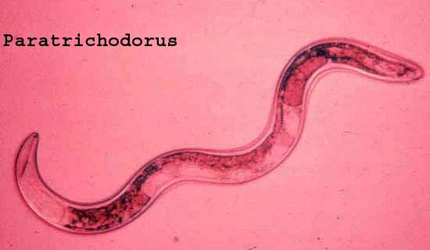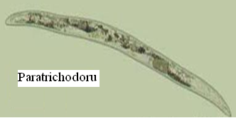
B
A
Figure. (5) Paratrichodorus nematode (A and B) was able to transmit TRV to healthy flax plants.

Table 3. Percentage of Paratrichodorus nematode transmission of TRV through "Sakha 3"as indexed by indirect-ELISA test.
Replicates | *No. infected / no. tested | % Nematodes Transmission
Healthy | 0/5 | 0
1 | 3/14 | 21.4
2 | 2/16 | 12.5
Mean | 5/30 | 16.7
* Number of infected / number of tested plants per each pots
** Percentage of nematodes transmission.

c.TRV detection in viruliferous nematode
TRV was detected using DAS-ELISA of Paratrichodorus nematodes which were handpicked from the final water suspensions and frozen. Positive reaction was obtained from samples, containing TRV-infested viruliferous nematode collected from rhizosphere of infected plant and negative reaction from sample, collected from healthy plants.
4. Presence of the virus isolate in leaves and all florets and flower parts:
Data tabulated in Table (4) indicated the presence of the virus antigen in all cultivars of flax, while differences were found in absorbance values among the cultivars tested. Giza 4 was highly absorbance indicated that it was very sensitive cultivar to TRV infection followed by Giza 7 and Giza 8 cultivars. The lowest absorbance value was found in Sakha 2 and Sakha 3 that is resistance cultivars. Also, data in Table (4) indicated the presence of the virus antigen in leaves of tested flax Giza 9, while differences were found in flower parts (Stamens, sepals and petals). Petals of infected Giza 9 were found highly absorbance at 405 by DAS–ELISA test, while sepals and stamens showed the lowest absorbance values.

Table (4): Absorbance of infected leaves, flowers parts of flowers using DAS-ELISA
Cultivar | Leaves |  | Flower
Giza 4 | 0.431 |  | 0.360
Giza 7 | 0.399 |  | 0.360
Giza 8 | 0.410 |  | 0.366
Giza 9 | 0.352 |  | 0.386
Sakha 2 | 0.383 |  | 0.330
Sakha 3 | 0.237 |  | 0.284
 | Flower part
Giza 9 | Stamens | Sepals | Petals
Giza 9 | 0.266 | 0.239 | 1.285

Corresponding author
Salwa N. Zein
Virus and Phytoplasma Res. Dept., Plant Patho .Res. Inst., ARC., Giza, Egypt
salwaelhiti2006@yahoo.com

References
- Boydston, R. A., Mojtahedi, H., Crosslin, J. M., Brown, C. R. and Anderson, T. (2008). Effect of hairy nightshade (Solanum sarrachoides) presence on potato nematodes, diseases, and insect pests. Weed Sci., 56 (1): 151-154.
- Brunt, A.A., Crabtree, K., Dallwitz, M.J., Gibbs, A.J. and Watson, L. (1996). Viruses of plants. Description and lists from the VIDE Database. CAB International Walling for U.K., 1484 pp.
3. Clark, M. F. and Adams, A. N. (1977). Charcteristics of the microplate method for enzyme linked immunosorbent assay for the detection of plant viruses. J.Gen. Virol. 34: 475-483.
- Dijkstra, J., and De-Jager, C.P. (1998). Virus isolation and purification. (219-269). In: Practial plant virology. DiJkstra, J and De-Jager, C.P. (eds) Springer-Verlag Berlin Heidlerg, New York.
- Dikova, B. (2005). Tobacco rattle virus (TRV) transmission by sugar beet seeds. Biotechnology & Biotechnological Equipment. 19 (2): 87-90.
- Fegla, G.I., Kawanna Maha A.I., and Fath- Allah Mervat M. (2009). Detection of Pea seed-borne mosaic virus (PSbMV) in individual and grouped samples by indirect ELISA and tissue blot immunoassay (TBIA). Annals Agric. Sci., Ain Shams Univ., Cairo, 54 (2): 449- 461.
- Hamed A. H., Om-Hashim M. El-Banna, Ghanem G. A. , Elnagaar M. H. and Shafie M. S. (2012). Isolation and identification of Tobacco rattle Tobravirus affecting onion (Allium cepaL.) plants in Egypt.International Journal of Virology 8 (1): 39-49
- Harrison, B.D., and Robinson, D.J. (1986). Chapter 17, Tobraviruses. In: Regenmortel, M.H.V. van & Fraenkel- D.J. Conrat, H. (Eds.) The Plant Viruses, Volume 2, The Rod-shaped Plant Viruses. - Plenum Press, New York and London: 339-369.
- Hernandez, C., Mathis, A., Brown, D. and Bol, J. F. (1995). Sequence of RNA 2 of a nematode-transmissible isolate of Tobacco rattle virus. J. of Gen. Virology, 76 (11): 2847-2851.
- Hsu, H.T. and Lawson, R.H. (1991). Direct tissue blotting for detection of tomato spotted wilt virus in impatiens. Plant Dis., 175:292-295.
11. Kuhn, C.W. (1964). Sparation of cowpea virus mixture. Phytopathology, 54:739-740.
- Maule, A.J. and Wang, D. (1996). Seed transmission of plant viruses: a lesson in biological complexity. Trends in Microbiology, 4: 153-158.
- Maury, Y., Duby, C., Bossennec, J and Boudazin, G. (1985). Group analysis using ELISA: determination of the level of transmission of soybean mosaic virus in soybean seed. Agronomie 5: 405-415.
- Mink, G.I. (1993). Pollen- and seed transmiaaion of plant viruses and viroids lesson in biological complexity. Annual Review of Plant Pathology. 31: 375-402.
- Mojtahedi, H., Boydston, R. A., Crosslin, J. M., Brown, C. R.; Riga, E., Anderson, T. L., Spellman, D. and Quick, R. A. (2007). Establishing a corky ringspot disease plot for research purposes. J. of Nematology, 39 (4): 313-316.
- Murant, A. F. and Lister, R. M. (1967). Seed-transmission in the ecology of nematode-borne viruses. Annals of Applied Biology, 59 (1): 63–76.
- Ploeg, A. T., Brown D. J. F. and Robinson, D. J. (1992). Acquisition and subsequent transmission of Tobacco rattle virus isolates by Paratrichodorus and Trichodorus nematode species. European J. of Plant Pathology, 98 (5): 291-300.
- Sabek, A. H. M. (1973). Studies on Viruses Affecting Gladiolus in A.R.A. M.Sc. Thesis, Faculty of Agriculture. Ain Shams Univ. 117p.
- Samuitienė, M., Navalinskienė,M. and Dapkūnienė, S. (2009). Investigation of Tobacco rattle virus infection in peonies (Paeonia L.). Biotechnology & Biotechnological Equipment, 28(3): 199-208.
- Seinhorst, l. W. (1988). The estimation of densities of nematode populations in soil and planes. Vaxcskyddrapporcer. Jordbruk 51, Research Information Centre of the Swedish University of Agricultural Sciences, Uppsala, Sweden, 107 p.
- Shafie, M. S. A. (1978). Further Studies on Viral Diseases of Some Medicinal Plants. Ph.D. Thesis, Fac. of Agric. Ain Shams Univ. 210 p.
- Sleper, D.A. and Poehlman, J.M. (2006). Breeding Field Crops. Fifth edition. Blackwell Publishing Professional, 2121 State Avenue, Ames, Iowa 50014. 424 pp.
- Sudarshana, M.R. and Berger, P.H. (1998): Nucleotide sequence of both genomic RNAs f a North American tobacco rattle virus isolate. Archives of Virology, 143: 1535-1544.
- Visser, P.B., Mathis, A. and Linthorst, H.J.M. (1999): Tobraviruses. Encyclopaedia of Virology: 1784-1789.
- Zein, Salwa N. (2004). Characterization of Tobacco Rattle Tobravirus from Kaki (Diospyros Kaki). . Egyption J.Virology. 1:187-193.

7/3/2012

