Effect of Fertigation on Clogging of Three Types of Emitters in Iran

F. Ansari Samani^{1*}, S. Boroomand Nasab²

1. M.Sc.Student. Dep. Of Irrigation and drainage, Shahid Chamran University of Ahvaz, Iran.
2. Prof. Dep. Of Irrigation and drainage, Shahid Chamran University of Ahvaz, Iran
*Corresponding author,( faride.ansari@yahoo.com).

Abstract: One of the potential advantages of drip irrigation is allowing the use of fertilizers and pesticides with irrigation water. In this study, the effect of fertilizers on clogging dripper and drip irrigation system performance has been investigated. This study in a randomized block design framework was done that its factors were three treatment of fertilizer (ammonium phosphate) includes treatment F0 (control), and two F1 and F2 treatments with concentrations of 5 g/l and 8 g/l, respectively, and three dropper treatment (the in line long path and two outline long path). Dropper with codes A, B and C were named. In order to investigating dropper clogging, reduce discharge rate, efficiency of uniform distribution, Kristiansen uniformity coefficient and coefficient of discharge variation was calculated. After test period the percentage of reduce discharge for droppers was obtained 19.9, 20.78, and 11 percent for treatment F0 (control) respectively, and 26.48, 26.49 and 16.65 percent for treatment F1, and 33.67, 33.06 and 18.59 percent for treatment F2, respectively. The results were shown increasing concentration of irrigation fertilizer caused increasing dropper clogging and have a significant effect on discharge variation.
[F. Ansari Samani, S. Boroomand Nasab. Effect of Fertigation on Clogging of Three Types of Emitters in Iran. Nat Sci 2012;10(10):21-25]. (ISSN: 1545-0740). http://www.sciencepub.net/nature. 3

Keywords: Trickle Irrigation, Emitter, Fertilizer, Clogging, Uniformity

Introduction
In the history Access to safe water, has been a basic condition for social development, economic, stability of the culture and civilization. Considering optimization use of water and soil resource, used of a new irrigation methods such as drip irrigation for have high efficient was a necessary subject. Keller and Blaisner (1990) mentioned that drip irrigation is one of the most efficient irrigation methods. Conception of drip irrigation was spread slowly from Israel to North American country, Australia, South African and finally all over the world and accepted as a useful method. Today South African and Israel with 1440000 ha and 104302 ha drip irrigation farm respectively, are progenitor country in this field.
Drop selecting is a most important factor in this method, because efficient of drip irrigation system is depend on to it and unconsidered to dropper problem, decrease uniformity of irrigation, increase time work of system and alternate dropper continuously (Bralts et al. 1983).
Many factors such as physical, chemical and biological, pressure and water temperature and construction changes, have affecting on the dropper discharge and uniformity of water distribution. So that changes in any of the mentioned factors particular, the pressure in the system caused by poor design will bring tremendous changes in discharge and the uniformity of distribution and thus lowering the efficiency. In the recent years many models was presented in the affecting factors on discharge and uniformity of dropper. Solomon has presented a model where flow discharge of dropper considered as a function of applied pressure, water temperature changes and clogging of dropper (Sohrabi 1999). Researches that was done by international committee to study irrigation and drainage (ICID) in trickle irrigation problems, indicate that in all countries of the fundamental problems in drip systems, dropper clogging and blockage problems associated the use of bad quality water and non-normative choices of water treatment system that caused non-uniform distribution of water in the laterals and finally reduced irrigation efficiency. Clogging the dropper is also increase maintenance costs and system governance, including control and replacement or repair droppers. Many studies have been conducted about clogging droppers including the following:
Nakayama and Bucks investigated emitter clogging effects on trickle irrigation uniformity. In this study, 1000 emitters have been tested for calculate they coefficient of discharge variation. Coefficient of variation of 0.05 and coefficients of variation 1.0 is considered fair to poor. Hills (1989) investigated effects of chemical clogging of emitters in the uniformly distribution. They were evaluated four different combinations of irrigation water and their effects on chemical clogging emitters and noted that the increase in calcium ions, magnesium, bicarbonate and PH in irrigation water, calcium carbonate become more that result in increased clogging and reduced discharge of droppers. Maximum clogging is belong to the water has the highest salt and minimal clogging is belong to the water has the lowest PH. Adin and sacks (1991) After examining three different drip emitter showed clogging of droppers that use of wastewater the first was occurred by solid particles but this is not the first step of clogging necessarily, and velocity of clogging is more influenced by the size of particle not amount of particles. And stated that when the algae are clogging factor, which stick to other particles. They also stated that chemical compounds found in sediments emitters varies with the changing seasons, so that aluminum and silicon are more clogging factors in the winter and spring, while in the summer and fall, a high percentage of phosphorus and calcium were observed in the dropper. Capra (1998) were examined the relationship between irrigation water quality standards and assessment systems in the field diameters. At the first the dropper assessment to determine the amount of nominal discharge coefficient of making the changes carried out and in the end of studies were identified in terms of uniformity 24% of Systems is ideal, 10% well, 10% good, 43% poor and 17% are unacceptable performance are required. In general most of trickle irrigation systems due to problems of clogging, have the undesirable uniformity of application. With a review of five types of emitter with discharges, 0.75, 0.91, 1.5, 2.3 and 3.5 liters per hour during the crop seasons 1998 and 1999 waste water stabilization ponds were working, Concluded that the two emitters that had the lowest discharge, were clogged. Rate of discharge reduce in 1998 for droppers with 0.57 and 0.91 liters per hour were 15 percent and 11 percent respectively that these values ​​are 21.5 and 13.7 percent increased respectively in 1999 but clogging was a little in the other three types and their reduce rate of discharge over the past two seasons has been 4 percent or less.
Rowan et al (2004) four types of emitters clogging (non-pressure regulator, with turbulent flow and two emitter with pressure regulator) that were collected from the three manufacturer, using wastewater distribution with different qualities (septic tank and sand bioreactor) were investigated. To review system performance and identify droppers that clogged discharge was measured every month. In the tasted droppers maximum decrease in discharge related to the average decrease of discharge for septic tanks for sewage and waste sand bioreactor were 16% and 3% respectively. The average reduction in discharge of emitters tested for septic tanks and sewage wastewater sand bioreactor was 2% and 11% respectively. Droppers that distribute sewage of septic tank, in the most of them discharge was decreased and more that 80% of droppers were clogged. Bozkurt and Ozekici (2006) were investigated effects of fertilizer on in line dropper clogging and trickle irrigation system performance. In this research, three irrigation fertilizer treatments (the first treatment with no fertilizer, second treatment consisted of 25% sulfate fertilizers and 75% nitrate fertilizers, third treatment consisted of 50% sulfate fertilizer and 50% nitrate fertilizer) and three types of in line emitter with discharges 4, 2.75 and 1.7 liter per hour were selected. In this study measuring flow rates, the percentage reduction of discharge were achieved. Results showed that the emitters with low flow have more percentage of decrease of discharge. Also in droppers that caused clogging discharge was reduced performance was decreased.
Haijun and Guanhua (2008) were studied three types of emitter clogging with fresh water and treatment sewage. Measuring and calculating the flow rate, coefficient of flow rate changes, distribution uniformity, uniformity coefficient, Kristiansen uniformity coefficient and clogging percent of stenosis droppers, evaluate the performance of the dropper. Results showed that all the above parameters are functioning of the quality of water used for irrigation, Emitter types and time of systems working. Muharrem et al. (2010) were investigated emitters clogging effects on trickle irrigation system performance. In this study to determine the clogging level of droppers, was used a number of droppers in trickle irrigation system farmlands located in the channel and their effect on irrigation performance was observed. They concluded that in general the more time droppers were used, have more clog and over time their performance was reduced.
The aim of this study is investigation effect of fertilizer on emitter clogging and performance of trickle irrigation system.

Material and Methods
This study was conducted in a randomized block design variables to investigate the effect of fertilizer on emitter clogging irrigation in year 2012 in the trickle irrigation laboratory in Faculty Water Sciences of Shahid Chamran University. The variables of this study included a control treatment (no fertilizer), two treatments, with different concentrations of 0.05 and 0.08 percent grams per liter (ammonium phosphate, 46%) and three dropper treatments (inline long-path and two outline long path types) each had 19 iterations. Dropper properties are presented in Table 1. Experimental period for each of the treatments was 72 days. Daily working time of 12 hours the system was considered and the system was running continuously. Applied pressure system was 7 m that equal to average pressure on farms. For each experiment, the first three lateral to the numbers 1, 2 and 3 with diameter 16 mm and 20 cm intervals on the main pipe and then 16 emitters on each lateral with distance of 15 cm was installed so that in the laterals No.1 emitters A, No. 2 emitters B and No.3 emitters C were placed. Fertilizer and water solution with known concentrations of 0.05 and 0.08 percent of grams per liter from plastic tank (The required pressure was supplied by the lift) by piping water was interred into the main pipe and then into the system. Plastic bins with a volume of approximately 6 liters were placed under emitters to collect water outlet from them and before filling vacant into the metal tank. To avoid of water evaporation and thus reduced the concentration of fertilizer water solution although small amounts, metal tank was covered with thick nylon. Dropper discharge every 4 days and in the last time of system working was measured in three times of 10 minutes and 3 iterations. Using a stopwatch the duration of each test determined and the amount of discharge of each emitters were measured by calibrate container.

Table 1. Nominal properties of used a emitters.
Emitter | Type of connection | Pressure (meters ) | Discharge (liters per hour )
A  B  C | in-lin  in-line  On-line | 10  10  10-40 | 4  4  8

For each of the studied treatments, discharge of each dropper was calculated by dividing the volume of water collected in containers on time. Then using equations (1), (2), (3) and (4) percent reduction in flow rate, the efficiency of distribution uniformity, Kristiansen uniformity coefficient and coefficient of variation of discharge was calculated, respectively.

=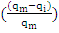 a (1)

In the above equation: Q_{i} is reduce discharge percent, q_{m} is maximum discharge in terms of liters per hour and: q_{i} is discharge of each emitter in terms of liter per hour.

$\text{EU}=\left(\frac{q_{n}}{q_{a}}\right)×\text{100}$ (2)

In the above equation: EU is the distribution uniformity of emitters in terms of percentage, q_{n} is the average a quarter of the lowest flow rate of emitters in terms of liters per hour and q_{a}: is the average discharge of emitters in terms of litters per hour.

$\text{UC}=\left[1−\left(\frac{1}{{\text{nq}}_{a}}\right)\sum_{i=1}^{n}{\left|q_{i}−q_{a}\right|}\right]×\text{100}$ (3)

In the above equation: UC is the Krystyasn uniform coefficient in terms of percentage, n is the number of views and q_{i} is the discharge of each emitter.
$$V_{m}=\frac{S_{m}}{q_{m}}$$

In the above equation: V_{m} is the variation coefficient of emitter discharge, s_{m} is the standard deviation of emitters flow, q_{m} is the average flow rate of emitters.

Results and Discussion
As seen in Table 2, clogging of emitter in F₁ and F₂ treatments is higher than F₀ treatment. Therefore concluded the irrigation fertilizer aggravated chemical clogging in emitters and causing clogging emitters increases. Because ammonium phosphate fertilizer in the water, hydrolyzed and is partly converted to nitrate, and nitrate produced by algae (vegetation) and other micro organisms were consumed as the main food and caused growth, reproduction and amplified of them. Algae and other micro organisms left from sludge that is caused emitters clogging. Table 2 shows that the clogging of the emitters A (inline-long path) is greater emitters than B and C (on-line - long-path) and in general clogging of the emitters A, B and C have decrease trend, respectively.

Table 2. Uniformity and discharge reduction in the treatments at the end of the tests.
Increase coefficient of variation of discharge Percent | Reduction using Krystyansn coefficient Percent | reduction in the efficiency of distribution uniformity Percent | reduction discharge Percent | Type of emitter | Fertigation treatment
48.56 | 19.11 | 35.64 | 19.90 | A | F0
42.84 | 10.16 | 38.54 | 20.87 | B | F0
39.32 | 10.17 | 22.16 | 11.00 | C | F0
55.24 | 25.25 | 49.65 | 26.48 | A | F1
45.83 | 16.36 | 40.14 | 26.49 | B | F1
46.65 | 13.80 | 27.61 | 16.65 | C | F1
67.51 | 34.25 | 59.59 | 33.67 | A | F2
63.64 | 31.52 | 49.58 | 33.06 | B | F2
32.34 | 15.54 | 31.60 | 18.59 | C | F2

The values of discharge variation coefficient ​​for all three treatments of fertilizer and for all three types of emitters was calculated using equation (4) the results are presented in Figures (2), (3) and (4). According to the results by passing time the clogging of emitters and then discharge variation coefficient are increases. Overall, the general slope of diagrams of fertilizer effect of different treatments on the discharge variation coefficient of emitters was ascending and its rate increases by passing time.

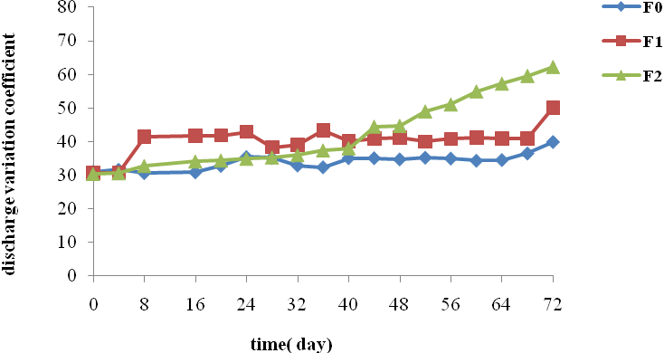
Figure 1. Effect of different concentration of fertilizer on discharge variation coefficient of emitter A.

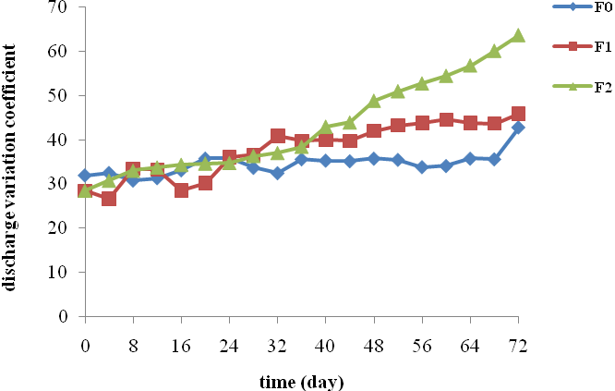
Figure 2. Effect of different concentration of fertilizer on discharge variation coefficient of emitter B.

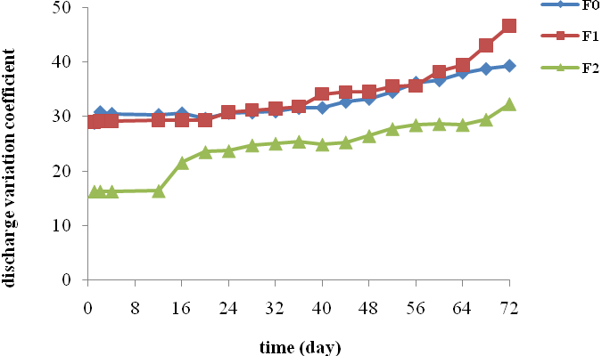
Figure 3. Effect of different concentration of fertilizer on discharge variation coefficient of emitter C.

In this study for investigation fertilizer effect on discharge variation coefficient, for each emitter using SAS 8.0 software and Duncan test at 1% probability level effects of three irrigation treatments on manure discharge coefficient of variation was assessed. In any case, the equality of discharge variation coefficient in different fertilizer treatments, considered as the assumed zero, that in 99 percent confidence level is accepted or rejected. The results of statistical tests in Tables (3), (4) and (5) are presented. By attention the results of the above tables, about the entire dropper equal discharge variation coefficient assumption to 99 percent confidence for different concentrations of fertilizer rejected and irrigation fertilization has a significant effect on discharge variation coefficient of droppers.

Table 3. Variance analysis of the effect of tested treatment on eclipse percentage of emitter A.
Parameter | Changes in resources | Sum of squares | degrees of freedom | Mean Squared | F
Coefficient of variation of discharge | Repeat | 2331.30 | 18 | 129.51 | **  5.47
Coefficient of variation of discharge | Treatmen | 903.28 | 2 | 451.64
Coefficient of variation of discharge | Total | 4298.88 | 56
Coefficient of variation of discharge | Error | 1064.29 | 36 | 29.56

Table 3. Variance analysis of the effect of tested treatment on eclipse percentage of emitter B
Parameter | Changes in resources | Sum of squares | degrees of freedom | Mean Squared | F
Coefficient of variation of discharge | Repeat | 1997.6 | 18 | 110.97 | **
Coefficient of variation of discharge | Treatmen | 674.38 | 2 | 337.19 | 5.37
Coefficient of variation of discharge | Total | 3566.98 | 56
Coefficient of variation of discharge | Error | 894.99 | 36 | 24.86

Table 3. Variance analysis of the effect of tested treatment on eclipse percentage of emitter C.
Parameter | Changes in resources | Sum of squares | degrees of freedom | Mean Squared | F
Coefficient of variation of discharge | Repeat | 950.75 | 18 | 52.81 | **
Coefficient of variation of discharge | Treatmen | 1052.45 | 2 | 526.22 | 27.89
Coefficient of variation of discharge | Total | 2132.49 | 56 | 3.59
Coefficient of variation of discharge | Error | 129.27 | 36

Summary and Conclusion
Reasons of increasing efficiency of fertilizer in trickle irrigation due to the timing and low amount fertilizer and uniform distribution of fertilizer in the roots developing zone and non-precipitation fertilizer to the soil. But this increase in fertilizer factor in many cases is caused of emitters clogging. Emitter clogging is as the main problem in trickle irrigation. By increasing amount of fertilizer the percent of discharge reduction is increased for all three types of emitters. Overall effect of fertilizer depends on the concentration of fertilizer, water quality and type of emitter and this effect is different in different types of emitter. Results showed that dropper A have the most clogging and emitters C have the lowest sensitivity against fertilizer. In general the sensitivity to clogging for studied emitters has a decrease trend for emitters A, B and C respectively. Increasing concentration of fertilizer has a significant effect on dropper discharge and discharge variation coefficient. The results of Table 2 are consistent with results Rowan and colleagues (2004). And also the results of statistical tests are consistent with the results of research Trooien and colleagues (2000), Bozkurt and Ozekici (2006) and Haijun and Guanhua (2008). Therefore, the clogging of emitters is also depends on the discharge rate emitter and water quality and type of dropper are two important factors in relation to clogging. Recommended more researches be done to examine the impact of fertilizer and temperature together, effect of irrigation fertilizer and pressure together, The effect of both fertilizer and various qualities of irrigation water, effect of fertilizer using a mixture of different fertilizers on emitter clogging.

References
Adin A. and Sacks M. 1991. Dripper clogging factors in wastewater. J. Irrig drain Eng ASCE 117: 813- 826.
Bozkurt S. and Ozekici B. 2006. The effects of fertigation managements on clogging of in-line emitters. J. A pplid Sciences 6(15): 3026-3034.
Bozkurt S. and Ozekici B. 2006. The effects of fertigation management in the differenc type of in-line emitters on trickle irrigation system performance. J. Applid Sciences 6(5):1165-1171.
Bralts V.F. and kesner C.D. 1983. "Drip irrigation field uniformity estimation". Trans . ASAE 26 (2):1369-1374.
Capra A. and Scicolone B. 1998. "Water quality and distribution uniformity in drip/trickle irrigation system". Journal of Agricultural Engineering Research.
Haijun L. and Guanhua H. 2008. Laboratory experiment on drip emitter clogging with fresh water and treated sewage effluent. Agricultural Water Management. Pages 745- 756.
Hills D.J. Nawar F.M. and Waller P.M..1989. Effects of chemical clogging on drip tape irrigation uniformity. Trans. ASAE. 32(4):1202-1206.
Keller J. and Blaisner R.D. 1990. " Sprinckle and Trickle Irrigation". New York. USA:champan and Hall.
Muharrem y. Kursad y. Okan d. Erdem e.b. and Merve d . 2010. Emitter clogging and effects on drip irrigation system performances. African journal of Agricultural Research vol. 5(7). pp.532-538
Nakayama F.S. and Bucks D.A. 1981. Emitter clogging effects on trickle irrigation uniformity.Trans.ASAE 24(1): 77-80.
Rowan M. Mancl K. and Tuovinen O. H. 2004. Clogging incidence of drip irrigation emitters distributing effluents of differing levels of treatment. Pp. March (Sacramento, California USA), ASAE Publication Number 701P0104, ed. K. R. Mankin.
Sohrabi T. Akramnya F. and Mirabzadeh M. 1999. “Evaluating hydraulic characteristics of emitters”. Iranian Journal of Agricultural Sciences.
Trooien T. Lamm P. F. R. Stone L. R. Alam M. Clark G. A. Rogers D. H. and A. J. schlegel. 2000. Subsurface drip irrigation using livestoke wastewater: Dripline flow rates. Appl. Eng. in Agric. 16(5): 505-508.

7/2/2012

