Survey, Biodiversity and Impacts of Economic Activities on Mangroves Ecosystem in Eastern Part of Lagos Lagoon, Nigeria.

Omogoriola, H.O., Williams, A.B., Ukaonu,S.C., Adegbile, O.M., Olakolu, F.C., Mbawuike,B.C., Akinnigbagbe, A.E and Ajulo. A.A

Marine Biology Section, Nigerian Institute for Oceanography and Marine Research (N.I.O.M.R), P.M.B. 12729, No 3, Wilmot Point Road, Victoria Island, Lagos, Nigeria.
adehannah2002@yahoo.com

Abstract: Mangrove swamps in Nigeria stretch along the entire coast and are found in nine of the 36 states. The eastern part of Lagos Lagoon is dominated by red mangrove (Rhizophora racemosa) which might be as a result of the abundant of this mangrove species in Nigeria. Invertebrates and vertebrates are found at the bottom of the mangroves while some are found on the body of the mangroves. Molluscs like periwinkles (Tympantonous fuscatus and Pachymelaian aurita) and oysters (Crassostrea sp). Crustaceans like purple mangroves crab (Goniopsis pelii), Africana mud crab (Panopeus africanus) and Lagoon land crab (cardiosoma armatum). Fish fauna like tilapia (Sarothenedon melanopterus), Mudskipper (Petriopthalmus Barbatum) and larva stages of some important fishes and shrimps. Other vegetations are found along with the mangroves trees while some are found attached to the prop root or the pneumatophores e.g water hyacinth and water lettuces. Economic activities that surround Lagos Lagoon mangrove communities are Fishing, aquaculture (acadja), sand mining, dredging activities and logging. Mangrove trees are cut to make fire wood, construction of road and artificial pond and local medicine. Soils are mined for bridge, house and industry construction. The negative impact of these economic activities can lead to climate changes, changes in the upstream habitat, loss of habitats and biodiversity and pollution due to population growth and urban development.
[Omogoriola HO, Williams AB, Ukaonu SC, Adegbile OM, Olakolu FC, Mbawuike BC, Akinnigbagbe AE, Ajulo AA. Survey, Biodiversity and Impacts of Economic Activities on Mangroves Ecosystem in Eastern Part of Lagos Lagoon, Nigeria. Nat Sci 2012;10(10):30-34]. (ISSN: 1545-0740). http://www.sciencepub.net/nature. 5

Keywords: Mangrove; Lagos Lagoon; Survey; Biodiversity; Economic activities

- Introduction
Mangroves are salt-tolerant characteristic complex plant communities occurring in sheltered coast line areas in the tropical and sub-tropical inter-tidal regions of the world such as bays, estuaries, lagoons and creeks. The plant community of a mangrove swamp is most commonly termed mangal, a forest with a dense canopy, also known as mangrove swamp forest or, simply, mangrove. The mangrove forest of Nigeria is the largest in Africa and third largest in the world after India and Indonesia (Macintosh and Ashton, 2003). Nigeria contains the most extensive mangrove ecosystems, which comprise nearly 35 per cent of the total cover for West Africa (UNEP-WCWC, 2006b). The total mangroves covers in Nigeria is about 7 386 km² which is 22 percent in Africa (UNEP-WCWC, 2006b). Mangrove swamps in Nigeria stretch along the entire coast and are found in nine of the thirty six states. The largest extent of mangroves is found in the Niger Delta between the region of Benin River in the west and the Calabar,Rio del Rey estuary in the west. The lagoons of Lagos and Lekki dominate the coastal systems in the west. Both Lagoons are fringed by mangroves and backed by swamp forests (FAO, in press). Several threats like population growth and economic development, petroleum and gas exploration and production, deforestation, invasive species and commercial fish farming are the major problems confronting mangrove ecosystem, This study is aimed to provide basic and current information on the state of mangrove ecosystem in Lagos Lagoon, and its key objectives are: (1) to Survey and identify mangrove areas in Lagos Lagoon; (2) to assess the types, abundance and distribution of mangrove species in Lagos Lagoon; (3) to identify mangrove associated fauna and flora in Lagos Lagoon; (4) to determine economic activities that is associated with mangrove ecosystem in Lagos Lagoon and their impact; and (5) to determine threats to mangrove ecosystem and the level of their destruction.

2. Methodology
Study Area
The Lagos Lagoon lying between longitude 6⁰26’N and 6⁰30’N and latitude 3⁰25’E and 3⁰36’E. On the available mangrove species, five stations were selected in eastern part of Lagos Lagoon for the purpose of this study; they are Badore, Langbasa, Agbeki (Mid lagoon), Bayeku and Oreta. Figure 1 presents the map of these stations on the lagoon in Lagos State. Badore and Langbasa are close to each other in Eti-Osa LG). Oreta and Bayeku are closed each other and found at Ikorodu. The entire mangrove found in these areas are on the coastline and surrounded by communities expect Agbeki and Bayeku that are found on middle of Lagoon (Figure1).

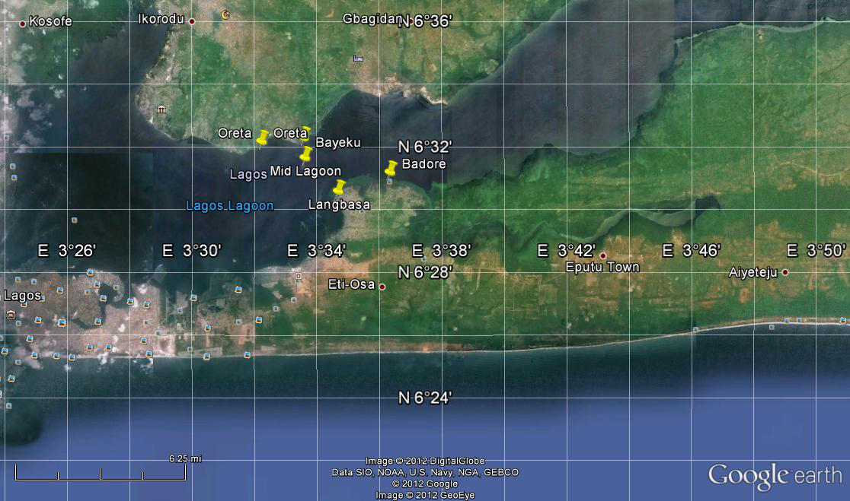
Figure 1: Satellite imagery map of eastern part of Lagos Lagoon showing the study sites

The Main Activities
- Global Positioning System (GPS) was used to determine the geographic and rectangular coordinates of each station (communities) on Lagos/Lekki Lagoon.
- Collection of water samples at each station for determination of Physico-chemical parameters.
- Collection of different mangroves plants at each station to determine their family and species.
- Visual/Direct observation was also included for determination of the followings:
- Economic activities surrounding the areas.
- Vegetations present along with the mangroves.
- Closeness to community.
- Collection of mangrove fauna for identification.
- One-on-One communication with the villagers on the usefulness of the mangrove.

Biodiversity Identification
Both flora and fauna species were taken to the laboratory for proper identification and taxonomy. Mangrove species were classified and identified according to APG III taxonomy classification for mangrove species. Mangrove fauna were identified using FAO guide (Schneider, 1990) while fish species were identified using Olaosebikan and Raji (Olaosebikan and Raji, 1998).

3. Results
Mangrove Diversity and Distribution in Eastern Part of Lagos Lagoons
The distribution of mangrove species in eastern part Lagos Lagoons is presented in table 1. All the stations had red mangrove (Rhizophoraceae) with the abundant of Rhizophora racemosa. White mangroves (Laguncularia racemosa) of the family Lambrataceae is also found along with red mangrove in Langbasa. Nypa palm (Nypa fruticans) is scantly present along this part of the Lagoon. Figures 2 and 3 present types of mangrove species found in Langbasa and Badore.

Table 1: Distribution of Mangrove Species in Eastern part of Lagos Lagoon (Bd, Badore; Lg, Langbasa;Ml, Mid Lagoon; By, Bayeku; Or, Oreta).
Scientific name | Bd | Lg | Ml | By | Or
Avicennia germinans |  |  |  | *
Rhizophora mangle | * | * | * | * | *
Rhizophora racemosa | * | * | * | * | *
Rhizophora harrisonii | * | * | * | * | *
Laguncularia racemosa |  | * | * |  | *
Conocarpus erectus
Nypa fruticans |  |  | * | * | *
Acrostichum aureum

Physico-chemical parameters of the water samples
Physico-chemical parameters of the areas where mangrove are found in Lagos Lagoon are presented in Table 2. Water sample in Langbasa had highest salinity and conductivity of about 4.7^{0/}00 and 8.67mS/cm respectively, compared to others stations. Most of these stations have water of little salt content. Dissolved oxygen ranged between 2 (Bayeku and Oreta) and 8 (Badore). Turbidity ranged between -4cm (Langbasa) and 9cm (Badore). Most of these stations were alkaline (pH > 7).

Biodiversity
Invertebrates and vertebrates were found at the bottom of the mangroves while some were on the body of the mangroves. Molluscs like periwinkles (Tympantonous fuscatus and Pachymelaian aurita) and oysters (Crassostrea sp). Crustaceans like purple mangroves crab (Goniopsis pelii) and Lagoon land crab (cardiosoma armatum). Fish fauna like tilapia (Sarothenedon melanopterus), Mudskipper (Petriopthalmus Barbatum) and larvae of some fishes. Table 3 showed fish species associated with these mangrove areas. In some areas, such as Badore and mid Lagos Lagoon other vegetations were found along with the mangroves trees e.g palm trees, water hyacinth and water lettuces.

Economic Activities surrounding eastern Lagos Lagoon Mangrove Communities
Fishing, aquaculture (acadja), sand mining, dredging activities and logging are the major economic activities along eastern part of Lagos Lagoon mangrove communities (Table 4). Mangrove trees are cut to make fire wood, construction of road, bridges, houses artificial pond and local medicine.

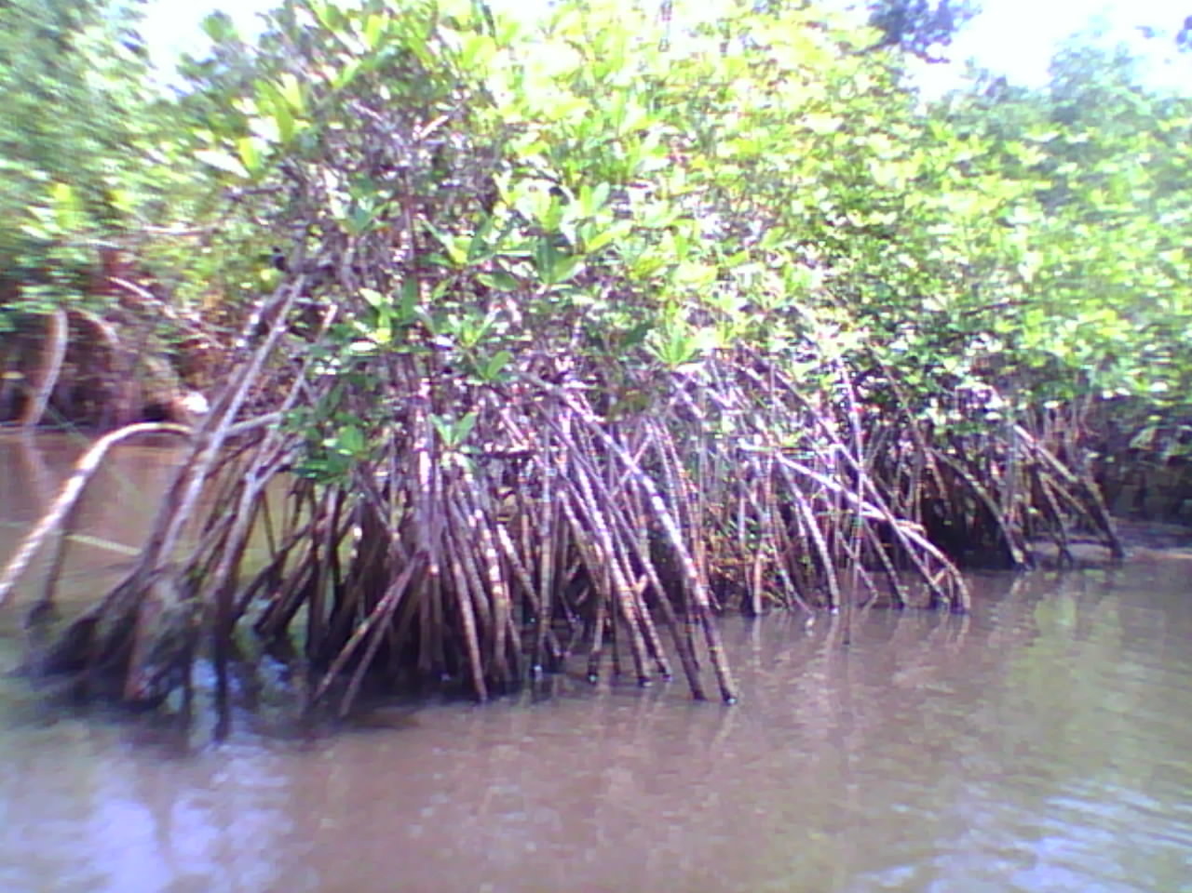
Figure 3: Red mangrove (Rhizophora racemosa) in Badore.

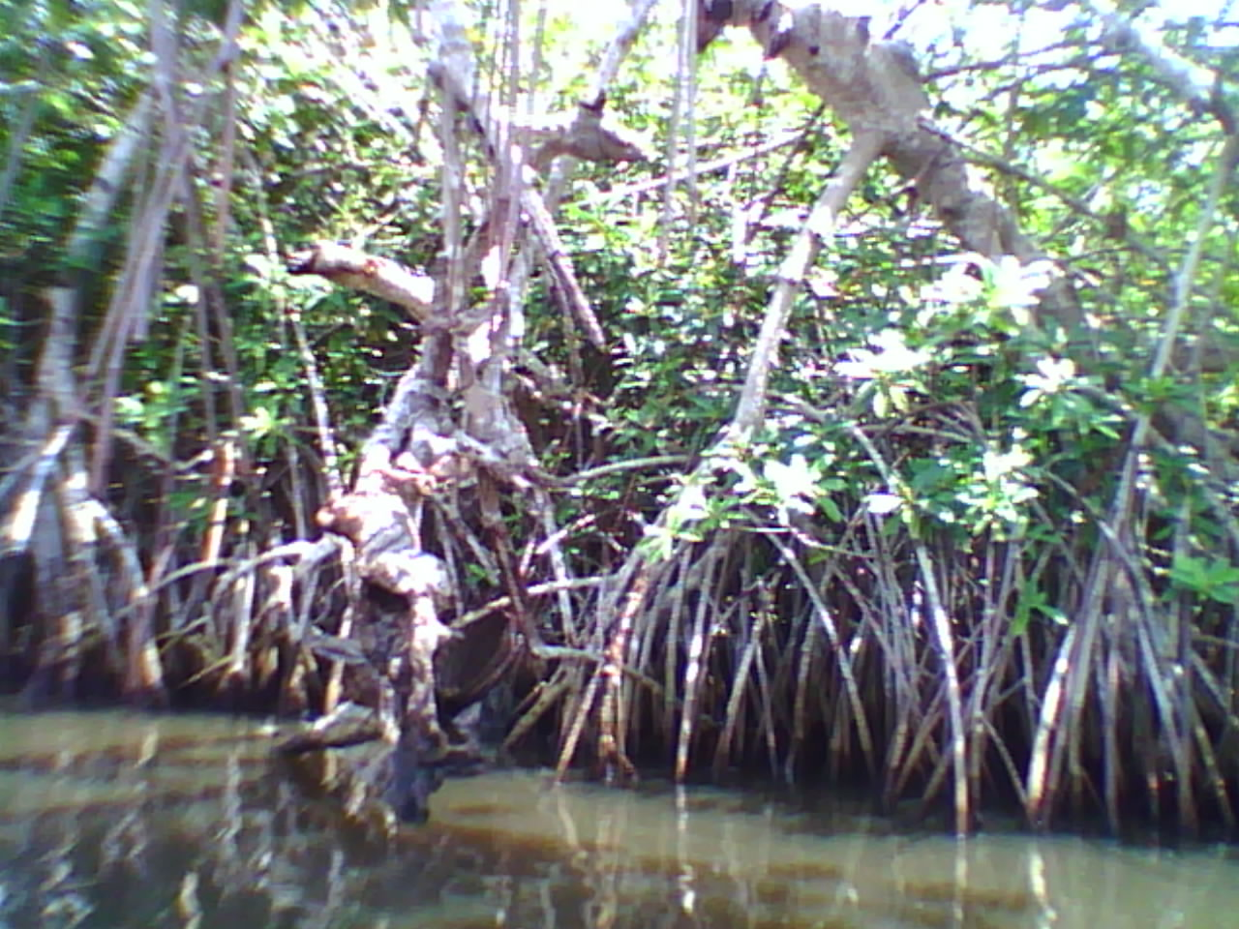
Figure 4: White mangrove (Laguncularia racemosa) in Langbasa

Table 2: Water chemistry of mangrove communities in Eastern part Lagos Lagoon (Bd, Badore; Lg, Langbasa;Ml, Mid Lagoon; By, Bayeku; Or, Oreta).
Parameter | Bd | Lg | Ml | By | Or
Water ^{temperature} O⁰C | 32 | 31 | 30 | 29 | 28
Air temperature O⁰C | 28 | 29 | 30 | 28 | 29
P^{H} | 8.22 | 8.51 | 8.57 | 8.67 | 8.75
Salinity (⁰/00) | 3.2 | 4.7 | 3.0 | 4.4 | 4.0
Conductivity(mS/cm) | 6.05 | 8.67 | 5.69 | 8.09 | 7.53
Turbidity (cm) | 9.0 | -4.0 | 0.0 | -7 | -3.0
Dissolved oxygen(mg/l) | 8 | 5 | 2 | 2 | 2
Total hardness | 36 | 64 | 42 | 20 | 16

Table 3: Fish species found in Mangroves Communities in Eastern part of Lagos Lagoon (SN, Scientific name; CM, Common Name)
Family | SN | CM
Clupeidae | Ethmalosa fimbriata | Bonga shad
Mugilidae | Mugil  Cephalus
Carangidae | chloroscombrus chrysurus | Atlantic bumper
Carangidae | Caranx  Hippo | Crevalle jack
Gobidae | Petriopthalmus barbatum | Mudskipper
Lutjanidae | Lutjanus goreensis | Red snapper
Cichlidae | Hemichromis fasciatus | Tilapia
Cichlidae | Orechromis niloticus | Tilapia
Cichlidae | Sarothendron melanotheron | Tilapia
Bagridae | Chrysichthys nigrodigitatus | Catfish

Table 4: Economic Activities surrounding Lagos and Lekki Lagoon Mangrove Community (Bd, Badore; Lg, Langbasa;Ml, Mid Lagoon; By, Bayeku; Or, Oreta).
Activities | Bd | Lg | Ml | By | Or
Fishing | * | * | * | * | *
Acadja | * | * | * |  | *
Sand minig | * | * | * | * | *
Dredging | * | * |  | *
Logging | * | * | * | * | *
Agro forestry
Water/Ship Port
Oil Depot
Hydroelectric project |  |  |  | * | *
Ecotourism

4. Discussion
Eight true mangrove species are found in West Africa (Tomlinson, 1986). All of the eight mangrove species found in West African are found in Nigeria (UNEP-WCMC, 2007). Therefore, there is possibility for the eight mangrove species to be present in this Lagoon but many of these species has lost due to environmental hazards and economics activities. Eastern part of Lagos Lagoon is dominated by red mangrove (Rhizophora racemose) which might be as a result of the abundant of this mangrove species in Nigeria. The true mangrove species found in most Lagoon is red mangrove (Rhizophora racemose). Ohimain (2006b) reported that in the lagoons and deltas, Rhizophora racemosa is the dominant species. It is the pioneer at the edge of the alluvial salt swamp; Rhizophora harrisonii dominate in the middle zone and Rhizophora mangle are most common on the inner edge, while Avicennia germinans is mostly restricted to relatively higher salinity zones, especially at the river mounts opening into the ocean and mangrove forests adjacent to coastal beach ridges bordering the Atlantic Ocean. Salinities recorded along this part of the lagoon were as a result of lagoon with low salt content compared to marine environment with high salt contents. However the fact that many species grow well at low salinities indicates the beneficial effects of salt content on their growth. Commonly found along the mangrove substrates are crustaceans like periwinkle and oysters while the fish juveniles of most families like cichlidae, Gobidae and Mugilidae are also present. The presences of the juvenile’s stages of these fish species support that mangrove swamp is breeding ground for most fish species. Ibe and Awosika (1991) reported that mangroves are very important ecologically because they provide spawning and nursery grounds for many coastal fish species. They also serve as the habitats for some of the crustaceans and molluscs. West African mangroves are also remarkable for supporting some indo-Pacific lineages of fish in the Atlantic Basin, such as the mudskipper (Kaufman, n. d). Mangrove ecosystems support industrial and subsistence activities in Nigeria, and are critical for food security for many living in abject poverty in the coastal zone. Great amount of mangrove species in Lagos State are lost to urbanization, industrialization and agriculture. While fragmentation itself does not greatly affect mangrove biodiversity, of greater concern is the total amount of mangrove area lost to urbanization, industrialization and agriculture, as well as impacts from timber and petroleum exploitation (Diop, 1993). Disposal of municipal solid wastes into the waterways is threatening the peri-urban mangroves in eastern part of Lagos Lagoon. Non-biodegradable wastes, particularly plastic and nylons that are carried into the mangroves during high tides are often stranded on the mangrove pneumatophores as the tide recedes (Omhimain, 2006b). Some mangrove loss has occurred as a result of coastal erosion and deforestation for commercial timber trade and subsistence-level use of wood products such as fuel wood, fish processing and construction timber. Greater amount of mangrove are lost due to industrialization and urbanization because many of these mangrove communities are sand filled and cleared for residential and commercial purposes. Key economically exploited resources in the mangrove regions of this Lagoon are fishing, aquaculture (acadja), sand mining, dredging activities and logging. Commercial exploitation of wood for poles, pulp and paper in 1988 was estimated at 10 to 750 million cubic meters (Macintosh and Ashton, 2003). At a subsistence level, mangrove wood is used for fish stakes, fish traps, boat building, boat paddles, yam stakes, fencing, carvings, building timber and fuel (Carrere, 2002).

Conclusion
In summary, mangrove ecosystem in Lagos Lagoon is degrading due to the negative impact of economic activities around this lagoon. It is therefore necessary to develop a conservation and management measure to rehabilitate the deforestation areas.

Acknowledgements:
Authors are grateful to the Nigeria Institute for Oceanography and Marine Research (NIOMR) for financial support to carry out this work.

Correspondence to:
Mrs Omogoriola Hannah.O
Marine Biology Section,
Nigeria Institute for Oceanography and Marine Research,
3, Wilmot Point Road, Off Ahmedu Bello Way, Bar Beach, V/Island,
P.M.B.12729, Marina, Lagos.
Telephone: +23480-2949-5588
E-mail: adehannah2002@yahoo.com

References
- Carrere, R. 2002. Mangroves: Local Livelihoods vs. Corporate Profits. World Rainforest Movement.
- Diop, E.D. (ed.) 1993. Conservation and Sustainable Utilization of Mangrove Forests in Latin America and Africa Regions. Part II – Africa. International Society for Mangrove Ecosystems and Coastal marine Project of UNESCO. Mangrove Ecosystems Technical Reports 3.
- FAO. In press. Global Forest Resources Assessment 2005. Thematic Study on Mangroves. Rome.
- Ibe, A. C., and L. F. Awosika. 1991. Sea level rise impact on African coastal zones. In A change in the weather: African perspectives on climate change, ed. S.H. Omide and C. Juma, 105-12. African Centre for Technology Studies, Nairobi, Kenya. [Reprinted with permission by CIESIN].
- Kaufman, L. n.d. Personal communication cited in: Shumway, C.A. 1999. Forgotten Waters: Freshwater and MarineEcosystems in Africa. Strategies for Biodiversity Conservation and Sustainable Development.
- Macintosh, D.J. and Ashton, E.C (eds).2003. Report on the Africa Regional Workshop on the sustainable management of mangrove forest ecosystems. ISME/cenTER/CAW.
- Ohimain, E.I. 2006b. Oil and gas exploration, poverty and environmental unsustainability in the Niger Delta. A paper presented at the International Association for Impact Assessment conference in Stavanger, Norway (May 2006).
- Olaosebikan, B.D. & A. Raji. 1998. Field guide to Nigerian freshwater fishes. Federal College of Freshwater Fisheries Technology, New Bussa, Nigeria. 106p
- Schneider,W.1990. FAO species identification sheets for fishery purposes. Field guide to the commercial marine resources of the Gulf of Guinea. Prepared and published with the support of the FAO Regional Office for Africa.
Rome, FAO. 1990. 268 p.
- Tomlinson, P.B. 1986. The Botany of Mangroves. Cambridge University Press, Cambridge, UK. (Reprinted in 1996).
- UNEP-WCMC. 2006b. Spatial data layer of Mangrove distribution derived through Landsat image classification, UNEPWCMC, Cambridge, UK. Data analysis, July 2006. Cambridge, UK.
- UNEP-WCMC.2007. Mangroves of Western and Central Africa. UNEPWCMC, Cambridge, UK. Data analysis, June 2007. Cambridge, UK.

7/6/2012

