Comparative Production of Ligninolytic Enzymes from Novel Isolates of Basidiomycetes and Their Potential to Degrade Textile Dyes

Harisha Poojary, Akshata Hoskeri, Amandeep Kaur and Gopal Mugeraya

Department of chemical engineering, National Institute of Technology, Karnataka (NITK), Surathkal-575025, India
harishjarkala@gmail.com

Abstract: In the present work we report the production of ligninolytic enzymes by indigenous basidiomycetes isolated from a village forest of Mangalore, Karnataka, India. Out of 45 strains of basidiomycetes 17 strains were considered as promising producers of ligninolytic enzymes based on initial solid agar screening method. However, only six strains produced significant amounts of Lignin Peroxidase, Manganese Peroxidase and Laccase enzymes in liquid cultures. The ability of the isolates to decolorize various textile dyes was carried out initially in solid plates containing 100mg/l dye concentrations. The predominant laccase producers identified as Peniophora sp.hpF-04 and Phellinus sp. hpF-17 were further employed for the decolorization of textile dyes in liquid cultures. Strain Peniophora sp. hpF-04 showed more than 80% of decolorization of six out of 14 textile dyes, where as Phellinus sp. hpF-17 showed nine out 14 dyes. The isolates showed good performance in the decolorization of textile dye which reinforces the potential of these fungi for environmental decontamination.
[Harisha Poojary, Akshata Hoskeri, Amandeep Kaur and Gopal Mugeraya. Comparative Production of Ligninolytic Enzymes from Novel Isolates of Basidiomycetes and Their Potential to Degrade Textile Dyes. Nat Sci 2012;10(10):90-96]. (ISSN: 1545-0740). http://www.sciencepub.net/nature. 14

Keywords: Laccase; Lignin Peroxidase; Manganese Peroxidase; Basidiomycetes; Textile dyes.

1. Introduction
Fungi are unique in their ability to degrade most components of wood due to their capability to synthesize the relevant hydrolytic and oxidative extracellular enzymes. The organisms principally responsible for lignocellulose degradation are aerobic filamentous fungi, and the most rapid degraders in this group are basidiomycetes (Kirk and Farrell, 1987).Wood-rotting basidiomycetous fungi are usually divided into white-rot, brown-rot and litter decomposing fungi. White rot fungi are the only organisms capable of mineralizing lignin efficiently into CO₂ and H₂O (Martinez et al., 2002).
White rot fungi and related litter degrading fungi produce various isoforms of extracellular ligninolytic enzymes: Lignin peroxidase (LiP) (EC.1.11.1.14), Manganese dependent peroxidase (MnP) (EC.1.11.1.13) and Laccase (Lac) (EC.1.10.3.2) (Tien and Kirk, 1988, Collins and Dobson, 1997, Hammel et al., 1997). These enzymes are directly involved not only in the degradation of lignocellulosic substrates, but also in the degradation of various xenobiotics compounds including dyes (Reddy et al., 1995, Pointing, 2005). Some wood degrading fungi contain all three classes of ligninolytic enzymes, while other contains only one or two of these enzymes (Hatakka, 1994). These enzymes are produced during the secondary metabolism of white rot fungi (Hammel et al., 1997). The synthesis and secretion of these enzymes is often induced by limited carbon and nitrogen levels (Keyser et al., 1978, Raghukumar et al., 2004). Frequently, more than one isoforms of ligninolytic enzymes are expressed by different taxa and culture conditions. Purified Lac, LiP and MnP are potential enzymes for various industrial applications (Ikehata et al., 2004).
White rot fungi and their enzymes are being studied for their application in the degradation of aromatic pollutants causing environmental problems like pulp and paper mill waste waters, olive mill wastewater, polycyclic aromatic hydrocarbons (PAHs), chlorinated phenols, polychlorinated biphenyls, dioxins, pesticides, explosives and dyes. The chemical reagents used in the textile industries are very diverse in chemical composition, ranging from inorganic compounds to polymers and organic products (Pointing et al., 2001, Robinson et al., 2001, Levin et al., 2003). There are more than 100,000 commercially available dyes with over 7×10⁵t of dyestuff produced annually (Couto and Herrera, 2006). Due to their chemical structure dyes are resistant to fading on exposure to light, water and different chemicals. Most of them are difficult to decolorize due to their synthetic origin. Decolorization of textile dye effluent is a serious environmental problem, which is evident from the magnitude of research done in this field in the last decade. Treatment of textile dye effluent by physical and chemical methods have a high cost potential and high sludge problem, whereas biological processes convert organic compounds completely into water and carbon dioxide, have low cost and are easy to use.
In the present study we report the isolation and screening of different fungi belonging to the group of basidiomycetes for ligninolytic enzymes production. Later the ability of selected fungi and their enzymes in the detoxification of various textile dyes was investigated.
2. Material and Methods

Isolation of the Fungi
Fungi were isolated from a village forest of Karnataka (Near Mangalore), India. Fruiting bodies of fungi were used for the isolation. In some cases, decaying wood sources showing signs of mycelial growth was taken. Fungi were isolated by placing pieces of samples on 2% malt extract agar containing chloramphenicol (250mg/l). The plates were incubated at 25-28ºC for 7-10 days under dark conditions. Colonies of different morphotypes were isolated and sub-cultured. The purity of isolates was checked and confirmed by light microscopy.

Screening for LME’s on solid media
Solid agar medium containing indicator compounds were used to detect the ability of the fungal strains to produce lignin-modifying enzymes. For LiP and MnP activities, screening was performed in Petri dishes (90 mm diameter) with 15 ml of PMM medium containing 0.01% of Azure-B (Pointing, 2001). The ability of the fungal strains to produce extracellular laccase activity was performed in Petri dishes (90 mm diameter) with 15 ml of AMM (Dhouib et al., 2005) medium which has the same composition as PMM medium except that the dye was replaced by 0.01% guaiacol (Sigma).
Plates were inoculated with agar disks (0.5 mm diameter) of active mycelia previously cultured in 2% malt extract agar. Each strain was processed on AMM and on PMM media; the plates were incubated at 30°C for 10-20 days. Decolorization of the dye azure-B by fungi has been positively correlated with production of LiP and MnP; however this dye is not a substrate for laccase (Pointing, 2001; Archibald, 1992). Colonies that showed reddish brown zone in AMM medium that exceeded the colony diameter were considered as laccase hyperproducer (Reddy and Mathew, 2001).

Production of LME’s in liquid culture
Decolorizing azure-B dye and guaiacol oxidizing strains were screened on liquid culture for LiP, MnP and Lac production. For determination of Lac activity, the isolated fungi were grown at 30°C for 14 days with rotary shaking (150 rpm) in 250-ml baffled-erlenmeyer flasks containing 30 ml of (LMM) medium composed of: glucose(10g/l), ammonium tartrate (2g/l), KH₂PO₄(1g/l), MgSO₄ .7H₂O(0.5g/l), KCl(0.5g/l), yeast extract(1g/l), Soy-tone(5g/l), CuSO₄.5H₂O(150μM), and 10mg/l of trace elements containing per litre of distilled water: EDTA(0.5g), FeSO₄(0.2g), ZnSO₄.7H₂O(0.01g), MnCl₂.4H₂O (0.003g), H₃BO₄ (0.03g), CoCl₂.6H₂O (0.02g), CuCl₂.2H₂O (0.001g), Na₂MoO₄.2H₂O (0.003 g).
For LiP and MnP’s determination, the isolated fungi were grown at 30°C for 12 days in static conditions in 250-ml Erlenmeyer flasks containing 30 ml of a (SMM) (Dhouib et al., 2005) medium composed of: glycerol (10g/l), ammonium tartarate (1.84 g/l), sodium tartarate (2.3 g/l), KH₂PO₄ (2 g/l), MgSO₄.7H₂O (0.7 g/l), CaCl₂.2H₂O (0.14 g/l), FeSO₄.7H₂O (0.07g/l), ZnSO₄.7H₂O (0.046g/l),\ MnSO₄.7H₂O (0.035g/l), CuSO₄.5H₂O (0.007g/l), thiamine (0.0025g/l), yeast extract (1g/l), veratryl alcohol (0.067 g/l) and tween80 (0.5g/l).

Assay for enzyme activities
Lac activity was determined by the rate of oxidation of 50 mM ABTS buffered with 50 mM acetate buffer, pH 4.5; the increase of absorption at 420 nm was measured (Tian, 2008) LiP activity was determined using veratryl alcohol oxidation assay (Tien and Kirk,1988). MnP activity was determined by phenol red oxidation at 610 nm (Machado, 2009). One unit of enzyme activity was defined as the amount of enzyme transforming 1μmol of substrate per minute.

Decolorization of textile dyes

Dye decolorization on solid medium
Fourteen textile dyes obtained from local textile industry, Tamilnadu, India were used in the present study (table 1).

Table 1. Textile dyes and their absorption maxima
DYES ( Commercial Name ) | Codes | λmax
Direct 7 ‘C’ Red | DR | 552
Inco LiF Olive Green BL‘C’ | IOG | 600
Inco LiF Brown 2 GLN‘C’ | IBr | 412
Inco LiF Grey 2 RL‘C’ | IGr | 582
Inco LiF Orange TGLL‘C’ | IO | 413
Inco LiF Blue GLL-‘C’ | IBlue | 591
Inco LiF Black FR ‘C’ | IBlack | 650
Inco Fast Orange SE ‘C’ | IFO | 500
Chrysosphenine CH | CCH | 475
Light fast brown BYRL | LFB | 465
Inco swiss pink | ISP | 530
Inco LIF yellow 54 LL ‘C’ | IY | 430
Light fast brown BRGL | LFB | 450
Inco LIF green 6 GL | IG | 670

A disc (∅ 2 mm) of fungal mycelium from MEA was inoculated into the center of Petri dishes (∅ 90 mm) containing MEA with 100ppm of the dye, in duplicate. The plates were incubated at 28ºC in the dark until they were completely colonized with the fungus or for a maximum period of 21 days. The diameters (cm) of the decolorization and growth halos were determined in two perpendicular directions of the plate (Dhouib et al., 2005). Plates containing the dye but not inoculated served as control.

Decolorization of dyes in liquid medium
Three discs (∅ 2 mm) of fungal mycelia from MEA were transferred to 100 mL Erlenmeyer flasks containing 20 ml of 2% malt extract broth supplemented with 100mg/l of textile dye, in duplicate. The flasks were incubated in dark at 28ºC for 21 days. Non-inoculated culture medium was used as control. Aliquots of the fungal culture after 0, 2, 6, 8 and 10 days of incubation were centrifuged at 10,000 g for 10 min, and then the supernatant was diluted to 1:10 ratio with distilled water. Dye decolorization was determined by monitoring the decrease in the absorbance at the wavelength of maximum absorption for each dye (table 1) using a uv/vis spectrophotometer (GBC). The color removal was reported as percentage decolorization (%) = (Ab – Aa)/Ab X 100, where Ab is the absorbance of the initial dye solution (day 0) and Aa is the absorbance at cultivation time (2, 4, 6, 8 and 10) (da Silva et al., 2009).

Decolorization of dyes by culture filtrate extracts
Fungi were grown on defined LMM medium for six days and mycelia free culture filtrate extracts was used for the in-vitro decolorization of dyes. Reaction mixture consisted of 1ml of the culture filtrate extract having laccase activity of 1U with 100mg/l of dye in acetate buffer of pH 4.5 (50mM) and incubated for 10hours at room temperature. Heat killed culture filtrate extracts were used for the controls.
3. Results
Forty five indigenous fungal strains were isolated, among them 24 strains showed positive reaction for laccase by oxidizing guaiacol and 12 strains showed positive reactions for LiP and MnP’s by decolorizing azure-B dye. A strain was qualified as a high extracellular guaiacol oxidizing activity producer if the reddish brown color appeared in the first look of incubation and the ratio (diameter of the color zone/diameter of the colony) was greater than 1.Among the 24 strains exhibiting guaiacol oxidation, only 5 were estimated as laccase hyper producers and were chosen for detailed investigations in liquid cultures. Positive fungal cultures considered most promising strains for the production of ligninolytic enzymes are shown in table 2.
Solid plate screening resulted in 12-azur B decolorizing strains and 5 strains of guaiacol oxidation hyperproducers. These strains were cultivated as agitated cultures on LMM and SMM media for the production of laccase and peroxidase enzymes respectively. Only six of the 17 strains were able to produce significant amounts of laccase, MnP and LiP (table 3).

Table 2. Positive solid plate guaiacol oxidation and azure-B decolorization of the isolated fungal strains.
Isolates/  (Identification) | Substrate  /habitat | Guaiacol  oxidation | Azure-B  Deco-lorization
hpF-02  (Polyporous sp) | Dead wood | 3.5/3  (6) | +(15)
hpF-04  (Peniophora sp) | Hard wood | 4.75/4 (4) | --
hpF-10  (Polyporous sp.) | Tree trunk | 5/5  (4) | + (17)
hpF-15  (Marasmius sp) | Leaf litter | -- | + (15)
hpF-16  (Pleurotus sp) | Decayed wood | 5/5  (4) | +(10)
hpF-17  (Phellinus sp) | Live tree trunk | 2.5/2  (4) | +(15)
hpF-30 (Perenniophora sp) | Tree trunk |  | + (10)
hpF-31  (Unidentified) | Decayed wood | 5/5  (8) | + (15)
hpF-33  (Panus sp) | Live tree trunk | -- | + (5)
hpF-34  (Trametes sp) | Tree trunk | -- | + (6)
hpF-35  (Trametes sp) | Tree trunk | 5/5  (4) | +(10)
hpF-37  (Unidentified) | Decayed wood | 4/4.5  (8) | +(10)
hpF-38  (Polyporous sp) | Live tree trunk | -- | +(15)
hpF-39  (Unidentified) | Hard wood | 4/4  (8) | +(10)
hpF-42 (Daedaleopsis sp) | Decayed wood | -- | +(15)
hpF-43 (Microporous sp) | Live tree twig | 3.75/4 (6) | +(12)
hpF-44  (Polyporous sp) | Decayed wood | -- | + (6)
Ratio in brackets: (diameter of the reddish brown zone/diameter of the colony); Values in parentheses: day on which ratio is maximum and complete decolorization of azure-B was observed.

The highest level of laccase production was observed in the strain Peniophora sp. hpF04, which also produced MnP but no LiP. The strain Phellinus sp. hpF-17 also showed significant laccase activity and traces of LiP activity but no MnP. The strain Trametes sp. hpF-35 produced highest amount of MnP, in which production of significant amount of LiP and Lac was also observed. The strain hpF-33, Panus sp. produced the highest amount of LiP. Traces of MnP could be detected in this strain but no laccase (table 3).

Table 3. LiP, MnP and Lac activities of the isolated strains screened in liquid cultures
Isolates | LiP (U/l) | MnP (U/l) | Laccase (U/l)
Peniophora sp. (hpF-04) | -- | 20(6) | 1025.4 (4)
Polyporous sp (hpF-10) | 45(3) | 17(3) | --
Pleurotus sp  (hpF-16) | 27(4) | 32(4) | 246.5 (6)
Phellinus sp  (hpF-17) | 20(6) |  | 585.5 (4)
Panus sp  (hpF-33) | 165(7) | 16(7) | ---
Trametes sp  (hpF-35) | 13.4(3) | 68.5(6) | 254.2 (4)
Values in parentheses: day on which maximum enzyme activity was observed.

Textile dye Decolorization
In order to assess the degrading ability of the isolated strains, the decolorization of textile dyes was carried out. The experiments were performed initially in solid plates containing 100 mg/l of individual dye concentrations. The plates were observed for the decolorization rates and the fungal mycelial growth after 5-10 days of incubation period under dark. Among the six fungal isolates tested, only Peniophora sp.hpF-04 and Phellinus sp.hpF-17 produced decolorization zones in almost all dyes with faster rates. The other strains such as Polyporous badius, Pleurotus sp., Panus sp., and Trametes sp. showed less or no ability to decolorize most of the dyes (table 4 summarizes the results).
Table 4. Screening of fungal isolates for textile dye decolorization in solid media
Dyes | Isolates
Dyes | hpF-04 | hpF-10 | hpF-16 | hpF-17 | hpF-33 | hpF-35
DR | ++ | + | + | +++ | + | +
IOG | + | -- | -- | ++ | -- | +
IBr | + | -- | -- | + | -- | +
IGr | + | -- | + | ++ | + | +
IO | -- | -- | -- | + | -- | --
IBlue | ++++ | + | + | ++++ | ++ | ++
IBlack | ++++ | ++ | +++ | ++++ | + | +++
IFO | +++ | + | ++ | +++ | ++ | +++
CCH | ++ | + | + | +++ | + | ++
LFB | +++ | + | ++ | +++ | ++ | ++
ISP | +++ | + | ++ | +++ | + | ++
IY | ++ | -- | + | +++ | -- | +
LFB | +++ | ++ | +++ | + | + | ++
IG | +++ | +++ | ++ | ++++ | + | ++
++++: complete decolorization; +++: faint color in some regions; ++: strong color in somee regions; +: small regions decolorized; --: no decolorization

Two fungal strains Peniophora sp.hpF-04 and Phellinus sp.hpF-17 showed greater ability to decolorize dyes in solid plates hence were further selected for the decolorization in liquid cultures. In both the fungal strains complete decolorization of 100mg/l of any dye was not achieved within 10 days of incubation period. But both were able to decolorize all the 14 dyes to some extent. Peniophora sp. hpF-04 showed more than 80% decolorization in six out of 14 dyes. This particular fungus showed decolorization of 90.3% of IBlue, 94.6% of IBlack, 88.1% of IFO, 82.6% of LLB, 91% of ISP and 92.8% of IGr with 9.7%, 5.4% 11.9%, 17.4%, 9% and 7.2% dye remaining in the culture broth respectively after 10 days (Fig.1). On the other hand, strain Phellinus sp.hpF-17 showed much greater ability to decolorize the dyes than Peniophora sp. hpF-04. It produced more than 80% of dye decolorization in nine out of 14 dyes. It showed decolorization of DR (81.2%), IBlue (95.5%), IBlack (97.3%), IFO (93.4%), CCH (83.5%), LLB(85.8%), ISP(92.7%), IY(84.8%) and IGr (92.7%) with 18.8%, 4.5%, 2.7%, 6.6%, 16.5%, 14.2%, 7.3%, 15.2%, and 7.3 % of dye remaining in the culture broth respectively after 10 days of incubation (Figure.1).
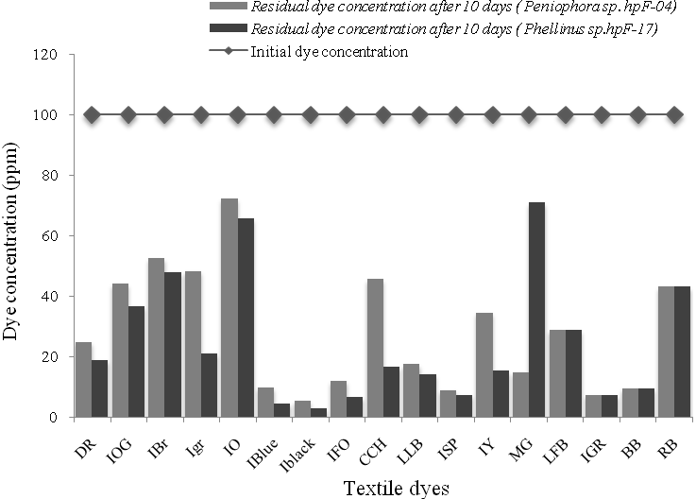
Figure 1. Decolorization efficiency (as dye % remaining after 10 days of incubation) of textile dye by isolates in liquid cultures.

Crude extracellular extracts were able to decolorize some of these dyes but not as efficiently as the cultures. Crude extracellular extracts of Peniophora sp.hpF-04 were able to decolorize only 2 and those of Phellinus sp.hpF-17 extracts were able to decolorize 5 out of 17 dyes only up to 60% (Fig.2).

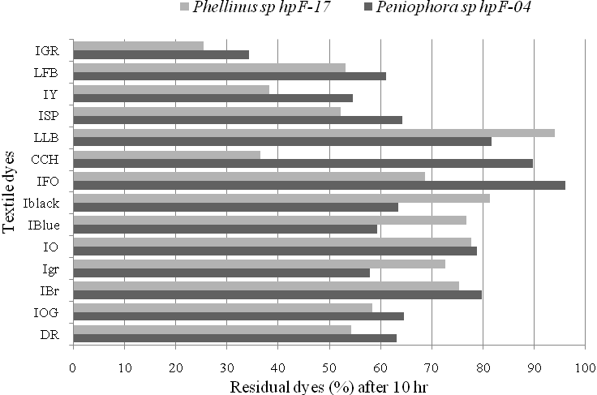
Figure 2. Decolorization efficiency (as dye % remaining after 10 hours of incubation) of textile dyes by Peniophora sp.hpF-04 and Phellinus sp.hpF-17 in liquid cultures.

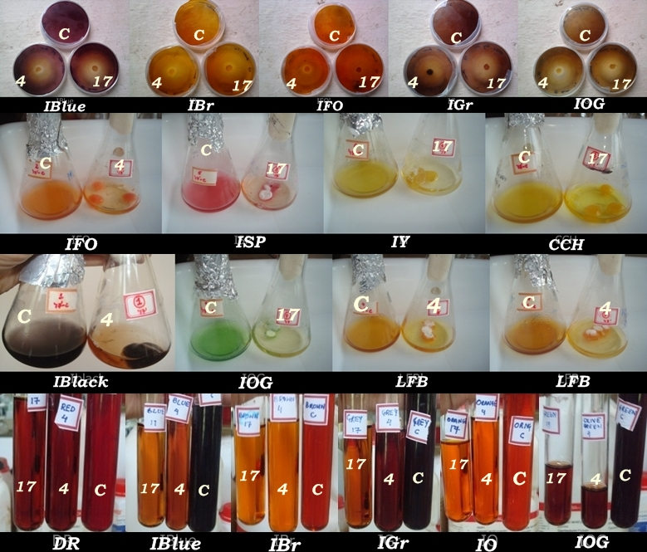
Figure 3. Visual observations of decolorization of textile dyes by solid plates (first row), liquid cultures (middle two rows) and culture filtrate extracts (last row). (Label: C-Control; 4-hpF-04; 17-hpF-17).

4. Discussions
Physiologically different fungal strains were isolated and studied for their ligninolytic enzymes. Isolation and screening of autochthonal fungi was previously carried out by many investigators. Dhouib and Co, in 2005 isolated 315 strains of fungi from different Tunisian biotopes and found only 8 cultures producing significant amount of MnP, Lac and LiP in liquid cultures. Levin et al., (2004) and Saparrat et al., (2002) evaluated the ability of native Argentinean WRF for ligninolytic enzymes and found essentially Lac activity. Muzariri et al., (2001) screened 224 fungal strains from Zimbabwe for ligninolytic and cellulolytic activities. Read and Co,in 2001 isolated 10 strains of WRF from decaying wood of Zimbabwe and identified based on their gross and icroscopic characters as Trematus sp., Lentinus sp., Pycnoporous sp., Datrionia sp., Irpex sp., and Creptidotus sp., producing no lignin peroxidase in any of the tested culture conditions. Okino et al, (2000) isolated 116 Brazilian tropical rainforest basidiomycetes producing laccase and peroxidase enzymes. Pelaez, (1995) reported that among 68 species isolated from fruit-bodies of basidiomycetes collected in the Central region of Spain, laccase and Mn²⁺-oxidizing peroxidase are more common ligninolytic activities than LiP in the studied conditions. Ruqayyah et al., (2011) screened 313 strains of white rot fungi from Malaysian terrestrial habitat and found six strains producing all three classes of ligninolytic enzymes, one strain producing two classes and five strains producing only one class of ligninolytic enzymes.
The enzyme production profile shown in table 3 is only an indicative sign of promising producers of ligninolytic enzymes and is useful just to show which enzymes may possibly be responsible for decolorization of dyes. Negative LiP or MnP or laccase production in some strains may suggest that these fungi either produce no significant levels of these enzymes or their production require different conditions other than those tested here. The later is true for several strains of Trametes versicolor, Bjerkandera adusta which are known as LiP producers but do not always produce lignin peroxidase depending on strain or culture conditions (Kirk and Farrell, 1987, Waldner, 1988). Nerud and Misurcova, (1996) considered that ligninolytic enzyme production is highly conditioned or strain-related.
During dye decolorization study in solid plates, it was observed that decolorization zones, when developed, either originated and radiated from the central inoculum during incubation or produced as scattered, diffused decolorized areas. In most of the cases, all the decolorized zones were smaller than the diameter of the corresponding colonies, consistent with the decolorization being a secondary metabolic activity (i.e. ligninolytic enzyme production) of the older mycelium. There was a large difference in dye decolorizing ability between the six fungal strains of different genera, suggesting their physiological differences. Similar results were obtained by Levin et al., (2004) while evaluating the Argentinean white rot fungi for their ability to decolorize industrial dyes and also by Chiu and Co, (1988) while screening white rot fungi for their ability to decolorize Poly-R-478.
The role of sorption in dye decolorization (by removal of dye from solution due to adsorption of dye to the mycelium) appears to be minimal. The dyes were rapidly removed from the medium, as a result of adsorption process, but later were eliminated from the surface of the mycelium due enzymatic degradation. Artexga et al., (2001) and Levin et al., (2003) reported similar results when performing dye degradation experiments using white rot fungi.
The extent of color removal was not consistent with all the dyes used during liquid culture decolorization. This difference is probably due to the enzymatic system of the fungi and its substrate specificity. Some dyes were more resistant to fungal action, probably because of their chemical structures. It is also important to note that, both fungi Peniophora sp.hpF-04 and Phellinus sp.hpF-17 being predominant laccase producers, decolorization depends upon the laccase production as well as media components. Several authors discussed the role of enzymes in the decolorization activity of ligninolytic fungi (Sathiya moorthi et al., 2007, Nerud et al., 2004, Liu et al., 2004, Verma et al., 2002). Among the several ligninolyitic enzymes, laccase is highly studied for its role in decolorization and detoxification of various industrial and textile dyes. Many authors reported that laccase is solely responsible for the decolorization and degradation of dyes (Liu et al., 2004, Abdulla et al., 2000, Rodriguez et al., 1999, Casieri et al., 2005).
Since decolorization of dyes was not carried out at higher concentrations of enzymes, the amount of enzyme (1U) used may not be sufficient for the complete degradation of dyes. However, another reason could be that the other enzymatic mechanisms could be involved in in-vivo experiments. The dye present in the growth medium may induce the organism to produces other enzymatic systems which could enhanced the complete decolorization of dye in the liquid culture. Such observations were also reported by Rodriguez, (1999) and Levin et al., (2004).

Conclusion
In the present work new white rot fungal species producing ligninolytic enzymes were documented. The results showed that the strains of different origin have different ligninolytic systems. Two fungal strains such as Peniophora sp.hpF-04 and Phellinus sp.hpF-17 are reported for the first time as the efficient producers of laccase. The excellent performance of the isolates in different textile dye decolorization accentuates their potential in environmental decontamination.

Acknowledgements:

The authors would like to thank National Institute of Technology Karnataka (NITK) India for providing research facilities.

Corresponding Author:
Harisha Poojary
Research Scholar
Department of Chemical Engineering
National Institute of Technology Karnataka (NITK), India-575025

E-mail: harishjarkala@gmail.com

References
- Abdulla E, Tzanov T, Costa S, Robra KH, Cavaco-Paulo A, Gubitz GM. Decolorization and detoxification of textile dyes with a laccase from Trametes hirsute. Applied Environmental Microbiology 2000; 66 (8); 3357-62.
- Archibald FS. A new assay for lignin-type peroxidases employing the dye azure B. Applied Environmental Microbiology 1992; 58(9); 3110–16.
- Aretxaga A, Romero S, Sarra M, Vicent T. Adsorption step in the biological degradation of a textile dye. Biotechnology Progress 2001; 17(4); 664–68.
- Casieri L. Biodegradation and Biosorption of synthetic dyes by fungi. PhD thesis, Department of plant biology, University of Turin (Italy), 2005.
- Chiu SW, Ching ML, Fong KL, Moore D. Spent oyster mushroom substrate performs better than many mushroom mycelia in removing the biocide pentachlorophenol. Mycology Research 1998, 102(12); 1553–62.
- Collins PJ, Dobson ADW. Regulation of laccase gene transcription in Trametes versicolor. Applied Environmental Microbiology 1997; 63 (9); 3444–50.
- Couto SR, Herrera JL. Industrial and biotechnological applications of laccases. Biotechnology Advances 2006; 24(5); 500-13.
- da Silva M, Bergsten-Torralba LR, Nishikawa MM, Baptista DF, MagalhAes DP. Decolorization of different textile dyes by Penicillium simplicissimum and toxicity evaluation after fungal treatment. Brazilian Journal of Microbiology 2009; 40(4); 808-17.
- Dhouib A, Hamza M, Zouari1 H, Mechichi T, Hmidi R, Labat M, Martinez J M, Sayadi S. Screening for ligninolytic enzyme production by diverse fungi from Tunisia. World Journal of Microbiology Biotechnology 2005; 21(8-9); 1415-23.
- Hammel KE. Fungal degradation of lignin. In: Cadisch G, Giller KE. Driven by nature: plant litter quality and decomposition, chapter 2. CAB International, United Kingdom, 1997:33-45.
- Hatakka A. Lignin-modifying enzymes from selected white-rot fungi: production and role in lignin degradation. FEMS Microbiology Reviews 1994; 13(2-3), 125– 135.
- Ikehata K, Buchanan ID, Smith DW. Recent developments in the production of extracellular fungal peroxidases and laccases for waste treatment. Journal of Environmental Engineering and Science 2004; 3(1); 1-19.
- Keyser P, Kirk TK, Zeikus JG. Ligninolytic enzyme system of Phanerochaete chrysosporium: synthesized in the absence of lignin in response to nitrogen starvation. Journal of Bacteriology 1978; 135(3); 790–97.
- Kirk TK, Farrell RL. Enzymatic combustion: the microbial degradation of lignin. Annual Reviews in Microbiology 1987; 41(1); 465–505.
- Levin L, Forchiassin F, Viale A. Degradation of organic pollutants by the white-rot basidiomycete Trametes trogii. International Biodeterioration and Biodegradation 2003; 52(1); 1-5.
- Levin L, Papinutti L, Forchiassin F. Evaluation of Argentinean white rot fungi for their ability to produce lignin-modifying enzymes and decolorize industrial dyes. Bioresource Technology 2004; 94 (2); 169–76.
- Liu WX, Chao XP, Yang XQ, Bao HB, Quian SJ. Biodecolorization of azo, anthraquinone and triphenyl methane dyes by white rot fungi and laccase secreting engineered strain. Journal of Industrial Microbiology Biotechnology 2004; 31(3); 127-32.
- Machado KMG, Compart LCA, Morais RO, Rosa LH, Santos MH. Biodegradation of reactive textile dyes by basidiomycetous fungi from Brazilian ecosystems. Brazilian Journal of Microbiology 2009, 37; 481-87.
- Martinez AT, Molecular biology and structure-function of lignin degrading heme peroxidases. Enzyme and Microbial Technology 2002; 30(4); 425-44.
- Nerud F, Baldrian P, Eichlerora I, Merhautova V, Gabriel J, Homolka L. Decolorization of dyes using white rot fungi and radical generation reactions. Biocatalysis Biotransformation 2004; 22(5-6); 325-30.
- Nerud F, Misurcova Z. Distribution of ligninolytic enzymes in white rot fungi. Folia Microbiology 1996; 41(3); 264–66.
- Okino LK, Machado KMG, Fabris C, Bononi VLR. Ligninolytic activity of tropical rainforest basidiomycetes. World Journal of Microbiology Biotechnology 2000;16 (8-9); 889-93.
- Pelaez F, Martinez MJ, Martinez AT. Screening of 68 species of basidiomycetes for enzymes involved in lignin degradation. Mycology Reswarch 1995; 99(1); 37–42.
- Pointing SB. Feasibility of bioremediation by white-rot fungi. Applied Microbiology Biotechnology 2001; 57(1-2); 20–33.
- Pointing SB, Pelling AL, Smith GJD, Hyde KD, Reddy CA. Screening of basidiomycetes and xylariaceous fungi for lignin peroxidase and laccase gene-specific sequences. Mycology Research 2005; 109(Pt1); 115-24.
- Raghukumar C, Mohandass C, Kamat S, Shailaja MS. Simultaneous detoxification and decolorization of molasses spent wash by the immobilized white rot fungus Flavodon flavus isolated from a marine habitat. Enzyme and Microbial Technology 2004; 35(4), 197-202
- Read JS, Tekkere M, Zvauya R. Ligninolytic enzyme production in selected sub-tropical white rot fungi under different culture conditions. Journal of Basic Microbiology 2001; 41 (2); 115–29.
- Reddy CA. The potential for white-rot fungi in the treatment of pollutants. Current Opinion in Biotechnology 1995; 6(3); 320-28.
- Reddy CA, Mathew Z. Bioremediation Potential of White Rot Fungi. In: Gadd GM. Fungi in Bioremediation 1st edn, Cambridge University Press, UK, 2001:1-12.
- Robinson T, McMullan G, Marchant R, Nigam P. Remediation of dyes in textile eﬄuent: a critical review on current treatment technologies with a proposed alternative. Bioresource Technology 2001; 77(3); 247–55.
- Rodriguez E, Pickard MA, Vazquez-Duhalt R. Industrial dye decolorization by laccases from ligninolytic fungi. Curr Microbiol 1999; 38(1); 27–32.
- Ruqayyah TID, Jamal P Md., Alam Z, Mirghani MES. Lignin modifying enzyme activities by some Malaysian white rot fungi. ACT-Biotechnology Research Communications 2011; 1(1); 14-19.
- Saparrat MCN, MartInez MJ, Cabello MN, Arambarri AM. Screening for ligninolytic enzymes in autochthonous fungal strains from Argentina isolated from different substrata. Review Iberoam Microlology 2002; 19(3); 181-85.
- Sathiya moorthi P, Periyar selvam S, Sasikalaveni A, Murugesan K, Kalaichelvan PT. Decolorization of textile dyes and their effluents using white rot fungi. African Journal of Biotechnology 2007; 6 (4); 424-29.
- Tian X, Airong Li, Zhu Y, Xu L, Zhu W. Comparative study on the determination of assay for laccase of Trametes sp. African Journal of Biochemical Research 2008; 2(8); 181-83.
- Tien M, Kirk TK. Lignin peroxidase of Phanerochaete chrysosporium. In: Abelson JN, Simon MI, Wood WA, Kellogg ST. Methods in enzymology-Biomass, part b, lignin, pectin, and chitin. 1st ed. CA: Academic press, San Diego. 1988:238-49.
- Verma P, Madamwar D. Decolorization of synthetic textile dyes by Lignin Peroxidase of Phaenerochaete chrysosporium. Folia Microbiology 2002; 47(3); 283-86.
- Waldner R, Leisola MSA, Fiechter A. Comparison of ligninolytic activities of selected white-rot fungi. Applied Microbiology Biotechnology 1988; 29 (4); 400–07.
- Zhao XH, Lu YP, Hardin I. Determination of biodegradation products from sulfonated dyes by Pleurotus ostreatus using capillary electrophoresis coupled with Mass spectrophotometer. Biotechnology Letters 2005; 27(1), 69-72.

07/14/2012

