Influence of spent mushroom compost (SMC) of Pleurotus ostreatus on the yield and nutrient compositions of Telfairia occidentalis Hook .F.A. (Pumpkin) ,a Nigerian leafy vegetable

Jonathan S.G,Oyetunji O.J and Asemoloye M.A

Department of Botany and Microbiology, University of Ibadan.Ibadan.Nigera
gbolyjoe@yahoo.com

Abstract: The potted pumpkin plants studied were harvested after twelve weeks and the results obtained showed that Telfairia occidentalis planted on 30% SMC soil had the best growth followed by 20%, 50%, 0% and 100% SMC (in respect to plant height, leaf number, stem girth, and leaf area). The Biological Efficiencies (B.E.) of the vegetable was calculated using the field dry weight (FDW) of the plant and the results obtained showed that 30% SMC produced the best above and below ground biomass with B.E. of 40.2% and 29.8% followed by 20% SMC (23.9% and 24% B.E.) and 10% SMC (14.1% and14%). The least B.E. was 1.4 and 4.9% of the 0 and 100% SMC plants respectively. Moreover, the mineral contents of the vegetable revealed that most of the minerals such as iron, magnesium, calcium, phosphorus and potassium increased as the concentration of the SMC in the soil increases, while zinc concentration decreases with SMC treatments. The pH values of SMC treated soil increased significantly with the % of SMC in the soil. The significance of the above observation was discussed.
[Jonathan S.G, Oyetunji O.J and Asemoloye M.A. Influence of spent mushroom compost (SMC) of Pleurotus ostreatus on the yield and nutrient compositions of Telfairia occidentalis Hook .F.A. (Pumpkin) ,a Nigerian leafy vegetable. Nat Sci 2012;10(10):149-156]. (ISSN: 1545-0740). http://www.sciencepub.net/nature. 21

Keywords: Telfairia occidentalis , mineral elements, biological efficiency, SMC, biomass.

Introduction
Mushrooms belong to the basidiomycetes class of the kingdom fungi (Jonathan et al.,2011a;Adebayo-Tayo et al.,2011). They are group of achlorophilous organisms which lack (devoid) photosynthetic pigments and are spore bearing, living parasitically or saprophytically on an organic substratum (Howarth, 2003;Aina et al.,2012). Many species of mushrooms are cultivated worldwide. Global production is greater than six million tonnes and has an approximate value of at least $US14 billion. Global production increased to about 6.2 million tonnes in 1997, with a more than 12% increase annually from 1981 to 1997 (Chang, 1999 and Danny, 2002).
Presently, global commercial mushroom production has skyrocketing by 35.9% between 1995 and 2005. It is estimated that world production of mushroom comprised about 5 million tonnes of fresh weight annually (Omarini et al., 2010).Artificial cultivation of mushroom is at its inception in Nigeria with few growing industries which could not meet mushroom demand of the populace (Jonathan et al., 2011b). Seventy percent of the global mushroom production is derived from three mushroom groups, Agaricus bisporus, Pleurotus spp, and Lentinula edodes. The remaining mushroom volume is generated by at least a dozen species (Chang, 1999)
Mushroom growing is an eco-friendly activity as it utilizes the waste from agriculture, horticulture, poultry, brewery etc. for its cultivation. However, piling up of “spent mushroom substrate” released after mushroom crop harvesting may cause various environmental problems, including ground water contamination and nuisance (Beyer, 1996).
Spent mushroom compost (SMC) also known as spent mushroom substrate (SMS) was defined as the leftover of wastes after different flushes of mushrooms have been harvested(Jonathan et al,2011c. It is a by-product of the mushroom industry, after different mushroom flushes have exhausted the main nutrient in the substrates(Fasidi et al., 2008). The weathered SMC are those that undergo further decomposition for several weeks before their utilization by farmers as soil conditioner (Jonathan et al., 2006;Jonathan et al.,2011c). Chang et al. (2000) reported that the SMC was entangled with innumerable mushroom threads (collectively referred to as mycelia) which could have modified the substrate biochemically by production of enzymes.
Uncontrolled disposal of SMC may pose a problem to the environment. This problem may include foul odour and other problems associated with air pollution. It is therefore, necessary to recycle this so called useless material to a utilizable .The demand for organic residues and compost has also increased several folds considering the ill effects of synthetic inorganic fertilizers. The low soil pH level is one of the most common limiting factors for plant development, and there is a need to increase it using compost.
Kabata-Pendias et al. (2000) explained that, critical aspects of soil fertility management include pH, secondary nutrients and micronutrients. Also, many of our agricultural lands have been over utilized by inadequate farming practice, and these results in nutrient depletion of soils (Jonathan et al., 2011c).
Telfairia occidentalis (Hook.f.) is an edible vegetable belonging to the family Cucurbitaceae. It is a tropical vine grown in West Africa as a leaf vegetable and for its edible seeds (Fagbemi et al., 2006). Common names for the plant include fluted gourd, fluted pumpkin, iroko and ugwu. It is a creeping vegetable shrub that spreads low Harvesting of fluted pumpkin takes place 120-150 days after sowing (Agatemor, 2006). The young shoots and leaves of the female plant are the main ingredient of Nigerian Ugwu soup. It has been shown that leaf protein concentrates from T. occidentalis are rich in protein and minerals (Aletor et al., 2002). The leaves and seeds Telfairia occidentalis are widely eaten as they are good sources of minerals (potassium, magnesium, sodium, phosphorus and iron), vitamins, fibres, fats (Schipper, 2000; Nkang et al., 2003; Christian, 2006). It is rich in amino acids, vitamins and minerals. It is a ready source of proteins because of its ability to synthesize amino acids from a wide range of virtually available primary materials such as water, carbon dioxide and atmospheric nitrogen. According to Oboh, (2005) Telfairia occidentalis prevents against garlic – induced oxidative stress. The plant also prevents the occurrence of abdominal pain, small intestine obstruction, dermatitis, asthma and increase of bleeding which are caused by garlic.
Inorganic fertilizers are mostly being used for production of organic food but their prices are beyond the reach of many local farmers in the developing countries like Nigeria (Jonathan et al., 2011c). Organic farms need to be supplied with Nitrogen through sources such SMC (Chefetz et al., 2000). SMC has many attributes aiding its exploitation in place of inorganic farm yard manure (FYM) in raising organic field crops and environment management (Ahlawat and Sagar, 2007). Therefore the objectives of this work are to convert the mushroom waste (SMC) to a utilizable product, to determine the dose of SMC that will best support the vegetable yield and to determine the effect of SMC on the pH of the soil.
2. Materials and methods
2.1 Collection of samples
Cultivated soil samples used for this experiment were collected from the Botanical Nursery of the Department of Botany, University of Ibadan while the SMC was collected from Beehay Mushroom Ventures dumping ground, at Ibadan, Nigeria, after it has been disposed for 7days. Treated seeds of the pumpkin were collected from Tobol Agro Care, Ibadan.
2.2 Experimental set up
This was done as a pot experiment and it was carried out in the greenhouse. Six different levels of SMC of oyster mushroom were chosen, that is, 0% (Control), 10%, 20%, 30%, 50% and 100% supplemented with 5grams of cultivated soil in green house. The cultivated soil and SMC properties are shown in Table 2 and 3 respectively. This experiment was done between the months of August to November 2011. The SMC and 5grams of soil were mixed together in a basin using bare hand (in different percentages) and bagged in polythene bags; these were done in three replicates and are arranged on the shelves in a completely randomised design fashion. SMC was applied to the experimental soil in the following fashion like the one developed by Onal and Topcoglu (2003) and Oyetunji et al. (2002).

- SMC0 %: no SMC application (Control)
- SMC10 %: 0.5kg of SMC /5kg of Soil
- SMC20 %: 1kg of SMC /5kg of Soil
- SMC30 %: 1.5kg of SMC /5kg of Soil
-SMC 50 %: 2.5kg of SMC /5kg of Soil
-SMC 100 %: Only SMC (Control)

All pots were arranged on the shelves in the greenhouse under controlled climatic conditions. Pots were maintained around field capacity by daily watering with 100mil of water.
The vegetable seeds were planted directly inside the pots based on the SMC treatment and each treatment was replicated trice and the pots were labelled. The seeds germinated after seven days and the collection of growth parameters started on the 14th day of planting.
The basic procedures taken for collection of growth parameters and analysis were as follows.
- Plant height was determined by placing a thread from the ground level to the tip of the terminal bud and the length of the thread measured with a ruler to determine- the height.
- Plant diameter was determined by the use of electronic calliper (Hand veneer calliper) by placing it 1cm above the ground level
- Number of leaf and node were recorded by counting
- Leaf Length, diameter and Leaf area was determined using the leaf Area Meters LI-COR (LI-3000C)
2.4Biomass analysis
The studied vegetable plants were harvested after 14weeks of planting. The shoots and roots of different SMC treatments were taken to the laboratory immediately after harvesting for quantitative measurement and were air-dried for 2 weeks. Field dry weight was measured using a digital Weighing balance (Ohaus Scout). The Field Dry Weight of the plant parts were measured after the water content of the plant has been eliminated.

2.5 Nutrient analysis
The nutrient analysis was done at the soil laboratory of The Department of Agronomy, University of Ibadan. Organic carbon, organic matters, % Nitrogen, Phosphorus, Potassium were determined using official methods of the Association of Analytical Chemists (AOAC, 2005). Total N were determined by Kjeldahl method. Plant tissues were ground and digested in aqua regia (1:3 HNO3/HCl). In wet ashed leaf samples total P were determined by molibdophosphoric yellow colour method, total K, Ca, Mg, Fe, and were determined by atomic absorption spectrophotometry (FAAS) under optimised measurement conditions.

2.6 pH Determination
The pH of the soil sample used for this experiment was first determined before mixing it with different percentages of SMC. After the addition of SMC, the pH of the mixture were taken in the next five weeks in other to allow the soil to adjust its PH as a result of the SMC addition as suggested by Herald, (2010).
To determine the pH of a pot, soil samples (about 20g) were taken from the top 20 cm with a trowel into a clean container selected at five random spots in the area of the pot. The soil samples were mix together to get an average reading. Soil pH test kit and the glass electrode pH meter called Eutech EcoTestr pH 2 were used in taking the readings. The Soil sample was scoop up loose with a clean, dry plastic jar, stones and any clumps of soil was crushed to prevent breaking the delicate tester’s glass electrode bulb.
The soil sample was then mixed with distilled water (1:1 ratio) in a clean jar to form an emulsion; the jar was tightly caped and shacked vigorously for some few times. The mixed sample was allowed to stand for 5 – 10 minutes so that the salts in the soil can dissolve in the distilled water. EcoTestr was switched on after the cap has been removed and the electrode bulb was submerged fully into the wet soil slurry.
The reading was taken after it stabilized. The hold button was pressed to freeze the reading for recording and pressed again to release the reading. This was repeated two more times for higher accuracies.

2.6 Yield and biological efficiency
The biological fficiency (B.E.) of the vegetable was calculated using the field dry weight (above and below ground biomass) of the harvested plant. These were calculated as given by Chang et al, 1981 using the formula:

BE= FDW / TFDW ÷ 100%

Where B.E. = Biological Efficiency
FDW = Field Dry Weight of the plant and
TFDW = Total Dry Weight of the plant

2.7 Statistical analysis
Data obtained were analysed using Analysis of Variance (ANOVA). The means were separated with Duncan Multiple Range Test (P<0.05)

3. Results and Discussion
3.1 Results from the growth analysis
Parameters recorded for the growth analysis of T. occidentalis is recorded in figures 1, 2, 3 and 4 above. The result on SMC application showed that the application of SMC has a direct growth promoting effect on the growth of the vegetable in terms of Leaf Number (Fig. 1), Plant Length (Fig. 2), Stem Diameter or Girth (Fig. 3), Number of Nodes, and Leaf Area (Fig. 4).
The result obtained showed that Pumpkin plants planted on 30% SMC soil had the best growth (with mean leaf area of 116.9cm², mean plant length of 103.0cm and mean girth diameter of 8.5cm) follow by 20% SMC plants (with mean leaf area of 95.9cm², mean plant length of 86.1cm and mean girth diameter of 6.3cm) and 50% SMC plants (mean leaf area of 80.1cm², mean plant length of 72.98cm and mean girth diameter of 5.1cm). The least growth was recorded for Pumpkin plant planted on 0% SMC (with mean leaf area of 59.1cm², mean plant length of 64.1cm and mean girth diameter of 1.6cm) and 100% SMC (with mean leaf area of 52.6cm², mean plant length of 51.6cm and mean girth diameter of 3.4cm).

3.2 Result from the biomass analysis.
The biological efficiencies (B.E.) of the vegetables was calculated using the Field dried above and below weight of the plant. The result otained (Table 5) showed that 30% SMC was the best off ground biomass for T. occidentalis with B.E. of 40.2% followed by 20% SMC with B.E. of 23.9% and 10% SMC with B.E of 14.1%, the least B.E recorded for above ground biomass of the plant was 1.4 and 4.9% of the 0 and 100% SMC plants respectively. Also, the result gotten for B.E of the bellow ground biomass of Pumpkin showed that 20% SMC was the best with B.E. of 29.8% followed by 20% SMC with B.E. of 24% and 10% SMC with B.E of 14%, the least B.E was 10.7 and 10.3% of the 0 and 100% SMC plants respectively.

Table 1: Effect of different levels of SMC application on the growth of Telfaira occidentalis

Parameters | SMC | NUMBER OF WEEKS
(Cm) | (%) | 2 3 4 5 6 7 8 9 10 11 12 |  |  |  |  |  |  |  |  |  |  | MEAN
Leaf No. | 0 | 3 | 5 | 7 | 10 | 12 | 15 | 17 | 19 | 20 | 23 | 24 | 12.9e
Leaf No. | 10 | 4 | 7 | 9 | 13 | 15 | 17 | 19 | 23 | 25 | 30 | 31 | 16.9d
Leaf No. | 20 | 5 | 8 | 13 | 16 | 19 | 21 | 24 | 26 | 29 | 36 | 38 | 21.3b
Leaf No. | 30 | 5 | 9 | 15 | 17 | 21 | 24 | 28 | 31 | 34 | 39 | 41 | 24.5a
Leaf No. | 50 | 5 | 7 | 9 | 12 | 15 | 17 | 20 | 23 | 25 | 31 | 32 | 20.5c
Leaf No. | 100 | 2 | 4 | 5 | 8 | 11 | 13 | 15 | 18 | 19 | 22 | 23 | 20c
Plant Length | 0 | 3.67 | 9.9 | 26.7 | 50.7 | 63.6 | 78.6 | 92.27 | 98.03 | 105.4 | 119.07 | 120.8 | 64.1e
Plant Length | 10 | 7.2 | 14.1 | 42.1 | 63.7 | 72.9 | 83.9 | 101.4 | 110.8 | 119.7 | 127.9 | 130.4 | 73.7c
Plant Length | 20 | 12.7 | 27.5 | 47.9 | 75.2 | 93.6 | 103.8 | 118 | 126.1 | 129.5 | 138.8 | 140 | 86.1b
Plant Length | 30 | 19.3 | 53.4 | 63.5 | 91.4 | 110.8 | 120.1 | 131.1 | 140.7 | 155.5 | 160.1 | 160.5 | 103.0a
Plant Length | 50 | 6.1 | 13 | 30 | 51.7 | 67.9 | 80.1 | 100.2 | 108.7 | 115 | 126.3 | 126.7 | 72.98d
Plant Length | 100 | 2.9 | 6.7 | 12 | 26.6 | 39.5 | 56 | 66.9 | 70 | 76.1 | 80.9 | 81.7 | 51.6f
No of Nodes | 0 | 2 | 2 | 4 | 5 | 6 | 7 | 9 | 10 | 11 | 15 | 16 | 7.25f
No of Nodes | 10 | 2 | 4 | 7 | 8 | 10 | 11 | 13 | 14 | 16 | 18 | 19 | 11e
No of Nodes | 20 | 3 | 4 | 7 | 9 | 11 | 12 | 1 | 15 | 17 | 22 | 23 | 12d
No of Nodes | 30 | 3 | 6 | 10 | 11 | 14 | 17 | 19 | 21 | 23 | 26 | 27 | 17.3a
No of Nodes | 50 | 3 | 4 | 5 | 7 | 10 | 11 | 13 | 15 | 17 | 20 | 21 | 14.7c
No of Nodes | 100 | 1 | 2 | 3 | 5 | 6 | 8 | 9 | 12 | 12 | 14 | 15 | 15.6b
Girth | 0 | 0.47 | - | 0.87 | - | 1.29 | - | 2.23 | - | 2.87 | - | 3.8 | 1.6f
Girth | 10 | 1.3 | - | 1.5 | - | 2.5 | - | 3.7 | - | 4.7 | - | 5.8 | 4.2d
Girth | 20 | 1.6 | - | 2.4 | - | 3.6 | - | 4.8 | - | 5.5 | - | 6.3 | 6.3c
Girth | 30 | 2.2 | - | 3.9 | - | 4.4 | - | 5.5 | - | 6.7 | - | 6.8 | 8.5a
Girth | 50 | 0.6 | - | 0.9 | - | 1.5 | - | 2.4 | - | 3.3 | - | 5 | 9.1b
Girth | 100 | 0.3 | -- | 0.6 | - | 0.9 | - | 1.5 | - | 1.9 | - | 3.4 | 3.4e
Mean Leaf Area (cm²) | 0 | 6 | 11.8 | 18.2 | 40 | 55 | 67.8 | 75.6 | 86.5 | 99.4 | 120 | 128.7 | 59.1d
Mean Leaf Area (cm²) | 10 | 12.2 | 19.5 | 34.8 | 69 | 80 | 89.1 | 105.1 | 120 | 125.6 | 146.2 | 150.5 | 80.2c
Mean Leaf Area (cm²) | 20 | 17.1 | 26.5 | 48.5 | 78.1 | 100.8 | 117.8 | 128 | 138.6 | 144.4 | 160.1 | 170.9 | 95.9b
Mean Leaf Area (cm²) | 30 | 24.8 | 48.5 | 84.4 | 108.8 | 127.8 | 136.9 | 145.2 | 153.6 | 161.5 | 184.4 | 197.6 | 116.96a
Mean Leaf Area (cm²) | 50 | 8.6 | 21.8 | 29.6 | 57.8 | 73.2 | 96.6 | 107.3 | 115.5 | 125.6 | 136.1 | 138.6 | 80.1c
Mean Leaf Area (cm²) | 100 | 2.8 | 5.6 | 12 | 21.8 | 29.3 | 40.1 | 48.5 | 57.2 | 63.8 | 124.2 | 126.4 | 52.6e
Values are mean of 3 replicates. Means with different letters in the same row on each growth parameters are significantly different (P <0.05).

Table 2: Mean Biomass Analysis of T. occidentalis

T. occidentalis | ABOVE GROUND (g) | BELLOW GROUND (g)
(% SMC) | FDW B.E. | FDW B.E
0% | 6.3 6.4e | 2.6 10.7d
10% | 14.4 14.7c | 3.4 14.0 c
20% | 23.4 23.9b | 5.9 24.4b
30% | 39.4 40.2a | 7.2 29.8a
50% | 9.6 9.8d | 2.6 10.7d
100% | 4.8 4.9f | 2.5 10.3d
Total Field Dry Weight | 97.9 | 24.2
Values are mean of 3 replicates. Means with different letters in the same row on each B.E are significantly different (P <0.05). B.E = Biological Efficiency. FDW = Field Dry Weight.

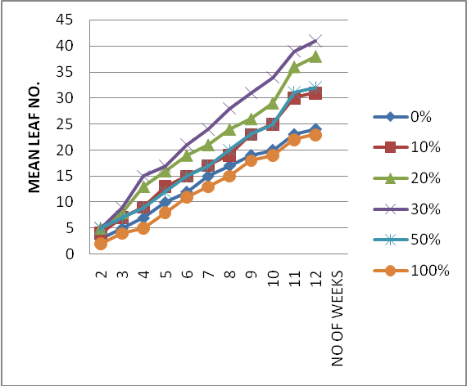 Figure 1: The impact of SMC on the leaf numbers of T. occidentalis.

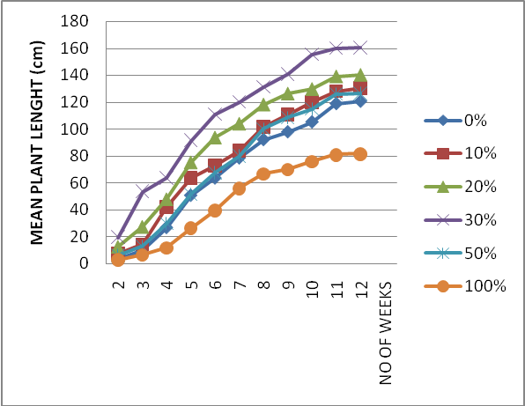
Figure 2: The effect of SMC on the length of T. occidentalis (cm).

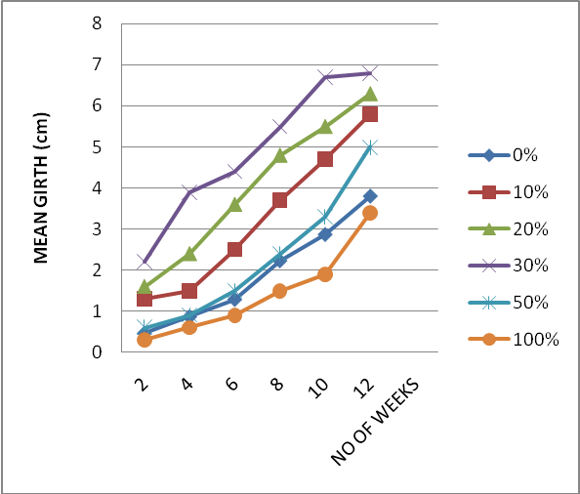
Figure 3: The effect of SMC on the stem girth of T. occidentalis.

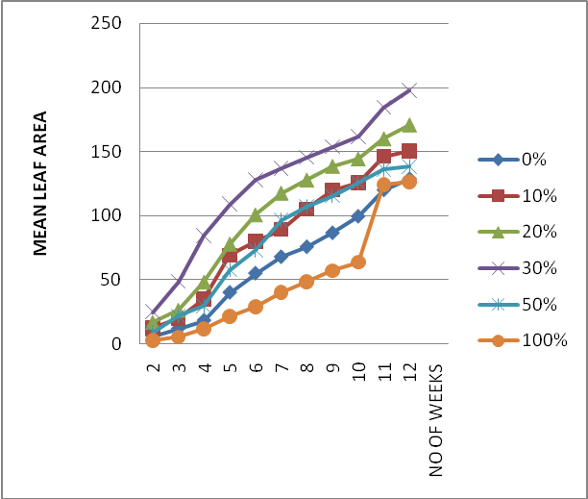Figure 4: The effect of SMC on the leaf area (cm²⁾ of T. occidentalis.

.

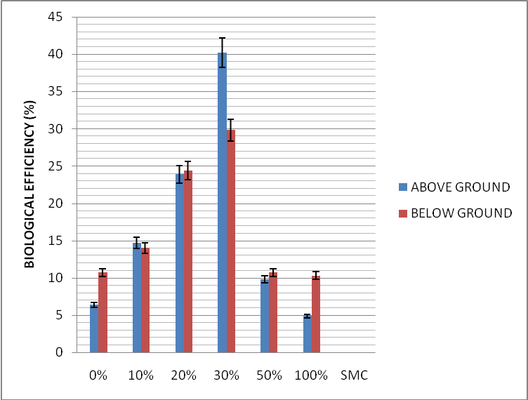
Figure 5: Effect of SMC on Biological Efficiency of T. occidental. (Error bars with 5% value)

3.3 Nutrient Analysis

Table 6: Effect of SMC Application on the Mineral Composition of T. Occidentalis (mg/100g)
NUTRIENTS
SMC | Fe Mg Ca Na K P Zn Mn %Ash
(0%) | 13.1a 16.1a 17.8a 3.4a 90.1a 76.0a 12.0f 0.16e 6.5a
10% | 14.1b 19.4b 22.1b 4.9b 90.1a 77.5b 11.1e 0.07d 7.3b
20% | 16.6c 20.1c 23.4c 5.2c 96.3b 78.3c 10.0d 0.05c 7.8c
30% | 16.7c 22.7d 23.7c 5.8c 96.1b 78.6c 9.1c 0.03b 8.1d
50% | 17.1d 23.4e 24.6d 6.4d 98.4c 80.1d 8.2b 0.03b 7.7e
100% | 18.6e 26.1f 29.5e 8.7e 104.3d 89.2e 7.6a 0.01a 4.6f
Each value is the mean for three replicates. Means with different letters in the same row on each growth parameters are significantly different (P <0.05).

Result of the nutrient analysis showed that the plant has potassium and phosphorus, as the highest nutrient constituents with manganese and sodium as the lowest constituents. Most of the minerals such as iron, magnesium, calcium, phosphorus and Potassium increased as the concentration of the SMC in the soil increased up to 100% while Zinc decreased with increased SMC concentrations. Magnesium concentrations increased up to 30% SMC and then, decreased up to 100% SMC level. The ash content of the plant was also found to be influenced by the addition of SMC. It increased from 0% SMC i.e. 6.5 to 30% SMC i.e.8.1 as the highest level and then decreased to 100% SMC i.e. 4.6.
3.4 pH Determination

Table 7. The Effect of SMC addition on the pumpkin soil pH
 | No of Weeks
% SMC | 0 4 5 6 7 8 9 10 11 12
0 | 4.8 - - 5.0 4.59 5.6 5.31 5.4 5.3 5.4
10 | - - - 6.2 6.4 6.3 6.6 6.6 6.6 6.4
20 | - - - 6.4 6.2 6.6 6.7 6.7 6.8 6.9
30 | - - - 6.5 6.7 6.8 7.1 7.2 7.0 7.1
50 | - - - 6.1 6.5 6.7 6.7 6.6 8.0 8.1
100 | - - - 6.6 6.9 7.4 7.8 7.8 8.1 8.5
Each value is the mean for three replicates

From table 7, the initial pH of the soil was recorded at 0day to be 4.8. after the addition of SMC the it was discovered that the SMC was able to raised the pH of the soil from 4.8 recorded from week 0 to 6.4 in 10%SMC soil, 6.9 in 20%SMC, 7.1 and 8.1 in 30 (which had the best growth and yield) and 50% SMC respectively.

4.0 Conclusion
This study showed that the different concentration of spent mushroom compost (SMC) of Pleurotus ostreatus in the soil has a direct effect of on the yield and nutrient composition of T. occidentalis. All plant cultivated on soil treated with SMC showed yield different from those of the control.This established the fact that SMC has positive effects on the growth of the vegetable.
This study made it clear that 30% Level of SMC in soil best support the pumpkin growth followed by 20, 30, and 50% SMC treatments. It was also observed that application of SMC at these rates raises the nutrient content of this desired vegetable. However, 100% SMC plant performed the least in terms of growth, biological efficiency and dry weight, this agrees with the suggestion of American Mushroom Institute, 2003 that SMC alone was not good for planting. Moreover, this study affirmed the ability of SMC to increase the soil pH.

Correspondence to:
Dr Jonathan Segun Gbolagade
Department of Botany & Microbiology,University of Ibadan,Ibadan.Nigeria.
Email: gbolyjoe@yahoo.com
Tel:2348164746758

References
- Adebayo-Tayo B.C,Jonathan S.G ,Popoola O.O and Egbomuche R.C 2011.Optimization of growth conditions for mycelia yield and exo -polysaccharides production by Pleurotus ostreatus cultivated in Nigeria. African Journal of Microbiology Research.5 (15):2130-2138
- Agatemor, C. 2006. Studies of selected physicochemical properties of fluted pumpkin (Telfaira occidentalis Hook F) seed oil and tropical almond (Terminalia catappia L.) seed oil. Pak. J. Nutr. 5: 308-309.
- Aina DA, Oloke JK, Jonathan SG and Olawuyi OJ(2012) .Comparative assessment of mycelial biomass and exo-polysaccharide production of wild type and mutant strains of Schizophyllum commune grown in submerged liquid medium Nature and Science 10(10):82-89.
- Ahlawat, O. P., Dev Raj, Sagar, M. P., Gupta Pardeep, and Vijay, B.. Effect of recomposted button mushroom spent substrate on growth, yield and quality of Ginger (Zingiber officinale). Indian Journal of Mushrooms.
- Aletor, O., Oshodi, A.A. and Ipinmoroti, K. 2002. Chemical composition of common leafy vegetables and functional properties of their leaf protein concentrate. Food Chem. 78: 63-68.
- Association of Official Analytical Chemists (A.O.A.C). 2005. Methods of Analysis. Washington D.C.
- Beyer, M.1996. The impact of the mushroom Industry on the environment. Mushroom News 44(11): 6-13.
- Chang S. T., Lau, O. W. And Cho, K. Y. 1981. The cultivation and nutritive value of Pleurotus Sajor-caju. European J. Appl. Microbiol. Biotechnol. 12:58-62.
- Chang, S.T. 1999. World production of cultivated edible and medicinal mushrooms in 1997 with emphasis on Lentinus edodes (Berk.) Sing. in China. International Journal of Medicinal Mushrooms 1:291-300
- Chang, I.S., P.K. Shin, B.H. Kim, I.S. Chang, P.K. Chang, P.K. Shin and B.H. Kim. 2000. Biological treatment of acid mine drainage under sulfate-reducing conditions with solid waste materials as substrate. Water Research 34(4):1269-1277.
- Chefetz, B. J. van Heemst, D.H., Chen, Y., Romaine, C.P., Chorover, J., Rosario, R., Guo, M.and Hatcher, P.G. 2000. Organic matter transformations during the weathering process of spent mushroom substrate. Journal of Environmental Quality 29(2):592-602.
- Christian, A. 2006. Studies of selected Physico chemical properties of fluted pumpkin (Telfaria occidentalis Hook F.) Seed oil and tropical almond (Terminalia catappia, L.) seed oil. Pakistan J. Nutr., 5 (4), 306 – 307.
- Fasidi, I.O., Kadiri, M., Jonathan, S.G., Adenipekun, C.O. and Kuforiji, O.O. 2008. Cultivation of tropical mushrooms. Ibadan: Ibadan University Press
- Herald Hoffmann. 2010. Soil pH and plant health in the home garden. ISSN. 0817-5969. Pg. 174-180. Website: www.agric.wa.gov.au/publications.
- Howath, R. S. 2003. Microbial co-metabolism and the degradation of organic compounds in nature. Bacteriol. Reu.362146-155.
- Gbolagade JS. 2006. Bacteria associated with compost used for cultivation of Nigerian edible mushrooms: Pleurotus tuberregium (Fr.) Singer, and Lentinus squarrosulus (Berk.) Afr J Biotechnol 5:338-42.
- Jonathan, S.G. 2002. Vegetative growth requirements and antimicrobial activities of some higher fungi in Nigeria [dissertation]. Ibadan: University of Ibadan.
- Jonathan S.G,Amos Tautua B.M.W and Olawuyi,O.J (2011a).Food values, heavy metal accumulation, aflatoxin contamination and detection of exo- polysaccharides inLentinus Squar-rosulus Berk, a Nigerian mushroom. African Journal of Agricultural Research. 6(13):3007-3012
- Jonathan, S.G., Adeoyo, O.R. 2011b. Evaluation of ten wild Nigerian mushrooms for amylase and cellulase activities. Mycobiology 39:103-8.
- Jonathan S.G., Muritala, M.L. and Oyetunji, J.O. 2011c. Effect of Spent Mushroom Compost of Pleurotus pulmonarius on Growth Performance of Four Nigerian Vegetables. Mycobiology 39(3) : 164-169.
- Kabata, A. and Pendias, H. 2000. Trace elements in soils and plants. CRC Press, Boca Raton, FL.
- Oboh, G. 2005. Hepatoprotective Property of Ethanolic extract of fluted pumpkin leaves against garlic – Induced Oxidative stress. J. Med. Food 8(4) 560-563.
- Omarini, A., Nepote, V., Grosso, N. R., Zygadlo, J. A. and Alberto, E. 2010. Sensory analysis and fruiting bodies characterization of the edible mushrooms Pleurotus ostreatus and Polyporus tenuiculus ontained on leaf waste from the essential oil production industry. International Journal of Food Science and Technology. 45: 466-474.
- Önal, M.K. and Topcuoglu, B. 2003. The Effect of Spent Mushroom Compost on The Dry Matter And Mineral Content of Pepper (Piper nigrum) Grown in Greenhouse. Available: http://aasl.psu.edu/plant_nutrients.htm
- Polat E, Onus AN, Demir H. 2004. The Effects of Spent Mushroom Compost on Yield and Quality in Lettuce Growing. J. Fac. Agric. Akdeniz Univ. 17(2): 149 154.
- Schippers, R.R. 2000. African indigenous vegetables: An overview of the cultivated species. University Greenwwish. England, Pp. 193 – 205.
- Nkang. A., Omokaro. D., Egbe A. and Amanke, G. 2003. Variations in fatty acid proportions during desiccation of Telfairia Occidentalis seeds harvested at physiological and agronomic maturity. Afr. J. Biotechnol, 2 (2), 33 – 39.

8/21/2012

