Comparative Studies of Antibacterial Properties of Three Pleurotus Species (Oyster Mushroom)

Nirmalendu Das¹, Birja Pasman¹, Sweta Mishra¹,Banhi Bhattacharya², Chandan Sengupta³

¹Post Graduate Department of Botany, Barasat Govt. College, Barasat, West Bengal, India, 700112.
nirmalendus@yahoo.co.uk
²Uttar Banga Krishi Viswavidyalaya, Pundibari, Cooch Behar, W.B., India, 736165
³ Department of Botany, University of Kalyani, Kalyani, Nadia, W.B. India, 741235

Abstract: P. sajorcaju, P. florida and P. floridanus three oyster mushroom were taken for studying their antibacterial activities. Fruiting bodies, mycelium and 10 days grown extracellular culture filtrate were taken for these study. All the three species efficiently grown on rice straw. The biological efficiency of P. sajorcaju was maximum followed by P. florida and P. floridanus. Both the 70% alcohol extract and aqueous extract of fruiting body and mycelium of P. floridanus showed antibacterial activities. Extracellular culture filtrate of P. floridanus showed antibacterial properties only against S. aureus. 70% alcohol extract of P. florida fruiting bodies showed the antibacterial properties whereas the aqueous fruiting body extract or the mycelial extract (both alcohol or aqueous) did not show any antibacterial property. P. sajorcaju on the other hand showed its inefficiency as a source of antibacterial agent in the present experimental conditions.
[Das N, Pasman B, Mishra S, Bhattacharya B, Sengupta C. Comparative Studies of Antibacterial Properties of Three Pleurotus Species (Oyster Mushroom). Nat Sci 2012;10(10):178-183]. (ISSN: 1545-0740). http://www.sciencepub.net/nature. 26

Key Words: Antibiotics; antibacterial activity; oyster mushroom; Pleurotus

1. Introduction
Mushrooms are being used as a food item from the paleolithic time and the medicinal properties of mushrooms have a rich and long history of use not less than 2000 years (Rahaman et al., 2009). Different mushrooms, particularly Agaricus spp (button), Lentinus edodes (shiitake), Coriolus versicolor, Ganoderma spp (reshi)., Cordyceps sinensis, Grifola frondosa (maitake), Polyporus umbellatus, Psilocybe sp., Lactarius sp., Tremella fuciformis (silver-ear), Poria cocos (hoelen) etc. have shown number of medicinal properties like antioxidant, antitumor, hypocholesterolaemic, antihypersensitive, antibacterial and antiviral properties (Novaes, 2007; Kuznetsov, 2005; Collins and Ng, 1997; Jonathon and Fasidi, 2003; Chihara, 1993; Turkoglu et al. , 2006; Arora et al., 2008; Acharya et al., 2005).
The oyster mushroom Pleurotus spp. are most popular edible mushrooms due to its easy cultivation procedures within a broad range of temperatures(15-30°C) on different varieties of substrates like agro-forest residues, weeds and wastes for the production of food, feed, vitamins, enzymes and a number of pharmaceuticals in addition to their waste degradation and detoxification properties (Gregori et al., 2007; Jonathan et al., 2012). The oyster mushroom positioned second in the world just after the button mushroom Agaricus spp. as per its world consumption (Sanchez, 2010). The medicinal properties of Pleurotus spp though less but was also reported (Gregori et al., 2007). Though there are about 40 species of Pleurotus but according to Ahmed et al. (2009) only 12 species are cultivated in different parts of India. Only 3-4 species of Pleurotus are tested for their pharmaceutical importance. Most of the work have been done using fruiting body ( Iwalokun et al., 2007). Purification of the medicinally important compound(s) and their therapeutic mechanisms are still largely untouched.
After the serendipitous discovery of penicillin in 1928 and subsequent discoveries of a large number of antibiotics, the treatment of bacterial and fungal diseases seems to be very simple. But repeated and excessive use of antibiotics not only showed harmful side effects to some crucial organs but also disrupted the internal ecology by harming the beneficial bacteria inside our body and disturbs the persons own immunity. Increasing antimicrobial resistance against a large number of antibiotics limited the treatment of invasive diseases caused by different pathogenic bacteria emphasizes the need for alternative therapies. So, search of an alternative drug from medicinal mushroom Pleurotus spp not only added another agent (s) to the therapeutic armory to control the bacteriall disease but also minimize the side effects as the source is the nutritious, fleshy, very common edible oyster mushroom ( Pleurotus spp).
In this context new drug from medicinal mushroom Pleurotus, hopefully will be less at risk in confronting the resistance mechanism in different bacteria. The aqueous and 70% alcohol extract of fruiting bodies and mycelia of three Pleurotus spp viz P. florida, P. sajorcaju and P floridanus and their extracellular culture filtrate from submerged culture were studied against Staphylococcus aureus, Escherichia coli, Bacillus subtilis and Bacillus megaterium and their antimicrobial spectrum were compared with some commonly available antibiotics in agar plates in well method as well as filter paper disc method.

2. Material and Methods
(1) Mushroom species
P. florida (ITCC, 3308) was collected from Society for Rural Industrialization, Ranchi, India. P. sajorcaju ( MTCC, 1806) and P. floridanus (MTCC, 6315) were collected from Microbial Type Culture Collection and Gene Bank, Institute of Microbial Technology, Chandigarh, India. Bacterial cultures of E. coli, Bacillus subtilis, B. megaterium and Staphylococcus aureus were collected from dept. of Botany, Presidency University, Kolkata, India.
(2) Materials
Antibiotics and other chemicals used in this study were manufactured by reputed companies and were of analytical grade.
(3) Submerged Fermentation
An inoculum (6mm in diameter) has been taken from the periphery of colonies growing on potato dextrose agar (PDA) for 10 days. The submerged fermenttion has been studied in liquid PD medium in stationary conditions at 25+1˚C.
(4) Spawn preparation
About 1000 gm of wheat grains have been chosen for spawn production. The grains were cooked for half an hour then washed in flowing water. Extra water present was drained off and the substrate was spread on the surface of a clean blotting paper and air dried for 15 min. 5 gm of calcium carbonate and 10 gm of calcium sulphate were mixed with the grains. About 100 gm of spawn (wet wt) has been placed in polythene bag and sterilized in autoclave at 121˚C for 15 min and inoculated with the fungal species and kept at 30°C for 15 days (Das and Mukherjee, 2007; Das et al., 2011).
(5) Substrate preparation
Dried rice straw was collected from a local farm at Barasat, West Bengal, India The rice straw have been chopped into small pieces (5-6 cm), weighed and soaked in water for overnight. Extra water present in the substrate was drained off and the substrate was air dried for 15 min. No heat treatment of the substrate has been done. About 250 gm wet substrate (~ 85% moisture content) was mixed with 10% spawn (wet wt. /wet wt.). The spawned substrate was then put into 30 cm x 42 cm polythene bags. The bags were tightly closed with pin holes on the surfaces and kept in a BOD at 25 + 1 ºC (Das et al., 2010).
(6) Biological Efficiency
% Biological efficiency (BE) =
(Dry wt. of substrate / Wet wt. of mushroom) x100

(7) Preparation of fruiting body/mycelia extract
10 gm of fresh fruiting body or wet mycelium (extra water was removed by squeezing) was weighed and crushed with either 10 ml of water or 10 ml 70% ethyl alcohol. Centrifuged at 15000 rpm for 20 min. Filtrate was collected, dried and finally 1ml volume was make up with water and maintained as stock solution of aqueous or alcohol extract, respectively.
(8) Antibacterial testing of Pleurotus extract
Mycelium/ fruiting body extract or the extracellular medium was tested for antibacterial activity by agar-well diffusion technique (Iwalokun et al., 2007). An overnight culture (approx 10 ⁶ cfu/ml of bacteria) was taken in sterile Petri plate. Molten nutrient agar was poured in the plate with gentle movement in clockwise and anticlockwise direction for uniform mixing of microbes in agar media and confluent growth throughout the plate. Wells have been made on agar plates by using sterile cork borer and filled with 30µl extract/extracellular medium. Standard antibiotics of 30µg/well ( 30µl of 1mg/ml stock ) was used as control. In some experiments paper discs soaked with antibiotics or mushroom extracts/culture filtrate (10 µl unless otherwise mentioned) was placed on agar plates in place of well. Growth inhibition was measured as diameters of inhibitory zones in the nearest 0.1mm after 24 h.
(9) Minimum Inhibitory Concentration
The MICs of the extracts was determined by broth by dilution method. The extract was diluted serially with normal saline and different conc. were given in well or disc in plate as previously mentioned. The minimum conc. of extract that inhibit the bacterial growth as visible as inhibition zone was the MIC.

3. Results
- Biological efficiency of fruiting body production
All the three Pleurotus spp. i.e. P. florida, P. floridanus and P. sajorcaju efficiently grown in rice straw (Fig. 1). Biological efficiency of three Pleurotus species (Table- 1) showed that P. sajorcaju produced highest amount of fruiting body followed by P. florida and P. floridanus.

Table 1. Biological efficiency (%) of three Pleurotus species for fruiting body production
Name of mushroom | 1st flush | 2nd flush | Total
P. florida | 80 | 50 | 130
P. sajorcaju | 92 | 46 | 138
P. floridanus | 65 | 45 | 110

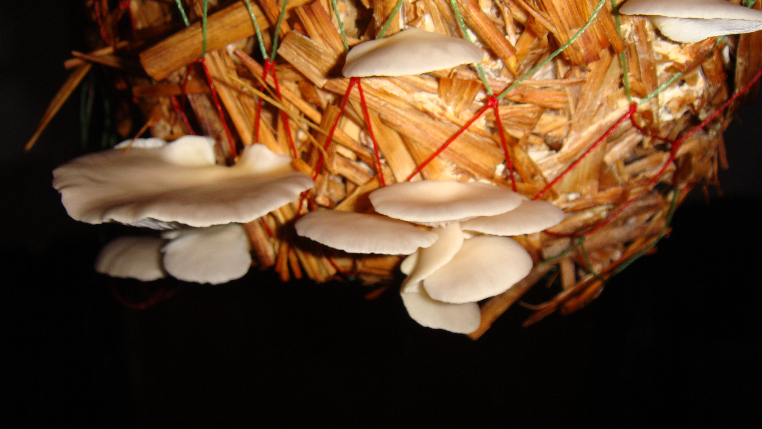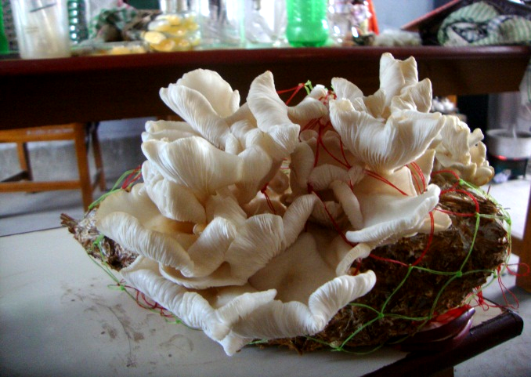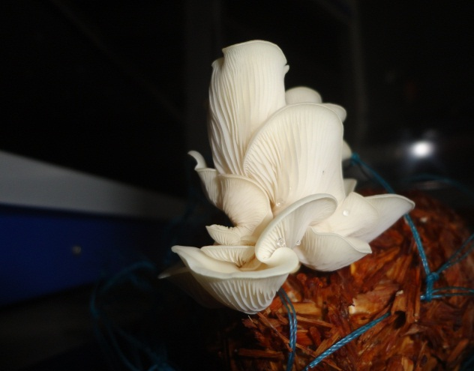
A B C
Figure 1. Fruiting bodies of different Pleurotus species A) P. sajorcaju B) P. florida C) P. floridanus

(2) Efficiency of alcohol extract of fruiting body of P. florida, P. sajorcaju and P. floridanus on bacterial growth
70% alcohol extract of P. florida and P. floridanus fruiting body showed growth inhibition to all the tested bacteria in both well (30µl) and disc (10µl) method but the P. sajorcaju extract did not show any inhibition (Table -2).
(3) Efficiency of aqueous extract of fruiting body of P. florida, P. sajorcaju and P. floridanus on bacterial growth
When 30µl aqueous extract of fruiting body of P. florida, P. sajorcaju and P. floridanus was applied in different wells to different bacteria, it showed inhibitory effect to all of them by P. floridanus extract but not by P. florida and P. sajorcaju extracts (Table-3).

Table- 2. Zone of inhibition (cm) of alcohol extract of fruiting body of different Pleurotus spp. and antibiotics
Sl. No. | Bacteria | P. florida |  | P. sajorcaju |  | P. floridanus |  | oxytetracycline | cefotaxime
 | Bacteria | well | disc | well | disc | well | disc | oxytetracycline | cefotaxime
1 | E. coli | 0.9 | 1.1 | - | - | 0.8 | 1.0 | 1.5 | 1.5
2 | B. subtilis | 0.5 | 0.8 | - | - | 1.1 | 0.7 | 1.5 | 1.1
3 | B. megaterium | 0.6 | 1.1 | - | - | 1.2 | 0.8 | 1.6 | 1.0
4 | S. aureus | 0.6 | 0.9 | - | - | 0.8 | 0.8 | 1.4 | 1.5

Table- 3. Zone of inhibition (cm) of aqueous extract of fruiting body of different Pleurotus spp. and antibiotics
Sl. No. | Name of bacteria | P. florida | P. sajorcaju | P. floridanus | oxytetracycline | penicillin
1 | E. coli | - | - | 0.7 | 1.5 | 0.6
2 | B. subtilis | - | - | 1.0 | 1.5 | 0.9
3 | B. megaterium | - | - | 0.6 | 1.6 | 1.3
4 | S. aureus | - | - | 0.6 | 1.4 | 1.0

(4) Zone of inhibition (in cm) of aqueous extract of mycelium and culture filtrate of different Pleurotus spp.
When culture filtrate of some oyster mushroom and their aqueous mycelial extracts were compared for antibacterial activities it was found that only P. floridanus (6315) mycelial extract showed inhibitory activities against all the bacteria while 6315 culture filtrate showed inhibitory activity against only Streptococcus sp. (Table-4).
(5) Zone of inhibition (in cm) of alcohol extract of mycelium of different Pleurotus spp.
When alcohol extracts of mycelium of P. sajorcaju, P. florida and P. floridanus were compared for their antimicrobial activities against different bacteria both in well as well as disc methods it was found that the discs containing P. floridanus extract showed inhibitory effect against all the tested bacteria (Table-5).

Table-4. Zone of inhibition (in cm) of aqueous extract of mycelium and culture filtrate of different Pleurotus spp.

Sl. No. | Name of bacteria | P. florida |  | P. sajorcaju |  | P. floridanus
Sl. No. | Name of bacteria | Mycelium | Culture filtrate | Mycelium | Culture filtrate | Mycelium | Culture filtrate
1 | E. coli | - | - | - | - | 2.5 | -
2 | S. aureus | - | - | - | - | 1.2 | 1.0
3 | B. subtilis | - | - | - | - | 1.1 | -
4 | B. megaterium | - | - | - | - | 2.2 | -

Table-5. Zone of inhibition of alcohol extract (70%) of mycelium of different Pleurotus spp.
Sl. No. | Name of bacteria | P. florida |  | P. sajorcaju |  | P. floridanus
Sl. No. | Name of bacteria | well | disc | well | disc | well | disc
1 | E. coli | - | - | - | - | - | 0.6
2 | S. aureus | - | - | - | - | - | 0.5
3 | B. subtilis | - | - | - | - | 1.1 | 0.7
4 | B. megaterium | - | - | - | - | 1.2 | 0.7

(6) The MIC of alcohol extract of P. florida fruiting bodies
The MIC of alcohol extract of P. florida fruiting bodies showed as low as 3 µl (equivalent to 30mg fresh mushroom) extract was sufficient to inhibit the growth of all the bacteria in disc method (Table-6) whereas in well method it required 18 µl alcohol extract to inhibit the growth of all the tested bacteria.
(7) MIC of 6315 alcohol extract on different bacteria in well and Disc methods
MIC of alcohol extract of 6315 fruiting body was tested against different bacteria in both well and disc methods (Table-7). It was found that the MIC was 3µl extract which is equivalent of 30mg of fresh fruiting body. Both the well and disc methods are more or less equally effective.

Table-6. Determination of MIC of alcohol extract of fruiting body of P. florida on different bacteria.

Sl. No. | Name of bacteria | Well (cm) |  |  |  |  | Disc (cm)
Sl. No. | Name of bacteria | 3 µl | 12 µl | 18 µl | 24 µl | 30 µl | 3 µl | 12 µl | 18 µl | 24 µl | 30 µl
1 | B. megaterium | 1.0 | 1.2 | 1.3 | 1.5 | 1.8 | 0.5 | 0.6 | 0.8 | 1.0 | 1.3
2 | B. subtilis | 0.9 | 1.2 | 1.0 | 1.2 | 1.3 | 0.5 | 0.6 | 0.8 | 0.8 | 1.0
3 | E. coli | - | - | 0.5 | 1.0 | 1.0 | 0.5 | 0.6 | 0.6 | 0.6 | 0.7
4 | S. aureus | - | - | 0.6 | 1.2 | 1.2 | 0.5 | 0.5 | 0.5 | 0.6 | 0.7

Table 7. MIC of P. floridanus fruiting body extract against some bacteria Table 7. MIC of P. floridanus fruiting body extract against some bacteria
Sl. No. | Name of bacteria | Well (cm) |  |  |  | Disc (cm)
Sl. No. | Name of bacteria | 3 µl | 12 µl | 18 µl | 30 µl | 3 µl | 12 µl | 18 µl | 30 µl
1 | B. megaterium | 0.6 | 0.6 | 0.8 | 1.2 | 0.5 | 0.6 | 0.8 | 0.8
2 | B. subtilis | 0.6 | 0.6 | 0.7 | 1.1 | 0.6 | 0.7 | 0.8 | 0.7
3 | E.coli | 0.7 | 0.6 | 0.8 | 1.0 | 0.6 | 0.7 | 0.8 | 0.8
4 | S. aureus | 0.5 | 0.5 | 0.6 | 0.8 | 0.6 | 0.5 | 0.7 | 0.8

(4) Discussion
In the present investigation the therapeutic significance of the edible fruiting bodies has been carried out in addition to submerged fermentation product (mycelium/extracellular culture filtrate) of different Pleurotus species against some bacteria in in vitro experiments. P. sajorcaju produced highest amount of fruiting bodies in rice straw followed by P. florida and P.floridanus (Table-1). There are a number of report about the cultivation of P. florida and P. sajorcaju whereas the P. floridanus cultivation is not very common (Sanchez, 2010, Gregory, 2007).
The resistance of bacteria against antibiotics is now-a-days a world-wide problem ( D’Costa et al., 2006). To come over the antibiotic resistance, sometimes more than one antibiotic are used simultaneously which have more chance of antibiotic related adverse effect (Kim et al., 2001). According to Iftikhar et al. (2011) as mushroom has taken as food item , they have devoid of dose related adverse effect as found with antibiotics whereas the mushroom along with antibiotics might lessen the undesirable effect (Kim et al, 2001).
In the present investigation fruiting bodies, mycelium and extracellular culture filtrate after 10 days growth in PD medium of three oyster mushroom viz. P. florida, P. sajorcaju and P. floridanus were studied for their antibacterial activities. It was observed that the 70% ethanolic extracts of fruiting bodies of P. florida and P. floridanus showed the antibacterial activities (Table-2 ). P. ostreatus , P.eryngii and P. sajorcaju was also reported for their antimicrobial activities (Gregory, 2007; Akyuz and Kirbag, 2009). Iwalokun et al. (2007) reported that both petroleum ether and acetone extract of P. ostreatus fruiting body also inhibited the fungal growth. In the present experimental condition antifungal activity was not done in any of the extracts or culture filtrate of the tested mushrooms. The aqueous extract of fruiting body of P. floridanus showed the antibacterial activity but the other two extracts are not efficient (Table-3). In addition to fruiting body, mycelial extract of P. florida, P sajorcaju and P. floridanus were tested for antibacterial activities. It was found that P. floridanus showed antibacterial activities in both aqueous or alcoholic condition (Table 4 and 5). P. floridanus mycelium showed better inhibition zone in aqueous condition than the alcohol extract (data not shown). Again both well and disc methods are used for the inhibitory experiment. The disc method showed better result than the well method (Table-5). The extracellular PD culture filtrate of P. floridanus also showed the antibacterial activity against a gram positive bacterium Staphylococcus aureus (Table-4). The antibacterial activities of mushroom extract showed that they have broad spectrum activities. Similar results were shown by Iwalokun, 2007; Iftekhar et al 2011, Rahaman et al, 2009. The MIC of alcohol extract of P. florida and P. floridanus was also studied (Table 6 and 7). The MIC of alcohol extract of fruiting body of P. florida and P. floridanus was as low as 3µl (=30mg fresh Fruiting body).
The alcoholic extract of fruiting body of P. florida showed the inhibitory activity for bacterial growth. The result agree with the experiments of Fagade and Oyelade (2009) and Iftekhar (2011). According to Iwalokun et al., (2007) the difference in response of mushroom extracts to test organisms might be due to a variety of factors like the nature of environment, growth media, mushroom species, solvent system for extraction, and obviously the genetic structure of mushroom species. Gao et al (2005) commented that the sensitivity pattern of microorganisms undergo alteration to chemotherapeutic agents depending on their strains and susceptibility or resistance to antibiotics.
In the present investigation P. floridanus is the most efficient mushroom so far its antibacterial properties are concerned. The aqueous and alcohol extract of mycelium, fruiting body, even extracellular culture filtrate showed bactericidal activity to some extent. The nature of inhibition indicate possible presence of different antibactericidal agents in alcohol and aqueous extract.
Ramesh and Patter (2010) commented that antibacterial activities of mushroom extract have been attributed to presence of biologically active components that have immunomodulatory activities. The antibacterial activities of mushroom extract was recognized in presence of terpene, polysaccharide, lectins etc. Wasser and Weis (1999) suggested that polysaccharides from mushroom do not directly act but altered the immune response of host by increasing the macrophage activity which then kill the pathogens i.e. bacteria, viruses etc.

(5) Conclusion
P. sajorcaju produced highest amount of fruiting bodies in rice straw followed by P. florida and P. floridanus.70% alcohol extract of fruiting body of P. florida showed antibacterial activities against all the tested bacteria but the extracellular culture filtrate did not showed antibacterial activities. Both alcohol and aqueous extract of mycelium and fruiting body of P. floridanus showed antibacterial activities against all the tested bacteria. The extracellular culture filtrate of P. floridanus showed antibacterial activity against only S. aureus. The MIC of alcohol extract of fruiting body of P. florida and P. floridanus was as low as 3µl (=30mg fruiting body). Both the alcohol and aqueous extract of fruiting body of P. sajorcaju showed no antibactericidal activity. So, in this investigation P. floridanus is the most efficient oyster mushroom as per its antibacterial activities are concerned .

Corresponding Author:
Dr. Nirmalendu Das
Post Graduate Department of Botany
Barasat Govt. College, Barasat,
West Bengal, 700124, India
E-mail: nirmalendus@yahoo.co.uk

References
- Acharya K, Yonzone, P, Rai M, Acarya R. Antioxidant and nitric oxide synthase activation properties of Ganoderma applanatum. Indian J Exp Biol. 2005, 42: 926-929.
- Ahmed SA, Kadam JA, Patil SS Baig MMV. Biological efficiency and nutritional contents of Pleurotus florida (Mont.) Singer cultivated on different agro-wastes. Nat Sci. 2009;7:44-48.
- Akyuz M., Kirbag S. Antimicrobial activity of Pleurotus eryngii var. ferulae grown on various agro-wastes. Eurasian J Biosc. 2009, 3:58-63.
- Arora RK, Singh, RP, Guru SK. Determination of bioactive compounds in medicinal mushroom Cordyceps sinensis.Mushroom Res, 2008, 17.
- Chihara G. Medical aspects of lentinan isolated from Lentinus edodes (Berk.) Sing. In: Chang S.T., Buswell, J.A., Chiu, A.W. (eds), Mushroom Biology and Mushroom Products. The Chinese University Press Hong Kong, 1993, 261-266.
- Collins RA, Ng TB. Polysaccharopeptide from Coriolus versicolor has potential for use against human immunodeficiency virus type-I infection. Life Sci. 1997, 60:383-387.
- Das N, Mukherjee M. Cultivation of Pleurotus ostreatus on weed plants. Bioresour. Technol. 2007, 98:2723-2726.
- Das N, Chowdhury P, Adhikari, D and Naskar, S. Concommitant production of sporeless fruiting bodies and laccase release during submerged fermentation practice of Pleurotus fossulatus. New York Sc. J. 2011; 4:27-32
- Das N, Chowdhury P, Pasman B. Cultivation practice of Pleurotus fossulatus on rice straw.J Life Sci. 2010, 4:20-25.
- D’Costa, VM, McGrann KM, Hughes DW, Wright GD. Sampling the antibiotic resistome. Science. 2006, 311:374-377.
- Gregori A, Svagel M, Pohleven J. Cultivation techniques and medicinal properties of Pleurotus spp. Food Technol Biotechnol. 2007, 45:238-249.
- Gao Y, Tang W, Gao H, Chan E, Lan J, Li X, Zhou S. Antibacterial activity of medicinal mushroom Ganoderma. Food Rev Int. 2005, 21: 211-29.
- Iftekhar HAF , Choudhry ZK, Khan IM. Abu Saleh A. Comparative study of antibacterial activity of wood-decay fungi and antibiotics. Bangladesh J Pharmacology. 2011, 6 : 14-17.
- Iwalokun BA, Usen UA, Otunba AA, Olukoya DK. Comparative phytochemical evaluation, antimicrobial and antioxidant properties of Pleurotus ostreatus. African J Biotechnol. 2007, 6:1732-1739.
- Jonathon SG, Fasidi IO. Antimicrobial activity of two Nigerian edible macro-fungi Lycoperdon pusilum (Bat.ex) and Lycoperdon giganteum (Pers). African J Biomedical Res. 2003, 6:85-90.
- Jonathan SG, Okon, CB, Oyelakin AO, Oluranti OO. Nutritional values of oyster mushroom (Pleurotus ostreatus) (Jacq. Fr.) Kumm. cultivated on different agricultural wastes. Nat Sci . 2012;10:186-179.
- Kim YS, Eo SK, Oh KW, Lee CK, Lee YN, Han SS. Antibacterial activity of water soluble components of Elfvingia applanata alone and in combination with quinolones. Korean Soc Myco Biol. 2001, 29: 11-14.
- Kuznetsov, OIU, Mil’kova EV, Sosnina AE, Sotnikova, NIU. Antimicrobial action of Lentinus edodes juice on human microflora. Zh Mikrobiol. Epidemiol,Immunobiol. 2005, 1:80-82.
- Novaes, MRCG, Novaes LCG, Taveira VC. Pharmacological side effects of agaricales fungi: a review of evidence. Rev. Cienc. Med. Campinas. 2007, 16: 87-95.
- Rahman A, Hossan T, Rahul Amin SM, Rahman AK, Khan MA. Khalil I. Antimicrobial activity of of Pleurotus ostreatus (Jacquin ex Fr.) Kummer upon human pathogenic bacteria. Bangladesh J. Mushroom. 2009, 3: 9-13.
- Ramesh CH, Pattar MG. Antimicrobial properties, antioxidant activity and bioactive compounds from six wild edible mushrooms of Western ghat of Karnataka, India. Pharmacog Res J. 2010; 2: 107-112.
- Sanchez C. Cultivation of Pleurotus ostreatus and other edible mushrooms. Appl Microbiol Biotechnol. 2010, 85: 1321-1337.
- Turkoglu A, Kivarak I, Mercan N, Duru ME, Gezer, K, Turkoglu, H. Antioxodant and antimicrobial activities of Morchella conica Pers. African J. Biotechnol. 2006, 5:1146-1150.
- Wasser SP, Weis AL. Medicinal properties of substances occurring in higher Basidiomycetes mushrooms: Current Prespectives. Int J Med Mushrooms. 1999, 1: 47-50.

8/22/2012

