Influence of storage time on biodeterioration, aflatoxin contamination and food values of onion (Allium cepa )

*Jonathan SG¹ , Olawuyi OJ ¹, Aina DA ² , Dada HG¹ and Oyelakin AO ³

¹Departmentof Botany and Microbiology, University of Ibadan , Ibadan.Oyo State. Nigeria
²Department of Biosciences and Biotechnology, Babcock University, Ilisan Remo, Ogun State. Nigeria
³College of Agriculture, Igbo-Ora.Oyo State. Nigeria
Corresponding author: gbolyjoe@yahoo.com

Abstract: Investigations were conducted on the onions (Allium cepa ) stored for 1, 3 , 9 and 12months respectively. The parameters studied include the proximate analysis and shelf life evaluation of the spice, mineral elements compositions, level of fungal and aflatoxin contamination on fresh and stored onion bulbs. Aspergillus and Fusarium specis were detected in all the samples while Penicillum sp was found in the 1 year old onion bulb sample. Proximate analysis showed variation in their nutrient contents. The moisture content, dry matter, ascorbic acid, starch, glucose, amino acid, protein and mineral nutrients were of significant values in all the samples. The results also showed that the aflatoxin level in the 1st , 3rd and 9th months were statistically insignificant(P>0.05), while those of 12 month old samples were relatively high.
[Jonathan SG, Olawuyi OJ, Aina DA, Dada HG and Oyelakin AO. Influence of storage time on biodeterioration, aflatoxin contamination and food values of onion (Allium cepa ). Nat Sci 2012;10(11):26-32]. (ISSN: 1545-0740). http://www.sciencepub.net/nature. 5

Keywords: Onion, aflatoxin, fungi, biodeterioration.

1.Introduction
Onion (Allium cepa) is an important plant of nutritional and medicinal values (Babatunde et al,2001;Jilani et al,2004). Both leaves and the bulb are used in the preparation of delicious dished among the Yoruba people of south Western Nigeria. There are several ethnic groups in Nigeria. These groups include Hausa,Igbo,Yoruba,Nupe,Itshekiri,Tiv,Urobo, Fulani and many others. Among these people, onion is an essential component of different varieties of meal and soups (Jonathan and olowolafe, 2001).It usually adds values, aroma, taste and nutritional qualities to different arrays of fresh and cooked Nigeria foods. Onion bulb is a biennial herb with over 600 species distributed world-wide. Onion has superficial root system, spherical fruit, long, linear and hollow leaves, and very short flattened stem at the base, which increases in diameter as it grows (Sullivan et al, 2001). All parts of onion produce a strong odour when crushed. A bulb is formed, by the thickening of the base leaves when the plant reaches a critical stage (Babatunde et al,2004).
Onion is high in food value, moderate in protein content, rich in calcium and riboflavin (Jilani et al,2004). Nutritional composition of onions may depend on type of varieties, developmental stage and period of storage. Fully developed onion bulb usually contain 85.0-88.6% moisture, 1.2-2.0 % protein, 0.1-0.3% fat, 0.6-1.0% fibre, 0.4-0.7% mineral elements and 10.2- 12.1% carbohydrates(Grubben and Denton, 2004). Its mineral and vitamin contents are calcium, iron, phosphorus, carotene, thiamine, riboflavin, niacin and vitamin C. Allium cepa is high in energy and water content. They are low in calories, and have a generous amount of vitamin B6, B1, and folic acid (Sullivan et al, 2001).
Allium cepa has been used as an ingredient in various dishes for thousands of years by many cultures around the world. World onion production is steadily increasing so that onion is now the second most important horticultural crop after tomatoes (Bankole et al,2004). There are many varieties of onion; red, yellow, white, and green, with different flavour, from very strong to mildly sweet. Onions can be eaten raw, cooked, fried, dried or roasted. They are commonly used to flavour dips, salads, soups, spreads, stir-fry and other dishes (NIHORT, 1986 and Jilanil et al., 2004).
Onion and other Allium vegetables are characterized by their rich content of thiosulfinates, sulphides, sulfoxides, and other odoriferous sulphur compounds. The cysteine sulfoxides are primarily responsible for the onion flavour and produce the eye-irritating compounds that induce lacrimation(Bankole et al,2004). The thiosulfinates exhibit antimicrobial properties. Onion is effective against many bacteria including Bacillus subtilis, Salmonella, and E. coli. Onion is not as potent as garlic since the sulphur compounds in onion are only about one-quarter the level found in garlic (Jackson and Groopman, 1999). The scales of onion contain catechol and protocatechuic acid. The odour in onion is due to organic sulphur compounds and is produced only when the tissues are cut or injured by enzyme action on a water soluble amino acid (Scott, 2007). The highly pungent onion bulbs have been recommended for revitalization of the brain as well as increasing potency in male reproductive organs (Babatunde et al.,2004)
Onions contain chemicals which help fight the free radicals in our bodies. Free radicals cause disease and destruction to cells which are linked to at least 60 diseases. Onions increase circulation, lower blood pressure, prevent blood clotting and useful in treatment of common heart disease (Grubben and Denton, 2004;Scott, 2007).Storage of onion bulbs in a warm condition where relative humidity is high can cause decay of onion bulb (Sullivan et al., 2001; Babatunde et al., 2004; Dantata and Machunga, 2007).
Extended periods of wet conditions in the four to six weeks prior to harvest will promote the storage rots caused by Aspergillus and Penicillium spp., especially in the tropics.
Major storage diseases of onions and other food include; black mould caused by Aspergillus spp which produced sooty black masses under surface scales, neck rot of Botrytis spp showing dusty grey appearance and rot in neck of bulb, Fusarium spp causing Fusarium rot which formed white fluffy growth with soft rot at base or neck of onion and blue green mould caused by Penicillium spp showing dusty green masses under surface scales (Jackson and Groopman, 1999).

2. Materials and methods
2.1Collection and preparation of the sample
A total of 24 onion bulbs were collected from the National Horticultural Research Institute Idi- ishin, Ibadan Oyo state. They were divided into four groups of 6 onions each. Two onions each from the samples were collected , cut into minute bits and dried for 7days, after which they were pulverised. The pulverised samples were used for the determination of the mineral elements and food composition.

2.2Determination of minerals in the sample
Mineral content determined include calcium, potassium, magnesium, sodium, iron, copper, zinc, phosphorus(AOAC,1990).

2.3 Microbiological analysis
The microbiological analysis was carried out in the laboratory using the four samples (1, 3, 9 and 12 months) of onions from which cultures were prepared by direct plate method.
Ten grams of synthesized Potato Dextrose Agar was diluted in 250ml of water. The mixture was heated in a Gallenkamp water bath till the powder dissolves completely. This was then dispensed into 500ml conical flasks. The mouth of the conical flasks was plugged with cotton wool and wrapped up with aluminium foil. The flasks were then sterilized at 1.05kg/cm² (121ºC) for 15 minutes in an autoclave. After the autoclave had cooled and pressure is at zero, it was opened and the flasks were removed and kept in a Gallenhamp water bath at controlled temperature of 45°C. The cooled agar was dispensed in 15 ml amounts into sterile glass petri dishes. The part of the sample was cut and surface sterilized in diluted ethanol after which the samples were plated on the prepared media and incubated for 3 to 5 days. Sub-culturing was done to obtain pure cultures. Fungi isolates were identified using morphological characteristics, spore formation and biochemical reactions (Jonathan and Olowolafe,2011;Fadahunsi et al,2011).

2.4Pathogenicity test
To ascertain that the organisms isolated caused the disease on the onions collected, pathogenicity test was conducted using Koch’s postulate as described by Markson et al., (2005). This was done by re-inoculating healthy onion samples with the microorganisms previously isolated from diseased onion samples. The establishment of the disease and disease symptoms on the onion and the affirmation of the organisms re-isolated from diseased experimental onion as being identical to the original specific causative agent confirmed the pathogenicity of the isolated fungi species on the Allium cepa bulb.

2.5 Proximate Analysis
This test included moisture content, protein, starch, glucose, amino acid, Ascorbic acid and
dry matter and it was carried out using AOAC (Association Official Analytical Chemist) method (1990).

2.5Aflatoxin detection
Aflatoxin detection were determined according to the method of Gnononfin et al(2008).

2.6.Shelf life stability Test
The storage stability study carried out on the Allium cepa samples showed that it took some time before spoilage organisms began to invade the samples. This was confirmed through the appearance , change in colour and odour. This study was carried out at room temperature and increased storage resulted in decline in quality and quantity.
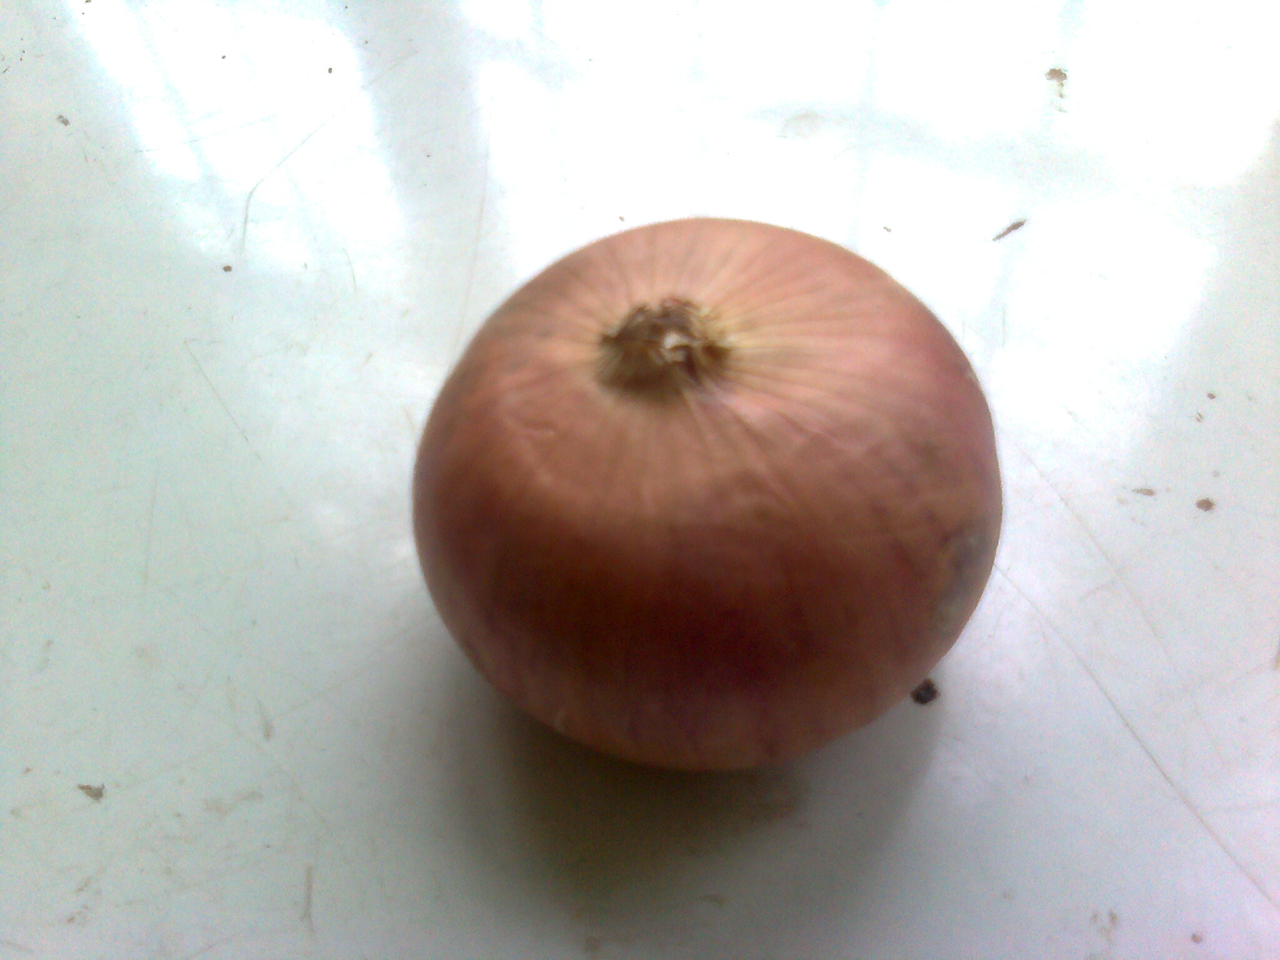
Plate 1: An Allium cepa bulb

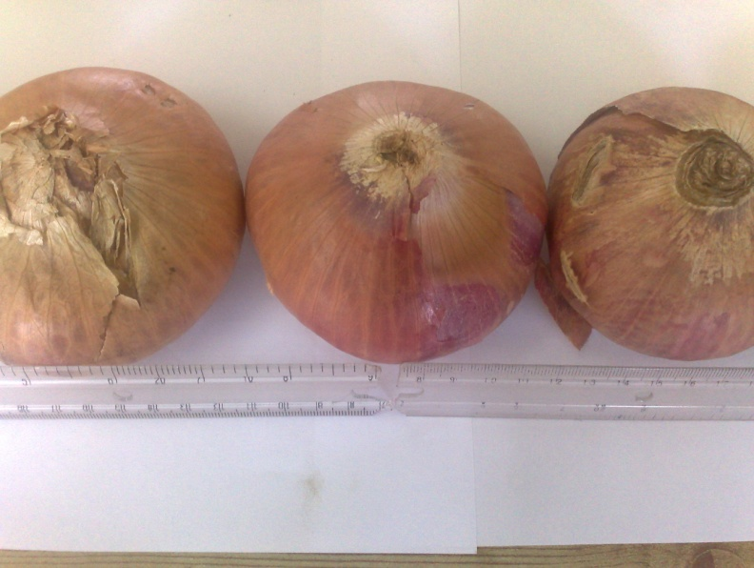
Plate 2: Allium cepa stored for 1 month

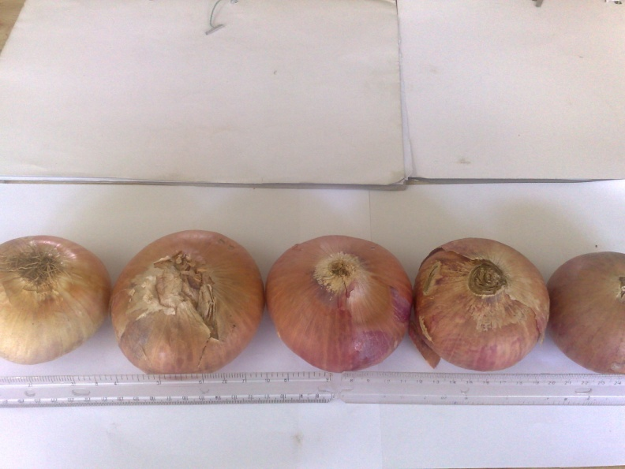
Plate 3: Allium cepa stored for 3 months

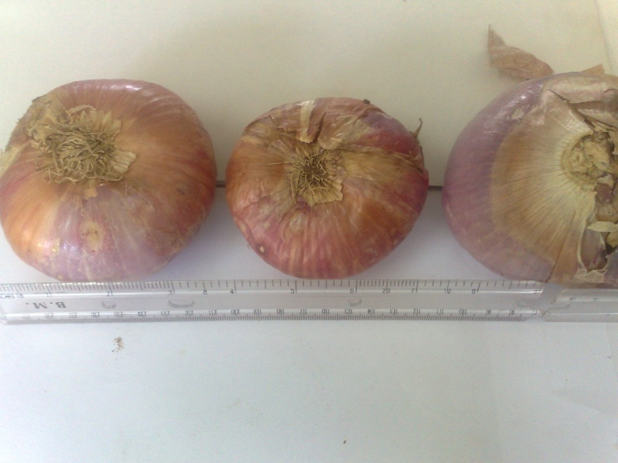
Plate 4: Allium cepa stored for 9 months

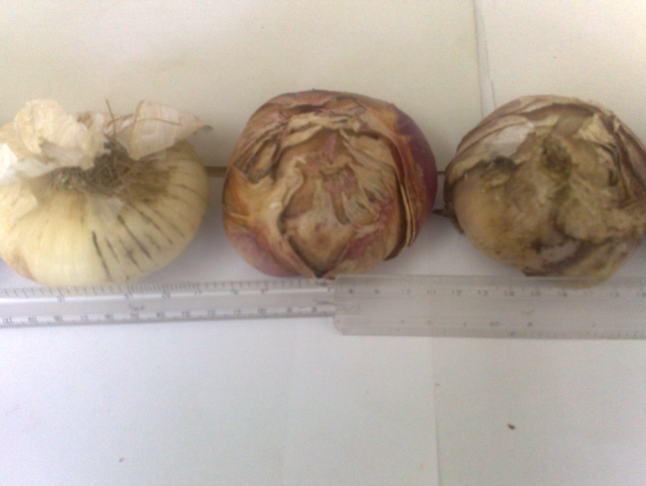
Plate 5: Allium cepa stored for 1 year

3. Results and Discussion
The results of food compositions of Allium cepa bulb at different duration of storage was represented on Table 1.Percentage of moisture content ranged from 20.0 to 23.0% within the 12 months of storage. Moisture was found to be less in one month old sample compared with twelve months old samples. This might be due to high relative humidity of the environment where these onions were stored (Jonathan and Esho, 2010).The % dry matter in 1,3,9 and 12 months were 80.0,78.1,77.5 and 77.0 respectively. The % increase in dry matter is not unexpected since these values represent the trend observed in other stored food materials reported by other authors (Jonathan and Olowolafe; Manzi et al,1999;Babatunde et al,2004).
Amino acids concentration observed during the period of storage (Table1) were found to be statistically similar (P>0.05).These showed that these compounds were relatively stable at 1, 3,9 and 12 months respectively. The glucose contents in the onion bulbs were found to be reducing with period of storage. This reduction may be due to the fact that this monosaccharide is used for metabolism during storage (Jonathan and Fasidi, 2003).The level of protein in the stored samples were unexpectedly low (Table 1). This may be linked to the type of onion used, physical nature of the land where it was planted and various environmental factors. Ascorbic acid in stored onion bulb was observed to be high. This shows that this spice is rich in vitamin C. This result is similar to the report of other researchers that other vegetables such as garllic ,Telfaria occidentalis and mushrooms are rich source of vitamins (Grubben and Denton , 2004;Aina et al,2012;Jonathan et al,2012a).
Mineral element analysis of onions showed that potassium, phosphorus, calcium, magnesium, iron and sodium were present in appreciable quantities in onion while manganese, copper and zinc were present at very low level. This result showed that onion is very rich in mineral nutrients. The mineral element composition obtained for onion bulb in this study is similar to the results of the mineral nutrients recorded for other vegetables(Jonathan et al,2012b; Grubben and Denton ,2004).).
It was also found that Aspergillus spp and Fusarium sp were the dominant organisms in all the samples of onion analyzed, while Penicillium sp was found only in the one year old sample (Tables 3 and 4). This shows that Aspergillus spp, Fusarium sp and Penicillum spp are the typical organisms that are associated with onion spoilage. It was also found out that the duration of storage and age of the onions could aid infection and dominance of particular fungus. It was obvious that the occurrence of these organisms may be as a result of moisture because when kept in a dry environment, the rate of infection was greatly reduced. This was also observed by Fadahunsi et al,(2011).
The aflatoxin level in the 1, 3 and 9 months onion samples were infinitesimal so there was no significant values, while the aflatoxin detected for the one year old samples was very high (5.0-5.2) microgram/ kilogram. According to the FAO/WHO (1990) and (1992), aflatoxin level in any food material meant for consumption must not be more than 4 microgram/ kilogram for Nigerians, while NAFDAC (National Agency for Food Drug Administration and Control) recommends 3.5 microgram/kilograms for Nigeria. Scientists and chemists put the bench mark of aflatoxin contamination at about 3 microgram / kilogram.
The results also showed that the stored onion samples of 1, 3 and 9 months were safe for consumption while that of one year should not be encouraged because of its level of aflatoxin. Similar observation were reported by Bankole et al,2002(for melon seeds) and Jonathan and Esho,2010 (for Pleurotus mushroom) that were stored values on the same column followed by the same letter(s) are not significantly different by Duncan’s Multiple Range Test (p > 0.05). Values are means of 3 replicates.
This was done for two different samples of onions at the same time.

Table 1: Proximate compositions of onion bulb during storage
Sample Moisture Dry Ascorbic Amino Protein Glucose Starch
content matter acids acids (mg/100) (g/100) (g/100)
(%) (%) (mg/100) (mg/100)
______________________________________________________________________
A 20.0d 80.0a 13.51d 0.027a 1.10b 4.45c 8.42d
B 22.0c 78.0b 81.08a 0.027a 1.07c 5.10a 8.70c
C 22.5b 77.5c 54.05b 0.024a 1.14a 5.02b 8.79b
D 23.0a 77.0d 40.54c 0.027a 1.00d 5.00b 9.34a
Mean 21.875 78.125 47.275 0.026 1.080 5.093 0.813
Std. dev 1.315 1.315 28.131 0.002 0.060 0.563 0.385
Std.Error 0.658 0.658 14.066 0.0008 0.030 0.282 0.193
________________________________________________________________________
Values on the same column followed by the same letter(s) are not significantly
different by Duncan’s Multiple Range Test (P > 0.05). Values are means
of 3 replicates.Key:A1 month B3 months C9 months D1 year (12months)

Table 2: Mineral element compositions of onion bulb during storage
______________________________________________________________________
Sample Ca Mg K Na P Mn Fe Cu Zn
______________________(ug/1000g) ___________________________
_______________________________________________________________________
A 23.5a 3.4a 146a 2.3b 33.0c 0.23a 2.31c 0.11a 0.09a
B 21.0c 3.1c 146a 2.4a 32.8d 0.24a 2.14d 0.10b 0.08a
C 23.7a 3.4a 146a 2.3b 33.5a 0.23a 2.39a 0.10b 0.09a
D 22.9b 3.3b 145b 2.2c 33.4b 0.27a 2.34b 0.12a 0.07a
________________________________________________________________________
Values on the same column followed by the same letter(s) are not significantly
different by Duncan’s Multiple Range Test (p > 0.05). Values are means

Table 3: Colonial and microscopic characteristics of fungal isolates
________________________________________________________________________
Organism Colonial characteristics Microscopic characteristics
________________________________________________________________________
1 Widely spread black colonies Presence of septate hypha growing in ring which also has spore-like and spore head. Round spores
appearance that are tiny brown
2 Grey powder like colonial Spores are rod-like in shape. Hyphae
Appearance are highly branched at the tip and
3 White fluffy growth like Presence of septate hyphae
Cushion
_____________________________________________________________________

Table 4: Name of Organisms and their sources
Organism Name Source
1 Aspergillus niger All samples
2 Penicillium sp A year old sample
3 Fusarium sp All samples

Table 5: Aflatoxin Level in Microgram/ gram
__________________________________________________________________
Onion sample _________________ Months __________________________
1 3 9 12
__________________________________________________________________
1 0 0 0 0 0 1.2a 5.0a 5.2a
2 0 0 0 0 0 1.5b 5.1b 5.2a
_____________________________________________________________

CONCLUSIONS
Harvested commodities from farm should be kept in the shade to minimize high relative humidity which could be a predisposing factor to the presence of bio-deteriorating fungi. The harvested commodities should be sorted, carefully packed in order to avoid bruises for the entrance of spoilage microorganisms.

Correspondence to:
Dr Jonathan Segun Gbolagade
Department of Botany & Microbiology, University ofIbadan, Ibadan.Nigeria.
Email: gbolyjoe@yahoo.com
Tel:2348164746758

References
- Aina DA, Oloke JK, Jonathan SG and Olawuyi OJ(2012) .Comparative assessment of mycelial biomass and exo-polysaccharide production of wild type and mutant strains of Schizophyllum commune grown in submerged liquid medium Nature and Science 10(10):82-89.
- AOAC 1990. Official methods of analysis. (15th ed). Association of Analytical Chemists. 14th Edn. Washington D.C 45pp
- Babatunde, FE., Oseni, TO and Auwalu, B.M.(2004). Effects of nutritional sources, mode of storage and post harvest losses on yield and economic returns in onions (Allium cepa L). Nigerian Journal of Horticultural Science 9: 17-21
- Bankole SA, Ogunsanwo BM, Mabekoje OO. 2004. Natural occurrence of moulds and aflatoxin B1 in melon seeds from markets in Nigeria.Food Chem. Toxicol., 42: 1309–1314.
- Dantata, I.J and Machunga, N.A 2007. Onion (Allium cepa L.) production in the Savanna Regions of Nigeria: Prospect and Potentials. Garu Academic Journal 2:51-60
- Fadahunsi ,IF Garuba EO and Elutade O 2011. Physico-chemical studies on the growth of an Ochratoxin A-degrading Rhizopus sp. Nature and Science:9(7) 240-244.
- Fasidi, I.O, 1996. Studies on Volvariella esculenta (Mass) Singer: Cultivation on agricultural wastes and Proximate composition of stored mushrooms. Food Chem., 55: 161-163.
- FAO/WHO 1990. FAO/WHO Standards Programme. Codex Alimentarius Commission. Alinorm 91/79.
- FAO/WHO 1992. FAO/WHO Standards Programme. Codex Alimentarius Commission Alinorm.93/12.
- Grubben, G.J.H and Denton, D.A 2004. Plant resources of Tropical Africa 2- Vegetables. PROTA Foundation, Wageningen, Bacjhugs, leiden CTA Wageingen.
- Gnonlonfin K,Hill P and Fandoham AB2008.Mycoflora and natural occurrence of aflatoxin and fumonisin B₁ in cassava and yam chips from Benin, West Africa.International Journal of Microbiology 122(1):140-147
- Jackson, P.E. and Groopman, J.D.1999. Aflatoxin and liver cancer. Bailluieres Best Pract. Res. Clin.Gastroenterol 13(4):545-555.
- Jilanil, M.S., Ghaffoor, A., Waseem, K and Farooql, J.I (2004). Effect of different levels of nitrogen on growth and yield of three Onion varieties. International Journal of Agriculture and Biology 6(3): 507-510
- Jonathan S.G. and Olowolafe, TB 2001. Studies on nutrient contents and microorganisms associated with ‘dodo Ikire’ a plantain snack from Western Nigeria. Nigerian Society for Experimental Biology(NISEB) Journal 1 : 27 – 30.
- Jonathan, SG. and Fasidi IO 2003. Requirements for vegetative growth of Tricholoma lobayensis (Heim), A Nigerian edible fungus. Advances in Food Science. 25(3.):. 91 – 95.
- Jonathan SG and Esho EO 2010.Fungi and aflatoxin detection in two oyster mushrooms Pleurotus ostreatus and Pleurotus pulmonarius from Nigeria Electronic Journal of Environmental, Agricultural and Food Chemistry(EJEAFche) 9(11):1722-1730.
- Jonathan SG,Oyetunji O.J and Asemoloye M.A2012a. Influence of spent mushroom compost (SMC) of Pleurotus ostreatus on the yield and nutrient compositions of Telfairia occidentalis Hook .F.A. (Pumpkin),a Nigerian leafy vegetable. Nature and Science 10(10):149-156.
- JonathanSG ,Okon, C.B.Oyelakin AO and Oluranti OO 2012b. Nutritional values of oyster mushroom (Pleurotus ostreatus) (Jacq. Fr.) Kumm cultivated on different agricultural wastes.Nature and Science; 10(9):186-191.
- Markson, A.A.; Madunagu, B.E., Umana, E.J. and Udo, S.E. (2005). Survey and biocontrol of fruit rotting fungi of tomato. Nigerian Journal of Plant Protection 22:122-131.
- Manzi, P., L. Gambelli, S. Marconi, V. Vivandti and L. Pizzoferrato, 1999. Nutrients in edible mushrooms: An interspecies comparative study. Food Chem., 65: 477–82.
- NIHORT 1986. Advances in fruit and vegetable research at the National Horticultural.
- Research Institute, Ibadan Nigeria (1976-1986). A commemorative publication to mark 10th anniversary of the Institute Pp61.
- Scott, .T. 2007). What is the chemical process that causes my eyes to tear when I peel an onion? Ask the expert; Chemistry Scientific American. Retrieved on 8th April, 2007.
- Sullivan, D.M., Brown, B.D., Shock, C.C., D.A., Horneck, D.A., Stevens, R.G., Peter G.Q and Feilber 2001. Nutrient Management for Onions in the Pacific Northwest 546:1-76.

8/20/2012

