Application of Geographic Information System (GIS) and Remote Sensing (RS) to estimate the available rainwater harvested for crop production in Kinoni watershed, Kirehe District, Rwanda

Alphonse Nahayo^{1,*} Clement Ntandayera^{1, 2}, Adrie Mukashema³

1. Higher Institute of Agriculture and Animal Husbandry (ISAE)-Busogo; Department of Forestry and Nature Conservation; P.O.Box 210 Musanze, Rwanda; email:nahayo1@yahoo.fr

2. Department of Soil and Water management

3. National University of Rwanda, CGIS, P.O.Box 117 Butare, Rwanda

Abstract: The purpose of this study conducted in 2011 was to assess the available rainwater harvested in Kinoni catchment area located in Kirehe district, Eastern Province in Rwanda in order to improve crop production. In this area, large proportion of the arable land is located in areas with water shortage subject to recurrent dry spells. This region also experiences long periods of drought leading to the decline of crop and animal productivity. The Geographic Information System and Remote Sensing tools were used to delineate catchment areas. Data on land use types and soil characteristics were analysed and Soil Conservation Service- Curve Number method were applied to estimate the runoff to be harvested. The daily rainfall record of Nyarubuye station for 30 years was also used. The results revealed that Kinoni catchment was delineated in two sub-catchments with a surface area equal to 759.7 ha. The water area and command catchment area, as sub-catchments were 580.5 ha and 179.2 ha respectively. The expected runoff yield was 5,515.94 m³ per day for the whole catchment while the Water area catchment had runoff potential equal to 139.8 Ha.m per year. There is a need to assess the quantity of water required for irrigation and stored in the irrigation structure.

[Nahayo A., Ntandayera C., Mukashema A. Application of Geographic Information System (GIS) and Remote Sensing (RS) to estimate the available rainwater harvested for crop production in Kinoni watershed, Kirehe District, Rwanda. Nat Sci 2012;10(11):38-52]. (ISSN: 1545-0740). http://www.sciencepub.net/nature. 7

Keywords: Geographic Information System, Remote Sensing, Kinoni watershed, Rwanda.

- Introduction
Water is at the heart of Millennium Development Goals (MDGs) numbers 1, 3 and 7, and is indirectly associated with the success of all the other goals. But for Africa to meet the MDGs, targeted actions are required in the water sector. Therefore, the African water vision for 2025 has set to develop the full potential of Africa’s water resources for sustainable growth in the region’s economic and social development (Relma et al., 2005). Traditional farming practices which depend on rain fed Agriculture encountered several problems, such as backward agricultural practices together with variation in climate from place to place and less amount, erratic and uneven spatial distribution of rainfall, fragmented farmland, use of backward agricultural implements and inadequate supply of agricultural inputs which contributed to low crop production and food insecurity in Rwanda. The agricultural sector encompasses farming and animal husbandry which largely depend not only on rain fed agriculture but also on very traditional and backward agricultural practice with poor management practices. Currently, farmers in Kirehe district are producing at subsistence level but there is sufficient evidence to show that peasant yields could be increased through the use of fertilizer, improved seeds and irrigation practices (Saba engineering, 2010).
In the past, misleading blue water analyses (focusing only on perennial river flow and accessible ground water) and drought assessment (focusing only on annual cumulative rainfall) have been used as arguments to rule out semi-aid tropical savannah agro-ecosystems as potential bread baskets. The availability of accurate information on runoff in the catchment is scarcely available in few sites. However, quickening of the catchment management programme for conservation and development of natural resources management has necessitated the runoff information (McCuen, 1998). One of the objectives of catchment modeling is the generation of synthetic hydrologic data for facility design like water resources planning, food protection, mitigation of contamination, or licensing of obstruction or for forecasting. Rainwater harvesting techniques enter in this concept of integration of water resource management. Thus to combat the prevailing problems, the Government of Rwanda had developed various policies which are targeted to alleviate the problems through establishing different government and non-governmental institutions that have the role to improve the livelihood of the farmers and better agricultural activities. Therefore, the country is required to use its great irrigation potential for increasing food supply and farmers’ household income that eventually result in its impact on the country’s overall economy.
The Ministry of Agriculture and Animal Resources (MINAGRI) proposed and started the implementation of Kirehe Community- Based Watershed Management Project (KWAMP) to alleviate the serious food shortage and food insecurity in Kirehe district and the region in general. The KWAMP project is one of the Rwandan government policy aiming at developing Kirehe District based on the existing irrigation potential as the District is poor due to rainfall shortage that deals with water management including drainage and rainwater management as well as irrigation. KWAMP’s target is 2,000 ha of which 1,500 ha will be targeted for hillside irrigation and 500 ha for marshland reclamation and development. The project rational stems from the country’s Strategic Plan for Agricultural Transformation (SPAT) that aims to promote the market-oriented intensification of agricultural systems built on sound environmental practices in order to assist very poor smallholders to overcome their food insecurity and low agricultural incomes, to arrest land degradation and to restore soil fertility. Water management can provide an opportunity for both intensification through increases in cropping intensity, yields and diversification. Kinoni watershed (site 4) is one of five KWAMP watershed selected project sites. The project gives the priority on five watersheds for the ease implementation, the reason why Kinoni watershed was included in these five watersheds selected.
In Kirehe district, the annual production and consumption are not enough to satisfy the population needs. The majority of the land users depend on rainfall for their livelihoods (green water), not on irrigation based on blue water. In this drought prone drylands, there are problems both due to rainfall deficiencies (primary due to poor temporal distribution of rainfall and high evaporation losses), soil problems as well as plant problems, the latter originating from dry spell damages and nutrient deficiency. Adding extra water is one way to compensate for soil water deficiency and to reduce the risk for plant damage during dry spells. The source of such water may be rainwater harvesting used as an umbrella term for a range of methods for collecting and conserving rainwater and runoff water. This study aims at applying GIS and RS techniques to assess rainwater harvested for crop production in Kinoni watershed. Therefore, it will provide a tool to be used in the determination of the runoff potential and water demand for crop production. The knowledge generated could also be used for implementing the rainwater harvesting as irrigation structure in the area. The specific objectives of this study are: (i) to delineate Kinoni catchment in sub-catchments;(ii) to quantify the amount of runoff in Kinoni catchment taking into account the effect of different land use and land cover types through the application of GIS based modeling techniques. During this study, these questions should be answered: (i) how the rainwater is distributed in the Kinoni catchment? (ii) What quantity of water is it possible to be collected in the Kinoni catchment through rainwater harvesting?

- Material and methods

2.1. Description of the study area
The district of Kirehe, in which Kinoni catchment (site 4) located, has a population of 229,468 and a surface area of 1,225. 4km². It is located at the South-East of the Republic of Rwanda at 133 km from Kigali capital. The figure 1 shows the location of Kirehe District in the administrative map of Rwanda.

Figure 1: Rwanda administrative ma ; Source: (Kwamp, Juin 2010)

The Kinoni catchment (site 4) is located in the three sectors of Kirehe District (Kigarama, Nyamugali and Kigina). The Kinoni watershed is located between Gahezi and Mwogo watershed, expected to lay between geographical coordinates of 30º45’ 30’’ et 30º41’ 51’’ East longitudes and 2º21’ 54’ and 2º16’ 20’’South latitudes with average altitude of 1500 m.a.s.l. The location of study area in the administrative map of Kirehe District is showns by the Figure 2.

Figure 2: Localization of study area in the Kirehe district
Source: SABA Engineering , 2010.

2.1.1. Climate and rainfall

Climate
The Kinoni watershed is situated in an arid geographical area. The climate is typically East-African plateau savanna climate. It is a tropical climate, where the temperature ranges from 20 to 24°C with a maximum of between of 26 to 29 °C (SABA Engineering Plc., 2010).
Seasons are marked by an alternation of rains and drought. The Kinoni watershed knows a climatic rhythm of 4 seasons permitting to make 2 harvests per year on the same plot. In general, the name of the seasons is given in consideration of the length and the intensity of rains or droughts: The small rain season of the ‘Umuhindo’ starts mid-October and finishes in December, The rainfall during this season cover 27% of yearly rains. It is the period of bean crop, Corn, potato, Sorghum, etc. The small dry season called ‘Urugaryi’ lasts from January to mid-March; it is the period of harvest of beans, corn and potato. Then a second planting season of bean is organized. The long rain season said ‘Itumba’ runs from mid-March to mid-June, In the District, only falls 40% of the yearly rains fall in March, April and May. During the month of March a new culture of bean and corns and peanuts can be organized. The big dry season of ‘Impeshyi’ covers the period from mid-June to mid-October. However, during these seasons, capriciously change both the beginning and the duration. The rains are not regular and this situation can especially contribute to a considerable reduction of the production in the region.

Rainfall
There are three meteorological stations around the study area. However, since 1994, after genocide, meteorological station data have not been observed. Location of each station is shown on figure 3.
As a part of Kirehe district area, compared to the other parts of the country, Kinoni has a weak rainfall. Rains are very irregular and the rainfall varies between 800 and 900 mm. The highest monthly rainfalls are observed, generally during November - December and March - May periods. Monthly rainfall can reach 250 mm in these months, while the period of June to October is largely dry.
Analysis of rainfall trends show that rainy seasons are tending to become shorter with higher intensity. This tendency has led to decreases in agricultural production and events such as droughts in dry areas; and floods or landslides in areas experiencing heavy rains. The Eastern region of the country, where KWAMP project operates, there were rainfall deficits over the last decades. Observations between 1961 and 2005 showed that the period between 1991 and 2000 has been the driest since 1961. These observations showed a marked deficit in 1992, 1993, 1996, 1999 and 2000 with rainfall excesses in 1998 and 2001, as shown in the figure 4.

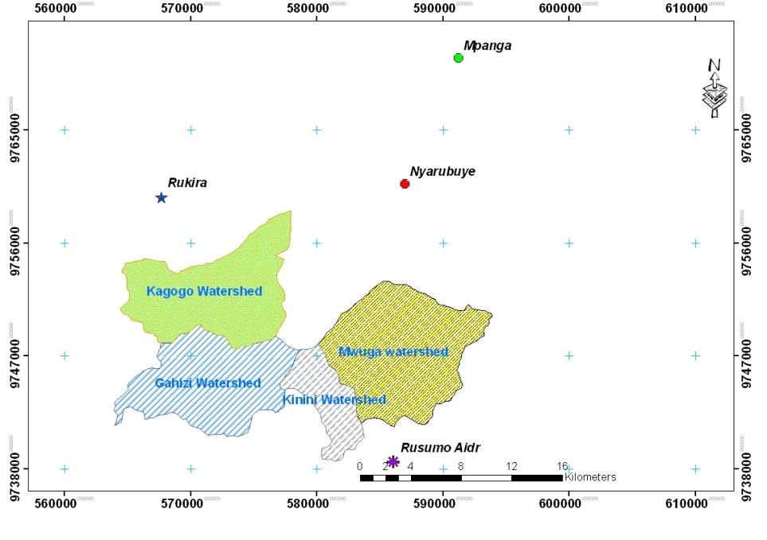

Figure 3: Meteorological stations distribution around KWAMP (UTM projection)
Source: Agricultural Information Center (GIS Unit), 2009
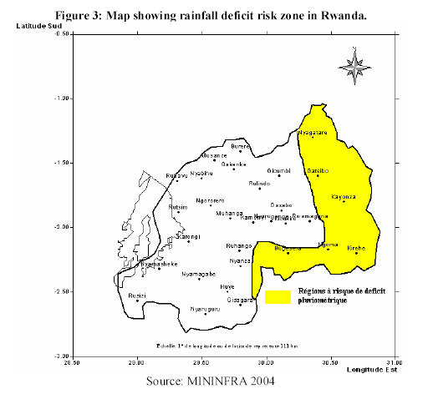

Figure 4: Rainfall Deficit Zone in Rwanda

2.1.2. Hydrography
Inside the District of Kirehe, water availability remains a major problem for the population, who often has to walk long distances to find potable water. The Kinoni watershed is drained by a small river of the similar name towards the Muyonza river all of which drains into the Akagera river (SABA Engineering, 2010).

2.1.3. Topography
As a part of the kirehe District, the relief is that of the areas of the low plateau. However, there is a mountain chain which divides the area into two geographical entities, characterized by a plain of low altitude of more or less than 1350m of altitude, punctuated by insulated hills and those of the hills and mountains with flat terrain at the tops (Mahama Mount and a mountain chain of Imigongo).The average altitude of Kirehe District is 1500 meters (SABA Engineering, 2010).

2.1.4. Soil
The tropical soils are widespread in Kirehe District. In the district, Kaolisols, xerokaolisols and the soils of the valley bottoms, vertisols and histosols predominate. Combined with a moderate weather, all these soils can be exploited and give a satisfactory production. In addition to these soils, considered good for planting, there are also sandy soils that can be used as construction material, found in the area of Bukora, of Nyamugari Sector (SABA Engineering, 2010).

2.1.5. Vegetation
The vegetation of the District of Kirehe is the Eastern savanna type and trees with predominance of Acacia sp. Outside of the natural area, trees have tendency to disappear completely. Here one meets the forest plantations of the District and woodlots belonging to private owners (SABA Engineering, 2010).

2.1.6. Agriculture production in the study area
Based on the reconnaissance survey and the farm household survey of Kirehe district, in four selected watershed areas under KWAMP project, done by MINAGRI, it was concluded that: The crop production is mainly accomplished along the flood plains of the valley of marshland on the residual soil moisture as the flood recedes following the rainy season which are devoted to produce maize, sorghum, vegetables, sweet potatoes and beans. Also along the hillside following the valley bottom crop productions are experienced to produce mainly Banana, Cassava, Maize, Sorghum, Beans and Coffee and in some areas, individual farmer use traditional irrigation by diverting the river.The practice is essentially subsistence, which follows aged and old traditional, low input and low output production system. The most common farming practice in the project areas are mixed Agriculture, whereby crop cultivation is integrated with livestock husbandry which is a strategy adopted by smallholding farmers to minimize risks of crop failure to the face of variable rainfall pattern.
The two major farming systems have been identified in the study area are banana- cereal based smallholding cropping system and small-scale traditional irrigation Agriculture. The major crops grown within the study area are Banana, maize, sorghum, dry beans, cassava and coffee under rain fed and cabbage, sweet potato, tomato under traditional irrigation using watering came from river and on marsh land (swamp areas) using flood during rainy season. Banana is the most predominant food crop in the district, with 63% of the total agricultural production recorded in 2005.

2.2. Materials

2.2.1. Data input
The data used were collected as follows:

Digital elevation Model (DEM): The SRTM (Shuttle Radar Topography Mission) obtained elevation radar data in high-resolution digital topographic database of the earth (30m). The SRTM generated consistent, comprehensive topographic data and radar images to model the terrain and map the land of most of the inhabited surface of the earth. For this study the SRTM for the study area was acquired from Center of GIS (CGIS) at the National University of Rwanda (NUR).
Rainfall data: These data consist of existing daily record of rainfall in the Nyarubuye station located around the study area and the data were obtained from Rwanda meteorological Services.
Color spot satellite imagery of Rwanda: It was taken in the driest month and acquired in the year 2009. This image gives the details information about the situation of land use and land cover. It was produced from satellite, recorded and acquired at CGIS-NUR.
Pedological map of Rwanda: This map was made in 2000 under supervision of the University of Ghent (Belgium), classifies the soil texture of the country based on the USDA triangle of soil texture. It will give detailed information about the soil texture and help to group the characteristics into hydrological soil groups.

2.2.2. Software used
CROPWAT 8.0: It is a decision support system developed by the Land Water development division of FAO for planning and management of irrigation. It is meant as a practical tool to carry out standard calculation for reference evapotranspiration, crop water requirements and crop irrigation requirements, and more specifically the design and management of irrigation schemes.

ArCGIS 9.2: This software was used for overlaying process. It was used to perform the hydro-processing operations, land cover reclassification and hydrological soil group maps were done by using ArcMap.
The other materials used are Global Positioning System (GPS) for collecting geographic data.

2.3. Methods
2.3.1. Catchment delineation
For the delineation of catchment in Kinoni watershed, a semi-automated approach has been chosen for accuracy. This method required GIS software to perform the task. The core data were the Digital Elevation model (DEM) of the Rwanda obtained from the Center of Geographic Information System of Rwanda (CGIS-NUR). The DEM was produced from an image of Shuttle Radar Topography Mission (SRTM) with a resolution of 30 meters. In order to analyze the surface on a horizontal plane, this file was projected into two dimensional coordinate system.
The delineation of catchment area was performed using the hydrological tools in the Arc-GIS 9.2 software environment. The hydro-processing operations performed include fill sinks, flow direction, flow accumulation, drainage network extraction, drainage network ordering, catchment extraction and catchment merge. The ‘‘fill sinks’’ operation aimed at eliminating undefined cells that are completely surrounded by cells of higher elevation. The operation uses kriging method which returns a raster map with estimation of undefined values, which are weighted average values similar to the moving average operation. The estimated values are thus a linear combination of the input values and have a minimum estimation error (Maathius and wang, 2006). The input data for this operation was the project DEM of the study area. This generates a sinkless map of the study area.
The map generated as the result of fill sink operation is then used as input for the next operation ‘‘flow direction’’ aimed at determining the runoff direction throughout the area. The steepest slope method was used. This means that flow direction was chosen according to the downhill slope between a central pixel and its 8 neighbouring pixels. The flow direction map was generated as the result of this operation. This map will serve as input data for the generation of flow accumulation map. The flow accumulation operation was performed to determine the cells of high flow to establish flow direction map. As the result of this operation, flow accumulation map was generated. This map was used as input data for the drainage network operation.
Drainage network extraction aimed at establishing the nature of drainage network in the study area. This operation requires an assumption of the minimum number of pixels that should drain into the examined pixel for it to be added to the output drainage network. In this study, an assumption of 90 pixels was made. A drainage network extraction map was generated as a result of this operation.
The next operation was the drainage network ordering “stream ordering’’. This operation allows us to have an appreciation of the nature of Streams and River in the area. Stream ordering operation required the use of DEM, the flow direction map and the drainage network map as input. During the operation of assigning a Strahler or Shreve order number to each stream in the drainage network is available. This operation requires an assumption of the minimum stream length to be displayed. This operation result in obtaining the drainage network map of the study area according to the given conditions.
After the stream ordering operation, the catchment extraction operation was performed. This operation delineates the unit catchment that drains in a particular stream. The input data are drainage network ordering map and the flow direction map. This operation generates a map with a catchment of every single stream in the drainage network. A number of catchment equal to the number of streams was obtained.
The catchment merge operation was performed to drain water to the same final outlet point or identifying streams that are the same order. These operations give an opportunity of dividing the study area into a number of catchment according to assigned outlet or stream order. For merging the small catchment into a number of larger ones, first an existing administrative boundaries layer of Kirehe district was overlaid on the drainage network. It was then possible to find the major streams that drain water out of the study area. The direction of stream could be seen through the different orders of streams. Then a point defining the major outlet points of streams in study area was created with two outlet point by considering the location of dam site and command area suggested by KWAMP project and used to delineate catchment. The field’s measurement of GPS points for dam site and command area was done to identify the outlets points. The catchment merge operation was then performed by obtaining the area of all catchment.

2.3.2. Classification of land use, land cover and soil type
- Land use and land cover
The land use and land cover situation was analyzed from color SPOT satellite imagery of 30 meters of resolution which was taken in the driest month. The land use/cover map of the study area was obtained by visual interpreting and digitizing of the color SPOT satellite imagery. After the analysis of land use/cover, the visit field inspection was used to classify the land use/cover in different land cover class that were reclassified into 6 groups to adapt it to the conditions set by the SCS Curve Number (Tan et al., 2002). The 6 groups of land cover are:
- All cropped lands have been classified as agricultural land
- The agricultural land with conservation treatment.
- Forest plantations and naturals have been classified as forest land
- Permanently flooded land and post flooding crop were classified as wetland
- Close to open shrubs and sparse trees were classified as range land or pasture land
- Whereas settlement land remains settlement area.
No land cover class characteristics were found to be similar to those of barren land.

- Hydrological soil group (HSG)
The analysis of soil characteristics aiming at classifying the different soil types into hydrologic soil group was performed. To get hydrological soil groups in the study area, interpretation of the pedological map of Rwanda were made and it was obtained by extracting it in ArcGIS from Rwanda soil characteristics map provided by CGIS. These
soils classes were grouped in three hydrological soil groups.

2.3.3. Determination of Curve Number within the catchment
To select the Curve Number value for each Sub-catchment, it was necessary to use land use /cover and soil characteristics data. These data were obtained by using respectively the analysis of the actual situation of land use/cover and soil characteristics in the catchment.
The land cover and soil type within the sub-catchment were obtained by overlaying the catchment map to the land cover and soil characteristics maps. Every land cover complex within a catchment was digitized in order to get occupied surface area (Ai) and associated to the corresponding soil characteristics to select curve Number (CNi). After all CNi in catchment were obtained, a weighted CN for the whole catchment was then computed.

2.3.4. Runoff estimation
Analysis of rainfall data
Rainfall data were obtained from the Rwandan Meteorological Office. This data consist of existing daily records of rainfall from 1951 to 1980. As our case study is Kinoni catchment, we considered the meteorological station of Nyarubuye located around the catchment. It is said that one rain gauge station provides a reliable picture on rainfall distribution by covering 250 to 1000 km² of area in mountainous region. The station is at 12 km far from our catchment and it covers the study area, the reason why Nyarubuye station was chosen.
To be able to estimate a consistent average daily rainfall needed in the SCS-CN method, 30 years rainfall records were needed. The total annual rainfall was determined considering the total monthly rainfall obtained from the daily rainfall records.
After computing the total annual rainfall, a plot of the probability of occurrence and the amount of rainfall has been made. Before plotting, the rainfall values were arranged in descending order and ranked. Values of the probability of occurrence were obtained using the formula
where: P%: probability of occurrence; m: rank of the rainfall event; n: total number of rainfall events. An average annual rainfall for the station was computed as the average of 3 values of total annual rainfall obtained from the plotted curve of probability. These 3 values were chosen as follows: A wet year or year with high amount of rainfall which corresponds to 10% of probability of occurrence; a dry year or year with low amount of rainfall which corresponds to 90% of probability of occurrence; an average year or year of average amount of rainfall which correspond to 50% of probability of occurrence. The average daily rainfall was obtained from the daily records of the year which total annual rainfall was nearly equal to the computed average.

- Estimation of runoff volume using SCS Curve Number method
To be able to estimate the runoff volume for each catchment, the SCS-CN method was used. For the application of this method, the analysis of rainfall data was done to accurately approximate the average daily rainfall of Kinoni catchment. Also the land cover and soil characteristics of the catchment have been analyzed to select the curve numbers of each sub-catchment to compute the weighted curve number (CN) for the whole catchment. The potential maximum soil water retention of Kinoni catchment was computed as well, as it is taken into consideration to compute the runoff volume.

2.3.5. Assessment of water need for irrigation and stored in the irrigation structure

Determination of irrigation water requirement
Procedure for calculating the irrigation water requirement was done based on FAO method by using CROPWAT Software. The irrigation water requirement was carried out with the input of climatic, crop and soil data. The estimation of irrigation water requirement was done in this study by determining the following parameters in the CROPWAT Software: Reference evapo-transpiration, effective rainfall, crop water requirement, net irrigation water requirement, gross irrigation water requirement.
Irrigation water requirement was determined as the crop water requirement less the effective rainfall. The irrigation water requirement was determined by using Rusumo climatic data, crop data for each crop including the cropping pattern and the soil data for clay loam as soil type found in the command area of Kinoni watershed (site 4). The climatic data used are mean monthly of rainfall, wind speed, and sunshine hours, relative humidity and minimum and maximum temperatures. The available climatic information was:
- Temperature minimum and maximum more than 36 years
- Wind speed Mean more than 57 years
- Sunshine hours Mean sunshine hrs of more than 57 years
- Humidity Mean relative humidity of more than 57 years
- Rainfall of 36 Years
The Above climatic information was computed and prepared to be used in a computer program of crop water requirement developed by FAO Version 8.0 for windows. The Climatic information's are prepared using the following data:
- Mean monthly air temperature, (⁰C minimum and maximum)
- Mean monthly relative humidity (%)
- Mean monthly wind velocity at 2m height in m/s
- Mean monthly relative duration of bright sunshine hours in hour of twenty-four hour
- Mean monthly rainfall (mm)
This table 1 shows these climatic data information.

Table 1: Climatic data for Rusumo meteorological station
Month | Maximum temperature (°C) | Minimum temperature (°C) | Mean humidity (%) | Wind Speed  (k.m/day) | Sunshine Hour | Rainfall  (mm)
Jan | 27.14 | 13.08 | 73.76 | 157.25 | 5.30 | 53.10
Feb | 27.20 | 13.75 | 76.87 | 159.84 | 5.00 | 57.23
March | 26.87 | 14.93 | 78.81 | 159.84 | 5.50 | 99.82
April | 26.52 | 15.07 | 83.41 | 149.46 | 4.70 | 128.06
May | 25.73 | 15.08 | 82.12 | 161.14 | 4.10 | 134.61
June | 25.29 | 13.82 | 68.68 | 170.62 | 7.20 | 84.29
July | 24.56 | 13.70 | 57.35 | 187.08 | 6.20 | 90.68
August | 24.17 | 14.70 | 53.48 | 194.38 | 6.20 | 141.90
Sep | 24.29 | 13.04 | 62.81 | 190.94 | 5.60 | 134.25
Oct | 25.20 | 13.70 | 77.73 | 186.19 | 3.80 | 119.04
Nov | 25.48 | 14.14 | 78.00 | 167.63 | 4.50 | 96.90
Dec | 26.92 | 13.66 | 81.34 | 160.25 | 4.10 | 75.24

Crop water requirement (CWR)
The calculation of CWR was based on the ETo, crop coefficient of crop (K_{c}) and Effective rainfall. The determination of CWR for each crop was done separately. The CWR was obtained automatically by using CROPWAT software. The information below helped in calculation of CWR filled in the CROPWAT software:
- Crop data include the planting date, the crop coefficient, the length of growth stage, critical depletion, crop height and yield response;
- Soil data include the total available soil moisture (FC-WP), the maximum rain infiltration rate, maximum rooting depth and initial soil moisture depletion.
Before the CWR calculation, the ETo (evapo-transpiration) and Peff (Effective rainfall) were calculated by applying the Penman-Monteith Method. After calculation of ETo and Peff, the selection of crop to be growth within the field (that have 96 ha) of the study area was based on the cropping patterns and cropping calendar. The crop data information including Kc, length of growth stage, root depth, critical depletion and yield response, were determined according to each selected crop including the cropping patterns in the study area.

- Results and discussion
3.1Catchment delineation in Kinoni catchment area
The hand delineation based on the contour information depicted on the Rwanda topographic map. A 30-meter resolution of Digital Elevation Model was used for delineation of catchment by using hydrological tools in ArcGIS software version 9.2. The map shows in the figure 6 was obtained by subtraction from the country’s SRTM DEM, at coordinates:
-Upper left corner X= 584200 and Y= 9748750
-Lower right corner X= 577750 and Y= 9740200
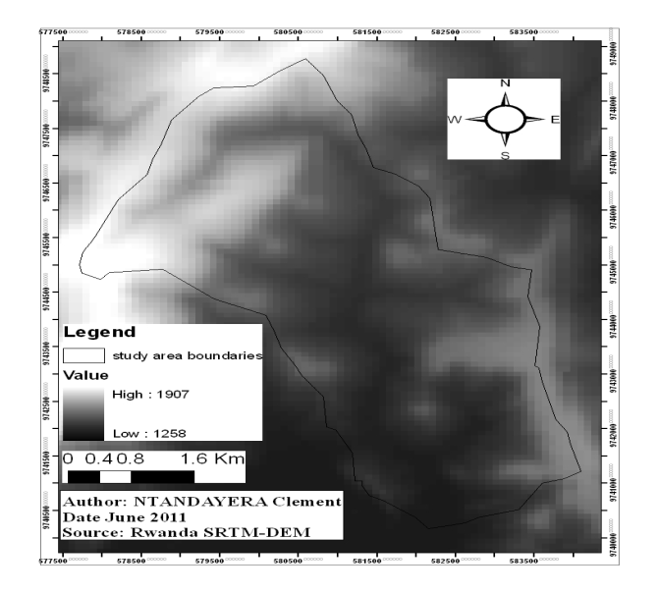

Figure 5: Altitude (in meter) of the SRTM DEM used for catchment delineation

Different altitudes in and around the Kinoni catchment are presented on map. Within Kinoni watershed boundary, the different altitudes range from 1762 to 1325 m around the watershed, the altitudes range from 1907 to 1258 m.a.s.l. The topography of the area is characterized as rolling, with hills and low lying areas side by side as shown in figure 6.

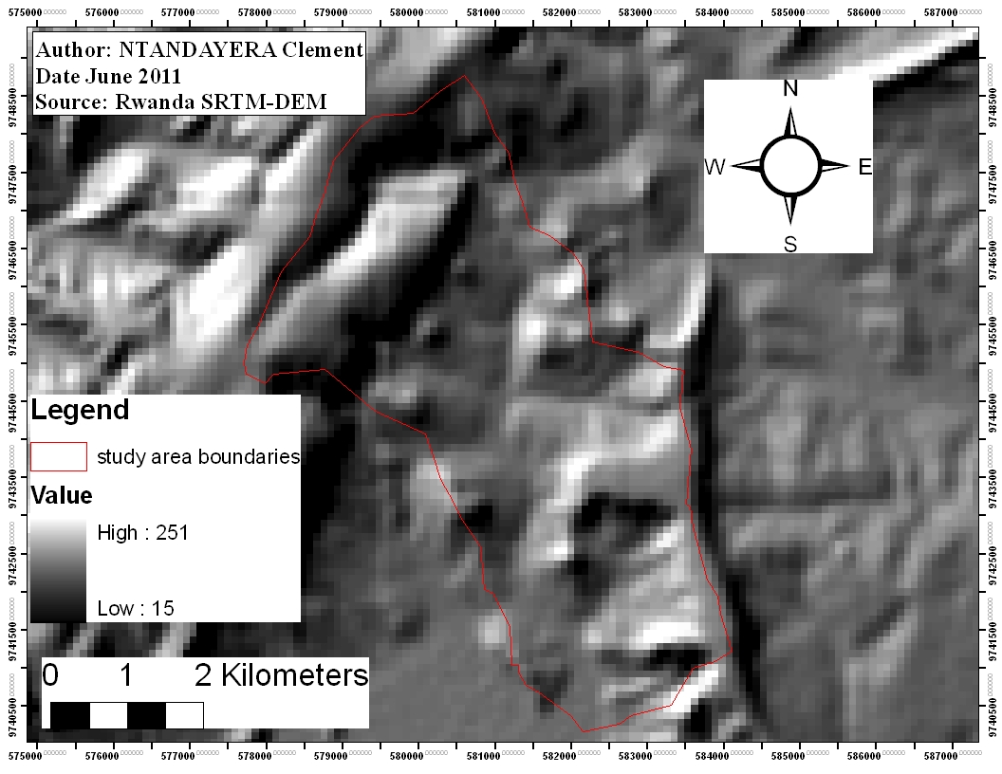

Figure 6: General topography situation in Kinoni catchment

In comparison with its surrounding, Kinoni catchment topography is characterized by hills round on top and U-shaped valleys, while all around the area the tendency is to find V-shaped and pick mountains. The topography of the area consists of valley, hills and mountains, determine the way rainwater runoff is going to be drained. The area is drained by the valleys separating the hills and generally flowing to the East into the Akagera River.
The drainage network within the topography of the area is shown on figure 7.

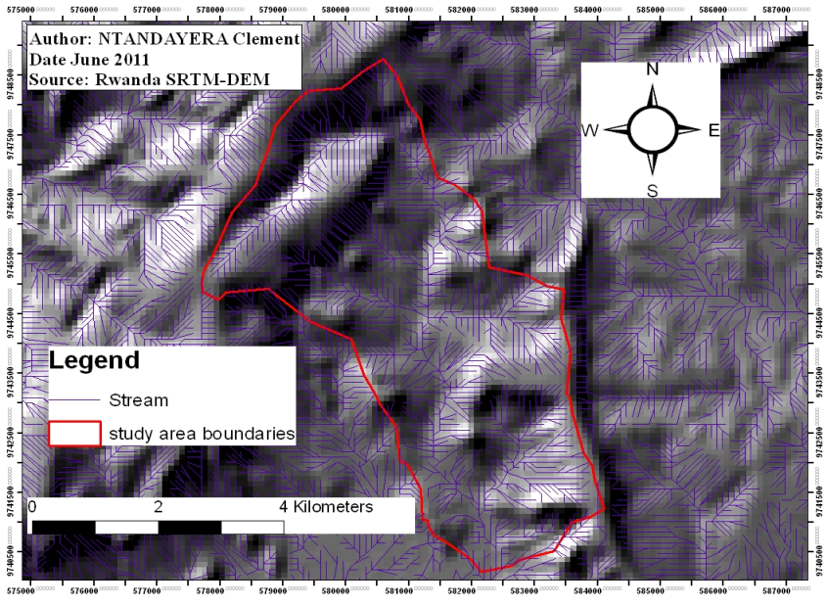

Figure 7: Drainage network within the topography of the area

Naturally, rainwater runoff is drained following low altitudes areas. The drainage network of the area falls into the valleys between the mountains. To be able to know the direction of streams, it is necessary to order them. Figure 8 presents the drainage network ordering using the Strahler stream ordering method.

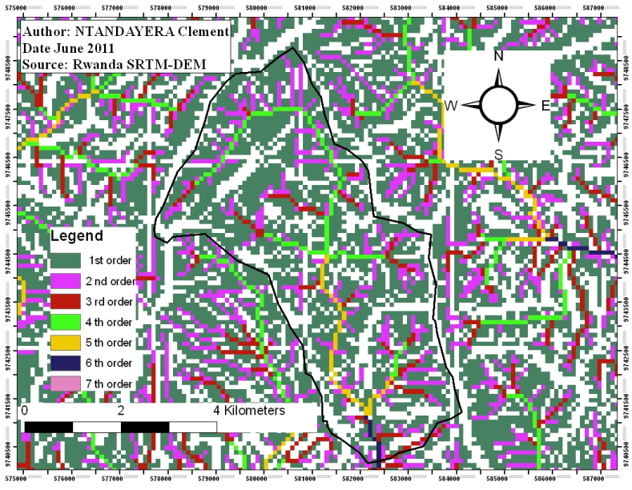

Figure 8: Strahler stream order of the drainage network

Low ranked streams are flowing to higher ranked streams. The highest Strahler stream order found in the drainage network is the 7th order. Analyzing these stream orders, it may be seen that we can hardly find some temporary runoff storage lakes within the Kinoni catchment.
After overlaying the Kinoni catchment to the drainage network, the outlets points of the major streams to be used for catchment delineation have been determined by considering the highest point of water accumulation. The outlet points are located at the points of high accumulation of water respectively in dam site and command area as presented in figure 9.
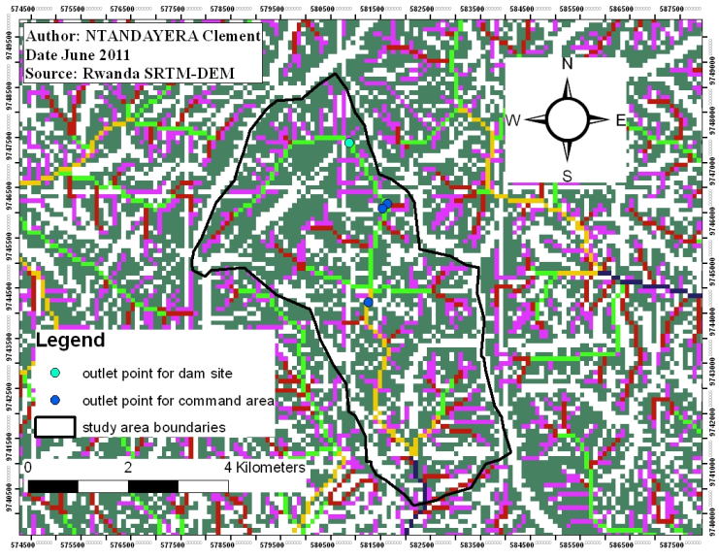

After defining the outlet points of catchment, which are areas that contribute runoff to those outlet points, have been delineated in two Sub-catchments. The figure 10 presents the extracted sub-catchments within the boundary of Kinoni watershed.

Figure 9: Outlet points of drainage network

within the study area

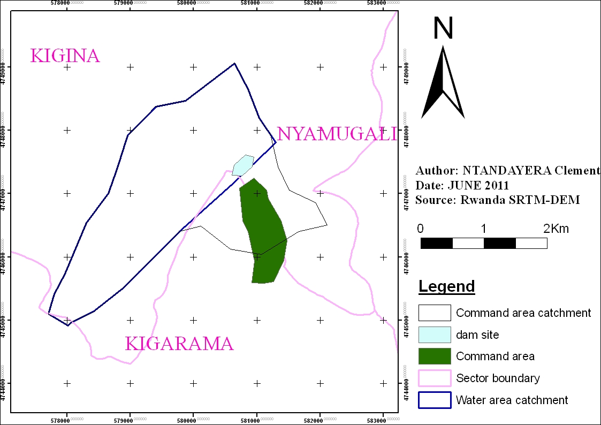

Figure 10: Delineated watershed with theirs Sub-catchments

This catchment was delineated in two Sub-catchments that are:
- Water area catchment: it is the entire watershed that is the main source of the water to be harvested in the reservoir; the area is 5805043 m² or 580.5043 Ha.
- Command-area catchment: is the land which is up-hill of the command area that could contribute runoff and flood to the down-catchment command area, the area is estimated to 1,792,157 m² or 179.2157 Ha.
Also, this figure 10 shows:
- Command area: is the land designed to be irrigated in dry seasons by the water to be harvested in the reservoir during the rainy seasons the area is 96 Ha. It is located just downstream of the dam site.
- Reservoir (dam site): is the land designed to be filled by water draining from the Water-catchment having the surface area of 40,824 m² or 4.08 Ha.

3.2 Land use, land cover and soil characteristic analysis
To analyze land use, land cover and soil characteristics is just very important before selecting the curve numbers (CN) which are needed for estimating the runoff within each sub-catchment. The analysis was done by visual interpreting and digitizing the color SPOT satellite imagery within the each Sub-catchment. Also the field visit inspection was done to verify the classification of the land use/cover in different land cover class that are: Agricultural (Banana plantation and season crop), Cultivated land with conservation treatment, Forest land, Range land, Settlements land and wetland. These land use classes were grouped and classified according to the combination of classification made or modify by Tan et al., (2002) and Mockus (USDA, 1792).

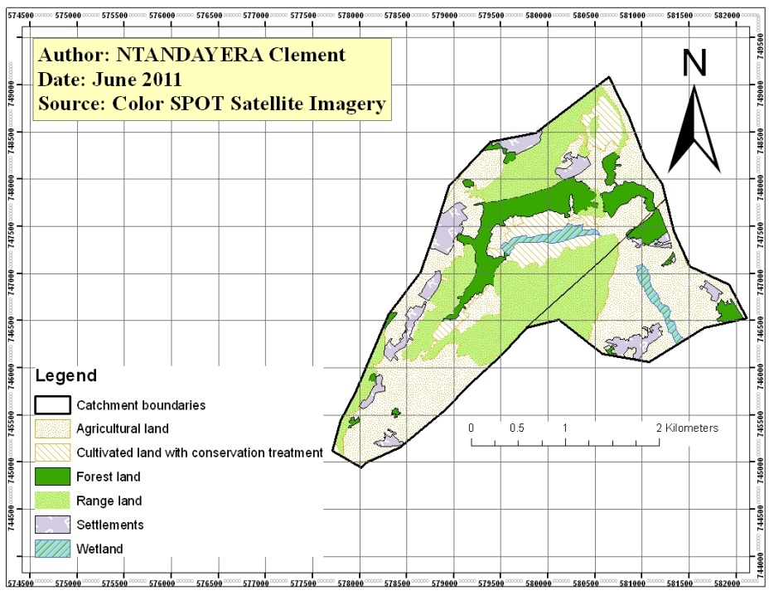

Figure 11: Land use in the Kinoni catchment (site 4)

The major landcover of Kinoni catchment found was Agricultural land, followed by rangeland, forest land, settlement land, wetland and the smallest one was a cultivated land with conservation treatment. The table 2 shows in percentages the distribution area of each land use type in the catchment.

Table 2: Land use distribution in the Kinoni catchment (site 4)
Landa use | Area in Ha | Area %
Agricultural land | 373.0019 | 49.01
Agricultural land with conservation treatment | 6.5833 | 0.86
Forest land | 84.7162 | 11.13
Range land | 223.2911 | 29.34
Settlement land | 54.5552 | 7.17
Wetland | 18.9569 | 2.49

The Kinoni catchment (site 4) soil map extraction was also performed for classifying the soil characteristics found in the Rwanda pedological map. The soil texture types were grouped into three classes. Figure 12 presents the three soil groups needed in the selection of curve number (CN).

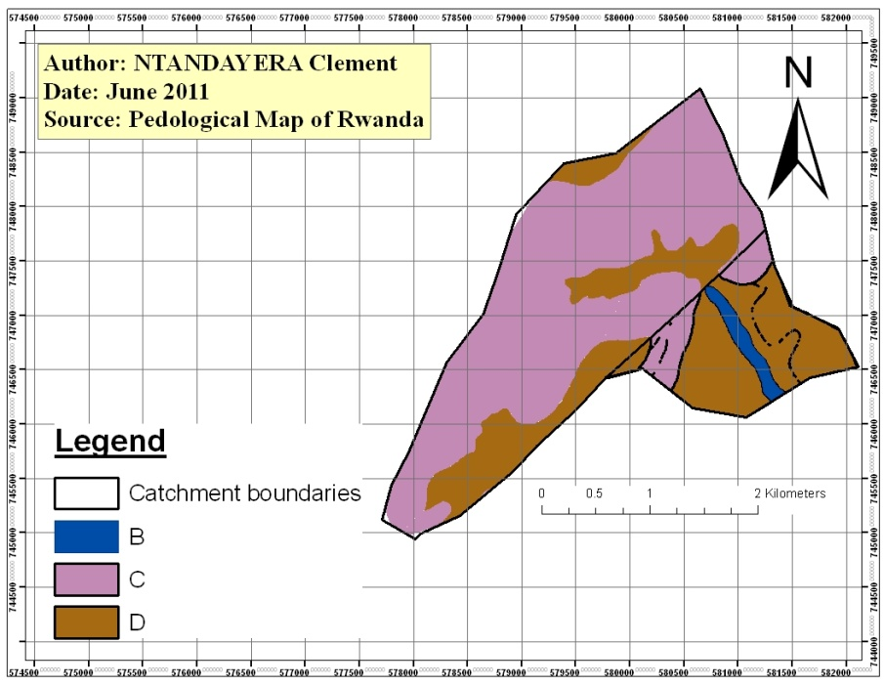

Figure 12: Hydrological soil group in the Kinoni catchment (site 4)

The major hydrologic soil group is C and the smallest is the hydrological soil group B. soil of hydrologic soil group B is located in the marshes, while hydrologic soil group C and D are found in the valley and the mountain. The table 3 shows the distribution of hydrological soil groups in the catchment.

Table 3: Hydrological soil group distribution in Kinoni catchment (site 4)
Hydrological soil group | Area in Ha | Area %
B | 13.7992 | 1.81
C | 486.8522 | 63.90
D | 261.2484 | 34.29

3.3 Determination of the curve number values within the Kinoni catchment (site 4) by regrouping land cover/use and soil
Land use/cover and Hydrological soil group maps were overlaid in the ArcMap for preparing combination of 6 land use classes and 3 Hydrological soil groups. This combination is termed as Hydrological soil cover complex (HSCC) along with antecedent condition and was used to assign the curve number of each Sub-catchment.

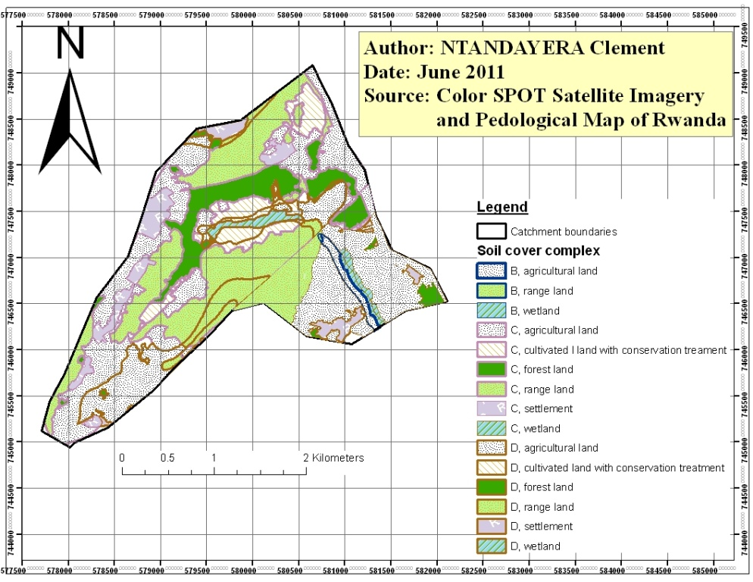

Figure 13: Soil cover complex in the Kinoni catchment (Site 4)

This figure 13 shows at the same time the location of land use and soil type in the catchment. Those soil complex characteristics are needed for curve number selection within the catchment.
The soil cover complex C, rangeland is major dominant groups in the whole catchment with 24.9% and the smallest is the hydrological soil cover complex B, range land with 0.05% as it shown in table 4 which shows in percentage the distribution area of each hydrological soil cover complex in the catchment.
After obtaining the Hydrological soil cover complex, the selection of the curve number is determined by considering the antecedent moisture condition for every soil cover complex as shown in table 5 that presents the soil cover complex, the occupied surface area (Ai) and the corresponding curve number (CNi) for antecedent moisture condition I, II, III.

Table 4: Hydrological soil cover complex distribution in kinoni catchment (site 4)
Soil cover complex | Area in Ha | Area %
B, agricultural land | 9.5379 | 1.26
B, range land | 0.3465 | 0.05
B, wetland | 3.9111 | 0.52
C, agricultural land | 155.2117 | 20.50
C, agricultural with conservation treatment | 41.2 | 5.44
C, forest land | 75.5078 | 9.97
C, range land | 189.1007 | 24.97
C, settlements land | 34.0011 | 4.49
C, wetland | 2.2092 | 0.29
D, agricultural land | 157.9676 | 20.86
D, agricultural with conservation treatment | 13.3466 | 1.76
D, forest land | 8.2129 | 1.08
D, range land | 33.1259 | 4.37
D, settlements land | 19.997 | 2.64
D, wetland | 13.5186 | 1.79

Table 5: Soil cover complex, occupied surface (Ai), and corresponding CNi
Catchment | Soil cover complex | Surface area (Ai) | Curve Number (CNi) |  |  | CNi X Ai
Catchment | Soil cover complex | Surface area (Ai) | AMC I | AMC II | AMC III | AMC I | AMC II | AMC III
Command area catchment | B, agricultural land | 9.5379 | 64 | 81 | 91 | 610.4256 | 772.5699 | 867.9489
Command area catchment | B, range land | 0.3465 | 35 | 56 | 75 | 12.1275 | 19.404 | 25.9875
Command area catchment | B, wetland | 3.9111 | 100 | 100 | 100 | 391.11 | 391.11 | 391.11
Command area catchment | C, agricultural land | 3.6877 | 75 | 88 | 94 | 276.5775 | 324.5176 | 346.6438
Command area catchment | C, forest land | 7.8575 | 53 | 73 | 86 | 416.4475 | 573.5975 | 675.745
Command area catchment | C, range land | 20.9975 | 49 | 70 | 84 | 1028.8775 | 1469.825 | 1763.79
Command area catchment | C, settlements land | 1.5325 | 86 | 94 | 97 | 131.795 | 144.055 | 148.6525
Command area catchment | D, agricultural land | 95.9192 | 81 | 91 | 96 | 7769.4552 | 8728.6472 | 9208.2432
Command area catchment | D, forest land | 5.5468 | 61 | 79 | 90 | 338.3548 | 438.1972 | 499.212
Command area catchment | D, range land | 11.4995 | 58 | 77 | 89 | 666.971 | 885.4615 | 1023.4555
Command area catchment | D, settlements land | 12.3959 | 89 | 95 | 98 | 1103.2351 | 1177.6105 | 1214.7982
Command area catchment | D, wetland | 4.1245 | 100 | 100 | 100 | 412.45 | 412.45 | 412.45
Water area catchment | C, agricultural land | 151.0328 | 75 | 88 | 94 | 11327.46 | 13290.886 | 14197.083
Water area catchment | C, agricultural with conservation treatment | 40.7088 | 71 | 78 | 81 | 2890.3248 | 3175.2864 | 3297.4128
Water area catchment | C, forest land | 67.1591 | 53 | 73 | 86 | 3559.4323 | 4902.6143 | 5775.6826
Water area catchment | C, range land | 167.612 | 49 | 70 | 84 | 8212.988 | 11732.84 | 14079.408
Water area catchment | C, settlements land | 31.9774 | 86 | 94 | 97 | 2750.0564 | 3005.8756 | 3101.8078
Water area catchment | C, wetland | 1.718 | 100 | 100 | 100 | 171.8 | 171.8 | 171.8
Water area catchment | D, agricultural land | 62.0484 | 81 | 91 | 96 | 5025.9204 | 5646.4044 | 5956.6464
Water area catchment | D, agricultural with conservation treatment | 13.3466 | 71 | 78 | 81 | 947.6086 | 1041.0348 | 1081.0746
Water area catchment | D, forest land | 2.6661 | 61 | 79 | 90 | 162.6321 | 210.6219 | 239.949
Water area catchment | D, range land | 21.6264 | 58 | 77 | 89 | 1254.3312 | 1665.2328 | 1924.7496
Water area catchment | D, settlements land | 7.6011 | 89 | 95 | 98 | 676.4979 | 722.1045 | 744.9078
Water area catchment | D, wetland | 9.3941 | 100 | 100 | 100 | 939.41 | 939.41 | 939.41

After selecting the curve number for every soil cover complex, a weighted CN for each Sub-catchment was then computed. Table 5 presents the weighted curve number CN for Sub-catchment.

Table 6: Weighted Curve Number CNj
Catchment | CNi X Ai |  |  | Catchment Area (Aj) in Ha | Weighted curve Number (CNj)
Catchment | AMC I | AMC II | AMC III | Catchment Area (Aj) in Ha | AMC I | AMC II | AMC III
Command area catchment | 13157.827 | 15337.445 | 16578.037 | 179.2157 | 73.41894 | 85.58092 | 92.50326
Water area catchment | 37918.462 | 46504.111 | 51509.932 | 580.5043 | 65.31986 | 80.10985 | 88.73308

3.4 Runoff estimation
- Analysis of rainfall data
For confident approximation of average values of rainfall in hydrology, 30 years time records were needed. This period was chosen from 1951 to 1980 by considering the available daily data complete. The obtained 30 years rainfall data are presented in the figure 14.
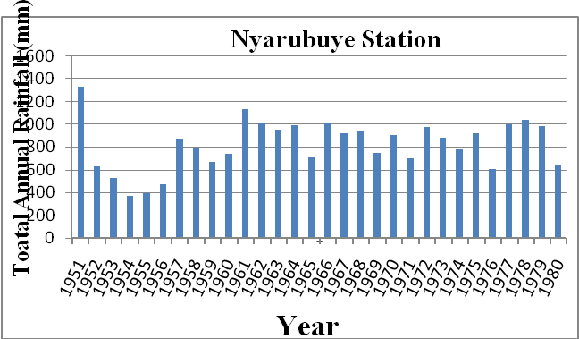

Figure 14: Distribution of total annual rainfall in the Nyarubuye station

The figure 14 shows the amount of total annual rainfall with a general trend to get maximum peak rainfall in 1951 and the minimum peak rainfall in 1954 and the total average annual rainfall of all rainfall stations for that considered period was 822.5 mm.
The year from which average daily rainfall was going to be approximated was set to be the
year during which total annual rainfall was nearly equal to the average of three values of total annual rainwater considered as the wet, the medium and the dry year (which correspond respectively to 10%, 50% and 90%). The probability of occurrence of the rainfall was calculated and plotted for the station as shown in figure 15:

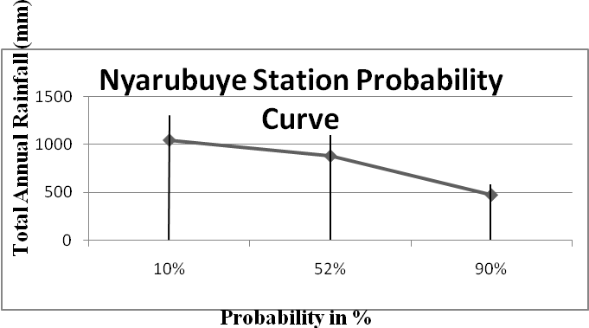

Figure 15: Maximum, medium and minimum years of total annual rainfall

The largest maximun, medium and smallest were respectively in 1978, 1957 and 1956. The maximum, minimum and medium values of total annual rainfall are recapitulated in table 7. The average value and corresponding year is presented in the same table.

Table 7: Wet, dry and medium year of rainfall (mm)
Probability of occurrence | Wet year (P=10%) | Medium year (P=50%) | Dry year (P=90%) | Average (mm)
Total annual rainfall | 10041.7 mm | 877.1 mm | 471.9 mm | 796.9 mm
Year of correspondence | 1978 | 1957 | 1956 | 1958

The mean daily rainfall of the year 1958 used was obtained by approximating the daily rainfall at Nyarubuye station, which was equal to 2.15 mm.

- Estimation of runoff volume using SCS Curve Number method
The table 8 presents the weighted curve number CNj for each catchment, the corresponding maximum potential of soil water retention Sj and the estimated direct runoff Q computed.

Table 8: Weighted CNj, Sj and direct runoff Q (mm)
Catchment | Weighted curve number CNj |  |  | Potential maximum retention Sj |  |  | Direct runoff Q (mm)
Catchment | AMC I | AMC II | AMCIII | AMC I | AMC II | AMCIII | AMC I | AMC II | AMCIII
Command area catchment | 73.418 | 85.580 | 92.503 | 3.62 | 1.68 | 0.81 | 0.40 | 0.94 | 1.41
Water area catchment | 65.319 | 80.109 | 88.733 | 5.31 | 2.48 | 1.27 | 0.18 | 0.66 | 1.13

The estimated average daily direct runoff in the delineated catchment in the study area, were converted into volume as shown in the table 8 for different antecedent moisture condition.

Table 9: Estimated runoff volume in m³
Catchment | Total area Aj (m²) | Runoff Q (mm) |  |  | Runoff Volume Q ( m³)
Catchment | Total area Aj (m²) | AMC I | AMC II | AMC II | AMC I | AMC II | AMC II
Command area catchment | 1792157 | 0.40 | 0.94 | 1.41 | 716.86 | 1684.62 | 2526.94
Water area catchment | 5805043 | 0.18 | 0.66 | 1.13 | 1044.90 | 3831.32 | 6559.69
Total |  |  |  |  | 1761.76 | 5515.94 | 9086.63

For determining the runoff volume, we consider the average antecedent moisture condition of AMC II. The average daily runoff volume of whole catchment is equal to 5,515.94 m³. While the average daily runoff volume of command area catchment and water area catchment, are respectively equal to 1,684.62 m³ and 3,831.32 m³. The quantity of runoff to be available for supplying our reservoir is estimated by considering only surface of the water area catchment. However, the runoff volume to supply the reservoir is equal to 3,831.32 m³ per day and 1,398,431.8 m³ per year. The SCS curve number methods applied to model runoff showed adequate and accurate results (Ngila, 2010). According to the hydrology investigation report done by SABA Engineering, (2010), the annual runoff volume for supplying the reservoir was equal to 842,550.45 m³ by using the empirical formula. This annual runoff volume is less than our results due to the difference of runoff coefficient taken and the methods of application.

Acknowledgements
We acknowledge the financial and technical supports provided by the Higher Institute of Agriculture and Animal Husbandry (ISAE)-Busogo, the National University of Rwanda through the Center of Geographic Information System (CGIS) and Kirehe Watershed Management Project (KWAMP) for the completion of this study.

Corresponding author
NAHAYO Alphonse
Higher Institute of Agriculture and Animal Husbandry (ISAE)- Busogo; Department of Forestry and Nature Conservation; P.O.Box 210 Musanze, Rwanda; Email: nahayo1@yahoo.fr

References
- Kwamp, Juin 2010. Plan d’amenagement du bassin versant de Kinoni, Volume 03.
- Maathius, B.H.P., & Wang, L. (2006). Digital Elevation Model Based Hydro-processing. Geocarto International, Volume 21, nº1, p.22
- McCuen, Richard, H., 1998. Hydrology Analysis and Design. Upper Saddle River, N.J: Prentice Hall. 2nd edition.
- Ngila Munyao John., Ferbuary 2010. Use of satellite products to assess water harvesting potential in Remote areas of Africa. A case study in Unguja island, Zanzibar. p 64
- RELMA in ICRAF and UNEP, 2005. Potential for Rainwater Harvesting in Afirca. A GIS overview, volume 1, p ii.
- Tan, C. H., Melesse, A. M. and Yeh, S. S., 2002. Remote sensing and Geographic Information
- System in runoff coefficient estimation in China, Tapei; GIS developement.net. pp6.
- USDA,Victor Mockus, 1972. National Engineering HandBook, section 4, Hydrology, pp 9.2, 10.3-10.6a.
- SABA Engineering Plc, 2010. Agronomy report consultancy service for feasibility study and detailed design for development of selected irrigation site in four watershed area (Kinoni, Gahezi, Mwogo and Kagogo), pp.1-5, 7-26.

8/25/2012

