Comparison of ELISA with traditional methods used for evaluation of blackleg and gas gangrene vaccine

El-Helw, H.A.; Elham F El-Sergany; Taha, M.M.; Abdella, Y.A.; El-Sehemy, M. M.

Veterinary Serum and Vaccine Research Institute, Abbasia, Cairo, Egypt.
Eladawy_yasser@yahoo.com

Abstract: Potency test for bivalent clostridial vaccine against Blackleg and Gas gangrene mainly based on challenge test for estimation of bacterial immunogenicity of Clostridium chauvoei, and on serum neutralization test or hemolysin test for the Clostridium septicum toxigenicity. In this study, ELISA was done for evaluation of immunogenicity of Blackleg and Gas gangrene vaccine; three batches of vaccine were evaluated in guinea pigs, rabbits, and sheep. Challenge test; plate agglutination test, and indirect ELISA were done for Clostridium chauvoei, on the other hand, serum neutralization test; Hemolysin test, and Indirect ELISA were carried out for Clostridium septicum. The results obtained by ELISA pass parallel with challenge test, plate agglutination test, and Hemolysin test and there is no significant difference between them. Also there is great reproducibility in the results obtained in three batches. Also alpha toxoid of Clostridium septicum containing vaccine can be evaluated in guinea pigs, and there is great correlation between units obtained in sera of guinea pigs and that obtained in rabbits. So it concluded that the batch potency for C. chauvoei and C. septicum could be done by ELISA and replaced the traditional methods for evaluation due to precision, sensitivity, rapid, and save animals used.
[El-Helw, H.A.; Elham F El-Sergany; Taha, M.M.; Abdella, Y.A.; El-Sehemy, M. M. Comparison of ELISA with traditional methods used for evaluation of blackleg and gas gangrene vaccine. Nat Sci 2012;10 (11):137-144]. (ISSN: 1545-0740). http://www.sciencepub.net/nature. 20

Key words: Clostridial vaccine, ELISA, Potency.

1. Introduction
C. chauvoei is an endospore forming Gram positive anaerobic bacterium which is the pathogenic agent of a disease called blackleg (Hamaoka and Terakado, 1994). Blackleg is a disease causing serious toxemia associated with spore contaminated soil (Sasaki et al., 2000). It considered being fatal disease of cattle, sheep and other ruminants and wild animals and it is the most important clostridial disease producing economic losses in livestock industry (Smith and Williams, 1984).
C. septicum is a Gram positive motile spore forming anaerobic bacterium that is implicated as the cause of traumatic and non-traumatic gas gangrene which is rapidly fatal disease (Keogh et al., 1994). Many aspects of C. septicum induced non-enteric disease in domestic animals (Gyles, 1993). Wound infection by C. septicum in animals is generally referred to as what is called malignant edema and usually followed direct contamination of traumatic wound (Macleman, 1962).
Immunity to both C. chauvoei and C. septicum is generally anti-bacterial and also anti-toxic. In malignant edema, the course of disease is rapid therefore the prevention of C. septicum induced infection is preferable than treatment. Commercial bacterins, toxoids and bacterin toxoids are available as vaccines usually consist of inactivated liquid cultures eliciting antibody responses to both bacterial surface antigens and toxic components (Cygan, 1990; Hjerpe, 1990; Gyles, 1993). This vaccine usually produces lifelong immunity (Green et al., 1987; Morgan et al., 1988).
In Blackleg disease unlike other clostridial infections, the predominant role in protection depends on cell wall, and flagellar antigen mainly (Smith and Holdeman, 1968; Chandler and Gulasekharan, 1974).
The potency test of the locally manufactured clostridial vaccines containing the C. chauvoei based on the challenge assay in guinea pigs as the vaccines must protect at least 85% of guinea pigs when challenged with either virulent strain or spore suspension of C. chauvoei (Hamaoka et al., 1990; British Pharmacopoeia, 2010). On the other hand the potency test of the locally manufactured clostridial vaccines containing C. septicum antigens is mainly dependent on the measurement of the antitoxic immunity either by serum neutralization test in mice or by the haemolytic assay as (British Pharmacopoeia, 2010).
Makhareta and Hammam, 2001 applied an enzyme linked immunosorbent assay (ELISA) for evaluation of immunogenicity of blackleg disease vaccine and found that good correlation between results of ELISA and challenge test. (Osman et al., 1997) studied the presence of antibodies in cattle sera previously vaccinated with blackleg vaccine by using plat agglutination test, indirect haemagglutination test, complement fixation test and enzyme linked immunosorbent assay, where they found that all these tests gave best results with no great difference between them. While the application of ELISA in the measurement of immune antibodies to C. septicum will measure both the antibodies against alpha toxin of C. septicum and the antibodies against the bacterial surface antigens because the ELISA plates were coated by using the whole culture filtrate which containing both bacterins and toxins.
ELISA is suitable for measuring the immune response to different antigenic fractions instead of challenge or serum neutralization test because it has two advantages:- First, it will allow a significant reduction in the number of used guinea pigs or mice. Second, ELISA allow on open ended fully quantitative estimation of potency for vaccines (Makhareta and Hammam, 2001).
So the aim of this work is to use indirect ELISA to evaluate three vaccine batches of Blackleg and Gas gangrene and compare it with traditional methods used in evaluation of this vaccine.

2. .Material and Methods
1:- Vaccine preparation for C. chauvoei and C. septicum:-
Three batches of bivalent blackleg and gas gangrene vaccines (C. chauvoei and C. septicum) were prepared according to Gadalla et al., 1974. And subjected to sterility, safety before using them in immunization according to British Pharmacopoeia, 2010)
2:- Preparation of antigens:-
2-1:- Preparation and titration of C. chauvoei agglutinating antigen:-
It was prepared according to (Claus and Macheak, 1972).
2-2:- Preparation of C. chauvoei antigen for ELISA:-
It was prepared according to (Matter et al., 2002).
2-3:- Preparation and titration of C. chauvoei spore suspension
It was prepared according to (Cooper et al., 1960).
2-4:- Preparation of C. septicum antigen for ELISA:-
It was prepared according to (Hong et al., 2002).
3:- Antisera:-
3-1:- Positive sera:-
C. chauvoei and C. septicum positive sera were supplemented by Anaerobic Vaccine Research Department, VSVRI, Abbasia, Cairo, Egypt.
3-2:- Negative Sera:-
C. chauvoei and C. septicum negative sera were collected from non immunized animals (guinea pigs, rabbits, and sheep).
4:- Animals:-
4-1:- Guinea pigs:-
A total number of 60 Guinea pigs weighting 250-300 gm were used, they were divided into three groups, twenty G. pigs for each vaccine batch.
4-2:- Rabbits:-
A total number of 21 bosket rabbits weighing about 2-3 kg. were divided into three groups, seven rabbits for each vaccine batch.
4-3:- Sheep:-
Fifteen sheep of 9-12 month old were divided into three groups, five sheep for each vaccine batch.
4-4:-Mice:-
Swiss mice weighting between 15-20g were used in determination of test dose of alpha toxin, and in serum neutralization test of sera of immunized animals.
Vaccination schedule:
All the above mentioned animals were vaccinated S/C in two doses with 3 weeks intervals, where the 1st dose of vaccine was 3ml, and 2nd dose 2ml. then blood samples were taken after 2 weeks from 2nd dose, sera separated individually and part of them pooled for serum neutralization test.
5- Detection of antibody titers:-
5-1:- Detection of antibody titers against antigens of C. chauvoei
5-1-1:- Challenge test was carried for all vaccinated guinea pigs of the three groups according to (British Pharmacopoeia 2010)
5-1-2:- Serum samples of all vaccinated animals (guinea pigs, rabbits, and sheep) were exposed to:-
- Plate agglutination test according to (Claus and Macheak, 1972), and the results was calculated according to equation:
(1/serum volume) ÷ (2* serum dilution) according to (Troxel et al., 1997)
- Indirect ELISA test according to (Wood, 1991; Matter et al., 2002)
5-2:- Detection of antibody titer against antigens of C. septicum:-
All serum samples of all vaccinated animals (guinea pigs, rabbits, and sheep) were exposed to:-
- Serum neutralization test according to (British Pharmacopoeia, 2010)
- Hemolysin test according to (Moussa, 1958).
- Indirect ELISA test according to (Wood, 1991;Matter et al., 2002)
5-3:-Determination of ELISA titers for C. chauvoei and C. septicum
It was done according to (Grabowska et al., 2002) where A relationship between ELISA absorbance of different dilutions of positive control serum (Y –axis) and corresponding units of these dilutions by mouse neutralization test or agglutination test (X – axis) made an equation (Y= α + βX) where X = units of Positive control serum and α and β (intercept and slope) fixed data, and it was calculated according to equation:
β=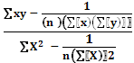

α=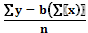

3. Results and Discussion
ELISA assay for measurement of antibody titer in serum samples are important for vaccine titration instead of serum neutralization test in mice. Many studies have described a comparison of antibody units from the results obtained from ELISA (Reizenstein et al., 1995; Grabowska et al., 2002).
The results of challenge test for C. chauvoei in vaccinated guinea pigs were illustrated in table (1) where the protection percent were 100% in G. pig challenge with 32 and 64 MLD of spore suspension. This results was passed with (British Pharmacopoeia, 2010) when accepted vaccine containing anaculture of C. chauvoei when passed challenged by 1 MLD of spore suspension of C. chauvoei.

Table (1): Surviving rate of vaccinated G. pigs with Bivalent Blackleg and Gas Gangrene vaccine against Challenge by spore suspension of C. chauvoei.
Spore suspension of C. chauvoei | No of G. pig | Batch (1) |  | Batch (2) |  | Batch (3)
Spore suspension of C. chauvoei | No of G. pig | Survive  Animal | Survive  % | Survive  Animal | Survive  % | Survive  Animal | Survive  %
32 MLD | 5 | 5/5 | 100 | 5/5 | 100 | 5/5 | 100
64 MLD | 5 | 5/5 | 100 | 5/5 | 100 | 5/5 | 100
128 MLD | 5 | 4/5 | 80 | 4/5 | 80 | 4/5 | 80
256 MLD | 5 | 4/5 | 80 | 3/5 | 60 | 4/5 | 80

Agglutination titer of C. chauvoei measured in sera of vaccinated g pigs in 3 batches of vaccines preparation as shown in table (2) the mean agglutination titer were 153.75, 143.75, and 143.75 in Batches (1,2,3) respectively.
There is no significant change between agglutination titer in three batches, and this result agree with (Claus & Macheak, 1972) which shown that there is correlation between agglutination titer and challenge test in g pigs and can be replaced the challenge test with plate agglutination test for saving lab animal.

Table (2): Mean agglutination Antibody titers against C. chauvoei in sera of vaccinated G. pigs, rabbits and sheep with Bivalent Blackleg and gas gangrene vaccine.
Vaccine Batches | G. pigs | Rabbits | Sheep
Batch (1) | 153.75 ± 56.05 | 39.28 ± 12.37 | 80 ± 24.49
Batch (2) | 143.75 ± 54.12 | 42.85 ± 11.29 | 80 ± 24.49
Batch (3) | 143.75 ± 44.63 | 42.85 ± 11.29 | 80 ± 24.49

Assays for measurement of antibody responses in serum samples using immunoassays are important diagnostic and epidemiological tools for a variety of purposes (Grabowska et al., 2002). Many studies have described comparisons of different methods for calculating antibody units from the results obtained by ELISA (Reizenstein et al., 1995) and different mathematical models for construction standard or calibration curves (Lagergard et al., 1988). So in this study obtained standard curve was calculated by Linear Regression method according to Freund, (2001) which is useful and important not only because many relationships are actually of this form, but also because they often provide close approximations to relationships that would otherwise be difficult to described in mathematical terms. The term linear equation arises from the fact that the graph of y= a +bx is a straight line. That is all pairs of values of x and y that satisfy an equation of the form y= a +b x constitute points that fall on a straight line. The values of a and b are usually estimated from observed data, and once they have been determined can be calculated the unknown value of x when known the corresponding value of y. These results was shown in tables (3, 5) were a linear curve was done for relation between optical density obtained by ELISA and known samples previously measured antibody titer either by plate agglutination test, serum neutralization test, then when obtained the values (a, b) in the equation the unknown samples was calculated in the equation and shown the results of antibody titers in serum samples of g pigs, rabbits, and sheep as shown in figures (1- 6).
The response of antibody titer against alpha toxin of C. septicum in sera of vaccinated rabbit were higher than that in sera of sheep as shown in table (4), this result come in accordance with (Frerichs and Gray, 1975) who found that rabbits responded as well as or better than sheep to the C. septicum component.
There is a great correlation between the results obtained by plate agglutination test, challenge test, Hemolysin test and results obtained by ELISA and also the reproducibility of the results obtained in different batches refer to be replaced the traditional methods for evaluation of Blackleg and Gas Gangrene vaccine with ELISA assay and calculated the results by linear regression method. And can be used only either guinea pig or rabbit for evaluation of vaccine. These results agree with (Reizenstein et al., 1995) who compared five calculation modes for antibody ELISA procedures using pertussis serology as the model and found that the highest reproducibility combined with a high diagnostic sensitivity was achieved when the reference line model was used.

Fig. (1): Standard Linear Regression curve of antibody titers against C. chauvoei measured by ELISA in sera of G. pigs.
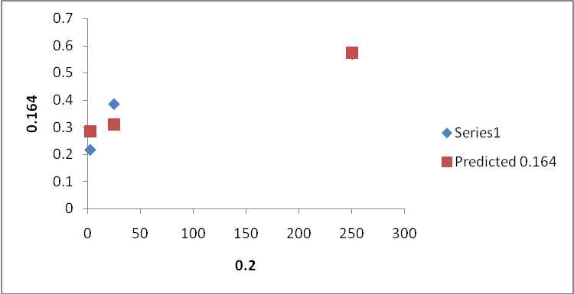

Y= (α) + (β) X [α=0.2391 β=0.00135]

Fig (2): Standard Linear Regression curve of antibody titers against C. chauvoei measured by ELISA in sera of rabbit.
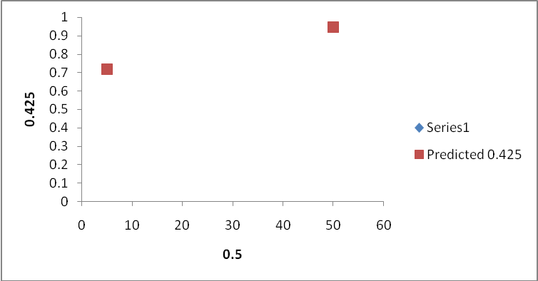
Standard curve: α +β X [α(0.542) β(0.00833)]

Fig. (3): Standard Linear Regression curve of antibody titers against C. chauvoei measured by ELISA in sera of sheep.
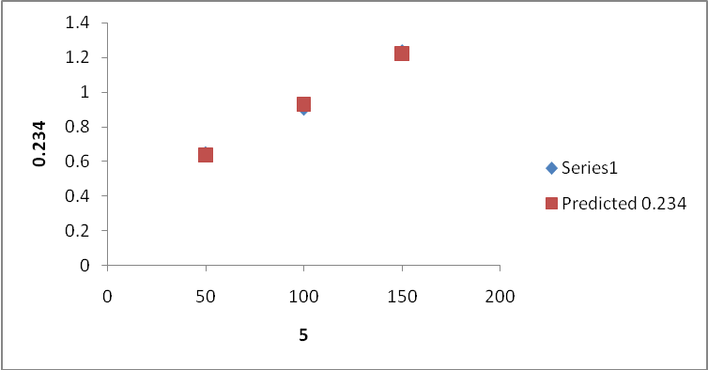
Standard curve: α +β X [α(0.243) β(0.0067)]

Table (3): Antibody titers against C. chauvoei in sera of vaccinated G. pigs, Rabbits and Sheep measured by ELISA.
Vaccine Batches | G. pigs | Rabbits | Sheep
Batch (1) | 202.35 ± 39.11 | 42.66±23.01 | 77.54 ± 21.98
Batch (2) | 198.95 ± 47.66 | 49.98±18.87 | 82.26 ± 24.96
Batch (3) | 203.05 ± 36.05 | 48.4±17.54 | 87.33 ± 10.64

Table (4): Antibody titer against alpha toxin of C. septicum in sera of G. pigs, Rabbits and Sheep vaccinated with bivalent Blackleg and Gas Gangrene vaccine batches.
Vaccine Batches | G. pigs | Rabbit | Sheep
Batch (1) | 4 IU | 6 IU | 4 IU
Batch (2) | 4 IU | 4 IU | 4 IU
Batch (3) | 4 IU | 6 IU | 4 IU

Fig. (4): Standard Linear Regression curve of antibody titers against alpha toxin C. septicum measured by ELISA in sera of G. pigs.
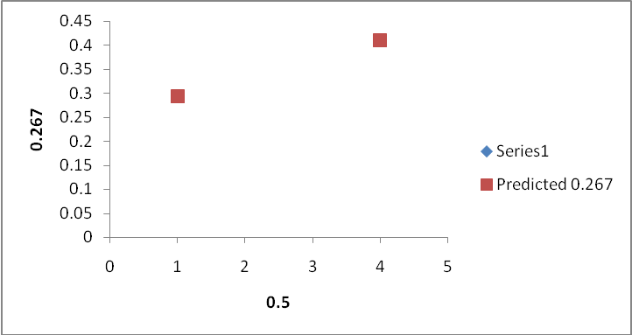
Standard curve: α +β X [α (0.2496) β (0.04020)].
Fig. (5): Standard Linear Regression curve of antibody titers against alpha toxin C. septicum measured by ELISA in sera of rabbit.
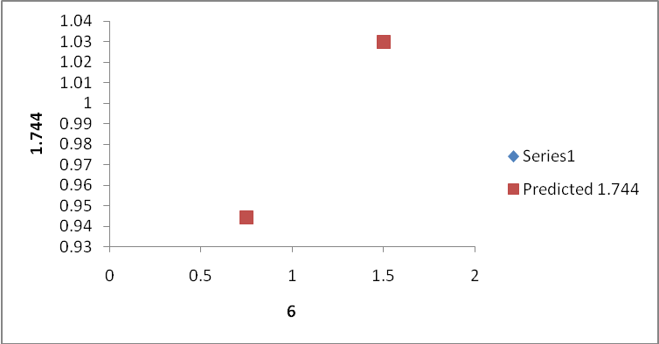
Standard curve: α +β X [α(0.81425) β(0.1545)].

Fig. (6): Standard Linear Regression curve of antibody titers against alpha toxin C. septicum measured by ELISA in sera of sheep.
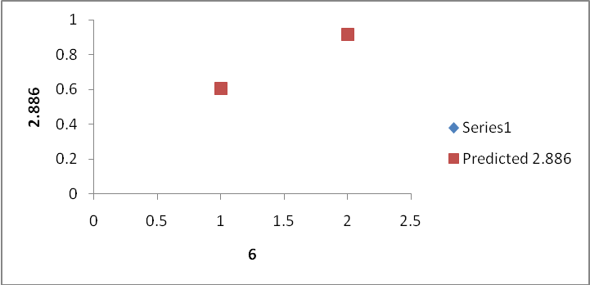
Standard curve: α +β X [α(0.0672) β(0.4669)].

Table (5): Antibody titer against alpha toxin of C. septicum in sera of G. pigs, rabbit and sheep vaccinated with bivalent Blackleg and Gas Gangrene vaccine measured by ELISA.
Vaccine Batches | G. pigs | Rabbit | Sheep
Batch (1) | 4.75 ±1.78 | 6.67 ±1.46 | 5.59 ±0.75
Batch (2) | 4.23 ±0.91 | 6.23 ±0.36 | 5.26 ±0.93
Batch (3) | 4.46 ±0.95 | 6.79 ±0.47 | 5.4 ±0.788

Table (6): Antibody titer against alpha toxin of C. septicum in sera of G. pigs, rabbit and sheep vaccinated with bivalent Blackleg and Gas Gangrene vaccine measured by Hemolysin test.
Vaccine Batches | G. pigs | Rabbit | Sheep
Batch (1) | 2 HU | 2 HU | 4 HU
Batch (2) | 2 HU | 2 HU | 4 HU
Batch (3) | 2 HU | 2 HU | 4 HU

HU=Haemolysin Unit

From results obtained in this work, it could be concluded that the potency for C. chauvoei and C. septicum can be done by ELISA and replaced the traditional methods for evaluation due to its precision, sensitivity, rapid, and save animals used.

Corresponding author
El-Helw, H.A.
Veterinary Serum and Vaccine Research Institute, Abbasia, Cairo, Egypt.
Eladawy_yasser@yahoo.com

References
British Pharmacopoeia (2010). Veterinary Supplement. Strasburg: Council of Europe. ISBN 9780113228287.
Chandler, H. M. and Gulasekharan, J. (1974). A study of the protective antigen of highly immunogenic strain of C. chauvoei including an evaluation of its flagella as a protective antigen. J. Gen. Microbiol. 84: 128-134.
Claus, K. D. and Macheak, M. E. (1972). Preparation of a Clostridium chauvoei antigen and determination of protective immunity by plate agglutination test. . Am. J. Vet. Res., 33, 1045.
Cooper, M., Martinie, F. V. and Personeus, G. R. (1960). Further studies in Clostridium chauvoei infection and immunity in laboratory animals. Cornell Vet., 50: 301-308.
Cygan, Z. (1990). Immunogenicity of an autovaccine. Closept.vac. prepared against braxy. Med. Vet. 46: 6-8.
Freund, J. E. (2001). Modern Elementary Statistics- 10th ed.: Prentice Hall, Upper Saddle River, New Jersey 07458.ISBN 0-13-017701-6.
Frerichs, G. N. and Gray, A. K. (1975). The relation between the rabbit potency test and the response of sheep to sheep clostridial vaccines. Res. Vet. Sci. 18: 70-75.
Gadalla, M. S., Farrag, I. and Sharaf, D. (1974). Effect of growth requirement on the improvement of clostridial vaccines. J. Egypt. Vet. Med. Assoc., 34 (2): 19.
Grabowska, K., Wang, X., Jacobsson, A. and Dillner, J. (2002). Evaluation of cost-precision rations of different strategies for ELISA measurement of serum antibody levels. J. Immunol. Methods, 271, 1-15.
Green, D. S., Green, M. J., Hillyer, M. H. and Morgan, K. L. (1987). Injection site reactions and antibody response in sheep and goats after the use of multivalent clostridial vaccine. Vet. Rec. 120: 435-439.
Gyles, C. L. (1993). Histotoxic clostridia, p. 106-113 in C. L. Gyles and C. O. Thoen (ed). Pathogenesis of bacterial infection in animals, 2nd ed. Iowa State University Press, Ames.
Hamaoka, T., Mori, Y. and Terakado, N. (1990). Enzyme linked immunosorbent assay for evaluation of immunity in mice vaccinated with Blackleg vaccine. Jap. J. Vet. Sci. 52 (1): 167.
Hamaoka, T. and Terakado, N. (1994). Demonstration of common antigens on cell surface of C. chauvoei and C. septicum by indirect immunoflourescence assay.
J. Vet. Sci. 56: 371-373.
Hjerpe, C. A. (1990). Clostridial disease vaccine. Vet. Clin. North Am. Food Anim. Pract. 6: 222-234.
Hong, Y., Ohishi, K., Inoue, N., Koug, J. Y., Shime, H., Horiguchi, Y., Goot, F. G., Sugimoto, N. and Kinoshita, J. (2002). Requirement of N-glycanon GPI- anchored proteins for efficient binding of aerolysin but not Clostridium septicum α-toxin. The EMBO J., 21(19): 5047-5056.
Keogh, G., Unsworth, I., Vowels, M. and Kern, I. B. (1994). Spontaneous Clostridium septicum myonecrosis in congenital neutropaenia. Aust. N. Z.J. Surg. 64: 574-575.
Lagergard, T., Trollfors, B., Claesson, B. A., Schneerson, R. and Robbins, J. B. (1988). Comparison between radioimmunoassay and direct and indirect enzyme- linked immunosorbent assays for determination of antibodies against Haemophilus influenza type b capsular polysaccharide. J. Clin. Microbiol, 26, 2554-2557.
Lorimer, J. W. and Eidus, L. B. (1994). Invasive Clostridium septicum infection in association with colorectal carcinoma. Can. J. Surg. 37: 245-249.
Macleman, J. D. (1962).The histotoxic clostridial infection of man. Bacteriol. Rev. 26: 177-276.
Makhareta, M. A. M. and Hammam, H. M. (2001). Application of enzyme linked immunosorbent assay for measuring the immunizing potential of Clostridium chauvoei antigens in multivalent clostridial vaccines. 6th Sci. Cong. Egypt. Soc. for cattle diseases, November 4-6, 2001.
Mattar, M. A., Cortinas, T. I., and de Guzman, A. S. (2002). Immunogenic protein variations of Clostridium chauvoei cellular antigens associated with the culture growth phase. FEMS Immunology and Medical Microbiology, 33, 9-14.
Morgan, K. L., Green, D. S., Green, N. J. and Hillyer, M. H. (1988). The injection site reaction and antibody response in sheep and goats following the use of multivalent clostridial vaccine. p. 117-124 In O.B. Smith and H.G. Osman (ed). Proc. Workshop Goat Produc. Humid Tropics. University of Life, 1987.
Moussa, R.S. (1958). Antigenic formulae for Clostridium septicum and Clostridium chauvoei. J. Pathol. Bacteriol., 77, 341-350.
Osman, Roukaia, M.; El-Nakashly, S. A. and El-Naenaeey, E. Y. (1997).Correlation between some serological tests for measuring antibodies in sera of cattle vaccinated against blackleg. J. Egypt. Vet. Med. Ass., 52 (4): 443.
Pigran, C., Ruiz, M. P. and Sagrista, J. (1995). Purulent pericarditis due to Clostridium septicum associated with carcinoma of the colon. Clin. Infect. Dis. 20: 202-203.
Reizenstein, E, Hallander, H. O., Blackwelder, W. C., Kuhn, I., Ljungman, M. and Mollby, R. (1995). Comparison of five calculation modes for antibody ELISA procedures using pertussis serology as a model. J. Immunol. Methods, 183, 279-290.
Sasaki, Y. Yamamato, K. Kojima, A. Norimatsu, M. and Tamura, Y. (2000). Rapid identification and differentiation of pathogenic clostridia in gas gangrene by polymerase chain reaction based on the 16S-23S rDNA spacer region. Res. Vet. Sci. 69: 289-294.
Smith, L. D. S. and Holdeman, L. V. (1968). The pathogenic anaerobic bacteria, p. 361-373, Charles C. Thomson, Springfield.
Smith, L. and Williams, B.L. (1984). The pathogenic anaerobic bacteria, 3rd ed. Charles C. Thomas, Springfield, III.
Stevens, D. L., Musher, D. M., Watson, D. A., Eddy, H., Hamill, R. J., Gyorkey, F., Rosen, H. and Mader, J. (1990). Spontaneous non-traumatic gangrene due to Clostridium septicum. Rev. Infect. Dis. 12:286-296.
Troxel, T. R., Burke, G. L., Wallace, W. T., Keaton, L. W., McPeakeD. Smith, S. R. and Nicholson. I. (1997). Clostridial vaccination efficacy on stimulating and maintaining an immune response in beef cows and calves. J. Anim. Sci., 75, 19-25.
Wood, K. R. (1991). An alternative to the toxin neutralization assay in mice for the potency testing of the Clostridium tetani, Clostridium septicum, Clostridium novyi type B, and Clostridium perfringens type D epsilon components of multivalent sheep vaccines. Biologicals, 19 (4): 281-286.

9/2/2012

