Cephalometric evaluation of Age-dependent Craniofacial Skeleton Changes in children of 7-17 years age group: Assessment of Gender Impact

Esam M. Mehlab* and Gamal Abdel Salam**

Faculty of Public Health & Health Informatics, Um-El Qurra University, Mekkah* and Faculty of Medicine, Northern Border University, ArAr, KSA**
Esam-mehlab-1000@hotmail.com

Abstract: This study was conducted at Faculty of Public Health & Health Informatics, Um-El Qurra University, Mekkah and Faculty of Medicine, Northern Border University, ArAr, KSA. The study aimed to evaluate the age and sex dependent changes of the craniofacial skeleton during the age period of 7-17 years old. Two hundred 200 children and adolescents (100 males and 100 females) were categorized according to age into 5 equal groups and underwent postero-anterior (PA) cephalograms using a high resolution (600 dpi), after digitizing the PA landmarks. The landmark co-ordinates were used to calculate the cranial, bifrontotemporal, bizygomatic, mid-facial, maxillary skeletal base, bigonial, biantegonial and nasal widths. Measurements of the maxillary and mandibular intermolar widths were made directly on plaster models with a dial caliper. There was a progressive age-dependent increase of cranial width with a significant increase in males compared to females and the difference was highly significant in age group 9-11 years. Bifrontotemporal width despite showed progressive increase with age in both sexes, which was significant only in older male children compared to females. Bizygomatic width showed a progressive significant difference with advance of age to peak at 15-17 years old children. Both mid-facial width and maxillary skeletal base width showed progressive increase with age, which was significant in all age strata being most significant in older age groups for both variables. Bigonial and biantegonial widths showed non-significant differences between males and females in all age groups, whereas, nasal width showed progressive significant difference, between males and females. Both maxillary and mandibular intermolar widths showed progressive significant difference, between males and females with age. Conclusion: there was a significant change in the transverse craniofacial skeleton with age that was significantly evident in male measurements compared to female ones.
[Esam M. Mehlab and Gamal Abdel Salam. Cephalometric evaluation of Age-dependent Craniofacial Skeleton Changes in children of 7-17 years age group: Assessment of Gender Impact. Nat Sci 2012;10(11):156-162]. (ISSN: 1545-0740). http://www.sciencepub.net. 23

Keywords: Gender, Age, Craniofacial dimensions, intermolar distance

1. Introduction
The purpose of craniomaxillofacial surgery is to improve function, occlusion, craniofacial balance, and aesthetics. Accurate diagnosis, assessment, and careful treatment planning are essential in achieving a successful outcome, and an understanding of the pattern of facial growth is integral in this process. Patients with craniofacial congenital dysmorphologies, posttraumatic asymmetries, or disturbances of facial balance from radiation may have functional and/or aesthetic issues that require treatment. Understanding the complexities of growth in the skull and face is a key component to appropriate treatment planning for these disorders (Costello et al., 2012).
Moreover, the development of distraction osteogenesis and the progressive study of craniosynostosis provide remarkable examples of the field of pediatric craniofacial surgery. The growing study of genetics, biotechnology, the influence of growth factors, and stem cell research provide additional avenues of innovation for the future (Taub & Lampert, 2011).
Certain systemic diseases showed direct influence on craniofacial growth of children; Kjellberg & Wilkberg (2007) assessed craniofacial growth using standard lateral cephalometric radiographs in growth hormone deficient boys under replacement therapy and reported that during replacement therapy, an overall enhancement in growth of the facial skeleton was observed in boys with short stature and the changes yielded a more prognathic growth pattern, a more anterior position of the jaws in relation to the cranial base, and increased anterior rotation of the mandible. Children with congenital heart disease commonly experience delayed growth, skeletal patterns were characterized by maxillary protrusion in the boys. The esthetic pattern showed a more pronounced lower lip in the girls (Goldner et al., 2009).
Furthermore, correction of transverse anomalies, such as cross-bite is a common orthodontic treatment objective; the importance of the transverse dimension becomes apparent when the potential and limits of certain treatment options, such as palatal expansion, have to be deciding between extraction or non-extraction in borderline cases, (Defraia et al., 2008).
Comparatively few studies have analyzed the craniofacial width and its change over time and the impact of gender on these changes, thus, the current study was designed to evaluate the age and sex dependent changes of the craniofacial skeleton in normal children among the age group of 7-17 years old.

2. Subjects and Methods
This analytic comparative study was conducted at Faculty of Public Health & Health Informatics, Um-El Qurra University, Mekkah and Faculty of Medicine, Northern Border University, ArAr, KSA. The study comprised 200 children and adolescents in age range from 7 to 17 years. Cases enrolled in the study were selected out of pupils at various school' grades. For equalization of results, study participants included 100 males and 100 females and were categorized according to age into 5 equal groups: Group A (7-<9 years), Group B (9-<11 years), Group C (11-<13 years), Group D (13-<15 years) and Group E (15-<17 years).
All study participants underwent postero-anterior (PA), (Fig. 1) cephalograms using a high resolution (600 dpi). After digitizing the PA landmarks, (Fig. 2), the landmark co-ordinates were used to calculate the following eight craniofacial widths:
- Cranial width: the distance between the eurya (Eu). The euryon is the most lateral point on the side of the skull, determined by the measurement of the greatest cranial width, (Raghavan et al., 1994).
- Bifrontotemporal width: the distance between both frontotemporalia (Ft). The frontotemporale is the most medial and anterior point on the temporal line of the frontal bone, (Richardson, 1967).
- Bizygomatic width: the distance between both zygia (Zy). The zygion is the most lateral aspect of the zygomatic arch, (Major et al., 1994).
- Mid-facial width: the distance between both zygomaxillaria (Zm). The zygomaxillare is topographically closely related to the most lateral and inferior aspect of the maxillo-zygomatic suture, (Richardson, 1967).
- Maxillary skeletal base width: the distance between the right and left maxillare (Ma). The maxillare is the intersection of the lateral contour of the maxillary alveolar process and the lower contour of the maxillo-zygomatic process of the maxilla, (Hsiao et al., 1997).
- Bigonial width: the distance between both gonia (Go). The gonion is the most inferior, posterior and lateral point on the external angle of the mandible, (Richardson, 1967).
- Biantegonial width: the distance between both antegonia (Ag). The antegonion is the deepest point on the curvature at the antegonial notch, (Major et al., 1994).
- Nasal width: the greatest distance between the right and left lateral bony walls of the nasal cavity (NC), (Da Silva Filho et al., 1995).
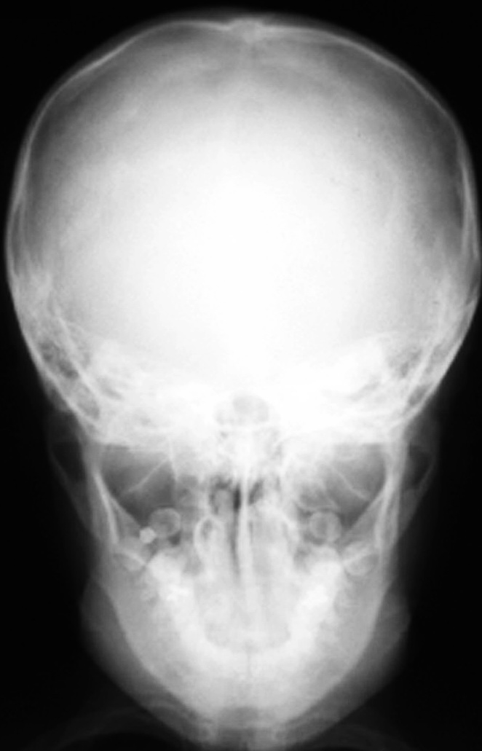
Fig. (1): Postero-anterior cephalogram
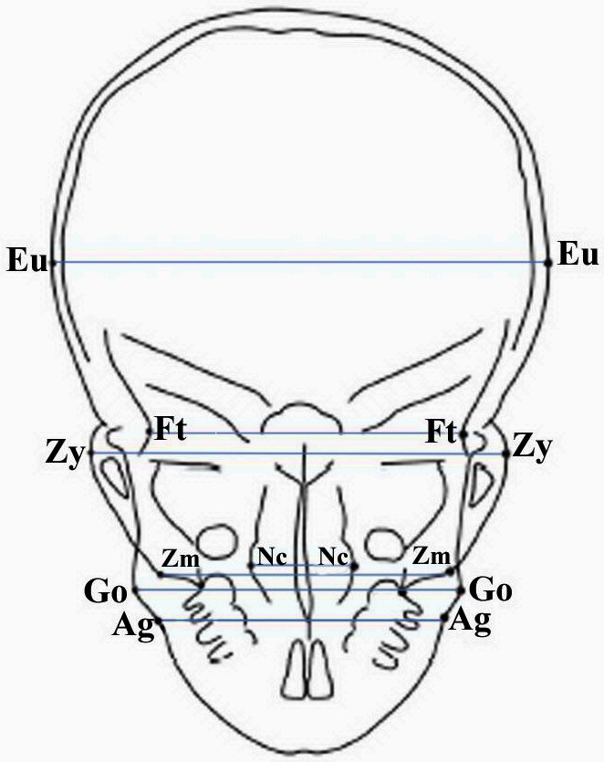
Fig. (2): Landmarks coordinates used for cephalofacial widths measurement

Measurements of the transverse development of the dental arches were made directly on the plaster models with a dial caliper, (Fig. 3). The following variables were determined, (Tollaro et al., 1996):
- Maxillary intermolar width (Max): the distance between the central fossae of the right and left first maxillary molars.
- Mandibular intermolar width (Mand): the distance between the tips of the distobuccal cusps of the right and left first mandibular molars.

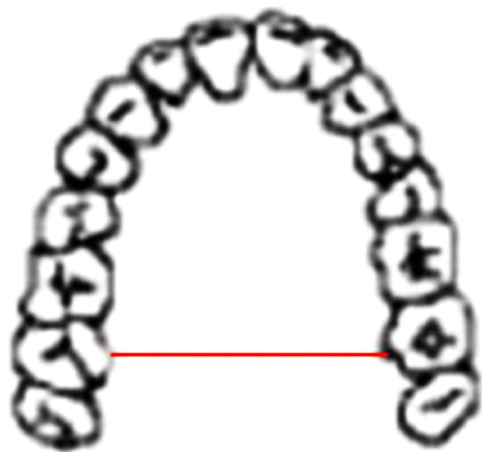

Fig. (3): Intermolar measurement

Statistical analysis
The obtained results were compared using Wilcoxon test for related samples by SPSS (Version 15, 2006) software program.

3.Results
The study comprised 100 males with mean age of 11.9±3 years and 100 females with mean age of 12±3 years. According to gender, there was a non-significant (p>0.05) difference between each age group, (Table 1).
There was a significant (p<0.05) progressive increase of cranial width with age in males compared to females with the difference being more significant in age group 9-11 years (group B), (Table 2). The bifrontotemporal width increased progressively with age in both sexes. Compared to female children, the increase in male children was significant (p=0.028) in group D and highly significant (p =0.003) in group E but was non-significant (p >0.05) in group B, (Table 3).
Bizygomatic width showed a non-significant difference between males and females in group A, while it was progressively significant in groups B, C and D to become highly significant in group E, (Table 4). Moreover both mid-facial width, (Table 5) and maxillary skeletal base width, (Table 6) showed progressive increase with age, which was significant in all age strata being most significant in older age groups for both variables.
On contrary, Bigonial and biantegonial widths showed non-significant (p >0.05) differences between males and females in all age groups, (Table 7), whereas, nasal width showed progressive significant difference, between males and females, however, the greatest difference was noticed in age groups B (11- years) and C (13-years), (Table 8).
Both the maxillary and mandibular intermolar widths showed progressive significant difference, between males and females with aging. The maxillary intermolar distance increased progressively in both sexes with a significant difference in favor of male groups reaching a maximum in Group D and E. The mandibular intermolar distance reached maximum increase in Group D and continued to increase in females thus reducing the difference against male measures despite still being significant. (Table 9).

Table (1): Mean (±SD) age of subjects in each study group according to gender
 | Males |  |  | Females
 | Number | Mean | ±SD | Number | Mean | ±SD
Group A (7-<9 years) | 20 | 7.8 | 0.6 | 20 | 7.84 | 0.53
Group B (9-<11 years) | 20 | 9.8 | 0.54 | 20 | 10 | 0.61
Group C (11-<13 years) | 20 | 11.9 | 0.5 | 20 | 12.1 | 0.52
Group D (13-<15 years) | 20 | 14 | 0.53 | 20 | 14.1 | 0.57
Group E (15-<17 years) | 20 | 16 | 0.62 | 20 | 16.2 | 0.49
Total | 100 | 11.9 | 3 | 100 | 12 | 3

Table (2): Cranial width measures (mm) of both males and females with their statistical evaluation
 | Males | Females | Z | p
Group A (7-<9 years) | 138.94±4.71 | 135.83±4.43 | 2.032 | =0.042
Group B (9-<11 years) | 140.23±4.92 | 136.63±5.54 | 2.666 | =0.008
Group C (11-<13 years) | 140.91±5.16 | 137.85±4.48 | 2.366 | =0.018
Group D (13-<15 years) | 142.72±4.06 | 138.57±5.4 | 2.472 | =0.013
Group E (15-<17 years) | 143.49±5.4 | 138.89±5.82 | 2.524 | =0.012

Table (3): Bifrontotemporal width (mm) measures of both males and females with their statistical evaluation
 | Males | Females | Z | p
Group A (7-<9 years) | 93.5±3.08 | 92.4±4 | 1.461 | >0.05
Group B (9-<11 years) | 95.47±4.17 | 93.94±5.16 | 1.014 | >0.05
Group C (11-<13 years) | 96.82±3.43 | 95.11±4.86 | 1.736 | >0.05
Group D (13-<15 years) | 98.83±4.3 | 96.03±6.57 | 2.197 | =0.028
Group E (15-<17 years) | 100.37±4 | 96.54±4.35 | 2.987 | =0.003

Table (4): Bizygomatic width (mm) measures of both males and females with their statistical evaluation
 | Males | Females | Z | p
Group A (7-<9 years) | 110.94±4.25 | 109.4±3.1 | 1.952 | >0.05
Group B (9-<11 years) | 114.79±3.95 | 112.76±3.4 | 2.128 | =0.033
Group C (11-<13 years) | 118.86±3.44 | 116.7±2.78 | 2.222 | =0.026
Group D (13-<15 years) | 122.83±3.13 | 120.37±2.53 | 2.446 | =0.014
Group E (15-<17 years) | 128.41±2.95 | 122.94±2.98 | 3.771 | <0.001

Table (5): Mid-facial width (mm) measures of both males and females with their statistical evaluation
 | Males | Females | Z | p
Group A (7-<9 years) | 79.63±2.09 | 77.61±3.03 | 2.053 | =0.040
Group B (9-<11 years) | 82.69±2.91 | 81.14±2.56 | 2.501 | =0.012
Group C (11-<13 years) | 86.29±2.87 | 82.42±2.83 | 3.472 | =0.001
Group D (13-<15 years) | 89.79±2.57 | 85.04±4.27 | 3.435 | =0.001
Group E (15-<17 years) | 94.66±3.53 | 87.1±4 | 3.696 | <0.001

Table (6): Maxillary skeletal base width (mm) measures of both males and females with their statistical evaluation
 | Males | Females | Z | p
Group A (7-<9 years) | 55.32±1.95 | 52.92±1.42 | 3.547 | =0.001
Group B (9-<11 years) | 57.35±1.85 | 54.69±1.45 | 3.696 | =0.001
Group C (11-<13 years) | 59.92±92 | 55.91±1.99 | 3.883 | <0.001
Group D (13-<15 years) | 62.11±1.85 | 57.31±1.87 | 3.920 | <0.001
Group E (15-<17 years) | 63.66±2.21 | 58.47±2.88 | 3.808 | <0.001

Table (7): Bigonial and biantegonial width (mm) measures of both males and females with their statistical evaluation
 |  | Males | Females | Z | p
Bigonial width | Group A (7-<9 years) | 80.51±2.72 | 78.49±2.65 | 1.28 | >0.05
Bigonial width | Group B (9-<11 years) | 83.07±3.13 | 80.99±3.06 | 1.95 | >0.05
Bigonial width | Group C (11-<13 years) | 86.6±3.71 | 84.44±3.61 | 1.62 | >0.05
Bigonial width | Group D (13-<15 years) | 90.4±3.55 | 88.14±3.46 | 1.59 | >0.05
Bigonial width | Group E (15-<17 years) | 94.82±3.83 | 92.45±3.73 | 2.03 | >0.05
Biantegonial width | Group A (7-<9 years) | 73.07±1.94 | 71.24±1.9 | 1.56 | >0.05
Biantegonial width | Group B (9-<11 years) | 75.21±2.4 | 73.33±2.34 | 1.62 | >0.05
Biantegonial width | Group C (11-<13 years) | 78.17±2.4 | 76.22±2.84 | 1.37 | >0.05
Biantegonial width | Group D (13-<15 years) | 80.63±2.93 | 78.62±2.85 | 2.01 | >0.05
Biantegonial width | Group E (15-<17 years) | 84.21±3.68 | 82.11±3.59 | 1.95 | >0.05

Table (8): Nasal width measures (mm) of both males and females with their statistical evaluation
 | Males | Females | Z | p
Group A (7-<9 years) | 27.79±2.17 | 26.14±1.81 | 2.611 | =0.030
Group B (9-<11 years) | 30.23±1.7 | 27.97±1.1 | 4.992 | =0.001
Group C (11-<13 years) | 31.27±1.57 | 29.18±1.03 | 4.978 | =0.001
Group D (13-<15 years) | 32.46±1.87 | 30.84±1.78 | 2.806 | =0.023
Group E (15-<17 years) | 34.54±2.15 | 32.82±2.04 | 2.595 | =0.031

Table (9): Maxillary and mandibular intermolar width (mm) measures of both males and females with their statistical evaluation
 |  | Males | Females | Z | p
Maxillary intermolar width  (Max IMW) | Group A (7- years) | 46.84±2.09 | 44.5±1.98 | 3.635 | =0.012
Maxillary intermolar width  (Max IMW) | Group B (9- years) | 47.92±1.92 | 46.25±1.85 | 2.801 | =0.024
Maxillary intermolar width  (Max IMW) | Group C (11- years) | 48.91±1.98 | 46.71±1.89 | 3.594 | =0.017
Maxillary intermolar width  (Max IMW) | Group D (13- years) | 49.5±1.86 | 47.03±1.77 | 4.302 | =0.001
Maxillary intermolar width  (Max IMW) | Group E (15- years) | 49.85±1.85 | 46.61±1.73 | 5.721 | <0.001
Mandibular intermolar width  (Mand IMW) | Group A (7- years) | 47.07±2.2 | 44.72±2.03 | 3.511 | =0.020
Mandibular intermolar width  (Mand IMW) | Group B (9- years) | 47.97±2.09 | 46.29±1.95 | 3.677 | =0.014
Mandibular intermolar width  (Mand IMW) | Group C (11- years) | 49.07±2.34 | 46.86±2.11 | 3.137 | =0.022
Mandibular intermolar width  (Mand IMW) | Group D (13- years) | 49.54±1.61 | 47.06±1.84 | 4.537 | <0.001
Mandibular intermolar width  (Mand IMW) | Group E (15- years) | 49.88±2.05 | 47.64±1.93 | 3.558 | =0.017

4. Discussion
In the clinical practice there are occasions when it is extremely important to have a transverse perspective on the facial structures. Not only in cases where there is unilateral or bilateral cross-bite but also cases where there is nasal obstruction with mouth breathing and tendency to "the long face syndrome", cases where rapid maxillary expansion is an option, cases where there is asymmetry, either skeletal or dento-alveolar (Mossey & McIntyre, 2003).
There was general lack of interest and few studies investigating the transverse facial dimension with special regard to the development and the impact of gender on these dimensions, a detailed depiction of maxillary growth was given by Singh & Savara (1966), and Savara & Singh (1968), separately for boys and girls and they ascertained that maxillary growth changes are most marked in the measurement of height, less in length and least in width. Through the current study the combined use of lateral and postero-anterior cephalograms the maxillary landmarks could be easily identified and maxillary and antegonial widths become feasible. Similarly, Cortella et al. (1997) could provide norms for the maxillary and antegonial widths in subjects with excellent static occlusion.
There was a progressive increase of cranial width with age that showed a significant increase (p<0.05) in males compared to females with the difference being more significant in age group 9-11 years (group B). Snodell et al. (1993), who found that at the 6 years of age the cranium had reached only 90% of the width at the 18 years indicating that the cranial width followed the neural growth pattern. These findings are in accordance with that obtained in the current study that also agreed with Carels (1998) who reported that sexual dimorphism: men and women differ during the 'active growth' period for the timing, amount and localization of growth and boys have larger final facial dimensions than girls.
Bizygomatic width showed progressive significant difference with age advance to become maximum in age group older than 15 years. These results agreed with Woods (1950), Basyouni & Nada (2000) and Darwis et al. (2003) who reported significant increase in bizygomatic width in both males and females between age of 7 and 15 years with a significant difference in favor of males.
Moreover both mid-facial width and maxillary skeletal base width showed progressive increase with age, which was significant in all age strata being most significant in older age groups for both variables. These findings go in hand with the variables reported by Athanasiou et al. (1992), and Cortella et al. (1997) who reported significant increase of both variables with age and with Basyouni & Nada (2000), as regards the gender differences of the maxillary skeletal base width. Also, Lux et al. (2004), reported that most of the craniofacial widths were larger in males than in females. The majority of the skeletal dimensions showed a progressive increase in width and at 15 years of age, the gender differences in craniofacial widths were more pronounced than at 7 years of age.
Clinically, alterations of mid-facial dimensions are important, Hsu et al. (2012) reported that with advances in dental technology, the placement of immediate implants has progressively gained popularity. However, a common complication that surfaced was mid-facial mucosal recession, which impaired esthetic outcomes.
The maxillary intermolar distance showed progressive increase in both sexes with a significant difference in favor of male groups reaching a maximum in those older than 15 years (Group E), while the mandibular intermolar distance reached maximum increase in age group D (11- years) and continued to increase in females thus reducing the difference against male measures despite still being significant. These results agreed with Lee (1999), who reported a larger increase in the intermolar width in the maxilla than in the mandible with a larger increase in the intermolar width in males than in females with minimal increase in the width between 11 and 15 years. Furthermore, Lux et al. (2004), reported that the majority of the skeletal dimensions showed a progressive increase in width and in contrast, there was a deceleration in the increase in maxillary and mandibular intermolar widths after 11 years of age in males.
The significant difference in the presented facial measures between males and females coincided with that reported in adults by Uysal & Sari (2005), who tried to establish cephalometric norms from posteroanterior cephalograms for Turkish adults, identify possible gender differences in these norms and reported that posteroanterior transverse linear norms for Turkish adults showed significant sexual dimorphism.
Naikmasur et al. (2010), concluded that cephalometric cranio-mandibular parameters can be used to discriminate the sex using discriminant function analysis and similar cranio-mandibular parameters contribute to sex prediction across populations.
Arboleda et al. (2011) evaluated the growth behavior of 8 anthropometric measurements including three cranial (head perimeter, head width, and head length), two craniofacial (maxillary and mandibular length), and three facial (face height, bizygomatic width, and bigonial width) in children of ages 6, 9, 12, and 15 and every year thereafter for 3 years and found that all dimensions increased between 6 and 17 years of age, the cranium grew less than the craniofacial, which in turn grew less than the facial dimensions. In addition, vertical dimensions showed more growth than antero-posterior dimensions, which in turn grew more than transverse dimensions. Males were generally larger than females and showed greater growth rates.
As an explanation for facial differences, Boehringer et al. (2011), reported that genetic prediction model explained 2% of phenotype variation in nose width in the German and 0.5% of bizygomatic distance variation in the Dutch cohort and concluded that there is a link between genetic loci involved in a pathological facial trait and variation of normal facial morphology.
It could be concluded that there was a significant change in the transverse craniofacial skeleton with age that was significantly evident in male measurements compared to female ones. This is of great help in craniofacial, ENT and orthodontic surgeries.

Corresponding author:
Esam Mehlab
Faculty of Public Health & Health Informatics, Um-El Qurra University, Mekkah, KSA
Email: Esam-mehlab-1000@hotmail.com

References
- Arboleda C, Buschang PH, Camacho JA, Botero P and Roldan S: A mixed longitudinal anthropometric study of craniofacial growth of Colombian mestizos 6-17 years of age. Eur J Orthod. 2011; 33(4):441-9.
- Athanasiou AE, Droschl H and Bosch C: Data and patterns of transverse dentofacial structure of 6- to 15-year-old children: a posteroanterior cephalometric study. Am J Orthodontics Dentofacial Orthoped., 1992; 101: 465-71.
- Basyouni AA and Nada SK: An Atlas of the transverse dimensions of the face. In: McNamaraJr JA (ed), Monograph No. 37, Craniofacial Growth Series, Center for Human Growth and Development, University of Michigan, Ann Arbor, 2000.
- Boehringer S, van der Lijn F, Liu F, Günther M, Sinigerova S, Nowak S, Ludwig KU, Herberz R, Klein S, Hofman A, Uitterlinden AG, Niessen WJ, Breteler MM, van der Lugt A, Würtz RP, Nöthen MM, Horsthemke B, Wieczorek D, Mangold E and Kayser M: Genetic determination of human facial morphology: links between cleft-lips and normal variation. Eur J Hum Genet. 2011; 19(11):1192-7.
- Carels CE: Facial growth: men and women differ. Ned Tijdschr Tandheelkd., 1998; 105(11):423-6.
- Cortella S, Shofer FS and Ghafari J: Transverse development of the jaws: norms for the postero-anterior cephalometric analysis. Am J Orthodont. Dentofacial Orthoped., 1997; 112: 519-22.
- Costello BJ, Rivera RD, Shand J and Mooney M: Growth and development considerations for craniomaxillofacial surgery. Oral Maxillofac Surg Clin North Am. 2012; 24(3):377-96.
- Darwis WE, Messer LB and Thomas CD: Assessing growth and development of the facial profile. Pediatr Dent., 2003; 25(2): 103-8.
- Da Silva Filho OG, do Prado Montes LA and Torelly LF: Rapid maxillary expansion in the deciduous and mixed dentition evaluated through posteroanterior cephalometric analysis. Am J Orthodontics Dental Orthoped. 1995; 107: 268-75.
- Defraia E, Marinelli A, Baroni G and Tollaro I: Dentoskeletal effects of a removable appliance for expansion of the maxillary arch: a postero-anterior cephalometric study. Eur J Orthod. 2008; 30(1):57-60.
- Goldner MT, Martins e Martins M, Quintão CC and Mendes Ade M: Craniofacial characteristics of patients with heart disease. Am J Orthod Dentofacial Orthop. 2009;136(4):554-8.
- Hsiao TH, Chang HP and Liu KM: A method of magnification correction for postero-anterior radiographic cephalometry. Angle Orthodontist., 1997; 67: 137-42
- Hsu YT, Shieh CH and Wang HL: Using soft tissue graft to prevent mid-facial mucosal recession following immediate implant placement. J Int Acad Periodontol. 2012;14(3):76-82.
- Kjellberg H and Wikland KA: A longitudinal study of craniofacial growth in idiopathic short stature and growth hormone-deficient boys treated with growth hormone. Eur J Orthod. 2007; 29(3):243-50.
- Lee RT: Arch width and form: a review. Am J Orthodont. Dentofacial Orthoped. 1999; 115: 305-13.
- Lux CJ, Conradt C, Burden D and Komposch G: Transverse development of the craniofacial skeleton and dentition between 7 and 15 years of age--a longitudinal postero-anterior cephalometric study. Eur J Orthod. 2004; 26(1): 31-42.
- Major PW, Johnson DE, Hesse KL and Glover KE: Landmark identification error in posterior anterior cephalometrics. Angle Orthodontist., 1994; 64: 447-54.
- Mossey P and McIntyre G: An Atlas of the Transverse Dimensions of the Face; Pp:1-3, 2003.
- Naikmasur VG, Shrivastava R and Mutalik S: Determination of sex in South Indians and immigrant Tibetans from cephalometric analysis and discriminant functions. Forensic Sci Int. 2010;197(1-3):122.e1-6.
- Raghavan R, Sidhu SS and Kharbanda OP: Craniofacial pattern of parents of children having cleft lip and/or cleft palate anomaly. Angle Orthodontist., 1994; 64: 137-44.
- Richardson ME: The reproducibility of measurements on depressed posteroanterior cephalometric radiographs. Angle Orthodontist., 1997; 37: 115-50.
- Savara BS and Singh IJ: Norms of size and annual increments of seven anatomical measures of maxillae in boys from three to sixteen years of age. Angle Orthodontist., 1968.; 38: 104-20.
- Singh IJ and Savara BS: Norms of size and annual increments of seven anatomical measures of maxillae in girls from three to sixteen years of age. Angle Orthodontist. 1969; 36: 312-24.
- Snodell SF, Nada RS and Currier GF: A longitudinal cephalometric study of transverse and vertical craniofacial growth. Am J Orthodont. Dentofacial Orthoped., 1993; 104: 471-83.
- Taub PJ and Lampert JA: Pediatric craniofacial surgery: a review for the multidisciplinary team. Cleft Palate Craniofac J. 2011; 48(6):670-83.
- Tollaro I, Baccetti T, Franchi L and Tanasescu CD: Role of posterior transverse interarch discrepancy in Class II, division 1 malocclusion during the mixed dentition phase. Am J Orthodontics Dentofacial Orthop., 1996; 110: 417-22.
- Uysal T and Sari Z.: Posteroanterior cephalometric norms in Turkish adults. Am J Orthod Dentofacial Orthop., 2005; 127(3): 324-32.
- Woods GA: Changes in width dimensions between certain teeth and facial points during human growth. Am J Orthodont. 1950; 36: 676-700.

9/2/2012

