Seasonal Influence of Physicochemical Variables on Phytoplankton Abundance in Jebel Aulia Reservoir in Khartoum – Sudan

Yatta S. LUKAW¹; ²; John Leju Celestino LADU^{2,3}; Denis D. KENYI⁴

- College of Natural Resources and Environmental Studies, Department of Basic Sciences, University of Juba, South Sudan.
- School of Energy and Environment, Dept. of Environmental Science and Engineering Southeast University, Nanjing 210096, P. R. China.
- College of Natural Resources and Environmental Studies. Dept. of Environmental Studies, University of Juba, South Sudan.
- College of Natural Resources and Environmental Studies, Department of Fisheries, University of Juba, South Sudan.
yattalukaw2002@yahoo.com; john.leju6@gmail.com

Abstract: Seasonal influence of physiochemical variables on the phytoplankton abundance was studied for one year from January 2003 to December 2003 in Jebel Aulia reservoir in Khartoum, Sudan. Selected physicochemical variables such as water temperature, rainfall, sechi depth, water discharge, pH, dissolved oxygen, dissolved organic matter; nitrate, phosphate and silicate were measured at the time of phytoplankton collection. All raw data were log transformed Log₁₀(X+1) for normality and parametric statistical test requirements were statistically analyzed using SPSS 16 for windows. Generally, the reservoir and its surrounding water was alkaline (pH- 7.99 ± 0.09 μgl^{-l-1}). The mean water temperature was (28.05 ±2.22ºC); rainfall, (26.58 ±9.64mm); discharge, (65.75 ±7.10 (10⁶m³) and the mean sechi depth measured was (120.59 ±23.77cm). Dissolved oxygen level was generally (7.98 ±0.303 mg/l); dissolved organic matter, (14.28±0.58 mgO₂/l); nitrate, (3858.50 ±1087.37 μgl⁻¹); phosphate, (340.83 ±12.44 μgl⁻¹) and silicate level was (29716.67±2621.47 μgl⁻¹). A total phytoplankton biomass of 13275.5 cells L⁻¹ was recorded in the reservoir of which 8397.5 cells L-¹ occurred in the rainy season, 4898 cell L-¹ in the dry season. All the physicochemical variables did not vary (P>0.05) between the rainy and the dry seasons, water temperature, transparency and rainfall varied significantly between the rainy and the dry seasons. All the phytoplankton classes indicated positive correlations ( P < 0.05) with the nutrients PO₄ and SiO₂ , no correlation with NO₃; positive correlation ( P < 0.05 ) with rainfall, negative correlations with water temperature and transparency and were not correlated with water discharge. A total of 33 phytoplankton genera were recorded, the phytoplankton classes dominated by Bacillariophyceae >Chlorophyceae> Cyanophyceae>Zygnemataphyceae>Dinophyceae >Oedogoniophyceae. Phytoplankton Density is influenced by both physicochemical variables and biotic, hydrobiological and hydrographic features of the reservoir. [Yatta S. LUKAW; Denis D. KENYI ; John Leju Celestino LADU. Seasonal Influence of Physicochemical Variables on Phytoplankton Abundance in Jebel Aulia Reservoir in Khartoum – Sudan. Nat Sci 2012;10(11):168-175]. (ISSN: 1545-0740). http://www.sciencepub.net. 25

Keywords: phytoplankton; biomass; biotic; physicochemical variables; sechi depth; hydrobiological.

1. Introduction
Reservoirs are seen as favorable environments to the development of plankton communities, which may establish diversed assemblages in relatively short periods of time after impoundment (Rocha et al., 1999 ). Knowledge of the reservoir plankton communities is therefore of paramount importance to furnish data for management guidelines to the reservoir water quality assessment and monitoring its fisheries, knowing that the phytoplankton play a vital role in the aquatic food web by being its primary producers (Anneaville et al. ,2002 ) and is the most important factor for production of organic matter in aquatic ecosystem. It is also to be stressed here that knowledge on phytoplankton could contribute to the understanding of the equilibrium concept in phytoplankton ecology (Feuillade and Feuillade, 1987; Davidson et al. 1999; Huszar et al. 2003; Naselli-Flores et al. 2003 and Moustaka-Gouni et al. 2007).
Phytoplankton in tropical reservoir ecosystems function in estimating potential fish yield (Hecky and Kling, 1981), productivity (Park et al., 2003), water quality (Walsh et al., 2001), energy flow (Simciv, 2005), trophic status (Reynolds, 1999) and management (Beyruth, 2000).
The role of physical, chemical variables of water in most cases results in the production of phytoplankton from hand and the same factors have influence on the population dynamics of the phytoplankton as structuring pressures.
The purpose of Jebel Aulia reservoir is to store water during the flood season in order to be used in down-stream areas during the dry season, but the economic importance of reservoirs on fish production is often ignored or not fully understood. However, studying the plankton communities of tropical African reservoirs such as Jebel Aulia reservoir could help in supplying information on the reservoir water quality and its fisheries, apart from its function of storing. The purpose of this study is to examine the seasonal influence of physicochemical variables on the reservoir large phytoplankton communities.

2. Material and Methods

2.1 Description of the Study Area
Jebel Aulia Dam is a tropical man-made reservoir situated 42 Km south of Khartoum (latitude of 15°N and Longititude of 32°E) and it is characterized by two climatic seasons: rainy season (May to November) and dry season (December to May).
The dam was constructed 377 m above sea level. The reservoir surface area ranges from 600 to 1 500 km², maximum depth is 12 m with mean from 2.3 to 6 m, with a volume of 3.5 m³. The lake's length is 500 and has a width that ranges between 6 and 7 km. The reservoir's level starts to drop in February and continues until the end of May. It reaches its maximum level in September. The amplitude of the water level movement is 6 m (Figure 1).

Source: www.FAO. Org
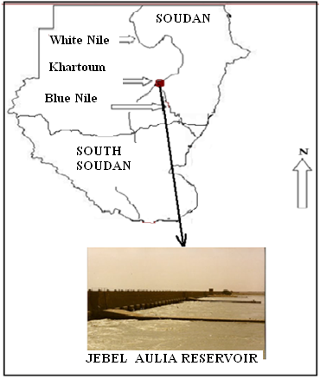
Figure1. Jebel Aulia Reservoir

Table 1. Morphometric features of Jebel Aulia Reservoir
Item | Parameter
Elevation | 337m
Surface area | 600 - 1 500 km²
Volume | 3.5 m³
Mean depth | 2.3 - 6 m
Maximum depth | 12 m
Length of shoreline | 500 km
Amplitude of water level movement | 6m

2.1 Sampling the Planktons
Samples were taken fortnightly for phytoplankton and physical factors and monthly for chemical factors and the study covered the period from January to December 2003. The phytoplankton were collected by towing plankton nylon net (mesh width=35μm) from a boat moving against the current for ten minutes to a vertical distance of 5 meters. Five hauling were taken at two minutes interval; contents were kept in a plastic bottle, capacity of a liter. Immediately 4% formalin was added and the sample was left to stand for 24 hours. When the suspension settled down, the supernatant water was siphoned off leaving sediment varying between 5– 25 ml in volume, according to the richness of the catch. Ten slides from the sample were first thoroughly examined under the lower power of the microscope (×10) before counting it under the high power (×40). Five transects, selected at random, and from each slide the phytoplankton were examined under the high power. All the phytoplankton encountered in these transects counted and were identified according to the following workers: (Cost and Iltis, 1981; Komárek and Fott 1983; Compere 1986; Compere, 1989; Krammer and Lange-Bertalot, 1991; Uherkovich, 1995; Da KP . et al., 1997 ; Komárek et al., 2003; Komárek and Anagnostidis, 2005) and the density of phytoplankton was estimated using the Utermöhl (1958) method.
2.2 Physical Variables
Air and water surface temperatures were recorded at the start, using an ordinary centigrade thermometer; water transparency was estimated by using a Sacchi disc 20 cm in diameter. The results were expressed in Centimeters. Data on the amount of rainfall and water discharge during the study period were obtained from the Meteorological Department at Jebel Aulia.
2.3 Chemical Variables
Water for chemical analyses was collected from a depth of about 20 cm. The sample was filtered on the site immediately after collection through filter paper (Whatman GF/C No. 42), except water for pH and dissolved oxygen. The chemical analyses were completed on the same day of collection. Dissolved oxygen was determined according to Machereth (1963) using Winkler procedure. Results were expressed as MgO₂ L⁻¹, dissolved organic matter was determined using Winkler procedure as described by Machereth (1963) and the results were recorded as MgO2 L⁻¹. The pH was measured on arrival to the laboratory using a digital pH meter (Huck).
2.4 Statistical analysis and data management
All raw data (physicochemical variables and the plankton) except pH, were log transformed Log₁₀(X+1) for normality parametric statistical test requirements. Differences of physicochemical variables between wet and dry seasons were tested using the Student T-test for paired samples and the correlations between the physicochemical variables and the phytoplankton groups were tested using General Linear Model-Multivariate Aanalysis.
All graphs were drawn using Microsoft Office Excel 2007 and all statistical analyses done using SPSS 16.0 software for windows 2007.
3. Results
3.1 Physical Variables
Water temperature varied between 18.50 ºC (in January) and 41.00 ºC (in June) with an annual mean temperature of 28.05 ±2.22ºC and no thermal stratification was recorded. Secchi depth varied between 30 cm in July and 268.50 cm (in October) with an annual mean transparency of 120.59 ±23.77cm. The transparency was high and the bottom of the river could be seen throughout almost the whole sampling period. Rainfall varied between 00mm (in January, February, November and December) and 94.00 mm (in April), the mean annual rainfall recorded was 26.58 ±9.64mm. An annual mean for water discharge recorded was 65.75 ±7.10( 10⁶m³ ) and varied between6.00 ( 10⁶m³ ) in July and 96.00 ( 10⁶m³ )in March. (Table 1).
3.2 Chemical Variables
An annual mean pH (7.99 ± 0.09 (μgl^{-l-1}) was mostly above neutral measured between 7.40(μgl^{-l-1} ) in May and 8.50(μgl^{-l-1} ) in September. Generally the reservoir water was alkaline (Table 1). The nutrient concentrations were low. Phosphate varied between 280.00(μgl⁻¹) in March and 420.00(μgl⁻¹) in August and a mean phosphate value of 340.83 ±12.44 (μgl⁻¹) was recorded. Nitrate varied between 600.00(μgl⁻¹) in November and 15002.00(μgl⁻¹) in September, an annual mean of (3858.50 ±1087.37 (μgl⁻¹) was recorded. Dissolved oxygen varied between 7.00(mg/l) in the months of August & December and 11.00(mg/l) in November and an annual mean of 7.98 ±0.303mg/l was observed. Dissolved organic matter varied between 11.60(mgO₂/l) in December and 16.80(mgO₂/l) in May, with an annual mean of 14.28±0.58 (mgO₂/l) and silicate varied between 16500.00(μgl⁻¹) in July and 42000.00(μgl⁻¹) in April, and the annual mean recorded for silicate was 29716.67±2621.47(μgl⁻¹) ( Tables 1 )

Table2. Annual Means of Physical and Chemical Variables from Jan-Dec 2003 in the Study Area
Variable | Mean ±SE | Minimum | Maximum
Water temperature(ºC ) | 28.05 ±2.22 | 18.50 | 41.00
Transparency(cm) | 120.59 ±23.77 | 30.00 | 268.50
Rainfall (mm) | 26.58 ±9.64 | 0.00 | 94.00
Water discharge( 10⁶m³ ) | 65.75 ±7.10 | 6.00 | 96.00
pH (μgl^{-l-1} ) | 7.99 ±0.09 | 7.40 | 8.50
Phosphate (μgl⁻¹ ) | 340.83 ±12.44 | 280.00 | 420.00
Nitrate(μgl⁻¹ ) | 3858.50 ±1087.37 | 600.00 | 15002.00
Dissolved oxygen (mg/l) | 7.98 ±0.303 | 7.00 | 11.00
Dissolved organic matter(mgO₂/l) | 14.28±0.58 | 11.60 | 16.80
Silicate(μgl⁻¹ ) | 29716.67±2621.47 | 16500.00 | 42000.00
3.3 Total Phytoplankton Seasonal Fluctuation with Physicochemical Variables
Figures 2 & 3 shows the fluctuations of the total phytoplankton community with physical and chemical variables during the study period. From the figures above it is clear that the phytoplankton community showed two maximum peaks. One maximum peak of 1648 cells L⁻¹ occurred in April, and the second maximum that showed the highest density of 1953.50 cells L⁻¹ occurred in September.
The phytoplankton population density rose from January and continued to rise through March and in April it attained its first maximum. The population then dropped to its lowest density of 496.5 cells L⁻¹ in June. In April during the first maximum peak the water temperature, transparency, rainfall, water discharge recorded were in the order: 26.8ºC; 79.5cm; 94mm and 94 X 10⁶m³. However, on the other hand water pH, phosphate, nitrate, dissolved oxygen, dissolved organic matter and silicate concentrations measured during the first maximum peak in April were in the order: 7.8μgl^{-l-1}; 300 μgl⁻¹; 3400 μgl⁻¹; 7.9 mg l^{-1; 15.6} mgO₂ l⁻¹ and 42000 μgl⁻¹. Whereas the maximum peak in September recorded at the temperature 28.5º; transparency 87cm; rainfall of 27mm; discharge 54 X 10⁶m³ .

The chemical variables measured in September during the second maximum peak were in the order: pH 8.5; phosphate concentration 350 μgl⁻¹ ; nitrate concentration 15002 μgl⁻¹ ; dissolved oxygen concentration 7.8mg l⁻¹ ; dissolved organic matter concentration16.3 mgO₂ l⁻¹ and Silicate concentration was 23800 μgl⁻¹ .
In June, the phytoplankton population density dropped to its minimum peak of 496.5 cells L⁻¹ at the water surface temperature, transparency, rainfall and water discharge of 30ºC, 45 cm ; 0mm and 50 X 10⁶m³ respectively.
It is also apparent that water pH, phosphate and nitrate and dissolved oxygen and dissolved organic matter and Silicate concentrations measured in June during the minimum phytoplankton’s population density were in the order: 7.6μgl^{-l-1}; phosphate concentration 360 μgl⁻¹; nitrate concentration 4100 μgl⁻¹;.dissolved oxygen concentration 7.4 mgL⁻¹; dissolved organic matter concentration16.2 mgO₂ l⁻¹ and Silicate concentration of 38000 μgl⁻¹.

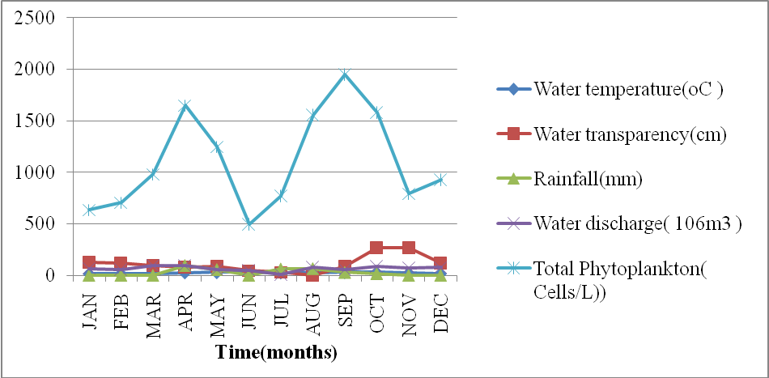
Figure 2. Fluctuation of physical variables

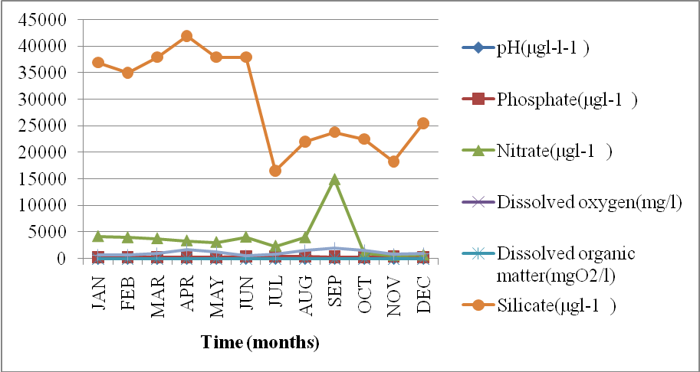
Figure 3. Fluctuation of Phytoplankton Density with Chemical Variables

3.4 Phytoplankton Community Composition
Six classes of phytoplankton namely Bacillariophyceae, Chlorophyceae (green algae) Cyanophyceae (blue-green algae), Zygnematophyceae, Dinophyceae and Oedogoniophyceae were recorded in the reservoir ( Figure 4). A total of 33 genera were found in the phytoplankton classes with Bacillariophyceae and Chlorophyceae having the highest of fourteen and eight genera respectively. A total phytoplankton biomass of 13275.5 cells L⁻¹ was recorded in the reservoir of which 8397.5 cells L-¹ occurred in the rainy season and 4898 cell L-¹ in the dry season giving the proportion of 63.16% and 36.86% in the rainy and the dry season respectively.
Looking at the classes of all the phytoplankton encountered during the study, the dominant class (Figure 4) was Bacillariophyceae (14 Genera) of which its Genera accounted for 41.42% of the total, Chlorophyceae (8 Genera) with proportion of 24.24%, Cyanophyceae (5 Genera) giving a generic proportion of 15.15%, Zygnemataphyceae (3Genera) that formed a Generic proportion of 9.09%, Dinophyceae (2Genera) with a proportion of 6.06% and Oedogoniophyceaea (1Genera) with a proportion of 3.03%. Majority of the phytoplankton cells belongs to the class Bacillariophyceae (Figure 3) which accounted for 92.38% of the total cells of the phytoplankton, followed by Chlorophyceae 0.84%, Cyanophyceae 6.03%, Zygnemataphyceae 0.21%, Dinophyceae (0.05%) and Oedogoniophyceae 0.49 %.

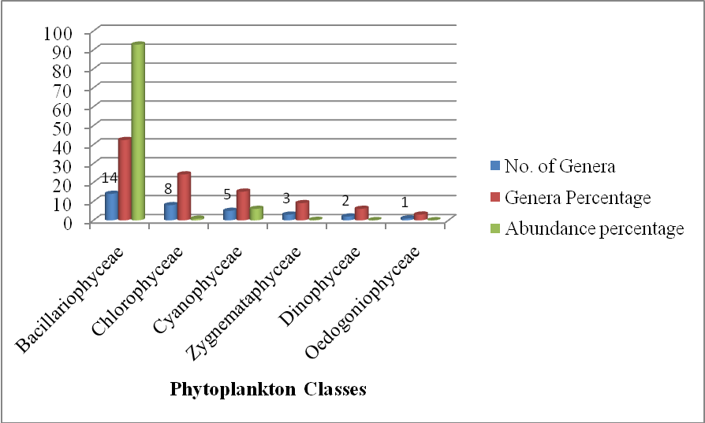
Figure 4. Phytoplankton Community Structure

3.5 Difference in the Mean Physicochemical Variables between the Rainy and the Dry Season
From table 4, it is conspicuous that there is no statistically significant difference ( P > 0.05 ) in the mean of water discharge (P= 0.16), pH concentration (P =0.62 ), phosphate concentration (P= 0.094), nitrate concentration(P = 0.45 ), dissolved oxygen concentration(P = 0.29), dissolved organic matter(P =0.20) and silicate concentration(P = 0.215 ) between the rainy and the dry season in the study area. Only three chemical variables demonstrated differences in their mean between the rainy and the dry season; Water surface temperature and water transparency both indicated a highly significant difference (P = 0.003) in their means between the rainy and the dry season and rainfall showed a significant difference(P = 0.03) between in its mean precipitation between the two seasons.

3.6 Correlations of the Physical Variables with the Phytoplankton Classes
The results of analysis of correlation of phytoplankton groups with the physical variables (Table 4) indicate that all the phytoplankton classes showed statistically significant positive correlations (P<0.05) with rainfall. However, the correlation coefficient ( r ) values show that all the phytoplankton classes were negatively correlated to both temperature and water transparency and it had also been observed that a non-significant correlation was seen between the phytoplankton classes with water discharge.

Table 3. Difference of mean physicochemical variables between the wet and the dry season
Season | Rainy | Dry
Variable | Mean ± SE | Mean ±SE | P-Value
Water Temperature | 35.16 ±2.64 | 21.56±1.46 | 0.003**
Transparency | 56.80 ±12.77 | 107.8 ± 8.73 | 0.003**
Rain | 35.16 ±2.64 | 21.56 ± 1.46 | 0.03*
Discharge | 49.20 ± 12.00 | 77.00± 8.21 | 0.16^{NS}
pH | 7.60 ±0.24 | 7.80 ±0.20 | 0.62^{NS}
PO4 | 373.00 ± 19.34 | 310.00 ±10.94 | 0.094^{NS}
NO3 | 5720.40 ±2341.20 | 3220.00 ± 643.73 | 0.45^{NS}
DO | 7.48 ± 0.19 | 7.88 ± 0.23 | 0.29^{NS}
DOM | 15.200 ± 0.80 | 12.92 ± 0.71 | 0.2^{NS}
SiO2 | 27660 ±4389. 26 | 35500 ± 2747.73 | 0.215^{NS}
*Significant difference (P > 0.05); ** highly significant difference (P<0.01); NS Non-significant difference (P>0.05).

Table 4. Multivariate correlation coefficient values (r) between the plankton groups and physical variables
 | Water temperature(ºC) | Transparency(mm) | Rainfall(mm) | Water Discharge(10⁶m³
Total phytoplankton | -0.500* | -0.899* | 0.999* | 0.430^{NS}
Bacillariophyceae | -0.500* | -0.900* | 1.000* | 0.380^{NS}
Chlorophyceae | -0.610* | -0.909* | 0.765* | 0.365^{NS}
Cyanophyceae | -0.640* | -0.795* | 0.754* | 0.471^{NS}
Zygnemetaphyceae | -0.700* | -0.983* | 0.729* | 0.412^{NS}
Dinophyceae | -0.500* | -0.789* | 0.9670* | 0.398^{NS}
Oedogoniophyceae | -0.500* | -0.888* | 1.000* | 0.490^{NS}
*Significant at (P<0.05); NS non-Significant (P > 0.05).

3.7 Correlations of the Chemical Variables with the Phytoplankton Classes
The results in table 5 indicates that the total phytoplankton and all the phytoplankton classes showed statistically positive correlations ( P < 0.05) with water pH ; phosphate concentration ; dissolved organic matter and silicate concentration . However, the correlation coefficients (r) indicated no statistically correlation ( P >0.05 ) between all the phytoplankton and the chemical variables, nitrate and dissolved oxygen.

Table 5. Multivariate correlation coefficient values (r) between the plankton groups and chemical variables
 | pH | PO₄ | NO₃ | DO | DOM | SiO₂
Total phytoplankton | 0.993* | 1.000** | 0.442^{NS} | 0.475^{NS} | 0.992* | 0.892*
Bacillariophyceae | 0.900* | 0.820* | 0.420 ^{NS} | 0.467^{NS} | 0.923* | 0.999*
Chlorophyceae | 0.852* | 0.902* | 0.432 ^{NS} | 0.327^{NS} | 0.869* | 0.883*
Cyanophyceae | 0.900* | 0.868* | 0.312 ^{NS} | 0.312^{NS} | 0.845* | 0.874*
Zygnemetaphyceae | 0.992* | 0.992* | 0.478 ^{NS} | 0.439^{NS} | 0.992* | 0.926*
Dinophyceae | 0.892* | 0.940* | 0.454 ^{NS} | 0.497^{NS} | 0.902* | 0.870*
Oedogoniophyceae | 0.888* | 0.857* | 0.439 ^{NS} | 0.375^{NS} | 0.975* | 0.992*
*Significant at (P<0.05); ^{NS} non-Significant (P > 0.05).

4. Discussion
The phytoplankton population composition of Jebel Aulia reservoir could be described as significantly abundant as a result of considerable amount of nutrients especially silicate that resulted in the proliferation of Bacillariophyceae as a dominant class and nitrate, phosphate that induced increment in the density of the Cholorophyceae class (Moshood K. Mustapha, 2010). The fact that Jebel Aulia Reservoir is eutrophic lake is evidenced by the positive correlation of the phytoplankton classes with the nutrients, with the exception of nitrate that did not show any correlation with the plankton classes in the reservoir despite its concentration was not below the required range; Mackenthun (1969) and Andersen & Hessen (1991) discussed that concentrations of phosphate and nitrate necessary for phytoplankton growth are at least, 15μgL⁻¹ and 300μgL⁻¹, respectively.
Another interesting finding was that the phytoplankton classes established hierarchical organization of dominance from Bacillariophyceae to Chlorophyceae, Cyanophyceae, Zygnemataphyceae, Dinophyceae and Oedogoniophyceae. This finding is relevant to the observations of Brook Lemma (1995) who found that the phytoplankton classes of a tropical lake in Ethiopia exhibited a hierarchy dominated by Bacillariophyceae followed by Chlorophyceae and Cyanophycea. The dominance of the phytoplankton class Bacillariophyceae over all the other phytoplankton classes is one of the most distinguishing features of tropical reservoir (Wood, R.B. & Talling, J.F.,1988) and Jebel Aulia is not an exception.
All the physicochemical variables were the same between the two seasons except for water temperature, transparency and rainfall which varied between the seasons. Despite this disparity in the level of the physicochemical variables between seasons, they however were in their normal ranges that could have made it possible for both seasons to have the same number of phytoplankton density. However, the low phytoplankton density in the dry season, despite the fact that the reservoir’s nutrient contents did not vary significantly between the two seasons might be due to high level of transparency as high transparency could have consequently exposed the phytoplankton to grazers such as zooplankton and fishes that predated on them (Moshood K. Mustapha, 2010 ) although the effect of grazing, one of the main factors shaping phytoplankton structure was not a subject of the present study.
However, the high abundance of phytoplankton during the rains might be due to the occurrence of high concentration of ions in this period that become concentrated in the reservoir (Thomas, S., et al., 2000).
Furthermore, the fact that there was no significant decrease in the concentration of both nitrate and phosphorus, in either during the rainy or the dry season might be attributed to the high abundance of the Bacillariophyceae class that dominates the other classes because it favors silicate to the other two nutrients (nitrate and phosphate) and this was apparently reflected in the positive correlation of Bacillariophyceae with Silicate, where as the high abundance of Chlorophyceae and Cyanophyceae, the second and the third dominating classes of the phytoplankton respectively, in the reservoir might be attributed to the high levels of phosphorus and nitrate (ADON Marie Paulette et al., 2011) although the result did not indicate any significant positive correlations between these nutrients and these classes.
ADON Marie Paulette et al. (2011) also discussed that phytoplankton densities in a tropical reservoir might be limited by a combination of variables, not nutrients alone, but involving light and possibly grazing and rainfall and that all are to be considered when attempting to explain phytoplankton seasonal variation. Talling (1986) from the other hand commented that, especially in Africa, annual patterns of phytoplankton seasonality are usually either dominated by hydrological features or by hydrographic ones which influences the chemical dynamics of the water column and ultimately their biota, whereas Bouvy et al. (2006) mentioned that eutrophic tropical systems are often characterized by opportunist piscivores and planktivores; predominant rotifers are considered to be inefficient grazers but the phytoplankton population could be regulated by fish, especially by tilapias.

5. Conclusion
Jebel Aulia Reservoir reflected the typical feature of the African Tropical reservoir in the population composition of its major phytoplankton communities and in terms of the influence of seasonality coupled with the physicochemical variables on its abundance.
In the reservoir, nutrients level seems not to be the only factor that affects the population density of its phytoplankton communities. However, phytoplankton abundance, beside nutrients is a function of many other factors such as predation by zooplankton and fish as well as hydrobiological and hydrographic features of the reservoir.
It is therefore important to know that any study to account for the seasonal influence of physicochemical variables on phytoplankton abundance in the reservoir should have to consider the synergistic influence of the factors mentioned above.

Acknowledgements
We would like to acknowledge University of Juba for its support for this research work. We also express our sincere thanks to the Jebel Aulia Meterological Department for supplying us with information pertaining to the monthly discharge and rainfall. We thank all the technicians in the University’s Fisheries laboratory for their assistance in sample processing.

References
- ADON Marie Paulette*, OUATTARA Allassane and GOURENE Germain (2011). Seasonal variation in the diversity and abundance of phytoplankton in a small African tropical reservoir. African Journal of Microbiology Research Vol. 5(18), pp. 2616-2626.
- Andersen, T. and Hessen. D.O. 1991. Carbon, Nitrogen and Phosphorous Content of freshwater zooplankton, Limnology and Oceanography 36:807 – 813.
- Anneville O, Ginot V, Druart JC, Angeli N. 2002. Long-term study (1974–1998) of seasonal changes in the phytoplankton in Lake Geneva: a multi-table approach. J Plankton Res 24:993–1008.
- Beyruth Z (2000). Periodic disturbances, trophic gradient and 2626 Afr. J. Microbiol. Res. phytoplankton characteristics related to cyanobacterial growth in Guarapiranga reservoir. Sao Paulo State, Brazil. Hydrobiologia, 424:51-60.
- Bouvy M, Ba N, Ka S, Sane S, Pagano M, Arfi R (2006). Phytoplankton community structure and species assemblage succession in a shallow tropical lake (Lake Guiers, Senegal). Aquat. Microb. Ecol., 45: 147-161.
- Cost, Iltis A (1981). Ultrastructure of the cell of Trachelomonas (Algae, Euglenophyta) harvested in the Ivory Coast. Rev. Hydrobiol., 14(2): 115-133.
- Da KP, Traore D, Assemien P (1997). The genus Scenedesmus in the microflora of the pond fish and the complex of Banco National Park (Ivory Coast). Bull. Jard. Bot. Nat. Belg., 66: 107-129.
- Davidson K, Wood G, John E, Flynn K .1999. An investigation of non-steady-state algal growth I. An experimental model ecosystem. J Plankton Res 21:811–837.
- Feuillade JB, Feuillade M. 1987.Modelling steady-state growth and photosynthesis rates of Oscillatoria rubescens continuous cultures in relation to temperature and irradiance. J Plankton Res 9:445–457.
- Hecky RE, Kling HJ (1981). The phytoplankton and protozooplankton of the euphotic zone of Lake Tangayinka: species composition, biomass, chlorophyll content and spatio-temporal distribution. Limnol. Oceanogr., 26: 548-564. http://www.fao.org/docrep/005/V4110E/V4110E05.htm-Visited on 12 June, 2012.
- Huszar V, Kruk C, Caraco N. 2003. Steady-state assemblages of phytoplankton in four temperate lakes (NE USA). Hydrobiologia 502:97–109.
- Komárek J, Fott B (1983). Chlorophyceae (Grûnalgen) Ordnung: Chroococcales. In G. Huber-Pestalozzi (ed.), Das Phytoplankton des Sübwassers 7(1), X + p 1044, 253 pl.
- Komárek J, K Anagnostidis (2005). Cyanoprokaryota 2. Teil: Oscillatoriales. In: Budel HrsgB, Gärtner G, L Krienitz, Schagerl M, von Sübwasserflora Mittelleuropa, 19(2): 759.
- Komárek J, King H, Komárková J (2003). Filamentous cyanobacteria. In Wehr, JD & Sheath RG. [Eds.] Freshwater Algae of North America. Ecology and Classification. Academic Press, San Diego, California, pp. 117-91.
- Krammer K, Lange-Bertalot H (1991). Bacillariophyceae. 3. Teil: Centrales, Fragilariaceae, Eunotiaceae. In: Sübwasserflora von Mitteleuropa 2/2. Gustav Fisher Verlag, p 576, 166 pl.
- Mackereth, F.J.H. 1963. Water Analysis, Some Revised Methods for Limnologists. Scientific Publications of the Freshwater Biological Association, U.K., No. 36.
- Moshood K. Mustapha(2010). Seasonal Influence of Limnological Variables on Plankton Dynamics of a Small, Shallow, Tropical African Reservoir. ASIAN J.EXP. BIOL. SCI., VOL 1(1)2010.
- Moustaka-Gouni M, Vardaka EE, Tryfon E .2007. Phytoplankton species succession in a shallow Mediterranean lake (L. Kastoria, Greece): steady-state dominance of Limnothrix redekei, Microcystis aeruginosa and Cylindrospermopsis raciborskii. Hydrobiologia 575:129–140.
- Naselli-Flores L, Padisak J, Dokulil MT, Chorus I .2003.Equilibrium/ steady-state concept in phytoplankton ecology. Hydrobiologia 502:395–403.
- Park S, Brett MT, Oshell ET, Goldman CR (2003). Seston food quality and Daphnia production efficiencies in an oligo-mesotrophic Subalpine lake. Aquat. Ecol., 37: 123-136.
- Reynolds CS (1999). Non-determinism to probability, or N:P in the community ecology of phytoplankton: Nutrient ratios. Arch. Hydrobiol., 146: 23-35.
- Rocha, O., Matsumura-Tundisi, Espindola, T. E.L.G. Roche, K.F. and Rietzler, A.C. (1999). Ecological theory applied to reservoir zooplankton. In Tundisi, J.G & M. Straskraba, (eds.). Theoretical Reservoir Ecology and its Applications. International Institute of Ecology, Brazilian Academy of Sciences. Backhuys Publishers, Leiden, Netherlands p. 29-51.
- Simciv T (2005). The role of plankton, zoobenthos, and sediment in organic matter degradation in oligotrophic and eutrophic mountain lakes. Hydrobiologia, 532: 69-79.
- Talling JF (1986). The seasonality of phytoplankton in African lakes. Hydrobiologia, 138: 139-160.
- Thomas, S., Cecchi, P. Corbin, D. & Lemoalle, J. (2000). The different primary producers in a small African tropical reservoir during a drought: temporal changesand interactions. Freshwat. Biol. 45: 43-56.
- Uherkovich G (1995). A scenedesmus zöldalga nemzetség (Chlorococcales, Chlorophyceae) különös tekintettel magyarországi elöfordulású taxonjaira. Ács Éva és Schmidt Antal Közremüködésével. Szerkesztette : Kiss Keve Tihamér. A könyv megjelenését a Magyar Könyv Alapítvány és a Nemzetközi. Limnológiai Társaság (SIL) támogatta. Magyar Algológiai Társaság. Budapest, p. 266.
- Utermöhl H (1958). Zur Vervollkommung der quantita-tiven Phytoplanktonmethodik. Mitteilungen. Internationale Vereinigung für Theoretische und Angewandte. Limnology, 9: 1-38.
- Walsby AE (2001). Determining the photosynthetic productivity of a stratified phytoplankton population. Aquat. Sci., 63: 18-43.
- Welcomme, R.L. 1979. Fisheries Ecology of Flood plain Rivers, Longman Inc. New York, 40 – 53.
- Wood, R.B. & Talling, J.F. (1988). Chemical and algal relationships in a salinity series of Ethiopian inland waters. Hydrobiol. 158: 29-67.

9/18/2012

