Immunohistochemical analyses of Survivin expression in patients with Oral Lichen Planus

Manar M. El-Sholkamy¹; Nagwa Osman¹; Heba Ahmad Farag² and Noha Ayman Ghallab¹

¹ Department of Oral Medicine and Periodontology, Faculty of Dentistry, Cairo University.
²Deprtment Oral Pathology, Faculty of Oral and Dental Medicine, Cairo University.
manarSholkamy@yahoo.com

Abstract: Oral Lichen Planus (OLP), is a chronic, inflammatory disease of immunological disorder. The most important complication of OLP is the development of oral squamous cell carcinoma (OSCC). Survivin is an inhibitor of apoptosis gene and encourages the continued proliferation and survival of tumors. The aim of this study was to detect the level of Survivin as a molecular indicator of malignancy in control, reticulo-papular and bollous-erosive OLP patients using immunohistochemistry. Materials and Methods: 25 subjects participated in this study,10 reticulo-papular, 5 bollous–erosive OLP patients and 10 healthy controls. All subjects were non-smokers and systemically free to standardize their medical condition. All patients and controls were subjected to biopsy procedures from the buccal mucosa for histopathological examination and immunostained with Survivin using the Ultra Vision System. Results: This study showed a highly significant difference (P<0.001), in mean Survivin optical density between the control group and OLP groups. The highest values were observed in the bullous-erosive group. Mean Survivin area % was nearly 30 % in the reticulo-papular group, 90% in the bollous-erosive group, but only around 10% in the control group. Conclusion: Survivin levels are higher in OLP than in healthy tissue and highest in bullous-erosive forms of OLP compared to the reticulo-papular form. Bullous-erosive forms of OLP are hence more liable to turn malignant than reticulo-papular forms. Diagnosis of OLP patients histopathologically together with molecular profiling and localization of their Survivin levels, can be therefore used as an early biomarker for malignant transformation, before the appearance of tissue abnormalities.
[Manar M. El-Sholkamy;Nagwa Osman; Heba Ahmad Farag and Noha Ayman Ghallab. Immunohistochemical analyses of Survivin expression in patients with Oral Lichen Planus] Nature and Science 2012;10(12):16-22]. (ISSN: 1545-0740). http://www.sciencepub.net. 4

Key Words: Oral lichen planus, Survivin, Malignant transformation.

1. Introduction
OLP is the most common, chronic inflammatory, non-infectious oral mucosal disease in patients referred to Oral Medicine and Oral Pathology clinics⁽¹⁾. OLP varies from 0.55 to 2.25% of the general adult population. Oral lesions comprise the sole manifestation of OLP in approximately 15% to 35% of the cases⁽²⁾. OLP is considered a T-cell mediated autoimmune disease, but until today the exact etiology has not been fully understood⁽³⁾. OLP can be clinically presented in several forms including; reticular, atrophic, bullous and erosive OLP ⁽⁴⁾ and some variants can co-exist in the same patient⁽⁵⁾. The most important complication of OLP is the development of oral squamous cell carcinoma (OSCC)⁽⁶⁾. The tongue appears to be the preferential site for the malignancy transformation, though an increased frequency of the carcinomas on the palatal midline, gums and lips has also been reported. The carcinomas that appear overlying OLP lesions are mainly of an exophytic nature, although in some cases an endophytic growth pattern was observed, suggesting rapid expansion of the lesion ⁽⁷⁾.
Survivin is an inhibitor of apoptosis gene and the smallest member of the inhibitor of the apoptosis protein family (IAP) ⁽⁸⁾.Survivin expression is abundant in the embryonic lung and fetal organs during the developmental stages⁽⁹⁾. Although it is undetectable in differentiated adult tissues⁽¹⁰⁾, it has been detected in the rapidly proliferating cells of the thymus, placenta, basal colonic epithelial cells⁽¹¹⁻¹³⁾, heomopiotic and stem cells⁽¹⁴⁾. It is also clearly detected in transformed cells and most human cancers, including lung, breast, pancreatic, colon carcinomas, soft tissue sarcomas and brain tumors⁽¹⁵⁾. The vast majority of tumours express Survivin protein at high levels, suggesting that reactivation of the Survivin gene occurs commonly in cancers ⁽¹⁶⁾.Furthermore, expression in tumors was found to be correlated with disease severity, prognosis and treatment outcome⁽¹⁷⁾.
The main established functions of Survivin are the regulation of cell division (mitosis)⁽⁸⁾ and inhibition of apoptosis⁽¹⁰⁾. Survivin is essential for the accurate proliferation of the normal human cells. Inhibition of Survivin expression or disruption in its function, induces defective cytokinesis but does not cause cell death, so human cells can survive in the absence of Survivin but fail to proliferate properly⁽¹⁸⁾. Absence or defective Survivin affects the ability of cells to align chromosomes properly during metaphase. Survivin depletion also causes abnormal behavior of mitotic chromosomes and centromeres, making cells abnormally large and flat with mini nuclei and bilobed nuclei. This generates cells with incorrectly aligned chromosomes, short mitotic spindles and abnormal multipolar spindles ⁽¹⁹⁾.
Survivin plays a role in regulating cell death by inhibiting apoptosis. It does so through physically binding to caspases thus inhibiting their proper function ⁽²⁰⁾. When Survivin inhibits caspase activation, it leads to negative regulation of apoptosis, thus encouraging tumour growth. It was found that the Survivin protein is highly expressed in most human tumours and fetal tissue, but is completely absent in terminally differentiated cells. Therefore, Survivin makes an ideal target for cancer therapy as decreasing the expression of Survivin in cancer cells will eventually lead to their death through apoptosis⁽²¹⁾.
The aim of the present study was therefore conducted to detect the level of Survivin as a molecular indicator of malignancy in control, reticulo-papular and bollous-erosive OLP patients using immunohistochemistry.

2. Materials and Methods.
This study included 25 subjects (15 patients and 10 controls). All subjects were non-smokers and systemically free according to Cornell's medical index to standardize their medical condition⁽²²⁾. Subjects included in this study were divided into two groups:
Group 1:Included 15 patients, 5 reticulo-papular and 10 bollous-erosive cases of OLP, clinically diagnosed according to the World Health Organization's (WHO's) clinicopathological diagnostic criteria for LP⁽²³⁾.
Group 2: Included 10 healthy normal individuals who served as the control group. Those subjects were free from any inflammatory oral lesions and were undergoing oral mucosal surgery for various reasons, e.g. during excisional biopsy of fibroma. All patients and controls were subjected to the following:

a)Biopsy procedures:
Biopsies were taken from the buccal mucosa after ring block anesthesia was performed. Biopsy material obtained from both groups was immediately fixed in 10 % neutral buffered formalin, and then processed in the routine way for histopathological examination to confirm the clinical diagnosis.

b)Immunohistochemical Staining:
Using the Survivin Primary antibody kit (Thermo Fisher Scientific Anatomical Pathology.Fremont U.S.A.): The immunostained sections were examined using an ordinary light microscope to assess the prevalence of immunopositivity of Survivin in the studied cases, together with an Image analyser computer system to assess area percentage of positive cells and intensity of immunostain. All the obtained data from the computer image analyses were statistically evaluated.

Statistical Analyses:
Data represented the value of Survivin immunoexpression and immunostaining intensity. They were given as mean values ± SD (standard deviation). The ANOVA (analysis of variance) test was used to compare the mean immunostain intensity values between different groups. Student t-test was used to compare mean % values of Survivin between control and each type of OLP.

3. Results
Immunohistochemical analysis:
There was a high significant difference (P<0.001), in mean Survivin optical density between the control group, reticulo-papular and bullous-erosive OLP groups. The control group showed a mean ± standard deviation (M±SD) of 31.0 ± 1.16. A higher value was seen in the reticulo-papular group with a M±SD of 49.9 ± 0.917. Highest values were observed in the bullous-erosive group which showed a M±SD of 68.1 ± 3.00. (Fig. 1).
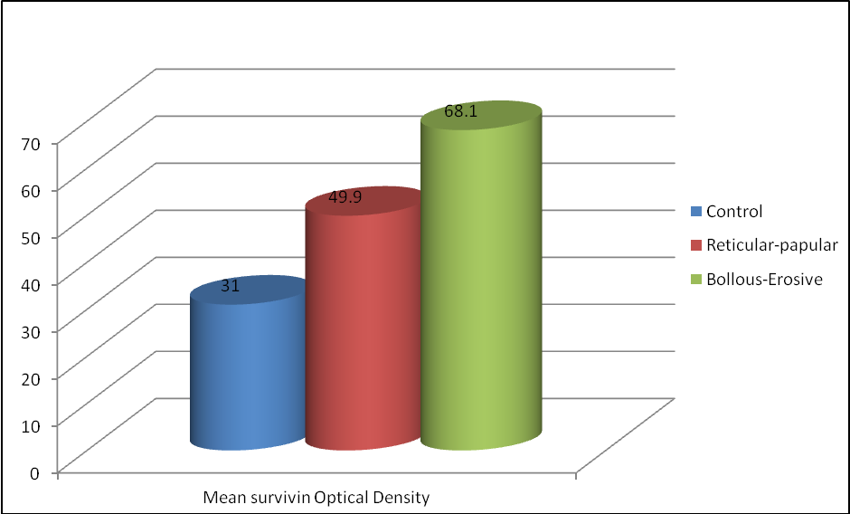

Fig. (1): Difference in Mean Survivin optical density between different groups.

Concerning mean Survivin area %, there was a high significant difference (P<0.001), between the control group, reticulo-papular and bullous-erosive OLP groups. The control group showed a mean ± standard deviation (M±SD) of 13.95±1.60. A higher value was seen in the reticulo-papular group with a M±SD of 35.48±3.71. Highest values were observed in the bullous-erosive group which showed a M±SD of 95.86±5.02 ( Fig. 2).

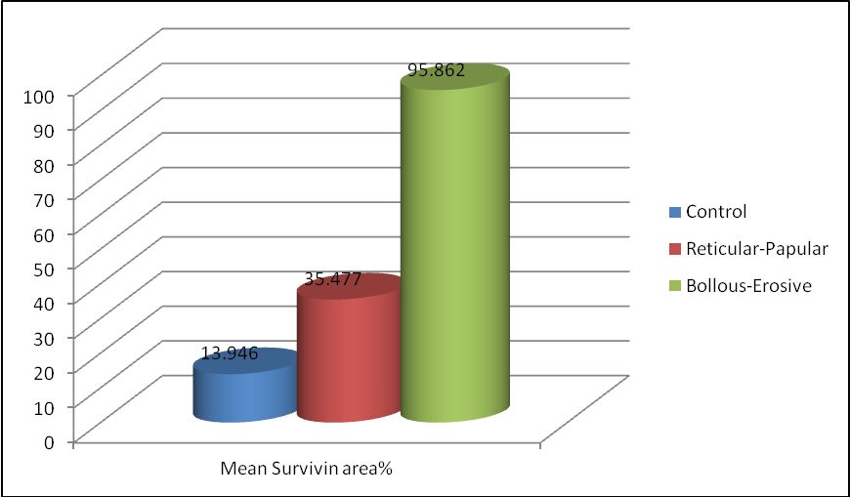

Fig (2): Difference in Mean Survivin Area% between different groups.

Histologic results:
According to the histological features, specimens were classified into 4 groups, Control group, Reticulo-Papular OLP, Erosive OLP and Bollous-Erosive OLP. Immunohistochemical staining revealed mild positive Survivin reaction in normal control specimen and patchy distribution of Survivin in the prickle and basal cell layers of stratified squamous epithelium in Reticulo-Papular OLP specimens. Erosive OLP specimens revealed cytoplasmic distribution of Survivin in all cell layers of stratified squamous epithelium while in the Bollous-Erosive specimens, a more membranous distribution of Survivin was evident.
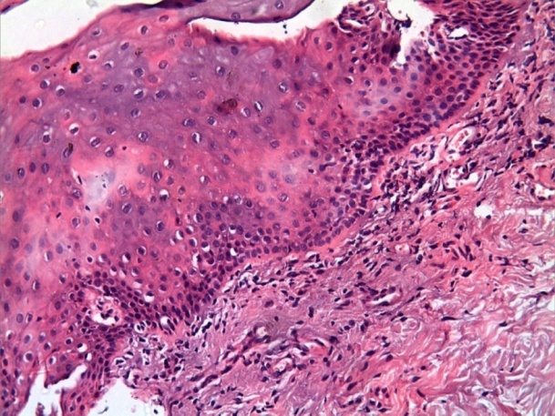
Fig (1): Photomicrograph from control specimen showing normal stratified squamous epithelium under which there is normal connective tissue. (H&E X200).
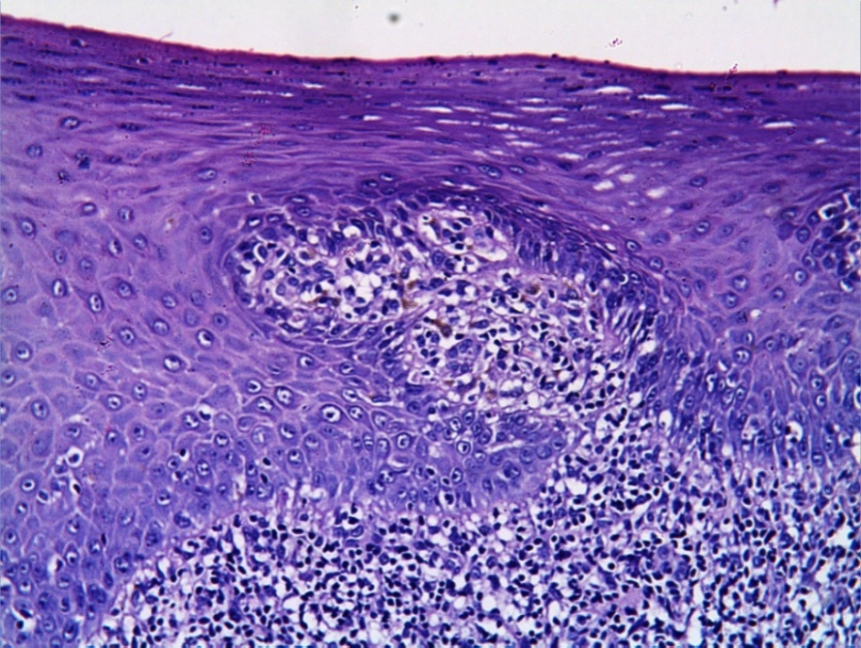
Fig (2): Photomicrograph of Reticular-Papular OLP showing hyperparakeratosis of stratified squamous epithelium with saw rete pegs (arrows) under which there is band of lymphocytic infiltration in the connective tissue. (H&EX200).
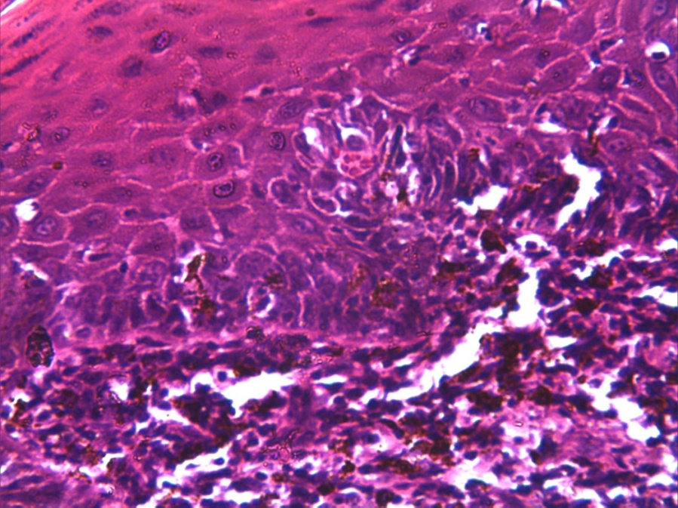
Fig (3): Photomicrograph of Bollous-Erosive OLP showing degenerated basal cell layer replaced with eosinophilic band (white arrows). Notice the (Max-Joseph space). Civatte bodies are noticed in both the basal and prickle cell layers (black arrow). Lymphocytic infiltration in the connective tissue.(H&EX400).

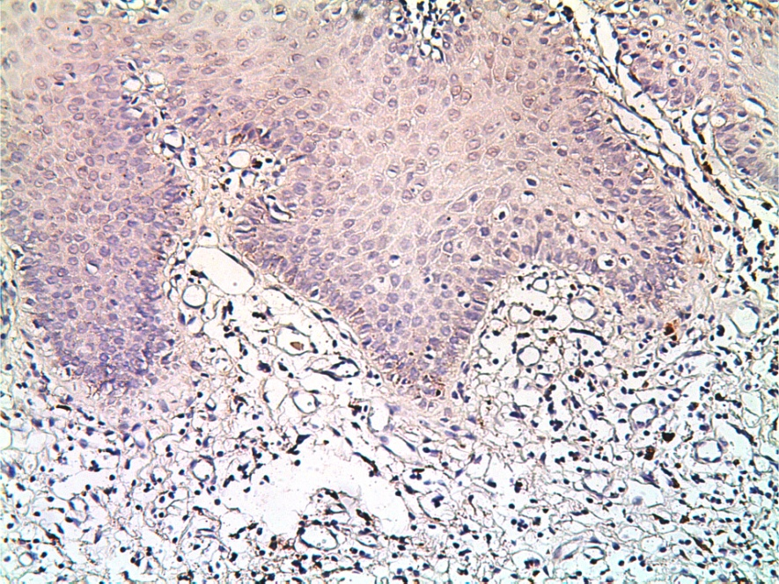
Fig (4): Photomicrograph of control specimen showing normal stratified squamous epithelium under which there is normal connective tissue showing mild positive Survivin reaction. (Survivin X200).
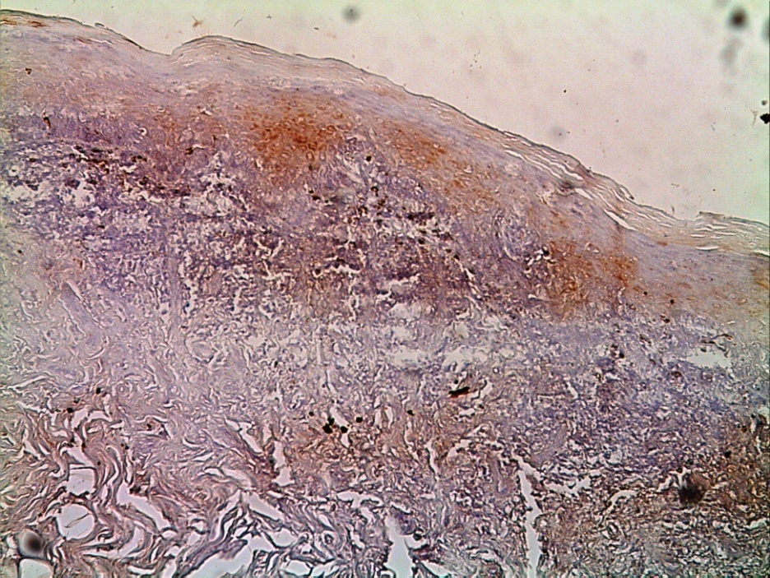
Fig (5): Photomicrograph of specimen from Reticulo-papular OLP showing patchy distribution of Survivin in the prickle and basal cell layer of stratified squamous epithelium (arrows). (Survivin X200).
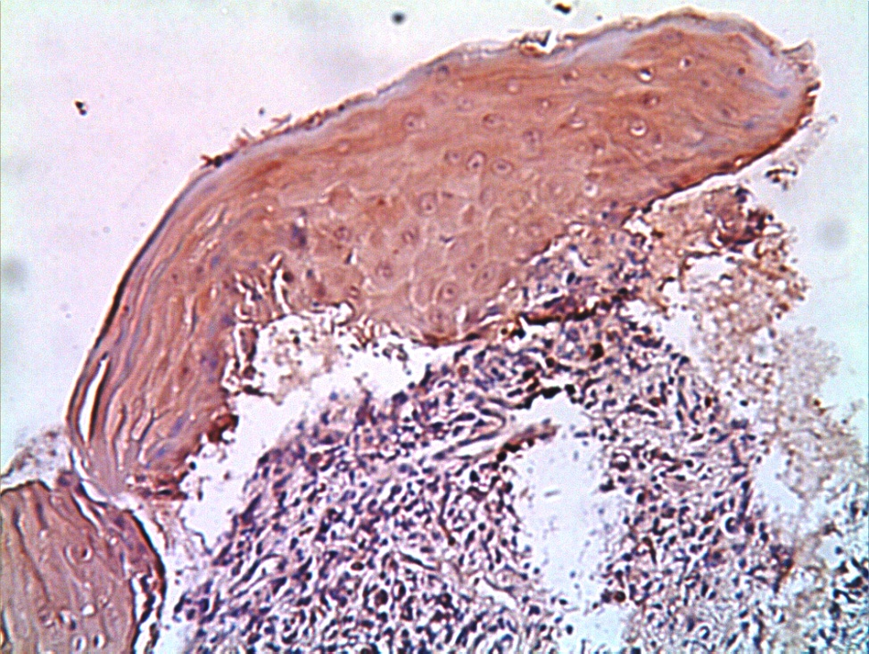
Fig (6): Photomicrograph of Erosive OLP showing increased distribution of Survivin in all cell layers of stratified squamous epithelium. (Survivin X200).

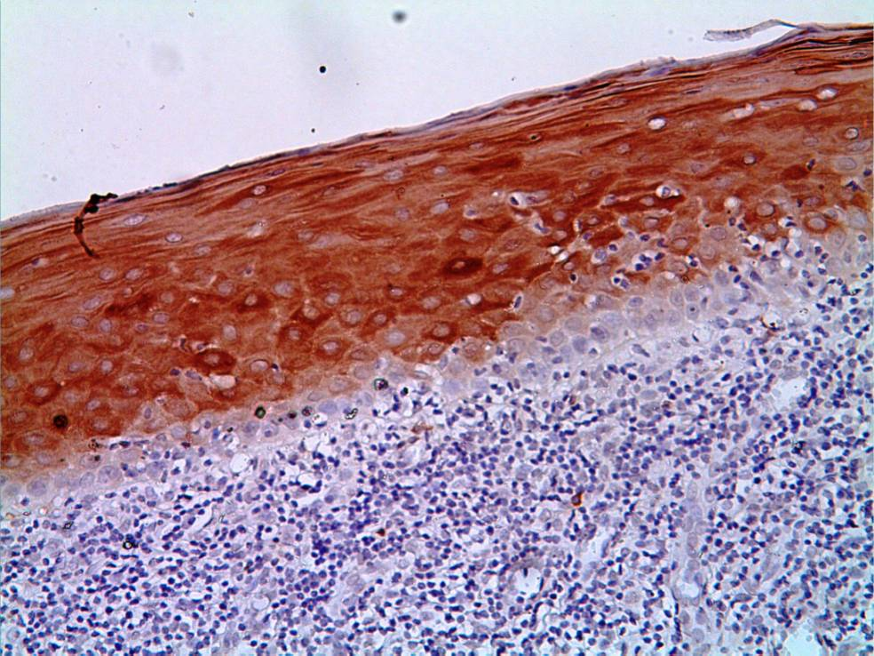
Fig (7): Photomicrograph of Erosive OLP showing increased intensity in the cytoplasmic distribution of Survivin in all cell layers of stratified squamous epithelium. (Survivin X200)

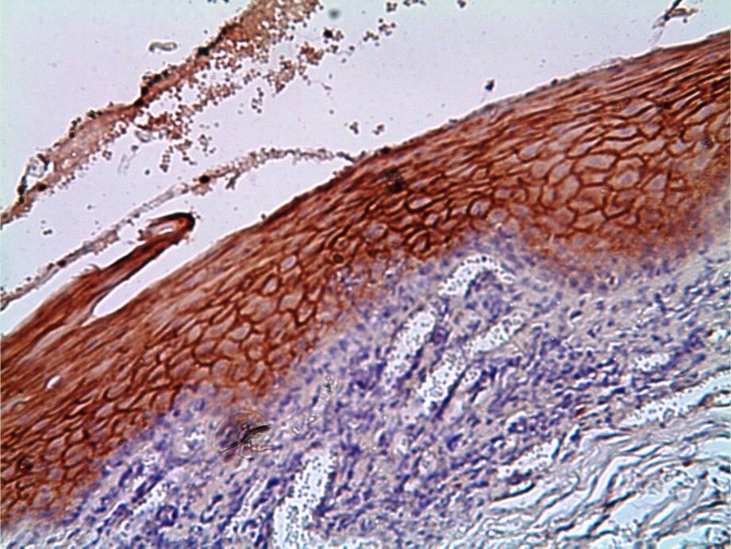
Fig (8): Photomicrograph of specimen from Bollous-erosive lichen planus showing increased intensity in the membranous distribution of Survivin in all cell layers of stratified squamous epithelium (Survivin X200).

4. Discussion
According to the World Health Organization (WHO), OLP has been categorized as a precancerous condition, associated with a significant increased risk of cancer⁽⁵⁾. Mignogna et al.⁽²⁴⁾ further suggested that OLP-malignant transformation may occur within a mean time interval of 2.6 years from the time of diagnosis.
Even though 33% of oral precancerous lesions will eventually evolve into invasive OSCC, no reliable histopathological parameters have been identified that can predict their potential for subsequent transformation. This stresses the need for discovering new molecular markers of disease progression that could reliably identify patients that are at a greater risk of invasive transformation into OSCC ^{(25).}
Survivin has been recently considered as a critical cancer specific protein, as it was found to be abundantly expressed in solid and hematological malignancies⁽¹⁰⁾. Survivin is required for cancer cell viability⁽²⁶⁾,as it was found to improve tumor angiogenesis⁽²⁷⁾, contribute to the phenotype of cancer cells making them more resistant to apoptotic stimuli⁽²⁸⁾ and was considered a radioresistant factor increasing tumors resistance to radiotherapy or chemotherapy⁽²⁹⁾.
Findings demonstrated from the current study revealed that Survivin levels were lowest in the control group with normal oral mucosa (NOM), and highest in the bollous-erosive forms of OLP. Therefore, bulluos-errosive form of OLP can be considered as an active condition with high chances of malignant transformation. On the other hand, the reticulo-papular form of OLP can be considered as a much stable condition with decreased chances of malignant change.
Immunohistochemical staining in the present study revealed that, erosive OLP tissues biopsies showed a more cytoplasmic distribution of Survivin while in the bollous-erosive tissue biopsies, a more membranous distribution of Survivin was evident. Cytoplasmic distribution of Survivin has been considered as a poor prognostic factor ^{(30,31)}, while the significance of the membranous distribution of Survivin needs to be further investigated.
The findings demonstrated in the present study are in agreement with another immunohistochemical study performed by Lo Muzio et al.⁽²⁵⁾ who investigated the potential predictive value of Survivin as an early predictor of malignant transformation, in precancerous lesions (leukoplakia) and OSCC. The results of the present study also agree with another immunohistochemical study carried out by Oluwadara et al. ⁽³²⁾ , investigating the expression of Survivin in patients with OLP and OSCC. The molecular signature of Survivin was clearly prominent in OLP, as all (100%) of OLP and OSCC biopsies expressed Survivin. Lodi et al. ⁽³³⁾, investigated Survivin levels in NOM, oral leukoplakia and in OSCC using RT-PCR. All samples of NOM showed very low/nearly undetectable Survivin levels, while the highest Survivin expression values were seen in the cancer group.
On the other hand, contradicting results were demonstrated by Chaiyarit et al.⁽³⁴⁾ who investigated the expression of Survivin in bollous/erosive OLP and NOM. Both NOM and OLP specimens were positive for Survivin. Furthermore, Survivin expressed in OLP specimens were actually "less" than Survivin levels in NOM specimens. This can be attributed to the difference in the site where the control samples were obtained (retromolar area), while in the present study as well as in all previous studies, control samples were obtained from the same site as the OLP samples (buccal mucosa). In addition, the authors explained that confounding variables such as fixation, antigen retrieval techniques, types of primary antibodies and detecting systems might have had a bearing on the outcome.
Histopathology in OLP remains a valued and viable diagnostic tool. However in order to achieve a molecular targeted approach in diagnosis, prognosis and therapy, histopathology needs to be complemented with reliable molecular parameters. This leads to propose that OLP lesions that are in the process of transforming into OSCC present histomorphologically as OLP, but posses certain molecular signatures that indicate their progression into cancer⁽³²⁾.
The application of the principle of biomarker voting may therefore represent a new frontier in the diagnosis, assessment and prognosis of OLP, suggesting that it is safer to monitor the progress of the disease molecularly as well as histopathologically⁽³²⁾ .Survivin expression together with its cellular localization should be considered to evaluate its impact on future prognosis and therapy options. Cytoplasmic and nuclear localization of Survivin can be utilized as an independent prognostic factor for cancerous and precancerous patients in the future⁽³¹⁾.
The molecular mechanisms by which Survivin control cell proliferation and cell apoptosis under the pathological condition of OLP still remains unclear. Thus, future studies should analyze the role of Survivin in the cellular immunobiology of oral epithelial cells. In addition, further investigations on the role of this molecule in the degeneration of basal epithelial cells are important for a better understanding of the importance of Survivin in the immunopathogenesis of OLP⁽³⁵⁾ .
It can be finally suggested that due to the choronocity and long-time nature of OLP, mutations may develop contributing to the pre-cancerous nature of the disease which can be detected by molecular indicators of malignancy such as Survivin.
Conclusion:
Survivin levels are higher in OLP than in healthy normal tissue and are significantly higher in bullous-erosive forms of OLP compared to the reticulo-papular form. Bullous-erosive forms of OLP are hence more liable to turn malignant than reticulo-papular forms. Diagnosis of OLP patients histopathologically together with molecular profiling and localization of their Survivin levels, can be used as an early biomarker for malignant transformation, before the clinical appearance of tissue abnormalities.

Recommendation:
Further investigations are needed to detect the correlation between the membranous localization of Survivin and the prognosis of OLP.

Corresponding author
Manar M. El-Sholkamy¹
Department of Oral Medicine and Periodontology, Faculty of Dentistry, Cairo University.
manarSholkamy@yahoo.com

Referances
- Sugerman PB, Savage NW, Zhou X, Walsh LJ, Bigby M. (2000): Oral lichen planus. Clinical Dermatology. 18(5):533-9.
- Huber MA(2004): Oral lichen planus. Quintessence International. ,35(9):731-52..
- Scully C, Carrozzo M (2008): Oral mucosal disease: Lichen planus. British Journal of Oral and Maxillofacial Surgery, 46(1):15-21.
- AnuradhaCh, Reddy BV, Nandan SR, Kumar SR(2008): Oral lichen planus. A review. The New York State Dental Journal, 74(4):66-8..
- Ismail SB, Kumar SK, Zain RB(2007): Oral lichen planus and lichenoid reactions: etiopathogenesis, diagnosis, management and malignant transformation. Journal of Oral Science, 49(2):89-106..
- Van der Meij EH, Mast H, Van der Waal I(2007): The possible premalignant character of oral lichen planus and oral lichenoid lesions: a prospective five-year follow-up study of 192 patients. Oral Oncology, 43(8):742-8.
- Lo Muzio L, Mignogna MD, Favia G, Procaccini M, Testa NF, Bucci E(1998): The possible association between oral lichen planus and oral squamous cell carcinoma: a clinical evaluation on 14 cases and a review of the literature. Oral Oncology, 34(4):239–46..
- Mita AC, Mita MM, Nawrocki ST, Giles FJ(2008): Survivin: key regulator of mitosis and apoptosis and novel target for cancer therapeutics. Clinical Cancer Research, 14(16):5000-5.
- Reed JC(2001): The Survivin saga goes in vivo. Journal of Clinical Investigation, 108(7):965-9..
- Altieri DC(2008): New wirings in the survivin networks. Oncogene, 27(48):6276-84.
- Zhang T, Otevrel T, Gao Z, Gao Z, Ehrlich SM, Fields JZ, Boman BM(2001): Evidence that APC regulates survivin expression: a possible mechanism contributing to the stem cell origin of colon cancer. Cancer Research, 61(24):8664-7.
- Fukuda S, Pelus LM(2001): Regulation of the inhibitor-of-apoptosis family member survivin in normal cord blood and bone marrow CD34(+) cells by hematopoietic growth factors: implication of survivin expression in normal hematopoiesis. Blood, 98(7):2091-100..

Gianani R, Jarboe E, Orlicky D, Frost M, Bobak J, Lehner R, Shroyer KR(2001): Expression of survivin in normal, hyperplastic, and neoplastic colonic mucosa.Human Pathology, 32(1):119-25..
- Pennartz S, Belvindrah R, Tomiuk S, Zimmer C, Hofmann K, Conradt M, Bosio A, Cremer H(2004): Purification of neuronal precursors from the adult mouse brain: comprehensive gene expression analysis provides new insights into the control of cell migration, differentiation, and homeostasis. Molecular and Cellular Neuroscience, 25(4):692-706..
- Kappler M, Bache M, Bartel F, Kotzsch M, Panian M, Würl P, Blümke K, Schmidt H, Meye A, Taubert H(2004): Knockdown of survivin expression by small interfering RNA reduces the clonogenic survival of human sarcoma cell lines independently of p53. Cancer Gene Therapy. 11(3):186-93..
- Ambrosini G, Adida C, Altieri DC(1997): A novel anti-apoptosis gene, survivin, expressed in cancer and lymphoma. Nature Medicine, 3(8):917-21..
- Montorsi M, Maggioni M, Falleni M, Pellegrini C, Donadon M, Torzilli G, Santambrogio R, Spinelli A, Coggi G, Bosari S(2007): Survivin gene expression in chronic liver disease and hepatocellular carcinoma. Hepatogastroenterology, 54(79): 2040-4.
- Yang D, Welm A, Bishop JM(2004): Cell division and cell survival in the absence of survivin. Proceedings of the National Academy of Science U S A. 101(42): 15100-5.
- Zhang W, Tong Q, Li S, Wang X, Wang Q(2008): MG-132 inhibits telomerase activity, induces apoptosis and G(1) arrest associated with upregulated p27kip1 expression and downregulated survivin expression in gastric carcinoma cells. Cancer Invest Journal, 26(10):1032-6..
- Tamm I, Wang Y, Sausville E, Scudiero DA, Vigna N, Oltersdorf T, Reed JC (1998): IAP-family protein survivin inhibits caspase activity and apoptosis induced by Fas (CD95), Bax, caspases, and anticancer drugs. Cancer Research, 58 (23): 5315-20..
- Sah NK, Khan Z, Khan GJ, Bisen PS(2006): Structural, functional and therapeutic biology of survivin. Cancer Letters, 244(2):164-71..
- Abramson, J.H(1966): The Cornell Medical Index as an epidemiological tool. The American Public Health Association, 56:287..
- Rad M, Hashemipoor MA, Mojtahedi A, Zarei MR, Chamani G, Kakoei S, Izadi N(2009): Correlation between clinical and histopathologic diagnoses of oral lichen planus based on modified WHO diagnostic criteria. Oral Surgery Oral Medicine Oral Pathology Oral Radiology Endododontics, 107(6):796-800..
- Mignogna MD, Lo Russo L, Fedele S, Ruoppo E, Califano L, Lo Muzio L(2002): Clinical behaviour of malignant transforming oral lichen planus.European Journal of Surgical Oncology, 28(8):838-43.
- Lo Muzio, G. Pannone, R. Leonardi, S. Staibano, M.D. Mignogna, G. De Rosa, Y. Kudo, T. Takata, and D.C. Altieri (2003): Survivin, a Potential Early Predictor of Tumor Progression in the Oral Mucosa. Dental Research, 82(11):923-928.
- Altieri DC(2001): The molecular basis and potential role of survivin in cancer diagnosis and therapy. Trends in Molecular Medicine, 7:542-547..
- Blanc-Brude OP, Mesri M, Wall NR, Plescia J, Dohi T, Altieri DC(2003): Therapeutic targeting of the survivin pathway in cancer: initiation of mitochondrial apoptosis and suppression of tumor-associated angiogenesis. Clinical Cancer Research, 9(7):2683-92..
- Mirza A, McGuirk M, Hockenberry TN, Wu Q, Ashar H, Black S, Wen SF, Wang L, Kirschmeier P, Bishop WR, Nielsen LL, Pickett CB, Liu S(2002): Human survivin is negatively regulated by wild-type p53 and participates in p53-dependent apoptotic pathway. Oncogene, 21(17):2613-22..
- Yamamoto H, Ngan CY, Monden M(2008): Cancer cells survive with survivin.Cancer Science, 99(9):1709-14..
- Tonini G, Vincenzi B, Santini D, Scarpa S, Vasaturo T, Malacrino C, Coppola R, Magistrelli P, Borzomati D, Baldi A, Antinori A, Caricato M, Nuzzo G, Picciocchi A(2005): Nuclear and cytoplasmic expression of survivin in 67 surgically resected pancreatic cancer patients. British Journal of Cancer, 92(12): 2225-32.
- Taubert H, Heidenreich C, Holzhausen HJ, Schulz A, Bache M, Kappler M, Eckert AW, Würl P, Melcher I, Hauptmann K, Hauptmann S, Schaser KD(2010): Expression of survivin detected by immunohistochemistry in the cytoplasm and in the nucleus is associated with prognosis of leiomyosarcoma and synovial sarcoma patients. Bio Med Central (BMC) Cancer, 10:65.
- Oluwadara O, Giacomelli L, Christensen R, Kossan G, Avezova R, Chiappelli F (2009): LCK, survivin and PI-3K in the molecular biomarker profiling of oral lichen planus and oral squamous cell carcinoma.Bioinformation. 4(6):249-57..
- Lodi G, Franchini R, Bez C, Sardella A, Moneghini L, Pellegrini C, Bosari S, Manfredi M, Vescovi P, Carrassi A(2010): Detection of survivin mRNA in healthy oral mucosa, oral leucoplakia and oral cancer. Oral Diseases, 16: 61–67..
- Chaiyarit P, Jintakanon D, Klanrit P, Siritapetawee M, Thongprasom K(2009): Immunohistochemical analyses of survivin and heat shock protein 90 expression in patients with oral lichen planus. Journal of Oral Pathology&Medicine, 38: 55–62..
- Altieri DC(2005): T cell expansion: the survivin interface between cell proliferation and cell death. Immunity, 22(5):534-5..

9/24/2012

