Litter fall and soil nutrient returns in community managed forest in Lamgara block of Uttarakhand

Vardan Singh Rawat

Department of Botany, D.S.B. Campus, Kumaun University, Nainital, Uttarakhand
E-mail-: singhvardan@rediffmail.com

Abstract: The litter biomass is needed to quantify the annual return of elements and organic matter to the soil. The tree species that covers the largest area in the present studied community managed forests are the common banj oak and chir pine. The mean annual litter fall in Anriyakot Van Panchayat forest was 6.25±0.26 t ha⁻¹. The mean litter fall value was higher in the summer season (2.86±0.39 t ha⁻¹) and minimum in winter season (1.53±0.04 t ha⁻¹). The mean annual litter fall in Bhatkholi Van Panchayat forest was 6.08±0.50 t ha⁻¹. The mean litter fall value was higher in the summer season (2.55±0.32 t ha⁻¹) followed by rainy (1.84±0.24 t ha⁻¹) and winter season (1.68±0.26 t ha⁻¹). The soil organic carbon percentage of the Anriyakot Van Panchayat ranged from 1.00±0.29% to 2.73±0.51%, while on Bhatkholi Van Panchayat it ranged from 1.41±0.54% to 2.97±0.46%.
[Rawat, V.S. Litter fall and soil nutrient returns in community managed forest in Lamgara block of Uttarakhand. Nat Sci 2012;10(12):38-42]. (ISSN: 1545-0740). http://www.sciencepub.net/nature. 7

Keywords: Community managed forest, Van Panchayat, litter fall

1. Introduction
In the Central Himalayan region where litter removals are high, the soil organic pool will be greatly affected. The duration of the litter lying on the ground is very small before it is removed by the local people for fodder and manuring. The greatest losses of annual Net Primary Productivity (NPP) occur as litter fall. Aboveground litter fall has shown to account for 57% to 85% of the above ground NPP (Kimins, 1987). Evaluation of litter fall production is important for understanding nutrient cycling, forest growth, successional pathways, biological and physicochemical properties of topsoil and interactions with environmental variables in forest ecosystems (Zhou et al., 2007).
Litter production varies with climate, season, vegetation type, soil conditions, species composition, age and density of the stand (Upadhyay et al., 1989; Vitousek et al., 1994). Knowledge of litter production was also important when estimating nutrient turnover, C and N fluxes in different ecosystems. Due to its influence on humus characteristics, tree growth and nutrition return litter production was used as a parameter to characterize forest ecosystems. Seasonal fluctuations in litter production are regulated mainly by climatic and biological factors (Hubert and Oyarzun, 1983). The relocate of matter and energy between autotrophs, heterotrophs and decomposers maintains the reliability of an ecosystem. A major part of the annual gain of energy and matter by plants is shed as litter, which enters into decomposition subsystem as detritus and plays a key role in the ecosystem structure and function (Christensen, 1975).
The litter biomass is needed to quantify the annual return of elements and organic matter to the soil. The tree species that covers the largest area in the present studied community managed forests are the common banj oak and chir pine. However, in the present scenario the banj oak in reserve forests are highly degraded due to strong anthropogenic influence. In order to preserve and recover these forests, the ecology of the oak forests needs to be known.

2. Material and Methods
The selected sites are located in the Van Panchayat forests of Anriyakot and Bhatkholi in Almora district (29º 32.98′ to 29º 34.32′ N latitudes and 79º 41' to 79º 43.2' E longitudes). The climate of the study area is influenced by the monsoon rhythm of rainfall. The monsoon strikes this area from June to the September and sometimes to late October. The average annual rainfall varied from 274.5 mm to 463.2 mm. The parent material forming the soils in the study area mainly comprises of schist, micaceous quartizimeta morphism, plutonic bodies of granodiorites and granites (Rawat, et. al., 2010). The vegetation type mainly comprises Himalayan moist temperate oak forest and subtropical pine forest. The dominated tree species of both the Van Panchayats are Quercus leucotrichophora, Pinus roxburghii, Rhododendron arboreum and Myrica esculenta. Majority of forest soils in the present study is residual, shallow and slightly acidic in reaction and the texture is more or less clay loam.

Table 1. Site structure and soil characteristics Van Panchayat (VP) forests
Stand characteristics | Anriyakot VP | Bhatkholi VP
Elevation (m) | 1572 to1704 | 1646 to1715
Area of VP Forests (ha) | 36.12 | 50
Tree density (ind ha⁻¹) | 150 to 490 | 193 to 324.3
Soil bulk density (g cm⁻³) | 1.09±0.07 to 1.42±0.01 | 0.97±0.06 to 1.36±0.004
Soil carbon% | 1.00±0.29 to 2.73±0.51 | 1.41±0.54 to 2.97±0.46
Annual range of soil moisture (%) | 7.53±1.06 to 29.72±1.15 | 6.52±1.09 to 14.50±1.15
Soil pH | 5.0 to 6.3 | 4.6 to 6.4
Nitrogen | 0.11 to 0.42 | 0.09 to 0.16
Phosphorus | 0.0006 to 0.0018 | 0.0001 to 0.0007
Potassium | 0.0035 to 0.0108 | 0.0026 to 0.0102

Four aspects at both the Van Panchayats were identified with in each aspect forest floor litter mass were collected from 10, (0.5Х0.5m) quadrats placed randomly following Rawat and Chandra (2012). All the herbaceous live and dead shoots at ground level were harvested. Litter were categorized into fresh leaf litter, partially decomposed litter, wood litter including seed, miscellaneous litter consisting of material other than above. The collection would be brought to the laboratory and the oven dried weight was determined (Rawat and Singh, 1988).
The soil samples were collected from three different locations within each aspect from different soil depths upto 1m. i.e., 0-10 cm, 10-20 cm, 20-30 cm, 30-40 cm, 40-50 cm, 50-60 cm, 60-70 cm, 70-80 cm, 80-90 cm and 90-100 cm from both Van Panchayats, packed in polyethylene bags and brought to the laboratory for analysis. For determination of soil pH, soil extract was assessed by digital pH meter using 1:5 proportion of soil water (Misra, 1968). The total nitrogen (%) was determined by micro-Kjeldahl assembly (Peach and Tracey, 1956). Soil phosphorous and potassium was determined following Jackson (1958). Soil carbon estimation was based on rapid titration method of Walkey and Black following Jackson (1958).

3. Results
The total annual litter fall in the present study across different aspects ranged between 5.12 to 7.47 t ha⁻¹. The mean annual litter fall in Anriyakot Van Panchayat forest was 6.25±0.26 t ha⁻¹ (mean of four aspect). The mean litter fall value was higher in the summer season (2.86±0.39 t ha⁻¹) followed by rainy (1.87±0.27 t ha⁻¹) and winter season (1.53±0.04 t ha⁻¹). Across different aspect the litter fall value was higher at south east facing aspect (6.83 t ha⁻¹) while the minimum litter fall value was recorded in south facing aspect (5.61 t ha⁻¹, Fig. 1).

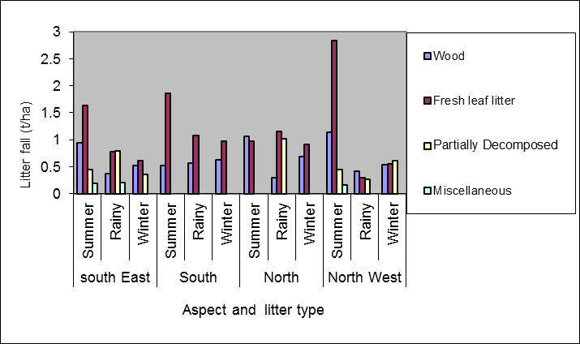
Figure 1. Litter biomass ((t ha⁻¹) among different season at Anriyakot Van Panchayat

The mean annual litter fall in Bhatkholi Van Panchayat forest was 6.08±0.50 t ha⁻¹ (mean of four aspect). The mean litter fall value was higher in the summer season (2.55±0.32 t ha⁻¹) followed by rainy (1.84±0.24 t ha⁻¹) and winter season (1.68±0.26 t ha⁻¹). Across different aspect the litter fall value was higher at north west facing aspect (7.47 t ha⁻¹) while, the minimum litter fall value was recorded in east facing aspect (5.12 t ha⁻¹, Fig. 2).

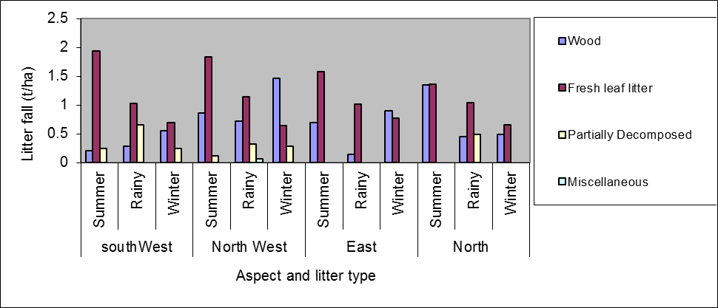
Figure 2. Litter biomass (t ha⁻¹) among different season at Bhatkholi Van Panchayat

The ANOVA test showed significant variation (P<0.05) across aspects, seasons and types of litter. The combined effects of seasons x types of litter, seasons x aspects also varied significantly (P<0.05). However, in case of site x aspects, sites x seasons, sites x litter types and aspects x litter types did not show significant variation.
The total organic soil carbon upto 100 cm soil depth varied from 13.39±0.36 t ha ⁻¹ to 30.08±0.30 t ha ⁻¹ across different soil layers of both Van Panchayats. The soil organic carbon percentage of the Anriyakot Van Panchayat ranged from 1.00±0.29% to 2.73±0.51%, while on Bhatkholi Van Panchayat it ranged from 1.41±0.54% to 2.97±0.46% (Figure 3 and 4).

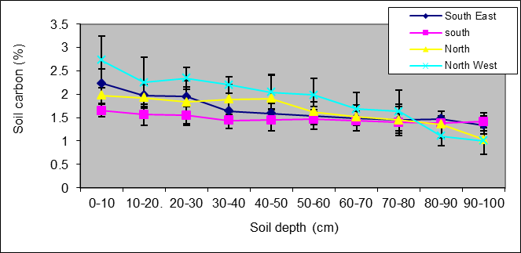
Figure 3 Soil organic carbon percent of Anriyakot Van Panchayat along different soil depth and sites

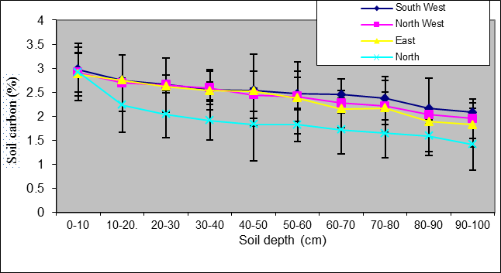
Figure 4 Soil organic carbon percent of Bhatkholi Van Panchayat along different soil depth and sites

The maximum soil organic carbon percent being in top soil layer upto10 cm and thereafter it decreased with increasing soil depth. Contrary to this, the soil bulk density followed a reverse trend and varied from 1.09±0.07 g cc⁻¹ to 1.44±0.22 g cc⁻¹ across different soil depths on Anriyakot Van Panchayat and 0.97±0.06 g cc⁻¹ to 1.36±0.004 g cc⁻¹ on Bhatkholi Van Panchayat. Across different soil depths in Anriyakot Van Panchayat forest the soil moisture percent varied from 7.53±1.06 to 29.72±1.15, soil pH from 5.0 to 6.3, Nitrogen percent ranged from 0.11 to 0.42%, Phosphorus from 0.0006 to 0.0018% and Potassium from 0.0035 to 0.0108%. Similarly in Bhatkholi Van Panchayat forest soil moisture percent varied from 6.52±1.09 to 14.50±1.15%, Soil pH varied from 4.6 to 6.4, Nitrogen percent ranged from 0.09 to 0.16%, Phosphorus from 0.0001 to 0.0007% and Potassium from 0.0026 to 0.0102% (Table 1).
The ANOVA test showed that the soil organic carbon, site, depth varied significantly at P<0.05. The combined effects of site x aspect also showed significant variation at P<0.05. However, the combined effects of site x depth aspect x depth did not varied significantly.

4. Discussions
Mehra et. al., (1985) studied the annual total litter fall in six central Himalayan forests. The value ranged from 2.1 to 3.8 t c ha⁻¹, of which 54-84% was leaf litter, 9-20% wood litter and 6-14% other litter. The forest floor biomass was 12.7-167.7 t ha⁻¹ for temperate, 14.2 t ha⁻¹ for tropical and 3.4 t ha⁻¹ for sal Central Himalayan forests, 5.7 - 7.7 t ha⁻¹ for Central Himalayan Quercus spp. The total annual litter fall in the present study across different aspects ranged between 5.12 to 7.47 t ha⁻¹. The present values of litter falls are within the range reported earlier by Chaturvedi and Singh (1987), Rawat and Singh (1989), Singh (2009), Raikwal (2009) for the central Himalayan pine and oak forests (1.3 to 6.2 t ha⁻¹ and 5.8 to 7.7 t ha⁻¹, respectively) and lower than those for temperate forests. This is due to the fact that the present studied forest was situated in a montane sub-tropical belt where temperatures are never too low to inhibit faunal and microbial activity (Upadhyay and Singh, 1985), but not as high as in the tropics. The system represents an intermediate situation between temperate and tropical conditions (Pandey and Singh, 1981a). In the present study fresh leaf litter accounted maximum amount (4.58 to 5.94 t ha⁻¹). Compared to mean values of 0.7 to 2.2 (arctic), 2.5-3.0 (cool temperate), 3.5-3.6 (warm temperate) and 6.6-6.8 t ha⁻¹ (equatorial forests) as reported by O'Neill and DeAngelis (1980) the annual average wood litter fall was 1.89 t ha⁻¹. This value lies within the range of 0.6-1.9 t ha⁻¹ yr⁻¹ reported for different forest types in Central Himalaya (Chaturvedi and Singh, 1987). Release of nutrients not only depends upon litter composition but also upon soil type, microbial communities and soil properties (Kutsch and Dilly, 1999). Being evergreen, the present forests exhibit year round litter fall. The pattern of litter fall in the present study was comparable to tropical ecosystems of India (Singh et. al., 1999). Maximum amount of litter fall in the present study was recorded during summer season (3.78 t ha⁻¹) and minimum litter fall was recorded in winter season (1.15 t ha⁻¹). The maximum litter falls observed in the summer may be due to warm and drier conditions prevailing during the summer period. The seasonal litter fall pattern was mainly controlled by community characteristics and environmental factors (Kavvadias et al., 2001; Pedersen and Hansen, 1999). The biotic agents, Presbytis entellus, Semnopithecus entellus, Solenarctos thibetanus and Himalayan black beer are active particularly in early summer. They cause severe damage to the twigs and branches due to which the probability of litter fall in the present study increase (Rawat and Singh, 1989). Such a pattern with peak leaf fall in summer has also been observed for other central Himalayan forest (Pandey and Singh, 1981a; Rawat and Singh, 1989; Singh, 2009; Raikwal, 2009).
According to Henery (1977) the nutrient content in the leaf varies considerably among species and even in the same species from different localities. The age, density of the forest which determines the quantity of litter fall and differences in soil nutrient levels may affect the nutrient return (Duvigneaud and Denaeyer, 1970). Different soil nutrients in the present study varied among different aspects and Van Panchayats (Table 1). The return of the major nutrients (C, N, P, and K) through litter fall in this study was similar to that reported by Singh (1968) for Shorea and Tectona forest of central India. The soil organic carbon percentage in the present study ranged from 1.00±0.29% to 2.97±0.46%. Soil organic carbon (SOC) plays a significant role in the global carbon cycle, as soil organic carbon is the largest terrestrial carbon pool. On an average, the percentage of carbon in the top 20cm, relative to that in the first meter soil column, is 50% of that in the first meter (Jobbagy and Jackson, 2000). Generally the surface layer soil is more affected by climate, litter type, while clay content seems to control deep soil carbon. However, in the top layers soil organic carbon was higher and declined with depths. These values are comparable with the values recorded earlier by the above mentioned workers.

Acknowledgements:
I am grateful to Dr. Ashish Tewari, Department of Forestry and Environmental Science for his valuable guidance and encouragement and Dr. Y.S. Rawat, Department of Botany, Kumaun University, Nainital for encouragement and perusal of the manuscript. I am also thankful to G.B. Pant Institute of Himalayan Environment and Development (GBPIHED) Kosi Katarmal, Almora (Uttarakhand) for financial assistance.

Corresponding Author:
Vardan Singh Rawat
Department of Botany
D.S.B. Campus, Kumaun University
Nainital, Uttarakhand 263002, India
E-mail: singhvardan@rediffmail.com

References
- Chaturvedi OP and Singh JS. The structure and function of pine forest in Central Himalaya. I. Dry matter dynamics. Annals of Botany 1987; 60:237-252.
- Christensen T. Wood litter fall in relation to abscission, environmental factors and the decomposition cycle in Danish Oak forest. Oikos 1975; 26: 187-195.
- Duvigneaud E and Denaeyer-DeSmet S. Biological cycling of minerals in temperate deciduous forests. In: Reichle, D. E. (ed.), Analysis of temperate forest ecosystems, pp. 1970; 199-225. Springer-Verlag, New York.
- Henery DG. Foliar nutrient concentrations of some Minnesota forest species. Minn. For. Res. Note, USA. 1977.
- Hubert J and Oyarzun C. Litter production and their relations with meteorological factors in a Pinus radiata D. Don. Forest- Bosque 1983; 5: 1–11.
- Jackson, ML. Soil chemical analysis, Prentice Hall Inc., USA 1958; 498p.
- Jobbagy EG and Jackson RB. The vertical distribution of soil organic carbon and its relation to climate and vegetation. Ecological applications 2000; 10: 423-436.
- Kavvadias VA, Alifragis D. Tsiontsis A, Brofas G. and Stamatelos G. Litter fall, litter accumulation and litter decomposition rates in four forest ecosystems in northern Greece. Forest Ecol. Manag 2001; 144: 113–127.
- Kimins JP. Forest ecology. Mac. Millian. New York 1987; 53 pp.
- Kutsch WL and Dilly O. Ecophysiology of plant and microbial interactions in terrestrial ecosystems. pp. 1999; 74–84 in Beyschlag, W. and Steinlein, T. (eds.) Okophysiologie pflanzlicher Interaktionen. Bielefelder Okologische Beitriage 14.
- Mehra MS, Pathak PC and Singh JS. Nutrient movement in litter fall and precipitation components for Central Himalayan forests. Ann. Bot 1985; 55: 153-170.
- Misra R. Ecology workbook, Oxford and IBH Publishing Co. Calcutta 1968; 224p.
- O'Neill RV and DeAngelis DL. Comparative productivity and biomass relations of forest ecosystems. In Reichle, D. E. (ed.), Dynamic properties of forest ecosystems 1980; pp. 411-449. Cambridge University Press, Malta.
- Pandey U and Singh JS. A quantitative study of the forest floor, litter fall and nutrient return in an oak-conifer forest in Himalaya. I - Composition and dynamics of forest floor. Oecol. Gener 1981a; 2: 49-61.
- Peach K and Tracey MV. Modern methods of plant analysis. Vol. I, Springer-Verlag, Berlin 1956.
- Pedersen LB and Hansen JB. A comparison of litterfall and element fluxes in even aged Norway spruce, sitka spruce and beech stands in Denmark. Forest Ecology and Management. 1999; 114: 55–70.
- Raikwal D. Effect of leaf litter removal on soil nutrients in Central Himalayan banj oak and chir pine forests with relation to carbon sequestration. Ph.D. Thesis submitted to Kumaun University, Nainital. 2009.
- Rawat VS, Tewari A and Rawat YS. Local level Community Forest Management an effective tool in conserving forest biodiversity. Russian Journal of Ecology 2010;. 42 (5):388-394.
- Rawat VS and Chandra J. Tree layer vegetational analysis in temperate forest of Uttarakhand. Nature and Science 2012; 10 (10):167-171.
- Rawat YS and Singh JS. Structure and function of forest in central Himalaya. ΙΙ. dry matter dynamics, R. (1968). Ecology workbook, annals of botany 1988; 62: 413-427.
- Rawat YS and Singh JS. Forest floor biomass, litter fall and nutrient return in central Himalayan oak forests. Vegetatio 1989; 82: 113-125.
- Singh KP. Litter production and nutrient turnover in deciduous forests of Varanasi. In: Misra R, Gopal B (eds) Advances in tropical ecology Part II. Proceedings of symposium on recent advances in tropical ecology. Banaras Hindu University, India 1968; pp 655–665
- Singh KP, Singh PK, Tripathi SK. Litter fall, litter decomposition and nutrient release patterns in four native tree species raised on coal mine spoil at Singrauli. India. Biol. Fertil. Soils 1999; 29, 371–378.
- Singh V. Biomass stock and Carbon Sequestration rates in banj oak (Quercus leucotrichophora, A. Camus.) forest under different disturbance regimes in Central Himalaya. Ph.D. Thesis, Kumaun University, Nainital 2009.
- Upadhyaj VP and Singh, JS. Decomposition of woody branch litter on an altitudinal transect in the Himalaya. Vegetatio 1985; 64: 49-53.
- Upadhyay VP, Singh J and Meentemeyer V. Dynamics and weight loss of leaf litter in central Himalayan forests: abiotic versus leaf litter quality influences. Ecology 1989; 77: 147–161.
- Vitousek PM, Turner DR, Parton WJ and Sanford RL. Litter decomposition on the Mauna Loa environmental matrix, Hawaii: Patterns, mechanisms and Models. Ecology (1994; 75: 418-429.
- Zhou G, Guan L, Wei X, Zhang D, Zhang Q, Yan J, Wen D, Liu J, Liu S, Huang Z, Kong G, Mo J, Yu Q. Litterfall production along successional and altitudinal gradients of subtropical monsoon evergreen broadleaved forests in Guangdong, China. Plant Ecol 2007; 188:77–89.

9/26/2012

