Diatom composition in relation to water quality characteristics in Porto-Novo creek, Lagos.

I. C. Onyema

Department of Marine Sciences, University of Lagos, Akoka, Lagos, Nigeria. iconyema@unilag.edu.ng

Abstract: The diatoms of the Porto-Novo creek in Lagos were investigated in relation to water quality characteristics for 2 years at 4 stations. The effect of tidal sea water inflow from the Lagos habour via the Badagry creek largely controlled the hydrodynamics of the area particularly in the dry season. In the wet season rainfall induced flood water were implicated. Water quality characteristics reflected an environmental gradient from Station 1 (with greater proximity to the sea) through to Station 4 (located further inland). A total of 77 diatom species (34 centric and 43 pennate forms) were recorded. There were clear differences in the diatom assemblages recorded in the fresh and brackish water situations within the creek. The diatom spectrum reflected influence from the salinity gradient linked to tidal influence and rainfall distribution. Comparatively higher species composition were recorded in the dry (46) than in the wet (31) season. Additionally, higher species diversity was recorded for Station 4, through Stations 3, 2 and Station 1. Notable species in the wet season were Aulacoseira granulata, Aulacoseira granulata var. angstissima, Aulacoseira granulata var. curvata, Aulacoseira granulata var. angstissima f. spiralis, Diatoma elongatum, Diatoma hyalinum and Eunotia glacialis whereas the dry season was better represented by Coscinodiscus centralis, Actinoptychus splendens, Amphiprora alata, Bacillaria paxillifer, Synedra crystallina and Pleurosigma angulatum. Water quality changes continuum directly reflected on the diatom composition within the creek.
[I. C. Onyema. Diatom composition in relation to water quality characteristics in Porto-Novo creek, Lagos. Nat Sci 2012; 10(12):100-107]. (ISSN: 1545-0740). http://www.sciencepub.net/nature. 16

Keywords: Diatom, creek, lagoon, Lagos, Porto-Novo, water quality.

Introduction
According to Onyema (2009), creeks and lagoons are common hydrological features in the coastal state of Lagos, Nigeria. These aquatic ecosystems are essentially fresh towards their upper reaches and brackish as they gravitate to the sea. Environmental gradients which fluctuate diurnally and seasonally are known to govern these systems. Creek ecosystems especially in this area are especially rich and diverse (Chukwu, 2002; Emmanuel and Onyema, 2007). They serve as feeding, nursery and breeding grounds for finfish, shellfish and even migratory and shore birds (Nwankwo, 2004; Onyema et al., 2007). Apart from their more ecological significance, these ecological systems serve as sink for the disposal of an array of waste types particularly as environmental regulations are rarely implemented (Ajao et al., 1996; Odiete, 1999; Chukwu, 2011). These stressors therefore impair water quality conditions within and around the creeks and make the immediate region less desirable to diverse ecological diversity, economics and aesthetics.
According to Dassow and Montresor (2011), the phytoplankton are unicellular phototrophs estimated to be responsible for approximately half of global primary production. The phytoplankton form the foundation of the foodweb and provide a nutritional base for zooplankton and subsequently other aquatic invertebrates, shell and finfish. In estuarine ecosystems like creeks, the main photosynthetic algal groups of the phytoplankton include the diatoms, cyanobacteria, dinoflagellates and green algae. Among these the diatoms are usually the dominant assemblage in the marine environment (Nwankwo, 2004; Onyema et al., 2006; Onyema, 2009; Kadiri, 2008).
The Porto-Novo creek is one of the notable creeks in Lagos in terms of drainage of the state and anthropogenic stressors viz-a-viz their effects (Chukwu and Nwankwo, 2004). Few ecological studies have been carried out on the creek and its environs. These includes Egborge (1988), Kusemiju (1988), Chukwu and Nwankwo (2004). Algal related materials in the area include Egborge (1988), Onyema (2008), Onyema (2007), Onyema and Nwankwo (2009), Onyema et al., (2009) and Adesalu et al., (2010). More importantly, algal studies in the Lagos area have indicated high levels of phytoplankton production in terms of biomass by number especially for the Lagos lagoon (Nwankwo, 1988, 1996, 2004).
Presently, there is a dearth of literature on the diatom assemblage regarding the water quality characteristics of the Porto-Novo creek, hence the need to attempt filling the gap in knowledge. The aim of this study was to investigate the water quality characteristics in relation to the spatio-seasonal diatom community of the Porto–Novo creek.

Description of Study Area
The Porto-Novo creek is located in Lagos, South-western Nigeria (Fig. 1). The Porto-Novo creek connects to the Ologe lagoon via the Elete creek to the west and the Lagos habour via the Badagry creek to the east. The creek is a large depository of the invasive water hyacinth (Eicchornia crassipes) and is one of the two conduits by which the weed entered the country in September, 1984 (Onyema, 2009). The Porto-Novo creek is estuarine and receives tidal inflow, which ebbs twice a day from the sea via the Lagos habour and Badagry creek. Fresh water discharges into the creek are associated with the seasonal bi-modal rainfall distribution in the region. Whereas the wet season in the creeks in South-western Nigeria is dominated by fresh water discharges and fresh water/low brackish conditions, the dry season is influenced significantly by tidal incursion from the sea (Nwankwo, 2004).
Others creeks in the immediate region include Elete, Tincan, Badagry, Tomaro, Ikota, Five cowrie and Ijora creeks. Waste discharges from Apapa, Isolo, Festac, Ijegun, Alaba, Abule-oshun, Navy and Satellite towns find their way into the creek enroute to the sea. Pollution from habour and ship associated waste discharges, commercial boat operators, and other related stressors impact the creek ecosystem (Onyema et al., 2006). The Northern shore of the creek’s length also has a myriad of industrial establishments, tank farms for refined petroleum products, embarcaderos, wharfs, jetties, private facilities and houses, whereas the southern part of the creek’s length is covered by a luxuriant growth of mangrove dominated by the Red mangrove (Rhizophora racemosa).
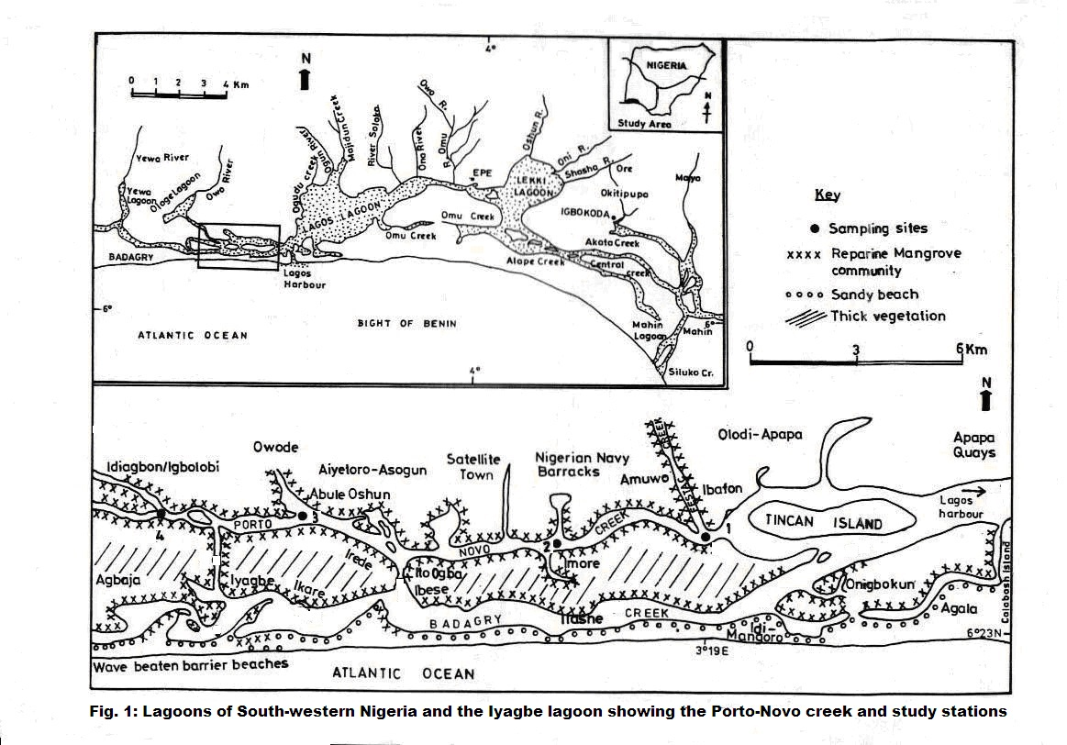
Four stations were chosen and investigated namely: Station 1- Ibafon (Latitude 6º 25¹ .964 N, Longitude 3º 19¹ .244 E), Station 2 - Imore (Latitude 6º 25¹ .755 N, Longitude 3º 19¹ .915 E), Station 3 - Abule-oshun (Latitude 6º 26¹ .134 N, Longitude 3º 13¹ .224 E) and Station 4 - Idiagbon / Igbolobi (Latitude 6º 26¹.214 N, Longitude 3º 11¹ .826 E). Whereas Ibafon is the closest to the Lagos habour, Imore, Abule-osun and Idiagbon / Igbolobi are located further inland respectively. The presence of human activities and settlements reduces in the same order.

Collection of water and plankton samples.
Water samples were collected in plastic bottles with screw caps at monthly intervals for a period of two years at the four stations. All sample collection were done between 9a.m and 12 noon each time. Plankton samples were collected horizontally with hauls made using a standard plankton net of mesh size (55μm) tied unto a motorized boat and towed slowly for 5 minutes at the four stations. Each 5 minutes haul filters approximately 500liters of water. The plankton samples were then transferred immediately to 250ml screw capped plastic containers, labeled and preserved in 4% unbuffered formalin before transfer to the laboratory for analysis.

Analysis of Physico-chemical parameters
Air and surface water temperatures were measured using a mercury thermometer. Rainfall values were obtained from the Nigerian Meteorological Agency, Lagos (NIMET). Transparency was estimated by the secchi disc method, Total Dissolved Solids by Cole Palmer TDS meter, pH by Electrometric / Cole Parmer Testr3, Measurement of Total Suspended Solids, Chloride, Total hardness, Conductivity, Salinity, Alkalinity, Acidity, Dissolved oxygen, Biological oxygen demand, Chemical oxygen demand, Nitrate – nitrogen, Phosphate – phosphorus, Sulphate, Silica, Calcium and Magnesium where measured using methods according to American Public Health Association (1998) for water analysis. Copper, Iron and Zinc were estimated with an Atomic Absorption Spectrophotometer Perkin Elmer 5000 AAS and using Perkin Elmer Application methods (2002).

Diatom Analysis
In the laboratory, plankton samples were concentrated to 10ml. Five drops of the concentrated sample (10ml) were investigated for diatoms only at different magnifications and the average recorded according to Nkwoji et al., (2010).

Results
Table 1 shows the summarized details of the physico-chemical / water quality characteristics and levels within the Porto-Novo creek. Air temperature (26 - 33°C), Surface water temperature (25 - 32°C), Total dissolved solids (197 - 24,320 mg/L), Transparency (23 - 231cm), Sulphate (18.9 - 1140 mg/L), Silica (1.1 – 5.3 mg/L), Dissolved oxygen (4.0 - 5.3 mg/L), Conductivity (263 – 33,605 S/cm), Salinity (0.2 – 34.2 ‰), Chloride (60 - 13,244 mg/L), pH (7.0 - 8.0), Acidity (4.0 – 36.0 mg/L), Alkalinity (15.3 – 330 mg/L), Total hardness (18 – 6,005 mg/L), Calcium (4.9 – 600.1 mg/L) and Magnesium (1.4 – 927.1 mg/L) increased values in the dry than wet season. On the other hand Chemical oxygen demand, Biological oxygen demand, Total suspended solids (24 – 2310 mg/L), Nitrate (3.9 – 48.4 mg/L), Phosphate (0 - 1.7 mg/L) and Iron (0.1 – 0.8 mg/L) recorded higher values in the wet season.

Table 1: Mean, range and standard deviation of water quality parameters and chlorophyll a at the Porto-Novo creek, Lagos.
Parameter / Station | Station 1 | Station 2 | Station 3 | Station 4
Parameter / Station | Range ; mean±SD | Range ; mean±SD | Range ; mean ±SD | Range ; mean±SD
Air Temperature (⁰C) | 26.0 - 32.5; 29.6±1.7 | 26.0-32.0; 29.7±1.5 | 26.0-33.0; 29.9±2.0 | 26.0-33.0; 30.1±2.1
Water Temperature (⁰C) | 25.0 - 32.0; 29.0±2.0 | 26.0-31.5; 29.3±1.6 | 26.0-32.0; 29.3±1.8 | 26.0-32.0; 29.6±1.9
Transparency (cm) | 32.0 - 231.0; 113.7±53.5 | 23.0-176.0; 104.3±46.3 | 32.0-183.0; 91.5±44.4 | 26.0-191.0; 87.8±44.8
Conductivity (uS/cm) | 5880.0-33600.0; 17289.1±9458.9 | 4090.0-33605.0; 15367.5±9536.8 | 508.0-32000.0; 12273.3±10269.6 | 263.0-32900.0; 9984.1±10136.1
Total Dissolved Solids (mg/L) | 3833.0-24320.0; 11371.0±6196.0 | 2399.0-20320.0; 9396.1±5585.1 | 284.0-22000.0; 8253.7±6675.9 | 197.0-21230.0; 6482.5±6631.5
Total Suspended Solids (mg/L) | 30.0-2310.0; 290.2±290.2 | 24.0-833.0; 186.0±210.0 | 26.0-717.0; 180.5±186.9 | 30.0-360.0; 131.2±91.7
Dissolved Oxygen (mg/L) | 4.0-5.0; 4.7±0.2 | 4.1-5.0; 4.6±0.2 | 4.3-5.3; 4.7±0.2 | 4.2-5.3; 4.6±0.2
Biological Oxygen Demand (mg/L) | 3.0-19.0; 7.5±4.3 | 3.0-12.0; 7.3±4.33.4 | 2.0-15.0; 7.1±3.4 | 3.0-14.0; 7.1±3.2
Chemical Oxygen Demand (mg/L) | 10.0-122.0; 34.0±28.3 | 10.0-85.0; 31.8±20.4 | 9.0-72.0; 30.5±16.2 | 10.0-55.0; 26.5±11.9
Total Hardness (mg/L) | 605.2-5625.0; 2631.3±1555.6 | 530.6-6005.0; 2337.7±1514.3 | 260.1-4068.2; 2023.0±1188.6 | 18.0-3760.0; 1672.3±1344.4
pH | 7.0-8.0; 7.4±0.3 | 7.1-7.9; 7.4±0.2 | 7.0-8.0; 7.3±0.3 | 7.0-7.8; 7.4±0.2
Acidity (mg/L) | 4.9-30.0; 12.0±7.1 | 4.0-32.5; 12.2±7.2 | 4.0-34.0; 11.5±6.9 | 4.6-36.0; 11.8±7.4
Alkalinity (mg/L) | 16.8-330.0; 77.3±78.3 | 18.0-260.1; 72.2±70.6 | 15.3-300.0; 71.8±78.9 | 16.8-266.2; 68.7±68.2
Chloride (mg/L) | 1100.0-13244.0; 6348.9±3555.5 | 840.0-11550.0; 3555.5±3435.8 | 80.0-10780.0; 4619.9±3504.6 | 60.0-11165.0; 3788.9±3747.4
Salinity (^{O}/_{OO}) | 3.3-34.2; 18.8±10.0 | 2.5-34.1; 17.1±10.4 | 0.3-29.9; 14.2±10.4 | 0.2-30.4; 11.3±10.2
Iron (mg/L) | 0.1-0.5; 0.2±0.1 | 0.1-0.8; 0.2±0.2 | 0.1-1.0; 0.3±0.2 | 0.1-1.0; 0.3±0.2
Phosphate (mg/L) | 0.0-1.7; 0.2±0.3 | 0.0-1.6; 0.2±0.3 | 0.0-0.8; 0.2±0.2 | 0.0-1.3; 0.3±0.3
Nitrate (mg/L) | 4.1-48.4; 12.5±12.3 | 3.9-36.0; 12.1±7.8 | 4.0-43.2; 9.8±7.7 | 4.1-42.0; 10.7±7.4
Sulphate (mg/L) | 40.8-820.3; 276.4±196.4 | 33.6-1080.0; 310.3±257.1 | 28.4-1120.0; 309.2±302.8 | 18.9-1140.0; 280.7±301.1
Silica (mg/L) | 1.0-5.3; 2.5±0.9 | 1.2-4.9; 2.7±0.8 | 1.1-5.0; 2.7±1.0 | 1.2-5.0; 2.7±0.9
Magnesium (mg/L) | 80.4-927.1; 430.2±265.3 | 87.8-820.3; 408.3±250.8 | 30.9-701.1; 325.2±231.1 | 1.4-648.0; 262.3±241.2
Calcium (mg/L) | 65.6-520.1; 223.7±127.0 | 38.2-400.1; 190.5±112.7 | 22.5-600.1; 181.6±126.0 | 4.9-400.2; 159.4±123.5

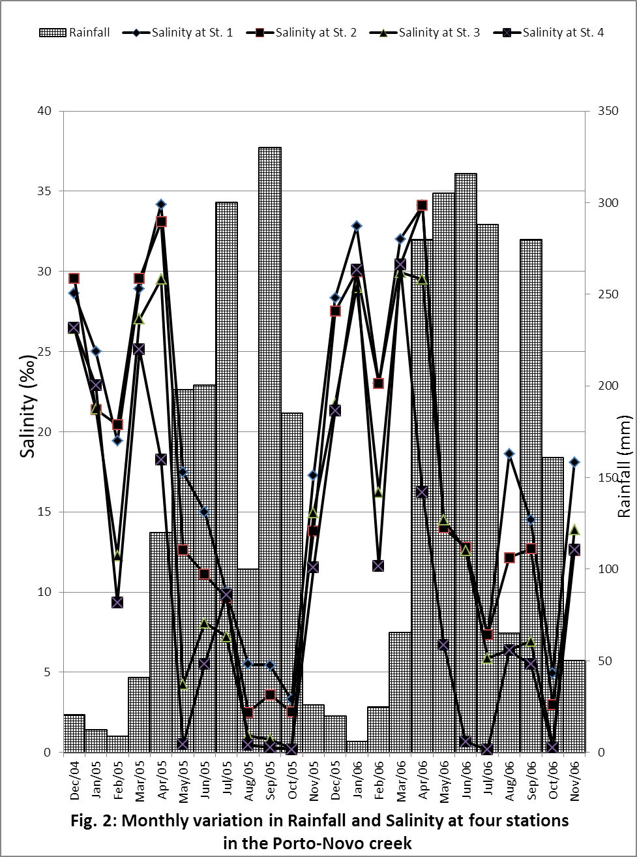

A few species were common annually in both seasons (Aulacoseira granulata var. angstissima, Aulacoseira granulata Ehrenberg, Cyclotella striata, Fragillaria construens, Nitzschia obtusa, Pleurosigma angulatum and Synedra crystallina). The genera Odontella (6 species), Coscinodiscus (6 species), Aulacoseira (5 species) (centric diatoms), Navicula (5 species) and Nitzschia (5 species) (pennate diatoms) recorded more taxa. Table 3 shows the seasonal occurrence of diatoms species per station in terms of diversity and number with regards to the four stations in the Porto-Novo creek.
Diatom species composition increased from Station 4 through to Station 3, 2 and Station 1. Station 4 recorded a higher number of species.

Table 3: Spatio-seasonal occurrence of diatom species in the Porto-Novo creek
PHYTOPLANKTON TAXA | Wet Season |  |  |  | Dry Season
 | St. 1 | St. 2 | St. 3 | St. 4 | St. 1 | St. 2 | St. 3 | St. 4
Class – Bacillariophyceae
Order I – Centrales
Actinoptychus splendens Ehrenberg |  |  |  |  | * | * | *
Amphiprora alata Ehrenberg |  |  |  |  | ** | * | *
Aulacoseira granulata Ehrenberg (Ralfs) | ** | ** | ** | *** |  |  |  | *
Aulacoseira granulata var. angstissima Muller | ** | *** | *** | *** |  |  | * | **
Aulacoseira granulata var. angstissima f. spiralis Muller |  |  | * | ***
Aulacoseira granulata var. curvata Simon |  | * | ** | ***
Aulacoseira islandica (O.F. Muller) Simonson | * | *
Campylodiscus clypeus (Ehr.) Kutzing |  |  |  |  | *
Chaetoceros convolutus Castracane |  |  |  |  | ** | **
Chaetoceros decipens Cleve |  |  |  |  | *
Coscinodiscus centralis Ehrenberg |  |  |  |  | ** | ** | * | *
Coscinodiscus eccentrius Ehrenberg |  |  |  |  | * | *
Coscinodiscus lineatus Ehrenberg |  |  |  |  | *
Coscinodiscus marginatus Ehrenberg |  |  |  |  | *
Coscinodiscus oculus-iridis Ehrenberg |  |  |  |  | *
Coscinodiscus radiatus Ehrenberg |  |  |  |  | **
Cyclotella menighiniana Kutzing |  | * |  | * | * | * | * | **
Cyclotella striata (Kutzing) Grunow |  |  | * | ** |  | * | * | **
Ditylum brightwelli (T. West) Grunow |  |  |  |  | *
Hemidiscus cuneiformis Wallich |  |  |  |  | *
Leptocylindricus danicus Cleve |  |  |  |  | *
Melosira moniliformis Agardh |  |  |  |  | * | *
Melosira nummuloides Agardh |  |  |  |  | * | **
Odontella aurita (Lyngbe) Brebisson |  |  |  |  | *
Odontella biddulphiana Bayer |  |  |  |  | *
Odontella laevis Ehrenberg |  |  |  |  | *
Odontella mobilensis Bailey |  |  |  |  | *
Odontella regia (Schultze) Ostenfeld |  |  |  |  | *
Odontella sinensis Greville |  |  |  |  | *
Paralia sulcata Ehrenberg |  |  |  |  | *
Rhizosolenia styliformis Brightwell |  |  |  |  | *
Skeletonema coastasum Cleve |  |  |  |  | *
Terpsinoe musica (Ehr.) Hustedt |  |  |  |  | *
Triceratium favus Ehrenberg |  |  |  |  | *
Order II – Pennales
Achnanthes longipes Agardh |  |  |  |  | * | *
Amphora ovalis Kutzing |  |  |  |  | * | *
Bacillaria paxillifer (O.F. Muller) Hendey |  |  |  |  | ** | ** | **
Cymbella affinis Kutzing |  |  |  |  |  | *
Diatoma elongatum (Lyngb.) Agardh |  | * | * | *
Diatoma hyalinum Kutzing |  | * | * | *
Eunotia monodon Ehrenberg |  |  | * | **
Eunotia glacialis Mesiter | * |  | * | **
Fragillaria construens Ehrenberg |  | * | * | ** |  | * | * | **
Fragillaria islandica Grunner |  | * |  | *
Fragillaria oceanica Cleve |  | * | * |  | * | *
Gomphonema parvulum Grunner |  | * |  | *
Gyrosigma balticum (Ehr.) Rabenhorst |  |  |  |  | ** | *
Gyrosigma spenceri W. Smith |  |  |  |  | * | *
Gyrosigma hippocampus Ehrenberg |  |  |  |  | *
Gyrosigma littorale (Wm. Sm) Griffith & Henfrey |  |  |  |  | *
Gyrosigma scalproides (Rabh) Cleve |  |  |  |  | *
Hantzschia amphioxys (Ehr.) Rbenhorst |  |  |  |  | *
Navicula cryptocephala (Kutz) Hustedt | * |  |  | *
Navicula cuspidata Kutzing |  |  |  | *
Navicula ergadensis Ralfs |  |  |  | *
Navicula mutica Kutzing |  |  |  | *
Navicula rhynchocephala Kutzing |  |  |  | *
Nitzschia closterium Wm. Smith |  |  |  |  | *
Nitzschia obtusa Wm. Smith | * | * |  |  | *
Nitzschia palea (Kutzing) Wm. Smith | ** |  | * | *
Nitzschia sigmoidea (Witesch) W. Smith | * | *
Nitzschia sigma Grunow | * |  |  |  | *
Parabelius delognei E.J. Cox |  |  |  |  | * | *
Pleurosigma angulatum (Quekett) Wm Smith | * |  |  |  | ** | *
Pleurosigma elongatum Wm. Smith |  |  |  |  | *
Pinnularia major (Kutzing) Rabenh |  |  | * | *
Pinnularia gibba Ehrenberg | * |  | *
Surirella ovata Kutzing |  |  | * | *
Surirella splendida Wm. Smith |  |  | * | *
Surirella striatula Turpin |  |  | *
Synedra ulna (Nitzsch) Ehrenberg | * | * | * | *
Synedra ulna var. biceps Ehrenberg |  |  | *
Synedra crystallina (Ag.) Kutzing | ** | * |  |  | * | * | * | *
Synedra sp. |  |  |  |  | *
Thalasiothrix fraunfeldii Cleve et Grunow |  |  |  |  | *
Thalasionema longissima Cleve & Grunow |  |  |  |  | *
Thalassionema nitzschioides Cleve & Grunow |  |  |  |  | *
Key: * Present (5 – 20 individuals per ml)
** Present (25 – 100 individuals per ml)
*** Present (101 – 10,000 individuals per ml)

Discussion
The characteristics of water quality parameters shows clearly that the Porto-Novo creek experiences an environmental gradients likened to a tropical estuarine aquatic environments from year to year (Nwankwo, 2004; Onyema, 2009; Kjerfve, 1994; Kirk and Lauder, 2000). Additionally, the water quality characteristics of the Porto-Novo creek reflected changes that were closely related to the distributive pattern of rainfall for the region. According to Brown and Kusemiju (2002), rainfall pattern in the tropics creates the dry and wet season experienced in West Africa. Similarly for the Iyagbe lagoon, Onyema and Nwankwo (2009) has also reported the effect of a continuum of water quality variations linked to rainfall events in the wet season. In the dry season, tidal seawater incursion from the Lagos habour is prominent.
In the Porto-Novo creek, diatom species composition was generally higher during the dry season than the wet season. Specifically, blooms of the centric diatom Aulacoseira granulata and Aulacosiera granulata var. angustissima were reported in the wet season at most stations. In the wet season Salinity, Conductivity, Total Dissoved Solids, Chloride and Cation estimates were considerably lower.
According to Onyema and Nwankwo (2006), the occurrence of pennate forms during the wet season in the Ijora creek suggests their dislodgement from the substratum probably during high water discharge. The tidal inflow accounted for the appearance of some marine forms in the plankton at the same period. A similar scenario played out for the Porto-Novo creek. The reports of pennate diatoms such as Suriella ovata, S. striatula, S. splendida, Cymbella affinis and Amphora ovalis during the survey may be slight reflections of possible stirring of the lagoon phytobenthic community into the plankton. Similar findings have been documented by Onyema and Nwankwo (2006) and Onyema (2007). According to Onyema et. al. (2003) frequently occurring pennate diatoms in the plankton samples from the Lagos lagoon was a likely reflection of the mixing of the shallow lagoon and phytobenthic community by tides and flood waters at different seasons. The presence of known marine forms (Amphora alata, Asterionella japonica, Ditylum brightwellii, Melosira moniliformis, M. nummuloides, Triceratium favus and the various species of Coscinodiscus, Odontella, Chaetoceros, Rhizosolenia, Leptocylindricus, Thalassosira and Thalassionema further confirms the incursion of seawater into the creek (Nwankwo, 1996; 2004, Kadiri, 2007, Onyema 2010, 2011). These species are commonly found in sea conditions within the coastal waters of Nigeria.
A notable species for this study were Actinoptychus splendens,encountered throughout this study by Kadiri (1999) in the report on the phytoplankton in coastal waters of Nigeria. This species had a good distribution in the Iyagbe lagoon (Onyema, 2008, 2011) Kadiri (1999) is of the view that Actinoptychus splendens, Aulacoseira granulate and Aulacoseira granulata var . angustisima f. curvata were important taxa for the coastal waters of Nigeria. Furthermore, there were differences in the assemblages that existed between the diatom spectrum of the seaward part of the creek and those further inland. Whereas a typical marine flora existed for most months in the stations closer to the harbour (sea) especially in the dry season a low brackish / freshwater community existed in areas more inland from the harbour especially in the wet season.
The presence of sea species such as Chaetoceros, Biddulphia, Thalassionema and Rhizosolenia species probably point to their source of recruitment. These taxa are known marine forms in the zone (Nwankwo and Onyema, 2004). According to Nwankwo (1986), salinity and floodwater conditions are known to regulate the algal composition and abundance in the Lagos lagoon. A similar situation exists for the Porto-Novo creek.
It is possible that the flushing of diatom algal forms towards the sea during the rains by flood waters, could also account for the reduced phytoplankton diversity in the wet season. Similarly, reduced phytoplankton diversity in the wet season may be linked to the low water clarity which reduces the amount of light available to the planktonic algal component for photosynthesis. Onyema and Nwankwo (2006) have also reported similar inferences for the Ijora creek. In the Porto-Novo creek, there existed environmental gradients from the habour to areas in the lagoon further inland and the phytoplankton assemblages and distribution reflected these trends.
From this study it is clear that the effect of meteorological forcings cannot be dispensed with as controlling factors in the availability of nutrients and flood situations that significantly determine diatom diversity and succession. Furthermore, Onyema et al. (2003, 2007) and Onyema (2011) are of the view that the diluting and enriching effects of floodwaters, inflow of seawater and the existence of environmental gradients govern the biota distribution of the Porto Novo biota Creek.

References
- Adesalu, T., Bagbe, M. and Keyede, D. (2010). Hydrochemistry and phytoplankton composition of two tidal creeks in South-western Nigeria. Rev. Biol. Trop. (Int. J. Trop. Biol.). 58(3): 827 – 840.
- Ajao, E.A. (1996). Review of the state of pollution of the Lagos lagoon. NIOMR Tech. Paper No. 106. 19pp.
- Bettrons, D.A.S. and Castrejon, E.S. (1999). Structure of benthic diatom assemblages from a mangrove environment in a Mexican subtropical lagoon. Biotropica. 31(1): 48 – 70.
- Brown, C.A. and Kusemiju, K. (2002). The abundance and distribution of Capitella capitata Fabricus in the Western Part of the Lagos lagoon, Nigeria. Journal of Scientific Research and Development. 7: 69 – 76.
- Chukwu, L.O. (2002). Ecological effects of human induced stressors on coastal ecosystems in southwestern Nigeria. PIM 2002 Conference: The ocean in the New economy. Held in Cape Town, South Africa between 8 – 14, December, 2002. 61 – 70.
- Chukwu, L. O. and Nwankwo, D. I. (2004). The impact of land based pollution on the hydro-chemistry and macrobenthic community of a tropical West African Creek. The Ekologia. 2 (1-2): 1 – 9.
- Chukwu, L. O. (2011). Ecophysiology of marine life: A science or management tool?. Inaugural lecture Series. University of Lagos, Nigeria. 62pp.
- Dassow, P. V. and Montresor, M. (2011). Unveiling the mysteries of phytoplankton life cycles: patterns and opputunities behind complexity. Journal of Plankton Research. 33 (1): 3 – 12.
- Egborge, A.M.B. (1988). Water hyacinth – biological museum. Proceedings of the international on water Hyacinth, Lagos 7 – 12 August, 1988. 52 – 70.
- Emmanuel, B.E. and Onyema, I.C. (2007). The plankton and fishes of a tropical creek in south-western Nigeria. Turkish Journal of Fisheries and Aquatic Sciences. 7: 105 – 114.
- Hendey, N.I. (1958). Marine diatoms from West African Ports. Journal of Royal Microscopic Society. 77: 28-88.
- Hendey, N.I. (1964). An introductory account of the smaller algae of British coastal waters. Part 5. Bacillariophyceae (diatoms) London. N.M.S.O. 317pp.
- Kadiri, M.O. (1993). Seasonal changes in the phytoplankton biomass of a shallow Tropical reservoir. Nigerian Journal of Botany. 6: 167 – 175.
- Kadiri, M.O. (1999). Phytoplankton distribution in some coastal waters of Nigeria. Nigerian Journal of Botany. 12 (1): 51 – 62.
- Kadiri, M.O. (2008). They bop, they sink: Nature’s energy charger and aquatic environment purifier. Inaugural lecture Series 108. University of Benin, Nigeria. 97pp.
- Kusemiju, K. (1988). Strategies for effective management of water hyacinth in the creeks and lagoons of south-western Nigeria. Proceedings of the international on water Hyayacinth, Lagos
7 – 12 August, 1988. 39 – 45.
- Nkwoji, L. A., Onyema, I.C. and Igbo, J. K. (2010). Wet season spatial occurrence of phytoplankton and zooplankton in Lagos lagoon, Nigeria. Science World Journal. 5 (2): 7 – 14.
- Onyema, I.C. (2008). A checklist of phytoplankton species of the Iyagbe lagoon, Lagos. Journal of Fisheries and Aquatic Sciences. 3(3): 167 – 175.
- Onyema, I.C. (2009). Pollution and the ecology of coastal waters of Nigeria: Dolps and Bolps Investment Limited, Lagos, Nigeria. 216pp.
- Onyema, I.C. (2010). Phytoplankton diversity and succession in the Iyagbe lagoon, Lagos. European Journal of Scientific Research. 43 (1): 61 – 74.
- Onyema, I.C. (2011). The Water Chemistry and Periphytic Algae at a Cage culture Site in a Tropical Open Lagoon in Lagos. actaSATECH. 4(1): 53 - 63.
20. Onyema, I.C. (2010). Phytoplankton diversity and succession in the Iyagbe lagoon, Lagos. European Journal of Scientific Research. 43 (1): 61 – 74.
- Onyema, I.C. (2011). The Water Chemistry and Periphytic Algae at a Cage culture Site in a Tropical Open Lagoon in Lagos. actaSATECH. 4(1): 53 - 63.
- Onyema, I.C. and Nwankwo, D.I. (2006). The epipelic assemblage of a polluted estuarine creek in Lagos, Nigeria. Pollution Research. 25 (3): 459 – 468.
- Onyema, I.C. and Emmanuel, B.E. (2009). Fishing impairment and Spirogyra africanum (Fruda) in a freshwater lagoon. Estonian Journal of Ecology. 58 (1): 1 – 7.
- Onyema, I.C. and Nwankwo, D.I. (2009). Chlorophyll a dynamics and environmental factors in a tropical estuarine lagoon. Academia Arena. 1(1) : 18 – 30.
- Onyema, I.C., Nwankwo, D.I. and Oduleye, T. (2006). Diatoms and dinoflagellates of an estuarine creek in Lagos. Journal of Scientific Research Development. 10: 73 – 82.
- Onyema, I.C., Otudeko, O.G. and Nwankwo, D.I. (2003). The distribution and composition of plankton around a sewage disposal site at Iddo, Nigeria. Journal of Scientific Research Development.7: 11-24.
- Onyema, 1.C., Okpara, C.U., Ogbebor, C.I. Otudeko, O. and Nwankwo, D.I. (2007). Comparative studies of the water chemistry characteristics and temporal plankton variations at two polluted sites along the Lagos lagoon, Nigeria. Ecology, Environment and Conservation. 13(1): 1 – 12.
- Nwankwo, D.I. (1986). Phytoplankton of a sewage disposal site in Lagos lagoon, Nigeria 1. The algae. Nigerian Journal of Biological Sciences. 1: 89-91.
- Nwankwo, D. I. (1988). A preliminary Check-List of Planktonic Algae of Lagos Lagoon. Nigerian Journal of Basic and Applied Sciences. 2(1): 73 – 85.
- Nwankwo, D.I. (1996). Phytoplankton diversity and succession in Lagos lagoon, Nigeria. Archiv Fur Hydrobiologie. 135(4): 529-542.
Nwankwo, D.I. (2004). A Practical Guide to the study of algae. JAS Publishers, Lagos. Nigeria.
84pp.
- Nwankwo, D.I. and Onyema, I.C. (2004). A check-list of planktonic algae off Lagos coast. Journal of Scientific Research Development. 9:75 -82.
- Odiete, W.O. (1999). Environmental Physiology of Animals and Pollution. Diversified Resources Ltd., Lagos. 261pp.
- Olaniyan, C.I.O. (1975). An introduction to West African Ecology. Heinemann Education Books Ltd., London. 170pp.
- Patrick, R. and Reimer, C.W. (1966). The diatoms of the United States exclusive of Alaska and Hawaii (Vol. 1). Monogr. Acad. Nat. Sci. Philadelphia. 686pp.
- Patrick, R. and Reimer, C.W. (1975). The diatoms of the United States exclusive of Alaska and Hawaii (Vol. 2, part 1). Monogr. Acad. Nat. Sci. Philadelphia. 213pp.
- Rosowski, J.R. (2003). Photosynthetic Euglenoids. In: Freshwater Algae of North America. Ecology and Classification, Wehr, J.D. and Sheath, R.G. (Eds). Academic Press, New York. pp 383 – 422.
- Siver, P.A. (2003). Synurophyte algae. In: Freshwater Algae of North America. Ecology and Classification. Wehr, J.D. and Sheath, R.G. (Eds). Academic Press, New York. pp 523 - 558.
- Vanlandingham, S.L. (1982). Guide to the identification and environmental requirements and pollution tolerance of freshwater blue-green algae (cyanophyta). U.S. Environmental Protection Agency, EPA – 60.
- Wimpenny, R.S. (1966). The plankton of the sea. Faber and Faber Limited, London. 426pp.
- Whitford, L.A. and Schmacher, G.H. (1973). A manual of freshwater algae. Sparks press Raeigh. 324pp. Witkowski, A., Lange – Bertalot, H. and Metzeltin, D. (2000). Diatom flora of Marine Coasts 1. (219 plates). A.R.G.Gantner Verlag K.

10/10/2012

