Performance of Centre Pivot irrigation Systems in River Nile State

Osama Osman Ali

Department of Agricultural Engineering, Alneelain University, Khartoum, Sudan
osamaosamaosamash@yahoo.com

Abstract: This study was carried out during the period December 2007 – July 2008, to evaluate water distribution under centre pivot irrigation systems in three projects in River Nile State and one project in Khartoum State (Sudan). Water distribution coefficients used in the evaluation were: Christiansen's coefficient of uniformity (CU%), distribution uniformity (DU%) and scheduling coefficient (Sc%). Values for the coefficient of uniformity ranged from 78 to 85%, for distribution uniformity the values ranged from 68 to 78, and the values for scheduling coefficient ranged from 1.3 to 1.47. Measured values were below or at the lower limits reported in reviewed research works.
[Osama Osman Ali. Performance of Centre Pivot irrigation Systems in River Nile State. Nat Sci 2012;10(12):184-187]. (ISSN: 1545-0740). http://www.sciencepub.net/nature. 27

Keywords: centre pivot irrigation, uniformity coefficient, distribution uniformity, scheduling coefficient

1. Introduction
The global population is expected to increase to about 30% by the year 2030, and as a result demand for food will increase (FAO, 2000). In many areas of the world the amount and timing of rainfall are not adequate to meet the moisture requirement of crops necessary to meet the needs of man for food and fiber (Michael, 1978). It is generally accepted that irrigation is one of the cultural practices that stabilizes yields and improves productivity in any agricultural development (Teeluck, 1997).
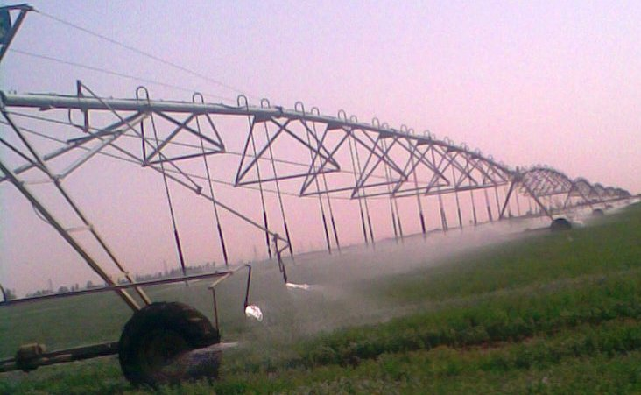
Irrigation is defined as the artificial application of water to the soil for the purpose of crop production. Irrigation systems are the mechanisms that allow water to be diverted from its original place to be applied to agricultural fields for the purpose of supplementing water for growing crops and enhancing crop yields (Rogers and Wilson, 2000). The major irrigation method practiced in the Sudan is surface irrigation. The demand for labor in this method is very high if compared to that for modern systems such as sprinkler and drip irrigation methods. They are of high efficiency, low water losses, and low labor demands (Ali, 2000).
Centre Pivot Irrigation systems, according to Makki et. al (2011), were recently introduced in limited areas in the Sudan. A Centre Pivot system (Fig. 1) consists of a single sprinkler lateral supported by series of towers. The towers are self – propelled so that the lateral of the system rotates around a pivot point in the center of the irrigated area. Time for the system to revolve through a complete circle could range from a few hours to many days. The longer the lateral, the faster the end of the lateral travels and the larger the area irrigated by the end section. Thus the water application rate must increase with the distance from the pivot to deliver ensure even application (Abdelrahman, 2006). Presently there is little information on the performance of the system in the projects adopting it. Owners are using few general guidelines for the operation and management of the system. Factors like efficiency, application rates and uniformity of distribution are not yet properly investigated or managed (Ali, 2008).
This study was intended to evaluate centre pivot irrigation systems, mainly in the Nile State of Sudan with regard to the following:
1. Calculation of uniformity coefficient(CU)
2. Calculation of distribution uniformity (DU)
3. Calculation of scheduling coefficient (SC)

Fig.1.Centre pivot irrigation system(Tala,Sudan)

2. Material and Methods
The study was carried out during the period December 2007 to July 2008. Three sites within the Nile State were chosen to evaluate the performance of the central pivot irrigation. The general texture of the soil in the State was sandy clay loam. A fourth site of a heavy clay soil from Khartoum area, used by the Arab Company for Agric. Production and processing, was added to the study. The crop grown there was Alfalfa. Sites in the Nile State were:
1. Ras Al Wadi Alakhdar Project
The Project lies approximately about 17 km north of Atbra town. The main crop was Alfalfa.
2. El Bashair Jordanian Company
The project was approximately 29.5 km south El Damar town. The main crop was onions.
3. Tala Company for Investment project in Shendi area the main crop was Alfalfa.

Measurement of System performance
Uniformity of distribution, uniformity coefficient and scheduling coefficient were determined using spray cans (Fig 2) as described by Michael (1978). The cans were placed at equal distances in one straight line from the pivot point towards the outward direction. The centre pivot system was allowed to pass over the cans and volumetric measurements with a graduated cylinder were made to measure the water caught in each can. To obtain the water depth in a can, the collected volume in that can was divided by the cross sectional area of the can.

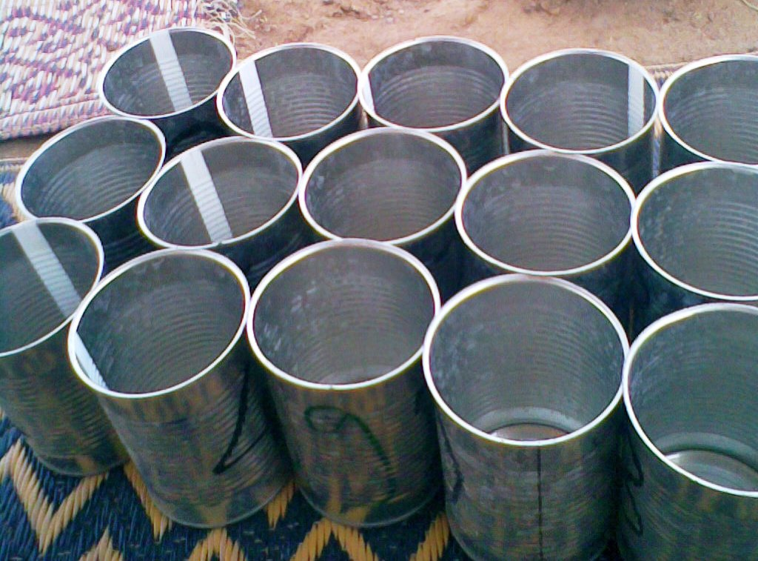
Fig.2.Spray cans for water collection

Coefficient of uniformity
A measurable index of the degree of uniformity from any sprinkler operation under a given condition has been developed and is known as coefficient of uniformity. The measure most commonly used by the industry is Christiansen coefficient of uniformity expressed as percentage. The coefficient as stated by Christiansen (1942) can be written as follows:

$$\text{Cu}=\text{100}\text{.}\left[1−\frac{\sum{x}}{\text{mn}}\right]$$

Where:
Cu = Coefficient of uniformity (percent).
x = deviation of individual observation from the mean (mm).
n = number of observations.
m = mean value of observation (mm).

Distribution Uniformity (Du)
The uniformity of distribution was computed by dividing the mean low quarter caught in the cans by the average depth caught in all cans (Ali, 2002).

$$\text{Du}\text{\%}=\frac{\text{mean low quarter caught in the cans }}{\text{average depth caught in all the cans}}$$
Scheduling coefficient (Sc %)
Scheduling coefficient will be determined to find the critical area in the water applicant pattern. This is the area receiving the least amount of water, which is divided by the average amount of water applied through the irrigation area (Solomon, 1988).

$\text{Sc}\text{\%}=\frac{1}{\text{Du}}$ .

Where:
Sc = scheduling coefficient.
Du = uniformity of distribution (decimal).

3. Results
The intention behind the work was to study the performance of the centre pivot irrigation system in the Nile State as it was practically applied there without intervention in the setting of the studied systems or how they were operated. The approach was considered to give an evaluation based on actual application more than the potentialities of the design.
Table 1 shows data collected at Tala Company. Data from the other sites was collected and tabulated in a similar manner. Calculated values for uniformity coefficient, uniformity of distribution, and scheduling coefficient for the four sites are shown in Table (2).

Table.1. Depth of water caught in the cans (mm) in Tala Company
Distance from pivot (m) | Run 1 | Run 2 | Run 3 | Distance from pivot (m) | Run 1 | Run 2 | Run 3
10 | 18.18 | 17.45 | 25.45 | 160 | 13.10 | 17.45 | 17.45
20 | 17.45 | 16.48 | 15.51 | 170 | 19.87 | 19.63 | 12.85
30 | 18.18 | 13.81 | 11.39 | 180 | 25.69 | 21.10 | 11.88
40 | 18.66 | 14.30 | 17.69 | 190 | 13.57 | 19.87 | 18.18
50 | 16.00 | 15.00 | 14.30 | 200 | 15.03 | 14.54 | 13.81
60 | 17.45 | 16.72 | 17.21 | 210 | 18.90 | 13.57 | 16.48
70 | 16.00 | 15.00 | 15.51 | 220 | 15.51 | 13.10 | 12.85
80 | 19.87 | 15.03 | 18.18 | 230 | 20.60 | 19.39 | 18.42
90 | 16.240 | 17.94 | 14.3 | 240 | 17.69 | 19.39 | 16.48
100 | 15.75 | 15.51 | 10.42 | 250 | 13.81 | 12.84 | 12.85
110 | 10.66 | 17.45 | 16.72 | 260 | 18.18 | 13.10 | 15.03
120 | 16.24 | 26.90 | 24.96 | 270 | 19.15 | 17.45 | 17.45
130 | 18.90 | 18.18 | 26.66 | 280 | 16.24 | 14.54 | 12.85
140 | 17.94 | 16.48 | 24.00 | 290 | 18.90 | 12.60 | 21.57
150 | 20.60 | 16.72 | 16.24 | 300 | 25.45 | 16.24 | 16.48

Table. 2 Performance coefficients for Center Pivot Systems
Company | Coefficient of Uniformity (%) | Distribution Uniformity (%) | Scheduling Coefficient
Arab Company for Agricultural Production | 79 | 71 | 1.41
El Bashir Jordanian Company | 79 | 78 | 1.47
Tala Company | 85 | 78 | 1.43
Ras Al Wadi Alakhdar Project | 78 | 68 | 1.47

4. Discussions
A) Uniformity coefficient
Water application uniformity is an important performance criterion for the design and evaluation of centre pivot irrigation systems. However, the water application depth of a centre pivot irrigation system is not usually uniform across a field as it depends on the sprinkler package, field topography, movement of the machine, and many other factors. In addition to that wind distortion of sprinkler distribution patterns is a major dynamic factor (Evans, 2001).The uniformity coefficient for the systems of the study was found to be 85% in Tala 79% in El Bashair Project and Arab company, and 78% in Ras El Wadi Al Akadar Project. Except for Tala Project, those results were lower than a range of 81 to 96% obtained by Duke (1992), and that of 81 to 90% obtained by Saeed (2001) for a centre pivot system under variable wind speed. However, according to Michael (1978), a satisfactory uniformity coefficient should be 85% or more. Therefore, only the system in Tala was marginally acceptable.
B) Uniformity of distribution
The uniformity of distribution was found to be 78% in El Bashair and Tala project, 71% in Arab company, 68% in Ras El Wadi Project. Solomon (1988), Keller and Bliensner (1990) and Jorge, Pereira, (2002) and Rain Baird (2008) found that the uniformity of distribution ranged from 75 to 85%. Ali (2002) and El Badawi (2001) found uniformity of distribution of about 77%. Therefore, uniformity of distribution was around the lower limits of the reported range in El Bashir and Tala projects, and below the range in the Arab Company and Ras El Wadi Project.
C) Scheduling coefficient
This test allows to provide a time adjustment factor to ensure that the dry or under watered areas receive adequate depth of application. Centre pivot systems usually use more water than other sprinkler methods because frequent irrigations have more evaporation losses from the plant canopy and soil as well as wind drifts which occur with every application rather than once every 7 to 10 days. Irrigations should be scheduled based on soil water levels to avoid undesirable levels of crop stress. This is compounded by the light frequent water applications, shallow rooting and cultural operations such as fertigation, spraying of chemicals and tillage programs (Evans, 2001).
The scheduling coefficient (SC) was found to be 1.30 1.41, 1.43, and 1.47 in Tala, Arab company, Al Bashair,and Ras Al Wadi , respectively.
SC was used because it depends on Du determination. Connellan (2002) and Abdelrahaman (2006), mentioned that an efficient irrigation system should aim to achieve an SC of less than 1.3. Values obtained at the four projects were above this limit.

5. Conclusion
The Central pivot irrigation systems used in Nile State were generally performing at or below the lower limits reported by researchers in this field. Further work is needed to determine the main contributing factors to this level of performance.

Acknowledgements:
I would like to acknowledge the department of Agricultural Engineering-Alneelain University, Khartoum, Sudan for supported this research.

Corresponding Author:
Dr. Osama Osman Ali
Department of Agricultural Engineering
Khartoum-Sudan
E-mail: osamaosamaosamash@yahoo.com

References
1. Abdelrahman, A.I. (2006). Designing and developing an automated sprinkler irrigation system. Ph.D. Thesis, Faculty of Agriculture, University of Khartoum.
2. Ahmed, E.E.(2005). A computer model for irrigation water indenting and optimization of optimization of minor canal operation. PhD. Thesis Faculty of Agricultural Sceince, Sudan University for Science and Technology.
3. Ali, O.O. (2002). Evaluation of the performance of centre pivot irrigation system. M.Sc. Thesis, University of Khartoum, Sudan.
4. Ali, O.O. (2008).A Simulation model for centre pivot irrigation system design and optimization of operation. Ph.D. Thesis, University of Khartoum, Sudan.
5. Connellan, G. (2002). Efficient irrigations: A reference manual for turf and landscape. Burnley College, University of Melbourne.
6. El Badawi, A.M. (2001). Centre pivot performance at Omdoum: A case study. M.Sc. Thesis, Faculty of Agriculture, University of Khartoum.
7. Elhassan, Z.A (2008). Assembling and Performance evaluation of centre pivot irrigation system, New Hamdab irrigation project, Northern State, Sudan. Msc. Thesis, Faculty of Agriculture, University of Khartoum.
8. Evans, R.G. (2001). Centre pivot irrigation. Supervisory Agricultural Engineer and Research Leader, Agricultural Systems Research Unit, North Plains Agricultural Research Laboratory, USDN-Agricultural Research Service, 1500 North Central Ave. Sidney, MT 59270. E-mail: revans@Sidney.ars.usda.gov.
9. FAO (2000). Yearbook. Production Vol. 55. Food and Agriculture Organization of the United.Nation, Rome.
10. Kristiansan, J.E. (1942). Irrigation by sprinkler. Agricultural experiment station, University of California, Berkely.
11. Jorge, J. and Pereira, L.S. (2002). Simulation and Evaluation of Set Sprinkler System with AVASPER Scientific paper published at www.google.com. Jorge Resu-N21.Pdf
12. Keller, J and Bliesner, R.D. (1990). Sprinkler and trickle irrigation. Book. Van Nostrand Reinhold. New York. 115 fifth Avenue. New York.
13. Makki, K.M, O.O.Ali and Mohamed, A.E (2011). Evaluation of uniformity coefficient and water distribution efficiency of some impact sprinklers in shambat, Sudan. U. of K.J. Agric.sci. 19(2), 161-177,2011
14. Michael, A.M. (1978). Irrigation: Theory and Practice. Vikas Publishing House. PVT.LTD. New Delhi, India. www.google.com
15. Rain Baird (2008). Distribution Uniformity. Rain Baird Distribution Uniformity for Sprinkler Irrigation. USA. www. rainbaird.com
16. Rogers, D and Wilson, B.B.(2000). Kansa irrigation system and cropping trends. Kansas State Board of Agriculture, Topeka.
17. Saeed, M.M. (2001). Probable impacts of the Hamdab Dam. M.Sc (Agric.) Thesis, University of Khartoum, Sudan.
18. Solomon, K.H. (1988). Irrigation systems and water application efficiencies. California State University, Fresno, California, 93740-0018.
19. Teeluck, M. (1997). Development of the centre pivot irrigation system in Mauritius. Food and Agriculture Research Council, Reduit, Mauritius.

9/6/2012

