Fatty acid composition and Lipid content in Muscle Tissue of Ghost crab (Ocypode rotundata ) in Bushehr Coastal Zone in Persian Gulf

Keivandokht Samiee¹, Abdolhossein Rustaiyan², Soheila Shahbazi³

¹Faculty of Biological Sciences, Shahid Beheshti University, Tehran, Iran
²Department of Chemistry, Science & Research branch, Islamic Azad University, P.O. Box 14515-775,Tehran, Iran
³Faculty of Marine Sciences and Technology, North Tehran branch, Islamic Azad University, Tehran, Iran
k.samiee@yahoo.com

Abstract:This study was aimed to gain knowledge on fatty acid composition and lipid content in muscle tissues of Ocypode rotundata in the Bushehr Coastal Zone, Iran in Aug 2012 using the method of Blight & Dyer (1959).The compounds were determined by Gas Chromatography-Mass Spectrometry (GC- MS). The components detected in both male and female species, including saturated fatty acids (SFA) Palmitic acid and Stearic acid, monounsaturated fatty acid (MUFA) Oleic acid, polyunsaturated fatty acids (PUFA) alpha- Linoleic acid, two methyl esters of fatty acids including Octadecanoic acid, methyl ester and Hexadecanoic acid, methyl ester, Cholesterol (Cholest-5-en-3-ol (3β) and Alkane including Hexadecane, Heptadecane and Octadecane. The dominant fatty acid identified in both sexes was Omega-3 alpha- Linoleic acid (ALA).
[Keivandokht Samiee, Abdolhossein Rustaiyan, Soheila Shahbazi. Fatty acid composition and Lipid content in Muscle Tissue of Ghost crab (Ocypode rotundata ) in Bushehr Coastal Zone in Persian Gulf. NatSci2012;10(12):205-208]. (ISSN: 1545-0740). http://www.sciencepub.net/nature. 31

Key words: Fatty acid composition, Lipid content, muscle tissue, Ocypode rotundata

1. Introduction
Ghost crabs called sand crabs are crabs of the genus Ocypode, common shore crabs in all ocean, from the tropical and subtropical coasts, in the American Atlantic, through the Mediterranean and Red Sea, to the American Pacific and Indo-Pacific region. Characteristics of the genus include one claw being larger than the other, but this difference is not as marked as in male fiddler crabs (Grave et al., 2009) Ghost crabs dominate sandy shores in tropical and subtropical areas, replacing the sand hoppers that predominate in cooler areas (karleskint et al., 2009). They breathe through gills, which they periodically wet with seawater (Figure 1).
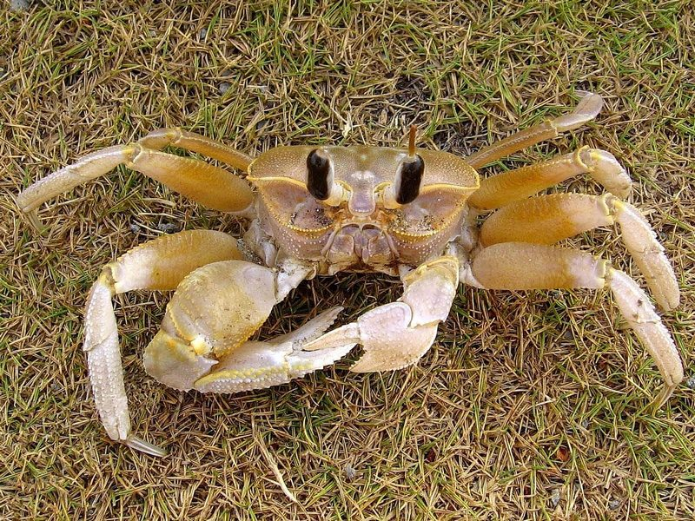

Figure 1. Ocypode rotundata

The scientific name Ocypode is derived from the Greek roots ocy- ("fast") and podos- ("foot") (Davey, 2010). There are 26 species in the genus Ocypode (Davie & Turkay, 2012). The Persian Gulf is located in Western Asia between Iran and the Arabian Peninsula. Persian Gulf has hosted some of the most magnificent marine fauna and flora (Ampf & Sadrinasab, 2006).
A fatty acid is a carboxylic acid with a long aliphatic tail (chain), which is either saturated or unsaturated (monounsaturated or polyunsaturated) (Thomas, 2002).
Essential fatty acids (EFAs) are fatty acids that humans and other animals must ingest because the body requires them for good health (Harris et al., 2004) but cannot synthesize those (Reiffel et al., 2006). Essential fatty acids play a part in many biological processes (Anneken et al., 2006). Only two EFAs are known for humans: alpha-linolenic acid (an omega-3 fatty acid) and linoleic acid (an omega-6 fatty acid). Some of the food sources of ω-3 and ω-6 fatty acids are fish ,shellfish, crab, flaxseed (linseed), hemp oil, soya oil, canola (rapeseed) oil, chia seeds, pumpkin seeds, sunflower seeds, leafy vegetables, and walnuts (Cornils & Lappe, 2006). The human body can convert α-linolenic acid (ALA) to ω-3 fatty acids eicosapentaenoic acid (EPA) and subsequently docosahexaenoic acid (DHA) (Rees et al., 2006). These omega-3 fatty acids (EPA& DHA) have been shown to prevent cancer (Hardman, 2002), and cardiovascular disease (Simopoulos, 2002), as well as being therapeutic for arthritis (Kremer, 2000), autoimmune disease (Harbige and Fischer, 2001), inflammatory effects (Grimm et al., 2002) and depression (Puri et al., 2001). DHA is also important during pregnancy for infant and brain development (Bousquet et al., 2008) and reduces the incidence of premature birth (Allen and Harris, 2002).
EPA lowers blood cholesterol (Pal et al., 2002) and reduces blood clotting, allowing better blood circulation (Heller et al., 2002).
The main objective of the present study was to identify of the lipid content especially fatty acids in muscle tissue of Ocypode rotundata as one the source of omega-3 fatty acids in Bushehr Coastal Zone in Persian Gulf.

2. Material and methods
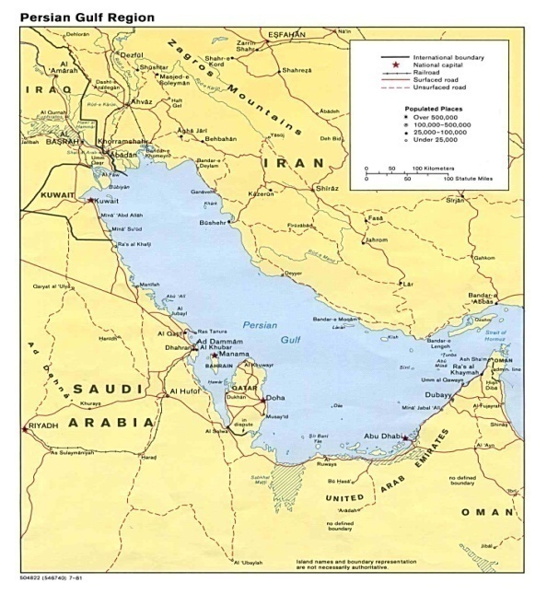
In this study, 30 Ocypode rotundata samples were obtained of Bushehr Coastal Zone in Persian Gulf (Figure 2).
Figure 2. Map of study area and location of sampling station in the Persian Gulf

Initially the muscle tissue was weighed separately and mixed into a soft uniform mixture.
Mixtures of chloroform and methanol were added as the lipid extract (Blight & Dyer, 1959).This solvent system allows for extraction of both polar and non polar compounds. The lower chloroform layer includes the lipids and the top methanol-water layer generally contains the non- polar components. The lipid in the chloroform layer is isolated using a separating funnel and then the solvent removed using a rotary evaporator under vacuum, at temperature of 40 ° C. The weight of the lipid was determined.
The lipid extract obtained was injected into chromatograph equipment with a mass spectra detector (GC- MS).components were identified by comparison of the retention time and mass spectra of the unknowns with those of authentic samples and also comparative analysis of kovats index & using references of Eight peak. It should be noted that the extraction and identification was performed separately for both sexes.

3. Results
This study investigated on the lipid content and fatty acid composition in muscle tissue of Ocypode rotundata.
The results are reported in Tables 1 and 2. Chloroform phase is discussed in this research because the fat content of the muscle tissue is extracted with chloroform (Blight & Dyer, 1959). The components identified in GC-MS analysis of the samples from female species is shown the below table.

Table 1.The compound identified in the chloroform phase of muscle tissue from the female Ocypode rotundata in Bushehr Coastal Zone in Persian Gulf
Compound | MF | KI | % of total
Fatty acid
Saturated fatty acid
Palmitic acid  (Hexadecanoic acid) | C₁₆H₃₂O₂ | 1839 | 11.32
Stearic acid  (Octadecanoic Acid) | C₁₈H₃₆O₂ | 1996 | 8.67
Mono-unsaturated fatty acid  Oleic acid  (9Z Octaecenoic Acid) | C₁₈H₃₄O₂ | 2103 | 22.87
Poly- unsaturated fatty acid  Alpha-Linoleic acid | C₁₈H₃₂O₂ | 1988 | 40.74
Ester
Palmitic acid –methylester  (Hexadecanoic acid ,  methyl ester) | C₁₇H₃₄O₂ | 1836 | 3.8
Stearic acid-methylester  ( Octadecanoic acid, methyl ester) | C₁₉H₃₈O₂ | 1989 | 2.7
Esterols
Cholesterol  (Cholesta-5en-3-ol (3.β) | C₂₇H₄₆O₂ | 1990 | 2.4
Alkane
Hexadecane | C₁₆H₃₄ | 1991 | 2.7
Heptadecane | C₁₇H₃₆ | 1991 | 2.5
Octadecane | C₁₈H₃₈ | 1991 | 2.3
MF: Molecular Formula KI: Kovats Index
%: Percent of the sample mass
Table 2 shows the components identified in GC-MS analysis of the samples from male species

Ocypode rotundata in Bushehr Coastal Zone in
Persian Gulf
MF: Molecular Formula KI: Kovats Index
%: Percent of the sample mass
Results of this research indicate that compounds identified are common between the two sexes such as saturated fatty acids Palmitic acid (11.32% in female and male 11.22%) and Stearic acid (8.67% in female and male 8.65%), monounsaturated fatty acid Oleic acid (22.87% in female and male 20.82%), polyunsaturated fattyacid alpha-linoleic acid (40.74% in female and male 40.71%). Two esters of fatty acid consist Palmitic acid –methylester (3.8% in female and male 3.7%), and Stearic acid-methylester (2.7% in female and male 2.6%), Cholesterol (2.4 % in female and male 5.11%) and Alkane including Hexadecane (2.7% in female and male 2.6%), Heptadecane (2.5 % in female and male 2.4%) and Octadecane (2.3% in female and male 2.2 %).

Table 2.The compound identified in the chloroform
Phase of muscle tissue from the male
Compound | MF | KI | % of total
Fatty acid
Saturated fatty acid
Palmitic acid  (Hexadecanoic acid) | C₁₆H₃₂O₂ | 1839 | 11.22
Stearic acid  (Octadecanoic Acid) | C₁₈H₃₆O₂ | 1996 | 8.65
Mono-unsaturated fatty acid  Oleic acid  (9Z Octaecenoic Acid) | C₁₈H₃₄O₂ | 2103 | 20.82
Poly- unsaturated fatty acid  Alpha-Linoleic acid | C₁₈H₃₂O₂ | 1988 | 40.71
Ester
Palmitic acid –methylester  (Hexadecanoic acid ,  methyl ester) | C₁₇H₃₄O₂ | 1836 | 3.7
Stearic acid-methylester  ( Octadecanoic acid, methyl ester) | C₁₉H₃₈O₂ | 1989 | 2.6
Esterols
Cholesterol  (Cholesta-5en-3-ol (3.β) | C₂₇H₄₆O₂ | 1990 | 5.11
Alkane
Hexadecane | C₁₆H₃₄ | 1991 | 2.6
Heptadecane | C₁₇H₃₆ | 1991 | 2.4
Octadecane | C₁₈H₃₈ | 1991 | 2.2

4. Discussion
In conclusion, these results indicate that the dominant fatty acid was polyunsaturated fatty acid alpha-linoleic acid (40.71-40.74%). Alpha-linolenic acid, an n−3 fatty acid (Burdge &Calder, 2005), is a member of the group of essential fatty acids (EFAs) (Landmark et al., 2006), so called because they cannot be produced within the body and must be acquired through diet (Baylin et al., 2003). Research shows that omega-3 fatty acids reduce inflammation (Gil, 2002) and may help lower risk of chronic diseases (Lord & Bralley, 2002) such as heart disease (Reiffel & McDonald, 2006)) ,cancer (Simon et al., 2009), and arthritis(Calo et al., 2005). Omega-3 fatty acids are highly concentrated in the brain and appear to be important for cognitive (brain memory and performance) and behavioral function (Bousquet et al., 2008).
Comparison of this study results and similar studies by Sullivan et al (2001) on Australian blue swimming crab (Portunus pelagicus), Naczk et al (2004) on green crab (Carcinus maenas), Chen et al (2007) on Chinese mitten crab (Eriocheir sinensis) and Samiee et al(2012) on blue swimming crab (Portunus pelagicus) indicated that the dominant fatty acid was polyunsaturated fatty acid alpha-linoleic acid, so the effectiveness using of seafood such as crabs in health and possibly in preventing cardiovascular disease (including myocardial infarction and sudden cardiac death) (chattipakorn et al.,2009) acknowledges. In the present study, the next dominant fatty acid was Oleic acid (20.82-22.87%) that is classified as a monounsaturated omega-9 fatty acid. The dominant use of oleic acid is as its sodium salt, which a major component of many kinds of soap. Oleic acid may hinder the progression of adrenoleukodystrophy (ALD), a fatal disease that affects the brain and adrenal glands (Stirban et al., 2010). Oleic acid may be responsible for the hypotensive (blood pressure reducing) effects of olive oil (Teres et al., 2008). Adverse effects also have been documented, however, since both oleic and monounsaturated fatty acid levels in the membranes of red blood cells have been associated with increased risk of breast cancer (Simon et al., 2009). Analysis of the lipids on Australian blue swimming crab (Sullivan et al., 2001), blue crab (Callinectea sapidus) (Celik et al., 2004), green crab (Carcinus maenas) (Naczk et al.,2004), Chinese mitten crab (Eriocheir sinensis) (Chen et al., 2007) Podopthalmus vigil crab( Sudhakar et al., 2011) and Samiee et al (2012) on blue swimming crab (Portunus pelagicus) indicated that the dominant monounsaturated fatty acid was oleic acid, so using of crabs such as Ocypode rotundata in nutrition and processing industry is approved .In the present study results showed that amount of alkane were identified in both male and female species .Since crabs are omnivorous absorb more environmental pollution in the tidal areas of the seabed and are not able to digest the oil compounds.

References
- Allen K. G. and M. A. Harris. (2001), the role of n-3 fatty acids in gestation and parturition. Exp. Biol. Med. (Maywood) 226(6):498-506.
- Ampf,J.K,Sadrinasab,M. (2006),The circulation of the Persian Gulf.Journal Ocean, 2:27-41.
- Anneken D,Sabine B,Christoph R,Fieg G,Steinberne U, Westfechte A. (2006), Fatty Acids in Ullmanns Encyclopedia of Industrial chemistry, Wiley-VCH, Weinheim.
- Baylin, A, Kabagambe, EK and Ascherio, A.(2003), Adiopose tissue α- linolenic acid and nonfatal acute myocardial infarction in Costa Rica. Circulation, 107:1586-91.
- Blight, E.G., and Dyer, W.J. (1959), A rapid method of total lipid extraction and purification. Can. J. Biochem. Physiol. 37, 911-917.
- Bousquet,M., Saint-Pierre,M., Julien, C., Salem, N., Cicchetti,F and Calon.F,(2008), Beneficial effects of dietary omega-3 polyunsaturated fatty acid on toxin-induced neuronal degeneration in an animal model of Parkinson’s disease. The FASEB Journal, 22: 1213-1225.
- Burdge, GC; Calder, PC (2005), "Conversion of alpha-linolenic acid to longer-chain polyunsaturated fatty acids in human adults". Reproduction, nutrition, development 45 (5): 581–97. DOI:10.1051/rnd:2005047.
- Calo L,Bianconi L,Colivicchi F,et al . (2005), N-3 fatty acids for the prevention of atrial fibrilliation after coronary artery bypass surgery.J AM Coll Cardio. 45:1723-8.
- Chattipakorn N,Settakorn J et al. (2009), Cardiac mortality is associated with low levels of Omega-3 and Omega-6 fatty acids in the heart of cadavers with a history of coronary heart disease.Nutr Res. 29(10);696-704.
- Chen,D.W., Zhang, M and Shrestha, S. (2007), Compositional characteristics and nutritional quality of Chinesemittencrab (Eriocheir sinensis). Food Chem., 103: 1343-1349.
- Cornils,B and Lappe,P, (2006), "Dicarboxylic Acids, Aliphatic" in Ullmann's Encyclopedia of Industrial Chemistry, Wiley-VCH, Weinheim. doi:10.1002/14356007.a08-523.
- Davey,K., (2010), "Ocypode cordimana (Family Ocypodidae)". SpeciesBank. Department of the Environment, Water, Heritage and the Arts.http://www.environment.gov.au/cgibin/species-bank/sbank-treatment.plid=77373.Retrieved November 5, (2010).
- Davie,P & Türkay,M (2012), "Ocypode Weber, 1795". World Register of Marine Species. http://www.marinespecies.org/aphia.php=taxdetails&id=106970. Retrieved November 6, (2012).
- Gil A. (2002), polyunsaturated fatty acids and inflammatory disease. Biomed.Pharmacother., 56: 388-396.
- Grave,S.D., Pentcheff,N.D., Ahyong,S.T., et al. (2009), "A classification of living and fossil genera of decapod crustaceans" (PDF). Raffles Bulletin of Zoology Suppl. 21: 1–109.
- Grimm H., K. Mayer, P. Mayser, and E. Eigenbrodt. (2002). Regulatory potential of n-3 fatty acids in immunological and inflammatory processes. Br. J. Nutr. 87 Suppl 1:S59:67.
- H arbige L. S. and Fischer B. A. (2001),. Dietary fatty acid modulation of mucosally-induced tolerogenic immune responses. Proc. Nutr. Soc. 60(4): 449-456.
- H ardman W. E. (2002), Omega-3 fatty acids to augment cancer therapy. J. Nutr. 132 (11 Suppl):3508S-3512S.
- Harris JI, Hibbeln JR, Mackey RH, Muldoon MF. (2004), Statin treatment alters serum n-3 and n-6 fatty acids in hypercholesterolemic patients. Prostaglandins, Leukotrienes and Essential Fatty Acids 71, (4):263-269.
- Heller AR, S. Fischer, T. Rossel, S. Geiger, G. Siegert, M. Ragaller, T. Zimmermann, and T. Koch. (2002), Impact of n-3 fatty acid supplemented parenteral nutrition on haemostasis patterns after major abdominal surgery. Br J Nutr 87 (Suppl 1):S95-10.
- Karleskint,G., Turner,R.K & Small,J (2009), "Intertidal communities". Introduction to Marine Biology (3rd ed.). Cengage Learning. pp. 356–411.
- Kremer J. M. (2000), N-3 fatty acid supplements in rheumatoid arthritis. Am. J. Clin. Nutr. 71(1 Suppl): 349S-352.
- Landmark, K., Alm, CS.,(2006),"[Alpha-linolenic acid, cardiovascular disease and sudden death"] (in Norwegian).Tidsskrift for Den Norske Lægeforening 126 (21): 2792-4.1.
- Lord, RS and Bralley, JA., (2002), Polyunsaturated Fatty Acid-Induced Antioxidant Insufficiency, Integrative Medicine Vol. 1, No. 1 Dec 2002/Jan 2003.
- Mozaffarian D, Katan MB, Ascherio A, Stampfer MJ, Willett WC, (2006), "Trans Fatty Acids and Cardiovascular Disease". New England Journal of Medicine 354 (15): 1601–1613.
- Naczk M, Williams J, et al.(2004), Compositional characteristics of green crab(Carcinus maenas).Food chem. 2004,88:429-434.
- Reiffel ,JA., McDonald , A (August 2006), "Antiarrhythmic effects of omega-3 fatty acids". The American Journal of Cardiology 98 (4A): 50i–60i. doi:10.1016/j.amjcard.2005.12.027. PMID 16919517.
- Rees, D., Miles, EA., Banerjee, T., Wells, SJ., Roynette, CE, et al., (2006), Dose-related effects of eicosapentaenoic acid on innate immune function in healthy humans: a comparision of young and older men. AM J Clin Nutr, 83:331-42.
- Samiee K,Rustaiyan A,Kabirian Far SH. (2012), Extraction and Identification of Natural Compounds in Muscle Tissue of Blue Swimming Crab (Portunus pelagicus) in Persian Gulf Coasts . J. American science 8(8.)
- Simon, JA; Chen, YH; Bent, S. (2009), "The relation of alpha-linolenic acid to the risk of prostate cancer". American Journal of Clinical Nutrition 89 (5): 1558S–1564S.
- Simopoulos A. P. (2002), the importance of the ratio of omega-6/omega-3 essential fatty acids. Biomed Pharmacother. 56(8):365-79.
- Stirban A,Nandrean S et al.(2010),Effect of n-3 fatty acids on macro-and microvascular function in subjects with type 2 diabets mellitus.AM J Clin Nutr 2874.
- Sullivan, M., X.Q. Su and D. Li. (2001), Distribution on n-3 polyunsaturated fatty acids in different edible portions of the blue swimmer crab (Portunus pelagicus). J. Clin. Nutr., 10: S42-S42.
- Teres S,Barcelo-Coblijn G,Benet M,Alvarez R,Bressani R et al.(2008),Oleic acid content is responsible for the reduction in blood pressure induced by olive oil. PNAS, 105(37);13811-6.
- Thomas, A, (2002), "Ullmann's Encyclopedia of Industrial Chemistry". Ullmann's Encyclopedia of Industrial Chemistry. Weinheim: Wiley-VCH.DOI:10.1002/14356007.a10-173. ISBN 3-527-30673-0.

11/10/2012

