Molecular characterization of humic acids isolated from farmyard manure and vermicompost used under a long-term fertilizer experiment on mulberry (Morus alba L.)

R. Kar¹, B. B. Bindroo¹, M. K. Ghosh¹, S. K. Majumder² and P. C. Bose¹

¹Central Sericultural Research and Training Institute, Berhampore, West Bengal, India
²National Silkworm Seed Organization, Basic Seed Farm,Dhubulia, West Bengal, India
ranjitkr4@gmail.com

Abstract: A long-term fertilizer experiment on mulberry (Morus alba L.) has been continuing for more than five years at Central Sericultural Research and Training Institute, Berhampore (West Bengal), India with different combinations of organic as well as inorganic sources of nutrients. The natural humic acids were extracted and fractioned from the farmyard manure (FYM) and the vermicompost (VC) used under the said experiment. Both the acid samples were characterized in terms of important properties, namely, charge characteristics through pH-potentiometry, ‘aliphatic-aromatic balance’ based coiling properties through visible spectrophotometry as well as structural characteristics through infrared (IR) spectroscopy. Attempts have also been made to evaluate the performance of mulberry in terms of productivity and nutrients mobilization after completion of 25 crop cycles under the said experimentation in relation to different soil attributes induced by humic acid mediated organics.
[R. Kar, B. B. Bindroo, M. K. Ghosh, S. K. Majumder and P. C. Bose. Molecular characterization of humic acids isolated from farmyard manure and vermicompost used under a long-term fertilizer experiment on mulberry (Morus alba L.). Nat Sci 2012;10(12):220-226]. (ISSN: 1545-0740). http://www.sciencepub.net/nature. 33

Key words: Farm yard manure, Humic acid, Infrared spectroscopy, Long-term fertilization, Mulberry, Potentiometry, Vermicompost, Visible spectrophotometry.

1. Introduction:
Organic manures obtained from decayed or decaying biomaterial have long been recognized as potential source of humic materials (Fortun et al., 1988; McCarthy, 2001). Humic acid (HA), the principal component of humic substances, is having the basic structure of macromolecular configuration and is believed to be an aromatic ring of di- or tri-hydroxy phenyl type bridged together by –O-, -CH₂-, -NH- including aliphatic groups as well as containing carboxylic and quinone groups (Sanyal, 2002). Polyprotic nature of HA molecule signifies its importance towards soil conditioning through its association with soil particles and nutrient-transport in soil due to its ion-binding capacity (Kar et al., 1995) as well. On the other hand, it acts as accumulator phase of various organic and inorganic materials and sometimes forms very stable complexes to prevent soil contamination (Ghosh et al., 2004; Sanyal and Dhillon, 2006; Banik and Sanyal, 2006a). Besides, coiling-decoiling behaviour of the HA molecule (Mandal and Sanyal, 1984; Kar and Sanyal, 1989) further regulates the extent of availability of different functional groups affecting the above-mentioned proceedings.
In field experiments, there are reasons to believe that manure/ fertilizer treatments once applied on a crop get stabilized only after a few years and responses of the crop to the treatments become stable and reliable thereafter (Kumar et al., 2006). In this context, organic manures play the principal role due to its decomposition and subsequent stabilization of the decomposed products, i.e., humic substances in association with the soil separates. Long-term field experiments, therefore, form one of the most useful tools for technical advances and are indispensable for framing empirical rule for precise monitoring of changes of soil fertility and crop productivity.
In view of the above, molecular characterization of HA isolated from the organic manures deserves attention in order to elucidate the nature of the effect of the latter on soil properties and, in turn, on mulberry (Morus alba L.) growth under continuous cultivation.

2. Materials and Methods:
The HA samples were extracted and fractioned from FYM and VC used under long-term fertilizer experiment (LTFE) on mulberry (Morus alba L.) at Central Sericultural Research and Training Institute, Berhampore (West Bengal), India. The general properties of FYM and VC have been furnished in the Table 1. The organic manure samples were treated with standard Na₂CO₃ followed by acidifying the supernatant solution by dilute HCL (Banik and Sanyal, 2006b) to precipitate HAs and were denoted as follows:
HA_{f}: Humic acid extracted and fractioned from FYM
HA_{v}: Humic acid extracted and fractioned from VC

Characterization of HA
The fractioned HA samples from organic manures were characterized in terms of pH-potentiometry, visible spectrophotometry and IR spectroscopy.
The potentiometric study was conducted by titrating equal volumes of suspension of HAs against standard NaOH (Kar and Sanyal, 1988). The carboxylic and phenolic-OH group contents were determined from the acidity equivalent of the first and final inflexion points (Datta et al. 2001) of the differential titration curves (Fig. I and Fig. II).
The amount of excess fresh titrating alkali and extra time required to attain stable higher pH, once the titration is over, and the titrated HA samples were allowed to stand for several hours, were determined by restoring the pH of the titrated samples to pH 10.0 with fresh addition of standard alkali as mentioned earlier as the pH fell by more than 0.05 units.
For visible spectrophotometric characterization, the optical densities at 445 nm (E₄) and 665 nm (E₆) of the dilute solutions of given HA samples (Na-form) were noted at two different values of pH, namely 5.0 and 9.0 (Mukhopadhyay and Sanyal, 2004).
For IR spectroscopy, thoroughly dried HA samples were dispersed in KBr and the spectra were recorded by using a Perkin-Elmer model of IR spectroscope fitted with NaCl prism.
LTFE on mulberry under HA mediated organic manures
A LTFE on mulberry (Morus alba L.) has completed 25 crop cycles (5 cycles/ year) on a sandy clay loam soil (Typic ustochrept) at the experimental farm of the Institute as mentioned above (24⁰4/ N – 88⁰9/ E) and the same is confined to the Bengal - Assam plain, hot sub-humid eco-geographic region with alluvium derived soils. The treatments considered for the present study are as follows:
T₁ = N₀P₀K₀, T₂ = 100% of recommended NPK, T₃ = T₂ + 100% of recommended FYM with a HA supplying potency of 17.6 kg ha⁻¹ year⁻¹, T₄ = T₂ + 100% of recommended VC with a HA supplying potency of 13.6 kg ha⁻¹ year⁻¹.
The treatments were applied on the mulberry variety, S-1635, planted at two different spacing, viz., 0.60 m x 0.60 m and 0.90 m x 0.90 m constituting a ‘factorial RBD’ design and the recommended package of practices for irrigated condition has been employing for the maintenance of the plantation. While recommended dose of NPK corresponds to 67 kg N, 36 kg P₂O₅ and 22 kg K₂O ha⁻¹ crop⁻¹, recommended dose of FYM and VC corresponds to 20 and 10 mt ha⁻¹ year⁻¹, respectively. Data pertaining to leaf yield as well as nutrient (NPK) uptake of mulberry and relevant soil properties under different treatments after 25 crop cycles were registered to examine the impact of HA mediated organic manures. N uptake by H₂SO₄ digested and PK uptake by tri-acid (HNO₃: HClO₄: H₂SO₄ :: 10: 4: 1) digested mulberry biomass (leaf and shoot) was estimated by employing the standard procedures of Jackson (1973) while different soil attributes were determined by following the respective standard procedure (Black, 1965; Subbiah and Asija, 1956).

3. Results and Discussion:

Characterization of HA

Potentiometry
The carboxylic and the phenolic-OH group contents of both the HA samples were computed from the first and final inflexion points of the corresponding differential pH-potentiometric titration curves (Fig. I and Fig. II) and have been furnished in Table 2. The acidity due to contribution of phenolic group was, in general, more than the corresponding carboxylic group in each of the samples and the same is in conformity with earlier reports (Kar and Sanyal, 1988; Banik and Sanyal, 2006a). In terms of charge density, computed from the cumulative contribution of both the groups under discussion (Kar et al., 1995), HA_{f} appeared superior to HA_{v} and the finding might be correlated with the advanced stage of humification of FYM reckoning lesser values of C:N, C:P as well as C:K in comparison to VC (Table 1). This, in turn, governs the ‘adsorptive capacity’ of HA molecules, which enables them to combine with various organic and inorganic soil constituents to exert their influence on formation, conditioning as well as fertility aspects of soil (Kar et al., 1995).
Table 2 also registers the pH values corresponding to the first and final inflexion points of the pH-potentiometric titration curves and a pH difference, namely Δ pH = pH_{3/4} – pH_{1/4}, where, pH_{3/4} and pH_{1/4} refer to pH values corresponding to the three fourths and one fourth of the pH at the final inflexion point. Δ pH values for both the HA samples were greater than 0.954 signifying polyprotic nature of the same (Kar et al., 1995).
Further, the amount of excess fresh alkali needed to attain the stable higher pH of 10.0 (when HA molecules were expected to have attained the completely unfolded shape) evidently depends upon the amount of remainder H⁺ ions which are not accessible to alkali. The ‘steric hindrance’, associated with the particular conformation of the HA molecule, due to their coiled nature, governs the phenomenon. Again, the extra time required to attain the same depends on the ease of decoiling of HA molecule, which is inversely related to the intra molecular hydrogen bonding. Formation of such bonds is often interrupted by alkyl group of the component unit of HA molecule, which determines the flexibility of the molecule. This may possibly account for the findings that HA_{v} required relatively longer time (259 h), consuming greater amount of fresh excess alkali (5.90 mL) than HA_{f} (Table 3) to attain the stable higher pH. Indeed, this may be due to highly polycondensed and polymerized nature of the former, which thereby exerts a strong hydrophobic hydration effect on the ‘local’ water structure (Sanyal, 2002). Moreover, such coil formation may involve the participation of carboxylic and phenolic-OH groups in the intramolecular hydrogen bonding and hence much excess acidity gets locked up inside the coils. The interaction of different hydrophilic groups of enzymes and microbial exudates present in the intestine of earthworm (Edwards and Lofty, 1977), the agent of vermicomposting, with that of similar groups of precursor of HA molecule may possibly initiate such network of hydrogen bonding. Thus, it may be inferred that HA_{v} is more coiled but less flexible than HA_{f}. This also corroborates lesser availability of charge sites in HA_{v} molecule than HA_{f} as discussed earlier.

Visible spectrophotometry
The visible spectrophotometric analysis data have been recorded in Table 4. The values of E₄/E₆ ratio of the given HA samples provided an index of the aliphatic-aromatic balance in the polymers. The aromatic moiety, being the most hydrophobic part tends to hide itself in the innermost core of the coil leaving the aliphatic part at the outer periphery (Sanyal, 2002). This results in a greater absorbance by the aliphatic part (i.e., absorbance at 445 nm, E₄) than that by the corresponding aromatic part (i.e., absorbance at 665 nm, E₆). The E₄/E₆ values of HA samples being greater than unity (Table 4) support the above contention.
Further, the E₄/E₆ values may be taken as an ‘index of coiling’ of the HA molecules (Kar et al., 1995) owing to the fact the additional alkali rendered the molecules relatively unfolded under ‘thermodynamic compulsion’ (Sanyal, 1984). This leads to the destruction of tertiary structure (i.e., three dimensional configuration) of the HA molecules following the release of the hidden aromatic parts, which thereby leads to a lowering of E₄/E₆ value, giving a positive value of Δ (E₄/E₆). The higher Δ (E₄/E₆) value of HA_{v} signifies that the latter is more coiled than HA_{f}. This has got close resemblance with potentiometric study discussed earlier.

IR spectroscopy
The IR spectroscopic data as obtained from electromagnetic spectrum (Fig. III and Fig. IV) revealed primary features of the given HA samples those are either similar or different are following:
- A common intense broad band at about 3400 cm⁻¹; attributed to hydrogen-bonded phenolic-OH and, secondarily, to NH stretching of various functional groups.
- Two peaks at about 2925 and 2850 cm⁻¹ in HA_{f}, but single peak at about 2930 cm⁻¹ in HA_{v}; caused by the stretching of aliphatic C-H, whose relative intensity is much higher in HA_{f} than HA_{v}.
- A peak at about 1700 cm⁻¹, caused by the C=O stretching of various carbonyl groups including COOH and the same is apparent only in HAv.
- A common strong band in the region 1630 – 1660 cm⁻¹, which is generally considered an envelope of a number of unresolved peaks primarily because of C=C aromatic vibrations, C=O stretching of amide groups (amide I band), quinines and/ or conjugated ketones, and COO⁻ symmetric stretching.
- A peak at about 1510 cm⁻¹ preferentially ascribed to N-H deformation and C=N stretching of amides (amide II band), which is very strong in HA_{f} and a faint shoulder in HA_{v}.
- A peak around 1450 cm⁻¹, attributed to aliphatic C-H, which is more intense in HA_{f} than HA_{v}.
- A peak around 1420 cm⁻¹, preferentially assigned to OH deformation and C-O stretching of phenolic groups, the intensity of which follows the similar trend as that of 1450 cm⁻¹.
- A small peak at about 1380 cm⁻¹, possibly attributed to C-H deformation of CH₂ and CH₃ groups and/ or to antisymmetric stretching of COO⁻ groups, which is intense in HA_{f} and a shoulder in HA_{v}.
- A peak at about 1220 cm⁻¹, generally ascribed to C-O stretching and OH deformation of COOH groups and C-O stretching of aryl ethers and phenols.
- A peak at about 1125 cm⁻¹, possibly attributed to C-O of various alcoholic and ether groups and relative intensity of the same is much higher in HA_{f} than HA_{v}.
- A peak at about 1045 cm⁻¹, attributed to C-O stretching of polysaccharides or polysaccharide-like components and/ or Si-O of silicate impurities, which is more intense in HA_{f} than HA_{v}.
The absorption band around 1630 - 1660 cm⁻¹ confirms that both the HA samples are well aromatized which is in agreement with the earlier reports (Kar and Sanyal, 1988; Saha and Sanyal, 1988). Another characteristic feature of HA spectra is the strong absorption at around 3400 cm⁻¹ in both the cases, which is assigned to an extensive hydrogen bonding in HA molecules. These two characteristic features are indicative of the coiled shape of the HA molecule as discussed earlier. On the other hand, absorption at about 1380 cm⁻¹, designating principally C-H deformation of CH₂ and CH₃ groups, imparts ‘flexibility’ to such coil. However, HA_{v} deviates from HA_{f} in terms of absorption around 1700, 1510, 1450, 1420, 1380, 1125 and 1045 cm⁻¹ and most of them substantiate the earlier findings from potentiometry as well as visible spectrophotometry in terms of greater coiled character of HA_{v} with lesser flexibility of the coil in comparison to HA_{f}.
LTFE on mulberry under HA mediated organic manures

Soil attributes
Physical properties and fertility status of soil under different combinations of nutrient- inputs emphasized the importance of organics in mulberry cultivation (Table 5). Bulk density and water holding capacity were improved substantially due to application of FYM and VC over sole chemical fertilizers as well as treatment without any nutrient input. Due to application of organics, the physical condition of the soil under experimentation has been approaching towards the optimum with special reference to mulberry cultivation (Bongale and Siddalingaswamy, 1996; Kar et al., 2008).
Charge characteristics of HA molecules due to their different functional groups (Table 2) imparted coagulating property to the organic manures in association with soil particles through ‘clay domain-organic polymer-clay domain’ ionic interaction (Harris et al., 1965) and the same, in turn, facilitated formation and stabilization of soil aggregates to improve bulk density. On the other hand, balance of hydrophobic/ hydrophilic moieties in the HA molecules as evidenced by visible spectrophotometry and IR spectroscopic study induced surface activity to the organic manures resulting enhancement of water holding capacity and the principle governing the phenomenon is virtually ‘hydrophobic hydration’ (Kar and Sanyal, 1988).
Improvement in the status of organic matter and available NPK due to application of organic manures and fertilizers is quite likely and can be explained in terms of source-sink relation. Nevertheless, additional availability of NPK in soil due to introduction of organics is quite conspicuous and the same may be ascribed to independent factors related to organic ambience within the soil system. The increase in available N could be attributed to the greater multiplication of microbes in the organic environment to convert organically bound N to inorganic form (Bharadwaz and Omanwar, 1994); the increase in available P could be attributed to the influence of organic manures to enhance the labile P in the soil by complexing Ca, Mg and Al (Subramanian and Kumaraswamy, 1989) and the increase in available K could be attributed to the direct addition of potassium to the available K pool of the soil besides the reduction of K fixation as well as release of K due to interaction of organic matter with clay (Bharadwaj and Omanwar, 1994).

Yield and nutrient mobilization
It is evident from the data (Table 6) that the annual leaf yield of mulberry ranged from 11.43 to 37.95 mt ha⁻¹ after completion of 25 crop cycles under closer spacing, whereas under wider spacing the same ranged from 7.30 to 34.48 mt ha⁻¹. The study also revealed that the closely spaced mulberry variety S-1635 even could produce more than 11 mt leaf without any manuring and/ or fertilization on the same piece of land under continuous mono-cropping and the yield could be increased substantially due to the intervention of manuring as well as fertilization. The variation of nutrient uptake also depicted the same trend under different combinations of nutrient-inputs for both the spacing. The supplementary and complementary use of organic manures and fertilizers augmented the efficiency of both the substances to maintain a high level of soil productivity (Thakuria et al., 1991), which in turn, enhanced the leaf productivity and nutrient uptake of mulberry. Moreover, higher yield and nutrient uptake under closer spacing than under wider spacing may be explained in terms of better utilization of resources by the mulberry plantation of higher density per unit area.
Yield as well as nutrient uptake response and apparent nutrient recovery (Table 7) due to organics also evinced an encouraging trend. Better supply of nutrients through incorporation of organic manures ascribed to conducive physical environment of soil as discussed earlier leading to better root activity and higher nutrient adsorption, which resulted in higher yield response over chemical fertilizers (Meelu, 1996). Further, extra amount of nutrients supplied by organics coupled with higher mobilization of native soil nutrients due to favourable physicochemical ambience within the soil system resulted in higher uptake response and apparent recovery of nutrients over sole in-organics (Bharadwaj et al., 1994). Moreover, comparative performance of organic manures with respect to these parameters may be correlated with the charge characteristics and coiling-decoiling phenomenon of the respective HA molecules. Interestingly, apparent K recovery due to organics was found much lesser than due to in-organics and the same might be correlated with the dominance of K-bearing minerals in the soil under experimentation (Kar et al., 1997).
From the proceedings of the study, the principle behind a LTFE, i.e., sustainable effect of organics towards the productivity of soil as well as mulberry is quite apparent. Improvement in the response and recovery parameters due to organics promises the stable and reliable effect of organic manures in conjunction with chemical fertilizers to sustain the mulberry production system under continuous cropping. It is also worthy to mention the role of organic manures to harness the colloidal characteristics of HA, the key molecule of such farming, to maintain proper ambience within the soil system to achieve the target as discussed.

Fig. 1 Differential pH-potentiometric titration curve for HA_{f}

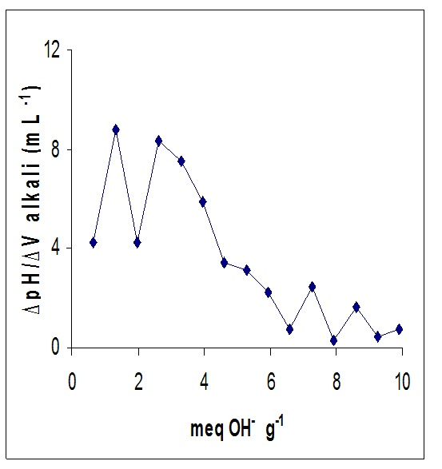
Fig.- II Differential pH-potentiometric titration curve for HAv

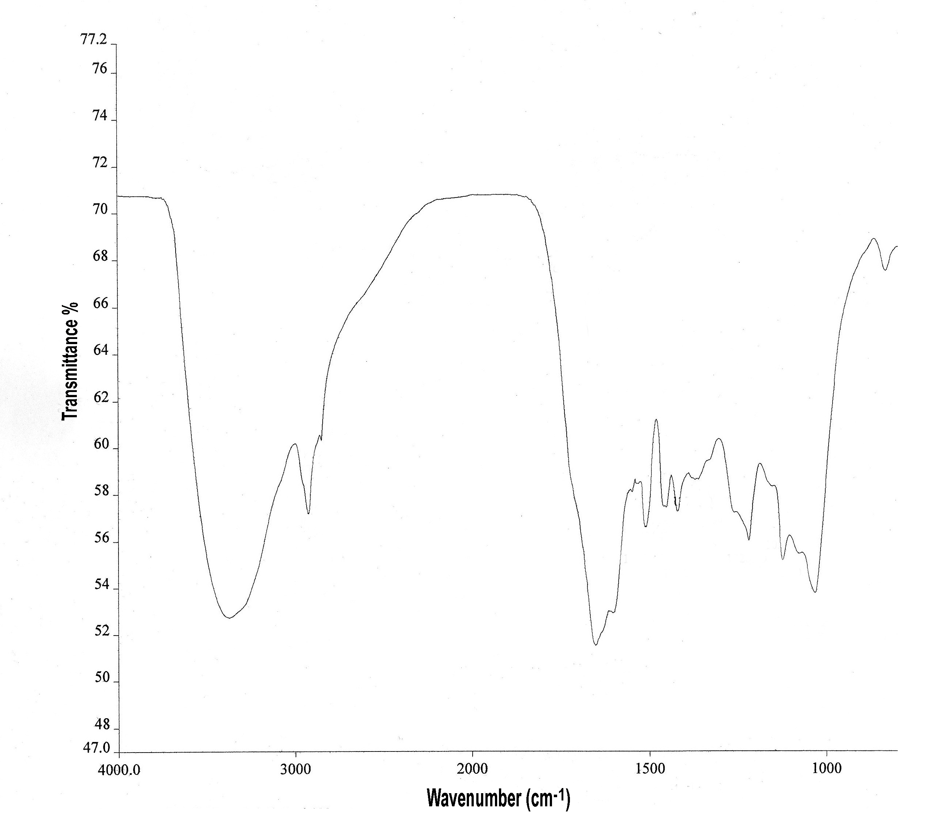
Fig.- III IR spectrum Of HA_{f}

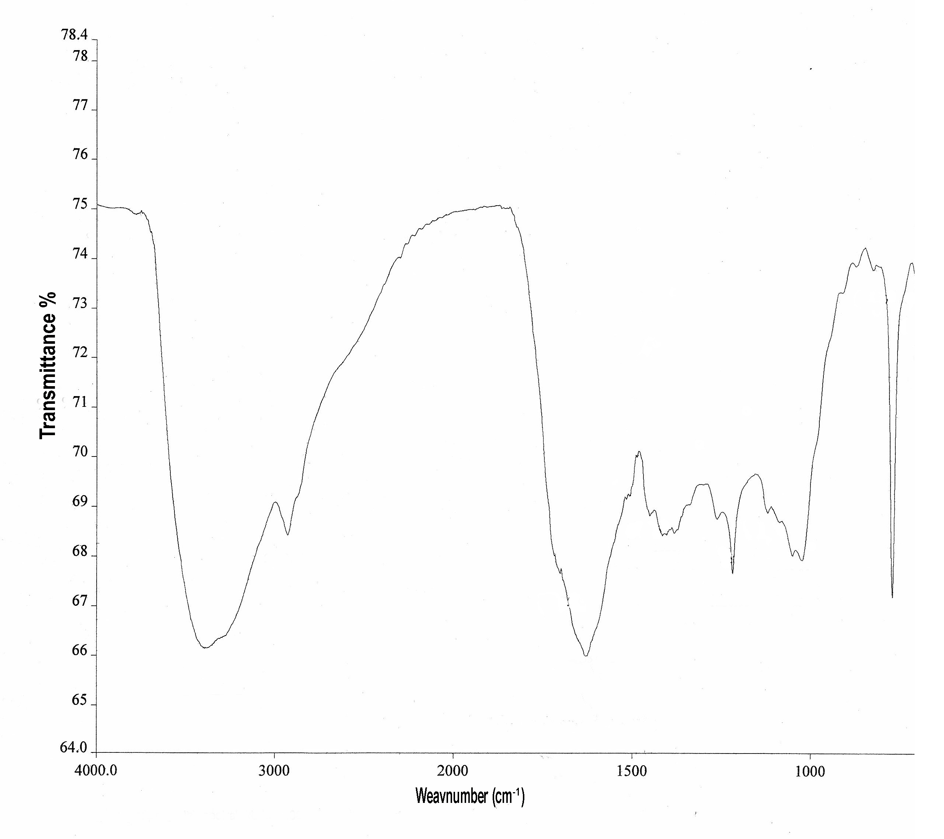
Wavenumber (cm⁻¹)
Fig.- IV IR spectrum Of HA_{v}

Figures in the parentheses indicate apparent nutrient recovery due to in-organics only.

Acknowledgement: The authors wish to thank Dr. H. Banerjee, Professor, Department of Agricultural Chemicals, Bidhan Chandra Krishi Viswavidyalaya, Mohanpur, Nadia (West Bengal), India for extending his support to carry out the IR spectroscopy.

Table 1. General properties of organic manures.
Organic manure | Organic matter (g kg⁻¹) | C:N | C:P | C:K | Extractable HA (g kg⁻¹)
FYM | 71.72 | 11.89 | 23.11 | 8.32 | 0.88
VC | 151.77 | 13.13 | 25.14 | 14.92 | 1.36

Table 2. Potentiometric information about HA samples.
HA sample | Amount of COOH (meq g⁻¹) | Amount of phenolic-OH (meq g⁻¹) | Approx. charge density (No. of charges g⁻¹) x 10⁻²⁰ | pH at first inflexion  (pH₁) | pH at final inflexion  (pH₂) | Δ pH = pH_{3/4}–pH_{1/4}  (pH = pH₂) | Conclusion
HA_{f} | 3.06 | 6.12 | 55.26 | 5.92 | 7.79 | 3.89 | Polyprotic
HA_{v} | 1.32 | 5.94 | 43.71 | 4.92 | 8.34 | 4.17 | Polyprotic

Table 3. Amount of excess fresh alkali and extra time required to attain stable higher pH of 10.0 for HA.
HA sample | Fresh excess standard alkali needed to attain stable higher pH (mL) | Extra time needed to attain stable higher pH (h)
HA_{f} | 4.10 | 210.5
HA_{v} | 5.90 | 259.0

Table 4. Visible spectrophotometric analysis of HA samples
HA sample | E₄/E₆ at pH |  | Δ (E₄/E₆)
HA sample | 5.0 | 9.0 | Δ (E₄/E₆)
HA_{f} | 4.55 | 4.24 | 0.31
HA_{v} | 6.44 | 5.85 | 0.59

Table 5. Soil characteristics under fertilizers and manures after 25 crop cycles of mulberry, var. S-1635.
Treatment | Bulk density  (Mg m⁻³) |  | Water holding capacity (kg kg⁻¹) |  | Organic matter  (g kg⁻¹) |  | Available N  (kg ha⁻¹) |  | Available P  (kg ha⁻¹) |  | Available K  (kg ha⁻¹)
Treatment | ← Spacing (m) →
Treatment | 0.60x0.60 | 0.90x0.90 | 0.60x0.60 | 0.90x0.90 | 0.60x0.60 | 0.90x0.90 | 0.60x0.60 | 0.90x0.90 | 0.60x0.60 | 0.90x0.90 | 0.60x0.60 | 0.90x0.90
T1 | 1.45 | 1.42 | 0.41 | 0.41 | 9.46 | 8.94 | 171.33 | 180.33 | 10.33 | 10.67 | 275.33 | 265.33
T2 | 1.43 | 1.41 | 0.39 | 0.39 | 9.80 | 9.12 | 196.00 | 214.67 | 22.33 | 24.33 | 303.33 | 318.00
T3 | 1.31 | 1.30 | 0.44 | 0.45 | 13.19 | 12.73 | 239.33 | 246.00 | 35.00 | 31.00 | 376.00 | 362.00
T4 | 1.30 | 1.34 | 0.45 | 0.45 | 12.33 | 12.56 | 242.67 | 236.67 | 30.67 | 29.00 | 361.33 | 344.67
CD_{fertilizer} * | 0.06 |  | 0.01 |  | 1.05 |  | 24.23 |  | 3.24 |  | 25.20
CD_{spacing} * | NS |  | NS |  | NS |  | NS |  | NS |  | NS

Table 6. Effect of fertilizers and manures on annual leaf yield and nutrient uptake of mulberry, var. S-1635.
Treatment | Leaf yield  (mt ha⁻¹) |  | N-uptake by mulberry biomass  (kg ha⁻¹) |  | P-uptake by mulberry biomass  (kg ha⁻¹) |  | K-uptake by mulberry biomass  (kg ha⁻¹)
Treatment | ← Spacing (m) →
Treatment | 0.60x0.60 | 0.90x0.90 | 0.60x0.60 | 0.90x0.90 | 0.60x0.60 | 0.90x0.90 | 0.60x0.60 | 0.90x0.90
T1 | 11.43 | 7.30 | 84.56 | 62.17 | 15.27 | 10.37 | 71.50 | 45.47
T2 | 31.65 | 31.19 | 269.71 | 294.43 | 35.50 | 34.80 | 203.41 | 201.08
T3 | 37.95 | 34.48 | 356.12 | 346.58 | 47.48 | 44.47 | 263.83 | 239.48
T4 | 35.21 | 32.53 | 354.05 | 297.67 | 44.60 | 40.15 | 247.18 | 225.56
CD_{fertilizer} * | 3.76 |  | 29.10 |  | 3.75 |  | 21.68
CD_{spacing} * | 2.17 |  | NS |  | 2.16 |  | 12.52

Table 7. Yield as well as nutrient uptake response and apparent nutrient recovery by mulberry, var. S-1635 due to organics.
Source of organics | Yield response (%) | Nitrogen |  | Phosphorus |  | Potassium
Source of organics | Yield response (%) | Uptake response (%) | Apparent recovery (%) | Uptake response (%) | Apparent recovery (%) | Uptake response (%) | Apparent recovery (%)
FYM | 15 | 25 | 99 | 31 | 29 | 24 | 50
VC | 8 | 16 | 66  (62) | 21 | 21  (28) | 17 | 59  (154)

References
- Banik, G.C. and Sanyal, S.K. (2006a) A study on chromium-humic complexation: part 1. characterization of humic substances. J. Indian Soc. Soil Sci., 54: 163-169.
- Banik, G.C. and Sanyal, S.K. (2006b) A study on chromium-humic complexation: part 2. complexation equilibria of chromium-humic/fulvic complexes. J. Indian Soc. Soil Sci., 54: 170-173.
- Bharadwaj, V. and Omanwar, P.K. (1994) Long-term effects of continuous rotational cropping and fertilization on crop yields and soil properties – II. Effects on EC pH organic matter and available nutrients of soil. J. Indian Soc. Soil Sci., 42: 387-392.
- Bharadwaj, V., Omanwar, P.K., Sharma, R.A. and Vishwanath (1994) Long-term effects of continuous rotational cropping and fertilization on crop yields and soil properties – I. Effects on crop yields and nutrient uptake. J. Indian Soc. Soil Sci., 42: 247-253.
- Black, C.A. (1965) Methods of Soil Analysis. American Society of Agronomy, Madison, Wisconson, USA.
- Bongale, U.D. and Siddalingaswamy, N. (1996) Physico-chemical properties of soils from major sericultural areas of Kolar and Bangalore districts, Karnataka, India. Indian J. Seric., 35: 152-154.
- Datta, A., Sanyal, S.K. and Saha, S. (2001) A study on natural and synthetic humic acids and their complexing ability towards cadmium. Plant Soil, 235: 115-125.
- Edwards, C.A. and Lofty, J.R. (1977) Biology of Earthworms. Chapman and Hall Private Limited, London, pp 283.
- Fortun, A., Fortun, C. and Ortega, C. (1988) Effect of farmyard manure and its humic fractions on the aggregate stability of a sandy-loam soil. European J. Soil Sci., 40: 293-298.
- Ghosh, K., Das, I., Saha, S., Banik, G.C., Ghosh, S., Maji, N.C. and Sanyal, S.K. (2004) Arsenic chemistry in ground water in the Bengal-delta plain: Implications in agricultural system. J. Indian Chem. Soc., 81: 1063-1072.
- Harris, R.F., Chester, G. and Allen, O.N. (1965) Dynamics of soil aggregation. Adv. Agron., 18: 107-160.
- Jackson, M.L. (1973) Soil Chemical Analysis. Prentice Hall of India Private Limited, New Delhi, India.
- Kar, R., Bose, P.C., Majumder, S.K. and Dutta, R.N (2008) Physical characterization of mulberry (Morus alba L.) growing soils in four states of Eastern India in relation to their organic carbon and available nutrient contents. Indian J. Seric., 47: 126-129.
- Kar, R., Dutta, R.N. and Majumdar, S.K. (1995) Characterization of humic acids isolated from soils under mulberry vegetation. Curr. Sci., 69: 67-68.
- Kar, R., Dutta, R.N. and Majumdar, S.K. (1997) Effect of different levels of N, P and K on leaf yield and nutrient uptake pattern of mulberry (Morus alba L.). Indian Agric., 41: 9-14.
- Kar, R. and Sanyal, S.K. (1988) A study on synthetic humic acids. J. Indian Chem. Soc., 65: 834-837.
- Kar, R., Sanyal, S.K. (1989) Coiling in synthetic humic acids. J. Indian Soc. Soil. Sci., 37: 244-247.
- Kumar, S., Sethi, I.C. and Arora, A. (2006) On-line data management system for long term fertilizer experiments. J. Indian Soc. Agril. Statist, 60: 162-168.
- Mandal, S.K. and Sanyal, S.K. (1984) Shape of humic acid (a natural polymer) from viscosity studies. J. Indian Soc. Soil Sci., 32: 224-229.
- Meelu, O.P. (1996) Integrated nutrient management for ecologically sustainable agriculture. J. Indian Soc. Soil Sci., 44: 582-592.
- Mukhopadhyay, D. and Sanyal, S.K. (2004) Complexation and release isotherm of arsenic in arsenic-humic/fulvic equilibrium study. Aust. J. Soil Res., 42: 815-824.
- Saha, P.B. and Sanyal, S.K. (1988) Synthetic humic acids – their constitution, shape and dimension. J. Indian Soc. Soil Sci., 49: 35-42.
- Sanyal, S.K. (1984) Structure of water in solution of organics-hydrophobic hydration. Chem. Educt. (UGC), 1: 14-18.
- Sanyal, S.K. (2002) Colloid chemical properties of soil humic substances: A re-look. Bull. Indian Soc. Soil Sci., 21: 278-307.
- Sanyal, S.K. and Dhillon, K.S. (2006) Arsenic and selenium dynamics in water-soil-plant system: a threat to environmental quality. Invited Lead Lecture. In: Proceedings of the International Conference on Soil, Water and Environmental Quality: Issues and Strategies, held in New Delhi, India during January 28 to February 1, 2005. pp. 239-263.
- Subramanian, K.S. and Kumaraswamy, K. (1989) Effect of continuous cropping and fertilization on chemical properties of soil. J. Indian Soc. Soil Sci., 37: 171-173.
- Subbiah, B.V. and Asija, G.L. (1956) A rapid procedure for the estimation of available nitrogen in soil. Curr. Sci., 25: 259-261.
- Thakuria, K., Borgohain, B. and Sarma, K.K. (1991) Effect of organic and inorganic sources of nitrogen with and without phosphate on fibre yield of white jute (Corchorus capsularis). Indian J. Agric. Sci., 61: 49-50.

10/11/2012

