Effect of Cyanobacteria Inoculation Associated With Different Nitrogen Levels on Some Sandy and Calcareous Soils Properties and Wheat Productivity

¹Y. M. El-Ayouty.; ²F. M. Ghazal; ²Wafaa T. El-Etr and ²Hanaa A. Zain EL-Abdeen

¹Botany Department, Faculty of Science, Zagazig University
²Soils, Water and Environment Research Institute, Giza, Egypt
Fekry_ghazal@yahoo.com

Abstract: Recently, a great attention is paid in establishing concept of the associations between wheat plants and a variety of N₂-fixing microorganisms. This phenomenon has entered the scientific scene arising from the prospects and the possibilities of their potentially application. . In this work, cyanobacteria inoculation (SBCI) was applied to wheat in a greenhouse experiment under different levels of nitrogen to explore its influence on wheat yield and its components as well as on some soil properties of both sandy and calcareous soils. Results revealed that inoculation with cyanobacteria generally enhanced the growth of wheat plants. Also, 75 % N + SBCI gave the highest wheat grain and straw yields, highest total NPK contents for both grains and straw. These results were not significantly differed from those recorded by 100 % N treatment. Regarding soil physical characteristics the results indicate that inoculation with cyanobacteria increased the proportion of macro-aggregates with a corresponding decrease in the micro-aggregates in both tested soils. Inoculation with cyanobacteria increased both soil organic matter and water holding capacity percentages, while decreased the soil bulk density for both tested soils. Generally, it is of preliminarily prediction that cyanobacteria inoculation can save 25 % of the mineral nitrogen required for wheat cultivation. Also, it can ameliorate and improve the physical properties of the marginal and poor soils such as those of sandy and calcareous soils applied in the present study.
[Y. M. El-Ayouty., F. M. Ghazal, Wafaa T. El-Etr and Hanaa A. Zain EL-Abdeen. Effect of Cyanobacteria Inoculation Associated With Different Nitrogen Levels on Some Sandy and Calcareous Soils Properties and Wheat Productivity. Nat Sci 2012;10(12):233-240]. (ISSN: 1545-0740). http://www.sciencepub.net/nature. 35

Keywords: Cyanobacteria Inoculation; Nitrogen Level; Sandy; Calcareous; Wheat

1. Introduction
The use of the conventional chemical farming methods, which substantially increased crop production, was once regarded as a kind of agriculture revolutions which would solve all problems relating to producing sufficient food for the ever growing world population. However, this belief was later over-shadowed by the emergence of numerous environmental and social problems associated with the heavy use of agrochemicals in intensive farming systems. Conventional farming methods are generally associated with degradation of the environment.
Among other things, soil degradation is one of the most serious problems which affect crop production. Increasing prices of agrochemicals especially nitrogen often leaves farmers with low profit. Uncertain availability of those agrochemicals, especially in the developing countries such Egypt, is often a serious constraint for the farmers in their attempt to increase crop production. Such problems have directed the attention of the agriculturists world-wide to seek alternative methods of farming.
In attempting to develop productive, profitable and sustainable agriculture systems, several agriculturalists have been turned to farming methods, which are based on biotechnologies. One of the several approaches to achieve this goal is using the nitrogen fixing cyanobacteria to improve soil fertility and productivity. The use of nitrogen fixing cyanobacteria ensures saving entirely or partially the mineral nitrogen required in crop production. Recently, there is a great deal of interest in creating novel association between agronomically important plants, partially cereals such wheat and N₂-fixing microorganisms including cyanobacteria (Spiller et al., 1993). The heterocystus cyanobacterium Nostoc sp. is usual among characterized cyanobacteria in its ability to form tight association with wheat roots and penetrate both roots epidermis and cortical intracellular space (Gantar et al., 1991). The N₂- fixed by Nostoc sp. in association with wheat is taken up by the plant and sports its growth, improving grain yields and grain quality (Gantar et al., 1995).
Cyanobacteria comprise a large group of structurally complex and ecologically significant gram-negative prokaryotes, which exhibit a wide range of nutritional capabilities ranging from obligate phototrophy to heterotrophy (Rippka, 1972, Vasudevan et al., 2006, Prasanna et al., 2009), although the majority of forms examined so far exhibit phototrophy. They live wherever there is light in a wide range of terrestrial, freshwater and hypersaline environments, among which soil is the best-studied terrestrial habitat. They are well adapted to a wide range of environmental conditions and have been widely employed as inoculants for enhancing soil fertility and improving soil structure, besides enhancing crop yields, especially in rice (Kaushik, 2004 and Dhar et al., 2007). Most of the studies reported in literature do not provide in-depth information regarding the mode of action involved in plant growth stimulation, and only report stimulation of growth yields (Misra and Kaushik ,1989 and Karthikeyan et al., 2007).
The aim of this work is to investigate the effect of cyanobacterial inoculation on wheat crop yield, its components, total NPK contents of both wheat straw and grains as well as on some physical soil characters.

2. Materials and Methods
A pot experiment was conducted in the greenhouse of Agric. Res. Center, Giza, Egypt to study the effect of cyanobacteria inoculation on some soil properties and wheat productivity in sandy and calcareous soils. According to Jackson (1976) and Page (1982) the experimental soils were sandy and calcareous in texture with chemical properties of pH 8.26 and 7.74 and EC 1.66 and 7.50 and organic matter of 0.30 and 0.5 %, respectively. Pots with 35 cm height and 30 cm in diameter were filled with 8 kg sandy and/or calcareous soils each. Before baking the pots, the soil was thoroughly mixed uniformly with phosphate and potassium fertilizers at rates of 100 and 50 kg fed⁻¹ in the form of superphosphates (15 % P₂O₅) and potassium sulfate (48 % K₂O), respectively, while nitrogen fertilizer added to the pots at recommended rates for the treatments. Nitrogen added in two split doses, the first 2/3 N dose was added prior to wheat sowing. The second (1/ 3 N) was added after 30 days from sowing. Five wheat grains were sowed into each pot and when the wheat seedlings developed, one seedling was thinned out and four healthy ones were left in each pot. Dried flakes from the soil based cyanobacteria inoculum (SBCI) were inoculated to pots 10 days after wheat sowing at the rate of 6 kg SBCI fed⁻¹. The cyanobacteria inoculation was carried out only for pots received this treatment. SBCI composed of different cyanobacteria strains namely Anabaena fertilissima, Anabaena anomala and Nostoc muscorum. Pots were irrigated with tap water every two days. Daily water irrigation had done to compensate the evaporated water. The experiment comprises the following treatment:
- Control (100 % N).
- 75 % N + cyanobacteria (SBCI).
- 50 % N + (SBCI).
- Zero % N + (SBCI).
The treatments were statistically arranged in a complete randomized design according to Gomez and Gomez (1984).
At harvest, wheat plants in each treatment were collected to determine, wheat yield and its components, N, P and K contents for both grains and straw. As well as, the remained soils in pots after wheat harvesting were sampled to determine some soil properties, i.e., , soil organic matter Walkely and Black (1934), soil aggregate stability and soil bulk density (Richards, 1954) and soil water holding capacity (Page, 1982).
All the obtained results exposed to statistical analysis to compare the means through L. S. D. test at probability of 0.05 as described by Gomez and Gomez (1984).
Cyanobacteria inoculum (SBCI) preparation:
Rectangle galvanized metal trays of ¹/₂ m² in area (plate 1) containing 10 kg alkaline clay loamy soil with pH 8.1, EC 2 dS m⁻¹, organic matter 1.00% (Walkley and Black, 1934), total nitrogen 1.2 % Jackson (1976) and available phosphorus 12.6 mg kg⁻¹ (Olsen et al., 1954). The soil in the trays were covered up to 10 cm height with tap water and supplied with 40 g superphosphate (15 % P₂O₅), 125 ml sodium molybedate (in 1% solution, w/v) and 1.0 g carbofuran (ai 3 % granules) under the greenhouse condition to produce the dried cyanobacteria flakes inoculum. This inoculum commonly used as biofertilizer in the rice fields and recently in other crops like wheat and maize. After the soil settled down and the water in the trays become clear, each tray was then being inoculated with 50 ml cyanobacteria culture of Anabaena fertilissima, Anabaena anomala and Nostoc muscorum at the log phase age as starter (One strain is inoculated for one tray). The trays kept in the open air, and when the thick cyanobacteria mat (plate 1) formed (10-15 days), it collected and allowed to dry in the sun. When completely dry, each dry cyanobacteria strain was thoroughly mixed together at the ratio of 1:1:1 (W/W) to represents the dried cyanobacteria inoculum (plate 2). The dried collected inoculum kept in sealed polyethylene bags and used as biofertilizer for field crops. The produced dried cyanobacteria flakes can survive and kept viable for 3 years in a dry place (Vennkataraman, 1972).

3. Results
Wheat yield and its components:
Data in Table (1) indicate the effect of the cyanobacteria inoculation combined with different nitrogen levels on wheat yield and its components cultivated in either sandy or calcareous soil. Results revealed that cyanobacteria inoculation can compensate partially the nitrogen fertilizer required for wheat cultivation. However, results showed that the inoculation with cyanobacteria (SBCI) combined with 75% N dose attained significantly the superior effect on wheat yield and its components except for both 1000-grain weight and plant height compared to that achieved by the other tested treatments except for those recorded by control treatment (100 % N) in both tested soils. The corresponding highest significant values were 8 spike plant⁻¹, 17.77 g pot⁻¹ (dry weight of spikes pot⁻¹), 17.66 g pot⁻¹ (grain yield) and 28.43 g pot⁻¹ (straw yield) for sandy soil against 8 spike plant⁻¹, 23.00 g pot⁻¹ (dry weight of spikes pot⁻¹), 22.11 g pot⁻¹ (grain yield) and 30.10 g pot⁻¹ (straw yield) for calcareous soil. These values were not significantly differed from those recorded by the use of control (100% N). On the other hand, cyanobacteria inoculation had not significantly affected both 1000-grain weight and the plant height of wheat. Although of this trend, both 1000-grain weight and the plant height gave their highest values in response to 75% N + SBCI treatment in both tested soils. Their corresponding highest values were 21.4 g (1000-grain weight) and 69.6 cm (plant height) for sandy soil and 23.2 g (1000-grain weight) and 73.3 cm (plant height) for calcareous soil. Nevertheless, these values were not significantly differed from those recorded by all tested treatments in both sandy and calcareous soils.

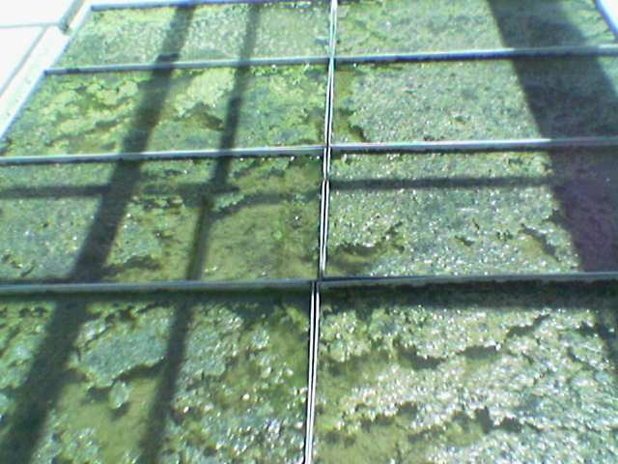
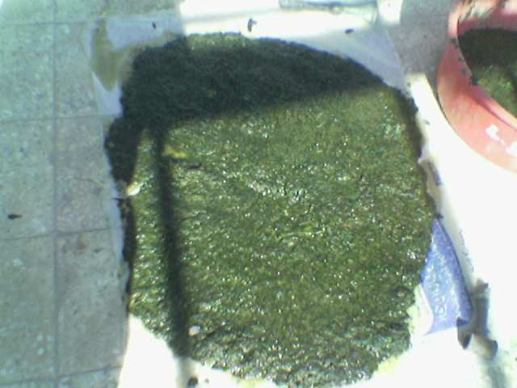

Plate (1): Cyanobacteria inoculum production. Plate (2): cyanobacteria flakes inoculum.
Table (1): Wheat yield components as affected by cyanobacterial inoculation combined with different nitrogen fertilizer
Soil Type | Treatments | Spike No. plant⁻¹ | Spike DW (g pot⁻¹) | Straw DW (g pot⁻¹) | Grain DW  (g pot⁻¹) | 1000 - grains  (g) | Plant height (cm)
Sandy | 100 % N | 7.00 | 16.73 | 27.73 | 16.83 | 20.60 | 68.2
Sandy | 75% N+ *SBCI | 8.00 | 17.77 | 28.43 | 17.66 | 21.40 | 69.9
Sandy | 50 % N + SBCI | 5.00 | 14.77 | 22.07 | 13.23 | 20.90 | 68.7
Sandy | Zero % N + SBCI | 3.00 | 11.33 | 16.27 | 10.33 | 20.80 | 67.90
Mean of treatments |  | 5.75 | 15.15 | 23.63 | 14.51 | 20.93 | 68.68
Calcareous | 100 % N | 7.00 | 21.50 | 28.90 | 21.96 | 22.60 | 71.80
Calcareous | 75% N+ *SBCI | 8.00 | 23.00 | 30.10 | 22.11 | 23.20 | 73.30
Calcareous | 50 % N + SBCI | 5.00 | 16.90 | 24.30 | 16.70 | 22.30 | 71.80
Calcareous | Zero % N + SBCI | 4.00 | 13.60 | 17.40 | 12.30 | 21.90 | 71.50
Mean of treatments |  | 6.00 | 18.83 | 25.18 | 18.27 | 22.50 | 72.10
L.S.D. at 0.05% |  | 2.65 | 6.57 | 4.21 | 1.29 | NS | NS
*SBCI = Soil based cyanobacteria inoculum.

Total NPK contents of wheat grains and straw:
Data in Table (2) show that the superior inoculation with cyanobacteria (SBCI) was favorable especially when applied in addition to 75 % N level. This treatment increased slightly total NPK contents in grains and straw over those the use of 100% N in both sandy and calcareous soils. In both soils, these two treatments were not significantly differed from each other. While, they were significantly higher in total NPK contents of both grains and straw in both tested soils than the other two treatments (50% N + SBCI and 0% N + SBCI). The highest corresponding total NPK contents for 75% N + SBCI treatment were 170.99, 28.74 and 309.89 mg pot⁻¹ (straw) and 480.59, 105.96 and 114.79 mg pot⁻¹(grains) in sandy soil against 185.95, 32.10 and 328.65 mg pot⁻¹ (straw) and 549.18, 132.66 and 143.72 mg pot⁻¹ (grains) in calcareous soil. However, the mean values of total NPK contents in wheat straw and grains were higher in calcareous soil than those obtained from sandy soil. This trend was not true for total P content in wheat straw only in both tested soils.

Table (2): Total Nitrogen, phosphorus and potassium content of wheat plants as affected by cyanobacterial inoculation combined with different nitrogen fertilizer
Soil Type | Treatments | Macronutrients uptake (mg pot⁻¹)
Soil Type | Treatments | Straw |  |  | Grains
Soil Type | Treatments | N | P | K | N | P | K
Sandy | 100 % N | 161.25 | 24.18 | 302.76 | 472.65 | 101.32 | 106.74
Sandy | 75% N+ *SBCI | 170.99 | 28.74 | 309.89 | 480.59 | 105.96 | 114.79
Sandy | 50 % N + SBCI | 105.21 | 17.66 | 233.94 | 322.81 | 52.92 | 59.90
Sandy | Zero % N + SBCI | 51.30 | 13.01 | 165.95 | 216.93 | 35.83 | 30.99
Mean |  | 122.19 | 20.90 | 253.14 | 373.25 | 74.01 | 78.11
Calcareous | 100 % N | 177.37 | 26.12 | 318.34 | 535.82 | 126.84 | 135.82
Calcareous | 75% N+ *SBCI | 185.95 | 32.10 | 328.65 | 549.18 | 132.66 | 143.72
Calcareous | 50 % N + SBCI | 125.16 | 14.44 | 257.58 | 407.48 | 66.80 | 75.15
Calcareous | Zero % N + SBCI | 61.60 | 13.92 | 177.40 | 238.30 | 40.75 | 46.90
Mean |  | 137.52 | 21.65 | 270.39 | 432.70 | 122.35 | 100.40
L S.D. at 0.05% |  | 12.78 | 7.12 | 22.45 | 16.23 | 15.32 | 14.12
*SBCI = Soil based cyanobacteria inoculum.

Soil properties:
Soil aggregate stability:
Data in Tables (3 & 4) illustrate the effect of cyanobacteria inoculation either alone or in combination with different nitrogen levels on soil aggregates stability for both sandy and calcareous soil through using the dry sieving test. Results indicate that inoculation with cyanobacteria increased the proportion of macro-aggregates with a corresponding decrease in the micro-aggregates in both tested soils. Regarding the sandy soil (Table 3), high aggregates proportions were recorded by the aggregates diameter of (0.5 -0.25 mm) for all treatments. The corresponding proportions were 62.33, 67.53, 64.5 and 68.61% for the treatments of 100 % N, 75% N + SBCI, 50% N + SBCI and 0% N + SBCI, respectively. However, the highest aggregate proportion of 68.61% was due to the cyanobacteria inoculation only followed by 67.53 % for the treatment received 75% N + SBCI. However, the treatment of 100% N + SBCI recorded the highest aggregates proportion of 62.33% for the same aggregate diameter of (0.5 -0.25 mm).

Table (3): Dry soil stable aggregates (%) for sandy soil as affected by cyanobacterial inoculation combined with different rates of nitrogen fertilizer
Soil Type | Treatments | Different fraction of dry sieving aggregate stability
Soil Type | Treatments | Aggregate diameter (mm)
Soil Type | Treatments | 10- 2 | 2-1 | 1-0.5 | 0.5-0.25 | 0.25-0.125 | 0.125-0.063 | < 0.063
Sandy soil | 100% N | 0.85 | 0.68 | 16.67 | 62.33 | 16.08 | 3.33 | 0.06
Sandy soil | 75%N + *SBCI | 0.89 | 0.63 | 14.59 | 67.53 | 12.45 | 3.85 | 0.06
Sandy soil | 50%N + SBCI | 0.74 | 0.66 | 14.63 | 64.50 | 15.77 | 3.63 | 0.07
Sandy soil | Zero% N + SBCI | 1.48 | 0.82 | 14.75 | 68.61 | 11.20 | 3.09 | 0.06

*SBCI = Soil based cyanobacteria inoculum.

For calcareous soil (Table 4), different behaviors were detected to the effect of cyanobacteria inoculation on the soil aggregate size proportion. Nevertheless, the highest aggregates proportions were attained by the macro-aggregates diameter of (> 2 mm) for all treatments. The corresponding proportions were 45.00, 43.20, 43.00 and 39.50% for the treatments of 75% N + SBCI, 50% N + SBCI, zero N + SBCI and 100 % N, respectively. However, the highest aggregate proportion of 45.00 % was recorded from 75% N + SBCI followed by 43.20 % for the treatment received 50 % N + SBCI. On the other hand, another high soil aggregate proportion of 17.70 % (75% N + SBCI), 17.00 % (50% N + SBCI) and 14.5 % (0% N + SBCI) were achieved by the soil macro-aggregate diameter of (0.5 – 0.25 mm).
Generally, in both sandy and calcareous soils, the least soil aggregate proportions were recorded by the soil diameters of 0.125 -0.063 and < 0.063 mm. However, The microscopic examination at magnification power of 100 x (Plates, 3, 4, 5 & 6) revealed that soil particles and fragments of non-inoculated soils when inoculated with cyanobacteria had coatings of the cyanobacteria extracellular polymeric substances, which were more pronounced in sandy soil than in calcareous soil. Thus, the Improvement of soil aggregate structure was more obvious in sandy soil than in calcareous soil.

Table (4): Dry soil stable aggregates (%) for calcareous soil as affected by cyanobacterial inoculation combined with different rates of nitrogen fertilizer
Soil Type | Treatments | Different fraction of dry sieving aggregate stability
Soil Type | Treatments | Soil aggregate diameters (mm)
Soil Type | Treatments | 10- 2 | 2-1 | 1-0.5 | 0.5-0.25 | 0.25-0.125 | 0.125 -0.063 | < 0.063
Calcareous soil | 100% N | 39.50 | 7.80 | 11.00 | 13.40 | 12.50 | 9.60 | 0.50
Calcareous soil | 75 %N +* SBCI | 45.00 | 10.70 | 12.00 | 17.70 | 11.30 | 6.60 | 0.50
Calcareous soil | 50 %N + SBCI | 43.20 | 8.40 | 11.40 | 17.00 | 10.40 | 8.50 | 0.30
Calcareous soil | 0% N + SBCI | 43.00 | 8.60 | 11.50 | 14.50 | 13.50 | 10.60 | 0.20

*SBCI = Soil based cyanobacteria inoculum.
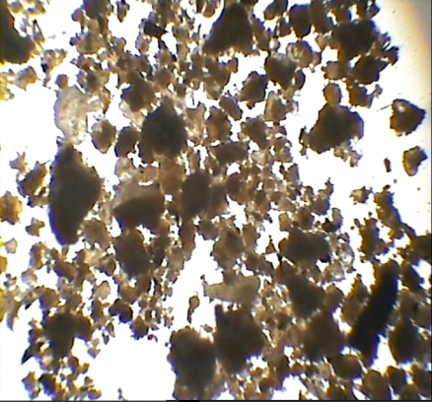
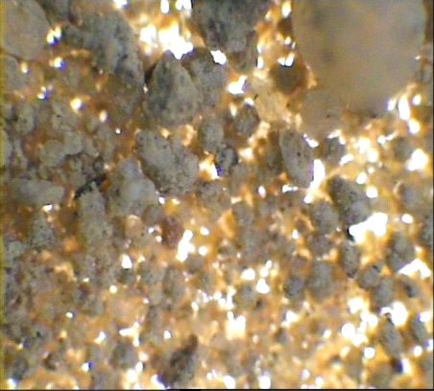

Picture (3): None inoculated calcareous soil (100 x). | Picture (4): Inoculated calcareous soil (100 x).
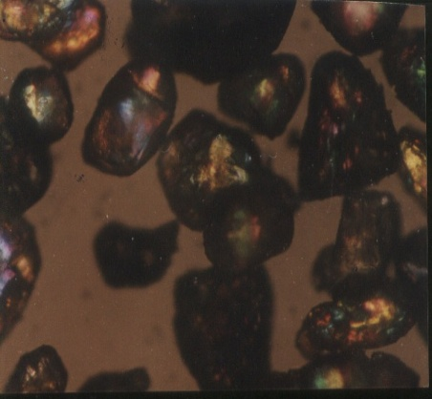
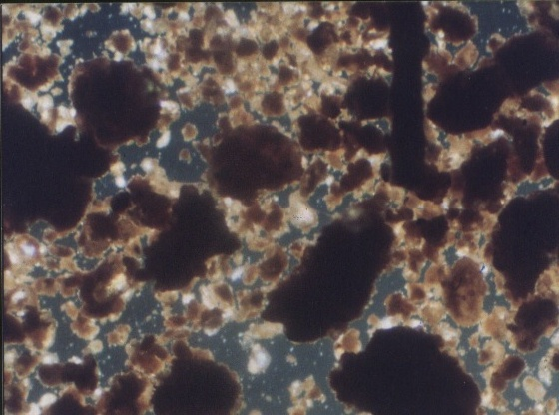

Picture (5): None inoculated sandy soil (100 x). | Picture (6): Inoculated sandy soil (100 x).

Soil organic matter, bulk density and water holding capacity percentages:
Data in Table (5) indicate the effect of (SBCI) on soil organic matter (OM %), bulk density and water holding capacity of sandy and calcareous soils. The results show that SBCI inoculation led to increase OM and WHC % but reduced the bulk density in both sandy and calcareous soils compared to non-inoculated treatment (100% N). In sandy soil, all the inoculated treatments increased slightly both soil organic matter and water holding capacity percentages than that recorded by 100% N treatment. The highest values of organic matter and WHC percentages of 0.23 and 36.10 respectively, were recorded by the treatment of 75 % N + SBCI followed by 0.21 and 34.5 % for 50 % N + SBCI treatment and the 0.20 and 34.40 % for 0% N + SBCI. Also, inoculation with SBCI reduced the soil bulk density from 1.72 g cm⁻³ (100 % N) to 1.50 g cm⁻³ (75 % N + SBCI). However, both 50 % N + SBCI and Zero % N + SBCI treatments gave bulk density values of 1.62 and 1.64 g cm⁻³. These two bulk density values were less than that of 1.72 g cm⁻³ for 100 % N treatment.
Concerning the calcareous soil, results in Table (5) exhibited the same behavior observed in sandy soil due to any of OM %, bulk density and WHC %, since also inoculation with cyanobacteria led to increase the both soil organic matter and water holding capacity percentages, while decreased the soil bulk density. Same like in sandy soil, the priority was for 75 % N + SBCI treatment the recorded the highest organic matter and WHC percentages in comparison with those obtained from the other tested treatments. The corresponding high percentages were 1.74 and 62.50. However, the other inoculated treatments gave higher OM and WHC % than those recorded by non-inoculated treatment (100% N). On the other hand, inoculation with cyanobacteria reduced the soil bulk density from 1.55 g cm⁻³ (100 % N) to 1.29 g cm⁻³ (75 % N + SBCI). Meanwhile, the other inoculated treatments also reduced the soil bulk density in comparison with the treatment of 100 % N; these decreases were with amounts less than that achieved by 75 % N + SBCI treatment (Table 5).

Table (5): Soil organic matter, bulk density and water holding capacity percentages as affected by cyanobacterial inoculation combined with different rates of nitrogen fertilizer
Soil type | Treatments | **OM (%) | ***BD ( g/cm³) | ****WHC (%)
Sandy | 100 % N | 0.19 | 1.72 | 33.90
Sandy | 75% N+ *SBCI | 0.23 | 1.50 | 36.10
Sandy | 50 % N + SBCI | 0.21 | 1.62 | 34.50
Sandy | Zero % N + SBCI | 0.20 | 1.64 | 34.40
Calcareous | 100 % N | 1.55 | 1.55 | 59.90
Calcareous | 75% N+ *SBCI | 1.74 | 1.29 | 62.50
Calcareous | 50 % N + SBCI | 1.61 | 1.33 | 61.20
Calcareous | Zero % N + SBCI | 1.56 | 1.35 | 60.90
LSD at 0.05% |  | 0.22 | 0.14 | 6.33
*SBCI = Soil based cyanobacteria inoculum. **OM= organic matter ***Bulk density **** Water holding capacity.

4. Discussion
Effect of cyanobacteria on wheat growth, yield component and its NPK contents
The effect of cyanobacteria on the growth and yield productivity and soil physical characteristics was studied in a greenhouse experiment by inoculating wheat plants with the soil based cyanobacteria inoculum (SBCI) in sandy and calcareous soil. Cyanobacteria exhibit a broad ecological and metabolic diversity, and their structural-functional plasticity confers great versatility, enabling them to adapt and inhabit a wide range of environments and niches (Sood et al., 2008). With the growing realization that chemical based agriculture is unsustainable and is slowly leading to ecological imbalance, the latter part of the last century witnessed the emergence of the concept of ‘‘organic agriculture’’ advocating minimum use of chemical fertilizer and increasing dependence on biological inputs like compost, farm yard manure, green manure and biofertilizers. Amongst the array of biofertilizers developed for different crops, cyanobacteria are popularly known as blue green algae, constitute the most important inputs in rice cultivation. They form an inexpensive farm grown input, which helps in better crop nutrient management, while working in perfect harmony with nature. Cyanobacteria also add organic matter, synthesize and liberate amino acids, vitamins and auxins, reduce oxidizable matter content of the soil, provide oxygen to the submerged rhizosphere, ameliorate salinity, buffer the pH, solubilize phosphates and increase the efficiency of fertilizer use in crop plants (Kaushik, 2004)
However, the limited information is available on their utilization in wheat crop. Most of the work related to cyanobacterial biofertilizers has been in relation to rice crop (Whitton et al., 1988). Gantar et al. (1991) recognized two types of associations with cyanobacteria in wheat were loose associations filaments growing between root hairs, which were typical of the Anabaena isolates, and tight associations of micro-colonies in intimate association with the root surface, which were restricted to certain Nostoc isolates Gantar et al. (1995) assessed the role of extracellular polysaccharides in the colonization process by cyanobacteria on wheat roots and characterized the nature of sugars and linkages aiding in the attachment process, but agronomic efficiency was not evaluated. Karthikeyan et al. (2007) in a pot experiment on wheat using the promising cyanobacteria strains under controlled glasshouse conditions found that treatments, which involved cyanobacterial strains (single or in combination) showed visible differences in terms of the appearance of plants. This was accompanied by enhancement in plant height, dry weight and grain yields of wheat crop. Therefore, plant growth stimulation, in terms of plant height, dry weight and grain yields in pot culture experiment can be attributed to IAA-like compounds and photo- eterotrophic/heterotrophic abilities of the cyanobacterial strains. Also they added that in their studies carried out up to harvest stage of wheat crop clearly demonstrated that cyanobacteria enhanced plant growth parameters (plant height, dry weight, grain yields) in addition some significant changes in soil microbial biomass carbon. Maqubela and Menkeni (2009) revealed that application of Nostoc caused improvement in the growth and NPK content of maize. They added, increased matter yield by 49% in response to Nostoc inoculation, and observed increases in maize tissue NPK following Nostoc inoculation mirrored observed improvements in soil N and mineral N content of the soil following inoculation with Nostoc. Also, they added that Nostoc strain established in the soil improved the soil C, soil N and exo-poymeric substances contents of the soil. The increment of soil N had translated to improved maize growth and N uptake.
Soil properties:
Good soil structure is important for aeration, root development, and ease cultivation and may minimize or prevent soil erosion losses to wind and water (Cheshier, 1979). Soil conditioners are amendments that either alter soil structure or lower the surface tension of water. Unfortunately, most soil conditioners that alter structure are too expensive for common use in agriculture, and this why the microbiological processes that influence aggregation and soil erosion are accorded attention (Lynch and Bragg, 1985). Among these is inoculation with fast growing palmelloid microalgae of irrigated sandy or calcareous soils low in organic matter content that are prone to erosion by wind or water (Metting and Raburn, 1983). In this study cyanobacteria were inoculated into sandy and calcareous soils to improve their expected poor structure. Inoculation led to improve the soil stability aggregates and in turn soil structure. This could be attributed to the heavy growth of cyanobacteria, which exert polysaccharides thereby improving soil aggregation, stimulate some beneficial soil microorganisms, improve soil water holding capacity, soil bulk density and increase soil organic matter (Rao and Burns, 1990). Exopolysaccharide increases the soil organic matter content as a consequence of the sugar derived from the abundant slime mainly secreted by cyanobacteria inoculated to soil in addition to the polymers produced by other microorganisms stemmed in soil in response to cyanobacteria inoculation (Caire et al., 1997). Omar (1983) reported that the stability of soil aggregates after potatoes is significantly increased more than that after clover, cotton, tomatoes and corn cultivated without biofertilizer, while inoculation with biofertilizer increased the soil organic matter, soil aggregates stability, water retention and consequently improved the soil structure. He owed these observation noticed with biofertilizer application to the exopolysaccharides secreted by biofertilizers especially those documented in case of algal inoculation applied in tomato cultivation. Obana et al. (2007) revealed that soil inoculation with Nostoc sp. to desert soil has the potential for increasing soil organic matter and reclaiming the degraded soil ecosystems. They added that the developed crust mat of Nostoc on the soil surface resulted in reduced evaporation from soil surface and therefore, helped retain the water. Maqubela et al. (2012) found that the observed improvement in aggregate stability of the soil following inoculation with the three cyanobacteria strains seems to have largely been due to the gluing effect of excreted polysaccharides since the aggregate stability was more strongly associated with exo-polymeric substances than with soil C. Therefore, changes in organic matter content per se, due to inoculation seem to have limited effect on aggregation.
Generally, inoculation of cyanobacteria to the marginal poor soil such as sandy or calcareous soils has the ability to ameliorate their aggregates stability especially in sandy soil rather than the calcareous one. This effect is translated to increases improvement in wheat growth, yield and nutrient contents.
In conclusion, it is of preliminarily prediction that cyanobacteria inoculation can save 25 % of the mineral nitrogen required for wheat cultivation. Also it can ameliorate and improve the physical properties of the marginal and poor soils such as those of sandy and calcareous soils applied in the present study. However, this work should be repeated in field trials to reach the level of recommendation.

Corresponding author
F. M. Ghazal
Soils, Water and Environment Research Institute, Giza, Egypt
Fekry_ghazal@yahoo.com

References
- Caire, G., M. Storni de Cano; M. C. Zaccaro de Mule; R. M. Palma and K. Colombo (1997). Exopolysaccharides of Nostoc muscorum (Cyanobacteria) in the aggregation of soil particles. J. Appl. Phycol., 9: 249-253.
- Cheshier, M. V. (1979). "Nature and Origin of Carbohydrate in Soil". Academic Press, London.
- Dhar, D. W., R. Prasanna and B. V. Singh (2007). Comparative performance of three carrier-based blue-green algal biofertilizers for sustainable rice cultivation. J. Sust. Agric., 30:41-50.
- Gantar, M., N. W. Kerby and P. Rowell (1991). Colonization of wheat (Triticum vulgarie L.) by N₂-fixing cyanobacteria: I. A survey of soil cyanobacterial isolates forming association with roots. New Phytol., 118: 477-483.
- Gantar, M., P. Rowell and N. W. Kerby (1995). Role of extracellular polysaccharides in the colonization of wheat (Triticum vulgarie L.) roots by N₂-fixing cyanobacteria. Biol. Fertl. Soils. 19: 41-48.
- Gomez, K. A. and A. A. Gomez (1984). Statistical Procedures For Agricultural Research. (2nd Ed.), 20-29 & 359-387.
- Jackson, M. L. (1976). "Soil Chemical Analysis". Prentice-hall Englewood Cliffs, New Jersy, USA.
- Karthikeyan, N., R. Prasanna, L. Nain and B. D. Kaushik (2007). Evaluating the potential of plant growth promoting cyanobacteria as inoculants for wheat. Eur. J. Soil Biol., 43:23-30.
- Kaushik, B. D. (2004). Use of blue-green algae and Azolla biofertilizers in rice cultivation and their influence on soil properties. pp 166-184 in P. C. Jain (ed.), Microbiology and Biotechnology for Sustainable Development. CBS Publishers & Distributors, New Delhi, India.
- Lynch, J. M. and E. Bragg (1985). The use of algae as soil conditioners. Centros. Invest. Baja Calif., Scripps Inst. Oceanogr. 3: 33-35.
- Maqubela, M. P. and P. N. S. Mnkeni (2009). Nostoc cyanobacterial inoculation in South African agricultural soils enhances soil structure, fertility and maize growth. Plant Soil. 315:79 - 92.
- Maqubela, M. P., P. Muchaonyerwa and P. N.S. Mnkeni (2012). Inoculation effects of two South African cyanobacteria strains on aggregate stability of a silt loam soil. Afr. J. Biotechnolo., 11:10726-10735.
- Metting, B. and W. R. Rayburn. (1983). The influence of microalgal conditioner on selected Washington soils. An empirical study. Soil Sci. Amer. J., 47: 682-685.
- Misra, S. and B. D. Kaushik (1989). Growth-promoting substances of cyanobacteria. I. Vitamins and their influence on rice plant. Proc. Ind. Sci. Acad., 55: 295-300.
- Obana, S., K. Miyamoto, S. Morita and M. Ohmori (2007). Effect of Nostoc sp. On soil characteristics, plant growth and nutrient uptake. J. Appl. Phycol., 19: 641 – 646.
- Olsen, S. R.; C. V. Cok, F.S. Watanabe and L.A. Dean (1954). Estimation of available phsphorus in soil by sodium bicarbonate. U S. Dept. Agric. Circ., USA, 939.
- Omar, M. S. (1983). Soil aggregation as affected by management under different cropping systems. Egypt. J. Soil Sci., 23: 43-50.
- Page, A. L. (1982). "Methods of Soil Analysis". Part I. Physical properties and Part II. Chemical and microbiological properties (2nd Ed.). Amer. Soc. Agron. In Soil Sci. Soc. Amer. Inc. Madison Wisconsin, USA, Chapter 12, 199-223.
- Prasanna, R., P. Jaiswal, S. Nayak, A. Sood and B. d. Kaushik (2009). Cyanobacterial diversity in the rhizosphere of rice and its ecological significance. Ind. J. Microbiol., 49: 89-97.
- Rao, D. L. N. and R. G. Burns (1990). The effect of surface growth of blue-green algae and bryophytes on some microbiological, biochemical and physical soil properties. Biol. Fertil. Soils. 9: 239-244.
- Richards, L. A. (1954). Diagnosis and improvement of saline and alkaline soils. U.S. Deprt. Agric, U.S.A., Handbook, No. 60.
- Rippka, R. (1972). Photoheterotrophy and chemoheterotrophy among unicellular blue-green algae. Arch. Microbiol., 87: 94-98.
- Sood, A., R. Prasanna, B. M. Prasanna and P. K. Singh (2008). Genetic diversity among and within cultured cyanobionts of diverse species of Azolla. Folia Microbiol., 53: 35 – 43.
- Spiller, H., W. Stallings, T. Woods and M. Gunasekaran (1993). Requirement for direct association of ammonia-excreting Anabaena variabilis mutant (SA-1) with roots for maximal growth and yield of wheat. Appl. Microbiol. Biotechnol. 40: 557-566.
- Vasudevan, V., R. Prasanna, A. Sood, p. Jaiswal and B. D. Kaushik (2006). Stimulation of pigment accumulation in Anabaena strains: effect of light intensity and sugars. Folia Microbiol., 51: 50-56.
- Venkataraman, G. S. (1972). Biofertilizer and rice cultivation."Today and Tomorrow". New Delhi, India. 81-84.
- Walkley, A. and I. A. Black (1934). An examination of the Degtrarff method for determining soil organic matter and a proposed modification of the chromic acid titration method. Soil Sci., 37: 29-38.
- Whitton, B. A., A. Aziz, B. Kawecka and J. A. Rother (1988). Ecology of deep-water rice fields in Bangladesh, 3. Associated algae and macrophytes. Hydrobiologia. 16: 31-42.

11/12/2012

