Responses of Celosia argentea L. to simulated drought and exogenous salicylic acid

Victor Johwo Odjegba, Adeola Mary Adeniyi

Department of Botany, University of Lagos, Akoka, Lagos, Nigeria.
jodjegba@unilag.edu.ng

Abstract: Salicylic acid (SA), which is known as a signal molecule in the induction of defense mechanisms in plants, could be a promising compound for the reduction of stress sensitivity. The present study investigated the possible protective role of SA against simulated drought effects in Celosia argentea. Seedlings were raised from seeds and were grouped into four categories, each representing a treatment and replicated 10 times. Category 1 (W) which served as the control received 200 ml of water every 2 days throughout the experiment period; category 2 (SA) received 200 ml 500 µM salicylic acid every 2 days throughout the study period; category 3 (W+DT) received 200 ml of water every 2 days for 3 weeks before subjecting them to 10 days of simulated drought; while the 4th category (SA+DT) received 200 ml 500 µM salicylic acid every 2 days for 3 weeks before subjecting them to 10 days of simulated drought. Physiological and biochemical, as well as metabolic parameters representative of oxidative damage and antioxidant activity were evaluated after the treatments. The results showed that drought caused a decrease in plant biomass, chlorophyll, relative water content (RWC) and a significant increase in lipid peroxidation, and activities of catalase and ascorbate peroxidase in seedlings that were not pretreated with SA. The negative effects of drought were however alleviated by the exogenously applied SA thereby underscoring the beneficial role of this signal molecule in mediating defense response in plants under stress.
[Odjegba VJ, Adeniyi AM. Responses of Celosia argentea L. to simulated drought and exogenous salicylic acid. Nat Sci 2012;10(12):252-258]. (ISSN: 1545-0740). http://www.sciencepub.net/nature. 38

Keywords: Antioxidant enzymes; drought; salicylic acid; oxidative stress; Celosia argentea

Introduction
In coming decades, the combination of the rising world population and climate change will place new demands on agriculture globally. The emission of carbon iv oxide (CO₂) and other greenhouse gases will result in the warming of the climate across the world, and this will have significant negative effects on agricultural productivity due to increase in incidence of extreme weather events, including heat waves and drought.
Drought is one of the most important abiotic stress factors that limit plant growth and ecosystem production around the world. Upon exposure to drought stress, plants exhibit a wide range of responses at the whole plant, cellular and molecular levels (Chaves et al. 2003). At the whole-plant level, the effect of drought stress is usually perceived as a decrease in photosynthesis and growth, which is associated with alterations in carbon and nitrogen metabolisms (Cornic and Massacci, 1996). The reduction in the photosynthetic activity is due to several coordinated events, such as stomatal closure and the reduced activity of photosynthetic enzymes (Chaves et al. 2003, Lawlor and Cornic, 2002). Stomatal closure is probably the most important factor controlling carbon metabolism, but the relative role of stomatal limitation on photosynthesis depends on the severity of water deficit. Under severe stress, photosynthesis may be controlled more by the chloroplast’s capacity to fix CO₂ (such as Rubisco activity) than by the increased diffusive resistance (Bota et al. 2004). Osmotic adjustment has also been considered as one of the crucial processes in plant adaptation to drought stress. It involves the synthesis and accumulation of small compatible solutes (osmolytes), such as proline, glycine betaine, sugars and some inorganic ions (Bray, 1997, Chaves et al. 2003, Hare et al. 1998). These compounds help the cells to maintain their dehydrated state and the structural integrity of the membranes so as to provide resistance against drought and cellular dehydration (Ramanjulu and Bartels, 2002).
Under unperturbed conditions, light is absorbed by chlorophyll and used to drive a process of electron transport, which generates reducing power, in the form of NADPH, and ATP which are used to fix CO₂ as sugar. Under stress conditions, the fixation of CO₂ is directly or indirectly inhibited, however the absorption of light is unaffected. The energy absorbed can drive the production of harmful reactive oxygen species (ROS) such as hydrogen peroxide, which can cause leaf bleaching, membrane and DNA damage. If plants are to tolerate a given level of stress then it is essential that the production of ROS is regulated. The capability of scavenging ROS and reducing their damaging effects may correlate with the drought tolerance of plants (Tsugane et al. 1999).
Investigations of compounds capable of reducing the stress sensitivity of crops are of great importance from both theoretical and practical points of view. Plant hormones play an important role in developmental processes, and some of them have key roles in mechanisms leading to acclimation to changing environments. Salicylic acid (SA) has long been known as a signal molecule in the induction of defense mechanisms in plants (Raskin, 1992; Shah, 2003). Recent studies suggest that it also participates in signaling during abiotic stresses (Horváth et al. 2007).
Previous results suggest that SA could be a promising compound for the reduction of abiotic stress sensitivity in plants, since under certain conditions it has been found to mitigate the damaging effects of various stress factors in plants (Horváth et al. 2007). Several methods of application (soaking seeds in SA prior to sowing, adding SA to the hydroponic solution, irrigating or spraying with SA solution) have been shown to protect various plant species against abiotic stress factors, such as heavy metals (Krantev et al. 2008), high temperature (Dat et al. 1998), chilling (Janda et al. 1999; Szalai et al. 2000), or salinity (El-Tayeb, 2005; Szepesi et al. 2009) by inducing a wide range of processes involved in stress tolerance mechanisms. Analysis of these protective mechanisms will contribute to our knowledge of tolerance and resistance to stress.
The aim of the present work was to investigate the responses of young Celosia argentea seedlings to drought stress, and to know whether exogenous application of SA can induce tolerance to drought stress. Celosia argentea was chosen for this study due to its popularity as a leafy vegetable that is grown in domestic gardens and widely consumed in many parts of West Africa.

- Materials and methods
2.1 Plant growth and treatment
Seeds of C. argentea were purchased from a local market at Idi Araba in a single batch and enough for the study. Seeds were broadcasted on a nursery bed (1.5 m x 2.0 m) in the Botanic garden of University of Lagos. After germination, seedlings were nursed for 3 weeks and seedlings of relatively equal height (12 cm) were transplanted into nursery bags filled with loam soil to achieve plant stand of one seedling per bag. Plants were grouped into four categories, each representing a treatment and replicated 10 times. Category 1 (W) served as the control and received 200 ml of water every 2 days throughout the experiment period; category 2 (SA) received 200 ml 500 µM salicylic acid every 2 days throughout the study period; category 3 (W+DT) received 200 ml of water every 2 days for 2 weeks before subjecting them to 10 days of simulated drought; while the 4th category (SA+DT) received 200 ml 500 µM salicylic acid every 2 days for 2 weeks before subjecting them to 10 days of simulated drought.

2.2 Dry weight determination
Plants were uprooted carefully and washed thoroughly in a running tap water to remove soil particles. After rinsing with distilled water, they were placed in labeled paper bags and oven dried at 70 ºC for 72 h. The dried samples were weighed using a digital top loading weighing balance (Mettler AE 100) to determine the dry weight. Plants were also partitioned into root and shoot and their dry weights determined to evaluate root/shoot weight ratio (Guo et al. 2010).

2.3 Leaf area measurement
The leaf area was determined by comparing the weight of leaf traces with a standard paper of known weight according to the method described by Eze (1965).

2.4 Relative water content of leaves
The fourth leaves were harvested for the determination of relative water content (RWC). The RWC of each leaf was determined according to the method of Turner (1981) by using the formula RWC (%) = [(fresh weight - dry weight)/(turgid weight - dry weight)] x 100.

2.5 Determination of total chlorophyll
Plant leaves (0.5g) were ground in 10ml 80% acetone in the dark. After centrifugation at 4000 g for 5 min, the absorbance of the supernatant was read at 645 and 663 nm (Arnon 1949). The total chlorophyll content was calculated using the formula given by Machlachlan and Zalik (1963).
2.6 Lipid peroxidation
Lipid peroxidation was measured by estimation of the malondialdehyde (MDA) content following a modified procedure of Wang and Jin (2005). Fresh leaves (0.5 g) were homogenized in 5 ml 20% trichloroacetic acid (TCA). The homogenate was centrifuged at 10000g for 5 min. The supernatant (1ml) was mixed with equal volume of 0.6% (w/v) thiobarbituric acid solution comprising 10% TCA. The mixture was incubated for 30 min in a boiling water bath and cooled quickly on ice bath. The absorbance of the mixture was read at 450, 532 and 600 nm. The concentration of MDA was calculated as 6.45 (A₅₃₂-A₆₀₀)-0.56 A₄₅₀.

2.7 Enzyme determination
For enzyme analysis, fresh samples of leaves (200 mg each) were ground in a ceramic mortar and extracted with 5 ml of 100 mM potassium phosphate buffer pH 7.5, with 1% (w/v) polyvinylpyrrolidone. The homogenate was centrifuged at 10,000 rpm for 5 min. The supernatant was used for the estimation of antioxidant enzyme activities.
Catalase (CAT) activity was determined according to Aebi (1984). The assay mixture (3.0 ml) consisted of 100µl enzyme extract, 100µl H₂O₂ (300mM) and 2.8 ml 50mM phosphate buffer with 2mM EDTA (pH 7.0). CAT activity was assayed by monitoring the decrease in the absorbance at 240nm as a consequence of H₂O₂ disappearance. Ascorbate peroxidase (APX) activity was assayed according to the method of (Nakano and Asada 1981). The reaction mixture consisted of 100µl enzyme extract, 100µl ascorbate (7.5 mM), 100µl H₂O₂ (300mM) and 2.7 ml 25mM potassium phosphate buffer with 2mM EDTA (pH 7.0). The oxidation of ascorbate was determined by the change in absorbance at 290nm.
2.8 Statistical analysis
Data were analyzed using one way analysis of variance (ANOVA) with differences determined using Duncan’s multiple comparisons test. Differences were considered to be significant at a probability of 5% (p= 0.05).
- Results
Generally, drought stress significantly reduced the whole plant dry weight of C. argentea. Under well watered control condition, a mean dry weight of 11.38±0.54 g was observed. This was significantly higher than 7.89±0.52 and 8.61±0.87 g observed for plants exposed to drought after pretreatments with water and salicylic acid respectively (Figure 1). It was however observed that C.argentea plants pretreated with 500 µM salicylic acid had a slightly higher dry weight value compared to plant pretreated with water before drought treatment.
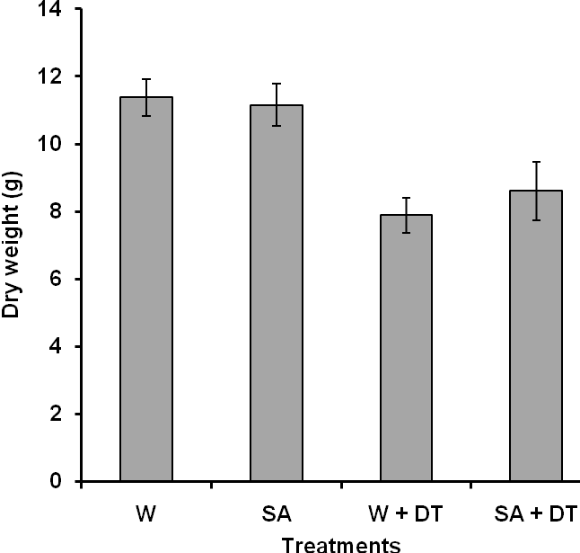
Figure 1. Whole plant dry weight of Celosia argentea under well watered (W), salicylic acid (SA), drought after water pretreatment (W+DT), and drought after salicylic acid pretreatment (SA+DT) conditions. Error bars represents standard error (n=3). Columns with different letters are significantly different at p<0.05.

The root/shoot weight ratio of C. argentea as affected by drought and salicylic acid treatments are presented in figure 2. It was observed that plants that continuously received salicylic acid and those pretreated with salicylic acid before drought treatment had significantly higher root/shoot weight ratio than plants that served as control.
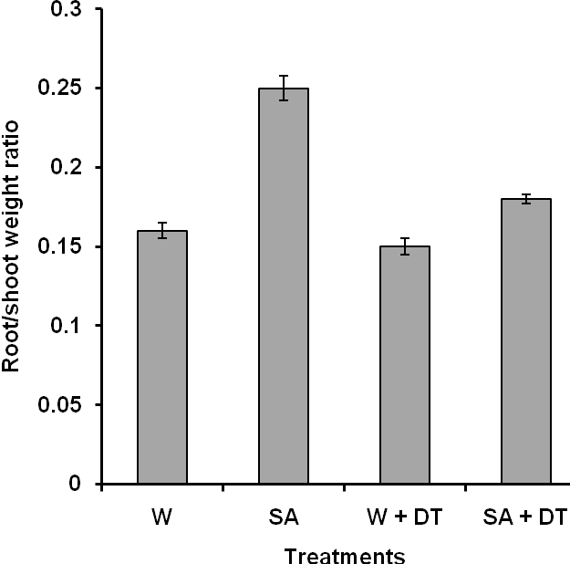
Figure 2. Root/shoot weight ratio of Celosia argentea under well watered (W), salicylic acid (SA), drought after water pretreatment (W+DT), and drought after salicylic acid pretreatment (SA+DT) conditions. Error bars represents standard error (n=3). Columns with different letters are significantly different at p<0.05.

Figure 3 showed the effects of drought and SA treatment on the relative water content in C. argentea leaves. The result indicated that SA boosted the RWC of the experimental plant. The RWC of plants pretreated with SA before drought treatment had a higher RWC values compared to plants that received water before drought treatment.
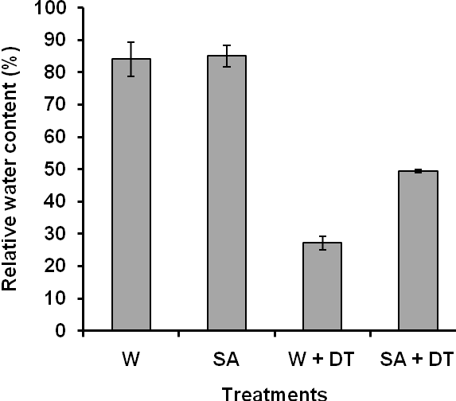
Figure 3. Leaf relative water content of Celosia argentea under well watered (W), salicylic acid (SA), drought after water pretreatment (W+DT), and drought after salicylic acid pretreatment (SA+DT) conditions. Error bars represents standard error (n=3). Columns with different letters are significantly different at p<0.05.

Drought stress led to a significant reduction in leaf area of C. argentea. Plants treated with salicylic acid only, had increased leaf areas with mean value of 23.18 ± 2.68 cm² while the control had mean value of 21.46 ±1.87 cm². It was observed in this study that SA pretreatment did not prevent the drought effect on the leaf area. While plants that were pretreated with SA before drought had 12.50 ± 0.84 cm², plants without SA pretreatment had 11.16 ± 1.76 cm² (figure 4).
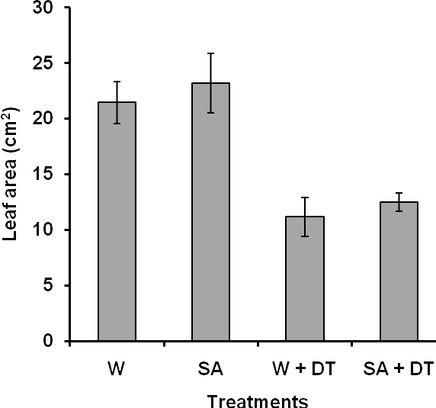
Figure 4. Leaf area of Celosia argentea under well watered (W), salicylic acid (SA), drought after water pretreatment (W+DT), and drought after salicylic acid pretreatment (SA+DT) conditions. Error bars represents standard error (n=3). Columns with different letters are significantly different at p<0.05.

In this study, it was observed that drought stress without SA pretreatment led to higher MDA in the leaves of C. argentea (figure 5). However, SA pretreatment had significant effect by reducing the concentration of MDA as result of drought treatment. Drought treatment led to the production of 2.56 ± 0.08 µmol/g f wt in plants without SA pretreatment, while 2.18 ± 0.08 µmol/g f wt was observed for SA pretreated plants.
Figure 6 showed the effects of drought and exogenous salicylic acid on the chlorophyll content of C. argentea. In the control plants, the total chlorophyll values recorded was 1.49 ± 0.08 mg/ g f wt. It was observed that plants that consistently received SA had a higher chlorophyll value of 1.60 ± 0.06 mg/g f wt. The level of chlorophyll was however reduced to 1.28 ± 0.06 mg/ g f wt when plants were exposed to drought without prior treatment with SA, while plants pretreated with SA before exposure to drought showed a significant increase in chlorophyll content.

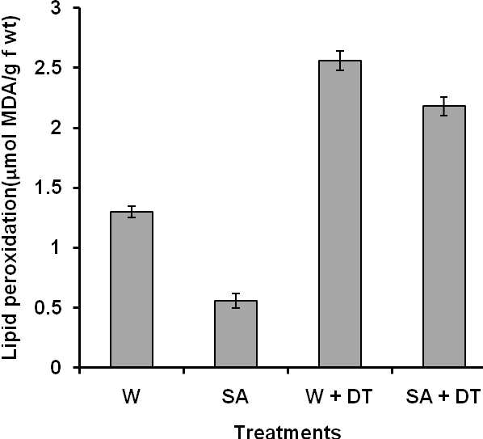
Figure 5. Malondialdehyde (MDA) in leaves of Celosia argentea under well watered (W), salicylic acid (SA), drought after water pretreatment (W+DT), and drought after salicylic acid pretreatment (SA+DT) conditions. Error bars represents standard error (n=3). Columns with different letters are significantly different at p<0.05.

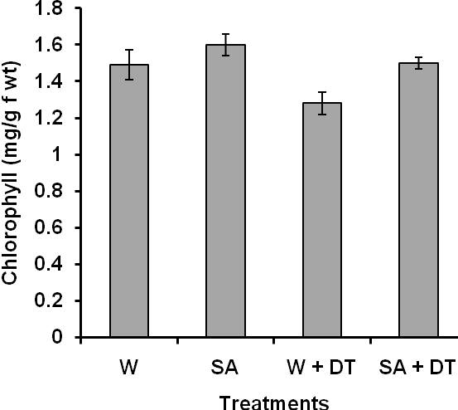
Figure 6. Chlorophyll content in leaves of Celosia argentea under well watered (W), salicylic acid (SA), drought after water pretreatment (W+DT), and drought after salicylic acid pretreatment (SA+DT) conditions. Error bars represents standard error (n=3). Columns with different letters are significantly different at p<0.05.

The activities of catalase (CAT) and ascorbate peroxidase (APX) were evaluated as representative enzymes involved in antioxidant metabolism. The activities of the two antioxidant enzymes followed the same trend when C. argentea were exposed to simulated drought. It was observed that drought treatment generally led to a significant increase in the activities of these enzymes, indicating drought- induced oxidative stress. Plants without SA pretreatment had the highest catalase activity of 32.09 ± 0.48 µmol/min/g f wt, while the control plants had the least value of 22.64 ± 0.28 µmol/min/g f wt. However, exogenous application of SA had some positive effect on the level of oxidative stress induced by drought (figure 7). In the same vein, plants exposed to drought without prior treatment with SA had the highest APX activity of 0.087 ±0.002 µmol ascorbate/mg protein/min. The control plants had 0.051±0.002 µmol ascorbate/mg protein/min, while plants that were pretreated with SA before drought treatment had 0.065 ± 0.002 µmol ascorbate/mg protein/min (figure 8).
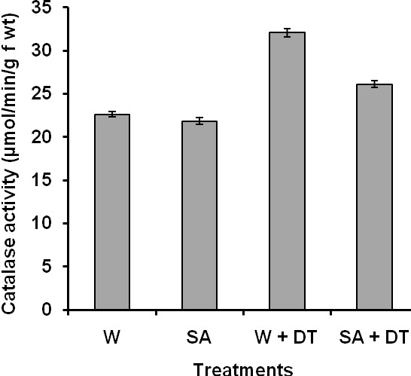
Figure 7. Catalase activity in leaves of Celosia argentea under well watered (W), salicylic acid (SA), drought after water pretreatment (W+DT), and drought after salicylic acid pretreatment (SA+DT) conditions. Error bars represents standard error (n=3). Columns with different letters are significantly different at p<0.05.

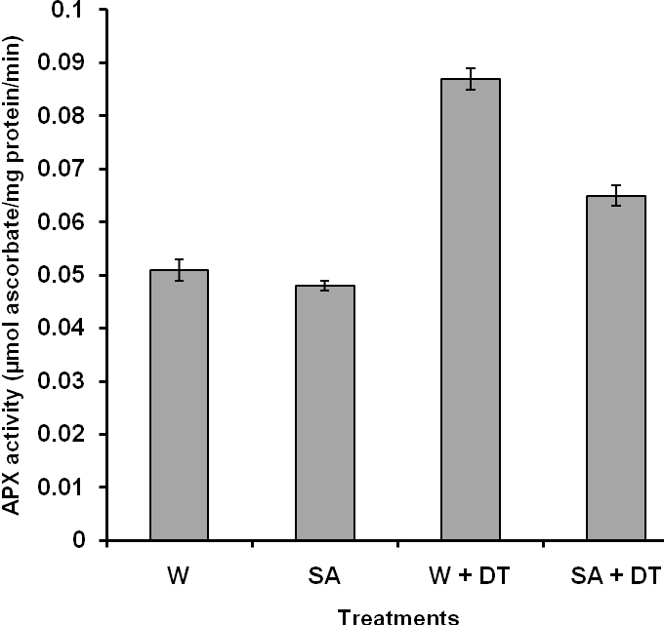
Figure 8. Ascorbate peroxidase activity in the leaves of Celosia argentea under well watered (W), salicylic acid (SA), drought after water pretreatment (W+DT), and drought after salicylic acid pretreatment (SA+DT) conditions. Error bars represents standard error (n=3). Columns with different letters are significantly different at p<0.05.

- Discussion
The present research was conducted to evaluate the beneficial role of SA on C. argentea exposed to simulated drought. Drought could affect plant growth and dry matter partitioning in plant parts differently (Spollen et al. 1993). Previous studies reported that the root growth and the root/shoot weight ratio were increased and that total dry biomass and shoot growth were reduced by drought stress (Alvarez et al. 2009). In this study, drought stress also increased the root/shoot weight ratio as a result of reducing shoot growth and promoting root growth (figures 1 and 2). The reason might be that plants grown under drought stress improved water use efficiency by increasing the proportion of water absorbing root biomass relatively to water-loosing shoot biomass (Lei et al. 2006). The reduction in whole plant dry weight could be attributed to drought effect on photosynthesis as it affects the gas exchange parameters such as CO₂ assimilation rate and stomata conductance (Yin et al. 2005). The beneficial role of SA in drought stress was evident in this study as plants pretreated with SA showed some levels of tolerance to drought. Similar result was reported by Shakirova (2007) that application of SA improved the growth of wheat exposed to salinity stress.
It is known that changes in leaf water content is one of the responses of whole-plant to drought stress, and has been used as an index for evaluating drought tolerance (Matin et al. 1989). The result of this study indicated reduction in RWC under drought stress. This agreed with the result earlier
reported by Liu and Jiang (2010); Bidabadi et al. (2012). The drought effect on RWC was ameliorated with the exogenous application of SA. It was observed that RWC of SA pretreated plants was higher than those without SA pretreatment when both were exposed to drought. Similar results have been reported in maize (Levent Tuna et al. 2007), wheat (Agarwal et al. 2005) and banana (Bidabadi et al. 2012).
With respect to the damage caused by drought to plants, drought induced considerable damage on the cellular membrane of C. argentea, as assessed by lipid peroxidation. The capacity to avoid membrane damage during dehydration process is crucial for the maintenance of membrane integrity. Increase in cellular damage appeared to reflect impairments in the equilibrium between the ROS production and antioxidant defense systems, which also indicated that photoprotection and antioxidant substances were not sufficient enough to protect against cell membrane damage caused by ROS. In this study, the severity of cellular damage was significantly reduced in plants that were pretreated with SA. This was in conformity with the findings of Agarwal et al. (2005) who mentioned that SA treatment of wheat leaves under water stress conditions, resulted in reduced amount of MDA.
The beneficial role of SA in enhancing plant performance under drought stress in terms of improved chlorophyll content was observed in this study. Generally, drought stress led to a significant reduction in total chlorophyll content, but this effect was alleviated with the application of SA. This result confirmed previous observations by other researchers that application of SA led to increased chlorophyll levels in plants under stress conditions (Hayat et al. 2007; Radwan et al. 2008; Delavari et al. 2010). This result suggests that SA pretreatment may improve the gross rate of carbon assimilation during drought stress.
Antioxidant enzymes (CAT and APX) associated with ROS scavenging, accumulated under drought stress. It was observed that SA pretreatment resulted in low accumulation of these enzymes in C. argentea under drought stress condition. This suggests that SA may also play an important role in inducing tolerance to oxidative stress conditions in plants.

5. Conclusion
In conclusion, this study showed that the harmful effects of drought stress on the growth of Celosia argentea plants were alleviated by exogenous application of salicylic acid. Thus, the increase in incidence of extreme weather events such as drought that could result from global warming can be allayed through biotechnological approaches by producing crop plants with high levels of endogenous salicylic acid.

Corresponding Author:
Dr. Victor Johwo Odjegba
Department of Botany
University of Lagos
Akoka, Lagos, Nigeria.
E-mail: jodjegba@unilag.edu.ng

References
- Aebi H. Catalase in vitro. Methods in Enzymology 1984: 105: 121-126.
- Agarwal S, Sairam RK, Srivastava GC, Meena RC. Changes in antioxidant enzymes activity and oxidative stress by abscisic acid and salicylic acid in wheat genotypes. Biologia Plantarum 2005: 49: 541 – 550.
- Alvarez S, Navarro N, Banon S, Sanchez-Blanco MJ. Regulated deficit irrigation in potted Dianthus plants: effects of severe and moderate water stress on growth and physiological responses. Scientia Horticulturae, 2009: 122: 579–585.
- Arnon DI. Copper enzymes in isolated chloroplast, polyphenol-oxidase in Beta vulgaris. Plant Physiology 1949: 24: 1-15.
- Bidabadi SS, Mahmood M, Baninasab B, Ghobadi C. Influence of salicylic acid on morphological and physiological responses of banana (Musa acuminata cv. ‘Berangan’, AAA) shoot tips to in vitro water stress induced by polyethylene glycol. Plant Omics Journal 2012: 5(1): 33-39.
- Bota J, Medrano H, Flexas J. Is photosynthesis limited by decreased Rubisco activity and RuBP content under progressive water stress? New Phytologist 2004: 162: 671–681.
- Bray EA. Plant responses to water deficit. Trends in Plant Science 1997: 2: 48–54.
- Chaves MM, Maroco JP, Pereira JS. Understanding plant responses to drought—from genes to the whole plant. Functional Plant Biology 2003: 30: 239–264.
- Cornic G, Massacci A. Leaf photosynthesis under drought stress. In: Baker NR ed Photosynthesis and the Environment. Kluwer Academic Publishers, Dordrecht 1996: 347–366.
- Dat JF, Lopez-Delgado H, Foyer CH, Scott IM. Parallel changes in H₂O₂ and catalase during thermotolerance induced by salicylic acid and heat acclimation of mustard seedlings. Plant Physiology 1998: 116: 1351-1357.
- Delavari PM, Baghizadeh A, Enteshari SH, Kalantari KHM, Yazdanpanah A, Mousavi EA. The effects of salicylic acid on some of biochemical and morphological characteristic of Ocimum basilicum under salinity stress. Australian Journal of Basic and Applied Sciences 2010: 4(10): 4832 – 4845.
- Eze JMO. Studies on growth regulation, salt uptake and translocation. Ph.D. Thesis. University of Durham, England. 1965: 31-33.
- El–Tayeb MA. Response of barley grains to the interactive effect of salinity and salicylic acid. Plant Growth Regulators 2005: 45: 215 – 224.
- Guo J, Yang Y, Wang G, Yang L, Sun X. Ecophysiological responses of Abies fabri seedlings to drought stress and nitrogen supply. Physiologia Plantarum 2010: 139: 335-347.
- Hare PD, Cress WA, Van Staden J. Dissecting the role of osmolyte accumulation during stress. Plant Cell and Environment 1998: 21: 535-553.
- Hayat S, Ali B, Ahmad A. Salicylic acid: Biosynthesis, metabolism and physiological role in plants. In: Hayat, S. and A. Ahmad eds. Salicylic acid: A plant hormone. Springer, Netherlands 2007: 1 –14.
- Horvath E, Szalai G, Janda T. Induction of abiotic stress tolerance by salicylic acid signaling. Journal of Plant Growth Regulation, 2007: 26: 290 – 300.
- Janda T, Szalai G, Tari I, Paldi E. Hydroponic treatment with salicylic acid decreases the effect of chilling injury in maize (Zea mays L.) plants. Planta 1999: 208: 175–180.
- Krantev A, Yordanova R, Janda T, Szalai G, Popova L. Treatment with salicylic acid decreases the effect of cadmium on photosynthesis in maize plants. Journal of Plant Physiology 2008: 165: 920-931.
- Lawlor DW, Cornic G. Photosynthetic carbon assimilation and associated metabolism in relation to water deficits in higher plants. Plant Cell and Environment 2002: 25: 275–294.
- Lei YB, Yin CY, Li CY. Differences in some morphological, physiological, and biochemical responses to drought stress in two contrasting populations of Populus przewalskii. Physiologia Plantarum 2006: 127:182–191.
- Levent Tuna A, Kaya C, Dikilitas M, Yokas I, Burun B, Altunlu H. Comparative effects of various salicylic acid derivatives on key growth parameters and some enzyme activities in salinity stressed maize (Zea mays L.) plants. Pakistan Journal of Botany 2007: 39(3):787– 798.
- Liu S, Jiang Y. Identification of differentially expressed genes under drought stress in perennial ryegrass. Physiologia Plantarum 2010: 139: 375-387.
- Machlachlan S, Zalik S. Plastid structure chlorophyll concentration and free amino acid composition of a chlorophyll mutant of barley. Canadian Journal of Botany 1963: 41:1053- 1062.
- Matin MA, Brown JH, Ferguson H. Leaf water potential, relative water content, and diffusive resistance as screening techniques for drought resistance in barley. Agronomy Journal 1989: 81: 100–105.
- Nakano Y, Asada K. Hydrogen peroxide is scavenged by ascorbate specific peroxidase in spinach chloroplasts. Plant and Cell Physiology 1981: 22: 867-880.
- Radwan DEM, Lu G, Fayez KA, Mahmoud SY. Protective action of salicylic acid against bean yellow mosaic virus infection in Vicia faba leaves. Journal of Plant Physiology 2008: 165: 845 – 857.
- Ramanjulu S, Bartels D. Drought and desiccation-induced modulation of gene expression in plants. Plant Cell and Environment 2002: 25: 141–151.
- Raskin I. Role of salicylic acid in plants. Annual Review of Plant Physiology and Plant Molecular Biology 1992: 43: 439- 463.
- Shah J. The salicylic acid loop in plant defense. Current Opinion in Plant Biology 2003: 6: 365-371.
- Shakirova FM. Role of hormonal system in the manifestation of growth promoting and anti-stress action of salicylic acid. In: Hayat, S. and A. Ahmad eds. Salicylic acid, A plant hormone. Springer, Netherlands 2007: 69-89.
- Spollen WG, Sharp RE, Saab IN, Wu Y. Regulation of cell expansion in roots and shoots at low water potentials. In: Smith, J.A.C. and H. Griffiths (eds.) Water deficits, plant responses from cell to community. Bios Scientific Publishers, Oxford 1993: 37-52.
- Szalai G, Tari I, Janda T, Pestenacz A, Paldi E. Effects of cold acclimation and salicylic acid on changes in ACC and MACC contents in maize during chilling. Biologia Plantarum 2000: 43: 637-640.
- Szepesi A, Csiszar J, Gemes K, Horvath E, Horvath F, Simon ML, Tari I. Salicylic acid improves acclimation to salt stress by stimulating abscisic aldehyde oxidase activity and abscisic acid accumulation, and increases Na⁺ content in leaves without toxicity symptoms in Solanum lycopersicum L. Journal of Plant Physiology 2009: 166: 914–925.
- Tsugane K, Kobayashi K, Niwa Y, Ohba Y, Wada K, Kobayashi H. A recessive Arabidopsis mutant that grows photoautotrophically under salt stress shows enhanced active oxygen detoxification. Plant Cell 1999: 11: 1195–1206.
- Turner NC. Techniques and experimental approaches for the measurement of plant water status. Plant and Soil 1981: 58: 339–366.
- Wang H, Jin JY. Photosynthetic rate, chlorophyll fluorescence parameters, and lipid peroxidation of maize leaves as affected by zinc deficiency. Photosynthetica 2005: 43: 591-596.
- Yin C, Peng Y, Zang R, Zhu Y, Li C. Adaptive responses of Populus kangdingensis to drought stress. Physiologia Plantarum 2005: 123: 445–451.

11/28/2012

