Efficacy of some living classical and variant infectious bronchitis vaccines against local variant isolated from Egypt.

Susan, S. El- Mahdy; Ekram, Salama and Amal, Ahmed

Central Lab. for Evaluation of Vet. Biol. Abb. Cairo (CLEVB).
Prof.s.elmahdy@gmail.com.

Abstract: This study was designed to evaluate the protection induced by different living classical and variant infectious bronchitis vaccines (IB vaccines) against local variant isolated from Egypt at 2012. Two hundred and fourty one day old Specific-pathogen-free (SPF) chicks were divided into eight groups. Groups (1-3) were vaccinated with three different variant infectious bronchitis living vaccine and group (4-6) with three different classical one. Groups (7&8) did not receive IBV vaccine and served as (+ve and –ve) controls respectively. Three weeks post vaccination, the chickens in groups (1-7) were individually challenged with 10 ^{4.0}EID₅₀ of IB (IS/885).The protection was evaluated at 7 days post-inoculation. The results of this study showed that we can use IB-88; IB primers (variant) and Ma5 (classical) vaccines as a method for controlling IB infection in Egypt.
[Susan, S. El- Mahdy; Ekram, Salama and Amal, Ahmed. Efficacy of some living classical and variant infectious bronchitis vaccines against local variant isolated from Egypt. Nat Sci 2012;10(12):292-299]. (ISSN: 1545-0740). http://www.sciencepub.net/nature. 44

Key words: Infectious bronchitis vaccines; chickens; local variant strain.

1. Introduction
The Egyptian poultry industry in recent years has observed an increasing incidence of respiratory and nephritis pathologies related to infection with infectious bronchitis virus (IBV) in vaccinated and non-vaccinated flocks that caused severe economic losses. (Susan et al., 2010). IBV was firstly descripted as a highly contagious pathogen in chickens in the late 1930s (Schalk and Hawn, 1931). During 1950s IB infection was firstly recognized in Egyptian farms by Ahmed (1954) and confirmed by Eissa et al., (1963) from birds showing respiratory signs.
IBV is a member of the Corona-virus and which considered a major cause of respiratory infection in broiler and poor egg laying in breeders and layers, which replicated primarily in respiratory tract and also in some epithelial cells of the gut, kidney and oviduct (Cavanagth and Nagi 2003; Wit et al., 2010) some stains of IBV can cause acute nephritis and urolithiasis associated with a high mortality rate in infected chickens (Ziegler et al., 2002; Liu and Kong 2004; Sultan et al., 2004; Abdel-Moneim et al 2006; Susan et al., 2010). Prevention and control of the disease are through the use of many types of vaccines. In spite of the intensive use of vaccines, out breaks of IB frequently occur in the field in many countries (El-Kady 1989; Gelb et al., 1991: Gough et al., 1992; Capua et al., 1994; Jia et al., 1995; Liu and Kong 2004; Susan et al., 2010). This situation may be due to the emergence of new variant serotypes of IBV (Bastami et al., 1987; Gelb et al., 1991; Gough et al., 1992; Kwon et al., 1993; Jia et al., 1995; Liu and Kong 2004; Gelb et al., 2005; Pohuang et al., 2009).
Consequently these emergences are of great concern to poultry producers. Since the isolation of IBV from chickens suffering from respiratory or renal problem in Egypt (Ahmed 1964). IB has continued to be an economically important disease in the Egypt poultry industry and has been found all over the country. Many researchers isolated IBV related to Massachusetts, D3128, D274, D-0880, 4/91, Egypt / Beni-Suef /01; Egypt/F/03 and IS/1494/06 were isolated from different poultry farms (Amin and Moustagger 1977.; Sheble et al., 1986; Bastami et al., 1987; El-Kady 1989; Eid Amal. 1994; El-Sisi and Eid Amal. 2000; Abdel Moneim et al., 2002 and 2006; Sultan et al., 2004 and Susan et al., 2010). IB complete protection is provided by vaccination with homologous strains however, partial protection may be provided after vaccination with a live attenuated heterologous strain (Wang et al., 1996; Liu et al., 2009). Although many strains of vaccine are commercially available at present, it is unknown whether the currently used vaccines offer enough cross-protective capability against the IBV strains present in the field in Egypt.
Hence, the objective of the present study was to examine the protection afforded by some living classical and variant infectious bronchitis commercial vaccines against recent local variant IBV isolated from Egypt at 2012.

2. Materials and Methods
Living infectious bronchitis vaccine:
Six IB commercial live attenuated vaccines were used; three variant IB Vaccines: Nobilis IB 4-91 Batch No. (A0860J01); Gallivac IB 88 (CR 88121) Batch No. (L381024) and polyvac IB Primer (D274); Batch No. (CZ056 0006). And another three classical IB Vaccines:Avipro IB M48 Batch No.( 2409F); H120 Marial; Batch No.( 11623LJ 01) and Intervet Ma5 Sphereon with Batch No.( A120A1N02).
Variant infectious bronchitis virus (IB-IS/885):
A local field isolate of variant infectious bronchitis virus was kindly supplied by (Dr. Rabab), Cairo poultry cooperation group (CPC). It was isolated from broiler flock, 24 day of age during an outbreak of IB in broiler farm in Egypt at May 2012. Clinical signs and lesions observed during the outbreak were an increase in mortality rate and nephritis. The variant virus was isolated from spleen and kidney of sick broiler in 9-11 day old embryonated SPF chicken eggs.
The strain was sequenced and identified by reference Lab for vet. Quality Control on Poultry Production. Virus titration was done using microtitre technique according to Rossiter and Jessett (1982) and calculated according to Reed and Muench (1938).
Experimental Hosts:
One day old SPF chicks: Chicks free from MDA (maternal driving antibodies) against IBV obtained from SPF poultry farm at Koum Osheim El-Fayoum, Egypt were used in this study.All birds were reared in cages and kept in a strict isolated mosquito proof room. The room was previously cleaned, thoroughly disinfected and provided with clean water and food.
Enzyme linked Immuno- Sorbent Assay (ELISA): (Snyder et al., 1986):
ELISA Kit was obtained from Biochek poultry immuno assys. Infectious Branchitis virus antibody test kit (CK 119); Serial No. F55419 product code: 5030.
Haemagglutination inhibition test (HI):
HI test was carried out according to Munir et al., (2012). Haemagglutinating (HA) antigens were prepared from chorioallantoic fluid harvested from IBV- inoculated embryonated SPF eggs and concentrated 100-fold by ultracentrifugation. The concentrated IBV strains were treated and used as HA antigens accordint to Mahmood et al., (2004).
Polymerase chain reaction (PCR): Council of Europe (1999) :
PCR used for detect of Identity of commercial vaccines under test: RNA extraction kit using Bioflux Simply totat RNA extraction kit cat # (20111103). Amplification by using BIOER reverse transcription polymerase chain reaction (RT-PCR) kit one step cat # 20120603.
Statistical analysis:
It was applied using Epi-Info-Computer programme designed by Dean et al., (1994) and produced by World Health Organization (WHO). The calculation was according to Knapp and Miller (1991).
Experimental Design:
Eight groups of 30 SPF chicks each were used in the study. Birds from groups (1 to 6) were vaccinated via the nasal route with recommended dose of different examined commercial vaccines at one day old as shown in table (1). While birds in groups (7 & 8) were kept as control (+ve &–ve); respectively. Three weeks after vaccination; chickens from groups (1-7) were challenged simultaneously with 100 UL of IB (IS/885) challenge virus at dose of 4.0 log 10 EID₅₀ per 0.1 mL, administered via the oculi nasal route. Group 8 was left as an unchallenged control. Before challenge a blood sample was collected from each bird in order to determine the HI and ELISA antibody titer for different type of vaccines under test.Following challenge, all birds were observed daily for clinical signs attributable to IB infection.

3. Results
After IBV challenge, there was no mortality but at 48h after challenge; birds of group (7) - unvaccinated group- exhibited conjunctivitis, mainly of a third type with reluctant to move and in some cases presented with dyspnea. Food and water consumption were decrease with high rate in comparison with (-ve) control group (8). These symptoms regressed progressively in intensity until disappearance. Approximately 84h after challenge. Birds in groups (1-6) no clinical signs attributable to IBV infection were observed except very mild conjunctivitis in some birds in groups (1; 4; 5 & 6) that resolved within 48h and the clinical signs of tracheal rales were observed. Serological results, HI and ELISA test were applied to evaluate the antibody response in chickens (table -1).
Body weight: The body weights of chickens before IBD challenge at 21 days old were not significantly different (P> 0.05). At 7 days post challenge, the body weight of chickens in groups (1-6) which had received the vaccine was better than that of (group 7), the positive control. A significant difference (P <0.05) in body weight was found between birds in groups (3& 6) and the +ve control group as in table (2). Virus isolation and detection: The tracheal swaps and kidneys were separately collected from individual chickens for virus detection at 7 days post challenge. SPF eggs were used for virus isolation. IB (IS /885) was detected in the trachea and kidney of each chicken of all groups. The detection rate of the virus in the kidneys was higher than in the trachea. The detection rate of the virus in the vaccinated groups was lower than that of the positive control group (G-7) with significantly difference (P <0.05). The rate of virus detection in birds in groups (3 and 6) was lower than that of groups (1; 2; 4; and 5), but it was not significantly difference (P >0.05).
Histological examination: At 7 days post challenge the kidney of non-vaccinated birds (G7) showed foci of necrosis and large amount of urates in ureters, which no lesions attributable to infection with IBV were observed in the vaccinated ones. (Fig: 3).

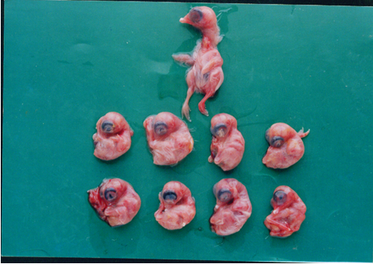
Fig (1): The embryos inoculated with the IB vaccine under test.
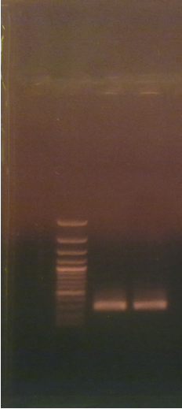
Fig (2): The PCR amplification of the spike gene from IB vaccines under test.
The amplification of the 300bp fragment of the vp gene of IB virus of six vaccine batches.

Fig (3): The histological examination.
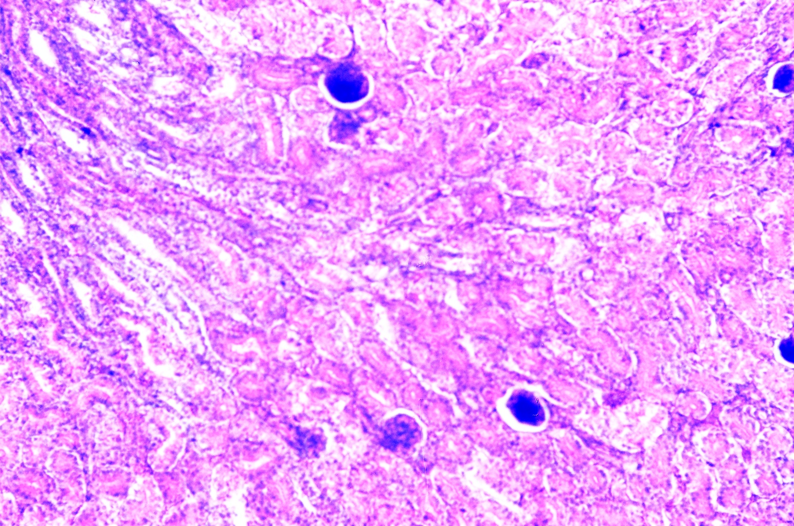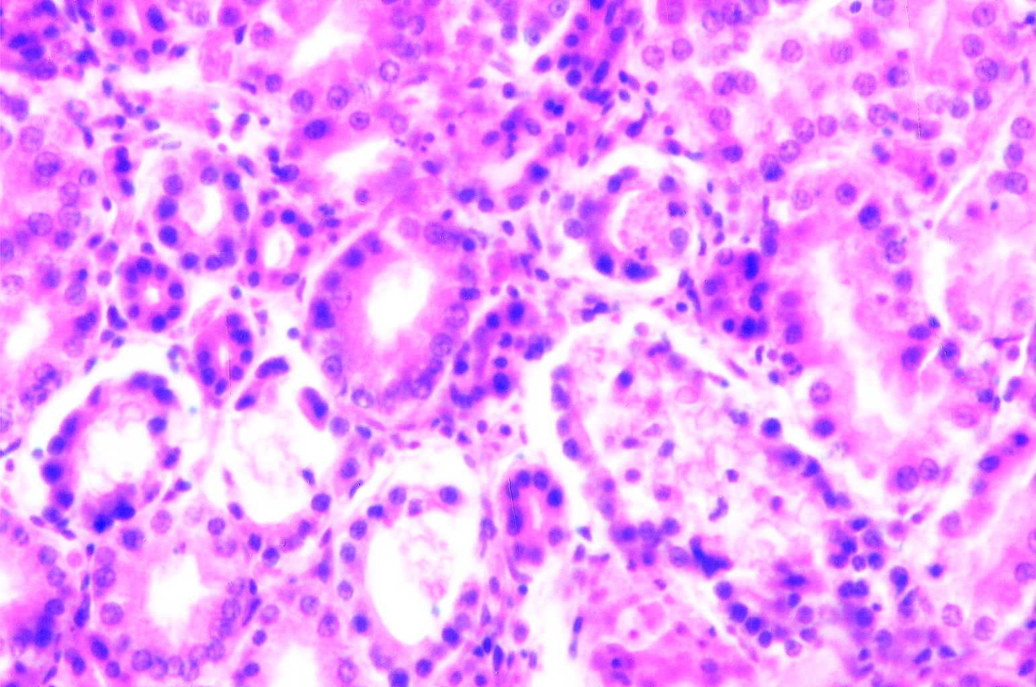
3.1
3.2
(3.1) kidney of chicken in control SPF group showing the normal histological structure of glomeruli and renal tubules (H & E, 40x)
(3.2) kidney of SPF chicken experimentally infected by IB showing hyperemic blood capillaries and inflammatory cells infiltration in between the degenerated and necrotic tubules (H&E, 40x)

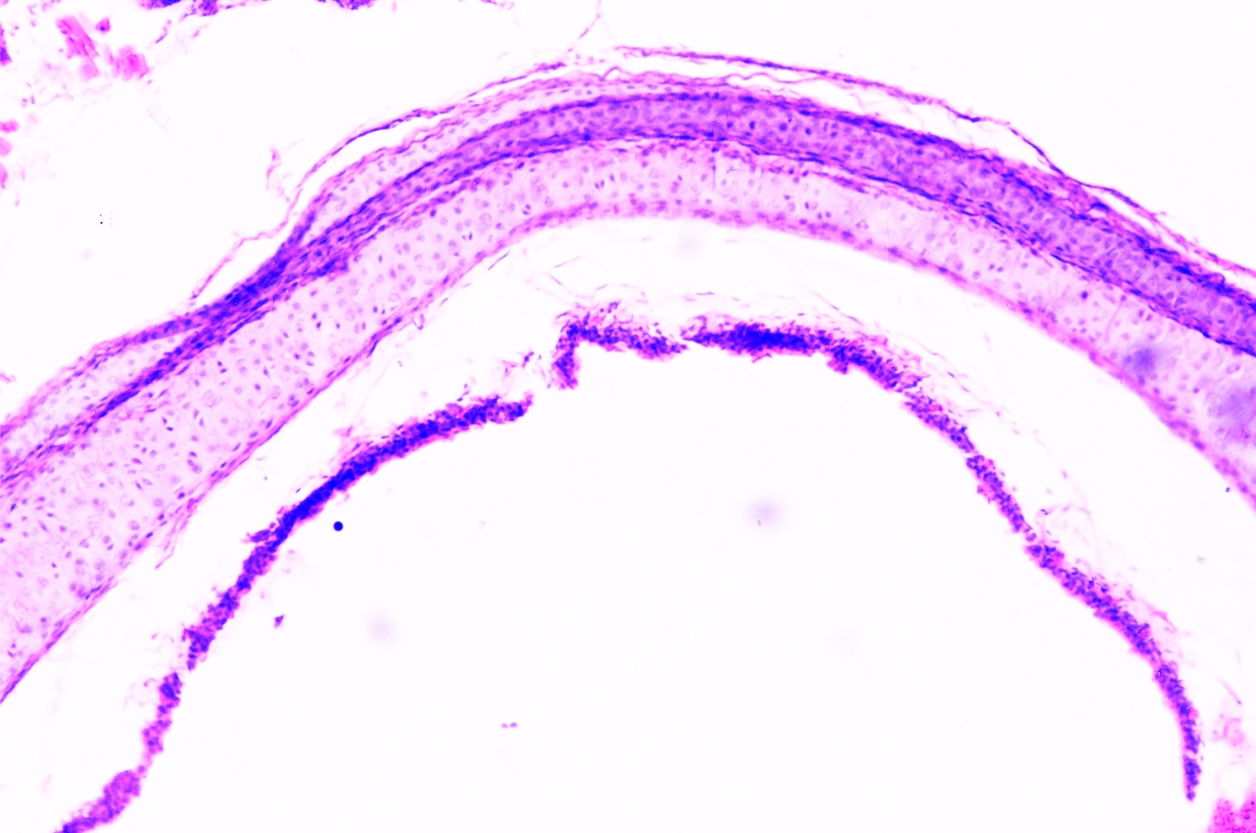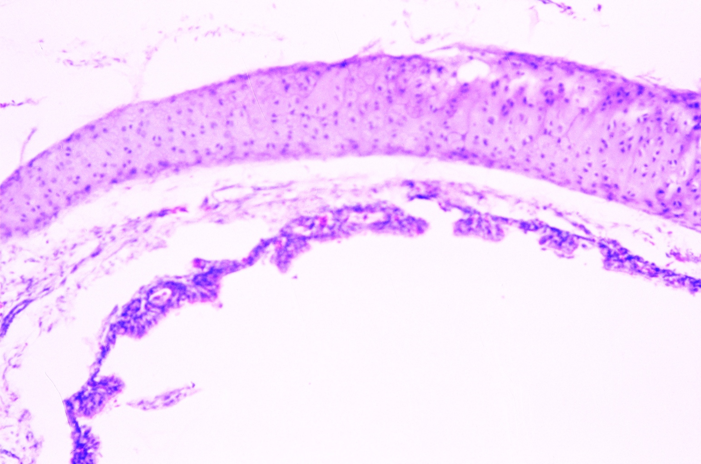
3.3
3.4
(3.3) Trachea of chicken in control SPF group showing the normal histological structure of mucosal layer cartilaginous layer. (H&E,40x)
(3.4) Trachea of SPF chicken experimentally infected by IB virus showing hyperplasia with polyps formation in the hyperemic lining mucosal layer. (H&E, 40 xs)

Table (1): Monitoring antibody response to different IB commercial vaccines (HI and ELISA)
Test Group | Type of Vacc | GMT of ELISA  Antibody titer | GMT of HI  Antibody titer
G1  G2  G3  G4  G5  G6  G7  G8 | IB 4-91  IB CR 88  IB Primer  M48  H 120  MA₅  Contol +ve  Control –ve | 8068.00  3195.40  5162.37  4850.00  3871.00  4210.10  156  156 | 7.60  9.12  8.80  9.50  10.0  9.90
GMT: Geomtric mean titer
N.B.: Titer of control positive serum is equal or more than 3000 in ELISA antibody titer for IB living vaccine according to OIE (2010).
Significant difference at P ≤ 0.05

Table (2): Body weight before and after IBV challenge and clinical sign after IBV challenge:
Test Group | Type of Vacc | *Body wight |  | **Clinical Sign | ***No. of survived | %
Test Group | Type of Vacc | 3 ws old | 4 ws old | **Clinical Sign | ***No. of survived | %
G-1  G-2  G-3  G-4  G-5  G-6  H-7  H-8 | IB 4-91  IB 88  IB primer  M 48  H 120  M A 5  Cont. + Ve  Cont. –ve | 1.201  1.205  1.310  1.205  1.207  1.390  1.400  1.405 | 1.500  1.590  1.699  1.460  1.500  1.780  1.450  1.807 | 2/30  0/30  0/30  2/30  5/30  0/30  30/30  0/30 | 28/30  30/30  30/30  28/30  25/30  30/30  0/30  30/30 | 93  100  100  93  83  100  0  100
*Mean of body weight ws : weeks
**Number of chickens with clinical signs / total chickens in group.
***Number of survived chickens till the end of test/total chicken.
Significant difference at P < 0.05

4. Discussion
In this study, the efficacy of some living classical and variant IBv vaccine which used in Egyptian farms was evaluated after the challenge with local variant (IB-IS/885) that isolated at May 2012 from broiler flock in Egypt. Four parameters were used for the evaluation of the protection including clinical protection based on conjunctivitis because the conjunctivitis being the primary sign of infection; protection against weight loss as an important economical parameter especially in broiler flocks. Anti-body level against IBV which monitoring by ELISA and HI. The last parameter was virological detection at 7 days post challenge with histological examination. The results of clinical protection showed no mortality and mild conjunctivitis in some birds in birds vaccinated with 4-91; M48; H120 and Ma5 respectively and clinical signs of tracheal roles were observed when compared with birds in group (G8). The results of clinical protection showed in chickens vaccinated with IBV vaccination were significantly lower (P< 0.05) that of the none vaccinated chickens, indicating that clinical protection had been achieved. The reasons for the clinical protection against the challenge strain might be that live attenuated vaccines induced local immunity in the upper respiratory tract which prohibited the invasion of the challenge. (IB-IS /885) virus in the tracheal mucosa. So that clinical protection had been achieved. Our results agree with Nakamura et al., (1991); Thompson et al., (1997); Pei et al., (2003) and Sasipreeyajan et al., (2012) which reported that results of clinical protection showed respiratory signs in chickens vaccinated with all of the IBV vaccination programs.
In our study, vaccination with different types of living commercial vaccines provided a low clinical sign of respiratory disease, but it could not prevent the effect of the disease on body weight gain which could be detected after challenge with (IB-IS/885).
The body weight affected in groups (4 & 5) more than (1 & 2); while birds in group (3 & 6) the rate of body weight near to control –ve group (G-8). The same results could be detected by Sasipreeyajan et al., (2012) which finding the body weight affect 7 days after using QX-Like IBV.
For studying potency effect in this trial; we used two serological tests (CELISA and HI), ELISA (GMT) gave 8068; 3195.4; 5162.37; 4850; 3871.0; 4210.1 when used different variant and classical living attenuated commercial vaccines in comparison with unvaccinated negative control (156). The ELISA Technique is a sensitive serological method and give earlier reactions and higher antibody titers than other tests according to Mockett & Darbyshire (1981). Our finding of serum antibody titers which detected by ELISA technique who agree with pensaert and Lambrechts, (1994); Alvarado. et al., (2003); Hamel. et al., (2006), Martin. et al., (2007), Salama. et.al., (2010) Susan et al., (2011) and Sasipreeyajan. et al., ( 2012).A medium to low humoral response is in keeping with that expected following the administration of live attenuated classical and variant IB vaccines. As expected, the highest titers were obtained using antigens homologous to vaccine strains.
Our results in table (1) for mean log₂ HI titers for differenet IB vaccines under test(7.6 -9.12 -8.80 -9.5- 10.0- 9.90)were agree with Macpherson and Feest (1978); Macdonald et al., (1981); Elham et al., (1995); Susan et al., (2000); Mahmood et al ., (2004) and Terregino et al., (2008).According to the European Pharmacopoeia's Reference standards (Council of Europe (2007)) the test to evaluate IBV vaccine protection is considered valid if the challenge virus is isolated from No. less than 80% of control group. A vaccine is considered effective if the challenge virus is isolated from less than 20% of birds vaccinated. All of the non vaccinated birds were infected based on detection of virus in kidney and so the challenge experiment was successful. The presence of viable virus in kidneys confirms the ability of IB/885 challenge virus to replication and act as nephropathogenic potential as reported in case of IBV-QX by Liu and Kong (2004) and Terregino et al., (2008) and parcially with Salama et al., (2010) when used virulent IBV (M41). For studying the relation between serological antibodies and results of protection percentage, it could be attributed to presence of local immunity of the upper respiratory tract induced by vaccination reduced the replication of challenge virus after challenge by the oculonasal route. Furthermore, immune responses directed to epitopes involved in protective immunity might not be fully detected by the HI test as reported by; Cook et al., (1999); Worthington et al., (2004) and Terregino et al.,( 2008).
Based on the data presented in this study it can be concluded that, under experimental condition the IB variant (IB-88; IB primers) and classical one (Ma5) vaccines administered at 1 day protect chickens from infection and disease following challenge with local IB (IS/ 885) variant strain which recently isolated in Egypt at May 2012. This confirms that under field conditions we can use vaccination programs based on our results to reduce the economic losses caused by variant IB infection viruses in Egypt.

Corresponding author
Susan, S. El-Mahdy
Central Lab. for Eval. of Vet. Biol. Abbassia Cairo, Egypt (CLEVB)
Prof.s.elmahdy@gmail.com

References
- Abdel-Moneim, A.S; El-Kady, M.F; Ladman B.S & Gelb J. Jr: (2006): S1 gene sequence analysis of a nephropathogenic strain of avian infectious bronchitis virus in Egypt. Virology. J 3:78
- Abdel-Moneim A.S; Madbouly H.M; Gelb, J .Jr. & Ladman BS. (2002): Isolation and identification of Egypt/Beni-Suef/ -1` a novel genotype of infectious bronchitis virus. Vet Med J Giza, Egypt . 50:1065-1078.
- Ahmed, A.A.S. (1964): Infektiose Bronchitis des huhmes in Agypten. Berl. Munchen Tieraerzl, Wschr, 77:481-484
- Ahmed, H.N. (1954): Incidence and treatment of some infectious viral respiratory diseases of poultry in Egypt.M.Sc. Thesis, Cairo Univ.
- Alvarado, I.R.; Villegas, P.; El-Attrache, J. & Brown, T.P. (2003): Evaluation of the protection conferred by commercial vaccines against the California 99 isolate of infectious bronchitis virus. Avian Dis. 47: 1298-1304.
- Amin, A.A. & Moustagger M. (1977): A preliminary report on an avian infectious bronchitis virus strain associated with nephritis nephrosis syndrome in chickens. J, Egypt. Vet. Med. Ass., 32: 71-77.
- Bastami, M.A.; Amer, M.M. & Hamouda, A.S. (1987): Viral nephritis induced by an isolant related to linfectious Bronchitis virus. 1. Isolation and identification of the isolant. Assiut Vet Med. J., 19 (37): 173.
- Capua, I.; Gough, R.E.;Mancini, M.; Casaccia, C. & Weiss, C. (1994): A "novel" infectious bronchitis strain infecting broiler chickens in Italy. Zentrabl Veterinarmed B, 41: 83-89.
- Cavanagth, D. & Nagi. S. (2003): Infectious bronchitis In Y.M. Saif, H. J. Barnes, J.R. Gisson, A. M. Fadly. L.R. McDougald & D.E. Swayne (Eds.), Disease of Poultry. 11th edn (pp. 511-526), Ames: Iowa State University Press.
- Cook, J.K.A.; Orbell, S.J.; Woods, M.A. & Huggins M.B. (1999): Breadth of protection of the respiratory tract provided by different live-attenuated infectious bronchitis vaccines against challenge with infectious bronchitis virus of heterologous serotypes. Avian Pathol. 28:477-
- Council of Europe (1999): 2, 6, 3 avian viral vaccines: Tests for extraneous Agents in seed lots pharmeuripa 11, 188-191.
- Council of Europe (2007): Avian infectious bronchitis vaccine (live) 01.2008. 9442. In European Pharmaopoeiu 6th edb (pp. 865-867(. Strasbourg, France. Nordlingen, Germany: Druckerei C.H. Beck.
- Dean, J. A.; Coulmbier, D.; Smith, D.; Brendel, K.; Armen, T, & Deon, A. (1994): Epi-Inf version 6., A word processing data base and statistics programme for public health on IBM compatible microcomputers.
- Eid, Amal. A.M. (1994): Studies on some avian viruses with a special reference to a heat resistant Newcastle disease virus, Ph.D Thesis, Poultry Dis Fac, Med, Zagazig Unit, Zagazig, Egypt.
- Eissa, Y.M.; Zaher, A, & Nafai, E. (1963): Studies on respiratory diseases. Isolation of infectious Bronchitis virus, J. Arab. Vet Med. Ass., 23:381.
- El- Kady Mf (1989): Studies on the epidemiology and means of control of infectious bronchitis disease in chickens in Egypt, In PhD thesis Faculty of Veterinary Medicine. Cairo University. Egypt.
- El- Sisi, M.A. & Eid, Amal. A.M. (2000): Infectious bronchitis virus and infectious bursal disease, concurrent infection among broilers in Egypt. Zagazing, Vet. J., 28: 150-153.
- Elham, A.El-Ebiary; Suzan,S.El-Mahdy &M.S. Wassel (1995): comparison between serological response in vaccinated chicks with different commercial ND and IBV vaccines either alone or combined vaccines Assiut. Vet. Med. J. Vol. 32 (64) pp 282-294.
- Gelb, J.Jr.; Weisman, Y.; Ladman, B.S. & Meir, R. (2005): S1 gene characteristic and efficacy of vaccination against infectious bronchitis virus field isolates from the United States and Israel (1996 to 2000). Avian Pathol. 34: 194-203.
- Gelb, J. Jr.; Wolff, J.B. & Moran, C.A. (1991): Variant serotype of infectious bronchitis virus isolated from commercial layer and broiler chickens. Avian Dis. 35: 82-87.
- Gough,R.E.;Randall,C.J.;Dagless,M.;Alexander,D.J;Cox,W.J. & Pearson,D.(1992):Anew strain of infectious bronchitis virus infecting domestic fowl in Great Britain. Vet Rec. 130:493-494.
- Hamel, K. R.; Burgess, S.C.; Pevzner, I.Y. & Erf, G.F. (2006): Maternal antibody transfer from dams to their egg yolks, egg whites, and chicks in meat line of chickens. Poult. Sci. 85: 1364-1372.
- Jia, W.; Karaca, K.; Parrish, C.R. & Nagi. S.A. (1995): A novel variant of avian infectious bronchitis virus resulting from recombination among three different strains. Arch virol. 140: 259-271.
- Knapp, R.J. &Miller, M. C. (1991): Clinical epidemiology and biostatistics. Harwal Publishing. Company Malvern Pennsylvania, Special Edition for National Medican Series for independent Study.
- Kwon, H.M.; Jackwood, M .W. & Gelb, J. (1993): Differentiation of infectious bronchitis virus serotypes using polymerase chain reaction and restriction fragment length polymorphism analysis. Avian Diseases, 37: 194-202.
- Liu, S. W.; Zhang, X.N.; Wang, Y.; Li. C.G.; Liu, Q.; Han, Z.X.; Zhang, Q.X.; Kong, X.G. & Tong, G. Z. (2009): Evaluation of the protection conferred by commercial vaccines an attenuated heterologous isolates in China against the CK/CH/LDL/971 strain of infectious bronchitis coronavirus. Vet J. 179:130-136.
- Liu, S.W. & Kong, X.G. (2004): A new genotype of nephropathogenic infectious bronchitis virus circulating in vaccinated and non-vaccinated flocks in china. Avian Pathol. 33:321-327
- Macdonald, J.W.; Randall, C.J.; Mcmartin, D.A.; Dagless, M.D; & Gazdzinski, P. (1981): Active and passive immunization against nephritis induced by an avian infectious bronchitis virus. Avian pathology, 10:121-129.
- Macpherson, I. & Feest, A. (1978): Some observations on the value of the infectious bronchitis haemagglutination inhibition test in the field. Avian path. 7: 337-347.
- Mahmood, M.S.; Siddique, M.; Hussuin, I & Khan, A. (2004): Trypsin – induced hemagglutination assay for the detection of infectious bronchitis virus. Pakistan vet., J., 24 (2): 54-58.
- Martin, M.P.; Wakenell, P.S; Woolcock, P. & O'Connor B. (2007): Evaluation of the effectiveness of two infectious bronchitis virus vaccine programs for preventing disease caused by California IBV field isolate. Avian Dis. 51: 554-589.
- Mockett E.P.A & Derbyshire J.H. (1981): Comparative Studies with an Enzyme-linked immunosorbent assay (ELISA) for antiboidies to avian infectious bronchitis virus, Avian Pathol., 10, 1-10.
- Munir Shahzad, Mubashir Hussain, Umar Faroog, Zabil Ullah, Qaiser Jamal, Mehwesh Afreen, Kalsoom Bano, Jafar Khan, Sultan Ayaz, Kill Yon Kim & Muammed Anees. (2012): Quantification of antibodies against poultry haemagglutinating viruses by haemagglutination inhibition test in Lahore Afr. J. Microbiol Res. Vol. 6 (21), PP. 4614-4619.
- Nakamoura, K.; Cook, J.K.A.; Otsuki, K.; Huggins, M.B; &Frzaier, J.A. (1991): Comparative study of respiratory lesion in two chicken lines of different susceptibility infected with infectious bronchitis virus: Histology, ultrastructure and immunohistochemistry. Avian Patholol. 23:631-641.
- OIE, (2010): Manual of Diagnostic Tests and Vaccines for Terrestrial Animals.
- Pei, J.,;Briles,W.E.& Collisson,E.W.(2003):Memory T cells protect chicks from acute infectious bronchitis virus infection. Virology.306:376-384.
- Pensaert, M. &Lambrechts,C.(1994):Vaccination of chickens against a Belgian nephropathogenic strain of infectious bronchitis virus B1648 using attenuated homologus strains. Avian Patholol.23:631-641.
- Pohuang, T.; Chansiripornchai, N.; Tawastsin, A. & Sasipreeyajan, J. (2009): Pathogenesis of a new genotype infectious bronchitis virus isolated in chickens, Indian Vet J. 86: 1110-1112.
- Reed, L.R. & Muench, H. (1938): A simple method of estimating fifty percent endpoints. Am J Hyg. 27:493: 497.
- Rossiter; R.B. & Jessett; D.M. (1982): Microtiter technique for the assay of rinderpest virus and neutralizing antibody. Res. Vet. Sci.; 32:253-256.
- Salama, S.S; Eman, A. Hasan; Hanan, E. Mohammed; Eman, S. Ahmed; Nadia ,Ebrahim & Susan, S. El-Mahdy (2010): Trial for preparation and evaluation of combined vaccine against ND, IB and M. gallisepticum diseases in chickens. BS. Vet. Med. J. 6th Sce. Conf. Vol. 20 No 1 pp 263-267.
- Sasipreeyajan, Jiroj; Tawatchai; Pohuang & Nida Sirikobkul (2012): Efficacy of different vaccination bronchitis virus. Thai J. Vet Med. 42 (1): 73-79.
- Schalk, A.F. & Hawn, M.C. (1931): An apparently new respiratory disease of baby chicks. Jornal of the American Veterinary Medical Association, 78: 413-422.
- Sheble, A.; Sabry ,M.Z; Davelaar, F.G.; Burger, A.G.; Khafagy, A.K.; Moustafa F, Moustafa .M,M. & Henna, M. (1986): Present status of infectious bronchitis in Egypt. Egypt Vet Med Assoc, 4:393-411.
- Snyder, D.B.; Marguardt, W.W.; Mallinion, E.T.; Russetcohen E.; Svage, P.K. & Allen D.C. (1986): Rapid serological profiling by enzyme linked immunosorbent assay. Avian Dis., 30:139-148.
- Sultan, H.A.; Tancawi, L.,;Youseif ,Al. & Ahmed, A.A.S. (2004): Urolithiathis in white commercial egg laying chickens associated with an infectious bronchitis virus. 6th Sci Conf Egypt vet Poult Assoc -155-169
- Susan, S. El-Mahdy; El-Hady, M.M. & Soliman, Y. A. (2010): Isolation and characterization of Nephropathogenic strain of infectious Bronchitis virus in Egypt; Journal of American Science 6 (9) 669-674.
- Susan, S. El-Mahdy; M.H. Khodeir; Elham, A. El-Ebiary &Nadia, M. Hassan (2000): Comperative evaluation of egg and tissue culture attenuated infectious bronchitis vaccines. Vet. Med. J. Vol. 84, No 4; 609-616.
- Susan, S. El-Mahdy; Y.A., Soliman & M.M. El-Hady (2011): Preparation and evaluation of Master Seed of infectious bronchitis vaccine from local variant isolate. Nature and science; 9 (10) pp 145-151.
- Terregino. C; Toffan. A; Beato. M.S; Nardi. R.D, ;Vascellari. M; Meini. A ; Ortali. G; Mancin. M & Capua. I. (2008): Pathogenicity of a QX strain of infectious bronchitis virus in specific pathogen free and commercial broiler chickens, and evaluation of protection induced by a vaccination programme based on the Ma 5 and 4/91 serotypes. Avian pathology 37 (5), 487-493.
- Thompson, G.; Mohammed, H.; Buaman, B. & Nagi, S. (1997): Systemic and local antibody responses to infectious bronchitis virus in chickens inoculated with infectious bursal disease virus and control chickens. Avian Dis. 41:519-527.
- Wang, C.H.; Hsieh, M.C. & Chang, P.C. (1996): Isolation, Pathogenicity, and H120 protection efficacy of infectious bronchitis virus isolated in Taiwan. Avian Dis. 40:620-625.
- Wit, J.J.; Swart W.A.J.M & Fabri, T.H.F. (2010): Efficacy of infectious bronchitis virus vaccination in the field association between the a-IBV IgM response, protection and vaccine application parameters. Avian Pathol.39: 123-131.
- Worthington. K.J. ; Savage. C.; Nayloc, C.K.; Wijmenga. W. & Jones R.C. (2004): An RT-PCR survey of infectious bronchitis virus genotypes in the UK and Selected European Countries between 2002 and 2004 and the results from a vaccine trial in proceedings of the IV symposium on avian corome and pneumovirus infections (pp, (125-133). Rauischholzhausen. Germany.
- Ziegler, F.A.; Ladman, S.B.; Dunn, A.P.; Schneider, A.; Davison, S.; Miller, G.P.; Lu, H.; Weinstock, D;, Slem, M.; Echroade, J.R. &Gelb, J., Jr. (2002): Nephropathogenic, infectious bronchitis in Pennsylvania chickens 1997-2000. Avian Dis. 46:847-858.

11/20/2012

