Effects Of Processing Variables On The Production Of ‘Burukutu’, A Nigerian Fermented Beverage

Adewara, A. O ¹ and Ogunbanwo S. T*²

^{1&2}Department of Microbiology, University of Ibadan, Nigeria

Corresponding Author*: Name of Corresponding Author: Ogunbanwo S.T.
Complete Postal Address: Department of Microbiology, University of Ibadan UI P.O. Box21422, Ibadan, Oyo State, Nigeria. Tel:+2-8110-11004; Fax:+2-8103-043/8103-118; E-mail: topzybanwo@yahoo.com

Abstract: The effects of some processing variables (fermentation temperature, steeping periods, particle sizes, variety of sorghum grains, and the use of germinated and ungerminated grains) on the proximate, mineral composition, anti nutritional components and sensory attributes were investigated during the production of burukutu. A total of thirty-four isolates were obtained from fermentation of sorghum grains for produced burukutu, twenty were lactic acid bacteria and fourteen were yeasts. The isolates were identified as Lactobacillus plantarum I, Pediococcus pentosaceus II, L. brevis I, L. pentosus I, L. plantarum II, L. fermentum I, Saccharomyces cerevisiae, S. chavelieria, Candida sphaerica and C. utilis. The entire processing variable evaluated during fermentation recorded a lowering of pH from 6.18 to pH range of 4.62-2.89 in 72 h and a corresponding increase in the total titratable acidity from 0.02% to 0.35%. Burukutu produced at the fermentation temperature of 30⁰C had the highest alcohol content (2.55%) compared to burukutu produced at 25⁰C and 40⁰C which recorded alcohol content of 2.05% and 2.05% respectively. Higher alcohol content were also observed in burukutu produced at 24 h steeping periods (2.40%), the use of red sorghum grains (2.05%), fine particle size (2.05%) and germinated grains (2.05%) compared to burukutu produced at 12 h steeping period, the use of white sorghum grains, coarse particle size and ungerminated grains. The various processing variables considered during the production of burukutu showed varying mineral composition, but burukutu produced with the use of germinated grains, fine particle size and at fermentation temperature of 30⁰C recorded a better mineral composition. Notable reduction in the anti nutritional components was observed in burukutu produced using germinated grains (Polyphenols 9.15mg/100l, Phytate 3.75mg/100l, Tannins 6.40mg/100l) than in burukutu produced using ungerminated grains (Polyphenols 12.75mg/100l, Phytate 6.45mg/100l, Tannins 9.05mg/100l). Similar reduction in the anti nutritional components were recorded in burukutu produced at fermentation temperature of 30⁰C, 24 h steeping period, the use of red sorghum grains and fine particle size. Evaluation of the sensory attributes of burukutu produced with the different processing variables showed that all the samples had a sour-like vinegary flavor, however, the highest overall acceptability was observed in burukutu produced at fermentation temperature of 30⁰C, the use of 24 h steeped grains, red sorghum grains, fine particle size and germinated grains.
[Adewara AO, Ogunbanwo ST. Effects of processing variables on the production of ‘burukutu’, a Nigerian fermented beverage. Nat Sci 2013;11(1):16-28]. (ISSN: 1545-0740). http://www.sciencepub.net/nature. 3

Keywords: Sorghum (Sorghum bicolor (L). Monech), fermentation, processing variables, burukutu.

1. Introduction
Sorghum a tropical plant belonging to the family of Poaceae is one of the important crop in Africa, Asia and Latin America (Anglani, 1998) and grown for consumption of human. The rest is used primarily for animal feed, alcohol production and industrial products (Awita and Rooney 2004a). Starch is the main component of sorghum grains, which has been successfully applied to the production of bio-ethanol. Sorghum is composed also of proteins, non-starch polyssacharides (NSP) and fats (Suresh et al., 1999; Aggarwal et al., 2001). α- amylase are endoenzymes that randomly split α- (1-4) - linkages in starch. β- Amylase on the other hand is exoglucosidases releasing maltose units from starch (Dicko et al., 2006).
Burukutu is an indigenous beverage produced and consumed locally in Nigeria and some African countries. The production of burukutu involves the processes of malting, mashing, boiling, fermentation and maturation (Ekundayo, 1969; Faparusi, 1970). In burukutu production, sorghum grains are usually steeped for 18-24 hours at 30⁰C and germination takes place at 30⁰C for 5 days. Kilning however can be carried out under the sun or in the oven at 50⁰C within 24 hours (Utere et al., 2000; Kingsley and Victor, 2007).
The microorganisms associated with fermentation include Saccharomyces cerevisiae, Saccharomyces chavelieria and Leuconostoc mesenteroides (Kolawole et al., 2007). The basic characteristics of burukutu include a sour taste due to the presence of lactic acid, a pH of 3.3-3.5 and an opaque colour because of suspended solids and yeasts. Generally, the quality of products varies from one processor to the other. These variations are suspected to be due to some local variations in the processing. For example, the duration of fermentation varies from one processor to the other (Ajibola et al., 1987).
Various studies had been carried out on the use of sorghum grains for human consumption as well as industrial use (Achi, 2005; Dicko et al., 2006). The Microbiology of burukutu beer as well as the chemical and sugar changes, kinetic study and lipase activity during the production of burukutu had also been reported (Faparusi, 1970: Faparusi et al., 1973; Odetokun, 1997; Orji and Uvere, 2002; Kingsley and Victor, 2007; Yabaya, 2008). Further studies on the effect of germination and killing on the cyanogenic potential, amylase and alcohol levels of sorghum malts used for burukutu production had also been reported (Uvere et al., 2000) but there is a dearth of information on the effect of processing variables on the production of burukutu. This study therefore investigated the effect of processing variables such as fermentation temperature, steeping periods, the use of particle size, variety of sorghum grains, germinated and ungerminated grains on proximate, mineral composition, anti nutritional component and sensory attributes during the production of burukutu.
2. Materials and Methods
Sorghum
The sorghum grains (red and white varieties) (Sorghum bicolor (L) Moench) used for this research was obtained from Bodija market, Oyo State, Nigeria. The grains were brought into the laboratory in clean polyethylene nylons for immediate use. The seeds were carefully freed from foreign materials as well as broken and shrunken seeds.
Laboratory Preparation of Burukutu
Using the method of Ekundayo (1969) the sorghum grains were steeped (150g in 2L of water) for 24 h, drained and germinated at 25⁰C for five days except the ungerminated sample. The grains were watered every morning and turned over at intervals of 24 h. Kilning was done at 55⁰C for 24 h using a moisture extraction oven (model PF200), followed by milling with an Autotomus laboratory mill. The malt was mixed with water and boiled for four hours. The mixture was left to ferment for 72 h.
Isolation and Identification of Microorganisms
Lactic acid bacteria (LAB) and yeasts were isolated from fermenting sorghum grains at 6 h interval on MRS agar and Malt Extract agar respectively. Each strain of the lactic acid bacteria were identified according to Kandler and Weiss (1986), based on the Gram staining, catalase test, spore staining, motility test, growth at 15⁰C and 45⁰C, growth at 4%, 6% and 8% NaCl, growth at pH of 3.9 and 9.4 and Carbohydrate fermentation pattern using API 50 CH Lactobacillus Identification System (Bio Merieux, 69280 Marcy I’Etoile, France).
Yeast identification was carried out following morphological, and physiological characters as described by Barnett et al., (1983); Chu et al., (1986) and the Carbohydrate Fermentation pattern using API 20 C AUX Yeast Identification System.
Processing Variations
The effects of the following processing variables were investigated:
Fermentation Temperature
Boiled malt in three different beakers each (250ml) were fermented spontaneously at temperatures of 40⁰C, 30⁰C and 25⁰C for 72 h.
Period of Steeping
Cleaned sorghum grains (150 grams each) were steeped for 12 h and 24 h and germination, drying, and boiling were carried out according to the method of Ekundayo (1969) for the production of burukutu. Hence, 250ml of 12 h and 24 h steeped samples were left to ferment for 72 h.
Varieties of Sorghum Grains
White and red sorghum grains (150 grams each) were used to prepare burukutu as described by Ekundayo (1969) and 250ml each of prepared burukutu samples produced with white and red sorghum grains were fermented for 72 h.
Particle Size
Cleaned sorghum grains (150 grams) which have been prepared to the point of grinding were divided into two parts, the first part was ground to moderate coarse particle size while the other part to finely ground particle size. Each of these parts was boiled and 250ml of each sample (coarse particle size and fine particle size) was left to ferment for 72 h.
Germinated and Ungerminated Sample
Steeped sorghum grains were divided into two parts, the first part was allowed to germinate while the other part was not germinated. Both the germinated and ungerminated samples were used for the preparation of burukutu as described by Ekundayo (1969). Hence, 250ml of each sample (ungerminated and germinated samples) was left to ferment for 72 h.
Assessment of Fermentation
The extent of fermentation under the various conditions was assessed (Oyewole and Odunfa, 1988). The fermenting medium was assessed at 0 h and then at 12 h intervals. The parameters used for the assessment include pH; total titratable acidity; proximate analysis; mineral contents; anti-nutritional components and sensory evaluation.
pH
Ten ml of the fermenting medium was aseptically removed into sterile bottles and pH was taken with a Jenway pH meter equipped with a glass electrode.

Total Titratable Acidity (TTA)
The TTA of the fermenting medium (expressed as percentage lactic acid) was determined potentiometrically according to Nout et al. (1989) by titrating 10ml of the decanted homogenate samples used for pH determination against 0.1N NaOH using a drop of phenolphthalein as indicator.
Proximate Analysis
The method of AOAC (1990) was used for the determination of ash content, dry matter content, moisture content, reducing sugar content, protein content and alcohol content.
Mineral Content Determination
The minerals analyzed were sodium, calcium, iron, zinc and phosphorus. They were determined spectrophotometrically as described by AOAC (1990).
Anti nutritional Component Determination
The phytate content of the flours was determined according to the method of Maga (1982). Two (2) milliliter of each finely ground flour sample was soaked in 20ml of 0.2N HCl and filtered. After filtration, 0.5ml of the filtrate was mixed with 1ml ferric ammonium sulphate solution in a test tube, boiled for 30min in a water bath, cooled in ice for 15min and centrifuged at 3000 x g for 15min. One milliliter of the supernatant was mixed with 1.5ml of 2, 2-pyridine solution and the absorbance measured in a spectrophotometer at 519nm. The concentration of phytic acid was obtained by extrapolation from a standard curve using standard phytic acid solution.
For tannin determination, 10ml of 70% aqueous acetone was added to 200mg of finely ground sample in a bottle and properly covered. The bottle was put in a bath shaker for 2 h at 30°C. The solution was then centrifuged and the supernatant stored in ice. From the supernatant, 0.2ml was pipette into 0.8ml distilled water. Standard tannic acid solution was prepared. Folin reagent (0.5ml) was added to both sample and standard followed by 2.5ml 20% Na₂CO₃ .The solutions were vortexes and incubated for 40min at room temperature after which the absorbance was read at 725nm. The concentration of tannin in the sample was estimated from the standard tannic (Makkar & Goodchild, 1996).
The total polyphenols in the samples was determined using Purssion Blue spectrophotometric method (Price and Butler, 1977). A standard curve which expressed the result as tannic acid equivalent (mg/100g) and gave a colour intensity equivalent to that given by polyphenols after correction for blank was prepared.
Sensory Evaluation
The sensory evaluation of burukutu samples was carried out to determine the acceptability of the product. The product (burukutu) was subjected to organoleptic assessment by a 10 member panel. Clean cups were provided for each of the sample; each panellist was requested to taste the sample one after the other and to indicate their degree of likeness or preference for the sample on the questionnaire provided. The samples were evaluated for colour, odour, taste, aroma, and overall acceptability. They were required to score each parameter on the 5 point hedonic scale ranging from 5 indicating like extremely to 1 dislike extremely.
Statistical Analysis
The experimental data was analyzed using Analysis of Variance (ANOVA) to determine significant difference between the means and these were expressed as mean ± standard deviation (SD). The level of significance was set at P< 0.05. The data were analyzed using SPSS version 17.0.
3. Results
Twenty Lactic Acid Bacteria were isolated from fermenting sorghum grains at 6 h interval and identified on the basis of Gram staining, catalase test, spore staining, physiological test and Carboyhdrate fermentation pattern test with API 50 CH as Lactobacillus plantarum I, Pediococcus pentosaceus II, Lactobacillus plantarum II, Lactobacillus pentosus I, Lactobacillus brevis I and Lactobacillus fermentum I. Table 1 shows the percentage occurrence of each of the isolates from the prepared burukutu product. It was observed that Lactobacillus plantarum I and Lactobacillus fermentum I had the highest occurrence of 25% while Lactobacillus plantarum II and Lactobcillus pentosus I had the least occurrence (10%).
Fourteen yeast were also isolated from the laboratory produced burukutu during fermentation and also identified on the basis of Gram staining, catalase test, physiological tests and sugar fermentation pattern test with API 20 C AUX as Saccharomyces cerevisiae, Saccharomyces chavelieria, Saccharomyces species, Candida utilis and Candida sphaerica (Table 2). It was observed that Saccharomyces cerevisiae had the highest occurrence of 35.7% while Candida sphaerica, Candida utilis and Saccharomyces spp had the least occurrence of 14.3% respectively.
The changes in the pH and total titratable acidity (TTA) of burukutu produced with different processing variables are as shown in Figures 1-5.
Figure 1a and 1b shows the effect of temperature on pH and total titratable acidity during the production of burukutu. Burukutu produced at 30⁰C showed a decrease in the pH from 6.17±0.00 to 3.17±0.00 after 72 h of fermentation and a corresponding increase in the total titratable acidity from 0.05±0.00g/l to 0.23±0.01g/l. A decrease in pH was also observed in Burukutu produced at 40⁰C (6.18±0.00 to 4.16±0.00) and 30⁰C (6.18±0.00 to 4.31±0.00) after 72 h of fermentation and a corresponding increase in the total titratable acidity from 0.04±0.00g/l to 0.19±0.01g/l and 0.07±0.01 to 0.01±0.00g/l in burukutu produced at 40⁰C and 30⁰C respectively.
Figures 2a and 2b shows the changes in pH and TTA of burukutu produced with sorghum grains steeped at 12 h and 24 h respectively. Burukutu produced from 24 h steeping period showed a decrease in pH from 6.18±0.00 to 4.30±0.00 at 72 h and a corresponding increase in the titratable acidity from 0.07±0.01g/l to 0.10±0.00g/l at 72 h while burukutu produced from steeping sorghum grains at 12 h also recorded a decrease in pH from 6.54±0.00 to 4.62±0.00 at the 72h and a corresponding increase in the titratable acidity from 0.03±0.00g/l to 0.08±0.00g/l at 72 h. Burukutu produced from sorghum grains steeped for 24 h recorded a higher titratable acidity which was significantly different from burukutu produced from sorghum grains steeped for 12 h.
The changes in the pH and TTA of burukutu produced using white and red sorghum grains is as shown in Figures 3a and 3b respectively. A gradual decrease in pH was observed in both varieties of grains however, a lower pH of 4.31±0.00 was obtained using red variety of sorghum grains and was significantly different from the pH obtained using white variety of sorghum grains (4.68±0.00). Similarly, a corresponding increase in the TTA was observed during fermentation using both varieties of sorghum grains.
Figures 4a and 4b shows the changes observed in pH and TTA of burukutu produced with different particle sizes (fine and coarse particle sizes). A decrease in pH from 6.33±0.00 to 4.65±0.00 was observed in burukutu produced with coarse particle size while a decrease in pH from 6.18±0.00 to 4.31±0.00 was also observed in burukutu produced with fine particle size at 72 h. A corresponding increase in the titratable acidity was recorded in the fermentation of sorghum grains using different particle sizes, with burukutu produced with fine particle size having a higher titratable acidity of 0.10g/l which was significantly different from the titratable acidity (0.08g/l) observed in burukutu produced with coarse particle sizes.
The changes in pH and TTA of burukutu produced from germinated and ungerminated grains are shown in Figures 5a and 5b respectively. Burukutu produced from germinated grains recorded a decrease in pH from 6.18±0.00 to 4.31±0.00 while burukutu produced from ungerminated grains recorded a decrease in pH from 7.08±0.00 to 5.72±0.00. Similarly, a higher TTA (0.10±0.00g/l) was observed in burukutu produced from the germinated grains which was significantly different from the TTA (0.03±0.00g/l) observed in burukutu produced from ungerminated grains.
The result of the proximate composition of burukutu produced with different processing variables is shown in Table 3. Burukutu produced at fermentation temperature of 30⁰C recorded the highest alcohol content (2.55±0.07%) which was significantly different from burukutu produced at fermentation temperatures of 25⁰C and 40⁰C according to the result of the analysis of variance. There was no notable significant difference in the total sugar content of burukutu produced at the temperatures of 40⁰C, 30⁰C and 25⁰C used in this work.
Influence of steeping periods on the quality of burukutu was investigated. The result of the analysis of variance did not reveal any significant difference in the moisture content, dry matter, total sugar and ash contents of burukutu produced at 12 h and 24 h steeping periods. However, the alcohol contents was observed to be higher and significant in burukutu produced at 24 h (2.40±0.07%) compared to burukutu produced at 12 h (2.00±0.03%) (Table 3).
The use of white and red varieties of sorghum grains did not have any significant difference in the total sugars content (0.20±0.03% in the white grains and 0.02±0.03% in the red grains) and protein content (1.28±0.01% in the white grains and 1.27±0.01% in the red grains which were not significantly different) of burukutu produced. However, the alcohol content was observed to be higher with burukutu produced with the red sorghum grains (2.05±0.07%) compared to that produced with white sorghum grains (1.15±0.07%)(Table 3).
Particle size significantly affected the quality of burukutu produced. The use of fine particle size significantly improved the protein content (1.27±0.01%) when compared to the protein content in burukutu produced with coarse particle size (1.23±0.015). Similarly, a higher alcohol content was observed in burukutu produced using fine particle sizes (2.05±0.07%) than in burukutu produced with coarse particle size (1.15±0.07%)(Table 3).
The proximate composition of burukutu made from germinated and ungerminated grains differ significantly in moisture content, dry matter, total sugar, ash, alcohol and protein contents according to the Duncan’s Multiple Range test. Higher alcohol content (2.05±0.07%) and lower protein content (1.27±0.01%) were recorded in burukutu produced from germinated grains compared to burukutu from ungerminated grain (Table 3).
Table 4 shows the result of the mineral composition of burukutu produced with different processing variables.
Influence of fermentation temperature on mineral content showed that burukutu produced at 30⁰C recorded higher values of Sodium (31.02±0.02mg/100l), Calcium (25.81±0.01mg/100l), Iron (6.50±0.07mg/100l) and Potassium (1.51±0.00mg/100l) compared to the burukutu produced at fermentation temperatures of 25⁰C and 40⁰C. In the same vein, burukutu produced at 24 h steeping periods recorded higher values of Sodium (27.53±0.03mg/100l), Magnesium (151.25±0.35mg/100l) and Potassium (1.45±0.00mg/100l) compared to burukutu produced at 12 h steeping period (Table 4).
The use of red sorghum grains in the production of burukutu recorded a higher mineral content compared to the use of white sorghum grains in burukutu production. Similarly, a higher mineral content was recorded in burukutu produced using fine particle size compared to burukutu produced from coarse particle size (Table 4).
Germination had an influence on the mineral content of burukutu. The use of germinated grains for the production of burukutu recorded higher mineral contents than burukutu produced from the ungerminated grains (Table 4).
The results of the anti nutritional components of burukutu produced using different processing variables is as shown in Table 5.
Fermentation temperature resulted in the reduction of anti nutritional components. Burukutu produced at fermentation temperatures of 30⁰C and 40⁰C recorded lower values of anti nutritional components compared to burukutu produced at fermentation temperature of 25⁰C. The influence of steeping periods did not reveal any significant differences in the reduction of polyphenols, phytates and tannins, however, burukutu produced from steeping grains at 24 h had a more reduced phytate component (3.55±0.07mg/100l) compared to burukutu produced from steeping grains at 12 h (3.85±0.07mg/100l)(Table 5).
The effect of variety of sorghum grains (red and white varieties) and particle sizes (coarse and fine particle sizes) did not reveal any significant differences in the reduction of anti nutritional components according to the result of the analysis of variance. The influence of germination on the reduction of anti nutritional components showed a wide significant difference between burukutu produced from germinated grains and burukutu produced from ungerminated. Higher polyphenols (12.7±0.07mg/100l), phytate (6.45±0.64mg/100l) and tannins (9.05±0.07mg/100l) was recorded in burukutu produced using ungerminated grains compared to burukutu produced from germinated grains (Table 5).
Table 6 shows the mean sensory scores for taste, aroma, color, aftertaste and overall acceptability of burukutu produced with different processing variables. Influence of fermentation temperature on the sensory analysis of burukutu produced at fermentation temperature of 30⁰C was preferred to burukutu produced at 25⁰C and 40⁰C.
Effect of steeping the grains at 12 h and 24 h and the use of variety of sorghum grains on the sensory quality of burukutu produced was investigated. It was observed that burukutu produced from steeping grains for 24 h was preferred to burukutu produced from steeping grains for 12 h. Also, higher mean value of preference in the sensory analysis was also recorded in burukutu produced using red sorghum grains than in burukutu produced using white sorghum grains. Similarly, a distinct significant difference was recorded in terms of their color. Burukutu produced from white grains recorded a higher color preference (3.55±0.07%) compared to burukutu produced from red grains (3.05±0.07%)(Table 6).
The influence of particle size on the sensory quality of burukutu showed that burukutu produced using fine particle size was preferred to burukutu produced from coarse particle size. While in the case of effect of germination on the sensory quality of burukutu, the lowest mean sensory scores were however observed in burukutu produced with ungerminated grains relative to burukutu produced from germinated grains. The result of analysis of variance showed that there was a significant difference in terms of taste, aroma, color, after taste and over all acceptability between burukutu produced from germinated and ungerminated grains (Table 6).
4. Discussion
In this study, a total of six species of Lactic acid bacteria and five species of yeast were isolated from fermenting sorghum grains. According to Odunfa and Adeyele (1985), members of the Lactic acid bacteria and yeast can be detected in a variety of habitats including fermented foods. It was also reported by Damelin et al. (1995) that samples from plant materials showed the greatest diversity of yeast and LAB with Lactobacillus strains being predominant in food related ecosystems.
The LAB and yeast isolates were identified using API 50 CH and API 20 C AUX kits respectively. The Lactic acid bacteria were identified as L. plantarum I, L. plantarum II, L. brevis I, L. fermentum I and Pediococcus pentosaceus I. The predominant LAB species isolated were L. plantarum I and L. fermentun I. This agrees with the findings of Akinrele (1970), Odunfa and Adeyele (1985), Sanni et al. (2000) who reported predominance of these organism in spontaneous cereal fermentation.
In the same vein, the yeasts were identified as Saccharomyces cerevisiae, Saccharomyces chavelieria, Candida sphaerica, Candida utilis and other Saccharomyces spp. This agrees with the findings of Kolawole et al. (2007) who reported the isolation of similar yeast strains in burukutu.
A co-metabolism between yeasts and lactic acid bacteria in fermented foods has been suggested whereby the bacteria provide the acid environment, which selects for the growth of the yeast and the yeast provide vitamins and other growth factors to the bacteria as well as utilizing the simple sugars thereby producing alcohol (Gobbetti et al., 1994; Steinkraus, 1996).
The fermentation of malted and unmalted sorghum for the production of burukutu was characterized by a fall in pH and corresponding rise in TTA (lactic acid production) which was observed throughout the period of fermentation in the different processing variables and is similar to the spontaneous fermentation of maize (Halm et al., 1993, Olsen et al., 1995), millet (Lei and Jakobsen 2004; Agarry et al., 2010) and sorghum (Odunfa and Adeyele 1985; Achi, 1990; Kunene et al., 2000; Muyania et al., 2003). Decrease in pH was as a result of increasing hydrogen ion content, probably due to the microbial activity on the carbohydrate and other food nutrients to produce organic acids. This agrees with the report of Adeyemi and Umar (1994).
In the use of temperature (25⁰C, 30⁰C and 40⁰C) during the production of burukutu, acid production was slow and low in burukutu samples produced at 25⁰C, while higher temperatures resulted in higher rates of acidification. Fermentation of malted sorghum grains at 30⁰C showed the best acid production. Akinrele (1964) reported in his investigation on the effects of temperature on the solid-state fermentation of cassava for ‘gari’ that the fermentation proceeded best at 35⁰C. In another investigation on the effects of processing variables on cassava fermentation for ‘fufu’ production, Oyewole and Odunfa (1992) reported that fermentation of cassava roots at 30 and 35⁰C showed best acid production. The temperature of fermentation also affected the production of alcohol. The highest alcohol content was observed in burukutu produced at 30⁰C.
The higher acid production observed in burukutu samples produced from 24 h steeping period than the 12 h steeping time is attributed to the longer period of steeping. This agrees with the observation made by Oyewole and Odunfa (1992) that the longer the soaking (steeping) period, the higher the production of acid in the fermenting medium. The rate and quantity of acid produced affects the spectrum and succession of microorganisms involved in the fermentation (Oyewole and Odunfa, 1988). Hence, a higher alcohol content observed in the burukutu samples produced at 24 h steeping period than in the burukutu samples produced at 12 h steeping period.
The findings from this study showed that the rate of acidification and the alcohol production was higher in burukutu samples produced using fine particle size of malted grains than in samples produced using coarse particle size of malted grains. The finer the particle size, the higher the rate of acidification during the initial and final period of fermentation. This could be attributed to increased microbial activity in the burukutu samples produced with the fine particle size. This agrees with work carried out by Oyewole and Odunfa (1992) where the highest rate of acidification was observed in smaller cassava roots sizes.
A higher rate of acidification was observed in burukutu produced using germinated grains than in samples produced using ungerminated grains. Similarly, the alcohol content was higher in burukutu produced from germinated grains. Studies have shown that germination induces the synthesis of hydrolytic enzymes, such as starch degrading enzymes and proteases (Traore et al., 2004). These enzymes produced during germination leads to the hydrolysis of starch and protein with the release of sugars and amino acids (Elkhalil et al., 2000). These sugars are then utilized by microorganisms (Lactic acid bacteria and yeast) and converted to alcohol and other aroma components such as esters, organic acids and carbonyl compounds (Janssens et al., 1992).
Mineral elements were observed present in all the burukutu samples prepared with the different variables; however, they varied with the different processing variables. Mineral elements are important because they are essential for regulating and building the living and aid in fighting depression. Calcium is essential for building the living cells that make up the human body balanced, it promotes a healthier cardiovascular system that help in maintaining the volume of water necessary for life processes maintaining (Harold and Herbert, 1970). Magnesium helps in keeping the muscles relaxed and the formation of strong bones and teeth. It helps to control the blood pressure and nerve transmitter. Iron is an important element that is necessary in the heamoglobin of the red blood cell and myoglobin in the muscle (Thomas, 2002).
The findings from this study revealed that burukutu produced at 30⁰C had a higher mineral content than in burukutu produced at 25⁰C and 40⁰C. Similar results have been observed in burukutu samples produced using red sorghum grains and fine particle size as well as in samples steeped for 24 h. A higher mineral content was also observed in the burukutu samples produced using germinated grains than in ungerminated grains. This agrees with the work of Anglani (1998) who reported an increase in the availability of minerals (e.g. Iron, Magnesium e.t.c) upon germination of sorghum grains.

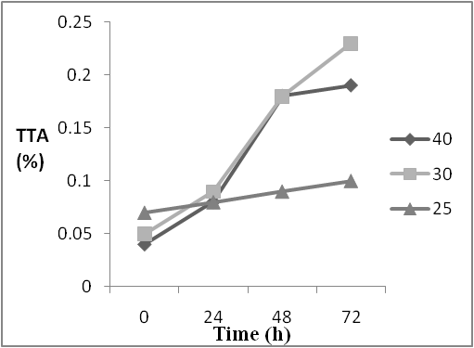
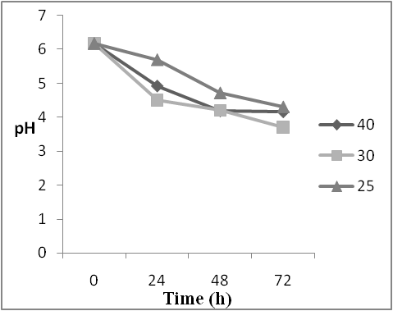

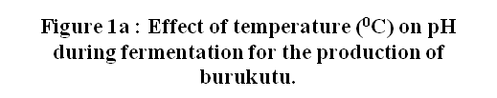 |  |  |  | 
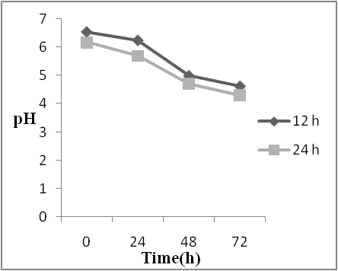 |  |  |  | 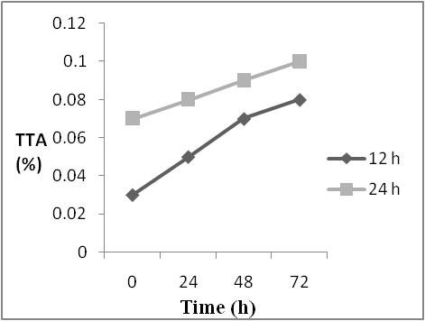

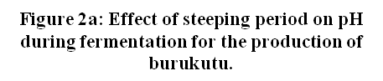 |  |  |  |  | 
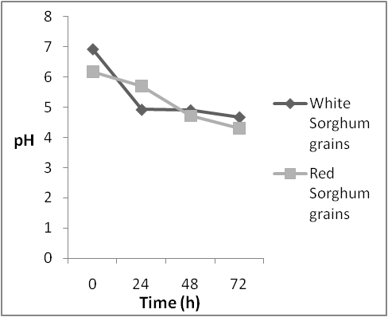 |  |  |  | 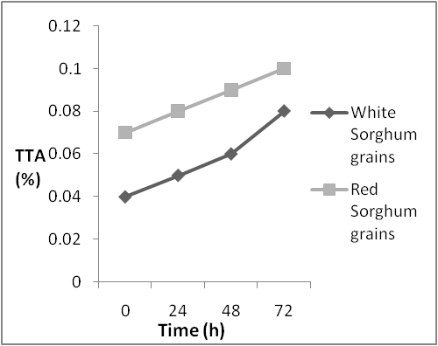

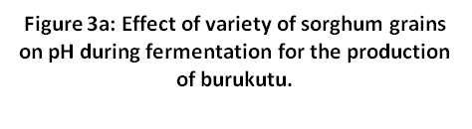 |  |  |  |  | 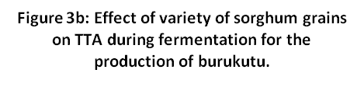
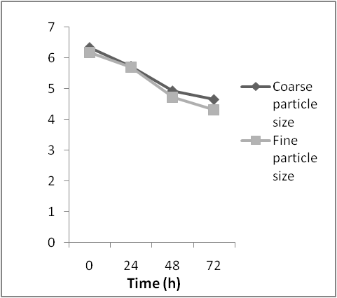 |  |  |  |  | 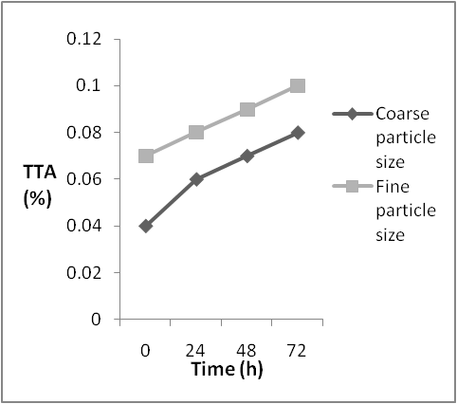

 |  | 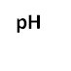 | 
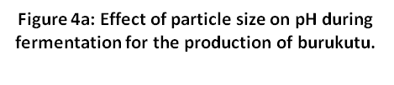 |  |  |  |  | 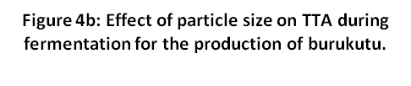
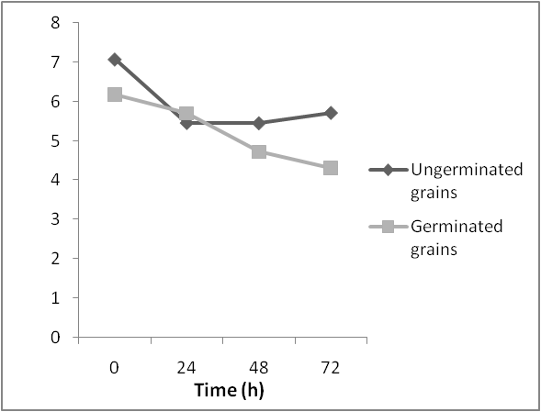 |  |  |  |  | 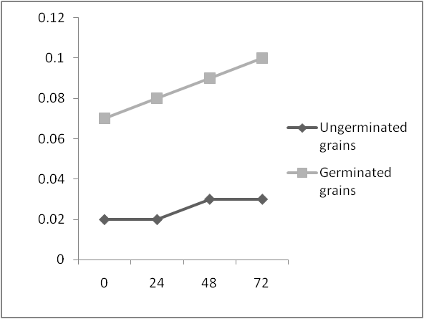
 |  |  | 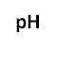 |  |  |  |  | 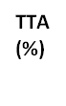
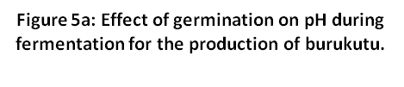 |  |  |  |  | 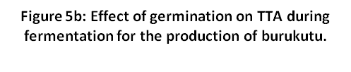

Table 1: Percentage Occurrence of Lactic Acid bacteria Isolated from traditionally fermented sorghum grains.
Isolate name | No of Occurrence | % of Occurrence
Lactobacillus plantarum I | 5 | 25
Pediococcus pentasaceus II | 3 | 15
Lactobacillus plantarum II | 2 | 10
Lactobacillus pentosus I | 2 | 10
Lactobacillus brevis I | 3 | 15
Lactobacillus fermentum I | 5 | 25
Total | 20 | 100
Table 2: Percentage Occurrence of Yeasts Isolated from Traditionally fermented sorghum grains
Isolate name | No of Occurrence | % of Occurrence
Saccharomyces cerevisiae | 5 | 35.7
Saccharomyces chavelieria | 3 | 21.4
Saccharomyce spp | 2 | 14.3
Candida sphaerica | 2 | 14.3
Candida utilis | 2 | 14.3
Total | 14 | 100

Table 3: Proximate Composition of Burukutu Produced Using Different Processing Variables
Variable parameters
 | Temperature |  |  | Steeping period |  | Variety of grains |  | Particle size |  | Germination
Proximate composition (%) | 40⁰C | 30⁰C | 25⁰C | 12 h | 24 h | White sorghum grains | Red sorghum grains | Coarse size | Fine size | Ungerminated grains | Germinated grains
Moisture content | 97.21+  0.01^{c} | 97.52+  0.03^{b} | 98.07+  0.03ª | 98.05+  0.03ª | 98.07+  0.03ª | 97.64+  0.01^{b} | 98.07+  0.03ª | 97.57+  0.06^{b} | 98.07+  0.03ª | 99.55+  0.03ª | 98.07+  0.03^{b}
Dry matter | 2.79+  0.01ª | 2.44+  0.03^{b} | 1.90+  0.02^{c} | 1.35+  0.07^{c} | 1.90+  0.02^{b} | 2.36+  0.01ª | 1.90+  0.02^{b} | 2.47+  0.01ª | 1.90+  0.02^{b} | 0.42+  0.02^{b} | 1.90+  0.02ª
Total sugar | 0.20+  0.03^{b} | 0.20+  0.03^{b} | 0.20+  0.03^{b} | 0.30+  0.03ª | 0.20+  0.04ª | 0.20+  0.03ª | 0.20+  0.03ª | 0.15+  0.07ª | 0.20+  0.04ª | 0.45+  0.07ª | 0.20+  0.03^{b}
Ash content | 2.55+  0.07^{b} | 3.05+  0.07ª | 2.40+  0.03^{b} | 2.30+  0.42ª | 2.35+  0.21ª | 2.00+  0.28ª | 2.40+  0.03^{b} | 2.00+  0.28^{b} | 2.50+  0.14ª | 2.55+  0.07^{b} | 2.40+  0.14ª
Alcohol content | 2.05+  0.07^{b} | 2.55+  0.07ª | 2.05+  0.07^{b} | 2.00+  0.03ª | 2.40+  0.07^{b} | 1.15+  0.07^{b} | 2.05+  0.07ª | 1.15+  0.07^{b} | 2.05+  0.07ª | 1.15+  0.21^{b} | 2.05+  0.07ª
Protein content | 1.31+  0.01^{b} | 1.39+  0.01ª | 1.27+  0.01^{c} | 1.38+  0.01ª | 1.27+  0.01^{b} | 1.28+  0.01ª | 1.27+  0.01ª | 1.23+  0.01^{b} | 1.27+  0.01ª | 1.30+  0.01ª | 1.37+  0.01^{b}
Mean along the rows with different superscript at each processing variables are significantly different from each other according to Duncan’s multiple range test at P< 0.05.

Table 4: Mineral Composition of Burukutu Produced Using Different Processing Variables
Variable parameters
 | Temperature |  |  | Steeping period |  | Variety of grains |  | Particle size |  | Germination
Mineral composition (mg/100ml) | 40⁰C | 30⁰C | 25⁰C | 12 h | 24 h | White sorghum grains | Red sorghum grains | Coarse size | Fine size | Ungerminated grains | Germinated grains
Sodium  (Na) | 29.05+  0.01^{b} | 31.02+  0.02^{c} | 27.55+  0.01^{b} | 26.23+  0.04ª | 27.53+  0.03^{b} | 28.27+  0.01ª | 27.55+  0.01ª | 28.38+  0.01ª | 27.54+  0.03ª | 23.66+  0.01^{b} | 27.55+  0.01ª
Magnesium (Mg) | 141.29  +0.01^{b} | 145.64  +0.01^{c} | 151.65  +0.35ª | 144.94  +0.76^{b} | 151.25  +0.35ª | 121.89  +0.01^{b} | 151.25  +0.35ª | 150.42  +0.73ª | 151.25  +0.35^{b} | 77.01+  0.01^{b} | 151.25  +0.35ª
Calcium (Ca) | 20.41+  0.01ª | 25.81+  0.01^{b} | 16.64+  0.01^{c} | 19.02+  0.03ª | 16.64+  0.01^{b} | 15.69+  0.01^{b} | 16.64+  0.01ª | 18.84+  2.12ª | 16.64+  0.01^{b} | 13.02+  0.02^{b} | 16.64+  0.01ª
Iron  (Fe) | 6.48+  0.00^{b} | 6.50+  0.07ª | 2.22+  0.00^{c} | 2.30+  0.01ª | 2.22+  0.00ª | 1.34+  0.01^{b} | 2.22+  0.00ª | 1.64+  0.00^{b} | 2.22+  0.00ª | 0.17+  0.00^{b} | 2.22+  0.00ª
Phosphorous (P) | 1.51+  0.00ª | 1.51+  0.00ª | 1.46+  0.00^{b} | 1.34+  0.03^{b} | 1.45+  0.00ª | 0.54+  0.00^{b} | 1.46+  0.00ª | 1.29+  0.00^{b} | 1.45+  0.00ª | 0.53+  0.01^{b} | 1.46+  0.00ª
Mean along the rows with different superscript at each processing variables are significantly different from each other according to Duncan’s Multiple range test at P< 0.05.

Table 5: Anti nutritional Components of Burukutu Produced Using Different Processing Variables
Variable parameters
 | Temperature |  |  | Steeping period |  | Variety of grains |  | Particle size |  | Germination
Anti nutritional composition (mg/100ml) | 40⁰C | 30⁰C | 25⁰C | 12 h | 24 h | White sorghum grains | Red sorghum grains | Coarse size | Fine size | Ungerminated grains | Germinated grains
Polyphenols | 5.20+  0.14^{b} | 4.25+  0.07^{c} | 9.30+  0.14ª | 9.15+  0.07ª | 9.15+  0.07ª | 9.40+  0.14^{b} | 9.30+  0.14ª | 9.05+  0.21ª | 9.15+  0.07ª | 12.75+  0.07ª | 9.15+  0.07^{b}
Phytate | 2.85+  0.07^{b} | 2.45+  0.07^{c} | 3.80+  0.00ª | 3.65+  0.07ª | 3.55+  0.07^{b} | 3.95+  0.07ª | 3.80+  0.00ª | 3.80+  0.28^{b} | 3.75+  0.07ª | 6.45+  0.64ª | 3.75+  0.21^{b}
Tannins | 3.35+  0.07^{b} | 2.20+  0.14^{c} | 6.40+  0.14ª | 5.65+  0.07ª | 6.40+  0.14ª | 6.60+  0.14ª | 6.40+  0.14ª | 6.50+  0.71ª | 6.40+  0.14ª | 9.05+  0.07ª | 6.40+  0.14^{b}
Mean along the rows with different superscript at each processing variables are significantly different from each other according to Duncan’s Multiple range test at P< 0.05.

Table 6: Sensory Attributes of Burukutu Produced Using Different Processing Variables
Variable parameters
 | Temperature |  |  | Steeping period |  | Variety of grains |  | Particle size |  | Germination
Sensory parameters | 40⁰C | 30⁰C | 25⁰C | 12 h | 24 h | White sorghum grains | Red sorghum grains | Coarse size | Fine size | Ungerminated grains | Germinated grains
Taste | 3.05+  0.07^{b} | 3.95+  0.07ª | 3.25+  0.07ª | 2.85+  0.07^{b} | 3.00+  0.28ª | 2.85+  0.07ª | 3.10+  0.14ª | 3.05+  0.07ª | 3.20+  0.28ª | 2.10+  0.14^{b} | 3.20+  0.28^{c}
Aroma | 3.07+  0.07^{b} | 3.80+  0.14ª | 3.05+  0.07^{b} | 2.95+  0.14^{b} | 3.05+  0.07ª | 3.15+  0.21ª | 3.10+  0.14ª | 2.85+  0.07ª | 3.05+  0.07ª | 2.35+  0.07^{b} | 3.10+  0.14ª
Color | 2.90+  0.07ª | 3.48+  0.07ª | 3.00+  0.28ª | 3.00+  0.07ª | 3.05+  0.07^{b} | 3.55+  0.07^{b} | 3.05+  0.07ª | 3.05+  0.07ª | 3.50+  0.07ª | 2.15+  0.07^{b} | 3.00+  0.28ª
After taste | 3.10+  0.07^{b} | 3.90+  0.14ª | 3.00+  0.14^{b} | 2.95+  0.07ª | 3.05+  0.07ª | 2.65+  0.07^{b} | 3.02+  0.07ª | 3.00+  0.07^{b} | 3.05+  0.07^{b} | 2.25+  0.07^{b} | 3.05+  0.07ª
Overall acceptability | 3.00+  0.14ª | 3.15+  0.07ª | 3.05+  0.07ª | 3.00+  0.14ª | 3.00+  0.14ª | 3.10+  0.14ª | 3.05+  0.07ª | 3.20+  0.28ª | 3.05+  0.07ª | 2.30+  0.14^{b} | 3.05+  0.07ª
Mean along the rows with different superscript at each processing variables are significantly different from each other according to Duncan’s Multiple range test at P< 0.05.

Anti nutritional components such as total phenols, tannins and phytic acid that precipitate nutrients (Brune et al., 1989; Muller and McAllan, 1992) have been observed to reduce during germination (Taur et al., 1984; Troare et al., 2004). Germination (sprouting of the seeds) induces hydrolytic enzymes which may have indirectly resulted in contributing to the reduction in the anti nutritional components.
From this study, lower anti nutritional components were observed in burukutu samples produced using red sorghum grains, fine particle sizes and 24 h steeping period, although, they showed insignificant differences to results of burukutu produced using the white sorghum grains, coarse particle size and 12 h steeping period respectively. This can be attributed to the use of germinated grains in all of these processing variables. However, a lower anti nutritional components was also observed in burukutu samples produced at 30⁰C which was significantly different from burukutu produced at 40⁰C and 25⁰C. In the same vein, lower amounts of anti nutritional components were recorded in burukutu produced using germinated grains which was significantly different from burukutu produced using ungerminated grains. Taur et al. (1984) and Troare et al. (2004) reported the reduction of phytic acid, some flavonoids and proanthocyanidins during germination.
Even though some minimal amounts of anti nutritional components have been recorded in this study, recent and ungoing researches have shown that these anti nutritional (polyphenols, phytate, tannins) can act as antioxidants (Miglio et al., 2008) which help to prevent cancer by enhancing the immune system as well as increase the activity of natural killer cells which attack and destroy cancer and tumor cells (phytate) (McGee, 2004). Tannins have been shown to improve mouthfeel when taking wine and as well as possesses potential antiviral (Lu et al., 2004), antibacterial (Akiyama et al., 2001) and antiparasitic effects (Kolodziej and Kiderlen, 2005).
The sensory ratings revealed that all the various processing variables considered had varying taste and aroma. The development of alcohol, organic acids, esters and carbonyl compounds contribute particularly to taste and aroma during fermentation (Hammond, 1993).
A higher and better sensory rating was observed in burukutu produced at 30⁰C compared to burukutu produced at 40⁰C and 25⁰C. Similarly, burukutu produced from steeping sorghum grains for 24 h showed a higher and better sensory rating than burukutu produced from 12 h steeping period. In their investigations on the effects of processing variables on cassava fermentation for ‘fufu’ production, Oyewole and Odunfa (1992) reported higher and better sensory ratings in products fermented at temperatures of 30⁰C and 35⁰C and in products steeped for longer periods after 12 h.
The sensory ratings observed in the use of variety of sorghum grains did not show any significant differences, however the color differences observed in burukutu produced with white and red sorghum grains can be attributed to their morphological traits in terms of color which distinguishes them into varieties (Taur et al., 1984; Deu et al., 1994).
A higher sensory rating was observed in burukutu produced using germinated grains than in burukutu produced with ungerminated grains. Germination is an important step during the production of burukutu, during germination, primary and secondary metabolites are mobilized and enzymes are synthesized. The biochemical composition of germinated and ungerminated grains is different (Limami et al., 2002; Troare et al., 2004; Dicko et al., 2006). Mtebe et al. (1993) and Lasekan et al. (1997) also reported the synthesis of flavor into the malt during germination.
Conclusion
The use of different processing variables (fermentation temperature, steeping periods, and variety of sorghum grains, particle sizes and the use of germinated and ungerminated grains) had significant effect on the proximate, mineral, anti nutritional and sensory attribute of burukutu. The production of burukutu at fermentation temperature of 30⁰C had a significant effect on the rate of acidification, the alcohol content, mineral composition, reduced anti nutritional components and a better organoleptic property. Similar results was also observed in burukutu produced at 24 h steeping periods, the use of red sorghum grains, fine particle size and the use of germinated grains. Hence, the utilization of these processing variables in the production of burukutu may enhance the quality of burukutu in terms of the mineral composition, sensory attributes and reduced anti nutritional components.
Acknowledgement
Due appreciation goes to Mr. Olajide of the Multidisciplinary central Laboratory (MDCL), University of Ibadan; Staff members of KAPPA Biotechnologies, Ibadan; Staff members of the Chemistry Laboratory, Nigerian Institute of Science and Technology (NISLT), Ibadan, Nigeria for their technical support during the research work.
Corresponding Author:
Ogunbanwo S.T.
Department of Microbiology,
University of Ibadan,
UI P.O. Box21422,
Ibadan, Oyo State, Nigeria.
E-mail: topzybanwo@yahoo.com

References
- AOAC. Official methods of analysis, 15th edn, Association of Official Analytical Chemists Washington D.C.1990
- Achi OK. Microbiology of ‘Obiolor’ Nigerian fermented non – alcoholic beverages. Journal of Applied Bacteriology. 1990; 69:321-325.
- Achi OK. The potential for upgrading traditional fermented foods through biotechnology. African Journal of biotechnology. 2005; 4:375-380.
- Adeyemi IA and Umar S. Effects of method of manufacture on quality characteristic of kunun-zaki, a millet based beverage. Nigerian Food Journal. 1994; 12:34-42.
- Agarray OO, Nkama I and Akoma O. Production of Kunni zaki (A Nigerian fermented cereal beverage) using starter culture. International Research Journal of Microbiology. 2010; 1(2): 018-025.
- Aggarwal NK, Nigam P, Singh D, Yadav BS. Process optimization for the production of sugar for the bioethanol industry from sorghum, a non-conventional source of starch. World Jornal of Microbiology and Biotechnology 2001; 17: 411-415.
- Ajibola OO, Makanjuola GA and Almazan AM. Effects of processing factors on the quality of gari produced by a steam gelatinization technique. Journal of Agricultural and Engineering Research. 1987; 38: 313-320
- Akinrele IA. Fermentation of cassava. Journal of the Science of Food and Agriculture. 1964; 15: 589-594
- Akinrele IA. Fermentation studies on maize during the preparation of a traditional African starch cake food. Journal of Science and Food Agriculture. 1970; 21: 619– 625.
- Akiyama H, Fujii K, Yamasaki O, Oono T and Iwatsuki K. Antibacterial action of several tannins against Staphylococcus aureus. Journal of Antimicrobial Chemotherapy. 2001; 48(4): 487–491.
- Anglani C. Sorghum for human food: a review. Plant Foods and Human Nutrition. 1998; 52: 85-89.
- Awika, J.M and Rooney, L.W. Sorghum phytochemicals and their potential aspects on human health. Phytochemistry 2004a; 65:1199-1221.
- Barnett JA, Payne RW, Yarrow D. Yeast characteristics and identification, Cambridge University Press, Cambridge. 1983; 781-807
- Brune M, Rossander L and Hallberg L. Iron absorption and phenolic compounds: importance of different phenolic structures. European Journal of Clinical Nutrition. 1989; 43(8): 547–557
- Chu G, Vollrath D, Davis TW. Separation of large DNA molecule by Contour-clamped Homogenous Electric Field. Science. 1986; 234: 1582-1585.
- Damelin LH, Dykes GA and von Holy A. Biodiversity of lactic acid bacteria from food-related ecosystem. Microbios. 1995; 83: 13-22.
- Deu M, Gonzalez de Leon D, Glaszmann JC, Degremont I, Chantereau J, Lanaud C and Hamon P. RFLP diversity in cultivated sorghum in relation to racial differentiation. Theoretical and Applied Genetics. 1995; 88:838-844.
- Dicko MH, Gruppen H, Zouzouho OC, Traoré AS, van Berkel WJH and Voragen AGJ. Effect of germination on amylases and phenolics related enzymes in fifty sorghum varieties grouped according to food-end use properties. Journal of Science and Food Agriculture. 2006; 86: 953-963
- Edundayo JA. The production of pito-a Nigerian fermented beverage. Journal of Food Technology. 1969; 4:217-225.
- Elkhalil EAI, El Tinay AH, Mohamed BE and Elshekh EAE. Effects of protein digestibility of sorghum flour. Food Chemistry. 2000; 72: 29-32
- Faparusi SI. Sugar changes during production of “burukutu” beer. Journal of Science and Agriculture. 1970; 13:563-568.
- Faparusi SI, Olofinboba MO, Ekundayo JA. The Microbiology of burukutu beer. Zeiftschrift fur Allgemeine Mikrobiologie. 1973; 13:563-568.
- Gobbetti M, Corsetti A and Rossi J. The sourdough microflora Interactions between lactic acid bacteria and yeasts: metabolism of carbohydrates. Journal of Applied Microbiology and Biotechnology. 1994; 41:456– 460.
- Halm M, Lillie A, Spreusen AK and Jakobsen M. Microbiological and aromatic characteristics of fermented maize dough for kenkey production in Ghana. International Journal of Food Microbiology. 1993; 19:135–143.
- Hammond JRM. Brewer’s yeasts In: Rose AH and Harrison JS, Eds. The Yeasts. Yeast Technology. Academic Press, London. 1993:7-67.
- Harold S and Hubert S. You and Your Health. Pacific Press Publishing Association. 1970; 3: 99-100
- Janssens L, de Pooter HL, Schamp NM and Vandamme EJ. Reviews: Production of flavors by microorganisms. Process Biochemistry. 1992; 27:195-215.
- Kandler O and Weiss N. Regular Nonsporing Grampositive rods. In Sneath P, Mar NS, Sharpe ME and Heltt J, eds. Bergey’s Manual of Systematic Bacteriology. Williams and Wilkins, Baltimore. 1986:1209-1234.
- Kingsley CE and Victor EE. A kinetic study of burukutu fermentation. Journal of Engineering and Applied Sciences. 2007; 2(7):1193-1198
- Kolawole O M, Kayode RMO and Akindayo B. Proximate and Microbial analyses of burukutu and pito produced in Ilorin. Nigeria. African Journal of Biotechnology. 2007; 6(5):587-590
- Kolodziej H and Kiderlen AF. Antileishmanial activity and immune modulatory effects of tannins and related compounds on Leishmania parasitised RAW 264.7 cells. Phytochemistry 2005; 66(17):2055–2070.
- Kunene NF, Geornaras I, von Holy A and Hastings JW. Characterization and determination of origin of lactic acid bacteria from a sorghum-based fermented food by analysis of soluble proteins and amplified fragment length polymorphism fingerprinting. Journal of Applied Environmental Microbiology. 2000;66:1084–1092
- Lasekan OO, Lasekan WO and Idowu MA. Flavour volatiles of malt beverage from roasted sorghum. Food Chemistry. 1997; 58(4):341-344
- Lei V and Jakobsen M. Microbiological characterization and probiotic potential of koko and koko sour water, African spontaneously fermented millet porridge and drink. Journal of Applied Microbiology. 2004; 96:384–397.
- Limami AM, Rouillon C, Glevarec G, Gallais A and Hirel B. Genetic and physiological analysis of germination efficiency in maize in relation to nitrogen metabolism reveals the importance of cytosolic glutamine synthetase. Plant Physiology. 2002; 130(4):1860-1870.
- Lü L, Liu SW, Jiang SB, and Wu SG. Tannin inhibits HIV-1 entry by targeting gp41. Acta Pharmacologica Sinica. 2004; 25(2):213–218.
- Maga JA. Phytates: its chemistry, occurrences, food interactions, nutritional significance and methods of analysis. Journal of Agriculture and Food Chemistry. 1982; 301:1-7.
- Makkar AOS and Goodchild AV. Quantification of tannins. A laboratory manual. International Center for Agriculture Research in the Dry Areas (ICARDA) Aleppo, Syria IV 1996; 25
- McGee H. On food and cooking: the science and lore of the kitchen. Hodder and Stoughton Publishers, New York. 2004; 714.
- Miglio C, Chiavaro E, Visconti A, Fogliano V and Pellegrini N. Effects of different cooking methods on nutritional and physicochemical characteristics of selected vegetables. Journal of Agriculture and Food Chemistry. 2008; 56:139–147
- Mtebe K, Ndabikunze BK, Bangu NTA and Mwemezi E. Effects of cereal germination on the energy of togwa. Journal of Food Sciences and Nutrition. 1993; 44:175-180
- Muller-Harvey I and McAllan AB. Tannins: Their biochemistry and nutritional properties. Journal of Advanced Plant Cell Biochemistry and Biotechnology. 1992; 1:151–217.
- Muyanja CMBK, Narvhus JA, Treimo J and Langsrud T. Isolation, characterization and identification of lactic acid bacteria from bushera: an Ugandan traditional fermented beverage. International Journal of Food Microbiology. 2003; 80:201-210
- Nout MJR, Rombouts FM and Havelaar A. Effect of natural lactic acid fementation of infant food ingredients on some pathogenic microorganisms. International Journal of Food Microbiology. 1989; 8:351-361.
- Odetokun SM. Chemical changes and the nutritive values of burukutu, a Nigerian beverage. Nahrung. 1997; 41(6):375-377
- Odunfa SA and Adeyele S. Microbiological changes during the traditional production of ogi-baba, West African fermented sorghum gruel. Journal of Cereal Science. 1985; 3:173-180.
- Olsen A, Halm M and Jakobsen M. The antimicrobial activity of lactic acid bacteria from fermented maize (kenkey) and their interaction during fermentation. Journal of Applied Bacteriology. 1995; 79 (5):506–512
- Orji GS and Uvere PO. Lipase activity during malting and fermentation of sorghum for burukutu production. Journal of Institute brewing. 2002; 108(2):256-260
- Oyewole OB and Odunfa SA. Microbiological studies on cassava fermentation for lafun production. Food Microbiology. 1988; 5:125-133.
- Oyewole OB and Odunfa SA. Effects of processing variables on cassava fermentation for ‘fufu’ production. Tropical Science. 1992; 32:231-240
- Price ML and Butler LG. Rapid visual estimation and spectophotometric determination of tannin content of sorghum grains. Journal of Agricultural and Food Chemistry. 1977; 25(6): 1268-1273.
- Sanni AI, Ohenhen RE and Onilude AA. Production of extracellular proteinase by Lactobacillus species isolated from traditional alcoholic beverage. Nigeria Journal of Microbiology. 2000; 14:55–61.
- Steinkraus KH. Introduction to Indigenous Fermented Foods. In: Steinkraus KH, ed. Handbook of Indigenous Fermented Foods. Marcel Dekker, New York. 1996: 1-5.
- Suresh K, Kiransree N, Venkateswar, Rao L. Production of ethanol by raw starch hydrolysis and fermentation of damaged grains of wheat and sorghum. Bioprocess Engineering 1999; 21:165-168.
- Taur AT, Pawar VD and Ingle UM. Effect of fermentation on nutritional improvement of grain sorghum (Sorghum bicolor (L) Moench). Indian Journal of Nutritional Diet. 1984; 21:129-136.
- Thomas MD. A textbook of Biochemistry: with clinical correlations. (5th ed) John Wiley and Sons, Inc. Publishers. 2002: 1159-1160
- Traore T, Mouquet C, Icard-Verniere C, Traore AS and Treche S. Changes in nutrient composition, phytate and cyanide contents and α-amylase activity during cereal malting in small production units in Ouagadougou (Burkina Faso). Food Chemistry. 2004; 88:105-114.
- Uvere PO, Adenuga OD and Mordi C. The effect of germination and kilning on the cyanogenic potential, amylase and alcohol levels of sorghum malts used for burukutu production. Journal of Science and Food Agriculture. 2000; 80:352–358.
- Yabaya A. Microorganisms associated with starter cultures of traditional burukutu liquor in Madakiya, Kaduna State, Nigeria. Science World Journal. 2008; 3:9-11.

11/17/2012

