Identification of Natural Compounds in Muscle Tissue of pickhandle barracuda (Sphyraena jello) in Bander Abbas in the south of Iran (Closed to the Persian Gulf)

Abdolhossein Rustaiyan ¹, Keivandokht Samiee ², Maryam Sadat Bagheri ³

¹Department of Chemistry, Science & Research branch, Islamic Azad University, P.O. Box 14515-775, Tehran, Iran
²Faculty of Biological Sciences, Shahid Beheshti University, Tehran, Iran
³Faculty of Marine Sciences and Technology, North Tehran branch, Islamic Azad University, Tehran, Iran
arustaiyan@yahoo.it

Abstract: Fish is a good source of omega-3 fatty acids. In this study, natural compounds from muscle tissue of pickhandle barracuda (Sphyraena jello) from the port of Bandar Abbas in the south of Iran closed to the Persian Gulf in Oct 2012 were extracted using the method of Blight & Dyer. The compounds were identified using a combination of GC and GC/MS. Components were also identified in both male and female species. Ten compound reperesenting 96.00% of the extract of Muscle Tissue of Sphyraena jello. Docosahexaenoic acid (DHA) (20.60%), Palmitic acid (15.24%) and Squalene (13.50%) were the main constituents Muscle Tissue. The other main components was Eicosapentaenoic acid (EPA) (12.01%), Oleic acid (11.30%) and Octadecanoic acid (10.65%).
[Abdolhossein Rustaiyan, Keivandokht Samiee, Maryam Sadat Bagheri. Identification of Natural Compounds in Muscle Tissue of pickhandle barracuda (Sphyraena jello) in Bander Abbas in the south of Iran (Closed to the Persian Gulf). Nat Sci 2013;11(1):91-94]. (ISSN: 1545-0740). http://www.sciencepub.net/nature. 14

Keywords: Pickhandle barracuda, Sphyraena jello, Muscle Tissue, Compositions, Persian Gulf

1. Introduction

Barracudas (family Sphyraenidae and genus Sphyraena) are found in tropical and subtropical oceans worldwide. Barracudas are popular both as food and game fish. They are most often eaten as fillets or steaks (Pastore, 2009). The pickhandle barracuda (Sphyraena jello) is capable of quickly pursuing its prey using thrusts of the powerful, forked tail fin. The mouth of this species is large, reaching back level with the small eye, and is armed with long, sharp, dagger-like teeth. The dark bars that streak its sides are vertical in the lower half, but angled in the top half in the shape of a pick, giving this fish its common name (Campbell & Dawes, 2005). The pickhandle barracuda is light silver in color, which acts as camouflage, making it difficult to see from below against the surface light (Figure 1).
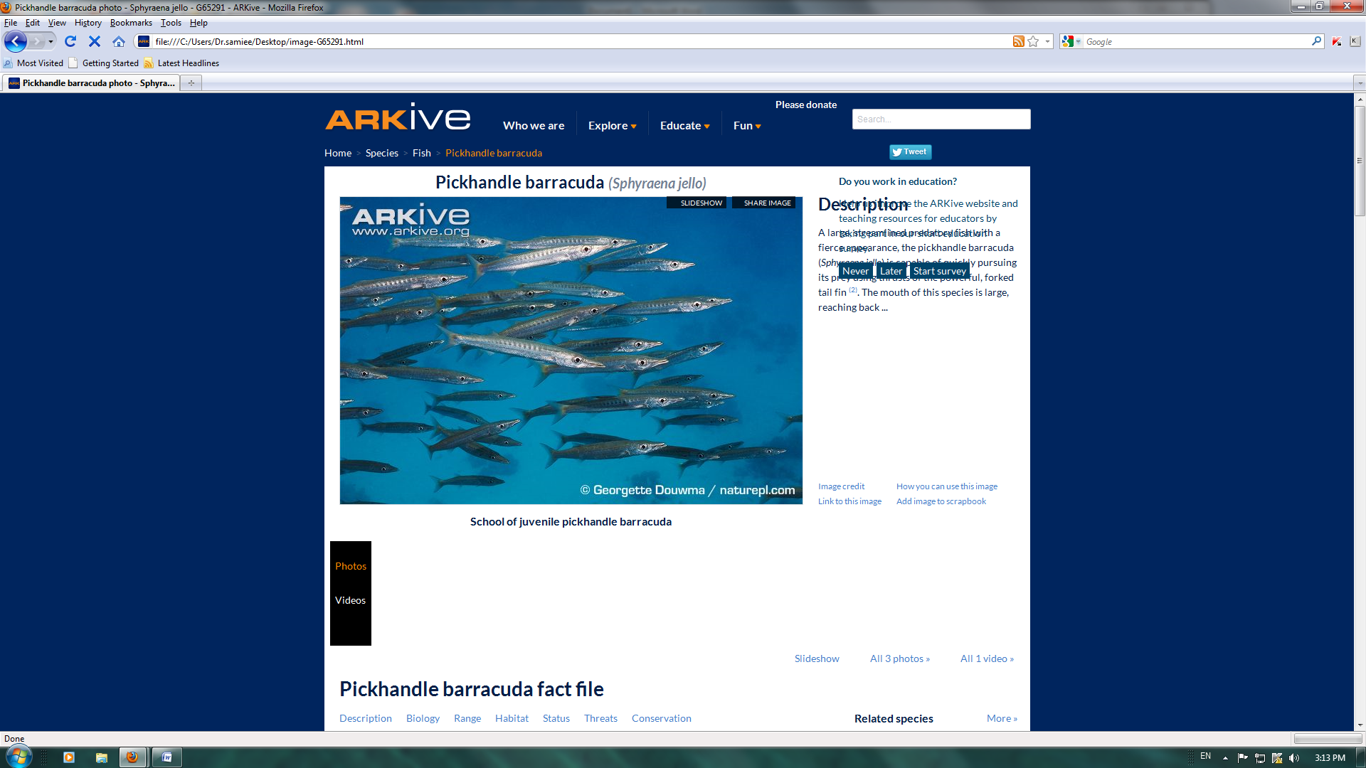
Figure1. pickhandle barracuda (Sphyraena jello)

The nutritive value of fish is determined by the content of fatty acids that are beneficial to health (Cornils & Lappe, 2006). Fish lipids are well known to be rich in long-chain (LC) n-3 polyunsaturated fatty acids (LC n-3 PUFA), especially eicosapentaenoic acid and docosahexaenoic acid (Visentainer, 2005).
Long chain, n-3 PUFA cannot be synthesized by humans and must be obtained from the diet (Martin et al., 2008). It is known that polyunsaturated fatty acids can regulate prostaglandin synthesis and hence induce wound healing (Baylin et al, 2003), These fatty acids have particular importance in fish since their consumption contributes in the reduction of appearance of cardiovascular diseases (Stancheva et al., 2010), anti-inflammatory and antithrombotic effects, reduction of blood cholesterol levels and cancer prevention (Nordov et al, 2001).The purpose of this study was to identify natural compounds, especially fatty acids in muscle tissue o pickhandle barracuda as one seafood in the port of Bander Abbas in the south of Iran.

2. Material and Methods
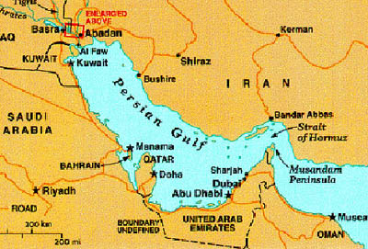
In this experimental study, 30 Sphyraena jello samples were obtained from the port of Bandar Abbas in the south of Iran (figure2).
Figure 2. Map of study area and location of sampling station in Bander Abbas in the south of Iran
Initially the muscle tissue was weighed and mixed into a soft uniform mixture.
Mixtures of chloroform and methanol were added as lipid extract ants (Blight & Dyer, 1959).This solvent system allows for extraction of both polar and non polar compounds. The lower chloroform layer includes the lipids and the top methanol-water layer generally contains the non- polar components. The lipid in the chloroform layer is isolated using a separator funnel and then the solvent removed using a rotary evaporator under vacuum, at temperature of 40° C. The weight of the lipid was determined.
The lipid extract obtained was injected into chromatograph equipment with a mass spectra detector (GC- MS).components were identified by comparison of the retention time and mass spectra of the unknowns with those of authentic samples and also comparative analysis of kovats index & using references of Eight peak. It should be noted that the extraction and identification was performed separately for both sexes.

3. Results
Results of this investigation are indicated in Tables 1 and 2. Chloroform phase is discussed in this research because the fat content of the muscle tissue is extracted with chloroform (Blight & Dyer, 1959). The components identified in GC-MS analysis of the samples from female species is shown the below table.

Table 1. The compound identified in the chloroform phase of muscle tissue from the female pickhandle barracuda (Sphyraena jello) in Bander Abbas in the south of Iran
Compound | MF | KI | % of total
Fatty acid
Saturated fatty acid
Palmitic acid (Hexadecanoic acid) | C₁₆H₃₂O₂ | 1797 | 16.02
Stearic acid (Octadecanoic Acid) | C₁₈H₃₆O₂ | 1892 | 10.98
Mono-unsaturated fatty acid  Oleic acid (9Z Octaecenoic Acid) | C₁₈H₃₄O₂ | 1915 | 11.60
Poly- unsaturated fatty acid  Docosahexaenoic acid | C₂₂H₃₂O₂ | 1910 | 21.10
Eicosapentaenoic acid | C₂₀H₃₀O₂ | 1900 | 11.70
Ester
Palmitic acid –methylester  (Hexadecanoic acid, methyl ester) | C₁₇H₃₄O₂ | 1819 | 3.60
Stearic acid-methylester  (Octadecanoic acid, methyl ester) | C₁₉H₃₈O₂ | 1894 | 2.90
Table 1. Continued.
Compound | MF | KI | % of total
Terpenes
Vitamin E (2H-1-Benzopyran-6-ol,3,4-dihidro-2,5,7,8-tetramethyl-2-94,8,12-trimethyltridecyl)  (α-Tocopherol) | C₂₉H₅₀O₂ | 2234 | 2.90
triterpene
Squalene | C₃₀H₅₀ | 2154 | 14.50
Esterols
Cholesterol  (Cholesta-5en-3-ol (3.β) | C₂₇H₄₆O₂ | 1972 | 5.80
MF: Molecular Formula
KI: Kovats Index
%: Percent of the compound

Table 2 shows the components identified in GC-MS analysis of the samples from male species
Compound | MF | KI | % of total
Fatty acid
Saturated fatty acid
Palmitic acid  (Hexadecanoic acid) | C₁₆H₃₂O₂ | 1797 | 15.34
Stearic acid  (Octadecanoic Acid) | C₁₈H₃₆O₂ | 1892 | 10.65
Mono-unsaturated fatty acid, Oleic acid  (9Z Octaecenoic Acid) | C₁₈H₃₄O₂ | 1915 | 11.30
Poly- unsaturated fatty acid  Docosahexaenoic acid | C₂₂H₃₂O₂ | 1910 | 20.60
Eicosapentaenoic acid | C₂₀H₃₀O₂ | 1900 | 12.01
Ester
Palmitic acid –methylester  (Hexadecanoic acid ,methyl ester) | C₁₇H₃₄O₂ | 1819 | 3.10
Stearic acid-methylester  (Octadecanoic acid, methyl ester) | C₁₉H₃₈O₂ | 1894 | 2.10

Table 2. Continued.
Compound | MF | KI | % of total
Terpenes
Vitamin E (2H-1-Benzopyran-6-ol,3,4-dihidro-2,5,7,8-tetramethyl-2-94,8,12-trimethyltridecyl)  (α-Tocopherol) | C₂₉H₅₀O₂ | 2234 | 2.50
triterpene
Squalene | C₃₀H₅₀ | 2154 | 13.50
Esterols
Cholesterol  (Cholesta-5en-3-ol (3.β) | C₂₇H₄₆O₂ | 1972 | 4.90
MF: Molecular Formula
KI: Kovats Index
%: Percent of the compound
According to the results of the present study, most compounds identified are common between the two sexes such as polyunsaturated fatty acids docosahexaenoic acid (20.6% in female and male 21.1%) and eicosapentaenoic acid (11.7% in female and male 12.01%), mono-unsaturated fatty acid Oleic acid ( 11.3% in female and male 11.6%), saturated fatty acids Palmitic acid (15.34% in female and male 16.02%) and Stearic acid (10.65% in female and male 10.98%) ,two esters of fatty acid Hexadecanoic acid ,methyl ester (3.1% in female and male 3.6%) , Vitamin E (2.1% in female and male 2.9%), Cholesterol (4.9% in female and male 5.8%) and squalene (13.5% in female and male 14.5 %).

4. Discussions
In the present study, the dominant fatty acid was polyunsaturated fatty acid docosahexaenoic acid (20.6 -21.1 %). DHA is an omega-3 fatty acid and an essential fatty acid (Anneken et al, 2006). Docosahexaenoic acid is essential for the growth and functional development of the brain. DHA has a positive effect on diseases such as hypertension, arthritis, atherosclerosis, depression (Bousquet et al, 2008), adult-onset diabetes mellitus, myocardial infarction, thrombosis (Burdge &Calder, 2005), and some cancers (Simon et al, 2009). Comparison of this study results and similar studies by Soltan et al (2008) on some pelagic fishes in Australia indicated that the dominant fatty acid was polyunsaturated fatty acid, so the effectiveness using of seafood such as fishes in health and possibly to prevention and treatment of coronary heart diseases(Connor, 2000) acknowledges. The next dominant fatty acid was Palmitic acid (15.34 -16. 02%). According to the World Health Organization, consumption of palmitic acid can increase the chances of occurrence of cardiovascular diseases. Palmitic is used in different anti-psychotic medicines, especially in the treatment of schizophrenia (Bousquet et al., 2008).Palmitic acid is mainly used to produce soaps (Thomas, 2002), cosmetics, and release agents (Cornils & Lappe, 2006). Comparison of this study results and similar studies by Imre & Glik(1998) on some Turkish fish species in Turkey indicated that generally palmitic acid was the dominant saturated fatty acids in species.
The third dominant fatty acid was Squalene. It is a hydrocarbon and a triterpene. It is a natural and vital part of the synthesis of cholesterol, steroid hormones, and vitamin D in the human body (Matyas et al, 2004). Squalene is used in cosmetics, and more recently as an immunologic adjuvant in vaccines. Results of in this study showed that Sphyraena jello is one of the best seafood.

Corresponding Author:
Prof.Dr.Abdolhossein Rustaiyan
Department of Chemistry
Science and Research Branch
Islamic Azad University
P.O.Box 14515-775
Tehran/Iran
E-mail: arustaiyan@yahoo.it

References
- Anneken, D.,Sabine,B, Christoph,R., Fieg,G,. Steinberne,U., and Westfechte, Al "Fatty Acids" in Ullmann's Encyclopedia of Industrial Chemistry 2006, Wiley-VCH, Weinheim. doi:10.1002/14356007.a10_245.pub2
- Baylin, A, Kabagambe, EK and Ascherio, A2003. Adiopose tissue α- linolenic acid and nonfatal acute myocardial infarction in Costa Rica. Circulation 2003; 107:1586-91.
- Blight, E.G., and Dyer, W.J. (1959) A rapid method of total lipid extraction and purification. Can. J. Biochem. Physiol. 37, 911-917.
- Bousquet,M., Saint-Pierre,M., Julien, C., Salem, N., Cicchetti,F and Calon.F,2008). Beneficial effects of dietary omega-3 polyunsaturated fatty acid on toxin-induced neuronal degeneration in an animal model of Parkinson’s disease. The FASEB Journal. 2008;22: 1213-1225.
- Burdge, GC; Calder, PC (2005). "Conversion of alpha-linolenic acid to longer-chain polyunsaturated fatty acids in human adults". Reproduction, nutrition, development 45 (5): 581–97. DOI:10.1051/rnd:2005047.
- Campbell, A. and Dawes, J. (2005). Encyclopedia of Underwater Life. Oxford University Press, Oxford, UK.
- Connor,W.E (2000). "Importance of n−3 fatty acids in health and disease". American Journal of Clinical Nutrition 71 (1 Suppl.): 171S–175S. PMID 10617967
- Cornils,B and Lappe,P,2006 "Dicarboxylic Acids, Aliphatic" in Ullmann's Encyclopedia of Industrial Chemistry 2006, Wiley-VCH, Weinheim. doi:10.1002/14356007.a08_523
- IMRE, S., GLIK,S. Fatty Acid Composition and Cholesterol Content of Some Turkish Fish SpeciesTurk J Chem22 (1998) , 321 - 324.
- Martin L, Zarn D, Hansen AM, Wismer W and Mazurak V. Food products as vehicles for n-3 fatty acid supplementation. Can J Diet Pract Res 2008; 69(4): 203-207.
- Matyas, G; Rao, M; Pittman, PR; Burge, R; Robbins, IE; Wassef, NM; Thivierge, B; Alving, CR (2004). "Detection of antibodies to squalene III. Naturally occurring antibodies to squalene in humans and mice". Journal of Immunological Methods 286 (1–2): 47–67.
- .Nordov A, Marcholi R, Arnesen Hand Videbaek J. N-3 polymaturated fatty acids and cardiovascular diseases. Lipids 2001; 36 (1): 127-129.
- Pastore .M.A (2009). "Sphyraena intermedia sp. nov. (Pisces: Sphyraenidae): a potential new species of barracuda identified from the central Mediterranean Sea.". Journal of the Marine Biological Association of the United Kingdom 89 (6): 1299–1303
- Soltan,S.S and Gibson,R.A ,2008. Levels of Omega 3 fatty acids in Australian seafood. Asia Pac J Clin Nutr 2008;17 (3): 385-390
- Simon, JA; Chen, YH; Bent, S (2009). "The relation of alpha-linolenic acid to the risk of prostate cancer". American Journal of Clinical Nutrition 89 (5): 1558S–1564S.
- Stancheva,M., Merdzhanova,A., Diana, A. and Makedonsk,L.. Fatty acid composition and fat-soluble vitamins content of sprat (Sprattus sprattus) and goby (Neogobius rattan) from Bulgarian Black Sea. Ovidius Univ Ann Chem 2010; 21(1):23-28.
- Thomas, A, (2002). "Ullmann's Encyclopedia of Industrial Chemistry". Ullmann's Encyclopedia of Industrial Chemistry. Weinheim: Wiley-VCH.
- Visentainer JV. Influence of diets enriched with flaxseed oil on the 毩-linolenic, eicosapentaenoic and docosahexaenoic fatty acid in Nile tilapia (Oreochromis niloticus). Food Chem 2005; 90(4):557-560.

12/23/2012

