Molecular Markers for Orobanche Crenata Resistance in Faba Bean (Vicia Faba L.) Using Bulked Segregant Analysis (BSA)

Azza F. El-Sayed¹; S.S.A. Soliman²; T.A. Ismail² and Sabah M. Attia¹

¹Food Legumes Res. Section, Field Crops Res. Inst., ARC, Giza, Egypt
²Genetics Dept. Fac. Agric., Zagazig Univ., Egypt.

Abstract: The present study aimed to discovery the molecular markers for Orobanche tolerant and susceptible in faba bean by using Bulked Segregant Analysis (BSA) using RAPD and ISSR techniques. A cross between x-1722 (tolerant) and Giza-40 (susceptible) was chosen for molecular analysis. DNA isolated from the two parents; F₁ and the two extreme groups of F₂ plants using bulked Segregant analysis (BSA) technique. Six RAPD primers (A09, B05, B11, B17, B18 and B20) and four ISSR primers (HB11, HB12, HB13 and 17899B) were used in this study. The results showed that, Primer B20 released four positive molecular markers with molecular size of 766, 557,419 and 281 bp), these four positive and three negative RAPD markers could be considered as a reliable markers for Orobanche tolerance in faba bean. While there were three negative molecular with molecular sizes 949, 355 bp for primer A09 and 441bp for primer B18. On the other hand, Primer B05 exhibited unique band for tolerant parent (x-1722) with molecular size 400 bp, as well as primer B11 showed three unique bands with molecular size 1278, 773 and 437 bp. While primer B17 exhibited unique band for sensitive parent (Giza 40) with molecular size 421bp. For ISSR primers, Primer HB12 showed one negative molecular marker which was found only in the sensitive parent (Giza 40), F₁ and the sensitive F₂ bulk with molecular size of 880bp. Only one unique band for sensitive parent (Giza 40) released in primer HB12 with molecular size 106.
[Azza F. El-Sayed; S.S.A. Soliman; T.A. Ismail and Sabah M. Attia. Molecular Markers for Orobanche Crenata Resistance in Faba Bean (Vicia Faba L.) Using Bulked Segregant Analysis (BSA). Nat Sci 2013;11(1): 102-109]. (ISSN: 1545-0740). http://www.sciencepub.net. 16

Key Words: Molecular Markers - Orobanche Crenata - Faba Bean - Bulked Segregant Analysis – RAPD – ISSR.

1. Introduction
Faba bean (Vicia faba L.) is one of the main pulse crops grown for seed in Egypt. It is widely considered as a good source of protein, starch, cellulose and minerals for humans in developing countries and for animals in industrialized countries (Haciseferogullari et al., 2003). In addition, faba bean is one of the most efficient fixers of the atmospheric nitrogen and, hence, can contribute to sustain or enhance total soil nitrogen fertility through biotical N2-fixation (Lindemann and Glover, 2003).
Broomrape (Orobanche sp. Orobanchaceae) is a parasitic plant that attacks and causes yield loss of many important dicotyledonous crops throughout the world (Parker, 1986), by removing carbohydrates and water (Schaffer et al., 1991). Various measures for Orobanche control have been tried including improved cultural practices, use of chemicals (Zahran et al., 1992, and Nassib et al., 1992) and use of high levels of nitrogen fertilization (Nassib and Hussein 1985). However, cultivar resistance remains the most effective and economic control means. Resistant genotypes can grow satisfactorily and yield well in infested fields thus alleviating the hazards of Orobanche attacks. Breeding efforts have been employed for combining genes for adaptability and high yield from elite faba bean genotypes with those for tolerance to Orobanche (Cubero, 1973; Nassib et al., 1979 and El-Deeb et al., 1999).
In faba bean breeding programs, the development of cultivars resistant to O. crenata is a key component and has also become a major research objective. Resistance against most parasitic weeds is, however, difficult to assess, scarce, of complex nature and of low heritability, making breeding for resistance a difficult task (Rubiales 2003). Not much resistance to O. crenata was available in faba bean until the appearance of the Egyptian line F402 (Nassib et al. 1982) that allowed the development of several resistant cultivars (Giza 402, Giza 429, Giza 674, Giza 843, Misr-1 and Misr-3) that are being utilized in crosses to breed for Orobanche resistance (Khalil et al. 2004).
For acceleration of breeding program for development of Orobanche resistant genotypes should be using of molecular approaches, which help to detection of molecular markers related to resistance or susceptible genotypes and subsequent by decrease of the period for development of new Orobanche resistance cultivar in faba bean.
Bulked Segregant Analysis (BSA), can be used to identify markers linked to a gene of interest. This process is highly efficient because it detect only a small percentage of polymorphisms in F2 individual progeny tests. The use of BSA in combination with PCR-based molecular markers has proven to be a very powerful technique for identifying markers tightly linked to or cosegregating with, genes underlying monogenic traits [Agrama and Moussa (1996) ;Cho et al., (1996) ;Nakamura et al., ( 2001) ; Rostoks et al. (2002) and Shen et al., (2003)].
On the other hand, randomly amplified polymorphic DNA sequences or RAPD markers are based on the amplification of unknown DNA sequences using single, short, and random oligonucleotide primers. Gutierrez and Kuti (2001) used RAPD markers to differentiate between 10 faba bean genotypes showed resistance and susceptibility to Orobanche crenata. They observed distinct polymorphic DNA bands corresponding to either resistance or susceptibility in 15 tested primers. Genetic characterization and relationships among accessions, lines and cultivars of faba bean based on RAPD molecular markers were reported by Crespo et al., (1995); Potokina et al., (1999); Patto et al., (1999); Wolko et al., (2000) and Weder (2002).
Inter-Simple Sequence Repeats (ISSRs) are a new type of DNA markers, which involve the use of microsatallite sequences directly for DNA amplifications using PCR. ISSR-PCR amplification use a single primer composed of a microsatallite sequence anchored at the 3′ or 5′ end by 2-4 arbitrary nucleotides (Fang and Roose, 1997). This technique enables amplification of genomic DNA and provides information about many loci simultaneously. Due to the technical difficulties in developing SSRs which are species-specific, tedious in their development and are not commonly used for gene tagging in plants, ISSR markers are universal, easy, repeatable useful to develop gene tagging and can be used for finding markers linked to the gene of interest. ISSR has been proposed as a new source of genetic markers which overcomes the technical limitations of RFLP and RAPD (Ratnaparkhe et al., 1998).
The ISSR-directed approach in combination with bulked segregant analysis (BSA) showed a wide application in plant and animal genome mapping. It can be extremely useful in: (1) identifying the markers at clusters of disease resistance gene, (2) filling large gaps in linkage maps, (3) developing the sequence-tagged microsatallite sites and (4) providing marker enrichment at desired regions. Román et al. (2002) used Inter Simple Sequence Repeat markers to assay the variation among and within populations of the parasitic weed Orobanche crenata from Spain and Israel. Fahmy et al. (2006) used ISSRs-PCR technique to get molecular markers for blast resistance. Fifteen primers were used to obtain ISSRs markers for blast disease, only 12 succeeded in the DNA amplification. As a general conclusion, ISSRs are considered good molecular markers for blast disease study, especially when comparing parents, F1 and F2 individual plants.
The aim of this investigation is trail to discovery the molecular markers for Orobanche tolerant and susceptible in faba bean by using Bulked Segregant Analysis (BSA) using RAPD and ISSR techniques.

2. Materials and Methods
The present study was carried out under insect free cages at Gemmeiza Agricultural Research Station, ARC, EGYPT during three successive winter seasons 2008/2009 , 2009/2010 and 2010/2011. For obtaining of F₁ and F₂ seeds and growing of them and their parents [x-1722 (resistance) and Giza-40 (susceptible)] under infested field at season 2010/2011. The pedigree and the important characteristics of these genotypes are given in Table1 1.

Table 1: The pedigree and some important characteristics of two faba bean parental genotypes.
Genotype | Pedigree | Characteristics
x-1722 | L.667 X (C. 241 X G.461)  FCRI | Medium seeded type  Tolerant to Orobanche
Giza 40 | Individual selected plant from Rebaya 40  FCRI | Small seeded type  Susceptible to Orobanche  early maturity  Planting zone : Upper Egypt and New vally

Bulk Segregant analysis (BSA):-
A cross between x-1722 (tolerant) and Giza-40 (susceptible) was chosen for molecular analysis, fresh leaves were collected from each plant (parents, F₁ and F₂) at flowering stage. The samples were recorded to determine any molecular marker associated with resistance to orobanche in faba bean. DNA isolated from the two parents; F₁ and the two extreme groups of F₂ plants using bulked Segregant analysis (BSA) technique Michelmore et al. (1991).
In this study, RAPD-PCR technique, according to the method of Michelmore et al. (1991) was used for the identification of markers associated with the most susceptible and the most resistant faba bean genotypes for Orobanche crenata.
PCR reaction was conducted using six arbitrary 10-mer primers. Their names and sequences are shown in Table (2).

Table (2): List of RAPD primers (Operon Technology USA).
No. | Primer | Sequence (5′ to 3′)
1 | OP-A09 | 5′ GGGTAACGCC 3′
2 | OP-B05 | 5′ TGCGCCCTTC 3′
3 | OP-B11 | 5′ GTAGACCCGT 3′
4 | OP-B17 | 5′ AGGGAACGAG 3′
5 | OP-B18 | 5′ CCACAGCAGT 3′
6 | OP-B20 | 5′ GGACCCTTAC 3′

An alternative method to SSRs, called inter-SSRs (ISSRs)-PCR, according to the method of Ratnaparkhe et al. (1998) has also been used with faba bean genotypes to get molecular markers for Orobanche crenata resistance. Four primers were used in this study. Table (3) shows names of these primers and their sequences.

Table (3): List of ISSR primers (Operon Technology USA)
No. | Primer | Sequence (5′ to 3′)
1 | HB11 | 5′-GTG TGT GTG TGT CC-3′
2 | HB12 | 5′-CAC CAC CAC GC-3′
3 | HB13 | 5′-GAG GAG GAG GC-3′
4 | 17899B | 5′- CAC ACA CAC ACA GG -3′

3. Results and Discussion
1. Responses of the F₂ plants:-
F₂ plants of (x-1722 "Orobanche tolerant" and Giza 40 " Orobanche sensitive") presented by 200 individuals were classified into two groups according to their behavior under Orobanche infestation. The first group refers to the best growing F₂ plants and the last group refers to the worst ones under Orobanche infestation. The F₂ plants were arranged in descending order according to their frequency, so plants with high frequency in group one were chosen as the most tolerant F₂ plants. While the plants in the last group were taken in maturity stage to represent the most sensitive F₂ plants.
According to these classifications, ten F₂ plants were taken to represent the most tolerant to Orobanche infestation for each trait as shown in (Table 4), while the most ten sensitive F₂ plants were death in maturity stage as an effect of Orobanche infestation and obtaining of leaf at early stage.
These twenty plants were used for Bulked Segregant Analysis to obtain molecular (RAPD_{S} and ISSR_{S}) markers linked with Orobanche tolerance.
2. Molecular genetic markers for Orobanche tolerance:-
2.1. RAPD molecular markers:-
DNA isolated from the two contrasting parents, x-1722 as an Orobanche tolerant parent and Giza 40 as an Orobanche sensitive parent, their subsequent F₁ and DNA bulks of the tolerant and sensitive groups of F₂ segregating population were tested against six preselected primers.
All primers gave polymorphisms with the studied genotypes, while three primers developed molecular markers for Orobanche sensitive and tolerance as shown in (Table 5).
Primer B20 showed four positive molecular markers which were found only in the tolerant parent (x-1722), F₁ and the tolerant F₂ bulk with molecular size of 766, 557,419 and 281 bp (Fig. 6), while their were three negative molecular markers which were found only in the sensitive parent (Giza 40), F₁ and the sensitive F₂ bulk with molecular sizes 949 , 355 bp for primer A09 and 441bp for primer B18 (Fig.1 and 5, respectively).These four positive and three negative RAPD markers could be considered as a reliable markers for Orobanche tolerance in faba bean. One monomorphic marker released in each primer except primer B18 with molecular size 216,284,516,604 and 92 bp for primers A09, B05, B11, B17 and B20, respectively. (Figures 1,2,3,4 and 6, respectively).
On the other hand, Primer B05 exhibited unique band for tolerant parent (x-1722) with molecular size 400 bp, as well as primer B11 showed three unique bands with molecular size 1278, 773 and 437 bp. While primer B17 exhibited unique band for sensitive parent (Giza 40) with molecular size 421bp (Table 5).

Table (4): The most tolerant F₂ (x-1722 X Giza 40) plants according to Orobanche tolerance related traits (i.e. Plant height (cm.), First pod height (cm.), No. of branches/ plant, No. of pods / plant, No. of seeds / plant, seed yield (g) and 100-seed weight (g)).
No. | Plant height (cm.) | First pod height (cm.) | No. of branches/ plant | No. of pods / plant | No. of seeds / plant | seed yield (g) | 100-seed weight (g)
1 | 95 | 10 | 7 | 22 | 66 | 33.0 | 50.00
2 | 100 | 15 | 6 | 10 | 27 | 18.7 | 69.26
3 | 95 | 15 | 5 | 8 | 26 | 20.6 | 79.23
4 | 75 | 15 | 5 | 5 | 12 | 3.9 | 32.5
5 | 75 | 10 | 4 | 13 | 34 | 19.5 | 57.4
6 | 75 | 20 | 5 | 17 | 43 | 19.00 | 44.2
7 | 75 | 15 | 3 | 11 | 35 | 17.2 | 49.1
8 | 75 | 5 | 4 | 14 | 47 | 22.3 | 47.4
9 | 100 | 15 | 7 | 33 | 103 | 51.9 | 50.4
10 | 75 | 15 | 5 | 2 | 4 | 1.4 | 35.00

Table 5: RAPD-PCR polymorphic bands of eight primers linked to heat and sensitive tolerance with the two parents, their subsequent F₁ and two bulks of F₂.
Primer name | PBN | M.S (bp) | SP | TP | F₁ | Tb | Sb | MT
A09 | 2 | 949 | 1 | 0 | 0 | 0 | 1 | N
A09 | 8 | 355 | 1 | 0 | 0 | 0 | 1 | N
B05 | 1 | 1018 | 1 | 1 | 0 | 1 | 1 | -
B05 | 4 | 711 | 0 | 1 | 0 | 1 | 1 | -
B05 | 6 | 530 | 0 | 0 | 0 | 1 | 1 | -
B05 | 7 | 400 | 0 | 1 | 0 | 0 | 0 | -
B05 | 8 | 360 | 1 | 1 | 0 | 1 | 1 | -
B11 | 1 | 1396 | 0 | 0 | 1 | 0 | 0 | -
B11 | 1 | 1371 | 0 | 0 | 0 | 0 | 1 | -
B11 | 1 | 1278 | 0 | 1 | 0 | 0 | 0 | -
B11 | 1 | 1111 | 1 | 0 | 0 | 1 | 0 | -
B11 | 4 | 773 | 0 | 1 | 0 | 0 | 0 | -
B11 | 7 | 437 | 0 | 1 | 0 | 0 | 0 | -
B11 | 8 | 359 | 0 | 0 | 0 | 0 | 1 | -
B11 | 9 | 256 | 1 | 1 | 0 | 0 | 1 | -
B17 | 6 | 535 | 0 | 1 | 0 | 1 | 1 | -
B17 | 7 | 421 | 1 | 0 | 0 | 0 | 0 | -
B17 | 8 | 371 | 1 | 0 | 1 | 1 | 1 | -
B17 | 8 | 321 | 0 | 0 | 0 | 1 | 1 | -
B17 | 9 | 280 | 1 | 0 | 1 | 1 | 1 | -
B18 | 3 | 808 | 1 | 1 | 1 | 0 | 1 | -
B18 | 4 | 771 | 1 | 0 | 0 | 0 | 0 | -
B18 | 7 | 441 | 1 | 0 | 1 | 0 | 1 | N
B18 | 9 | 265 | 1 | 0 | 1 | 1 | 1 | -
B18 | 10 | 177 | 0 | 0 | 1 | 0 | 0 | -
B18 | 10 | 124 | 0 | 0 | 1 | 0 | 0 | -
B20 | 1 | 1295 | 0 | 0 | 0 | 1 | 0 | -
B20 | 1 | 1019 | 0 | 0 | 0 | 1 | 0 | -
B20 | 4 | 766 | 0 | 1 | 1 | 1 | 0 | P
B20 | 5 | 693 | 0 | 0 | 0 | 1 | 0 | -
B20 | 6 | 557 | 0 | 1 | 1 | 1 | 0 | P
B20 | 7 | 419 | 0 | 1 | 1 | 1 | 0 | P
B20 | 9 | 281 | 0 | 1 | 1 | 1 | 0 | P
B20 | 10 | 171 | 0 | 0 | 1 | 0 | 0 | -
PBN: polymorphic band number; Tb: tolerant bulk; P: positive; SP: sensitive parent; Sb: sensitive bulk;
N: negative; TP: tolerant parent; MT: marker type; F₁: F₁ generation

M 1 2 3 4 5  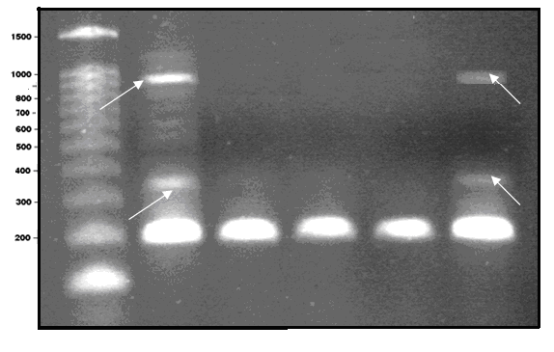  Fig. 1: RAPD-PCR banding patterns of faba bean genotypes under infested field using primer A09. Lane M 1-kb molecular- size ladder, 1) sensitive parent (Giza-40), 2) tolerant parent (x-1722), 3) F₁, 4) tolerant F₂ bulk, 5) sensitive F₂ bulk. | M 1 2 3 4 5  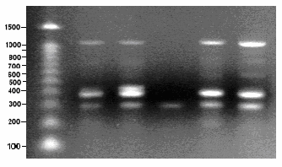  Fig. 2: RAPD-PCR banding patterns of faba bean genotypes under infested field using primer B05. Lane M 1-kb molecular- size ladder, 1) sensitive parent (Giza-40), 2) tolerant parent (x-1722), 3) F₁, 4) tolerant F₂ bulk, 5) sensitive F₂ bulk.
M 1 2 3 4 5  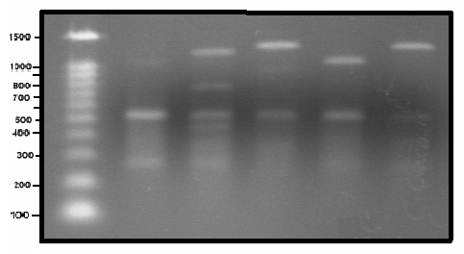  Fig. 3: RAPD-PCR banding patterns of faba bean genotypes under infested field using primer B11. Lane M 1-kb molecular- size ladder, 1) sensitive parent (Giza-40), 2) tolerant parent (x-1722), 3) F₁, 4) tolerant F₂ bulk, 5) sensitive F₂ bulk. | M 1 2 3 4 5  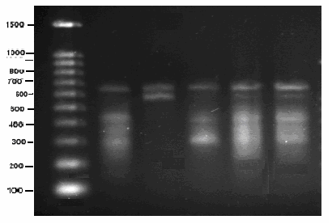  Fig. 4: RAPD-PCR banding patterns of faba bean genotypes under infested field using primer B17. Lane M 1-kb molecular- size ladder, 1) sensitive parent (Giza-40), 2) tolerant parent (x-1722), 3) F₁, 4) tolerant F₂ bulk, 5) sensitive F₂ bulk.
M 1 2 3 4 5  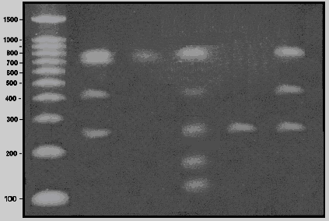  Fig. 5: RAPD-PCR banding patterns of faba bean genotypes under infested field using primer B18. Lane M 1-kb molecular- size ladder, 1) sensitive parent (Giza-40), 2) tolerant parent (x-1722), 3) F₁, 4) tolerant F₂ bulk, 5) sensitive F₂ bulk. | M 1 2 3 4 5  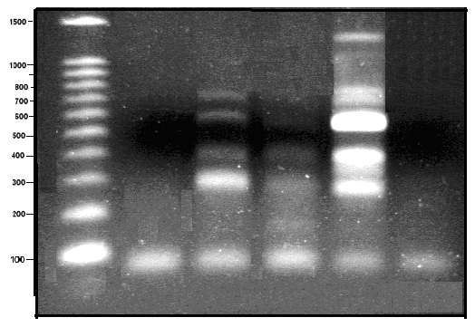Fig. 6: RAPD-PCR banding patterns of faba bean genotypes under infested field using primer B20. Lane M 1-kb molecular- size ladder, 1) sensitive parent (Giza-40), 2) tolerant parent (x-1722), 3) F₁, 4) tolerant F₂ bulk, 5) sensitive F₂ bulk.

2.2. Inter simple sequence repeats (ISSRs) analysis:-
DNA isolated from the two contrasting parents, x-1722 as an Orobanche tolerant parent and Giza 40 as an Orobanche sensitive parent, their subsequent F₁ and DNA bulks of the tolerant and sensitive groups of F₂ segregating population were tested against four preselected primers.
All primers gave polymorphisms among the studied genotypes except primer 17899B released only one monomorphic marker (Fig. 10). Primer HB12 showed one negative molecular marker which was found only in the sensitive parent (Giza 40), F₁ and the sensitive F₂ bulk with molecular size of 880bp (Fig. 8). Four unique bands for tolerant parent (x-1722) were found, one of them was in primer HB13 with molecular size 1043bp, and another one released in primer HB12 with molecular size 900 bp, while two unique bands were found in primer HB11 with molecular sizes 559 and 288 bp. Only one unique band for sensitive parent (Giza 40) released in primer HB12 with molecular size 106 (Table 6).

M 1 2 3 4 5  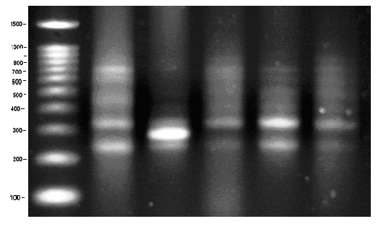  Fig. 7: ISSR-PCR banding patterns of faba bean genotypes under infested field using primer HB11. Lane M 1-kb molecular- size ladder, 1) sensitive parent (Giza-40), 2) tolerant parent (x-1722), 3) F₁, 4) tolerant F₂ bulk, 5) sensitive F₂ bulk. | M 1 2 3 4 5  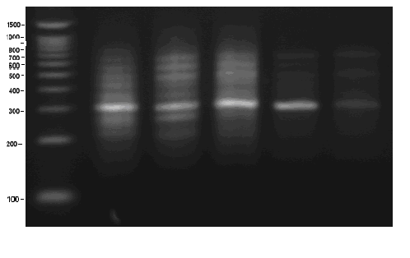  Fig. 8: ISSR-PCR banding patterns of faba bean genotypes under infested field using primer HB13. Lane M 1-kb molecular- size ladder, 1) sensitive parent (Giza-40), 2) tolerant parent (x-1722), 3) F₁, 4) tolerant F₂ bulk, 5) sensitive F₂ bul
M 1 2 3 4 5  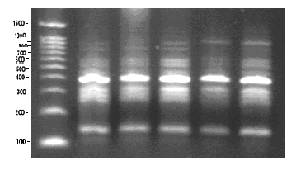  Fig. 9: ISSR-PCR banding patterns of faba bean genotypes under infested field using primer HB12. Lane M 1-kb molecular- size ladder, 1) sensitive parent (Giza-40), 2) tolerant parent (x-1722), 3) F₁, 4) tolerant F₂ bulk, 5) sensitive F₂ bulk. | M 1 2 3 4 5  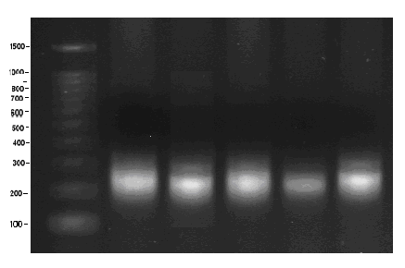  Fig. 10: ISSR-PCR banding patterns of faba bean genotypes under infested field using primer 17899B. Lane M 1-kb molecular- size ladder, 1) sensitive parent (Giza-40), 2) tolerant parent (x-1722), 3) F₁, 4) tolerant F₂ bulk, 5) sensitive F₂ bulk.

These results confirmed the possibility for breeding of new Egyptian lines and hybrids possess high tolerance and yielding in Egyptian cultivars will be acceleration of breeding program for development of new lines and subsequently new hybrids having more tolerance to Orobanche and high seed yield.
From this study we can concluded that only four RAPD markers were linked to Orobanche tolerance. Thus, BSA allowed us to directly target the gene, as demonstrated by Michelmore et al., (1991).

Table 6: ISSR -PCR polymorphic bands of eight primers linked to heat and sensitive tolerance with the two parents, their subsequent F₁ and two bulks of F₂.
Primer name | PBN | M.S (bp) | SP | TP | F₁ | Tb | Sb | MT
HB11 | 2 | 932 | 0 | 0 | 1 | 0 | 1 | -
HB11 | 4 | 786 | 0 | 0 | 1 | 0 | 0 | -
HB11 | 5 | 639 | 1 | 1 | 0 | 1 | 1 | -
HB11 | 6 | 559 | 0 | 1 | 0 | 0 | 0 | -
HB11 | 7 | 417 | 0 | 0 | 1 | 1 | 0 | -
HB11 | 7 | 411 | 0 | 0 | 0 | 0 | 1 | -
HB11 | 9 | 288 | 0 | 1 | 0 | 0 | 0 | -
HB12 | 2 | 911 | 0 | 0 | 0 | 1 | 0 | -
HB12 | 2 | 900 | 0 | 1 | 0 | 0 | 0 | -
HB12 | 3 | 880 | 1 | 0 | 1 | 0 | 1 | N
HB12 | 4 | 755 | 1 | 1 | 1 | 0 | 1 | -
HB12 | 7 | 430 | 1 | 0 | 1 | 1 | 1 | -
HB12 | 9 | 274 | 1 | 1 | 1 | 0 | 1 | -
HB12 | 9 | 251 | 0 | 1 | 1 | 0 | 1 | -
HB12 | 10 | 106 | 1 | 0 | 0 | 0 | 0 | -
HB12 | 10 | 105 | 0 | 1 | 1 | 0 | 0 | -
HB13 | 1 | 1209 | 0 | 1 | 1 | 0 | 0 | -
HB13 | 1 | 1043 | 0 | 1 | 0 | 0 | 0 | -
HB13 | 3 | 810 | 1 | 1 | 1 | 0 | 1 | -
HB13 | 4 | 700 | 0 | 0 | 1 | 1 | 0 | -
HB13 | 5 | 631 | 1 | 1 | 1 | 1 | 0 | -
HB13 | 7 | 484 | 1 | 1 | 1 | 0 | 0 | -
HB13 | 7 | 433 | 1 | 1 | 1 | 1 | 0 | -
HB13 | 8 | 361 | 1 | 1 | 0 | 0 | 1 | -
HB13 | 9 | 256 | 1 | 1 | 1 | 0 | 0 | -
HB13 | 9 | 218 | 1 | 1 | 1 | 0 | 0 | -
PBN: polymorphic band number Tb: tolerant bulk P: positive
SP: sensitive parent Sb: sensitive bulk N: negative
TP: tolerant parent MT: marker type F₁: F₁ generation

Acknowledgment
We wish to express our gratitude to the supervisor Prof Dr. M. K. Ameen Prof. of Genetics, Faculty of Agriculture, Zagazig University. Our special thanks also for Dr. M. A. Hassan Assistant Prof. of Genetics, Faculty of Agriculture, Zagazig University and M. M. Abdel Tawab Lecture of Genetics, Faculty of Agriculture, Zagazig University for their beneficial helps in this study.

References
Agrama, H.A. and M.E. Moussa (1996). Identification of RAPD markers tightly linked to the dwarf mosaic virus resistance gene in maize. Maydica, 41:205-210.
Cho, Y.G.; M.W. Blair; O. Panaud and S.R.M. Couch (1996). Cloning and mapping of variety –specific rice genomic DNA sequences: Amplified fragment length polymorphisms (AFLP) from silver-strained polyacrylamide gels. Genome, 39:373-378.
Crespo, M; J. Nienhuis; J. Tivang and P. Skroch (1995). Genetic relationships among accessions and cultivars of faba bean (Vicia faba L.) based on RAPD molecular markers. Hortscience 30 (4): 773.
Cubero, J.I. (1973). Resistance to Orobanche crenata Forsk in Vicia Faba. In Proc.1st Symposium on Parasitic Weeds. The European Weed Research Council, Parasitic Weed Research Group, Wageningen, the Netherlands, pp: 205-217.
El-Deeb, M.A.; A.H.A. Hussein; H.A. Saber and S.R. Saleeb (1999). Performance of some new Orobanche tolerant faba bean genotypes to Orobanche infestation and faba bean yield in Middle- and Upper-Egypt. J. Agric. Sci. Mansoura Univ., 24(11): 6281-6285.
Fahmy, Eman M.; F.M. Abdel-Tawab; M. H. Mostafa; Abdel-Salam, Droze A. and Sayed, Lamyaa M. (2006). Development of molecular markers associated with blast resistance in rice (Oriza sativa L.). in press.
Fang, D.Q. and M.L. Roose (1997). Identification of closely related citrus cultivars with inter-simple sequence repeat markers. Theor. Appl. Genet., 95: 408-417.
Gutierrez HE and J.O. Kuti (2001). Use of random amplified polymorphic DNA (RAPD) markers to differentiate faba bean genotypes with resistance and susceptibility to Orobanche crenata. Phytopathology 91, 6 Supplement: S111.
Haciseferogullari, H.; I. Geaer; Y. Bahtiyarca and H.O. Menges (2003). Determination of some chemical and physical properties of Sakiz faba bean (Vicia faba L. Var major). J. Food Eng., 60: 476- 479.
Khalil S.; M. Kharrat; R. Malhotra; M. Saxena and W. Erskine (2004). Breeding faba bean for Orobanche resistance. In: Dahan R, El-Mourid M (eds) Proceedings of the expert consultation on IPM for Orobanche in food legume systems in the Near East and North Africa. Integrated management of Orobanche in food legumes in the Near East and North Africa, Rabat, Morocco, pp 1–18
Lindemann, C. and R. Glover, (2003). Nitrogen fixation by legumes, New Mexico state University, Mexico. Available at: www.cahe. nmus. edu/pubs/_a/a-129.pdf.
Michelmore, R.W.; I. Paran and R.V. Kasseli (1991). Identification of markers linked to disease-resistance genes by bulked segregant analysis: A rapid method to detect markers in specific genomic regions by using segregating populations. Proc. Natl. Acad. Sci. USA,November,88:9828-9832. Genetics.
Nakamura, K.; A. Ozaki; T. Akutsu; K. Iwai; T. Sakamoto; G. Yoshizaki and N. Okamoto (2001). Genetic mapping of the dominant albino locus in rainbow trout (Oncorhychus mykiss). Mol. Genet. Genom., 265: 687- 693.
Nassib, A.M. and A.H.A. Hussein (1985). Effect of variety, plant population, and glyphosate spray on Orobanche control and yields of faba bean in On-Farm trial. Agric. Res. Rev., 63(1).
Nassib, A.M., A.A. Ibrahim and H.A. Saber (1979). Broomrape (Orobanche crenata Forsk) resistance in broad beans. Breeding work in Egypt. Food Legume Improvement and Development. G.C. Hawtin and G.J. Chncellor (Editors) ICARDA/IFAD (Publishers).
Nassib, A.M. ;A.A. Ibrahim and S.A. Khalil (1982). Breeding for resistance to Orobanche. In: Hawtin G, Webb C (eds) Faba bean improvement. Martinus NijhoV, The Hague, pp 199–206
Nassib, A.M.; A.H.A. Hussein; E.E. Saber and M.A. El-Deeb (1992). Effect of N, P, and K. nutrients with a reduced rate of glyphosphate on Orobanche control and yield of faba bean in Middle-Egypt. J. Appl. Sci., 7(7).
Parker, C. (1986). Scope of agronomic problems caused by Orobanche species. In: Borg-ter, S.J. (ed.). Proc. of a Work. on Biology and Control of Orobanche. pp: 11–7. Wageningen, The Netherlands.
Patto, M.C.; A.M. Torres; A. Koblizkova; J. Macas and J.I. Cubero (1999). Development of a genetic composite map of Vicia faba using F₂ populations derived from trisomic plants. Theoretical and Applied Genetics 98 (5): 736-743.
Potokina, E.; N. Tomooka; D.A. Vaughan; T. Alexandrova and X. Ru-Qiang (1999). Phylogeny of Vicia subgenus Vicia (Fabaceae) based on analysis of RAPDs and RFLP of PCR-amplified chloroplast genes. Genetic Resources and Crop Evolution 46 (2): 149-161.
Ratnaparkhe, M.B.; M. Tekeoglu and F.J. Muchlbauer (1998). Inter-simple Sequence repeat (ISSR) polymorphisms are useful for finding markers associated with disease resistance gene clusters. Theor. Appl. Genet., 97: 515-519.
Rom´an, B.; Z. Satovic; D. Rubiales; A.M. Torres; J.I. Cubero; Katzir, N. and D. M. Joel (2002). Variation among and within populations of the parasitic weed Orobanche crenata from Spain and Israel revealed by inter simple sequence repeat markers. Phytopathology, 92(12): 1262-1266.
Rostoks, N.; J.M. Zale; J. Soule; R. Brueggeman; A. Druka; D. Kudrna; B. Steffenson and A. Kleinhofs (2002). A barley gene family homologous to the maize rust resistance gene Rp1-D. Theor. Appl. Genet., 104: 1298-1306.
Rubiales, D. (2003). Parasitic plants, wild relatives and the nature of resistance. New Phytol 160:459–461
Schaffer, A.A., R. Jacobsohn, D.M. Joel, E. Elliasi and M. Fogelman (1991). Effect of broomrape (Orobanche spp.) infection on sugar content of carrot roots. Hort. Sci., 26 (7): 892–893.
Shen, X.; M. Zhou; W. Lu and H. Ohm (2003).Detection of Fusarium head blight resistance QTL in a wheat population using bulked segregant analysis. Theor. Appl. Genet. 106: 1041-1047.
Weder, J.K. (2002). Identification food and food legumes by RAPD-PCR. Lebensmittle-Wissenschaft und Technologies/FST 35 (3):504-511.
Wolko, B.; W.K. Swiecicki; K. Kruszka and L. Irzykowska (2000). Isozyme and RAPD markers for the identification of pea, field bean and lupin cultivars. J. of Applied Genetics 41:151-165.
Zahran, M.K.; A.H.A. Hussein; M.A. El-Deeb and H.A. Saber (1992). Effect of herbicides on Orobanche control and yield in faba bean. Fayoum Journal Agric. Res. And Dev., 6(2).

12/27/2012

