Land Degradation Assessment of the Irrigated Lands in the Middle Nile Delta, Egypt

A. Shalaby

National Authority for Remote Sensing and Space Sciences (NARSS), Egypt
adel_shalaby@hotmail.com

Abstract: The main objective of this study is to assess the land degradation risk of the irrigated lands in Middle Nile Delta. The physiographic map of the area was produced by using remote sensing and land surveying data. The study area comprises river terraces of various elevation (55.82 %), decantation and overflow basin (37.49 %), river levees (5.31 %) and swales (1.38 %). The landforms were delineated using satellite data, land surveying and laboratory analyses. A GIS model was designed to use these data for assessing the chemical and physical risk of land degradation using Arc-GIS 9.2 software. The obtained results indicate that severe risk to soil degradation affect 11.81 % of the study area. The current status of soil salinity, sodicity and water table indicate that most of soils (42.17%) are actually slightly degraded by salinization, sodification and waterlogging. The results of degradation risk and the actual hazard indicate that the human activities are not sufficient to overcome the degradation processes in 34.38% of the area.
[A. Shalaby. Land Degradation Assessment of the Irrigated Lands in the Middle Nile Delta, Egypt. Nat Sci 2013;11(1):121-126]. (ISSN: 1545-0740). http://www.sciencepub.net/nature. 19

Keywords: soil degradation, landforms, remote sensing, GIS, middle Delta, Egypt

- Introduction:
Land degradation is defined as a process, which lowers the current and/or the potential capability of soil to produce goods or services (UNEP, 1992). The cultivated land represents about 40 - 50 % of the global (Smith et al., 2007), 20 % of them are severely degraded (Adams and Eswaran, 2000; and Davis and Masten, 2003). In irrigated agriculture under the arid climate, water logging and salinization are the major land degradation processes (Dwivedi et al., 1999). Most of these processes are directly affected by human activities (Singh, 1995). Land degradation leads to a gradual decrease in soil productivity (Hillel, 2009), hindering sustainable development (Lal, 2008, and Bockstaller et al., 2009) and consequently food gap (Cassman et al., 2003). In Egypt, the alluvial soils being degraded drastically due to water logging and soil salinity (Darwish and Abdel Kawy, 2008 and Wahab et al., 2010), these problems have already emerged after the construction of the High Dam (e.g. Waterbnty, 1979). These problems are serious in the future if remedied measures are not taken (Dregne, 1986 and Mohamedin et al. 2010). In terms of productivity loss land degradation is a result of mismatch between land use and land quality (Tekwa et al., 2011). The main objective of this study is to map the physiographic units and assess the risk of land degradation of Middle Delta irrigated agriculture (Figure 1).

- Materials and methods:
  - Study area:
El-Gharbia Governorate dominates the Middle Nile Delta; it is administratively sub-divided into 8 administrative districts. Al - Mahalah Al - Kobra and Kafr Az – Zayat districts, known by their famous textile industry, cover areas of 441,91km² and 204.87 km² representing 22.65% and 10.50% respectively.

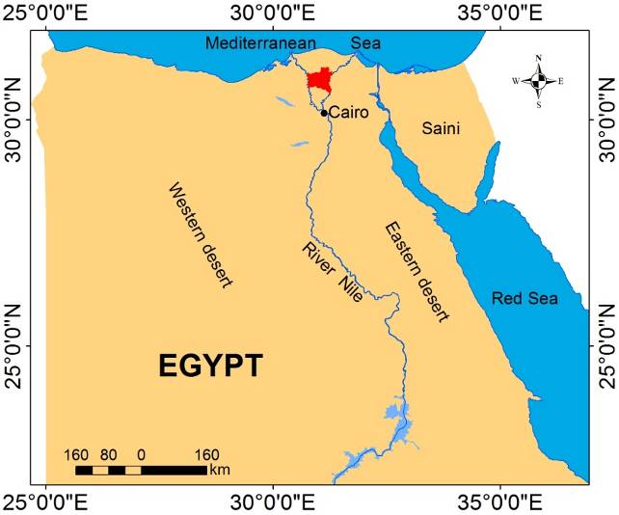
Figure (1): Location of the study area (solid red)

Tanta district is the government capital, covers 331.2 km², and representing 16.98%. The districts of As-Santah, Qutour and Zefta have amost simlar areas ranging from 229.04 km² to 215.81 km². Basyoun and Samanoud districts represent the smallest ones covering areas of 161.05 km2 and 148.57 km2, representing 8.25% and 7.61% respectively. The Governorate belongs to the late Pleistocene era which is represented by the deposits of the neonile. It includes Nile deposits which are composed of medium and fine silt (Said, 1993). The area is characterized by a climate of Mediterranean Sea with hot arid summer and little rain winter. The mean temperatures are especially high in the dry season when they range between 24 and 31 C with average temperature, 22°C and the difference between the average temperature in summer and winter is 6°C (Climatological Normal for Egypt, 2011). Based on the USDA (2010), the soil temperature regime of the studied area is defined as Thermic and soil moisture regime as Torric.

  - Image processing
The study area is covered by two Landsat ETM+ images path 177 row 39 and path 177 row 39 acquired in 2011. The images were mosaicked (Figure 2) and processed using ENVI 4.7 software (ITT, 2009). The Landsat 7 Enhanced Thematic Mapper Plus (ETM+) scan line corrector (SLC) failed on May 31, 2003, causing the scanning pattern to exhibit wedge-shaped scan-to-scan gaps. The ETM+ has continued to acquire data with the SLC powered off, leading to images that are missing approximately 22 percent of the normal scene area (Storey et al., 2005). To improve the utility of the SLC-off data, the original SLC-off image have been replaced with estimated values based on histogram-matched scenes. Data were calibrated to radiance using the inputs of image type, acquisition date and time. Image was stretched using linear 2%, smoothly filtered, and their histograms were matched according to Lillesand and Kiefer (2007). Image was atmospherically corrected using FLAASH module (ITT, 2009).

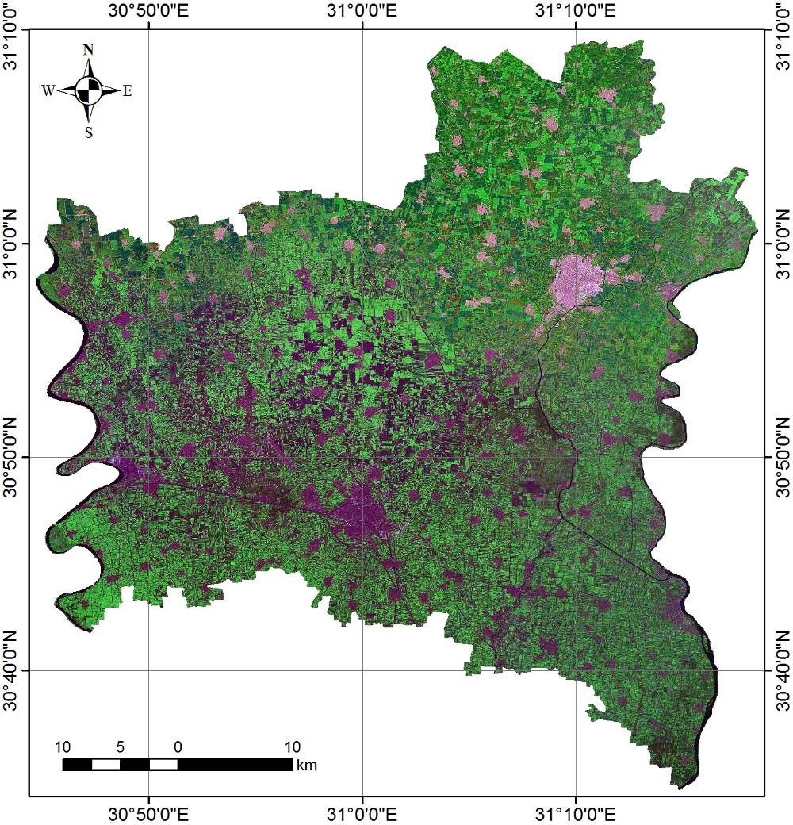
Figure (2): Landsat ETM+ mosaic of the investigated area

  - Landform mapping
The different landforms were initially determined from the satellite image and the digital elevation model extracted from the available contour maps at scale 1:25000, following the methodology developed by Dobos et al., (2002).

  - Field work and Laboratory analyses
The classification of satellite images generates a preliminary land use/cover map which was checked through 40 field observation points. A semi detailed survey was done throughout the investigated area in order to gain an appreciation on the soil patterns, the land forms and land use/cover. A total of 7 soil profiles were taken to represent different mapping units; the morphological description of these profiles was carried out according to the guidelines edited by FAO (2006). Representative disturbed soil samples have been collected and analyzed using the soil survey laboratory methods manual (USDA, 2004 and Klut, 1986) the analyses include, particle size distribution, soil pH, organic matter %, CaCO3 %, electric conductivity (dS/m), cation exchange capacity (meq/100g soil) and exchangeable sodium percentage. Using the field work and laboratory analyses data, the soils were classified on the basis of the key to soil taxonomy (USDA, 2010).
  - Soil degradation assessment:
The soil degradation risk is considered as the diminution of current or potential productivity which results from the action of climate, soil and topography without the intervention of human effect. The risk of degradation is governed by several factors i.e. surface slope, soil depth, soil texture, organic matter, soil salinity, ground water salinity, exchangeable sodium percentage, monthly and annually precipitation, potential evapotranspiration and irrigation water quantity. The influence of these factors can be definite by interpreting its effects on the physical and chemical degradation. Arc-GIS 9.2 software was used to design a simple model for assessing the risk of land degradation depends on the equations provided by FAO/UNEP (1979).

- Results and Discussion
  - Landforms
Digital elevation model analysis, satellite images interpretation and land surveying data indicated that, the study area is a flood plain containing high terraces (11.99%), moderately high terraces (22.30%), low terraces (21.53%); decantation basins (14.24%), overflow basins (23.25%), river levees (5.31%) and swales (1.38%). Table (1) and Figure (3) represent the main landforms of the investigated area.

Table (1): Areas of the different landforms in the investigated area
Landforms | Symbol | Area (km²) | Area (acre) | Area (%)
High terraces | HT | 232.23 | 58057.14 | 11.99
Moderately high terraces | MT | 431.99 | 107998.22 | 22.30
Low terraces | LT | 416.98 | 104243.92 | 21.53
Decantation basins | DB | 275.83 | 68958.26 | 14.24
Overflow basin | OB | 450.44 | 112609.37 | 23.25
Levees | L | 102.91 | 25727.53 | 5.31
Swales | S | 26.75 | 6687.75 | 1.38
Total |  | 1966.30 | 491575.61 | 100.00

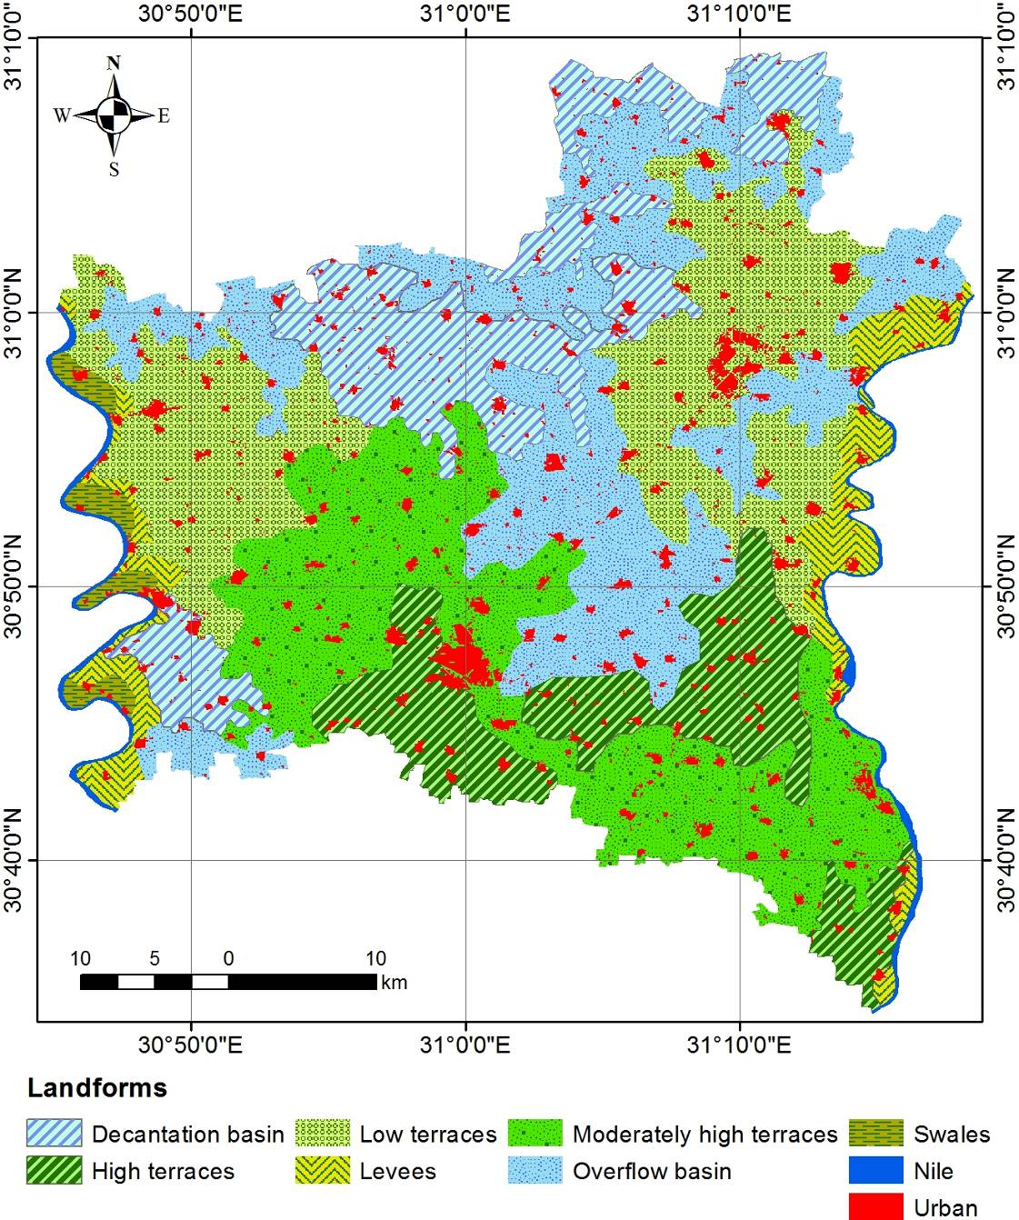
Figure (3): The main landforms of the investigated area

  - Soils
The analytical data (Table 2) showed that the soil depth ranged between 80 and 130 cm, the shallow soils depth is associated with the decantation basins (DB). The soil texture is differing between loam, clay loam, sandy loam, sandy clay loam and clay, the coarser fraction exhibits the decantation basins and swales. The soil reaction (pH) is high where the pH values range between 7.89 and 8.30. The EC values are widely varied ranging between 1.97 and 6.42 dS/m. The CaCO₃ content is low ranging between 1.35 and 4.56 %. Organic matter content is low recording a range of 0.88 - 1.23 %. Cation exchange capacity is high where it ranges between 28.51 and 47.74 meq/100g soils reflecting the high amount of clay content (39.50 - 58.67 %). Exchangeable sodium percentage (ESP) is high where it ranges between 12.02 and 24.21. The Argilic horizon was identified clearly in the overflow basin (DB2). Soil compaction was noticed in some fields with low management practices in the river levees soil where the bulk density reaches to 1.48 g/cm3. The surface cracks dominating the soils of moderately high terraces, overflow basins and river levees. The soils of the study area were classified into Vertic Torrifluvents (MT, & L), Typic Torrifluvents (HT, LT, DB & S) and Typic Natrargids (OB).

Table (2): Some chemical and physical analysis of the studied soil profiles
Mapping unit | Profile no. | Soil characteristics
Mapping unit | Profile no. | D | T | Si/C | K | O.M | pH | ECg | ECs | CEC | ESP
HT | 1 | 90 | CL | 0.99 | 3.16 | 1.23 | 7.84 | 6.54 | 3.42 | 37.15 | 24.25
MT | 2 | 110 | C | 1.26 | 3.98 | 0.89 | 8.20 | 3.21 | 2.61 | 29.26 | 17.33
LT | 3 | 100 | L | 1.30 | 3.72 | 0.88 | 8.10 | 5.51 | 3.97 | 34.24 | 12.02
DB | 4 | 80 | SL | 1.32 | 4.56 | 1.12 | 8.17 | 3.41 | 1.46 | 35.43 | 19.44
OB | 5 | 110 | C | 0.54 | 3.89 | 0.97 | 8.00 | 3.30 | 2.69 | 47.74 | 22.15
L | 6 | 120 | C | 0.83 | 2.13 | 1.11 | 8.30 | 3.63 | 2.48 | 47.49 | 18.51
S | 7 | 130 | SCL | 1.14 | 1.35 | 0.98 | 8.21 | 4.46 | 3.58 | 28.51 | 14.63
Where: D= soil depth (cm), T= soil texture (class), Si/C= silt (%) / clay (%), K= calcium carbonate content (%), O.M= organic matter content (%), pH= soil reaction (1:2.5), ECg= groundwater salinity (dS/m), ECs= soil salinity (dS/m), CEC= cation exchange capacity, ESP= exchangeable sodium percent (%).

  - Land degradation risk
Soil, topographic and climatic factors were used for defining the risk of the chemical and physical degradation. The considered parameters are soil depth, texture, silt/clay ratio and ground water salinity, slope %, precipitation (annual, monthly), evapotranspiration and quantity of irrigation water. The slope values (0.1 – 0.5 %) are slightly affecting the degradation risk, accordingly the topographic rating was considered as 1.0 in the different physiographic unit. The climatic indexes are calculated using four different formulas adapted to the different degradation process. The quantity of irrigation water has been taken into account when calculating these indexes (Table 3). The results of physical and chemical degradation risk are illustrated in Table 4. The spatial distribution of degradation risk in study area is represented in Figure 4. The obtained data indicate that about 11.81 % of the soils are located under a very high risk of chemical degradation (4,1). These soils are occupied the landforms of relatively high river terraces. The high values of ECs and ESP of these soils reflect the improper land management. The soils of low terraces and swales are attributed by a high risk of the chemical degradation (3,1) due to soil salinity and the salinity of ground water. These soils represent 22.57% of the total area. The moderate risks to chemical degradation (2,1) mainly attribute the landforms of moderately high river terraces representing about 21.97 % of the total area. The values of ECs and ESP of these soils are 2.61 dS/m and 17.33 respectively. The high values of ESP are associated to the landforms of HT and OB indicating the negative impact of human activities. The rest of the area is characterized by low risk of soil degradation representing 42.17% of the total area. Regarding to the physical degradation, the soils of the investigated area are affected by low hazard of compaction and water logging. The depth to water table in these soils ranges between 80 and 130 cm indicating minimum level of proper management.
These results indicate that salinity, and sodicity are the main degradation types in the middle of the Nile Delta. The hazards of these types could be defined in relation to the present value of electric conductivity (EC), exchangeable sodium percentage (ESP) and the depth of water table respectively. The high Values of these types are due to the over irrigation, improper use of heavy machinery and the absence of conservation measurements.

Table (3): Topographic and climatic indexes
Mapping unit | Profile  no. | Topographic index | Climatic index
Mapping unit | Profile  no. | Topographic index | Chemical degradation |  | Physical degradation
Mapping unit | Profile  no. | Slope % | ∑(Pm)² /(P)  (1) | PET/1000*ECg  (2) | PET/(Pa) 10  (3) | PET/(Pa+Q) 10  (4)
HT | 1 | 0.45 | -- | 18.16 | -- | 0.13
MT | 2 | 0.41 | 1.74 | -- | -- | 0.13
LT | 3 | 0.50 | -- | 18.04 | -- | 0.13
DB | 4 | 0.50 | -- | 21.64 | -- | 0.13
OB | 5 | 0.32 | 1.74 | -- | -- | 0.13
L | 6 | 0.44 | 1.74 | -- | -- | 0.13
S | 7 | 0.50 | -- | 17.84 | -- | 0.13
Where: Pm= monthly precipitation (mm), P= seasonal precipitation (mm), PET= potential evapotranspiration (mm), ECg= ground water salinity (dS/m), Q= irrigation water quantity (mm/season), equation (1) is used when groundwater salinity < 4 dS/m, equation (2) is used in the case of saline groundwater more than 4 dS/m, equation (3) is used in case of bare land (non-irrigated), equation (4) is used in case of irrigated land.

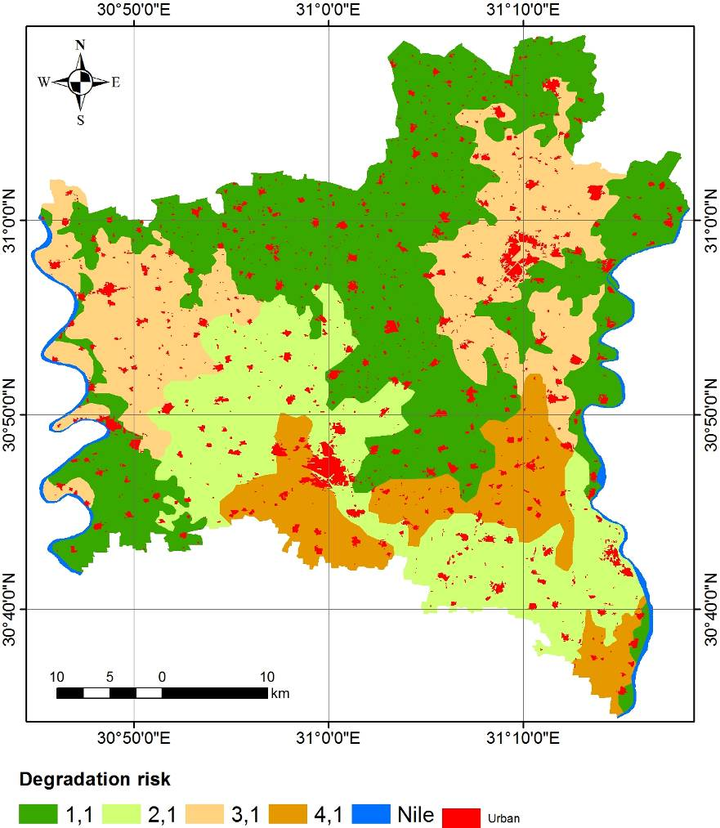
Figure (4): The spatial distribution of degradation risks over the investigated area

Table (4): The computed chemical and physical degradation risks in the studied area
Mapping unit | Profile  no. | Chemical degradation |  |  |  |  | Physical degradation |  |  |  |  | Risk
Mapping unit | Profile  no. | SR | TR | CR | Risk | Class | SR | TR | CR | Risk | Class | Risk
HT | 1 | 1.5 | 1 | 18.16 | 27.24 | 4 | 0.97 | 1 | 0.13 | 0.13 | 1 | 4,1
MT | 2 | 2 | 1 | 1.74 | 3.48 | 2 | 1.24 | 1 | 0.13 | 0.16 | 1 | 2,1
LT | 3 | 1 | 1 | 18.04 | 18.04 | 3 | 1.28 | 1 | 0.13 | 0.17 | 1 | 3,1
DB | 4 | 0.1 | 1 | 21.64 | 2.164 | 1 | 1.28 | 1 | 0.13 | 0.17 | 1 | --
OB | 5 | 1.5 | 1 | 1.74 | 2.61 | 1 | 0.45 | 1 | 0.13 | 0.06 | 1 | --
L | 6 | 1.5 | 1 | 1.74 | 2.61 | 1 | 0.75 | 1 | 0.13 | 0.10 | 1 | --
S | 7 | 1 | 1 | 17.84 | 17.84 | 3 | 1.02 | 1 | 0.13 | 0.13 | 1 | 3,1
Where: SR= soil rating; TR= topographic Rating; CR= climatic rating; Risk= SR*TR*CR; risk < 2 (class= 1 low), risk = 2 – 4 (class= 2 moderate), risk= 4 – 6 (class= 3 high), risk > 6 (class= 4 very high)

- Conclusion
Land degradation processes take place in about 34.38% of the Middle Nile Delta. The soil degradation in this area is mainly related to the salinity and alkalinity processes. Most of the soils of the Middle Nile Delta (56.35%) are improperly managed where the human activities are not sufficient to overcome the dominant degradation processes. Achieving of agriculture sustainability in the area needs great efforts related to the soil management that considered the conditions of the soil, climate and topography.

Corresponding author
Adel Shalaby
National Authority for Remote Sensing and Space Sciences (NARSS), Egypt
adel_shalaby@hotmail.com

References
- Adams, C.R., and Eswaran, H. (2000) Global land resources in the context of food and environmental security. Pp.35-50. in: Gawande SP, eds. Advances in Land Resources Management for the 20th Century. New Delhi: Soil Conservation Society of India.
- Bockstaller, C., Guichard, L., Keichinger, O., Girardin, P., Galan, M.B. and Gaillard, G. (2009) Comparison of methods to assess the sustainability of agricultural systems, A review. Agron. Sustain. Dev. 29, 223–235.
- Cassman, K.G., Dobermann, A., Walters, D.T. and Yang, H. (2003) Meeting Cereal Demand While Protecting Natural Resources and Improving Environmental Quality, Ann. Rev. Environ. Res. 28, 315–358.
- Climatologically Normal for Egypt (2011), the normal for Ghrbia Governorate station, (1960 – 2011), Ministry of civil Aviation: meteorological Authority, Cairo, Egypt.
- Darwish Kh. M. and W.A. Abdel Kawy 2008. Quantitive Assessment of Soil Degradation in some Areas North Nile Delta, Egypt International Journal of Geology: 2 (2): 17-22.
- Davis, M.L. and Masten, S.J. (2003) Principles of Environmental Engineering and Science, McGraw-Hill Professional, 704 p.
- Dobos, E., B. Norman, W. Bruee, M. Luca, J. Chris, and M. Erika, (2002). The Use of DEM and Satellite Images for Regional Scale Soil Database. 17th World Congress of Soil Science (WCSS), 14-21 August 2002, Bangkok, Thailand.
- Dregne, H. E. 1986. Desertification of arid lands. In Physics of desertification, ed. F. El-Baz and M. H. A. Hassan. Dordrecht, The Netherlands: Martinus, Nijhoff.
- Dwivedi, R. S., K. Sreenivas, and K. V. Ramana, 1999. Inventory of salt affected soils and water logged areas: a remote sensing approach. Intern. Journal of remote sensing 20: 8, 15891599, 14 ref.
- FAO, 2006. Guidelines for soil description. 4th edition. FAO, Rome, Italy.
- FAO/UNEP, (1979). A Provisional Methodology for Soil Degradation AssessmentM-57 ISBN 92-5-100869-8, FAO, Rome, Italy.
- Hillel, D. (2009) The mission of soil science in a changing world, J. Plant Nutr. Soil Sci. 172, 5–9.
- ITT, (2009). ITT corporation ENVI 4.7 software, 1133 Westchester Avenue, White Plains, NY 10604, USA
- Klut, A. (1986). Methods of soil analysis (part – 1) physical and Mineralogical methods, Madison, WI: American Society of Agronomy and Soil Science Society of America.
- Lal, R. (2008) Soils and sustainable agriculture, A review. Agron. Sustain. Dev. 28, 57–64.
- Lillesand TM. , Kiefer RW., (2007). Remote sensing and image interpretation. 5th ed. Paper back September 2007, John Wiley, New York, pp. 820.
- Mohamedin, A.A.M., M.S. Awaad and Ahmed, A. R. (2010) The Negative Role of Soil Salinity and Waterlogging on Crop Productivity in the Northeastern Region of the Nile Delta, Egypt. Research Journal of Agriculture and Biological Sciences, 6 (4): 378-385.
- Said, R. 1993. The River Nile Geology and Hydrology and Utilization. Pergmon Press, Oxford, 320 pp.
- Singh, S. (1995) Desert spread and desertification: some basic issues. Annals of arid zone 24 (2):87-98.
- Smith, P., Martino, D. Cai, Z., Gwary, D., Janzen, H., Kumar, P., McCarl, B., Ogle, S., Mara, F.O. Rice, C., Scholes, B. and Sirotenko, O. (2007) Agriculture. In Climate Change 2007: Mitigation. Contribution of Working Group III to the Fourth Assessment Report of the Intergovernmental Panel on Climate Change [B. Metz, O.R. Davidson, P.R. Bosch, R. Dave, L.A. Meyer (eds)], Cambridge University Press, Cambridge, United Kingdom and New York, NY, USA.
- Storey, J. C., P. Scaramuzza, and G. Schmidt, (2005). Landsat 7 Scan Line Corrector-off Gap Filled Product Development. PECORA 16 Conference Proceedings, Sioux Falls, South Dakota (pp. 23-27).
- Tekwa, I. J., Shehu, H. E. and Maunde, S. M. (2011) Soil nutrient status and productivity potentials of lithosols in Mubi Area, Northeastern Nigeria. Agric. Biol. J. N. Am., 2011, 2(6): 887-896.
- UNEP (1992) World atlas of desertification. Publ. E. Arnold , London , 69 pp.
- USDA, (2004). Soil Survey Laboratory Methods Manual Soil Survey Investigation Report No. 42 Version 4.0 November 2004.
- USDA, 2010. Keys to Soil Taxonomy. United State Department of Agriculture, Natural Resources Conservation Service (NRCS) eleventh edition.
- Wahab, M. A., Rasheed, M. A. and Youssef, R. A. (2010) Degradation Hazard Assessment of Some Soils North Nile Delta, Egypt. Journal of American Science: 6 (6): 156-161.
- Waterbnty, J., 1979. The Nile stops at Aswan part II: international hydroplitics. North West Africa Series, vol. XXI no.2.

12/12/2012

