Analysis of some Physico chemical parameters of soil from a protected forest in Uttarakhand
P.C. Joshi ¹, P. Pandey ¹, B.R. Kaushal ²

¹ Department of Zoology & Environmental Sciences, Gurukula Kangri University Haridwar
²Department of Zoology, D.S.B. Campus, Kumaun University, Nainital
prakash127@yahoo.com, pandey.pradeep34@gmail.com

Abstract: The present study focuses on analysis of physico chemical parameters of soil in a protected forest ecosystem of Askot Wild Life Sanctuary in the district of Pithoragarh, Uttarakhand, India. The soil moisture showed fixed seasonal trend with maximum in rainy season (20.55% ± 3.90) (Aug) and minimum in summer season (8.84% ± 3.96) (May). The mean values of Water holding capacity was maximum during January (50.95%) and minimum during November (42.1%). The soil pH was acidic in nature and ranged from 5.3 to 6.5. The soil organic matter was maximum (5.68 %) in high altitude forest at site V (Kanar) (2000-2300m) and minimum (3.76%) in low altitude forest at site II (Baram) (900-1000m).
[Joshi PC, Pandey P, Kaushal BR. Analysis of some Physico chemical parameters of soil from a protected forest in Uttarakhand. Nat Sci 2013; 11(1):136-140]. (ISSN: 1545-0740). http://www.sciencepub.net/nature. 21

Keywords: Forest ecosystem; soil; Physico chemical parameter

1. Introduction
A forest is a complex ecosystem which mainly comprises of trees, shrubs and is generally a closed canopy. Forests are store houses of a large variety of life forms such as plants, animals and have plentiful microorganisms and fungi, which ensure, the decomposition of dead organic matter thereby enriching the soil. The forest ecosystem has two components- the non-living (abiotic) and the living (biotic) component. Climate and soil type are part of the non-living component and the living components include plants, animals and other life forms. Forest reserves are areas of land especially dedicated to the protection and maintenance of biological diversity, and of natural and associated cultural resources, and managed through legal or other effective means IUCN, (1994). Human interference are excluded in these areas to promise that these ecosystems are protected (Bachamn et al., 2002). Soil is unconsolidated mineral matter that has been subjected to and influenced by genetic and environmental factors. Soil differs from the parent material in the morphological, physical, chemical and biological properties. Forest leaf litter fall conveys important changes in physical, chemical and biological characteristics of soil (biophysical environment) and balances the nutrient resources of soils.
Vegetation has a pronounced effect on many soil properties (Banerjee et al., 1985; Miles, 1985). The formation of forest soils is mainly governed by characteristics deposition of organic matter derived from forest growth. Four major groups, i.e., red loams, brown forest soils, podosols and transitional podosols have been observed in the Himalayan region, of these brown forest soils and podosols are predominant. Soil is comprised of minerals, soil organic matter (SOM), water, and air. Soil organic matter (SOM) is the most important factor of soil quality and fertility (Reeves, 1997) and maintaining some quantity and quality is critical to ensuring land sustainability and restoration of degraded soils (Liang et al., 1988; Ghani et al., 2003). The soil water storage have important role for the forest growth, and development, governed by the infiltration rate, water holding capacity (WHC) etc. The infiltration rate is highest in the forest land in comparison to bare, grass and agriculture soils (Annon, 1962). The forest had higher initial infiltration rate due to thick layer of humus, higher organic matter (7.27%), moisture equivalent (39.80%), pore space and water holding capacity (60.26%) of soils. This is of utmost importance for control of soil erosion in forest ecosystem.
Organic matter is the carboneous part of forest litter, it is generated by microbes and micro-arthropods during the process of decomposition of forest litter. The carbon exchange between forest ecosystem and atmosphere represents balance between the carbon assimilated by plants and lost through decomposition of the materials. Organic matter is the major source of nutrients such as nitrogen, and available P and K in unfertilized soils (Donahue et al., 1990). A level of organic carbon greater than 0.75% indicates good fertility (Ghosh et al., 1983), tropical rain forest soils contains less organic matter than temperate forests and most of available nutrients are found living plant and animal material (MBG, 2002). The composition and proportion of these components greatly influence soil physical properties. Including texture, structure, and porosity, the fraction of pore space in a soil. In turn these properties affect air and water movements in the soil, and thus the soil’s ability to function, and over effects for the forest ecosystem and thus related forest biotic and abiotic components. The soil and vegetation relationship is dynamic as well as temporal. Several studies with regard to soil and correlation with plant growth have been done in deciduous forests of the country (Singhal et al., 1980; Singhal and Sharma 1985; Minhas et al., 1997).
In the present study soil moisture, water holding capacity, pH, and organic matter content in soil samples collected from a protected forest have been determined.

2. Materials and Methods
The study was conducted in Askot Wildlife Sanctuary which is located in between 20⁰ 46’ 45” – 30⁰ 27’ 45” N latitude and 81⁰ 01’ 53” – 80⁰ 01- 53” E longitude in north of the Pithoragarh district in Uttarakhand with an approximate area of 600 km² and a wide altitudinal range from 600-6905 masl. The Physico chemical parameters of soil collected from five selected sites viz. Askot (1200-1500m), Baram (900-1100m), Gogai (1300-1600m), Khatikhan (1600-1800m) and Kanar (2000-2300m) were analyzed.
The soil of site Askot is red in color and in site Gogai it is slightly red in color. The soil of Baram is brownish to black in color, it is black to slightly red around Khatikhan and black in color in Kanar. The dominant plant species at Baram are Shorea robusta, Maesa indica and Mallotus philippensis, and the dominant plants species at Askot, Khatikhan and Kanar dominant species include Quercus leucotrichophora Pinus roxburghii, Rhododendron arboretum and Myrica esculenta. At Gogai the dominant species is Pinus roxburghii. The grass species Heteropogon contertust is very dominant in study sites, viz., Askot, Baram, and Gogai and less dominant in Khatikhan and Kanar. On the basis of altitude, vegetation distribution, parent material and topography the forest type of the area is Himalayan moist temperate forests (Champion & Seth 1968). Three seasons – warm and wet rainy season (July - September) cool and dry winter season (October - February) and hot and dry summer season (March- June) is distinctive in study locations.
For analysis of soil, soil samples were taken monthly from each study site during 2010 – 2012. Soil samples were taken from 10-15 cm depth of ground. Grass, leaf litter, foliage were removed from ground surface and kept in plastic bags and sealed and labeled carefully and brought to the laboratory of Gurukula Kangri University Haridwar. The analysis of different parameters was done by using Trivedi and Goel (1986) and Walkey and Black (1934) modified methods.

3. Results
The climate of the study area is warm temperate with moderate summer and severe winter. The annual rainfall recorded during first year was 266.65cm and during second year of study it was and 179.86 cm. Monthly variations in rainfall during the study period has been shown in Fig. 1.

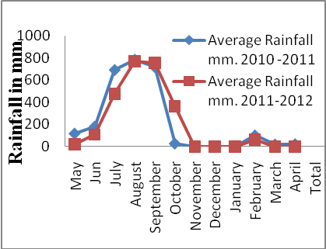
Fig: 1. Monthly variation in rainfall during the study period.
Monthly mean values of soil moisture and water holding capacity of soil from different study sites have been presented in Table 1. The monthly maximum mean values of soil moisture at site I, II, III, IV and V were 20.34% (Aug), 20.38% (Aug), 20.26% (Aug), 20.72% (Sep), 20.40% (Aug), respectively while the minimum mean values for these sites were 8.48% (May), 8.7% (May), 8.53% (Jun), 8.85% (Jun), 8.82% (April), respectively.
Monthly maximum mean values of water holding capacity recorded from site I, II, III, IV and V were 50.15% (Sep), 47.9% (Sep), 49.7 % (Jun), 50.95 % (Jan), 48.95 (Nov) respectively and minimum mean values were 42.1% (Nov), 42.4% (Aug), 43.35% (Oct ), 43.25% (Jun), 43.65% (Jan) respectively. Data on monthly variation in soil pH and organic matter during study period have been presented in Table 2.
The maximum mean values of soil pH recorded were 6.35 (Oct), 6.3 (Aug), 6.1 (Aug), 6.4 (Dec), 6.55 (Dec) for soil samples from site I, II, III, IV and V respectively and the minimum mean values for the same sites were recorded as 5.9 (July), 5.8(Feb), 5.4 (May), 5.3 (July), 5.4 (July).
The maximum mean values of organic matter were 4.29% (April), 4.57% (March), 4.52 % (July), 4.81% (Jan), 5.65% (April) in soil samples collected from site I, II, III, IV and V respectively and minimum mean values of the same were 3.14%.(Jan), 3.61% (Oct), 3.51% (Jan), 3.73% (April), 3.80% (Sep) respectively.

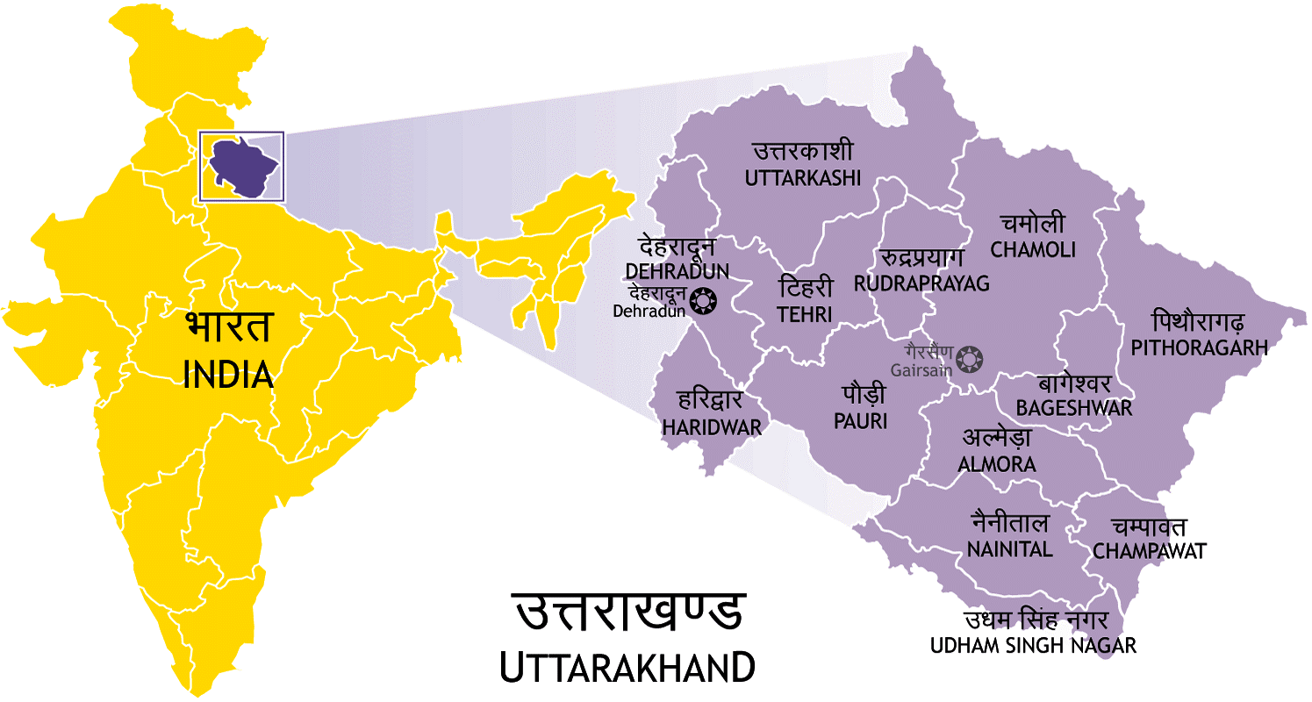
Map of the study area. (Source –Internet)

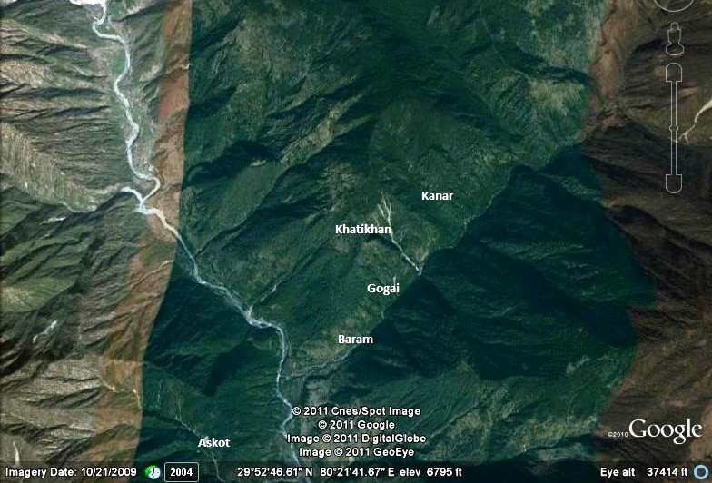
The aerial view of the study sites of Askot wild life sanctuary. (Source - Google Earth)

Table: 1. showing the mean value of Soil moisture and water holding capacity during 2010 - 12.
(S.M- Soil Moisture, W.H.C- Water Holding Capacity)
S.N. | Month |  | Site1st |  | Site 2nd |  | Site3rd |  | Site4th |  | Site 5th
S.N. |  |  | S.M | W.H.C | S.M. | W.H.C. | S.M. | W.H.C. | S.M. | W.H.C | S.M. | W.H.C
1. |  | May | 8.48 | 44.75 | 8.45 | 46.4 | 8.54 | 45.45 | 8.95 | 44.75 | 8.94 | 45.35
2 |  | Jun | 8.49 | 45.35 | 8.7 | 43.7 | 8.53 | 49.7 | 8.85 | 43.25 | 9.03 | 45.0
3 |  | July | 15.52 | 43.2 | 15.65 | 43.8 | 15.11 | 45.75 | 15.22 | 43.6 | 15.09 | 46.5
4 |  | Aug | 20.34 | 48.95 | 20.38 | 42.4 | 20.26 | 45.75 | 20.20 | 44.7 | 20.40 | 46.35
5 |  | Sep | 19.57 | 50.15 | 20.62 | 47.9 | 19.88 | 46.2 | 20.72 | 46.25 | 19.89 | 46.45
6 |  | Oct | 15.69 | 45.35 | 16.39 | 46.75 | 16.76 | 43.35 | 15.50 | 44.75 | 16.86 | 49.7
7 |  | Nov | 12.49 | 42.1 | 12.11 | 43.75 | 11.58 | 43.6 | 11.32 | 45.6 | 12.91 | 48.95
8 |  | Dec | 13.53 | 46.4 | 12.67 | 47.4 | 12.77 | 44.35 | 13.16 | 49.2 | 13.01 | 47.1
9 |  | Jan | 13.52 | 42.35 | 12.79 | 43.9 | 13.13 | 45.75 | 12.54 | 50.95 | 12.87 | 43.65
10 |  | Feb | 13.19 | 45.3 | 12.92 | 43.15 | 12.98 | 48.2 | 13.55 | 50.0 | 13.51 | 44.75
11 |  | Mar | 10.78 | 42.7 | 10.48 | 43.65 | 10.68 | 47.45 | 10.93 | 48.8 | 10.81 | 44.8
12. |  | April | 9.39 | 45.7 | 8.63 | 47.00 | 9.13 | 45.35 | 9.75 | 46.75 | 8.82 | 45.9
 |  | SD± | 3.90 | 2.49 | 4.21 | 1.93 | 4.04 | 1.83 | 4.01 | 2.59 | 3.96 | 1.74

Table: 2. Monthly mean value of pH and organic matter recorded during study period.
(OM - organic matter)
S.N. | Month | Site1st |  | Site 2nd |  | Site3rd |  | Site4th |  | Site 5th
S.N. | Month | pH | O.M | pH | O.M | pH | O.M | pH | O.M | pH | O.M
1. | May | 6.35 | 3.89 | 6.2 | 4.33 | 5.4 | 3.90 | 5.65 | 3.94 | 5.75 | 4.09
2. | Jun | 6.35 | 3.81 | 6.25 | 4.50 | 5.8 | 3.57 | 5.95 | 4.10 | 6.0 | 4.54
3 | July | 5.9 | 3.52 | 6.15 | 3.79 | 5.85 | 4.52 | 5.3 | 4.17 | 5.4 | 4.55
4. | Aug | 5.9 | 3.99 | 6.3 | 4.11 | 6.1 | 4.18 | 5.55 | 3.85 | 5.55 | 4.79
5. | Sep | 5.65 | 4.15 | 6.2 | 4.44 | 6.1 | 4.11 | 5.65 | 4.34 | 5.8 | 3.8
6. | Oct | 6.35 | 3.43 | 5.9 | 3.61 | 5.75 | 3.89 | 5.55 | 4.48 | 5.65 | 4.1
7. | Nov | 6.1 | 3.57 | 5.75 | 4.14 | 5.7 | 4.03 | 6.15 | 4.46 | 6.2 | 3.85
8. | Dec | 5.75 | 3.93 | 6.25 | 4.82 | 5.7 | 3.72 | 6.4 | 4.12 | 6.55 | 4.44
9. | Jan | 5.95 | 3.14 | 6.1 | 4.14 | 5.75 | 3.51 | 6.15 | 4.81 | 6.15 | 4.33
10. | Feb | 5.95 | 3.7 | 5.8 | 3.76 | 5.55 | 4.31 | 5.75 | 4.38 | 5.85 | 5.68
11. | Mar | 6.2 | 3.9 | 6.15 | 4.57 | 5.85 | 3.7 | 6.0 | 4.63 | 5.85 | 5.16
12. | April | 6.1 | 4.29 | 6.05 | 3.90 | 6.1 | 3.46 | 5.8 | 3.73 | 6.3 | 5.05
 | S.D± | 0.235 | 0.324 | 0.181 | 0.369 | 0.217 | 0.329 | 0.313 | 0.324 | 0.331 | 0.563

4. Discussion
Soil is an important segment of our ecosystem, as it serves as an anchorage and source of nutrients for plants. Thus it is the seat, the medium and fundamental raw material for plant growth and maintenance of forest ecosystem by different ecological processes. Among all the study sites, the maximum and minimum value of soil moisture was observed during the month of August (20.55%) and May (8.48%) respectively. In a study carried out by Joshi et al., (2002) in the buffer zone of Nanda Devi Biosphere Reserve in western Himalaya, the variation in soil moisture has been reported as 21% to 65%. Jina et. al., (2011) while working on soil physiochemical parameters of different status of forest, viz. degraded and non - degraded forest of Lamgarha Block in district Almora showed that soil moisture ranged between 6.56±0.16 and 18.07±0.44, respectively. In present study we found that the soil moisture showed fixed seasonal trend, i.e. maximum in rainy seasons followed by winter and summer showing direct relationship with precipitation.
The mean values of water holding capacity was maximum (50.95%) during the month of January and minimum during the month of November (42.1%) at site I and IV respectively. Jina et. al., (2011) have reported the similar trend in soil water holding capacity which varied between 43.34±1.26% to 45.27±0.72%. Maximum mean values of water holding capacity were observed during rainy season at site I and site II, it was summer at site III, in winter at site IV and V. Minimum mean values were observed during winter season at site I and V, it was rainy season at site II and III, in winter season at site IV. It was found that water holding capacity show no positive relation with seasons. pH of soil is the measure of hydrogen ion activity, pH of the soil from study area ranged between 5.3 (July) from site IV to 6.55 (December) from site V. Jina et. al., (2011) have reported that soil pH was highest at non degraded forest site and ranged between 5.5±0.0 to 6.5±0.0. The pH values indicate that soil of Askot wild Life Sanctuary is acidic in nature.
The organic matter shows the bio-productivity of the forest ecosystem. In the present study it was found that organic content was maximum (5.68%) at site V during the month of February and minimum (3.76%) at site II during the month of January. Arya (2002) had studied different physico - chemical parameters of soil from two study sites in the Alpine Meadows of Pindari and Milam area of Nanda Devi Biosphere Reserve and reported that the soil organic carbon varied from 4.93 to 25.71%.
Thus the present study clearly shows that the soil of Askot wild life Sanctuary is having high organic matter, which makes it fertile for the growth of vegetation in the area.

Acknowledgements:
The authors are thankful to Govind Ballabh Pant Institute of Himalayan Environmental & Development, Kosi Katarmal, Almora and Indian Academy of Environmental Sciences, Haridwar for financial support to conduct this study.

Corresponding Author:
Pradeep Pandey
Research scholar
Gurukula Kangri University
Haridwar-249404
Uttarakhand, India.
Email: pandey.pradeep34@gmail.com

References:
- Annon. Forest influences forestry series 9.
F.A.O Rome, 1962:
- Arya S C. In: Assessment of habitat diversity, distribution of vegetation and human dependence in alpine meadows of Nanda Devi Biospher Reserve, West Himalaya. Ph.D Thesis, Kumaun University, Nainital, 2002; 152pp.
- Banerjee S K. Singh S B. Nath S. Pal D K. Some chemical properties of soil under different old stand on upper forest hills of Kaling pong (Darjeeling), West Bengal. J. Indian Soc. Soil Sci., 1985; 33 (4): 788- 794.
- Bachman G. Zechmeister Boltenstenm B. Pfefer M. Hack E. Microbial Nutrient Turnover in soils of Natural forest communities, (2002). htpp//chemisrvo.pph.univie.ac.at. leha/ biogeoch.litm.
- Champion H G. Seth S K. A revised survey of forest types of India. Manager of publications, GoI, Delhi, 1968.
- Donahue R L. Miller R W. Shickluna J C. Soils: An introduction to soils and plant (5th ed.). Prentice-Hall, 1990; 234 p.
- Ghani A. Dexter M. Perrott K W. Hot- water extractable carbon in soils: a sensitive measurement for determining impacts of fertilization, grazing and cultivation. Soil Biology & Biochemistry., 2003; 35, 1231–1243.
- Ghosh A B. Bajaj J.C. Hassan R. and Singh D. Soil and water testing methods- A laboratory manual, IARI, New Delhi, 1983; 31-3.
- IUCN Guidelines for Protected Area Management Categories. IUCN and the World Conservation Monitoring Centre Gland, Switzerland and Cambridge, UK, 1994.
- Jina B S. Bohara C S. Lodhiyal L S. Sah P. Soil characteristics in Oak and Pine forests of Indian Central Himalaya. E – International Scientific Research Journal. 2011; 3 (1). 19 22.
- Joshi P C. Badoni V. Arya. Some geo- ecological aspects of Pindar valley, district Bageshwar (Uttaranchal), India. Him. J. Env. Zool., 2002; 16 (2): 271- 279.
- Liang B C. MacKenzie A F. Schnitzer M. Monreat C M. Voroney P R. Beyaert R P. Management-induced changes in labile soil organic matter under continuouscorn in eastern Canadian soils. Biology and Fertility of Soils., 1998; 26, 88–94.
- MBG http// www.mbgnet. Net. Bio plant. Missouri Botanical Garden, 2002;
- Miles J. The pedogenic effects of different species and vegetation types and the implications of succession. J. Soil Sci., 1985; 36, 571–584.
- Singhal R M. Sharma J S. Sharma S D. Pandey P. Sharma S K. Soil Biosequence of a forest land of Doon valley with references to vegetation. Presented at Indian Symposium on tropical rural Ecosystem held at A. P. S. University, Rewa, 1980.
- Singhal R M. Sharma S D. Study of the soils of Doon valley forests. Journal of Indian society for Soil Science., 1985.
- Reeves D W. The role of soil organic matter in maintaining soil quality incontinuous cropping systems. Soil & Tillage Research, 1997; 43, 131–167.
- Trivedi R K. Goel P K. Analysis of soils and aquatic sediments. In chemical and biological methods for water pollution studied. Environmental Publication Karad, 1986; 97-112.
- Walkey A E. and Black J A. an examination of the Degtiga vett.Method for determining soil organic matter and proposed modification of the chromic acid titration method. Soil Science., 1934; 37: 29.

12/28/2012

