Bandwidth Enhancement of Rectangular Patch Microstrip Array Antenna by Micromachining Technique

R.K. Verma¹, N.K. Saxena¹ and P.K.S. Pourush¹

¹Microwave Lab, Department of Physics, Agra College Agra, PIN 282002 (U.P), India.
Email: nav3091@rediffmail.com,
rkvaca1976@gmail.com, ppourush@yahoo.co.in

Abstract: Study of micromachining technique for bandwidth enhancement of sixteen elements microstrip array antenna of rectangular patches printed on the RT-duroid substrate. The radiation patterns for E-plane, H-plane and array geometry has been plotted and presented here. The radiation parameters of this array antenna are also compared with the same array antenna configuration without using electromagnet coupled technique. Comparison shows that the micromachined technique used for bandwidth enhancement has provided around 74% compare to simple patch antenna. This technique is quite complicated but very effective. The bandwidth enhancement percentage of this technique is highest compare to others.
[R.K. Verma, N.K. Saxena and P.K.S. Pourush. Bandwidth Enhancement of Rectangular Patch Microstrip Array Antenna by Micromachining Technique. Nat Sci 2013; 11(2):69-72]. (ISSN: 1545-0740). http://www.sciencepub.net/nature.13

Key Words: Bandwidth enhancement; Rectangular patch microstrip antenna; RT-duroid; Micromachined Technique.

- Introduction
The integration of various techniques of bandwidth improvement into microstrip printed circuit antenna has numerous advantages and potential applications. One of the main limitations of microstrip antennas is narrow bandwidth. Hence, much effort has gone into broadening the bandwidth. Compact circuit designs are typically achieved in high-index material which is in direct contrast to the low-index substrates imposes by high bandwidth antennas. The solution requires the capability to integrate the planer antenna on electrically thick low index region while the circuitry remains on the high index region. Thus, to integrate patch antennas into circuit designs on high index substrates without losing the advantages of low index materials, the regions in the substrate which will house the redacting element must have low index of reflection. This can be achieved by using electromagnetic coupling, aperture coupling and by using micro-machining to eliminate a portion of the substrate material [1-4].

- Theory
The bandwidth of an antenna in a practical system depends upon how severe an effect the variation of the antenna characteristic with frequency has upon the overall system performance [5-8, 11]:

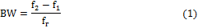

where, f_{r} is the resonant frequency. At resonance, the patch input impedance is real. Let its value be R₀. When it is connected to a transmission line with characteristic impedance, Z₀, the bandwidth can be expressed as

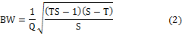

where T = R_{o}/Z₀ For the antenna fed with microstrip line and uses a quarter wave transformer connected to the patch edge and for the probe fed patches, the above expression in Equation 2 reduces to

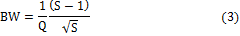

The scope of this research is to improve the bandwidth of microstrip antenna, thus, some of the important wide band techniques are listed below [7-11].

- Using low dielectric thick substrate
- Using non regular shaped antennas
- Using Impedance matching network
- Using Multilayered configuration
- Using air gap configuration
- Using micromachining technique
- Using electromagnetic coupling
- Using aperture coupling

All of these techniques have their own merits and demerits, for example, using thick substrate, does increase the bandwidth linearly, but also results in the excitation of the surface wave adding to losses other than radiation, thereby reducing the radiation efficiency of the patch. On the other hand realizing microstrip antenna with active component is a tedious improves the impedance bandwidth but degrade the pattern bandwidth. Therefore, a judicious approach should be employed for selection of these techniques. Here, in the present work we have enhanced the bandwidth by considering the Micromachined Technique.

- Antenna structure
The micro machined antenna configuration consists of a rectangular patch over the cavity, sized according to the effective index of the cavity region, and fed by a micro strip line. More specifically, the antenna is printed on a cavity region that is comprised of two dielectric sections: (1) air and (2) high dielectric substrate. Using micro-machining techniques, substrate is laterally removed from the cavity region producing a substrate area that has thickness less than or equal to 50% (i.e. amount of substrate removed varies from 50 to 80%) of the original substrate thickness and an air region that is created by the removal of material.

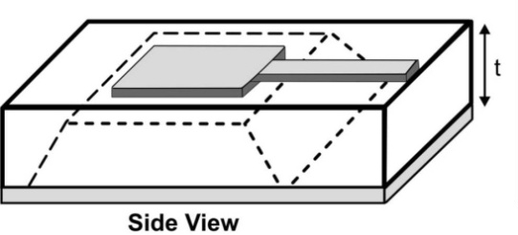
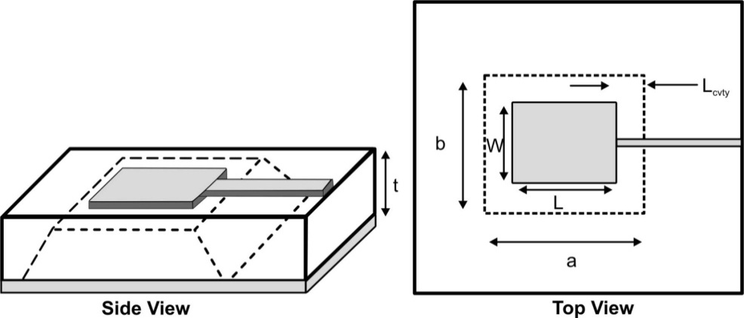
Figure 1: Geometry of the micro machined patch antenna with mixed Air-substrate region that has been laterally etched away

The walls of the hollowed cavity are in general slanted due to the anisotropic nature of the chemical etching. The geometry of the micro machined patch antenna is shown in Figure 1. A cavity model is used to predict the effective dielectric constant of the mixed air-substrate region for varying thickness ratios underneath the patch antenna. A quasi-static model based on series capacitors is used to determine the patch capacitance in the mixed region [11-13].

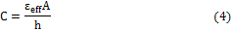
For simplicity the walls of the cavity are assumed to be vertical and the effective dielectric constant ε_{reff} is estimated by the following expression [13-15]:

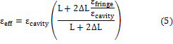

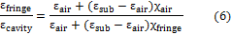

where


In the above expressionisms ε_{cavity} represents the relative dielectric constant of the mixed substrate region and ε_{fringe} represents the relative dielectric constant in the fringing fields region.

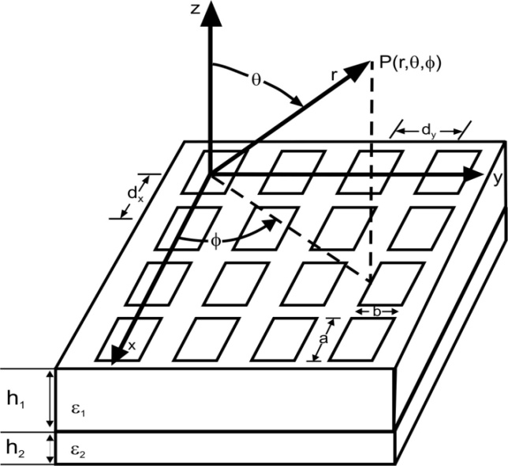

Figure 2: Geometry and coordinate system of array microstrip rectangular patch antenna

Equation 7 includes the open end effect extension length ΔL to the antenna, where ε_{fringe} is the permittivity used for the calculation of ΔL. Hence, the dimensions of the patch are calculated as [11-12]:

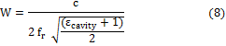
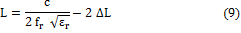

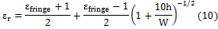

The thickness parameters χ_{air} and χ_{fringe} are ratios of the air to full substrate thickness in mixed and fringing field regions, respectively. The configuration and coordinate system of a planar array antenna considered are depicted in figure 2. The planar array of Micromachined Rectangular Patch Antenna consists of 16 identical elements on a dielectric substrate of thickness ‘h’ and substrate permittivity ε_{r}.
Using micro-machining techniques, substrate is laterally removed from the cavity region producing a substrate area that has thickness equal to around 50% of the original substrate thickness. The length and width of rectangular patch are ‘a’ and ‘b’ respectively. The array elements which are poisoned along x-axis are separated by d_{x} and array elements which are poisoned along y-axis are separated by d_{y}.

- Results
The radiation patterns and radiation parameters have been plotted and calculated respectively.

Figure 3: Radiation pattern of rectangular patch antenna in E-plane (θ = 90⁰)

A 16 elements planar array having length b = 1.57 cm and width a = 2.12 cm respectively, is printed with elements separation d_{x} = d_{y} = 3 cm on RT-duroid substrate of ε_{r} = 2.33 and height h = 0.165 cm.
The far field radiation patterns are obtained for E plane (θ = 90⁰) and H plane (φ = 0⁰). The total field pattern R(θ,φ) is generally obtained by the relation: R(θ,φ) = |E_{θ}|² + |E_{φ}|². The planar array pattern is computed for source frequency f_{r} = 10 GHz with progressive phase excitation b_{x} = b_{y} = 0.

Figure 4: Radiation pattern of rectangular patch antenna in H-plane (φ = 0⁰)

Figure 5: Variation of R(θ,φ) for 4×4 rectangular microstrip array configuration

Table 1: Comparison of characteristics of microstrip rectangular patch antenna on RT-duroid with and without micromachining technique to enhance bandwidth
S. No. | Parameter’s Formula | Values
S. No. | Parameter’s Formula | Without  Technique | With  Technique
 | Length (b) | 0.86 cm | 1.57 cm
 | Width (a) | 1.64 cm | 2.12 cm
 | Bandwidth (BW) | 6.14 % | 10.66 %
 | Directivity (D) | 4.77 dB | 4.77 dB
 | Q. Factor (Q_{F}) | 8.22 | 5.82
 | Gain (G) | 4.38 dB | 5.65 dB
 | Total Imped. (Z_{in}) | 255ohms | 173ohms
 | HPBW | E-82⁰,  H-156⁰ | E-36⁰,  H-177⁰

The patterns of E plane, H plane and planar array are shown in figures 3, 4 & 5 respectively. All important parameters like bandwidth, directivity, gain, half power beamwidth (HPBW), total impedance and quality factor of rectangular microstrip patch array antenna has been calculated on the basis of equations 4-10.

- Conclusion
A Comparison of characteristics of microstrip rectangular patch antenna on RT-duroid with and without micromachining technique to enhance bandwidth is tabulated in table 1. From the table 1 we can compare the values of bandwidth, directivity and gain for Micromachined Patch Antenna which is better than the antenna on RT-duroid substrate without micromachining, Here if we consider only quality factor, it shows a decrement in value compare to antenna on RT-duroid which compromise the increment of bandwidth, directivity and gain. It has been established that using the technique of micromachining, it alters the overall radiation performance of antenna system with a little bit increase in the patch size, about 15% compare to antenna printed on RT-duroid substrate without micromachining.

References

- Bhal I.I., et.al, “Design Of Microstrip Antenna Covered With Dielectric Layer”, IEEE Trans. on A & P, vol. 30(2), pp. 314-318, 1982.
- Papapolymerus I., /drayton R.F. and Katechi L.P.K., “Micromachined Patch Antennas”, IEEE Trans. on A & P, vol. 46(2), pp. 275-283, Feb. 1988.
- Chew, W.C. "A broadband annular ring antenna", IEEE Trans. Antennas & Propagation (USA), AP-30, pp. 918-922, Sept. 1982.
- Palanisamy, V. and Gart, R., "Rectangular ring and H-shaped microstrip antennas", Electron. Letts (UK), Vol. 21, pp. 874-876, Dec. 1985.
- Wong, K.L. and Hsu, W.H., "Broadband triangular microstrip antenna with U-shaped slot", Electron. Lett (UK), Vol. 33, pp, 2085-2087, Dec. 4, 1997.
- Yang F., et al., "Wide band E shaped patch antennas for wireless communications", IEEE Trans. Antennas & Propagation (USA), Vol. 49(7), pp. 1094-1100, July 2001.
- Pues, H.P. and Van de Capelle, A.R., "An impedance matching technique for increasing the bandwidth of microstrip antennas", IEEE Trans. Antennas & Propagation (USA), Vol. 37(11), 1345-1354, Nov. 1989.
- Derneryd, A.G. et al., "Broadband microstrip antenna element and array", IEEE Trans. Antennas & propagation (USA), AP-29 (Jan. 1981) 140-142.
- Pues, H.G. et al. "An impedance matching technique for increasing bandwidth of microstrip antennas", IEEE Trans. Antennas & Propagation (USA), AP-37, (Dec. 1989) 1345-1351.
- Sze, J.Y., and Wong, K.L., "Single-layer single patch broadband rectangular microstrip antenna", Microwave Opt. Technol. Lett. 22 (Aug. 20, 1999) 234-236.
- Sze, J.Y. and Wong, K.L., "Slotted rectangular microstrip antenna for bandwidth enhancement", IEEE Trans. Antennas & Propagation (USA), 48 (Aug. 2000) 1149-1152.
- Mann S. and Pourush P.K.S., “Computation of input impedance of rectangular, circular and hexagonal patch microstrip antennas in S and X band”, Indian J. Physics, vol. 74B (3), pp. 1-6, 2000.
- Mann S., “Analysis and Design of Broadband Microstrip Antennas”, Thesis, Dr. B.R. Ambedkar University, 2004.
- Hall, P. S., C. Wood, and C. Garrett, ‘‘Wide Bandwidth Microstrip Antennas for Circuit Integration,’’ Electronics Letters, Vol. 15, July 1979, pp. 458–460.

1/8/2013

