Assessment of watershed management implemented on springal peak flood discharge and flood volume, using HEC-HMS model
(Case study: Kushk Abad sub-basin in Iran)

B. M. Golrang ¹, F.S.Lai ², S.H.R. Sadeghi ³, Khamurudin. M.N ⁴, Kamziah, Abd Kudus ⁵, M.Mashayekhi ⁶, R. Bagherian ⁷

^{1.} Department of Forest Management (ph.D Candidate), Faculty of Forestry, University Putra Malaysia, 43400 UPM, Malaysia
^{2, 4, 5.} Department of Forest Management, Faculty of Forestry, University Putra Malaysia, 43400 UPM, Malaysia
^{3.} Department of Mathematic (PhD Candidate), Faculty of Science, University Putra Malaysia, 43400, Malaysia
^{3.} Department of Watershed Management Engineering (Assoc. Professor), Faculty of Natural Resources, Tarbiat Modares University (TMU), Noor 46417-76489,Mazandaran,Iran.
⁶ Department of English Language (PhD Candidate), Faculty of Modern Language, University Putra Malaysia, 43400, Malaysia
⁷ Department of Watershed Management (Assistant Professor), Khorasan Razavi Agricultural and natural resources Research center, Iran
b_golrang@yahoo.com

Abstract: Assessment of watershed management operation is one of the main subjects for future planning of practical projects and natural resources management. Flood Damage is one of the most important problems in countries same Iran, which is mostly, affected most parts of the country and caused hazards. Therefore, identification of the area with high potential risk of flood occurrence is the main purpose in order to the flood control and reducing its damages. Due to the lack of any tool for assessment of watershed processes in many cases, distributed hydrological models can be useful. The indicator watershed of Kushk-Abad Basin as the study area in Khorasan province of Iran divided to 6 sub-basins which was processed geometrically using GIS and HEC-HMS extension. With using HEC-HMS model and emission of individual repetition of the sub-basins, the homogenous flood hydrographs have gained in relation to the recorded precipitation calculated for different sub-basins. For this purpose, first by considering observed events, HEC-HMS model was optimized and calibrated. Then, for evaluating the effects of check dams on time of concentration, it was optimized and calibrated. Then, for evaluating the effects of check dams on time of concentration, it was calculated before and after of check dam’s construction by use of field observations and vegetation cover improvement was also estimated after the project. These parameters were imported to HEC-HMS to find out the effects of watershed practices and then flooding condition was simulated. For assessment purposes, peak discharche and flood volume were calculated for before and after construction conditions. Results showed that check dams as mechanical measures had low effect on time of concentration while biological practices lead to decease in curve number with an average value of 4.5. This result in decrease of peak flow and flood volume meanly 19% and 14%, respectively.
[B. M. Golrang, F.S. Lai, S. H. R. Sadeghi, Khamurdin. M.N, Kamziah. A. K, Mashayekhi. M, R. Bagherian. Assessment of watershed management implemented on springal peak flood discharge and flood volume, using HEC-HMS model. Nat Sci J 2013; 11(3):6-12]. (ISSN: 1545-0740). http://www.sciencepub.net/nature. 2

Keywords: HEC-HMS Model- SCS method, GIS, Rainfall-Runoff, Kushk-Abad Basin, Iran.

1. Introduction
Evaluation of watershed management activities is one of the main subjects for future planning of practical projects and natural resources management. Due to the lack of any tool for assessment of watershed processes in many cases, distributed hydrological models can be useful. The purpose of this study was evaluation of watershed management activities in Kushk-Abad Watershed by HEC-HMS (Hydrologic Modelling System). HEC-HMS is one of the computer models for simulation of its ability in simulation of short time events; ease to use and use of common methods it became very popular in Iran. Selection of a rainfall-runoff model is a compromise between model complexity and available input data. For this purpose, first by considering observed events, HEC-HMS model was optimized and calibrated (Coonrad. J and Bui.C, 2011; Boucher. M, 2011; Emerson., et al. 2003; Karmirmizad,2009; Kathol, et al.2003; Khalighi,2004; Mirmehdi 2009; Sorinezahad, 2001; USACE, 2000; Zinatishoaa, 2007; Arekhi., et al. 2011, Abbassi, 2009; Alizadeh,2001; Kim.,et al, 2001; Radmanesh., et al, 2006). Then, for evaluating the effects of check dams on time of concentration, it was calculated before and after of check dam's construction by use of field observations and vegetation cover improvement was also estimated after the project. The aim of the study was evaluation of HEC-HMS model using SCS unit hydrograph method in basins, and results showed that in the bell form (Normal) hydrographs, error was very small. These parameters were imported to HEC-HMS to find out the effects of watershed practices and then flooding condition was simulated. For assessment purposes, peak discharge and flood volume were calculated for “before” and “after” construction conditions. Soil conservation service-curve number (SCS-CN) method is one of the most employed methods for computing discharge as well as surface runoff from watersheds (SCS, 1972; Gandini, 2004; Khojini, 2001, Malekian., et al,2005). Recent studies show that this much used method is susceptible to difference in curve number (Rawals,.et al 1981; Rallison & Shelby 1982; Garen & Moore 2005, Arekhi, et al, 2011). On other hand, estimation of time of concentration have important and considerable role in physiographic and hydrologic studies of watersheds. Especially it affects on estimation of peak discharge in hydrological studies of watersheds. So, in this study, beside of introduction of new straightforward method for sensitivity analysis of simple equations, four common applicable time of concentration in Iran, e.g. kirpich, California, Bransly Williams and SCS, have been surveyed by sensitivity analysis.

2. Material and Methods
2.1 Study area
The 8500 ha study area (Kushk-abad sub watershed basin) is located in the northern part of the Khorasan province in north-eastern of Iran, and sough of Kardeh watershed basin Dam(Figure 1). The mean altitude is 2867 m, mean slop 38.8 with a mean annual rainfall 286 mm mainly falling in winter. The climate of Kush—abad is cold and watershed soils based on SCS classification.
2.2 Study methods
Considering the rich background of watershed management in Iran, we come to the result that assessing the performed operations and the effects caused by these plans is a required operation in reaching successful activities. But lack of the required equipments to cite the changes in a variety of areas, it leads to the difficulty of work, considering the application of hydrological models simulating results in developing soil and water supplies and making decision in watershed area management and using them for hydrological studies of watershed area and their application in this filed (Sahoo et al 2006 ).
Conversion of rainfall to runoff using various models and flood routing in rivers done by Muskingum method of HEC-HMS software. A lot of data and information used for this study like 1:50000 topography maps, soil map of Tehran natural resources office (Watershed management office, 1993), hydrometric data (hour and daily rainfall inside and outside of study area.
HEC-HMS is a numerical simulator, includes a range of conceptual and experimental models to simulate rainfall-runoff processes, calculating direct runoff, determining basic flow and considering the flow in channel. Considering the selective methods in this model, model inputs were identified; Curve number or CN method was used to convert rainfall to runoff. To do this, CN plan of the area, was provided from integration of vegetative plans, soil hydrological and earth application groups in GIS and Arc View3.3 for before and after the performance of watershed management and weight CN were performed of the following areas. To estimate the Lag Time and Concentration Time of watershed basin as two other required variants to perform the model, the Kirpich method used with the description of 1, 2 relation( HEC 2000).
For running of model, watershed and climate sub models, methods and control indices must be completed. There are some methods in watershed sub model for calculation of initial loss, runoff, base flow and flood routing. All of rainfall and evapotranspiration data introduce to model by climate sub model. There are some methods for calculation of spatial and temporal distribution of rainfall in watershed. In control indices, the data and time of start and end of simulation and time interval must be entered(Radmanesh, 2006).
2.2.1 Calculation of time of Concentration (TC):
To calculate the focus time, different methods are given. In this report, because of considering the changes of watershed management and estimating the CN effect on focus time, in order to estimating focus and delay time, modified kirpich method is used. The focus time in kirpich method gains of the following equation:
(1) $t_{c}=\frac{0\text{.}\text{000325}∗L^{0\text{.}\text{77}}}{S^{0\text{.}\text{385}}}$
Tc: is time of concentration (hour), L: is length of main river (m),
S: is mean slop of main river (m / m).
Kirpich method will modify for areas including CN less than so by following equation:
(2) $T_{c}=t_{c}∗(1+(\text{80}−\text{CN})∗0\text{.}4)$
Tc: is time of concentration (hour), t_c: kirpich equation time concentration
CN: curve number in SCS method. Table 1, show the result of TC calculation by Kirpich method.
2.2.2 SCS method
In SCS method, it is assumed that the amount of the real soil water retention is equal with the runoff rate to potential of runoff occurrence which means:
(3) $\frac{F_{a}}{S}=\frac{Q}{P−I_{a}}$
And using continuity equation we have:
(4) $P=Q+I_{a}+F_{a}$
And with solving two above equations, we have:
(5) $Q=\frac{(P−I_{a})^{2}}{(P−I_{a})+S}$
Q= runoff height P= Precipitation
S= is a parameter which shows the soil water retention in the surface of area and gains from the following equation.
(6) $S=\frac{\text{25400}}{\text{CN}}−\text{254}$
CN: curve number, Ia: Primary soil water retention
2.2.3 Flow calculation in reaches
In Muskingum method for flow modelling X and K parameters must be evaluated. Theoretically, K is time of passing of a wave in reach length. K was calculated equal to 1.66 and 2.44 for 1 and 2 reaches respectively by below equation:
(7) K =
Where : L is length of reach and V is velocity (m/s).
(8) X =
Where: I is river slop, n is roughness coefficient of Manning and P is wet perimeter (m) ( Mahdavi, 2005).
2.2.4 Models of calculation of HEC-HMS
Initial and constant loss rate include two parameters of constant rate and Initial loss which show the physical characteristics of soil, land use and antecedence conditions of basin( Radmanesh., et al 2006).
SCS method, classify soil based on their infiltration capacity into four categories. Khalighi (2004) calculate and published the rate for different groups of soil ( Radmanesh, 2006). Classification of soils and their infiltration rate is presented in table (2).
2.2.5 Validation of model results
For validation of model, events of 2006/3/22 & 23 were used. In this way, methods ran for these rainfalls after optimizing and applying of calibrated parameters. Also, range of changes of discharge for validation was ± %50 . After validation of models for prioritization, changes percent of observed to simulated discharges in every event determined for every method and objective function with results are presented in table 1.

Table (1) – Describes how to calibrate the model at different return periods
Period return | The calibration
2 | 3% reduction of CN
5 | 1% reduction of CN
10 | Without change
25 | 2% Increase of CN
50 | 4% Increase of CN
100 | 6% Increase of CN

RESULTS AND CONCLUSIONS
Calculating the time of leg and the time of concentration
Using the presented equations Leg and Concentration time, these two parameters for each of the sub-watershed Kushk-Abad and SCS hydrological soil groups are calculated before watershed management and the results are presented in table 2 and 3.

Table 2: concentration time and lag time of Kushk-Abad Basin before watershed management operations.
Sub-basin | Area () | Slope of river basin(m ×m) | CN | Concentration time(h) | Leg time(h) | Leg time(min)
B' | 12.23 | 0.062 | 81 | 0.87 | 0.52 | 31.4
B1 | 14.2 | 0.096 | 84 | 0.62 | 0.37 | 22.4
B2 | 7.78 | 0.083 | 84 | 0.61 | 0.36 | 21.8
B3 | 2.68 | 0.263 | 84 | 0.17 | 0.10 | 6.1
B4 | 2.51 | 0.191 | 88 | 0.26 | 0.16 | 9.5
B5 | 7.16 | 0.066 | 86 | 0.70 | 0.42 | 25.1
B6 | 3.07 | 0.141 | 81 | 0.34 | 0.20 | 12.2
Total | 49.64 | 0.047 | 84 | 1.53 | 0.92 | 54.9

Table 3: SCS hydrological soil groups and their infiltration rate
Hydrological soil groups | Soil texture | Infiltration (mm/hr)
A | Sand, Loamy sand or Sandy Loam | 8.76- 10.73
B | Silt loam or loam | 4.1 – 6.89
C | Sandy clay loam | 1.56 – 4.34
D | Clay loam, Silty clay loam, Sandy clay, Silty clay or Clay | 1.80

Providing the input information of Rain-Run off model:
Note that in Kushk-Abad sub-watershed hydrologic model, to calculate damages and to estimate hydrograph from SCS method, and for routing, we used cinematic wave routing method. In field visits, the required parameters to develop Rain-Runoff model include qualitative properties, related to the area, soil type, and the vegetation status of the region, and also the related factors to route cinematic wave method like the mean wide and the channel side gradient in each river, the route and the Manning coefficient ins measure or estimated.
As, it is clarified in above tables and figures, the watershed management has an important role in decreasing flood and also, it considerably decreases the peak flow rate of flood. This reduction is more obvious in low returning periods and the maximum effect was on a five years period, as the peak flow rate of the area decreases 37%. Also, the flow rate reduction in a one hundred years period was about 27%. In B5 sub-basin, the maximum flood reduction and in B1 sub-area, the least flood reduction was observed (Figure 3). For assessment purposes, peak discharge and flood volume were calculated for “before” and “after” construction conditions. Results showed that check dams as mechanical measures had low effect on time of concentration while biological practices lead to decrease in curve number with an average value of 3.1. This effects result in decrease of peak flow and flood volume meanly 21% and 11%, respectively.
Flood peak flow rate after watershed management:
Here, the changes include: time of concentration, CN, equivalent of some of the effective factors with effective level. Operating the corresponding effects with performing watershed management in Rain-Run off model, the model runs for different returning periods and flood peak flow rate, is calculated next to watershed management. The results are in table 4. Note that the performed changes for model calibration are exactly the same in raw data next to watershed management.

Table (4) - The peak flow is calculated for the model before the watershed ()
watershed | Area  () | Leg of time(min) | Return period(year)
watershed |  | Leg of time(min) | 2 | 5 | 10 | 25 | 50 | 100
B' | 12.23 | 44.0 | 2.8 | 3.7 | 4.9 | 8.0 | 10.6 | 14.9
B1 | 14.21 | 22.9 | 2.3 | 4.6 | 8.5 | 16.4 | 22.6 | 32.8
B2 | 7.78 | 22.2 | 1.0 | 1.5 | 2.7 | 5.6 | 8.9 | 13.3
B3 | 2.68 | 8.8 | 0.5 | 0.7 | 1.1 | 2.7 | 4.0 | 6.0
B4 | 2.51 | 9.5 | 0.5 | 1.4 | 2.6 | 4.8 | 6.4 | 8.9
B5 | 7.16 | 25.5 | 0.4 | 0.8 | 1.5 | 5.3 | 8.5 | 12.3
B6 | 3.07 | 37.8 | 0.8 | 1.0 | 1.1 | 1.5 | 2.0 | 2.8
OB1B2 | 21.98 | - | 3.3 | 6.1 | 11.2 | 22.0 | 31.5 | 46.1
OB3 | 27.18 | - | 3.7 | 7.3 | 13.2 | 25.5 | 36.3 | 53.0
OB4 | 24.50 | - | 3.5 | 6.9 | 12.5 | 24.3 | 34.5 | 50.5
OB5 | 34.34 | - | 3.9 | 8.0 | 14.4 | 29.8 | 43.3 | 63.7
ROB1B2 | 21.98 | - | 3.3 | 6.1 | 11.2 | 22.0 | 31.4 | 46.1
ROB3 | 27.18 | - | 3.7 | 7.2 | 13.2 | 25.5 | 36.2 | 53.0
ROB4 | 24.50 | - | 3.5 | 6.9 | 12.5 | 24.2 | 34.5 | 50.4
ROB5 | 34.34 | - | 3.9 | 8.0 | 14.4 | 29.8 | 43.2 | 63.7
Outlet | 49.64 | 55.4 | 6.2 | 11.5 | 19.9 | 39.2 | 55.7 | 80.9

Investigating the effect of watershed management:
Table (5) – Percent reduction in peak flow from operations in the Kushk-abad watershed study
Watershed | Area  () | Return period (year)
Watershed |  | 2 | 5 | 10 | 25 | 50 | 100
B' | 12.23 | 17.6 | 21.3 | 27.9 | 29.8 | 30.7 | 30.7
B1 | 14.21 | 4.2 | 17.9 | 15.0 | 12.8 | 11.7 | 10.6
B2 | 7.78 | 23.1 | 51.6 | 51.8 | 46.7 | 37.3 | 34.5
B3 | 2.68 | 16.7 | 61.1 | 65.6 | 53.4 | 47.4 | 41.7
B4 | 2.51 | 37.5 | 51.7 | 42.2 | 35.1 | 37.9 | 28.8
B5 | 7.16 | 69.2 | 78.9 | 76.6 | 53.5 | 43.7 | 42.0
B6 | 3.07 | 33.3 | 37.5 | 56.0 | 65.9 | 66.1 | 66.7
OB1B2 | 21.98 | 10.8 | 29.9 | 28.2 | 24.9 | 20.9 | 19.1
OB3 | 27.18 | 19.6 | 33.0 | 30.5 | 26.5 | 23.1 | 20.5
OB4 | 24.50 | 18.6 | 31.0 | 29.4 | 25.9 | 22.8 | 20.3
OB5 | 34.34 | 32.8 | 42.4 | 39.7 | 32.3 | 28.0 | 25.6
ROB1B2 | 21.98 | 10.8 | 29.9 | 28.2 | 24.9 | 20.9 | 19.1
ROB3 | 27/18 | 19/6 | 33/9 | 30/2 | 26/5 | 23/3 | 20/4
ROB4 | 24/50 | 18/6 | 31/0 | 29/0 | 26/0 | 22/6 | 20/4
ROB5 | 34/34 | 32/8 | 42/4 | 39/7 | 32/1 | 28/1 | 25/5
Outlet of Ghoosh-Bahreh | 49/64 | 18/4 | 36/8 | 35/6 | 30/9 | 28/2 | 26/8

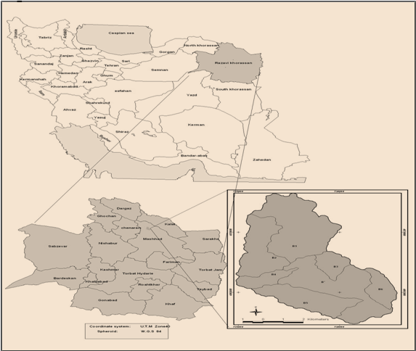
Figure 1: Location map of the study watershed

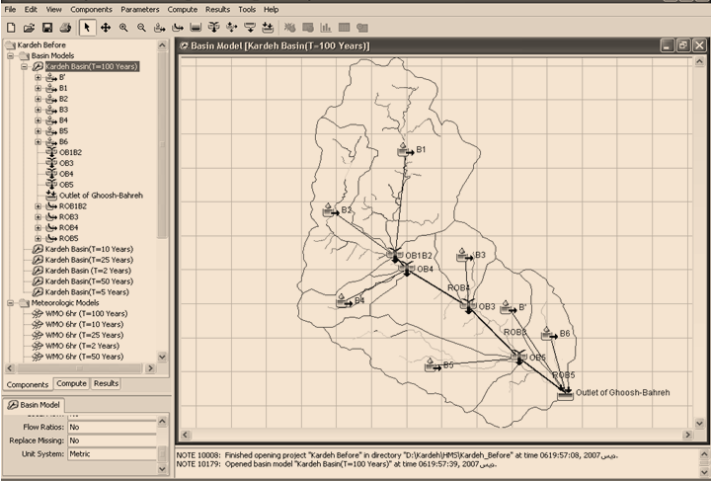
Figure 2: HEC_HMS Model in Kushk-abad Basin

In Figure (3) to (8) at different return periods before and after the flood hydrograph of the watershed are compared

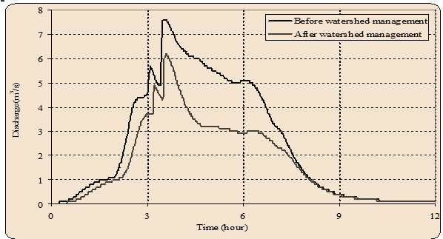
Figure 3. The comparison of 2 year return period hydrograph in watershed study before and after watershed management operations
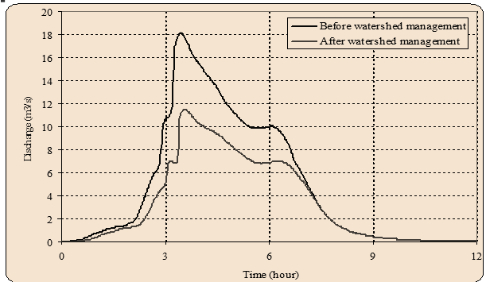
Figure 4. The comparison of 5year return period hydrograph in watershed study before and after watershed management operations

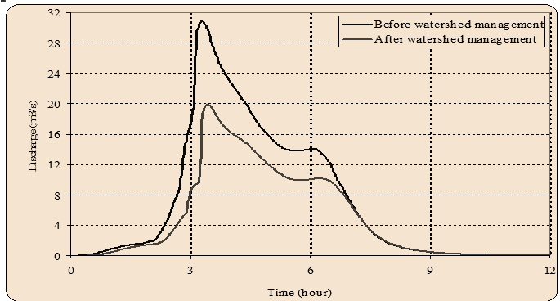
Figure 5. The comparison of 10 year return period hydrograph in watershed study before and after watershed management operations
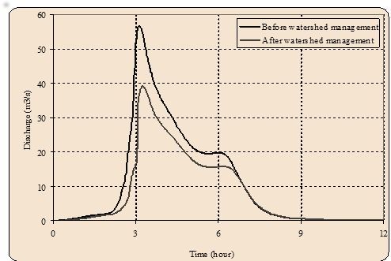
Figure 6. The comparison of 25 year return period hydrograph in watershed study before and after watershed management operations

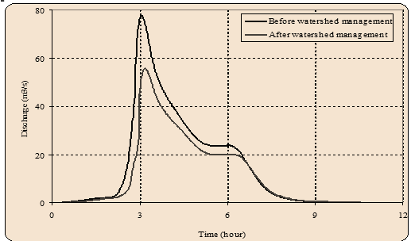
Figure 7. The comparison of 50year return period hydrograph in watershed study before and after watershed management operations

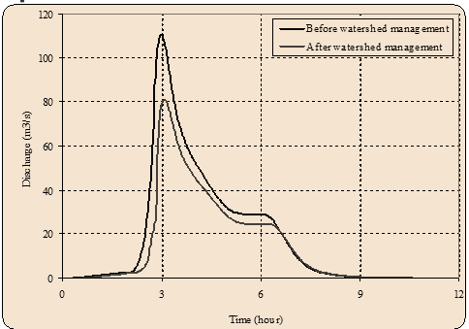
Figure 8. The comparison of 100 year return period hydrograph in watershed study before and after watershed management operations

Next to watershed management, the flood peak flow rate decreases. The percent of peak flow rate reduction for each of the studied subarea and areas will be calculated with the following equation and the results are presented in table 5.
(9); $ΔQ=\frac{Q_{\text{old}}−Q_{\text{new}}}{Q_{\text{old}}}×\text{100}$
In figures 3 to 8 flood hydrographs in different returning periods ware compared before and after the watershed management.

Conclusion:
As, it is clarified in above tables and figures, the watershed management has an important role in decreasing flood and also, it considerably decreases the peak flow rate of flood. This reduction is more obvious in low returning periods and the maximum effect was on a five years period, as the peak flow rate of the area decreases 37%. Also, the flow rate reduction in a one hundred years period was about 27%. In B5 sub-basin, the maximum flood reduction and in B1 sub-area, the least flood reduction was observed.

ACKNOWLEDGEMENT
We are thankful to be the participation of 200 respondents in the Kushk-Abad basin in this study. We also thank University Putra Malaysia and Agricultural and Natural resource center of Khorasan of Iran to support of this study. Furthermore, we are grateful to anonymous referees for their additional comments.

Corresponding Author:
Bahram Mohammadi Golrang
Department of Forestry Management
University Putra Malaysia (UPM)
43400 Malaysia
E-mail: b_golrang@yahoo.com

References
- Abbassi, M., 2009. Technical assessment of watershed management structures using mathematical model, (Case Study: Kan watershed), Thesis of M.Sc. natural resources faculty, university of Tehran
- Alizadeh, A., 2001. Applied hydrology, 15th edition, Astan- e Quds- e Razavi press.
- Boucher.M.(2011), HEC-HMS Guidance for Contra Costa Country Flood Control & Water Conservation District Unit Hydrograph Method, A repot of Flood Control institute.
- Arekhi, S, Rostamizad, G & Rostami N, 2011. Evaluation of HEC-HMS methods in Surface Runoff Simulation (Kan, Iran), Advance in Environmental Biology, 5(6) : 1316-1321, 2011.
- Coonrod,J and Bui,C.(2011), Application of HEC-HMS 3.4 in Estimation streamflow. Awra 2011 Annual Water Resources Conference, New Mexico, November7-10, 2011
- Emerson, C.H., C. Welty and R.G. Traver, 2003. Application of HEC-HMS to model the additive effects of multiple detention basins over a range of measured storm volumes, Civil Engineering Database, Part of world water & Environmental Resources Congress 2003 and Related Symposia.
- Gandini, M.L., and E.J. Usunoff, (2004), “SCS Curve Number Estimation Using Remote Sensing NDVI in A GIS Environment”, Journal of Environmental Hydrology 12, (Paper 16).
- Garen, D.C. and Moore, D.S. (2005), Curve number hydrology in water quality modeling: uses,abuses, and future directions. Journal of the American Water Resources Association 41(2):377-388
- Malekian A., M. Saravi Mohseni and M. Mahdavi, (2005), “Applicability of the USDA-NRCS Curve Number method for runoff estimation”, Iranian Journal of Natural Resources 57(4), pp. 621-633.
- Mir Mehdi, M., A. Jehangir, 2009. Calibration of HEC-HMS model and assessment of this model response to flood of Maron watershed, 4 th national conference of civil engineering, Tehran university
- Rallison, R.E. and Miller, N. (1982), Past, present, and future SCS runoff procedure. In V.P. Singh (ed.) Rainfall-Runoff Relationships: Proceedings, International Symposium on Rainfall-Runoff Modeling May 18-21, 1981 at Mississippi State University. 353-364.
- Rawls, W.J., A. Shalaby, R.H. McCuen, (1981), Evaluation of methods for determining urban runoff curve numbers. Transactions of the ASAE. 1562-1566.
- Radmanesh, F., J. Por Hemat, A. Behnia, A. Khond, B. Ali Mohamad, 2006. Calibration and assessment of HEC-HMS model in Roodzard watershed, 17 th international conference of river engineering, university of Shahid Chamran, Ahva
- Soil Conservation Service (SCS) (1972), National Engineering Handbook. Part 630 Hydrology, Section 4, U.S. Government Printing Office, Washington, D.C.
- Sori Nezhad, A., 2001. HydroClimate simulation of rainfall- runoff models in south west watersheds of Iran. Ph.D Thesis, Remote Sensing group, Humanities faculty, Tarbiat Modares University.
- Kim, D.H., M. Gautam, D. Gera, 2001. On the prediction of concentration variations in a dispersing heavy-duty truck exhaust plum using HEC-HMS. Atmospheric Environment, 35(31): 5267-527.
- Khojini, A. (2001), “Investigation on the applicability of the SCS-CN method in runoff depth and peak discharge estimation in representative watersheds of Alborz Mountain chain”, Research and reconstruction 38, pp. 12-15.
- Kousari, M, Saremi, M 2010, Sensitivity analysis of some equation for estimation of time of concentration in watersheds, Arid Biom Scientific and Research Journal, Vol.1 No. 1 2010.
- Karimizad, K., 2009. Technical assessment of effects of watershed management projects on river discharge (Case Study: Sira-kalvan watershed), Thesis of M.Sc. natural resources faculty, university of Tehran.
- Kathol, J.P., H.D. Werner and T.P. Trooien, 2003."Predicting Runoff for Frequency based Storm using a Prediction- Runoff Model", A.S.A.E,. South Dakota, U.S.A.
- Khalighi Sigaroodi, S.H., 2004. Effect of land use changes on hydrological characteristics of surface waters (Case Study: Barandoozchai watershed), Ph.D Thesis, natural resources faculty, university of Tehran, pp: 224.
- USACE., 2000. HEC-HMS Technical Manual Hydrologic Engineering Center. Davis. CA., pp: 187.
- Zinati Shoaa, T., 2007. Effect of tonder transmission in rainfall- runoff simulation (Case Study: lattian watershed), Thesis of M.Sc. natural resources faculty, university of Tehran.

1/8/2013

