Tropane Alkaloid Production via New Promising Atropa belladonna L. Lines by In Vivo and In Vitro

Khater M.A. ¹, S.S.A.Soliman², M.S. Abdel-Hady¹, and A.H. Fayed²

¹Botany Dept., National Research Centre, Egypt
²Genetics Dept., Fac. Agric., Zagazig Univ., Egypt
Mahmoudkhater2000@yahoo.com

Abstract: Atropa belladonna L. seeds of the three promising new lines (M-11-1, M-11-2 and M-15-1) were used to produce alkaloids especially atropine via in vivo and in vitro. Highly significant effect on lines was reported on callus induction frequency. There were a markedly increases in callus induction percentage by increasing 2, 4-D concentrations until 2.0 mg/l. Highly significant differences between two concentrations of 2, 4-D (1.0 and 2.0 mg/l) were recorded on callus fresh weight and callus dry weight respectively. M-11-1 line had higher callus fresh weight than the control and other genotypes at 4th subculture. The rate of total alkaloids between in vivo and in vitro (callus) were approximately one and half times. The behavior of atropine values at callus tissues was higher increasing than plant leaves. More well as the increase of callus atropine values than the leaves about 5 ^{th} times for M-11-1 callus comparing with leaves of control.
[Khater M.A., S.S.A. Soliman, M.S. Abdel-Hady and A.H. Fayed. Tropane Alkaloid Production via New Promising Atropa belladonna L. Lines by In Vivo and In Vitro. Nat Sci 2013;11(3):32-40]. (ISSN: 1545-0740). http://www.sciencepub.net. 5

Key words: Atropa belladonna - Promising new lines - In vitro -Callus – 2,4-D-Tropane alkaloid –Atropine – HPLC.

1. Introduction
Plants are known for the production of a large array of natural products, also referred to as secondary metabolites. They are economically important to man due to their multiple applications, such as pharmaceuticals, flavors, fragrances, insecticides, dyes, food additives, toxins, etc. The majority of pharmaceutically important secondary metabolites obtained from wild or cultivated plants. The pharmaceutical use of plants involves problems that should be seriously considered. Firstly, variations in the expression of genetic potential can occur according to the harvest period, pathogen contamination and environmental factors, which can drastically influence the production of secondary metabolites. Secondly, increasing commercial interest in medicinal plants frequently leads to exploitation without compensatory actions with the consequent risk of decrease and extinction of important populations. Tissue culture techniques recognized as excellent tools for medicinal plants propagation, allowing the production of contaminant-free plants, under controlled conditions and with independence of climatic factors.
The first attempt for the industrial production of secondary metabolites in vitro was made during 1950 to 1960 by Pfizer Company and the first patent was obtained in 1956 by Routien and Nickell. Several kinds of bioreactors have been designed for large-scale cultivation of plant cells. In several cases cell cultures have been shown producing certain metabolites in quantities equal to (Kaul and Staba, 1967) or many fold greater than the parent plant(Zenk, 1978).
The low yield and high market price of the pharmaceutically important alkaloids have created interest in improved alternative routes for their production such as using cell and tissue culture. The callus developed on Murashige and Skoog (MS) media supplemented with different concentrations of auxins and cytokinins was found to have variable alkaloid contents (Verma et al. 2012).
One of the most important medicinal plants is Atropa belladonna L. (Deadly night shade). It is an annual herb belongs to the family solanaceae . Atropa belladonna L. plant is a very important medicinal plant as a known source of the tropane alkaloids; hyoscyamine, atropine and scopolamine (hyoscine). (Arroo et al. 2007).
Three promising mutant lines of Atropa belladonna L. were developed as a high alkaloid content than the mother genotype. These lines were named M-11-1, M-11-2 and M-15-1 (Khater 2007). These lines possessed twice values than the control, as well as stable morphological criteria at M₃ until M₅ generation.
Therefore, the present study aimed to:
- Trial to alkaloid production especially atropine in vivo (plant leaves) and in vitro callus culture conditions from these lines.
- Determine the optimum conditions for increasing of tropane alkaloids from callus culture.
- Comparing between tropane alkaloid production from callus culture and in vivo (plant leaves).
2. Materials and Methods
The present investigation was carried out at greenhouse of Genetics Dept., Fac. of Agriculture, Zagazig Univ. Tissue culture experiment was carried out at Tissue culture laboratory, Botany Department, National Research Centre.
- Plant material:
Atropa belladonna L. seeds of the three promising new lines, i.e. M-11-1, M-11-2 and M-15-1 and origin seeds (Khater 2007) were used in this study.
- Callus induction:
The leaves of fourth plant genotypes ( origin plant and three lines, thus sterilized are cut to approximately 1 cm in length and each piece planted on a solid agar medium in ten replicates (jars) with frequency of two leaf’s segments per jar for callus induction. MS medium (Murashige and Skoog, 1962) in organic components and B5- Vitamins (Gamborg et al, 1968) were used. Three concentrations of 2,4-dichlorophenoxyacetic acid (2,4-D) and 0.5 mg/l Kinetin (Kin.) were applied in the present study (Table 1).

All mentioned cultures were incubated in a complete dark for 20 days at 25 ± 2º C followed by artificial light / dark (16/8 h) at 25 ± 2ºC (Vidhyasekaran, 1993).
After 4 weeks callus formed that had developed at the edge of the cutting was excised and transferred to fresh media with the same composition as used for callus (MS media supplemented with 1 and 2 mg/l 2, 4-D + 0.5 mg/l Kin. + 30 g/l sucrose). Calli were subcultured on fresh media every month for five times to growth and maintain of callus stock.
The formula for calculating callus induction frequency (C_{ip}) is shown:
Number of explants forming callus
C_{ip} = × 100
Total number of used explants
Callus growth was represented with growth index which was calculated according to (Dung, et al. 1981) according the following equation:
Final callus fresh weight - initial callus fresh weight
Growth index= × 100
Initial callus fresh weight
Dry Matter Content (%):
The fresh weight (mg) of different calli were dried at 60°C for 48 hrs and the dry matter content was estimated according the following equation: Callus dry matter (%) = Callus dry weight x100 / Callus fresh weight.

Table 1: MS-media supplemented with different growth regulators at different concentrations for callus production from leaf explants of Atropa belladonna L lines.
No. of media | MS-media composition
1 | MS (4.4g/l) + Sucrose (30g/l) + Agar (7.5 g/l) + 1 mg/l (2,4-D) + 0.5 mg/l (Kin)
2 | MS (4.4g/l) + Sucrose (30g/l) + Agar (7.5 g/l) + 2 mg/l (2,4-D) + 0.5 mg/l (Kin)
3 | MS (4.4g/l) + Sucrose (30g/l) + Agar (7.5 g/l) + 3 mg/l (2,4-D) + 0.5 mg/l (Kin)

3. Alkaloid extraction from in vivo and in vitro tissues:
Extraction of tropane alkaloids from leaves (in vivo) of studied genotypes of Atropa belladonna L. (Control, M-11-1, M-11-2 and M-15-1) at flowering stage that were shade dried and ground by electric mill to moderately fine powder prior to extraction. (Cordel; 1981and adapted by Mahmoud, 2004) and as described in British Pharmacopoeia 1998. Calli were dried and ground to obtain fine powder prior to extraction.
Determination of Tropane alkaloids:
Total alkaloids were estimated in callus and leaves and Atropine percentage was determined according to the colorimetric method of Karwya et al. (1975).
HPLC Analysis of Tropane Alkaloids:
Chromatographic Conditions:
Apparatus: - Backman HPLC, pump: 126 solvent module, 168 Detector photo diode array, auto sampler (507e), soft ware (system gold). Column: - Hypersil, ODS (C18), [250 x 4.6 mm] 5 micron + grade column 5cm.
Mobile phase:-
2 Eluent ; (acetonitrate: 30%, [1L H O + 3ml triethyl amino TEA (70%); Flow rate; 1ml/ min; Injection volume; 20µl;Run time; 25min;Wave length; 254nm and Temperature; 35°C
Tropane Alkaloids Standards: Atropine standard authentic samples were purchased from Sigma – Aldrish Company.
Statistical Analysis
Data on callus frequencies were analyzed by Chi-square test to estimate the effect of different factors, genotypes and growth regulators, on response for callus induction frequency. Means and L.S.D. were estimated according to Sokal and Rohlf (1995), and Microsoft Excel Version 2007 was used too.
3. Results and Discussion
Effect of 2, 4-D concentrations and genotypes on callus induction frequencies:
The effect of Atropa belladonna L. mutant genotypes and 2, 4- D concentrations (1, 2 and 3 mg/l) with 0.5 mg/l Kin. on callus induction frequencies were shown in Table (2).

Highly significant effect on lines (M-11-1, M-11-2 and M-15-1) were reported on callus induction frequency. M-11-1 which was a surpassing response and recorded the highest increase (65 %) as compared to control which gave the lowest one (35 %). There were a markedly increases in callus induction percentage by increasing 2,4-D concentrations until 2.0 mg/l. The average of callus induction at 2.0 mg/l concentration of 2, 4-D gave highly significant increase (82.50 %), while increasing 2, 4-D concentration to 3.0 mg/l gave highly significant reduction (12.50 %). These results confirmed the importance of M-11-1 line and 2.0 mg/l 2, 4-D concentration for obtaining of high callus frequencies in Atropa belladonna L.
With regard to the interaction between lines and 2, 4-D concentrations, there were highly significant differences between most treatments as shown in Table (2). However, callus induction frequency increased in response to the increase of 2, 4-D concentrations and varied from one Genotype to another. The best interaction genotypes and 2, 4-D concentration was between 2.0 mg/l 2, 4- D and all Genotypes.
Khanam et al 2000 reported that callus induction of Duboisia myoporoides in medium supplemented with 2,4-D alone or various concentrations of cytokinins (Kin.) + 2, 4-D. Also, reported that callus induction took place after 7 to 10 days on 90.19% of the leaf explants.

Table 2: Chi-square test of callus induction frequency of Atropa belladonna L. lines under 2, 4-D concentrations (1, 2 and 3 mg/l) and Kin. 0.5 mg/l.
Genotypes | 2,4-D concentrations |  |  |  | Genotypes mean
Genotypes | 1 mg/l | 2 mg/l |  | 3 mg/l | Genotypes mean
Cont. | 5 | 100 |  | 5 | 36.67
M-11-1 | 85 | 100 |  | 10 | 65.00
M-11-2 | 55 | 45 |  | 25 | 41.67
M-15-1 | 35 | 85 |  | 10 | 43.33
Treatment mean | 45.00 | 82.50 |  | 12.50
 |  |  | - Genotypes
X²t = 7.815 |  |  | X²c = 30.357
 |  |  | - Growth regulators
X²t = 5.991 |  |  | X²c = 210.354
- Independence
Genotypes × Media
X²t = 12.542 |  |  | X²c = 96.586

In addition, Kin. in combination with 2,4-D had been used to induce calluses from Scutellaria columnae (Lamiaceae), which produced triterpenes and other substances (Stojakowska and Kisiel, 1999). The same findings were reported by (Castellar et al. 2011) decided that 2, 4- D induced faster growing calluses. which formed at the basal end of shoots cultured on MS showed continued growth when subcultured to fresh medium. However an efficient callus induction from leaf explants was observed on media supplemented with 2, 4-D.
As well as, the present results were in agreement with that obtained by Jinchen and Raghavan (1985) on Hyoscyamus niger, and with Dodds and Roberts (1995) who decided that using 2.0 mg/l from 2, 4-D with Datura stramonium L. produced and increased callus induction. Also, these results showed agreement with Engvild (1973) reported that, callus cultures of Datura innoxia grow well on any single one of the growth substances NAA (10 ⁵ M), 2,4-D (10 ⁶ M) or BA (3×10 ⁶ M).
In contrast, El-Bahr et al., (1997) studied the effect of different growth regulators on callus culture of Hyoscyamus muticus L. and found that the better growth of callus obtained with 1 mg/l both 2, 4-D and Kin. Also Mahmoud (2004) obtained that 2, 4-D induce strong, large non-organogenic callus on MS with 1.0 mg/l 2, 4-D which was better than 2 mg and 3 mg per liter media. Also disagree with (Raoufa et al 2008).
Other recent investigations, Manju Madhavan and Joy P. Joseph (2010) reported that using MS medium supplemented with 3.0 mg/l 2,4-D and 0.5 mg/l BAP induced callus. As well as, Patni Showkat et al. (2010) also showed that best results for callus formation in Bacopa monnieri (L.) Penn. was obtained in the leaf explants on MS supplemented with 0.5 mg/l 2, 4 -D.
Callus Growth Criteria:
The growth characteristics and pattern of calli derived from leaf explants of Atropa belladonna L. growing in MS media containing 1 and 2 mg/l of 2,4-D and 0.5 Kin. were investigated (Table 3). Calli growth patterns were expressed as callus fresh weight (mg), callus dry weight (mg) and callus dry matter (%). M-11-1 line possessed highly significant of callus fresh weight (mg) and callus dry weight (mg) than the other lines under 1.0 and 2.0 mg/l 2, 4-D concentrations (Table 3). Highly significant differences between two concentrations of 2, 4-D (1.0 and 2.0 mg/l) were recorded on callus fresh weight and callus dry weight respectively. Interest remarkable, interaction between M-11-1 line and 1.0 mg/l 2, 4-D had highest callus fresh weight (1446 mg) and callus dry weight (590 mg) also. But M-15-1 line at 2.0 mg/l 2, 4-D possessed higher callus fresh weight than other interactions between genotypes and hormone concentrations. While, no response of M-11-2 line at 1.0 mg/l 2, 4-D and it had callus fresh weight (1290 mg) at 2.0 mg/l 2, 4-D .
These results were in agreement with that obtained by El-Bahr (1989) recorded that the best growth as expressed on callus fresh weight was obtained at 2.0 mg/l 2,4-D.

Table 3: Interaction between Atropa belladonna L. lines and 2, 4-D concentrations (mg/l) on callus fresh weight, callus dry weight (mg) and callus dry matter (%) before subculture.
Genotypes | Callus Fresh Weight (mg) |  |  |  |  | Callus Dry Weight ( mg ) |  |  |  |  | Callus Dry Matter (%)
Genotypes | 2,4-D Conc. (mg/l) |  |  |  | Mean | 2,4-D Conc. (mg/l) |  |  | Mean |  | 2,4-D Conc.(mg/l) |  |  | Mean
Genotypes | 1.0 mg/l |  | 2.0 mg/l |  | Mean | 1.0 mg/l |  | 2.0 mg/l |  |  | 1.0 mg/l | 2.0 mg/l |  | Mean
Cont. | 894 |  | 1150 |  | 1022 | 474 |  | 314 | 394 |  | 53.02 | 27.30 |  | 40.16
M-11-1 | 1446 |  | 1840 |  | 1643 | 590 |  | 498 | 544 |  | 40.80 | 38.61 |  | 39.71
M-11-2 | 0 |  | 1290 |  | 645.0 | 0 |  | 554 | 277 |  | 0 | 30.11 |  | 15.06
M-15-1 | 367 |  | 1520 |  | 943.5 | 215 |  | 456 | 335.5 |  | 58.58 | 30.00 |  | 44.29
Treatment mean | 676.75 |  | 1450 |  |  | 319.75 |  | 455.5 |  |  | 38.1 | 31.51
Dry Weight |  |  |  | Fresh Weight
0.01 |  | 0.05 |  | 0.01 |  |  | 0.05 |  |  | L.S.D
101.979 |  | 75.724 |  | 385.114 |  |  | 285.965 |  |  | Genotypes
144.22 |  | 107.09 |  | 544.634 |  |  | 404.415 |  |  | 2,4-D conc.
101.979 |  | 75.724 |  | 385.114 |  |  | 285.965 |  |  | Interaction

These findings confirmed that different lines (mutants and their origin) possessed different genes or loci controlling response of callus induction frequencies and callus growth (callus fresh weight). These lines of Atropa belladonna L. differed between them in the molecular levels (Khater 2007) and subsequently it confirmed the above results.
The growth dynamics of the obtained different calli cultures were determined monthly for five subcultures on fresh media (Table 4 and Fig. 1, 2).
Highly significant differences were reported between lines and number of subcultures (Table 4). M-11-1 line had higher callus fresh weight than the control and other genotypes at 4th subculture (16.187gm) at 1.0 mg/l 2, 4-D , with regard of subculture, the subculture number 4 possessed higher values of callus fresh weight and subsequently the fourth subculture consider as the maximum number of subcultures for callus yield.
M-11-2 line was absent at 1.0 mg/l 2, 4-D and represent at 2.0 mg/l 2, 4-D (Table 4). This finding confirmed the importance of genotype and hormone balance interaction and requires more future study. The same trend was showed for the effect of subculture numbers. The fourth subculture gave higher callus fresh weight than the fifth subculture, and then, no require for carried out fifth subculture.
As well as, M-11-1 consider as an excellent genotype under two different concentrations of 2, 4-D and possessed 13.01gm at 4th subculture under 2.0 mg/l 2, 4-D. In addition M-15-1 gave higher callus fresh weight at 4th subculture (13.33 gm). These results confirmed the possibility of tropane alkaloids production from callus culture using four subcultures only.

Table 4: Effect of subcultures on callus fresh weight (gm) at 1.0 and 2.0 mg/l 2, 4-D and 0.5 mg/l Kin.
Genotypes
NO. of Subcultures | Mean |  |  |  |  |  | NO. of Subcultures | Mean
NO. of Subcultures | 1.0 mg/l 2, 4-D |  |  |  |  |  | NO. of Subcultures | 2.0 mg/l 2, 4-D
NO. of Subcultures | 0 | 1 | 2 | 3 | 4 | 5 | NO. of Subcultures | 0 | 1 | 2 | 3 | 4 | 5
Cont. | 0.894 | 2.780 | 5.132 | 7.524 | 9.298 | 9.250 | 5.813 | 1.15 | 2.37 | 4.75 | 6.89 | 8.67 | 8.34 | 5.362
M-11-1 | 1.446 | 5.734 | 9.898 | 13.480 | 16.187 | 16.134 | 10.480 | 1.84 | 3.34 | 7.02 | 10.04 | 13.01 | 12.38 | 7.938
M-11-2 | - | - | - | - | - | - | - | 1.29 | 2.97 | 5.73 | 8.22 | 10.32 | 10.14 | 6.445
M-15-1 | 0.367 | 0.410 | 0.471 | 0.513 | 0.567 | 0.522 | 0.475 | 1.52 | 3.87 | 7.57 | 10.67 | 13.33 | 13.10 | 8.343
Mean | 0.677 | 2.231 | 3.875 | 5.380 | 6.513 | 6.477 |  | 1.45 | 3.138 | 6.268 | 8.955 | 11.333 | 10.990
L.S.D | 0.05 | 0.01 |  | L.S.D | 0.05 | 0.01
Genotype | 2.932 | 6.763 |  | Genotype | 1.530 | 2.025
Subcultures | 1.179 | 1.786 |  | Subcultures | 1.249 | 1.653
Interaction | 0.604 | 1.732 |  | Interaction | 0.625 | 0.827
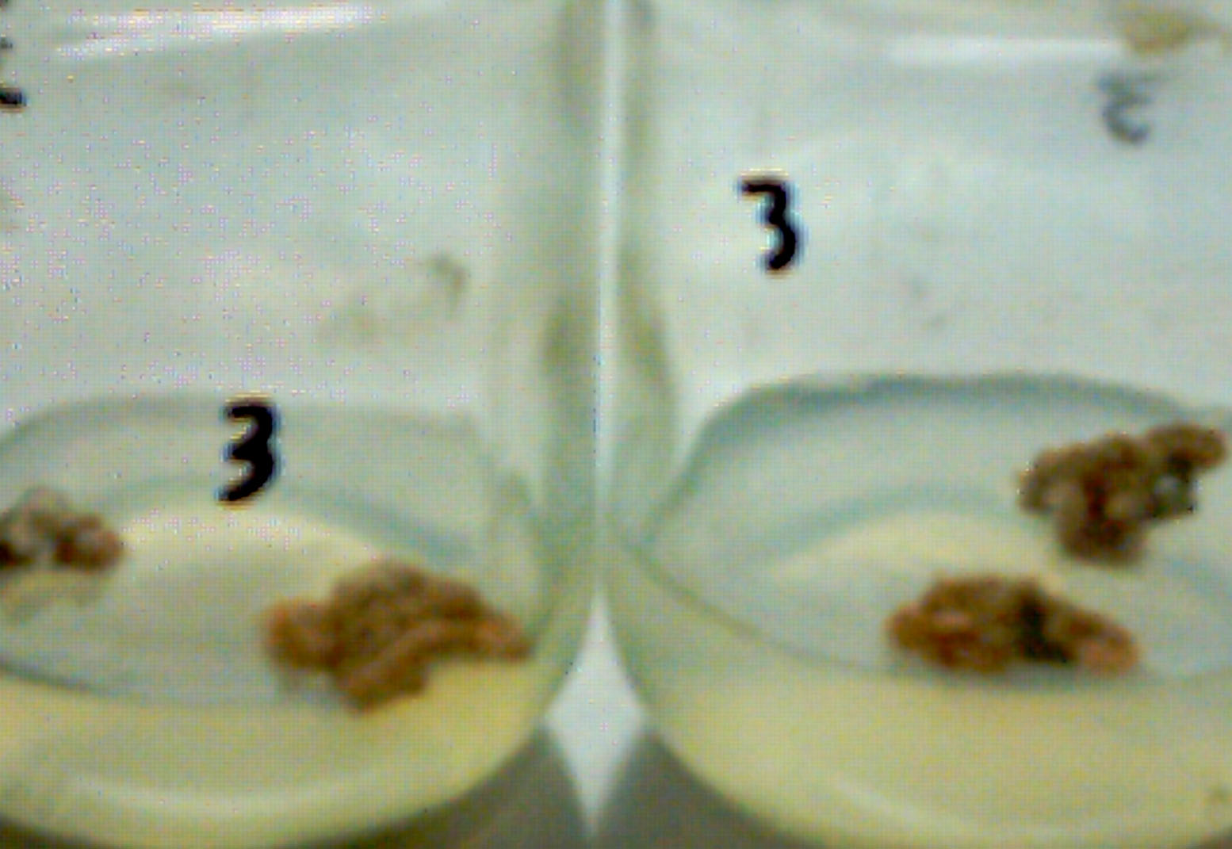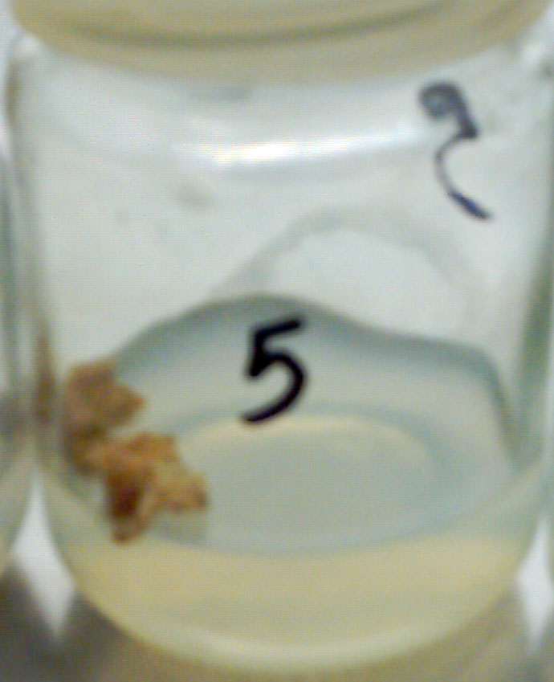
A

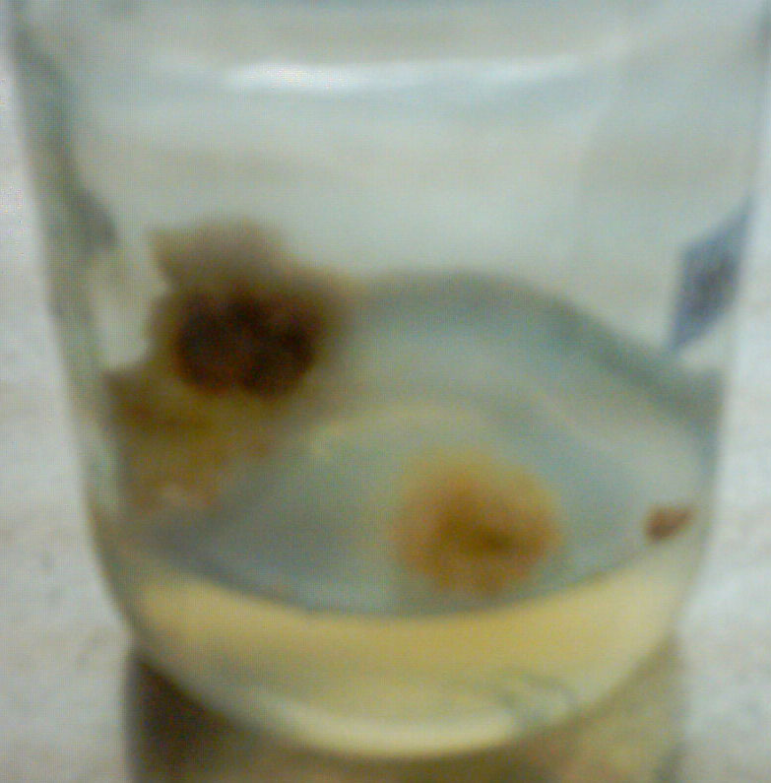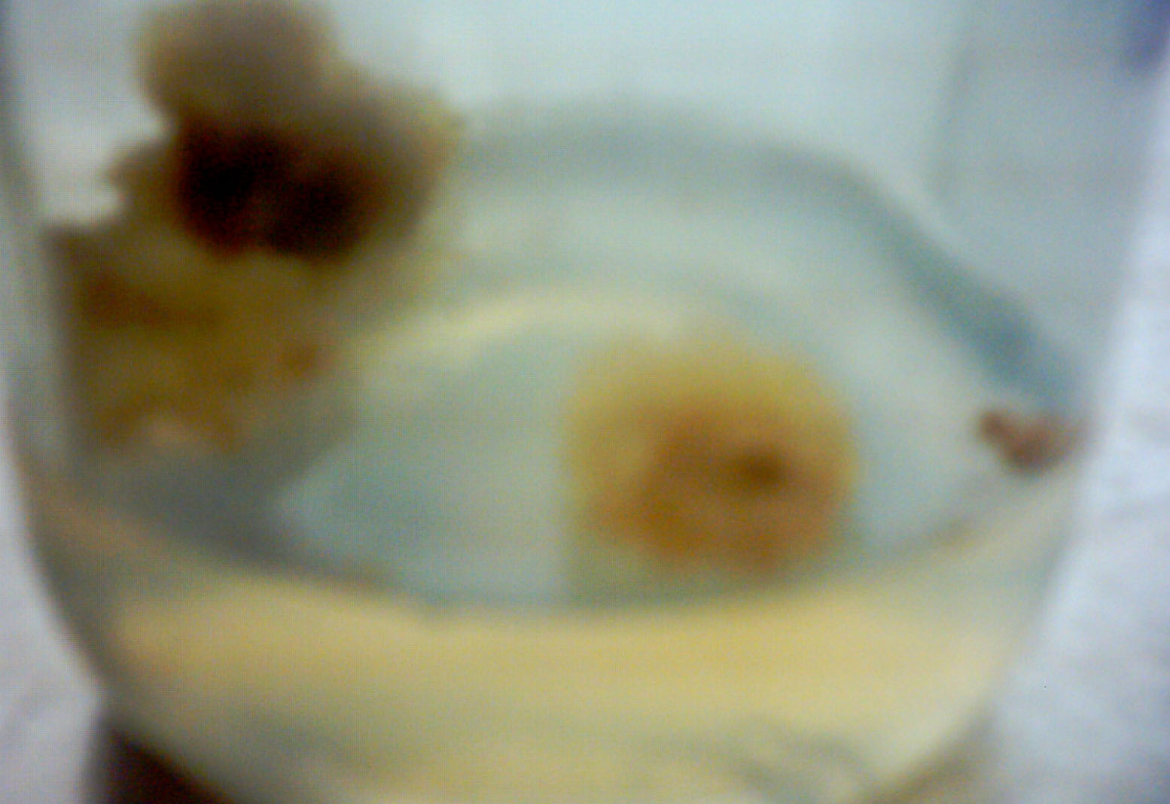
B
C
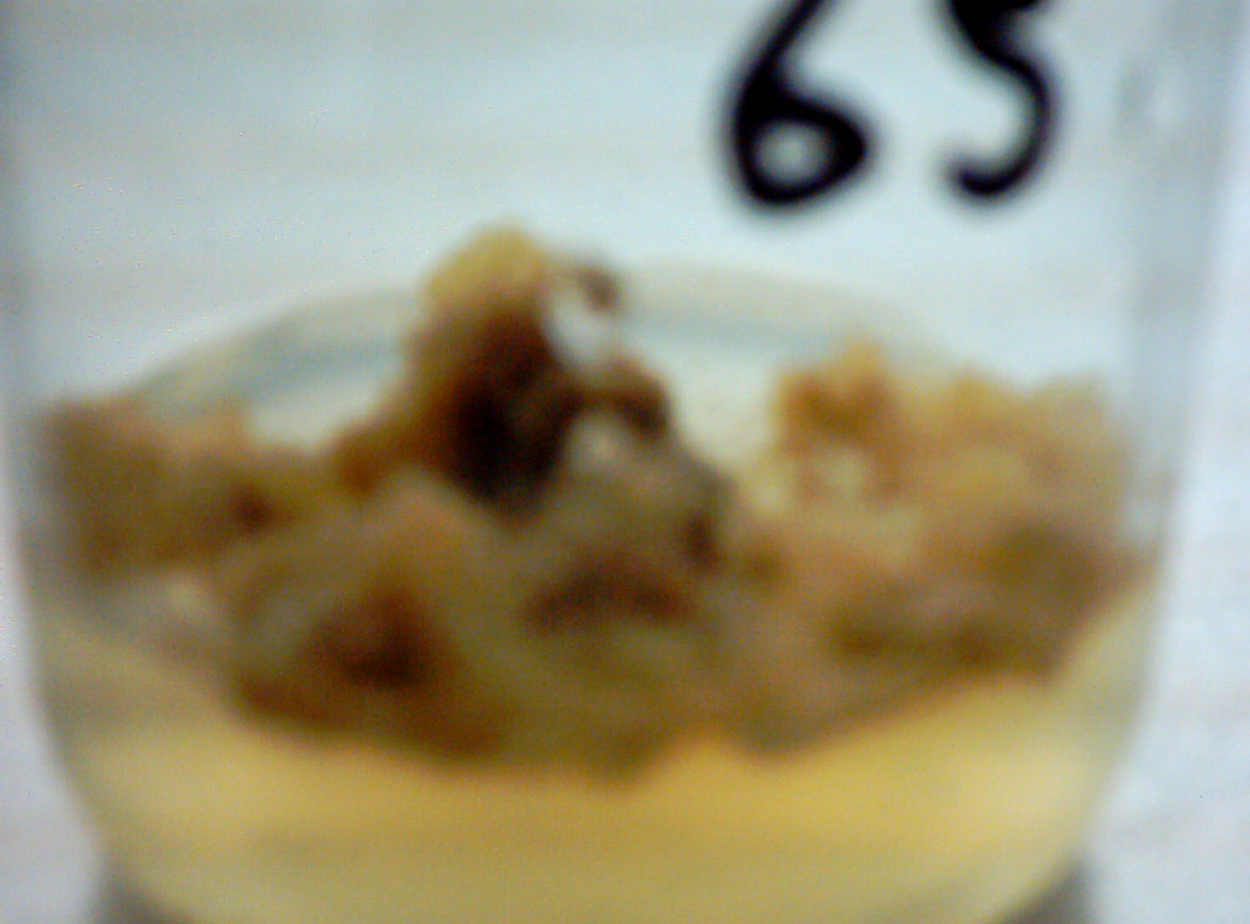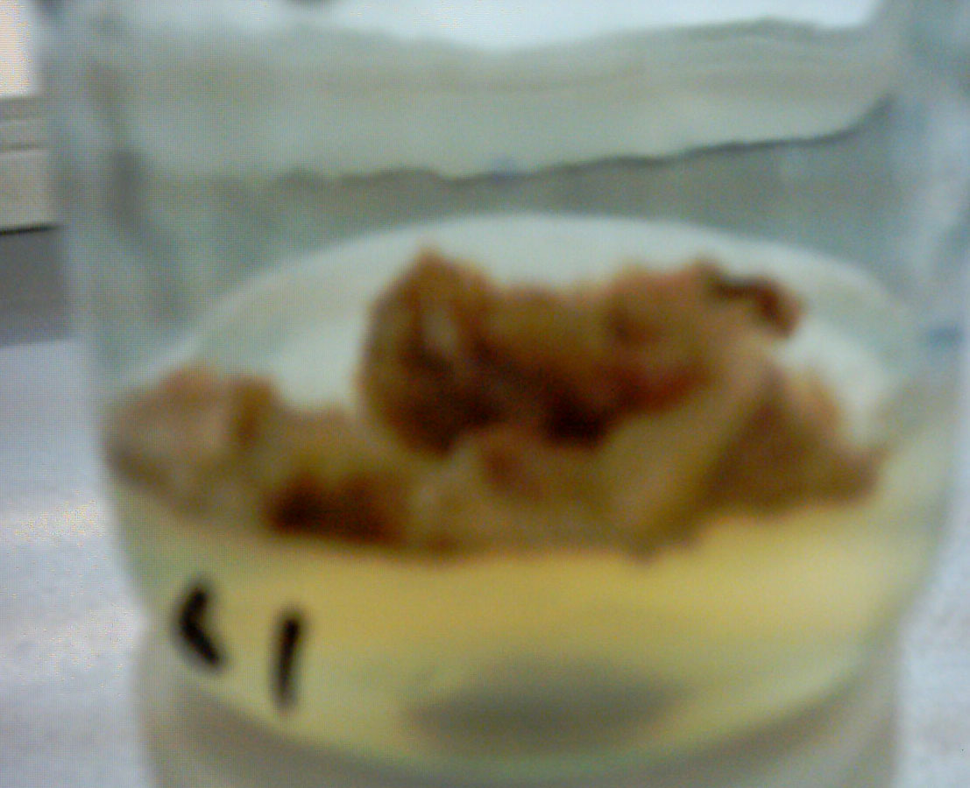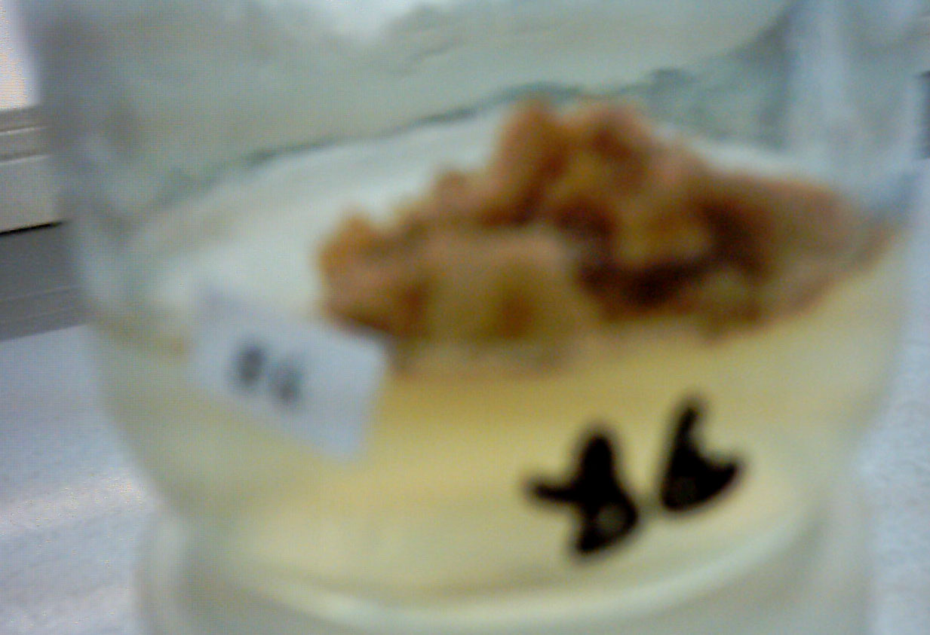
Fig. 1: Callus induction from leaf explants of Atropa belladonna L. lines cultured on MS medium supplemented with 1 and 2 mg/l 2,4-D and 0.5 mg/l Kin.
(A); Before subculture (B); After one subculture (C); Last subculture (5th)

Callus FW. (gm)
Subcultures
Fig. 2 : Fresh weight of callus derived from leaf explants of Atropa belladonna L. lines during 5 subcultures of cultivation at 1.0 and 2.0 mg/l 2,4- D and 0.5 mg/l Kin.

The growth rate of callus under subculture numbers until fourth subculture were doubled approximately ten (10.0) times under 1.0 mg/l 2, 4-D, while under 2.0 mg/l 2, 4-D the growth rate were 6 times at M-11-1 genotype (table 5).
The results showed agreement with Smith (2000) reported that, the growth rate of calli tissue parallels in many ways the sigmoid curve seen in population of single- cell organisms. There are usually five stages for callus growth rate; a lag phase in which cells prepare to divide, a period of exponential growth in which cell division is maximal, a period of linear growth in which division slows down and cells enlarge, a period of decelerating growth and stationary or no-growth period in which the number of cells is constant. The behavior of cells of callus tissue is different during each stage of growth. The media composition can also influence how long the callus remains at a particular stage.

Table 5: Effect of subcultures on callus growth rate (%) at 1.0 and 2.0 mg/l 2, 4-D and 0.5 mg/l Kin.
Genotypes | NO. of Subcultures |  |  |  |  | Mean | NO. of Subcultures |  |  |  |  | Mean
Genotypes | 1.0 mg/l 2, 4-D |  |  |  |  | Mean | 2.0 mg/l 2, 4-D |  |  |  |  | Mean
Genotypes | 1 | 2 | 3 | 4 | 5 | Mean | 1 | 2 | 3 | 4 | 5 | Mean
Cont. | 210.96 | 474.05 | 741.61 | 940.05 | 934.68 | 660.27 | 106.09 | 313.04 | 499.13 | 653.91 | 625.22 | 439.48
M-11-1 | 296.54 | 584.51 | 832.23 | 1019.43 | 1015.77 | 749.70 | 81.52 | 281.52 | 445.65 | 607.07 | 572.83 | 397.72
M-11-2 | - | - | - | - | - | - | 130.23 | 344.19 | 537.21 | 700.00 | 686.05 | 479.54
M-15-1 | 11.72 | 28.34 | 39.817 | 54.50 | 42.23 | 34.568 | 154.61 | 409.87 | 601.97 | 776.97 | 761.84 | 541.05
Mean | 173.07 | 362.30 | 537.89 | 671.33 | 664.23 |  | 118.11 | 337.16 | 520.99 | 694.49 | 661.49

Total alkaloids (mg/gm) and Atropine values (mg/gm) in vivo (plant leaves) and callus for different genotypes under study were shown at (Table 6 and Fig. 3, 4).
Higher concentrations of total alkaloids under in vivo than in vitro (callus tissues) were recorded. The rate between in vivo and in vitro (callus) were approximately one and half times. Important remark, the behavior of atropine values were reversely than the total alkaloid behavior. Atropine value of callus increased than in vivo (plant leaves) under control, about four times. More well as for the three lines, the increase of callus atropine values than the leaves about 5 ^{th} times for M-11-1 callus comparing with leaves of control. In addition the atropine value of
M-11-2 was absent in leaves and represent in callus were recorded significant increasing, approximately three times than the leaves of control plants. Regarding with comparison between the control and other genotypes in total alkaloids and atropine values confirmed significant increasing of total alkaloids value in M-11-1 and M-15-1 genotypes 9.401 and 8.781 mg/g dry weight leaves and 2.711, 2.411 mg/g dry weight callus respectively compared with control that recorded 5.631 and 1.761 mg/ g for total alkaloids of leaves and callus tissues respectively. With regard of atropine values, M-11-1 gave higher duplication than other genotypes and control, about eight and half times for atropine values with comparison control from leaves. But from callus the higher increase of atropine values than the plant leaves as a control i.e: 1.069 and 0.225 mg/g for M-11-1 callus and plant leaves of control, respectively. The behavior of atropine values at callus tissues was higher increasing than plant leaves. These results contrasting the major other results and subsequently, the very important of these mutant lines genotypes for production of atropine as alkaloids from callus in laboratory alternavely from mature plant leaves.
These results confirmed with several investigators on Atropa belladonna L. (Helmy (1984), Habba (1989), Mahmoud (2004) and Khater (2007)).
There were many examples explained the relation between differentiation and secondary metabolites accumulation. Hiraoka and Tabata (1974) showed that alkaloid concentration in mature plant and callus tissue of Datura innoxia was 0.10% and 0.01% of dry weight, respectively (10:1). Also, (Oliveira et al 2001) showed that Aspidosperma ramiflorum Muell the ratio of alkaloid concentration between mature plants and morphologically undifferentiated cells of callus was 4:1 (brown friable callus) and 6:1 (yellowish coloured friable callus) increases in total alkaloids concentration.

Table 6: The average mean of total alkaloids and Atropine content in vivo and in vitro Callus.
Treatments  Genotypes | Total alkaloid  (mg/gm) |  | Atropine Value  (mg/gm)
Treatments  Genotypes | M₅ plants | Callus | M₅ plants | Callus
Control | 5.631 | 1.761 | 0.225 | 0.815
M-11-1 | 9.401 | 2.711 | 1.925 | 1.069
M-11-2 | 5.941 | 1.781 | 0.000 | 0.740
M-15-1 | 8.781 | 2.411 | 0.326 | 0.812

Fig. 3: Total alkaloid and Atropine concentrations (µg /g) in in vivo and in vitro callus of Atropa belladonna L. lines.

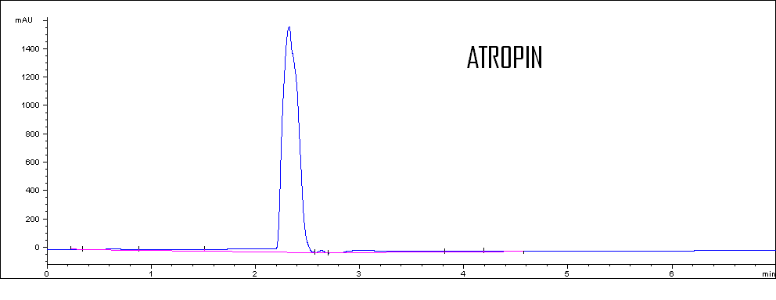
A

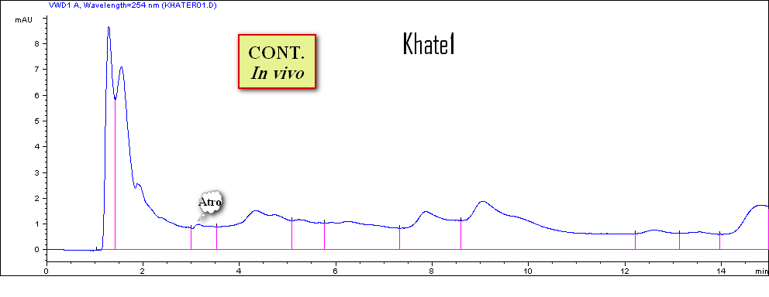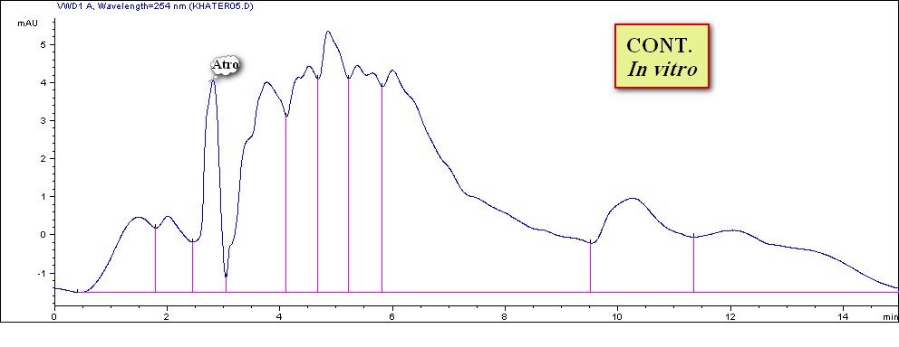
b

c
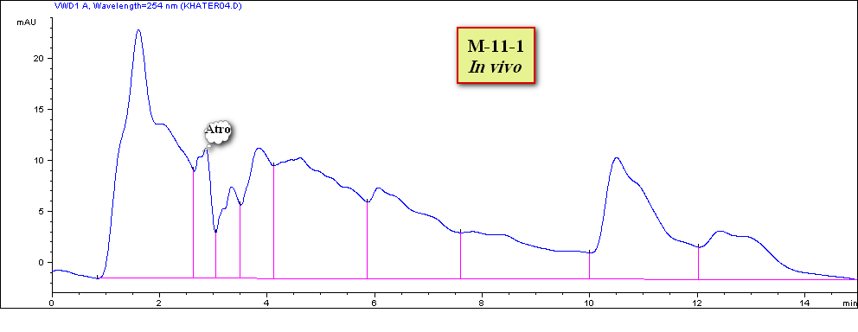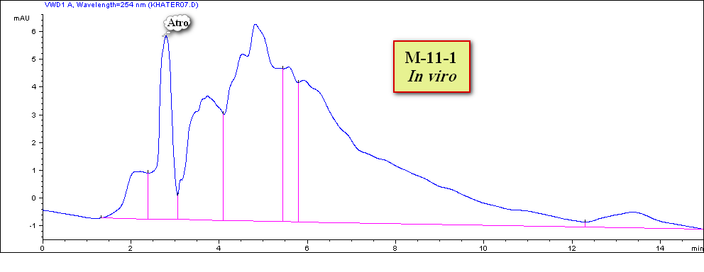
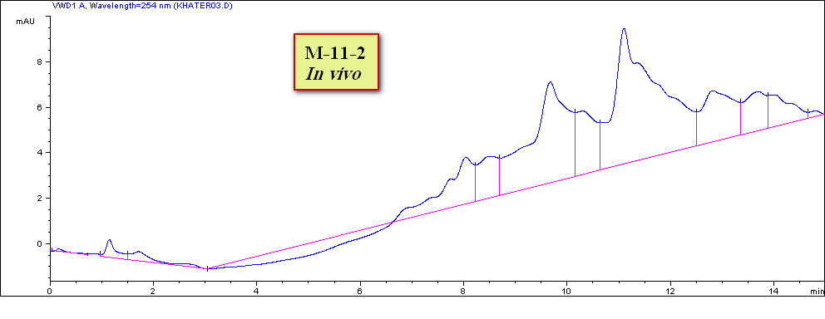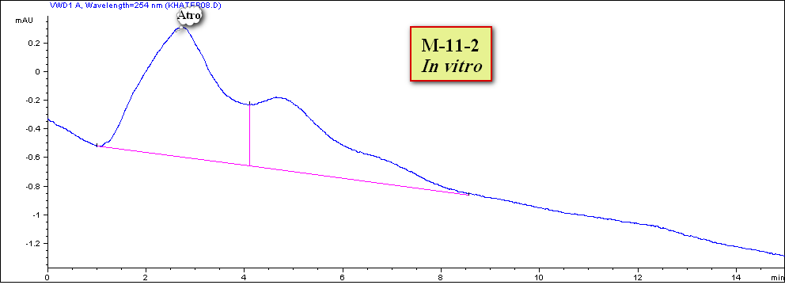
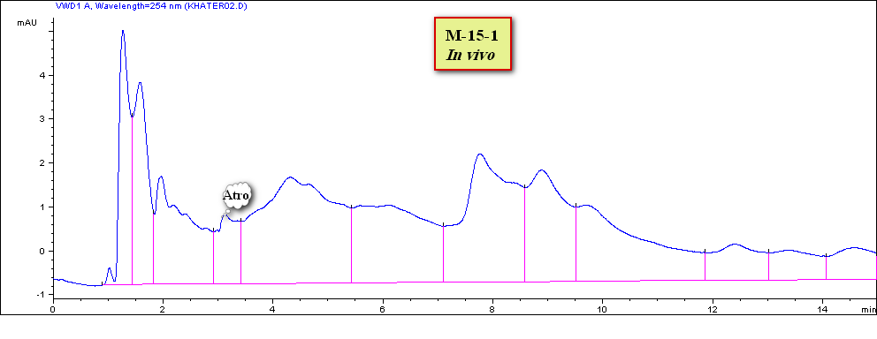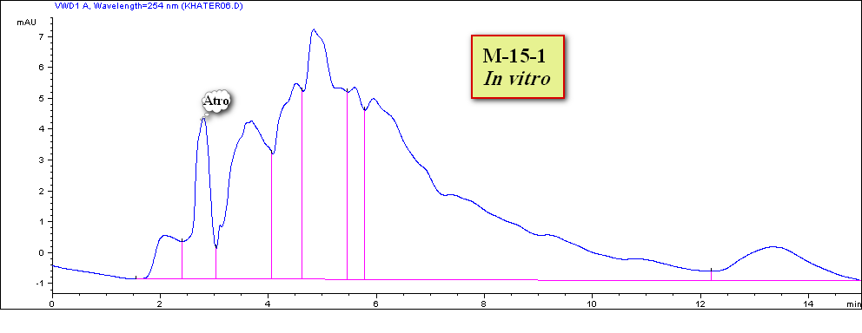
Fig. 4: HPLC chromatograms of: (a) – Atropine as a standard alkaloids (b)- In vivo plant extract;
(c)- In vitro callus extract of Atropa belladonna L. genotypes.

References
- Arildo José Braz de Oliveira, Luzia Koike, Francisco de Assis Machado Reis and Simone Liliane Kirszenzaft Shepherd, (2001). Callus culture of Aspidosperma ramiflorum Muell. Arg.: growth and alkaloid production. Maringá, v. 23, n. 2, p. 609-612.
- Arroo R., J.Woolley, and K.-M. Oksman-Caldentey. (2007)., Henbane, Belladonna, Datura and Duboisia. Biotechnology in Agriculture and Forestry, Vol. 61.
- British Pharmacopoeia, B.P., (1998). The stationary office Dept., BP. KE 5833 Norwich, NR 3-IBR. 1: 709-711.
- Castellar A., R. F. Gagliardi and E. Mansur. (2011). In vitro propagation and establishment of callus and cell suspension cultures of Petiveria alliacea L., a valuable medicinal plant . Journal of Medicinal Plants Research Vol. 5(7), pp. 1113-1120, 4 April, 2011.
- Cordell, G. A. (1981). Introduction to alkaloids “(A Biogenetic Approach)” John Wiley and Sons, New York, Chichester, Brisbane, Toronto, p.p.1, 94 .
- Dodds, J.H. and W. Roberts (1995). Experiments In Plant Tissue Culture. Cambridge University press, 3rd Edition.
- Dung, N.N., E. Szoki, and G. Verzar-Petri, (1981). The growth dynamics of callus tissue of root and leaf origin in Datura innoxia Mill. Acta. Botanica Academiae Scientiarum Hungaricae, 27(3/4): 325-33.
- El- Bahr M. K. (1989). Influence of sucrose and 2, 4-D on Trigonella. foenum-graecum L. tissue culture. African Journal of Agricultural Sciences Vol. 16, NO. 1 + 2.
- El. Bahr, M.K.; S.A. Ghanem.; M.M. El-Missiry and M.M. El-Nasr (1997). Fitoterapia 68, 423.
- Engvild, K.C., (1973). Shoot Differentiation in Call Callus Cultures of Datura innoxia. Physiologia Plantarum, 28(1): 155-9.
- Gamborg O. L.; R. A Miller and K. Ojima (1968). Nutrient requirements of suspension cultures of soybean root cells. Expt. Cell Res. 50: 151-158.
- Geiger PL, Hesse K (1833) Darstellung des Atropins. Ann Pharm 5:43
- Habba, I.E. (1989). Physiological Effect of Gamma Rays on Growth And Productivity Of Hyoscyamus muticus L. and Atropa belladonna L. Ph.D. Thesis, Fac. Agric. Cairo Univ., Cairo, Egypt.
- Helmy. F.M. (1984). Chemical and Biological Effect of Gamma Rays Combined with Growth Regulators on Datura stramonium L. M.Sc.Thesis, Fac. Agric. Menoufia Univ.
- Hiraoka, N.; Tabata, M, (1974). Alkaloid production by plants regenerated from cultures cell of Datura innoxia. Phytochemistry, Tokyo, v. 13, p.1671-1675.
- Iranbakhsh AR, Oshagi MA, Ebadi M. (2007). Growth and production optimization of tropane alkaloids in Datura stramonium cell suspension culture. Pak.J. Biol Sci. 10(8):1236-1242.
- Jinchen and V. Raghavan (1985). Somatic embryogenesis and plant regeneration in Hyoscyamus niger. Amer. J. Bot. 72 (4): 580-587.
- Kaul, B. and E.J. Staba, 1967. Amni visnaga (L.) tissue cultures multilitre suspension growth and examination for furanocouerins. Planta. Med., 15: 145–156.
- Khanam, N.; C.Khoo and A.G.Khan. (2000). Effects of cytokinin/auxin combinations on organogenesis, shoot regeneration and tropane alkaloid production in Duboisia myoporoides. Plant Cell, Tissue and Organ Culture 62: 125–133.
- Khater, M.A. (2007). Genetical and Physiological Studies on Atropa belladonna L. Plants. M.Sc.Thesis, Fac. Agriculture, Zagazig Univ.
- Mahmoud, S.S. (2004). Studying of Some Antispasmodic alkaloids in Hyoscyamus aureus L. growing in Egypt.. M.Sc.Thesis, Fac. Pharmacy, Zagazig Univ.
- Manju Madhavan and Joy P. Joseph (2010). Histological Marker to Differentiate Organogenic Calli fromNon Organogenic Calli of Gloriosa superba L. Plant Tissue Cult. & Biotech. 20(1): 1-5, 2010 (June).
- Murashige T. and Skoog, F. (1962). Revised medium for rapid growth and bioassays with tobacco tissue culture. Physiol. Plant. 15, 473-497.
- Patni Showkat, Yaseer Zaidi, Suhail Asghar and Shamsuddin Jamaluddin., (2010). In vitro Propagation and Callus Formation of Bacopa monnieri (L.) Penn. Plant Tissue Cult. & Biotech. 20(2): 119-125, 2010 (December).
- Raoufa Abd El-Rahman, El-WakilH. El-Din, Abou Gabal A. El-Said and Khlifa H.D.(2008). Production of Scopolamine and Hyoscyamine in Calli and Regenerate Cultures of Datura metel (L.). Journal of Applied Sciences Research, 4(12): 1858-1866, 2008.
- Smith, R.H., (2000). Callus induction, pp. 98-103. In plant tissue culture techniques and experiments .Second edition. Acad. press, San Diego, California.
- Sokal. R.R. and F.J. Rohlf (1995). Biometry third edit, Freeman Company, New York.
- Stojakowska A, Kisiel W (1999). Secondary metabolites from a callus culture of Scutellaria columnae. Fitoterapia, 70: 324-325.
- Ashutosh K. Verma, R. R. Singh and Seema Singh. (2012). Improved alkaloid content in callus culture of Catharanthus roseus. Botanica Serbica., 36 (2): 123-130
- Vidhysekaran P. (1993). Genetic Engineering, Molecular Biology and Tissue Culture for Crop Pest and Disease Management, 239.
- Zarate, R. and R. Verpoorte, (2007). Strategies for the genetic modification of the medicinal plant Catharanthus roseus (L.) G. Don. Phytochem Rev., 6: 475-491.
- Zenk, M.H., 1978. Production Von Sekundaren Flanzenstoffen Durch Pflazliche Zellkultwren. Production of Natural Compounds by All Culture Methods. Alfermann, A.W. and E. Reinhard (Eds.), Gesellschaft for Strahlen-Und Umwelt for Scung mbH, Minchen, pp: 180-200.
- Zhao, J. and R. Verpoorte, (2007). Manipulating indole alkaloid production by Catharanthus roseus cell cultures in bioreactors: from biochemical processing to metabolic engineering. Phytochem Rev., 6: 435-457.

1/8/2013

