Use of WRF-ARW model to forecast some aviation reports

G. H. AlESSA

Department of Astronomy, Space Sciences and Meteorology, Faculty of Science-Cairo University-Cairo-Egypt
ghazi.alissa@gmail.com

Abstract: This study was mainly focused on Damascus International Airport (Syria) to examine the capability of such approach and to compare with now cast observations. Also the study demonstrate a real 5 days prediction to Fog of occurrences which mainly act as the main factor can produce some divert for airplanes at this airport. This study use high performance limited area model (WRF-ARW) and the product of the model was used to verify the accuracy and uncertainty in using such procedure by comparison with real observation data. The key parameters included in the (TAF and METAR) reports like (T, T_{d}, RH, WS and P) were proven to be of more close as observation. Also the results are predicting Fog is very much good in comparison with the actual observations.
[G.H. AlESSA. Use of WRF-ARW model to forecast some aviation reports. Nat Sci 2013;11(3):58-62]. (ISSN: 1545-0740). http://www.sciencepub.net. 8

Key words: METAR, TAF, WRF-ARW and Fog.

1. Introduction
The WRF model is being developed as a collaborative effort among the National Center for Atmospheric Research’s (NCAR) Mesoscale and Microscale Meteorology (MMM) Division, the National Oceanic and Atmospheric Administration’s (NOAA), National Centers for Environmental Prediction (NCEP) and Earth System Research Laboratory (ESRL), the Department of Defense’s Air Force Weather Agency (AFWA) , Naval Research Laboratory (NRL), the Center for Analysis and Prediction of Storms (CAPS) at the University of Oklahoma, and the Federal Aviation Administration (FAA), with the participation of university scientists.
- The WRF model is flexible, state-of-the-art, portable code that is efficient in computing environments ranging from massively-parallel supercomputers to laptops.
- It is designed to be highly modular, and a single source code is maintained that can be configured for both research and operations.
- It offers numerous physics options, thus tapping into the experience of the broad modeling community.

2. Aviation Weather Reports
Aviation weather reports are designed to give accurate depictions of current weather conditions. Each report provides current information that is updated at different times. Some typical reports are aviation routine weather reports (METAR and SPECI).
2.1 Metar
METAR is the name of the code for an aviation routine weather report. A METAR is issued at hourly or half – hourly intervals, it is a description of the meteorological elements observed at an airport at a specific time. SPECI is aviation special weather report issued when there is significant deterioration or improvement in airport weather conditions, such as significant changes of surface winds, visibility, cloud base height and occurrence of severe weather. The format of the SPECI report is similar to that of the METAR and the elements used have the same meaning , a SPECI can be issued at any time when certain criteria are met (Technical Regulations, Volume II [C.3.1] (WMO- NO.49) part II Appendix 3, section, 2.3). Both METAR and SPECI have the same code, METAR and SPECI contains the following information in the order shown:
- Indentification Groups ( COR CCCC YYGGgg Z )
This section will have three parts
- The report code name (COR = METAR or SPESI).
- The ICAO location indicator of the reporting station (CCC), for example OSDI.
- The day of the month (YY) and time of the observation in hours (GG) and minutes (gg) UTC (coordinated universal time), followed by the latter Z.
- Surface Wind (dddff)
This section normally there will be a five – figure group, the first three figures indicate the wind direction, and the last two figures indicate the wind speed.
- Previling Visibility(VVVV)
The group VVVV shall be used to report prevailing visibility. When horizontal visibility is not the same in different directions, and when visibility is fluctuating rapidly and the prevailing visibility cannot be determined, the group VVVV shall be used to report the lowest visibility. When visibility sensors are used in such a manner that no directional variations can be given, the abbreviation NDV shall be appended to the visibility Reported. The reporting scales of visibility are as follows:
- In steps of 50 m if VVVV is less than 800 m.
- In steps of 100 m if VVVV is 800 m or more, but less than 5 km.
- In steps of 1000 m if VVVV is 5 km or more, but less than 10 km.
- As 10 km when visibility is 10 km or more.
- Cloud (N_{s}N_{s}N_{s}h_{s}h_{s}h_{s)}
Cloud group consist of six characters under normal circumstances. The first three indicate cloud amount , the last three characters indicate the height of the base of the cloud.
- Air and Dewpoint Temperature (TT/T_{d}T_{d})
The observed air temperature and dew point temperature, each as two figures rounded to the nearest whole degree Celsius, should be reported as follows temperatures below 0C will be preceded by M to indicate “minus”.
- Pressure – QNH (QP_{H}P_{H}P_{H}P_{H})
The last group of the main part of the report should indicate the QNH rounded down to the nearest whole hectopascal. The group starts with letter Q followed by four figures.

2.2 Terminal Aerodrome Forecast-TAF
Terminal Aerodrome Forecast ( TAF) are complete descriptions of the meteorological elements expected at and over the aerodrome thought the whole of the forecast period , including any changes considered to be signification to aircraft operations. TAF describe the forecast prevailing conditions at an aerodrome and cover a period of not less than 6 hours and not longer than 30 hours. The period of validity of TAF produced by meteorological offices should be determined by regional air navigation agreement. Routine TAF valid for less than 12 hours should be issued every 3 hours, and those valid for 12 up to 30 hours every 6 hours (updated four times a day at 0000Z, 0600Z, 1200Z, and 1800Z). Usually the Aerodrome forecasts contain specific information presented in a fixed order.

3. Results and Discussion
It has been used in these study 10 cases as during (2006-2012) to validate the accuracy of the model against observations. These cases were selected randomly as severe cases of low visibility.
The following section shows one the case study in details and total evaluation all cases will be followed.
3.1 case study 1 (JAN_2012)
This case study is (72 hours) starting from 02_JaN_2012 at 00 Z to 05_JAN_2012 at 00 Z. Figure (1 a) shows the trends of T, T_{d}, RH, WS, and P for both output of the WRF-ARW model and observed. Figure (1 b) shows the T, T_{d}, RH, WS, and P corresponding to Fog hours (18Hours) in this case study.

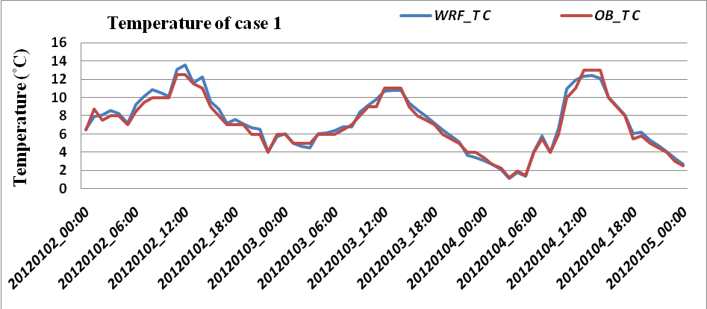
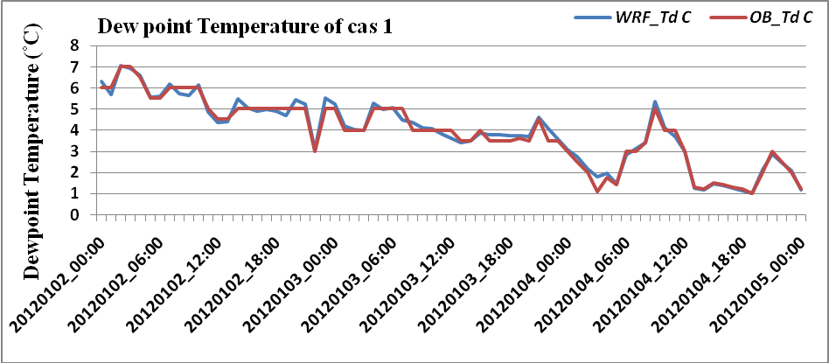
Figure (1 a) Trends of Temperature (, Dew point Temperature (, Relative Humidity (), Wind Speed (m/s) and Pressure (mb) for Case Study 1.
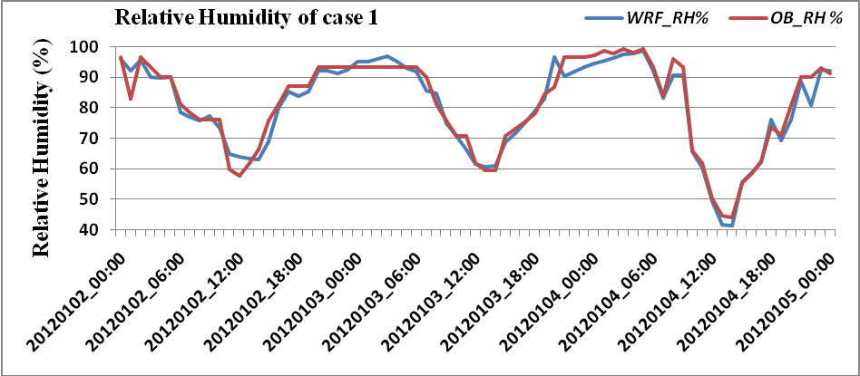
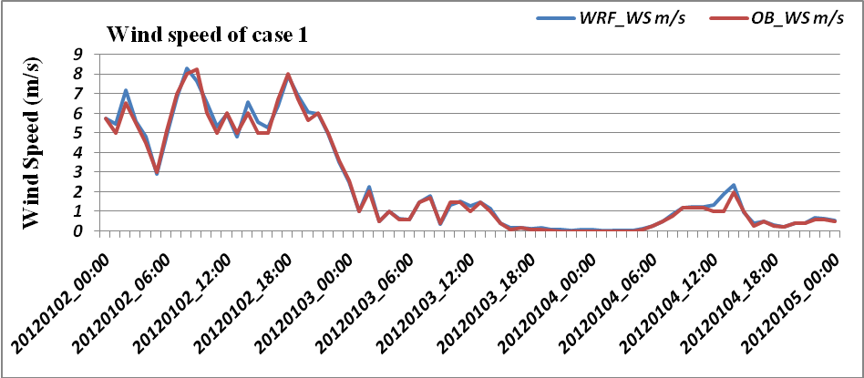
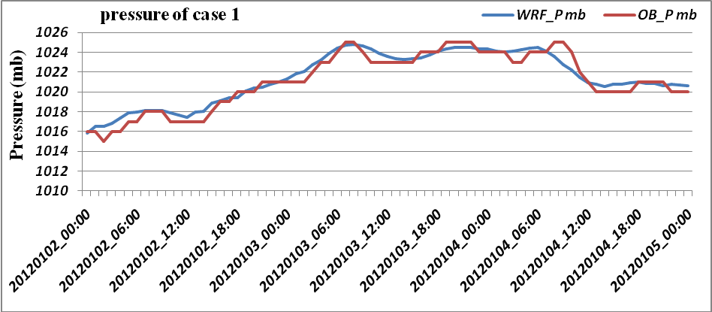
Continued (1 a)

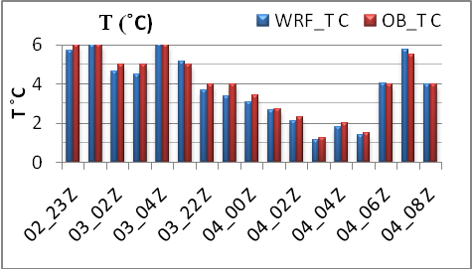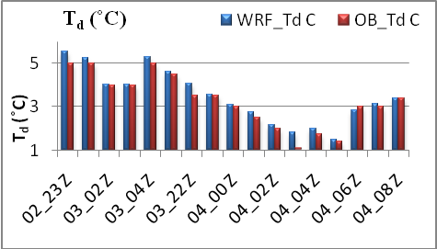
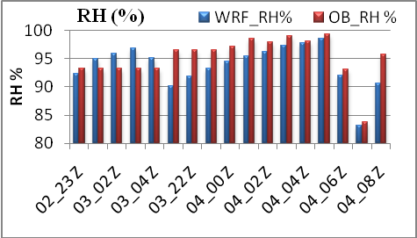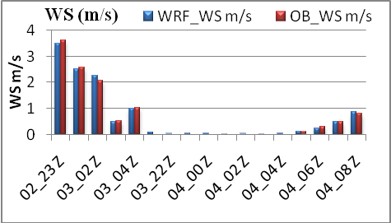
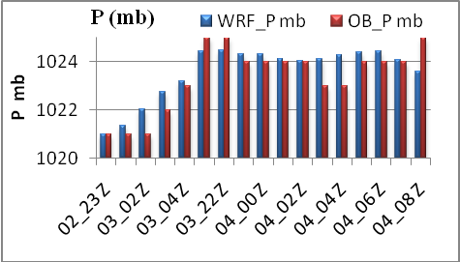
Figure (1b): parameters controlling fog formation at this case study – model against observations.

As shown in figure (1 a) the estimate of T, T_{d}, RH, WS, and P for output of WRF-ARW model are very closed to the observed. For fog hours in figure (1 b) the T, T_{d}, RH, WS, and P are relatively the same as the observed. Table (2) shows Root Mean Square Error (RMSE) and Mean Bias Error (MBE) between WRF-ARW model and observed values. A summary of 10 cases studies are included in the following table.

Table (1): RMSE and MBE for T, T_{d}, RH, WS, and P for 10 cases study.
Case study | Statistical analysis | T | Td | RH% | WS m/s
Case study 1 | N | 73 | 73 | 73 | 73
Case study 1 | RMSE | 0.457579662 | 0.277175742 | 3.144459509 | 0.232422813
Case study 1 | MBE | 0.159432068 | 0.048499329 | -0.776152461 | 0.068939475
Case study 1 | (RMSE/y̅)*100 | 6.440490366 | 7.141435479 | 3.925649937 | 9.869200709
Case study 1 | (MBE/ y̅)*100 | 2.244026093 | 1.249585642 | -0.968975065 | 2.927326718
Case study 2 | N | 40 | 40 | 40 | 40
Case study 2 | RMSE | 0.844488549 | 0.306553782 | 4.334816745 | 0.845120036
Case study 2 | MBE | -0.4036275 | -0.20335045 | -0.265966922 | -0.06349286
Case study 2 | (RMSE/y̅)*100 | 9.219682233 | 9.398924989 | 6.253247435 | 21.92072639
Case study 2 | (MBE/ y̅)*100 | -4.40659295 | -6.23471553 | -0.383674114 | -1.64687802
Case study 3 | N | 67 | 67 | 67 | 67
Case study 3 | RMSE | 0.707241737 | 0.304428495 | 3.875264558 | 0.19282279
Case study 3 | MBE | -0.33550298 | -0.11856188 | 0.072905636 | 0.08617834
Case study 3 | (RMSE/y̅)*100 | 10.43973529 | 9.362818707 | 4.538842425 | 9.896760082
Case study 3 | (MBE/ y̅)*100 | -4.95242598 | -3.64641750 | 0.085389575 | 4.423161588
Case study 4 | N | 37 | 37 | 37 | 37
Case study 4 | RMSE | 0.86266812 | 0.336135193 | 5.710042333 | 0.053829713
Case study 4 | MBE | -0.51275946 | -0.13796997 | -0.449841994 | 0.026188889
Case study 4 | (RMSE/y̅)*100 | 10.99553183 | 10.43494268 | 7.521009948 | 7.40579384
Case study 4 | (MBE/ y̅)*100 | -6.53561065 | -4.28312413 | -0.592511564 | 3.603019655
Case study 5 | N | 66 | 66 | 66 | 66
Case study 5 | RMSE | 0.648063 | 0.404175 | 3.838672 | 0.309921
Case study 5 | MBE | -0.05273 | -0.24542 | -0.07711 | 0.052445
Case study 5 | (RMSE/y̅)*100 | 7.724185 | 8.88068 | 4.862658 | 9.07776
Case study 5 | (MBE/ y̅)*100 | -0.62847 | -5.39242 | -0.09768 | 1.53614
Case study 6 | N | 61 | 61 | 61 | 61
Case study 6 | RMSE | 0.751469481 | 0.592016 | 4.741695 | 0.118248
Case study 6 | MBE | -0.12518852 | -0.16465 | -1.33418 | 0.076505
Case study 6 | (RMSE/y̅)*100 | 9.07389489 | 9.112086 | 5.206902 | 5.18556
Case study 6 | (MBE/ y̅)*100 | -1.51163493 | -2.53426 | -1.46508 | 3.354997
Case study 7 | N | 61 | 61 | 61 | 61
Case study 7 | RMSE | 0.87434 | 0.436084276 | 4.10608 | 0.090322343
Case study 7 | MBE | -0.36877 | -0.12567902 | -2.22668 | 0.051414426
Case study 7 | (RMSE/y̅)*100 | 11.1348 | 10.19705886 | 4.4839 | 6.932137519
Case study 7 | (MBE/ y̅)*100 | -4.6963 | -2.93878132 | -2.43157 | 3.945998993
Case study 8 | N | 43 | 43 | 43 | 43
Case study 8 | RMSE | 0.76437534 | 0.35309339 | 4.62446193 | 0.2391471
Case study 8 | MBE | -0.56404419 | -0.21468712 | 1.32900698 | 0.16008914
Case study 8 | (RMSE/y̅)*100 | 10.8654325 | 9.97386248 | 5.7788975 | 14.3421551
Case study 8 | (MBE/ y̅)*100 | -8.01776782 | -6.06428726 | 1.66077594 | 9.60088285
Case study 9 | N | 37 | 37 | 37 | 37
Case study 9 | RMSE | 1.117058562 | 0.701997259 | 5.429374738 | 0.482714226
Case study 9 | MBE | -0.28347586 | -0.22281192 | -0.06293625 | -0.04051208
Case study 9 | (RMSE/y̅)*100 | 0.002315039 | 8.982829594 | 7.40150454 | 26.81343099
Case study 9 | (MBE/ y̅)*100 | -2.17370271 | -2.85112438 | -0.085796799 | -2.25033326
Case study 10 | N | 67 | 67 | 67 | 67
Case study 10 | RMSE | 0.793405567 | 0.433239792 | 5.829391595 | 0.269440711
Case study 10 | MBE | -0.52819254 | -0.05067852 | -1.77260746 | 0.071458194
Case study 10 | (RMSE/y̅)*100 | 0.00140527 | 20.61009484 | 8.25204388 | 14.13777717
Case study 10 | (MBE/ y̅)*100 | -6.26803844 | -2.41087999 | -2.50929009 | 3.749470593
Where [RMSE = , MBE= , y is observed value , y̅ is mean of observed values ,x is modelled value,
N is number of observations, RMSE is Root mean square error, and MBE is main bias error]

4. Conclusions
In this study, the WRF-ARW model was tested to predict the codes TAF and METAR formed over study area, this is clearly by the comparison of the meteorological features used (T, T_{d,} RH, WS and P) between output of the WRF-ARW model and observed . The results extracted in the following pattern.
- The meteorological features T, T_{d,} RH, WS and P are more realistic as the observed in all cases study.
- The meteorological features T, T_{d,} RH, WS and P for Fog hours are relatively same as observed in all cases
- The accuracy of the WRF-ARW model acceptable to some extent to predict in most of the elements that are contained in codes of TAF and METAR (For 72 hours).

Corresponding Author:
Ghazi Husain Alessa
Department of Astronomy, Space Sciences and Meteorology
Faculty of Science-Cairo University-Cairo-Egypt
E-mail: ghazi.alissa@gmail.com

References
- Joseph B. Klemp., 2006: The Weather Research and Forecasting (WRF) Model.
- National Weather Service, Aviation Services Branch (2004) Terminal Aerodrome Forecasts. NWS Instruction 10-813. U.S. Department of Commerce, National Oceanic & Atmospheric Administration, National Weather Service Headquarter, Silver Spring, MD.
- NATIONAL OCEANIC AND ATMOSPHERIC ADMINISTRATION (1995), Surface weather observations and reports, Federal Meteorological Handbook No. 1, 94 pp. [Available from Department of Commerce, NOAA, Office of the Federal Coordinator for Meteorological Services and Supporting Research, 8455 Coleville Road, Suite 1500, Silver Spring, MD, 20910.
- Technical Regulations, Volume II [C.3.1] (WMO- NO.49) part II Appendix 3, section, 2.3.
- WMO/TD-No. 1390 (World Meteorological Organization) Secretariat of the World Meteorological Organization-Geneva-Switzerland June 2007.
- WMO (1966), International Meteorological Vocabulary (World Meteorological Organization. Geneva Switzerland).
- WMO-NO.306, Volume 1.1, part A – Alphanumeric codes, section C.

1/15/2013

