The Use of Earthworm Cast as a Casing Material, Time of Application and Substrate size on Yield of Pleurotus tuberregium. (Fr.) Singer, a Nigerian Mushroom

Idowu Olufunmilayo Omowumi¹ and Kadiri, Mukaila²

¹Vegetable Programme, National Horticultural Research Institute, Idi-Ishin,G Ibadan
²Dept. of Biological Sciences, University of Agriculture, Abeokuta
funmilayoidowu@yahoo.com; mukailakadiri@yahoo.co.uk

Abstract: The possibility of using earth worn cast as casing material in the fructification of a popular edible mushroom (Pleurotus tuberregium) from Nigeria was investigated. Chemical characteristics of the earthworm cast was done. Time of casing application was varied from 1st - 6th week after spawning, and the effect of substrate size on sclerotia yield was also investigated. The result showed that all the cased substrates produced both sclerotia and fruit bodies except those cased at 3rd week after spawning on which only fruit bodies were produced while the uncased produced only the sclerotia. The highest fruit body yield (118.00g) was obtained where casing was applied at 3rd week after spawning. Biological efficiency (62.10%) and sclerotia yield (141.45g) were highest at 1st week of casing application and least on the control. Mean fruit size (48.84g), pileus width (18.35cm), stipe length (16.90cm) and girth (4.75cm) were significantly highest (p< 0.05) at 4th week of casing layer application and least in others. Significant increase in sclerotia yield was also observed with increase in growth substrate size at p<0.05. These findings suggest that for direct fruit body production of P. tuberregium, casing material should be applied preferably at 3 - 4 weeks after spawning and that earth worm casts can be used as casing material as readymade casing materials such as peat moss and vermiculite are not available in Nigeria for now and that increase substrate size also results into increased sclerotia yield of these mushroom.
[Idowu OO and Kadiri M. The Use of Earthworm Cast as a Casing Material, Time of Application and Substrate size on Yield of P. tuberregium. (Fr.) Singer, a Nigerian Mushroom. Nat Sci J 2013;11(4):4-8]. (ISSN: 1545-0740). http://www.sciencepub.net/nature. 2

Key words: Spawn preparation, cultivation, sclerotium, substrate weight,

Introduction
The use of fungi for the conversion of lignocellulose into food and feed rich in protein offers an alternative for developing unconventional source of proteins as food/feed. Yeast and algal proteins require sophisticated techniques and heavy inputs whereas the beauty of mushroom cultivation lies in its ability to grow on cheap lignocellulosic materials with minimum inputs and a high yield of valued food protein for direct human consumption. (Mane et al, 2007)
Mushrooms have become more and more important food stuffs because of their possible preventive roles against human life style-related diseases such as hyperlipidemia and diabetes (Fukushima et al., 2001 and Yang et al., 2002). A lot of information exists on the cultivation of some edible and medicinal mushrooms in many developed countries of the world but little is known about mushroom cultivation in Nigeria. Presently, mushroom culture represents the only major process in biotechnology which successfully converts cellulosics into useful foods and by-products (Tautorus and Townsley, 1983)
Mushrooms are fast becoming a delicacy in Nigeria; the commercial cultivation is up coming. Mushrooms are not only of nutritional significance to Nigerians, they are also considered for their religious and medicinal importance. Traditionalists use mushrooms for curing of ailments such as headache, fever, cold and stomach upset while some are used as pot herbs (Oso, 1977).
Pleurotus tuberregium, a tropical sclerotial forming mushroom which produces sclerotium, an underground tuber which is globose to ellipsoid in shape and mushroom fruit body both of which are edible. The fruit body are popularly eaten in the western part of Nigeria while the sclerotia are eaten in the Eastern part of the country (personal communication). The cultivation of P. tuberregiun by the people of Nigeria is by collecting the mushroom sclerotia from the wild, bury it in the soil and watering to induce fructification.
Casing material or ‘soil’ (casing) is used in mushroom (Agaricus bisporus) culture to cover a nutritional composted substrate colonised with mycelium, and has an essential function in stimulating and promoting the development of sporophores (fruit bodies) (Noble and Dobrovin-Pennington, 2005). For several decades, casing in many countries has been based on mixtures of peat and chalk or lime (Flegg and Woods, 1985; Visscher, 1988). In many mushroom-growing areas of the world, there are no available sources of peat which has led to considerable research into possible peat alternatives for casing (Poppe, 2000). These materials include tree bark (Rainey et al., 1986), spent mushroom compost (Szmidt, 1994), coconut ﬁbre (Labuschagne et al., 1995), and paper waste by-products (Dergham et al., 1991) tea waste (Gulser and Peksen, 2003). However, information on the use of earthworm cast as an alternative casing material is lacking, therefore the objectives of this research are to evaluate the possibility of using earth worm cast as a casing material in the cultivation of leurotus. Tuberregium for direct sporophore production, effect of time of casing layer application on mushroom yield and substrate quantity on sclerotia yield of the mushroom.

Materials and method
The mushroom employed in these experiments (Pleurotus tuberregium) was collected from the mushroom production unit of the Vegetable programme of National Horticultural Research Institute (NIHORT), Ibadan, Nigeria. The inoculum used was obtained by tissue culture of the sporophore of the mushroom which was maintained on potato dextrose agar (PDA) for regular sub-culturing.

Preparation of the mother spawns
Cereals seeds (Sorghum bicolor) were purchased from Ojaba market in Ibadan, Nigeria. The seeds were picked to rid the seeds of broken kernels and extraneous debris .These were soaked in water for two hours, drained, boiled for ten minutes, drained again with the pH adjusted by adding 1% calcium carbonate and were filled into 200ml bottles plugged with cotton wool wrapped in aluminium foil. These bottles were sterilized in an autoclave at 121⁰C for 30minutes. After cooling down to room temperature, the sterilized seed bottles were inoculated separately with two weeks old actively growing mycelium of P. tuberregium. The inoculated bottles were then incubated in a dark room at room temperature and relative humidity of 70 ±5% for 15days.

Preparation of the planting spawn
Sorghum seeds were prepared as outlined above, and was inoculated with freshly prepared mother spawn generated above, these were then incubated for two weeks at ambient temperature and relative humidity of about 70% in a dark room after which they were preserved in the refrigerator until needed.

Cultivation of the mushroom
Shelled maize cobs were collected from Chi farms at Ajanla village along Lagos-Ibadan express way, Nigeria. These were shredded into smaller bits of 3-5cm, water was added to adjust the substrate moisture content to about 65% level, and left over night for the moisture to permeate the entire substrate. The following morning, the moistened maize cobs were subjected to heat treatment by steam pasteurization in an empty oil drum that was ¼ filled with water for 6hours after which they were filled into clean perforated plastic trays lined with polyethylene sheet to prevent drying out of substrate (a kilogram per tray). Each tray was inoculated with freshly prepared planting spawn of P. tuberregium prepared above at 100g spawn / tray. Earthworm cast was collected from farm land of NIHORT, these were air dried, ground into powder, moistened with water with its pH adjusted by adding 1% calcium carbonate and was packed in polyethylene bags at 200g per bag with each bag held in place with a pvc pipe and coverd with cotton wool wrapped in aluminium foil and autoclaved at 121⁰C for 30minutes, The treatments evaluated were application of 200g of prepared earthworm cast at 0, 1, 2, 3, 4,5, and 6th weeks after inoculation and 0 application served as the control. The fruit body weight per treatment was taken as well as sclerotia weight where applicable. Biological efficiency (Ratio of the total fresh mushroom harvested to substrate dry weight x 100) was calculated.

Effects of substrate weight on sclerotium size of P. tuberregium
Maize cobs from the source mentioned above was moistened with water until the moisture level was about 65%, the pH was also adjusted as mentioned in the previous experiment above, these were left over night and filled in cane basket suspended on a tripod in an oil drum filled ¼ way with water with the drum itself suspended on a tripod stand and heated from beneath until boiled and was allowed to boil for six hours after which the substrate was left to cool over night and bagged the following day after spawning. The following substrate volumes, 0.5, 1, 1.5, 2, 2.5, 3, 3..5, 4, and 4.5 were filled in polyethylene bags which were tied and each treatment was replicated four times. These bags were taken to the incubation room for vegetative growth. Three and half months after incubation the sclerotia were harvested and weighed.

Results
Table 1 shows the result of the analysis of the earthworm cast used. The pH of the earthworm cast was acidic, with high organic carbon and organic matter and was also rich in macro and mineral elements.

Table 1: Chemical analysis of the earthworm cast used as casing soil
Parameters determined | Chemical composition of the cast
pH (H2O) | 6.60
Organic carbon (%) | 13.40
Organic matter (%) | 23.10
Total N (%) | 0.18
Available P. mg. kg-1 | 10.60
Exchangeable Na C mol. kg-1 | 0.53
Exchangeable Ca C mol. kg-1 | 0.59
Exchangeable K C mol. kg-1 | 0.66
Exchangeable Mg C mol. kg-1 | 0.40
Fe mg. kg-1 | 0.37
Zn mg. kg-1 | 0.26

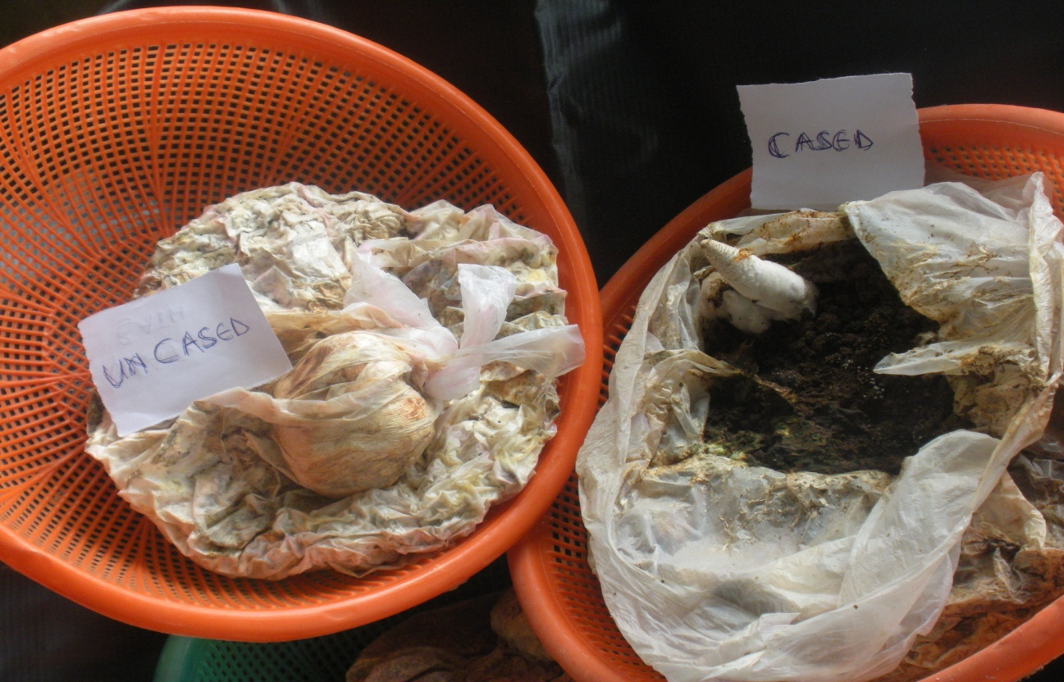
Plate 1: Sclerotium and fruiting body of P. tuberregium on cased and uncased substrate.
\Fruiting bodies and sclerotia yield of P. tuberregium are shown in figure 1. Fruiting bodies and sclerotia were produced on all cased substrates while the uncased produced no fruiting body at all (plate 1). However, all the trays cased at 3rd week after inoculation produced only fruiting bodies without sclerotia formation at all. Highest sclerotia yield was recorded at the 1st week of casing layer application with the least recorded at the 6th week of casing layer application and the highest fruiting body yield was obtained when the casing layer was applied at 3rd week after spawning. Biological efficiency was best at 1st week of casing application and the lowest was at the 6th week .The biggest fruiting body was obtained at the 4th week of casing soil application with no fruiting body formation at all on the control.
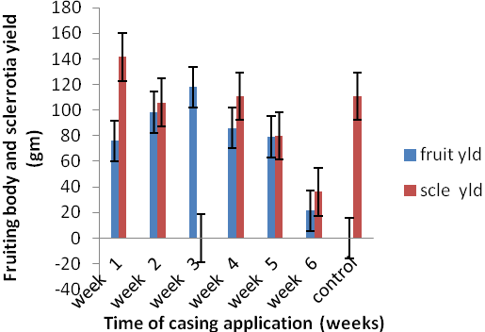
Figure 1: Effect of casing layer, time of application on fruit body and sclerocia yield of P. tuberregiumfruit yld= fruit body yield, scle yld= sclerotia yield
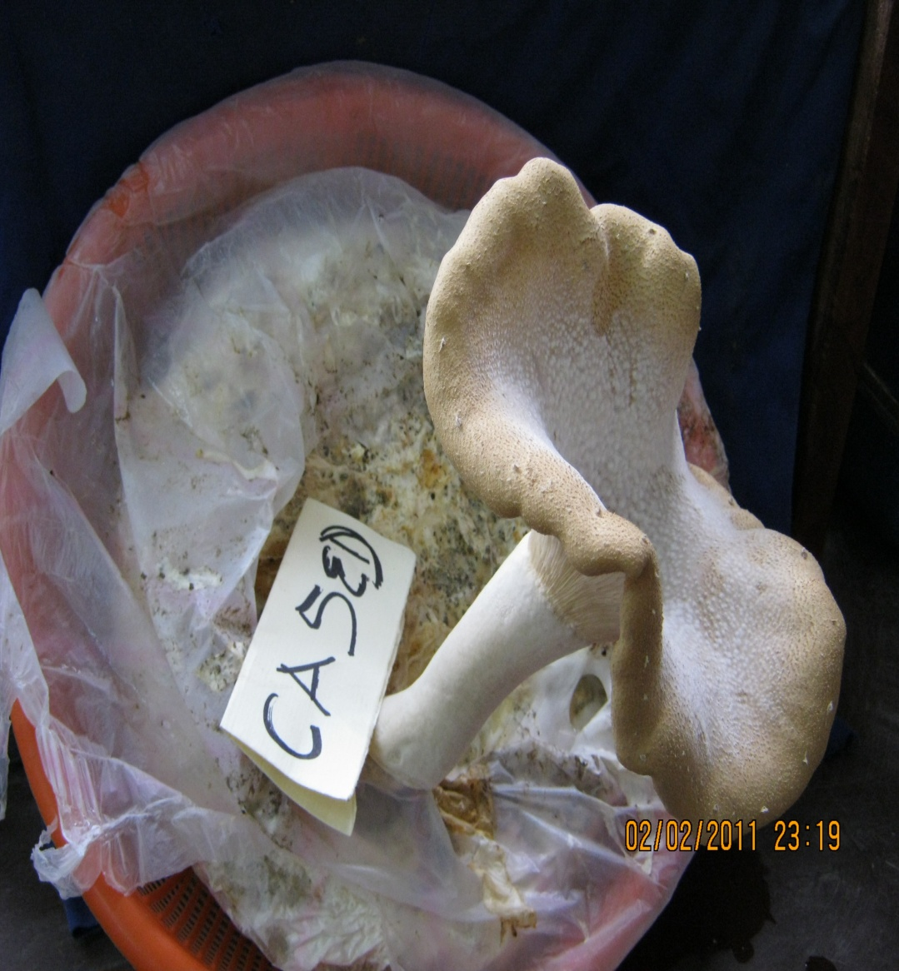

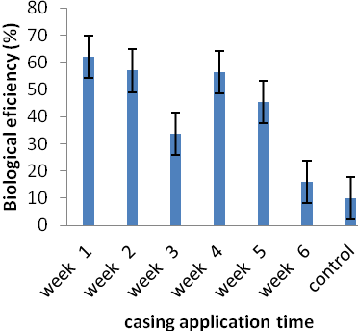
Fig 2: Effect of casing layer and time of application on fbiological efficiency of P tuberregium

Table 2 is showing the effects of casing and time of application on the growth and yield of P. tuberregium. The biggest fruiting body was obtained at 4th week after application of casing material and no fruiting body was obtained at zero casing application which is the control. Widest pileus width (18.35cm), longest stipe (16.9cm) and widest stipe girth (5.75cm) were observed at 2nd week after casing application, total yield comprising of both the weight of fruit body and sclerotia was best at 1st and 2nd week of casing application and least at the sixth week and in the control.

Table 2: Effects of casing layer and time of application on growth and yield of P. tuberregiums
Time of casing layer application | Mean fruit size (g) | Width of pileus (cm) | Length of stipe (cm) | Girth of stipe (cm) | total yield (g)
week 1 | 22.13c | 15.90 c | 14.40 c | 2.60 d | 217.35 a
week 2 | 31.06b | 17.00b | 13.12 d | 4.40b | 199.09 b
week 3 | 21.64c | 15.11 d | 15.90 b | 4.15c | 118.00 e
week 4 | 48.84a | 18.35 a | 16.90a | 4.75 a | 196.82 c
week 5 | 17.81d | 16.40 c | 13.86 d | 4.05c | 159.08 d
week 6 | 7.12e | 7.30 e | 7.25 e | 2.40 d | 56.40g
control | 0.00f | 0.00 f | 0.00 f | 0.00 e | 110.93 f
Means followed by the same superscript letter(s) in each column are not significantly different (P>0.05) by Duncan’s multiple range test.
The results on figure 3 shows that increased substrate size brought about increased biological efficiency but a point was reached when the biological efficiency began to decline ( Fig 3). Growth substrate size was varied initially and this initial substrate sizes were reduced significantly at sclerotia harvest across the treatments with sclerotia yield, sclerotia diameter and production efficiency increasing as substrate size increased (Table 3).

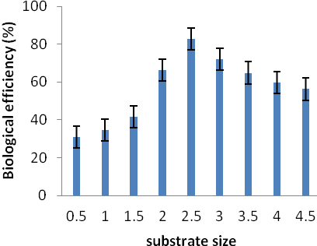
Fig 3: Effect of substrate weight on biological efficiency of P tuberregium

Table 3: Effects of substrate size on mushroom growth and sclerotia yield of P tuberregium
Initial substrate weight  (Kg) | Initial dry substrate weight(g) | Final substrate weight at harvest | Sclerotia yield (g) | Sclerotia. Diameter (cm)
0.5 | 175i | 156.5i | 48.381 | 6.88g
1 | 350h | 317h | 110h | 10.78f
1.5 | 575g | 466.5g | 194.49g | 14.22e
2 | 700f | 675f | 414.52f | 15.3 d
2.5 | 875e | 781.25e | 646.75e | 15.7d
3 | 1050d | 935.75d | 668.73d | 16.48c
3.5 | 1225c | 1093c | 709.28c | 18.2 b
4 | 1400b | 1248.25b | 747.24b | 18.35 b
4.5 | 1575a | 1465a | 790.25a | 19.73 a
Means followed by the same superscript letter(s) in each column are not significantly different (P>0.05) by Duncan’s multiple range test

Discussion
In order to coerce fungus mycelium to producing or creating fruiting bodies, a low nutrient casing or top dressing is applied on top of the colonized substrates making the mushroom feel it is about to run out of food supply. In this study, the possibility of fructification of P. tuberregium without the usual fruiting through sclerotia cropping was done. Earlier workers have reported fructification of P. tuberregium by burying of the sclerotia in moist soil with fruit body emerging as from two weeks after burying of the sclerotium. Fresh casts of earth worm Eudrilus Eugeniae was used as casing material and the time of casig application was also varied. All cased substrate trays yielded both sclerotia and fruit body of P. tuberregium with the exception of substrate trays cased at 3rd week which produced only fruit bodies while uncased substrates yielded only sclerotia. In similar studies by Gulser and Aysup, (2003) Umamatheswari and Vijayalakshmi (2004) and Sassine et al. (2005), reported that casing layer application increased the yield of milky mushroom (Lactarius deliciosus) and Agaricus bisporus. Time of casing layer application is usually done when the substrate is fully ramified by the mushroom mycelium, in this study, time of application of this casing was varied starting from a week after spawning to 6 weeks after spawning and the result obtained showed that application at 3-4 weeks after lnoculation yielded more mushroom fruit bodies which suggests that for direct fruiting body production of this mushroom, casing material should be applied preferably at 3-4 weeks after spawning and that earth worm casts can be used as casing material as ready-made casing materials such as peat moss and vermiculite are not available in Nigeria for now. Effect of substrate volume on sclerotium yield of P. tuberregium was also studied. Increase in substrate volume brought about increase in biological and production efficiencies of the mushroom. The volume of the substrate on which mushroom is growing has a significant effect on the mushroom yield. The sclerotia yield of P. tuberregium was increased with increase in the volume of the substrate but a point was reached when the yield increase, biological efficiency and production efficiency were no longer significant. This may imply that irrespective of the food source made available for an organism, at the attainment of its full growth size, increase in its size stops.
In conclusion, the results obtained showed that the use of earth worm cast as a casing material in the fructification of P. tuberregium is new and practicable casing material in Nigeria where the peat casing is not available at all.

Acknowledgement
We are grateful to Mr. Otunla, C.A., Mrs. Akinrinsola, F.O., Mrs Majekadegbe, G.A. and Mr. Daropale, S. for their support.

Corresponding Author:
Dr. Idowu Olufunmilayo Omowumi
National Horticultural Research Institute,
Idi-Ishin, Ibadan.
E-mail: funmilayoidowu@yahoo.com

Refrences
- Aletor VA and Aladetim OO.Compositional evaluation of some cowpea varieties and some underutilized edible legumes in Nigeria. Die Nuhrung 1989; 33,99-107.
- Dergham Y, Lelley J and Ernst AA. Waste paper as a substitute for peat in mushroom (Agaricus bisporus) casing soil production. In: Maher, M.J. (Ed.), Science and Cultivation of Edible Fungi. Balkema, Rotterdam 1991; pp. 263–268.
- De- Vedie R. Perforated plastic ﬁlm coverage of the casing soil and its inﬂuence on yield and microﬂora. In:Elliott, T.J. (Ed.), Science and Cultivation of Edible Fungi. Balkema, Rotterdam1995; pp. 347–352
- Food and Agricultural Organization.”The state of food security in the world” Progress Report on World Food Hunger 1992; Rome.
- Flegg PB and Wood DA. Growing and fruiting. In: Flegg, P.B., Spencer, D.M., Wood, D.A. (Eds.), The Biology and Technology of the Cultivated Mushroom. John Wiley & Sons Ltd. 1985; pp. 141– 178.
- Gulser C and Aysup P. Using tea waste as a new casing material in mushroom (Agaricus bisporus (L) Sing.) cultivation. Bioresource Technology 2003; 88(2):153-156.
- International Conference on Nutrition (ICN). Country Report: Nigeria International Conference on Nutrition 1992; p7.
- Iyangbe CO and Orewa SI. Determination of daily protein intake among rural and low-income urban households in Nigeria. American-Eurasian Journal of Scientific Research 2009; 4 (4): 290 – 301.
- Labuschagne P, Eicker A, van Greuning M. Casing medium for Agaricus cultivation in South Africa, a preliminary report. In: Elliott, T.J. (Ed.), Science and Cultivation of Edible Fungi. Balkema, Rotterdam 1995; pp.329–344.
- Mane VP, Patil SS, Syed AA, Baig MM. Bioconversion of low quality lignocellulosic agricultural waste into edible protein by Pleurotus sajor-caju (Fr.) Singer. Journal of Zhejiang University of Science 2007; 8(10):745-751
- Noble R and Dobrovin-Pennington A. Partial substitution of peat in mushroom casing with ﬁne particle coal tailings. Scientia Horticulturae 2005; 104 351–367.

Ologhogbo AD. Biological and nutritional studies on cowpea and lima beans with particular reference to some inherent anti-nutritional components. Ph.D thesis University of Ibadan, Nigeria 1981.
- Oso BA. Pleurotus Tuber regium from NigeriaMycologia 1977; 69:271-279.
- Poppe J. Use of agricultural waste materials in the cultivation of mushrooms. In: van Griensven, L.J.L.D. (Ed.), Science and Cultivation of Edible Fungi. Balkema, Rotterdam 2000; pp. 3–23.
- Rainey PB, Cole AL, Sanderson FR. Air ﬁlled pores—an important component of the mushroom casing layer. In: Proceedings International Symposium on the Scientiﬁc and Technical Aspects of Cultivating Edible Fungi, Elsevier, Amsterdam 1986; pp. 501–514.
- Sassine YN, Ghora Y, Kharrat M, Bohme M and Abdel-Mawgoud AM. Waste paper as an alternative to casing soil in mushroom (Agaricus bisporus) production. Journal of Applied Science Research 2005;1(3):277-284.
- Sinden J. The American mushroom industry. Mushroom J. 1987; 173, 165–169.
- Szmidt RA. Recycling of spent mushroom substrates by aerobic composting to produce novel horticultural substrates. In: Wuest, P.J. (Ed.), Environmental, Agricultural and Industrial Uses for Spent Mushroom Substrate from Mushroom Farms. The JG Press Inc., Emmaus, PA, USA 1994; pp. 134–143.
- Tautorus TE and Townsley PM. Biological Control of Olive Green Mold in Agaricus bisporus Cultivation. Applied and Environmental Microbiology 1983; 45 (2) 511-515
- Umamatheswari S and Vijayalakshmi GS. Milky mushroom cultivation using earth worm cast. The Hindu online edition of India’s National News Paper, Sci Tech, Thursday, march 25th 2004.
- Visscher HR. Casing soil. In: van Griensven, L.J.L.D. (Ed.), The Cultivation of Mushrooms. Darlington Mushroom Laboratories Ltd., Rustington, Sussex, UK 1988; pp. 73–88.
- Yang BK, Kim DH,Jong SC, Das S, Choi YS, Shin JS, Lee SC and Song JS. Hypoglycemic effect of Lentinus edodes exo-polymer produced from submerged mycelia culture. Biosc. Biotechnol. Biochem 2002; 66, 937 – 942.
- Yeo SG, Hayes WA. A new medium for casing mushroom beds. Mushroom Sci. 1978; 10, 187–216.

1/25/2013

