Comparative Anaesthetic Efficacy of Thiopental Sodium, Ketamine Hydrochloride, Propofol and Combination of Propofol with Ketamine Hydrochloride in Egyptian Mongooses, Herpestes Ichneumon.

Hassan, M. M.

Department of Surgery, Anaesthesiology & Radiology, Faculty of Veterinary Medicine, Suez Canal University, Egypt
Dr_zaghlol68@yahoo.com

Abstract: The present study was performed on 12 adult apparently healthy male Egyptian mongooses to determine the comparative anaesthetic efficacy of thiopental sodium, ketamine, propofol alone and propofol in combination with ketamine. Durations of induction, surgical stage and recovery from anaesthesia were recorded. Heart rate, respiratory rate and rectal temperature, in addition to the effects of anaesthetic agents on various body reflexes were recorded. Animals treated with thiopental sodium (Group A), showed rapid induction, the longest duration of surgical anaesthetic stage and prolonged non smooth recovery, while animals treated with ketamine (group B), showed unstable surgical anaesthetic stage with spasm in skeletal muscles and animals treated with propfol (group C), showed rapid induction and respiratory depression with very rapid recovery. Combination of ketamine with propofol (group D), reduced the dose of propofol required and prolonged the anaesthetic stage. Moreover, it avoided respiratory depression caused by propfol. It was concluded that propofol in combination with ketamine is a safe anaesthetic agent for mongooses as an alternative of thiopental sodium for prolonged surgical procedures.
[Hassan, M. M. Comparative Anaesthetic Efficacy of Thiopental Sodium, Ketamine Hydrochloride, Propofol and Combination of Propofol with Ketamine Hydrochloride in Egyptian Mongooses, Herpestes Ichneumon. Nat Sci 2013;11(6):6-12]. (ISSN: 1545-0740). http://www.sciencepub.net. 2

Keywords: Egyptian mongooses, thiopental sodium, propofol, ketamine.

1. Introduction
The need for training to capture and restraint of the mongooses are required. Padded foothold traps are used for restraining (Palomares, 1990). Hand restraint was used by grabbing the animal around the back of the neck and using the thumb and middle or ring finger placed on either side of the lower jaw lifting the head backward slightly. The restrainer's other hand should be placed under the animal's body to support its weight or, the restrainer's arm should be placed around the middle of the body and used to pin the animal against their body (McDonald, 2001). Anaesthesia is an indispensable pre-requisite to most of the surgical interventions. Intravenous anaesthetics are preferred because of their early and safe induction. Injectable anaesthesia has a longer recovery period than inhalant anaesthesia (Muir, 1991and Kreeger, 1999).Thiopental sodium has been the sole anaesthetic agent so far relied upon by the veterinarians for most of surgical interventions. Its unavailability or irregular availability in local market renders the veterinary surgeons incapable of performing any surgical intervention. This situation compels the veterinary surgeons to look for some other suitable and safe alternative readily procurable from the market having better or an equivalent spectrum of anaesthesia (Kelawala, 1992). Pentobarbital sodium was found to be good for immobilization of mongooses over a wide dosage range (24.6 - 66.7 mg/kg) (Ishibashi, et al., 2009). Propofol is a unique non-barbiturate, non-steroid, short-acting general intravenous anaesthetic agent (Hofmeister et al., 2008). It is associated with a rapid smooth induction and a rapid recovery. Anaesthetic stage duration of propofol could be enhanced if used in combination with ketamine hydrochloride (VanNatta and Rex, 2006). ketamine was not suitable due to unstable effect on immobilization when it was used alone (Maddock, 1989 and Delibes, 1992). Induction and recovery time did not differ significatively among sex and age classes (Palomares, 1990 and Ishibashi, et al., 2009). The present study was performed to determine the comparative anaesthetic efficacy of thiopental sodium, ketamine hydrochloride, propofol alone and propofol in combination with ketamine hydrochloride in Egyptian mongooses.

2.Material and Methods
This study was approved by the Sceintific Ethical Committee, Faculty. of Veterinary Medicine, Suez Canal Univerisity, Ismalia, Egypt.
Experimental animals
Twelve adult apparently healthy male Egyptian mongooses were captured with box-traps from Abu-Rwash, Giza- Egypt. Their age (1.5-2 years old) was estimated by body mass and teeth wearing. Their weight was ranged from 3.5–5.5 Kg. Animals were randomly divided into 4 equal groups (A, B, C& D). Food and water were withheld for 6 hours prior to the induction of anaesthesia. The method for physical restraining of the mongooses during intravenous injections was mentioned by (Palomares, 1990 and McDonald, 2001).
Administration of anaesthesia
All Mongooses were allowed to relax for some time to overcome excitement created during restraining. Normal heart rate, respiratory rate and rectal temperature of each animal were recorded. Animals of group (A) treated with Pentobaribital sodium (Thiopental sodium®, E.I.P.C.O., Egypt) in a dose of 30 mg/kg Intravenously (IV), while animals of group (B) treated with ketamine hydrochloride (Ketalar® 50; Parke-Davis) in a dose of 30 mg/kg IV. Animals of group (C) treated with Propofol in a dose of 12 mg/kg, while animals of group (D) treated with Propofol-Ketamine combination in a dose of 6 mg/kg for each IV.
Post treatment monitoring
A team of trained academic persons was deputed to record observations for various clinical parameters at 5 minutes interval till the complete recovery obtained.
The effects of anaesthetic agents on various body reflexes like corneal, pupil, anal sphincter and tail flaccidity were recorded. Pinch reflexes (noxious stimuli) were applied to a rear limb metatarsus and base of the tail using small artery forceps, by closing it to the first ratchet for 10 sec respectively. Responses to the noxious stimuli were categorized as no response (score 0), minimal response (score 1), limb/tail withdrawal (score 3) or limb/tail withdrawal with lifting of the head (score 4). Anaesthesia was considered adequate at score (0), according to (Beltran et al., 1985 and McDonald, 2001). Onset of anaesthetic action, duration of surgical stage and recovery time were determined in all animals.
Statistical analysis
The data obtained were analyzed by Analysis of Variance (one-way ANOVA) according to Ronald Fisher (1962). Mean separations were done by Multiple Duncan’s Range Test (1934). Results considered highly significant at (P ≤ 0.01). SPSS (16.0) was used for analysis. Statistical graphs were applied using Microsoft Excel (2003).

3. Results
All animals in the present study showed smooth induction ranged from 6:9 seconds. The animals of group C showed the shortest duration of the surgical stage of anaesthesia (24 mins), while the longest duration of the surgical stage (52 mins) was seen in animals of group A (Fig. 1 A & B). The animals of groups B, C and D, revealed smooth recovery ranged from 2.7:7 mins, while the animals of group A showed prolonged non-smooth recovery (12.7 min) (Table 1& Fig. 2).
Corneal reflex
The corneal reflex was absent within three minutes in mongooses of all groups post medication (the most rapid absence was appeared in animals treated with propofol). The corneal reflex remained absent for almost the same time duration in all groups except group C which remained absent for a significantly shorter time (P≤0.01).and group A which remained absent for a significantly longer time. Then this reflex recovered in a short time in three groups B, C and D but group A showed prolonged recovery (Table 2 & Fig. 3).
Pupil reflex
Pupil was dilated in a significantly shorter time in mongooses of groups A and B than groups C and D. It remained dilated for longer duration in groups A and D. Then it started to constrict and became normal rapidly in groups B and C, while groups A and D showed prolonged recovery (P≤0.01). (Table 3 & Fig. 4).
Anal sphincter reflex
All the groups took almost the same time for anal sphincter dilatation after anaesthetic administration except animals of group B showed a longer induction time. Then it remained dilated for prolonged period in group A than the other groups. Recovery was delayed in both groups A and D while it was rapid in groups B and C (P≤0.01) (Table 4 &Fig. 5).
Tail flaccidity
In groups B and C, the flaccidity of tail was achieved later than groups A and D post anaesthetic administration. Then it remained flaccid for longer duration in groups A and D, while it was short in group C. Recovery was rapid in group C more than other groups (P≤0.01). (Table 5 & Fig. 6).
The animals of group A, showed significant increase in the heart rate at 5 mins and persisted till the end of the observation, while in groups C & D, showed increase in the heart rate at 5 mins and begun to decrease to the normal at 30-35 mins (Fig. 7). There was significant decrease in the respiratory rate in animals of group C, which returned to the normal at 30-35 mins., while in group A the respiratory rate persisted decrease till the end of the observation. Administration of ketamine with propofol in animals of group D, avoided respiratory depression which was seen when propofol was used alone (Fig. 8). Temperature was significantly decreased till recovery in animals of group A, while there was no marked decrease in the other groups (Fig. 9).

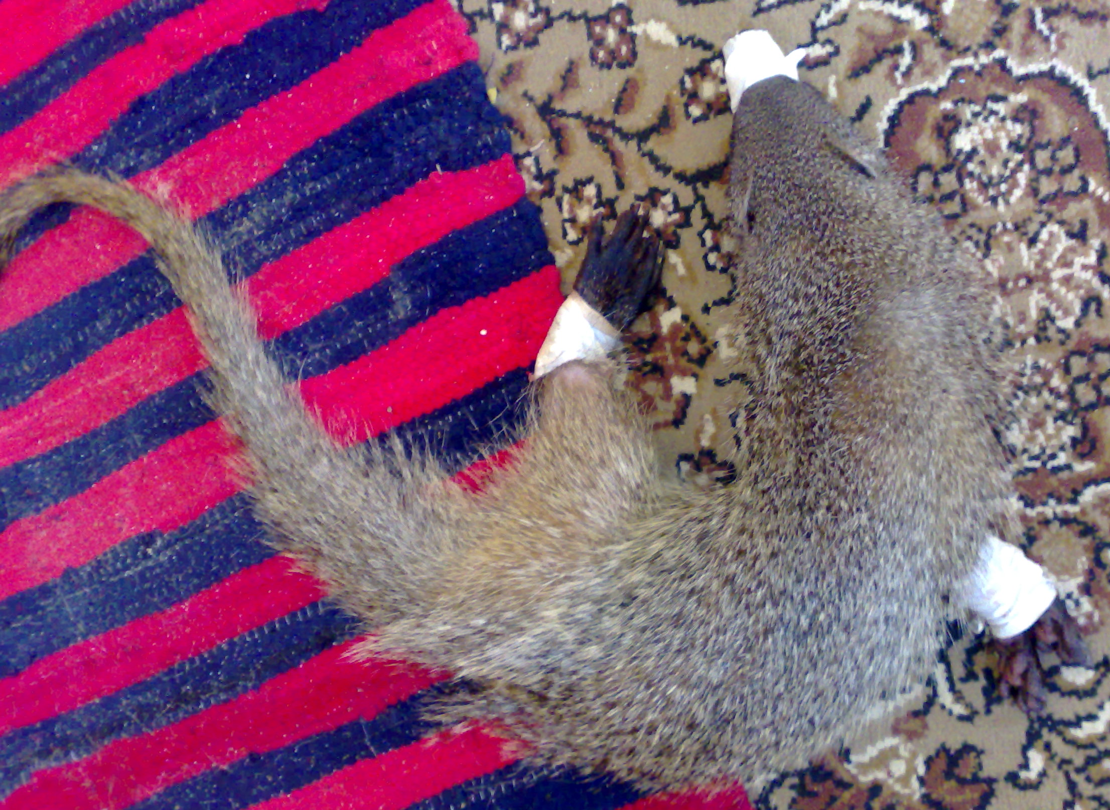
B
A
Fig. (1): Showing the deep surgical stage of anesthesia at 30 min. (A). Note, recovery in the same group 50 mins post thiopental sodium administration (B).

Stage  Group | Induction (sec) | Duration (min) | Recovery (min)
A | 6.00^{c} ±1.00 | 52.33ª ± 5.13 | 12.67ª ± 1.53
B | 9.67ª ± 1.15 | 39.67^{b} ± 1.53 | 7.00^{b} ± 1.00
C | 7.33^{bc} ± 0.58 | 24.67^{c} ± 1.15 | 2.67^{c} ± 0.58
D | 8.67^{ab} ± 0.58 | 37.33^{b} ± 1.15 | 4.33^{c} ± 0.58
(Table 1& Fig. 2) Induction, duration and recovery times of the 4 administered groups with anesthetic drugs (3 animals/ group). Each value represents the mean ± SD. Note: Within the same column, means with different superscripts are highly significant (P≤0.01).

Stage  Group | Induction (min) | Duration (min) | Recovery (min)
A | 1.33^{b} ± 0.29 | 15.67ª ± 0.76 | 10.50ª ± 0.86
B | 2.17ª ± 0.29 | 13.33^{b} ± 0.29 | 7.83^{b} ± 0.29
C | 1.17^{b} ± 0.29 | 8.33^{c} ± 0.76 | 3.33^{d} ± 0.29
D | 1.67^{ab} ± 0.29 | 12.17^{b} ± 1.04 | 5.00^{c} ± 0.50

(Table 2 & Fig. 3): Effects of thiopenton, ketamin, propofol and propofol-ketamin on corneal reflex. Each value represents the mean ± SD. Note: Within the same column, means with different superscripts are highly significant (P≤0.01).

Stage  Group | Induction (min) | Duration (min) | Recovery (min)
A | 1.33^{c} ± 0.29 | 15.83ª ± 0.56 | 5.17^{ab} ± 1.26
B | 2.00b^{c} ± 0.50 | 13.83^{c} ± 0.29 | 3.83^{bc} ± 0.56
C | 3.67ª ± 0.76 | 10.33^{d} ± 0.29 | 3.33^{c} ± 0.29
D | 2.83^{ab} ± 0.29 | 14.83^{b} ± 0.29 | 6.33ª ± 0.29
(Table 3& Fig. 4): Effects of thiopenton, ketamin, propofol and propofol-ketamin on pupil reflex. Each value represents the mean ± SD. Note: Within the same column, means with different superscripts are highly significant (P≤0.01).

Stage  Group | Induction (min) | Duration (min) | Recovery (min)
A | 1.33^{b} ± 0.29 | 15.67ª ± 0.76 | 10.50ª ± 0.86
B | 2.17ª ± 0.29 | 13.33^{b} ± 0.29 | 7.83^{b} ± 0.29
C | 1.17^{b} ± 0.29 | 8.33^{c} ± 0.76 | 3.33^{d} ± 0.29
D | 1.67^{ab} ± 0.29 | 12.17^{b} ± 1.04 | 5.00^{c} ± 0.50

(Table 4& Fig. 5): Effects of thiopenton, ketamin, propofol and propofol-ketamin on anal sphinicter reflex. Each value represents the mean ± SD. Note: Within the same column, means with different superscripts are highly significant (P≤0.01).

Stage  Group | Induction (min) | Duration (min) | Recovery (min)
A | 1.67^{c} ± 0.29 | 17.83ª ± 0.76 | 7.33ª ± 0.76
B | 3.00ª ± 0.50 | 15.83^{b} ± 0.29 | 5.33^{b} ± 0.29
C | 3.17ª ± 0.29 | 13.17^{c} ± 0.58 | 2.83^{c} ± 0.29
D | 2.33^{b} ± 0.29 | 17.17^{ab} ± 1.04 | 6.00^{b} ± 0.50
(Table 5& Fig. 6): Effects of thiopenton, ketamin, propofol and propofol-ketamin on tail flaccidity. Each value represents the mean ± SD. Note: Within the same column, means with different superscripts are highly significant (P≤0.01).
Fig. (7): Showing significant increases in the heart rate in the animals of group A, this persisted until the end of the observation.

Fig. (8): Showing significant decreases in the respiratory rate in the animals of group C, while in group A the respiratory rate persisted decreases until the end of the observation.

Fig. (9): Showing significant decreases in temperature until recovery in the animals of group A, while there were no marked decreases in the other groups.

4. Discussion
Group
Stages
Group
Stages
Group
Group
Thiopental sodium had been the sole injectable anaesthetic agent upon which veterinarians have relied surgery in our country, but sometimes it is not readily available in the market. So, to resolve this problem, propofol, a new anaesthetic agent, was evaluated in this study alone or in combination with ketamine hydrochloride.
The animals of group A, showed rapid and smooth induction. All body reflexes were disappeared and the animals were in perfect surgical stage for a significant long duration, while the recovery was prolonged and non smooth. Temperature was significantly decreased, while the respiratory rate was markedly decreased and the heart rate was significantly increased during the surgical stage of anaesthesia. These parameters were not regained to the normal after recovery; these results were in accordance with the findings of Ishibashi, et al., (2009). The animals of groups B, showed rapid induction and the animals were unstable with smooth muscles spasm during the surgical stage with rapid recovery; similar findings were reported by Maddock, (1989) and Delibes, (1992).
The animals of groups C, showed marked rapid and smooth induction. All body reflexes disappeared and animals were in the surgical stage for a significant short duration with a significantly quicker smooth recovery. There were increases in the heart rate and a significant respiratory rate depression who returned to the normal values at 25 – 30 mins, similar findings were reported by VanNatta and Rex, (2006) and Hofmeister et al., (2008). Administration of ketamine with propofol in animals of group D, prolonged and improved the anaesthetic surgical stage duration and avoided the respiratory depression which were seen when propofol was used alone, results which is in agreement with the findings of VanNatta and Rex, (2006) and Ishibashi, et al., (2009). There was no significant decrease in body temperature in groups (B, C& D), these results were in accordance with the findings of Ishibashi, et al., (2009).

Conclusion
It was concluded that propofol in combination with ketamine hydrochloride is a safe anaesthetic agent for mongooses as an alternative of thiopental sodium for prolonged surgical procedures.

Reference
- Beltran, J.F.; Delibes, M.; and Ibanez, C. (1985): Immobilization and marking of the egyption mongoose, Herpestes Ichneumon (L.), In Spain. Z. Saugetierkunde 50, 243- 244.
- Delibes, M. (1992): Immobilization of egyptian mongooses, Herpestes ichneumon, with a combination of ketamine and xylazine. Zietschrift fur Saugetierkunde 57: 251–252.
- Hofmeister, E. H.; Williams, C. O.; Braun, C.; and Moore, P. A. (2008): Propofol versus thiopental: effects on peri-induction intraocular pressures in normal dogs. Vet. Anaesth. Analg., 35: 275-281.
- Ishibashi, O.; Nishuima, T.; Sumida, k.; Yamashita, K. Suda, k.; Gura, G.; Sunagawa, K. and Nakada, T. (2009): Chemical Immobilization of the Small Asian Mongoose using Anesthetic Medicine. Laboratory of Subtropical Zoology, Faculty of Agriculture. University of the Ryukyus. Okinawa 903-213. Japan.
- Kelawala, N. and Persania, R. R. (1992): Preliminary studies on propofol, ketamine and propofol-ketamine anaesthesia in diazepam premedicated goats. Indian Vet. J., 69: 724-729.
- Kreeger, T.J. (1999): Handbook of Wildlife Chemical Immobilization. 1st ed, Intl Wildlife Veterinary Services.
- Macdonald, D. W. (2001): New Encyclopedia of Mammals.3rd ed. Oxford. Univ. press.
- Maddock,A.H. (1989): Anesthesia of four species of viverridae with ketamine. S. Afr. Tydskr. Naturnav. 19, 80-84.
- Muir, W. and Hubbel, J. A. E. (1991): Specific intravenous anaesthetic drugs. In: “Handbook of Veterinary Anaesthesia”, J. B. Brothers, New Delhi, India, pp: 77-88.
- Palomares, F. (1990): Ecologia y organizacion social del meloncillo, Herpestes ichneumon L., en el Parque National de Donana. Ph. D. thesis, Univ.Granada, Spain.
- VanNatta, M. E. and Rex, D. K. (2006): Propofol alone titrated to deep sedation versus propofol in combination with opioids and/or benzodiazepines and titrated to moderate sedation for colonoscopy. Amer. J. Gastroenterol., 101: 2209-2217.

3/22/2013

