Petrography of subvolcanic rocks of Givshad (south west of Birjand, East of Iran) and the effective factors in rising magma

Fazilat Yousefi¹, Mohamad Hosein Zarrinkoub²

1, 2: Department of petrology, Birjand University
f.yousefi87@gmail.com

Abstract: Rocks complex of givshad is in the southwest of Birjand, consists of subvolcanic rocks that outcrops into the paleocene flysch. The composition of this complex is porfiritic diorite. Their textures are porfiric and microgranolar. Plagioclase, amphibole, biotite and Quartz are main minerals and petty mineral is opaque. Zoning phenomenon is observed in these plagioclases. The difference density between magma and its formation environment and fracture creation in surface are the effective factors in rising and increasing velocity of magma. We use raws of fluid mechanics and modeling in order to establish this subject.
[Yousefi F, Zarrinkoub M.H. Petrography of subvolcanic rocks of Givshad (south west of Birjand, East of Iran) and the effective factors in rising magma. Nat Sci 2013; 11(6):22-24]. (ISSN: 1545-0740).
http://www.sciencepub.net/nature.

Keywords: East Iran; Birjand; porfiritic diorite; rise magma and fluid mechanics

1. Introduction
The studied area is in the south west of Birjand in the south Khorasan Province, around Givshad village lies between 32°34′21″- 32°39′49″ longitude and 59°- 59º10′56″ latitude in Sistan suture zone. This mountain with the especial shape has seen as a ring set in the west of Givshad village (Figure 1).This region is in the boundary between the Lut and Sistan Block (Figure 2). Tirole and others (1983), point that this structural zone is suture due to collision Afghan zone and Lut block has the general trend of the North-South. The aim of this study was to investigate the petrography of complex ring set Givshad and the effective factors in rising magma.

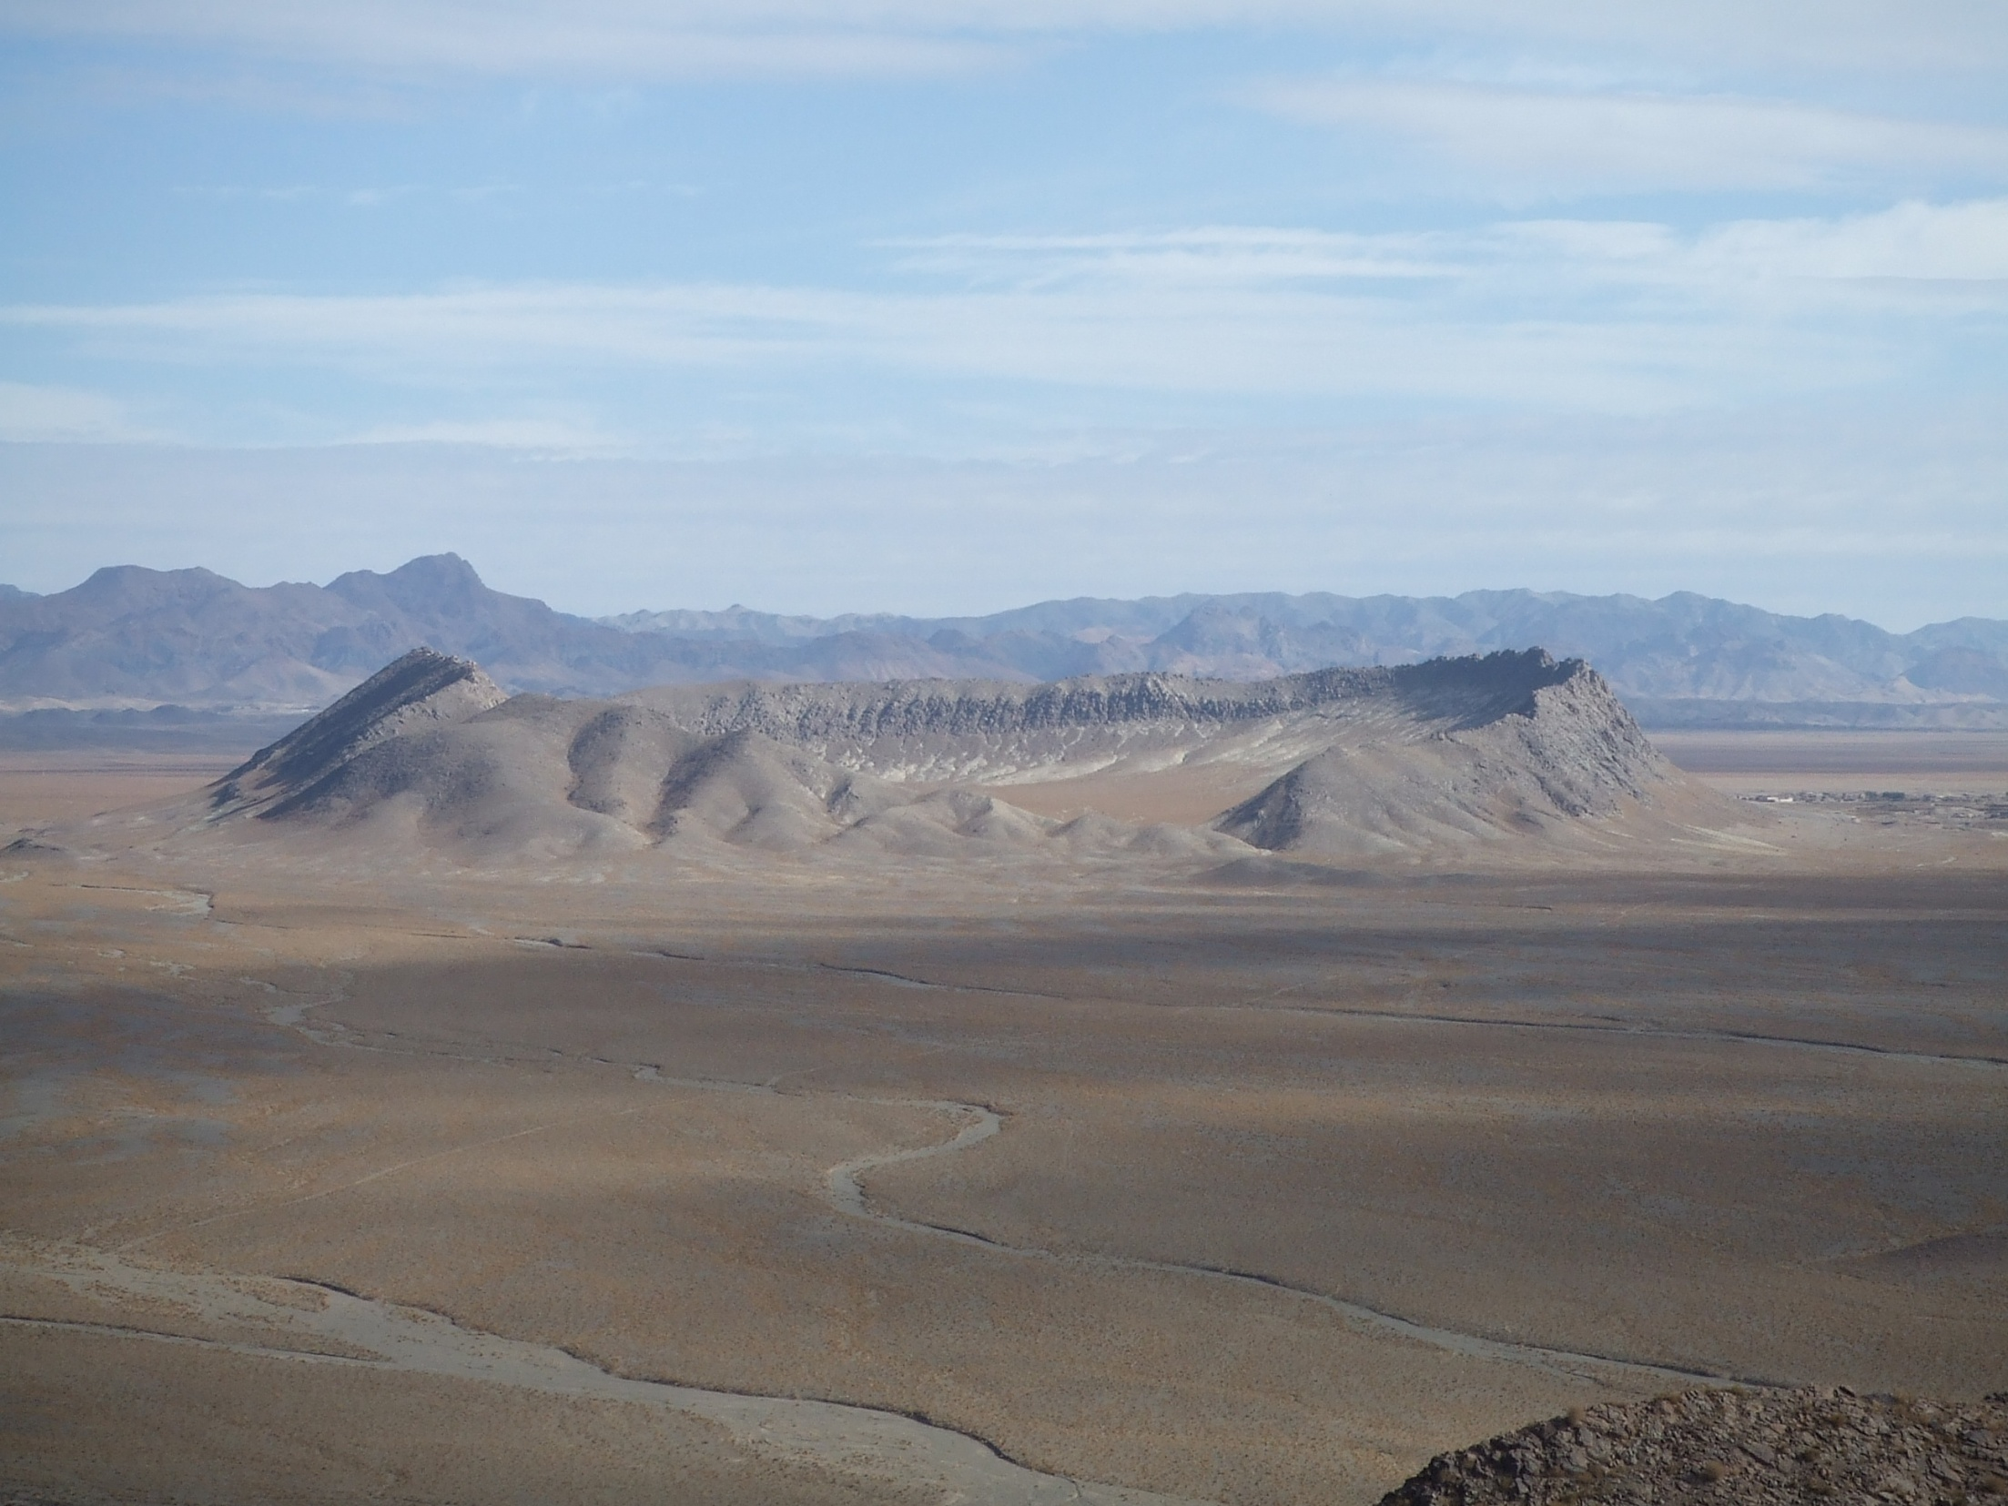

Figure 1: Complex ring set Givshad
2. Discussion
Petrography: These rocks consist of Diorite to quartz porfiritic diorite. Diorite: Their texture are porfiric and microgranolar. Plagioclase, hornblende, biotite and quartz are the main minerals. Plagioclase minerals are andesine-oligoclase. Zoning phenomenon is observed in these plagioclases. Opaque minerals with nearly 5 percent is considered as secondary minerals. Alteration observed in these rocks includes plagioclases alterated to clay minerals (Fig. 3) and calcium carbonate (Fig. 4). Hornblends alterated to epidote (Figure 5) and biotite (Fig. 6). This type of alteration occurs in the existence of hydrothermal solutions in temperatures 200 to 300 ° C (Puura et al, 2004).

3. Magma ascension
Several reasons have been stated for magma ascent: The main factor for rising magma is the density that is between magma and its formation environment. When partial melting happens in the mantle, magma moves to surface. Although, the continental crust has lower density than the liquid melt and should be prevented rising of this liquid melt the extra pressure comes from below the surface helps move it (Middle Most, 1986). Other factors in magma-ascension are presence fractures and stretching occur in near surface environment. To better understand the rising magma, we have used the fluid mechanics perspectives. In this study, at first used rules has been considered in the stable environment and then in environment affected by the shear stress. While the fluid is stable and shear stress is zero, intermolecular force causes the viscosity characteristics in fluid. Thus, by the effect of this matter, fluid is stable (White, 1979). In laminar flow, velocity gradient and shear stress, related to each other by the law of Newton viscosity (Hosseini et al, 2007).
T= µ dv/dy (1)

T: Shear stress
µ: coefficient of viscosity
dv/dy: Velocity gradient

In application of this equation we should Note that (White, 1979): 1) Even a small amount of shear stress creates velocity gradient. 2) When shear stress is zero, the fluid is stationary. By increasing shear stress, fluid velocity changes and flows. Because of shear stress in the south of Birjand, some stretching environments have been shaped and these stretching environments are in accordance with volcanic and subvolcanic units are in this region (Khatib and Zarrin Koub, 2009).

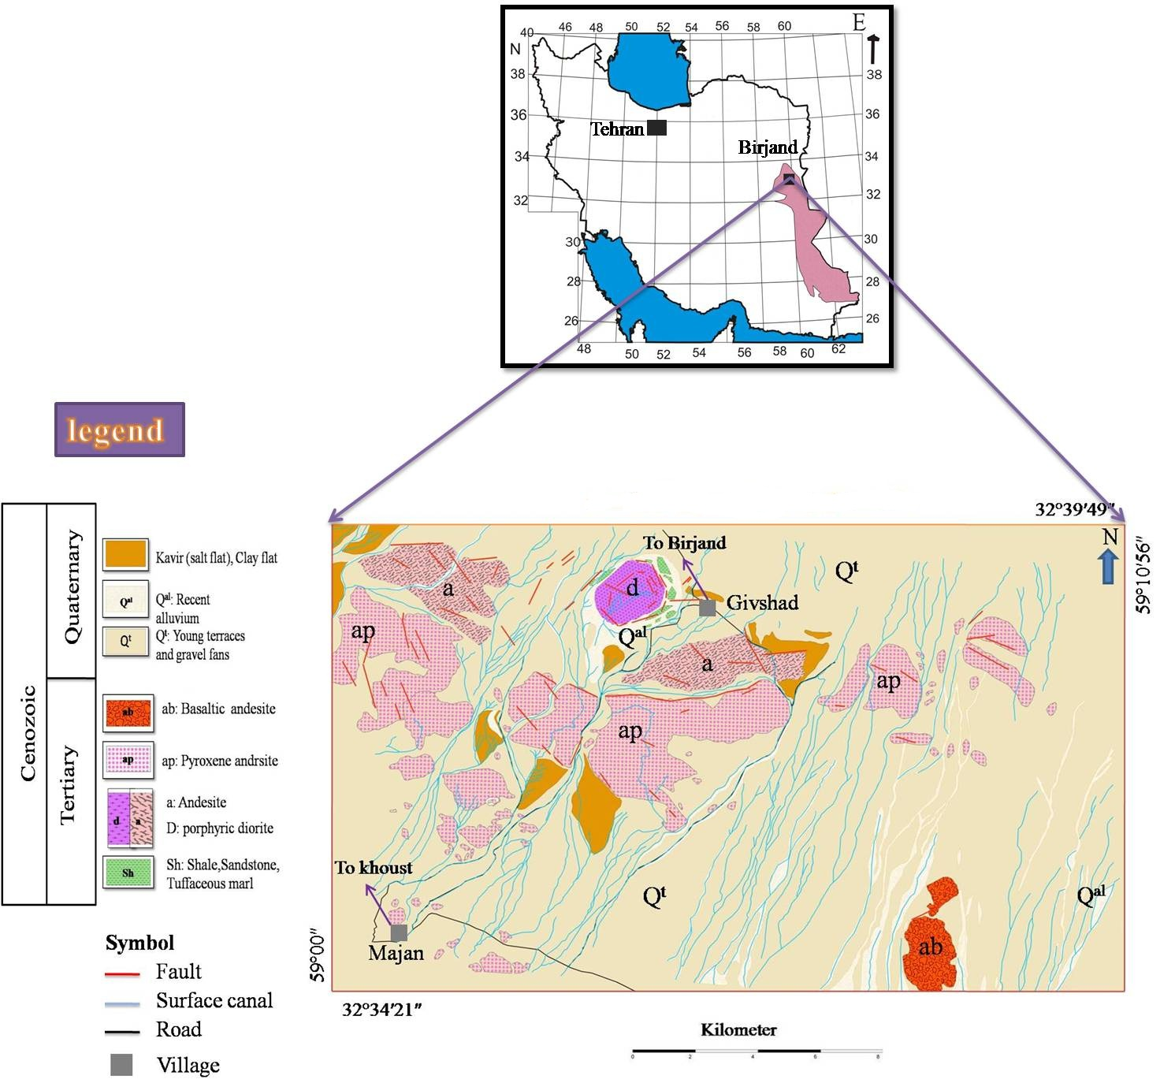

Changing in cross sectional area of ​​the magma, are effective factors in the rate of rising. To better understand this topic and how to make existing fractures, we have tested empirical tests of tectonic in the area. Based on experiments have been conducted, we found this mountain has appeared in near surface with the ring structure. According to these experiments, this subvolcanic complex of Givshad is sort of pure collapse caldera. Features of pure collapse caldera are creating normal faults, fractures in the middle and then the curvature of the roof of the central block (Figure 7). In early movement of fluid (magma) to the top, cross-sectional is high and then decreases. In the low cross-sectional, intermolecular force of fluid increases and finally the fluid move upward more rapidly.

Figure 2: Geographical location of the study area

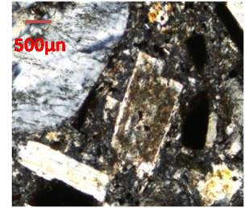  Figure 3: plagioclase alteration to clay minerals | 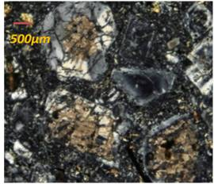  Figure 4: Calcium carbonate alteration of plagioclase
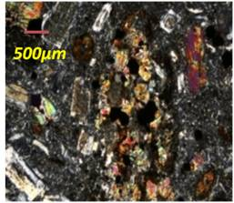  Figure 5: epidote alteration of hornblende | 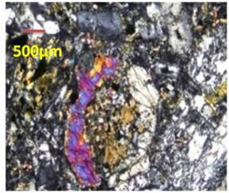  Figure 6: The biotite-hornblende

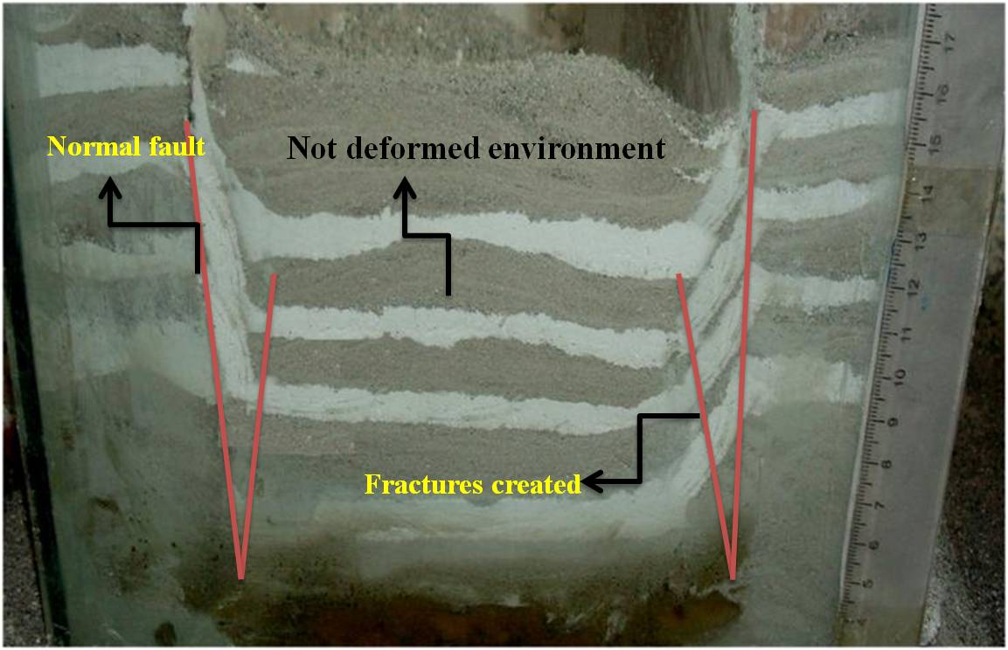
Figure 7: Caldera falling of pure
4. Results
The sub volcanic rocks in this area is Porfiritic diorite. Plagioclase, amphibole, biotite and Quartz are main minerals and petty mineral is opaque. Plagioclases are altered to clay minerals and calcium carbonate, and phenocrysts of hornblend alterated to biotite and epidote. The main cause of rising magma is difference of density between the molten liquid and its formation environment. Another factor in the rising magma is decrease pressure at the surface, has been caused by a fracture in the region. As Hornblende and biotite are main minerals, these minerals show hydrous magma thus we realized the effective role of water as one of reducing viscosity of magma and rate of rising. With function of the shear zone in south of Birjand, stretching environments and fractures formed and and these stretching environments are in accordance with volcanic and subvolcanic units are in this region. In early movement of fluid (magma) to the top, cross-sectional is high and then decreases. In the low cross-sectional, intermolecular force of fluid increases and finally the fluid move upward more rapidly.
References
1. Hosseini, SA. S., and Silk, c., (2007) Hydraulics of open channels, Razavi Institution Press, 585 pages.
2. Khatib, M.M., and Zarinkoub, M.H., (2009) Morpho - tectonics and mecanism of emplacement of the andesitic ring in Givshad, east of iran. EGU 2009 meeting.
3. Middlemost, E.A.K., (1986) Magmas and magmatic rocks, an introduction to igneous petrology: 469 p.
4. Puura, V., Kirsimae, K., Karki, A., Kirs, J., Suuroja., K., and Polikarpus, M., (2004) Hornblende alteration in impact-influenced basement rocks at the Kardla Impact Crater, Estonia. Institute of Geosciences, University of Oulu, Finland, 3Geological Survey of Estonia, p.1-2.
5. Tirrul.R., Bell.L.R., Griffis R.J., and Comp, V.E., (1983) The sistan suture zone of eastern Iran .G.S.A. Bulletin , vol.84, PP.134-140.
6. White, M., Translation doctor Mousavi genealogy, (1979) Fluid Mechanics, Sound Publishing, 984 pages. April 2013

