Salinity tolerance of the flora halophytes to coastal habitat of Jarjr-oma in Libya

Abusaief, Huda Mohamed Abd Al Razik.¹ Dakhil Ansaf Husien², Abd Al Naby, Mohamed Mahmod.³ Al-Mogasby, Abd Al Salam.⁴

¹Agron. Fac. Agric., ²Bot. Fac. Sci. ³Soil Depar. Fac. Agric. Omar Al-Mukhtar Univ. ⁴Herbarium Fac. Sci. Benghazi Univ.
Bossef_mohamed@yahoo.com

Abstract: Halophytic vegetation and flora of Jarjr-oma in Libya. The recorded 33 species in Sandy beach during four seasons of autumn 2010 and winter, spring and summer 2011. Importance value and density of the different association type are perennials Cynodon dactylon and Tamarix tetragyna. It appears exclusive in Sandy beach, association Sarcopoterium spinosum, Limonium sibthorpianum, Cichorium spinosum. The dominant species Sandy beach of this type is Allium rumherianum and Sarcopoterium spinosum. Density of Sandy beach habitat of winter and spring seasons Cynodon dactylon, in summer season highest annuals Euphorbia peplis and Salsola kali. As well as, total 19 species in Salt march gave highest Dominance Suaeda vera and Limoniastrum monopetalum its species salinity tolerance. Appear all seasons similar in results density of species perennial of Salt march habitat. Found 114 species in Saline lands of four associations the dominant species of this type is Polycarpon tetraphyllum, the indicator species is Suaeda vera and Onopordum cyrenaicum, Rumex bucephalophorus, Sarcopoterium spinosum. Association by Mercurialis annua and Arisarum vulgare, Juniperus phoenicea. association by Anagallis arvensis, Bellevalia sessiliflora and Rhus tripartita. Vegetation in Sand formation habitat recorded eight species during four seasons. The dominant species of this type is Carex divisa, which attained the highest density in winter and spring. The indicator species are Pancratium maritimum. The principal components analysis for the vegetation habitats-soil relationships distinguished that the highest affinity for sand and clay soil content. The maximum mean value for Cl⁻, Na⁺, So4⁻⁻ and EC. The species Suaeda vera, Retama raetem, Cynodon dactylon and Juncus acutus preferred to grow in coarse sand soil.
[Abusaief, Huda Mohamed Abd Al Razik. Dakhil Ansaf Husien, Abd Al Naby, Mohamed Mahmod. Al-Mogasby, Abd Al Salam. Salinity tolerance of the flora halophytes to coastal habitat of Jarjr-oma in Libya. Nat Sci 2013;11(6):29-45]. (ISSN: 1545-0740). http://www.sciencepub.net. 6

Key Words: Salinity, Halophytes, Flora, Density and Important value

1. Introduction
Halophytic communities of Libya are still among the most poorly known vegetation units. Our knowledge of the list of halophytes is restricted to Flora Libya (Jafri and El-Gadi, 1977). Saline soils of various nature and degree occupy over 80 million hectares in the Mediterranean basin (Hamdy, 1995). In previous years, it has been demonstrated that revegetation of saline habitats with halophytic species is profitable and provides many additional benefits (Marcar et al., 1993). There are about 6000 species of terrestrial and tidal halophytes in the world and 700 species in the Mediterranean climate area (Le Houérou, 1991). In general, these species are neglected and usually considered impediments rather than opportunities for agricultural development. Many plants have adapted, genetically, morphologically and physiologically to withstand stresses, partially or completely, with variable degrees between plant species (Gad et al., 2012). This is mainly due to the absence of up-to-date information on the halophytes and the interest of most botanists and ecologists in the rich flora of low-salt or salt-free habitats. The distribution of halophytic species on salt-affected sites is zoned in response to minor differences in topography. The saline soil habitats are mostly covered by xerohalophytic communities with salt-tolerant xerophytes. As with other plant formations, the annual species also play an important role in the vegetation of salty habitats (Akhani and Ghorbanli, 1993). Shrubs grew faster in the sandy than in the rocky habitat in semi-arid savanna (Schleicher et al., 2011). The Coastal Beach Association is comprised of unconsolidated sand and gravel deposits that are subject to marine wave and tidal action. This association also include eolian, or dune deposits that form immediately landward of the coastal beach (Town of Scituate Open Space Conservation & Recreation Plan, 1998). The halophytic vegetation is briefly discussed and a proposal is made to use some of the halophytes for soil improvement. The objectives of our study were to (1) define vegetation patterns through assessing spatial distribution and density, Importance value, Dominance of plant species and plant groups, (2) evaluate the halophytes plants in salinity habitats. (3) Difference density between seasons.
The study area
Location: The study area is located in the Mediterranean Coast of Libya Jarjr-oma between latitude 32̊, 47′ ,49.8″ N and longitude ,26َ ,21ْ 40.6″ E. distance 28 km west Al Baida city (Figure 1). Three transect were investigated from north to south. Distance Jarjr-oma 300 m of the sea with altitude 1 m.
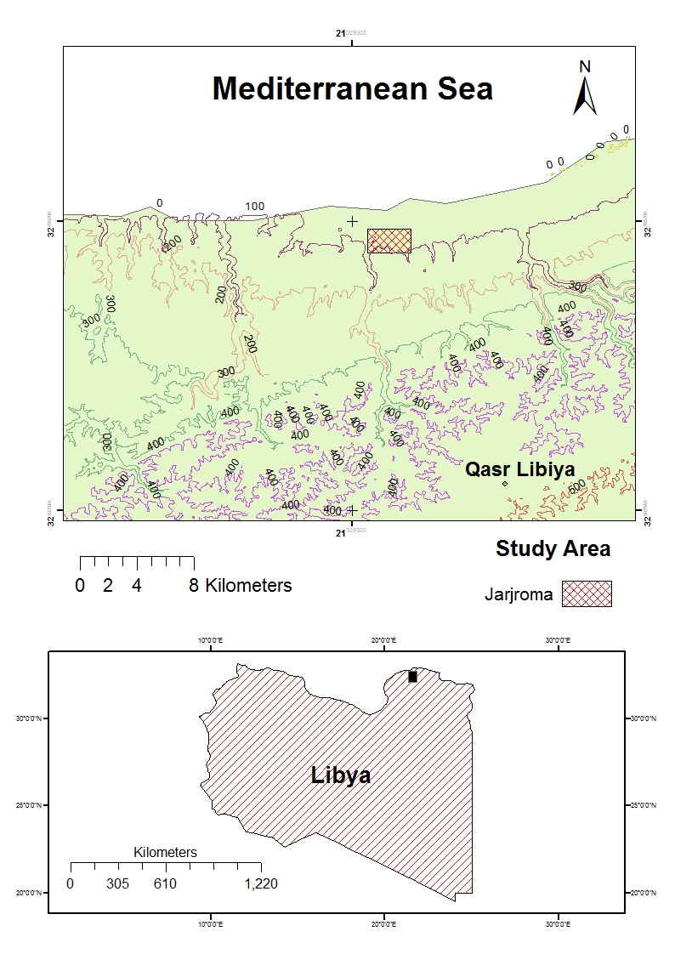
Fig. 1. Map of the Western Mediterranean sea coast region of Libya indicating the location Jarjr oma area in Al- Jabal Al- Akhdar.

Climatic: The maximum rainfall was Meteorological station Al Baida actress for Jarjr-oma region, 131.3 and 191.6 mm in December and January, respectively. The average rainfall 550.5 mm / year in Al Baida station for the period from 1999 to 2009. The lowest monthly average of rainfall 1.2 mm in July in Al Baida station. Temperature in the study area, the dry period extends from June to Augustus. The highest mean temperature meteorogical station Al Baida imitation Jarjr-oma for years 1999 to 2009 about 24 ˚C through Augustus month. The lowest mean temperature in Al Baida 10 and 9.7 ˚C in January and February, respectively.
Dunes cohesive Calcarenite arise dunes result weathering physical and erosion by wind rocks era tripartite era Cretaceous Supreme south coast at the top of the mountains and valleys and firmed this dune by materials carnivorous limestone and can be dubbed the dunes cohesive or rocks Calcarenite that exist along the coastal strip Green Mountain especially among Al Hania and Hamama and Jarjr-oma area (Al-Jabal Al-Akhdar south project, 2005).

2. Material and Methods
Vegetation study was undertaken during the autumn 2010 and winter, spring and summer 2011. A total of 24 stands in all season were sampled of Jarjr-oma from Al- Jabal Al-Akhdar (Figure 1). Stands and sites were selected as to represent the variation of vegetational, climatic and edaphic characteristics prevailing in the study area so that the location of stands was based on visual changes in habitats and plant communities along the transect. Examples of habitat classes include habitat types derived from Electric Conductivity (EC) classification schemes, habitat salinity EC from 6 – 9 ms/cm and habitat salt march from 11-36 ms/cm.
Sample collection: The floristic categories and chorology of species recorded in the study area were made with their characteristic distribution terms, the species were identified according to Jafri and El-Gadi (1977) and Boulos (1999, 2000, 2002 and 2005).
Three line transects at Jarjr-oma were chosen for this study. The take 500 meters for each transect the number of three transects and all transect four stands with an area of ​​5 5 m². In these stands, the quadrate method was used and the size of each analytic quadrate area was 1 m². The stands were selected on the basis of visual difference and change in their vegetation coverage. The species in each quadrate were listed. The number of individual of each species was counted. Salinity tolerance four habitats Sandy beach, Salt march, Saline land and Sand formation.
Therefore, for each stand the absolute frequency, absolute density, and absolute cover were determined. The sum of relative density, relative frequency and relative cover gave the importance value (Ludwig and Reynolds, 1988) for the different species as following:
Density/m² = number of individuals area sampled
Relative density = (density for a species total density for all species) 100
Frequency = number of sampled quadrates in which a species occurs total number of quadrates in the stand
Relative frequency = (frequency for a species total frequency for all species) 100
Cover = the area occupied by the species the whole investigated area
Relative cover = (coverage of a species in the sample m² total cover of all species in the sample m²) 100
Coverage = Dominance species = average area of spatial coverage Number of individuals species in every 1 m² (Al Hawas, 2004).
Importance value (IV) = Relative density + Relative cover + Relative frequency
Data Analysis: Classification and ordination of communities (stands) followed two trends of multivariate analysis. The applied classification technique here was the Two-Way Indicator Species Analysis (TWINSPAN), a CAP Program (Henderson and Seaby, 1999). The applied ordination techniques were the Detrended Correspondence Analysis (DCA) and PCA (principal components analysis) the application of the techniques based on the importance value, dominance and density of the species. The statistical treatments applied were according to Nie et al., 1975.

3. Results
Sandy beach
Three transects extended from the north to south with 12 stands. Vegetation in sandy beach habitat from autumn which differ in their characteristics and consequently association type. Ten species were recorded in the studied 12 stands. The application of TWINSPAN classification on the importance values of the recorded 33 species during four seasons in sandy beach by 12 stands led to the recognition of two associations. The importance value and density of the different two association type are presented in (Tables 1-6). Each type comprises a set of stands with greater homogeneity of vegetation.
Group A. The dominant species of this type is Cynodon dactylon (L.) Pers. and Crucianella maritime L. which attained the highest IV of 57 and density 0.28. Group B. The IV 100 of Tamarix tetragyna Ehrenb. It appears exclusive in sandy beach, association Sarcopoterium spinosum (L.) Spach, Limonium sibthorpianum and Cichorium spinosum.
The dominant species Sandy beach of this type is Allium rumherianum which attained the highest to 4.67, Sarcopoterium spinosum 0.4. Density of Sandy beach habitat of winter season Cynodon dactylon (L.) Pers. of 1.3 in group A and group B Cichorium spinosum L. 0.5. Density of spring season Fig 2 group A Cynodon dactylon (L.) Pers. 0.53 and group B Cichorium spinosum L. and Elymus farctus (Viv.) Runem. Ex Melderis 0.33 and 0.2, respectively. Group B of summer was Euphorbia peplis L. higher density.
In winter season Sandy beach gave perennials Cynodon dactylon and Moraea sisyrinchium highest density in group A and group B perennials Limonium sibthorpianum and Elymus farctus. As well as, spring season were Cynodon dactylon and Triplachne nitens its annual in group A and perennial Cichorium spinosum in group B. while in summer season was annuals Euphorbia peplis and Salsola kali in group B.

Table (1) Importance value of Sandy beach habitat of autumn season in Jarjr oma area
Twinspan groups |  | Scientific name | No.
B | A | Scientific name | No.
7.7 ±13.3 |  | Suaeda vera Forak. ex Gmel. | 1
10.7±18.6 |  | Allium rumherianum Asch. | 2
15.2±26.4 |  | Cichorium spinosum L. | 3
5.7±8.1 |  | Colchium palaestinum Baker. | 4
11.5±19.9 |  | Juncus acutus L. | 5
23.7±41.0 |  | Limonium sibthorpianum (Guss.) O. Ktze. | 6
 | 57.4±99.5 | Cynodon dactylon (L.) Pers. | 7
25.4±44.1 |  | Sarcopoterium spinosum (L.) Spach | 8
 | 42.5±73.7 | Crucianella maritime L. | 9
100±173.2 |  | Tamarix tetragyna Ehrenb. | 10

Table (2) Dominance of Sandy beach habitat of autumn season in Jarjr oma area.
Twinspan groups |  | Scientific name | No.
B | A | Scientific name | No.
0.03±0.04 |  | Suaeda vera Forak. ex Gmel. | 1
4.67±8.08 |  | Allium rumherianum Asch. | 2
0.005±0.008 |  | Cichorium spinosum L. | 3
0.001±0.002 |  | Colchium palaestinum Baker | 4
0.05±0.09 |  | Juncus acutus L. | 5
0.22±0.38 |  | Limonium sibthorpianum (Guss.) O. Ktze. | 6
 | 0.02±0.03 | Cynodon dactylon (L.) Pers. | 7
0.4±0.69 |  | Sarcopoterium spinosum (L.) Spach | 8
 | 0.05±0.09 | Crucianella maritima L. | 9
0.13±0.23 |  | Tamarix tetragyna Ehrenb. | 10

Table (3) Density per m² of Sandy beach habitat of autumn season in Jarjr oma area.
Twinspan groups |  | Scientific name | No.
B | A | Scientific name | No.
0.03±0.05 |  | Suaeda vera Forak. Ex Gmel. | 1
0.09±0.16 |  | Allium rumherianum Asch. | 2
0.16±0.28 |  | Cichorium spinosum L. | 3
0.01±0.02 |  | Colchium palaestinum Baker. | 4
0.07±0.12 |  | Juncus acutus L. | 5
0.13±0.23 |  | Limonium sibthorpianum (Guss.) O. Ktze. | 6
 | 0.28±0.48 | Cynodon dactylon (L.) Pers. | 7
0.03±0.05 |  | Sarcopoterium spinosum (L.) Spach | 8
 | 0.01±0.02 | Crucianella maritima L. | 9
0.03±0.05 |  | Tamarix tetragyna Ehrenb. | 10

Table (4) Density per m² of Sandy beach habitat of winter season in Jarjr oma area.
Twinspan groups |  | Scientific name | No.
B | A | Scientific name | No.
0.01±0.02 |  | Suaeda vera Forak. ex Gmel. | 1
0.01±0.02 |  | Allium roseum L. | 2
0.01±0.02 |  | Anthemis secundiramea Biv. | 3
0.52±0.90 |  | Cichorium spinosum L. | 4
0.01±0.02 |  | Launaea foxii (Post) Eig. | 5
0.01±0.02 |  | Silene colorata Poiret | 6
0.07±0.12 |  | Lotus halophilus Boiss. Et Sprun | 7
0.04±0.07 |  | Ononis vaginalis Vahl. | 8
 | 0.01±0.02 | Moraea sisyrinchium (L.)Ker Gaweler (Europe) | 9
0.04±0.07 |  | Juncus acutus L. | 10
0.15±0.25 |  | Limonium sibthorpianum (Guss.) O. Ktze. | 11
 | 1.3±2.3 | Cynodon dactylon (L.) Pers. | 12
0.13±0.23 |  | Elymus farctus (Viv.) Runem. Ex Melderis | 13
0.09±0.16 |  | Sarcopoterium spinosum (L.) Spach | 14
0.03±0.05 |  | Tamarix tetragyna Ehrenb. | 15
0.04±0.07 |  | Zygophyllum album L. | 16

Table (5) Density per m² of Sandy beach habitat of spring season in Jarjr oma area.
Twinspan groups
Scientific name |  | No.
B | A | No.
0.03±0.05 |  | Suaeda vera Forak. ex Gmel. | 1
0.01±0.02 |  | Anthemis secundiramea Biv. | 2
0.33±0.58 |  | Cichorium spinosum L. | 3
0.01±0.02 |  | Silene colorata Poiret | 4
0.05±0.09 |  | Lotus halophilus Boiss. Et Sprun | 5
0.01±0.02 |  | Medicago polymorpha L. | 6
0.04±0.07 |  | Ononis vaginalis Vahl. | 7
0.01±0.02 |  | Trifolium purpureum Lois. | 8
0.15±0.25 |  | Trigonella stellata Forsk. | 9
0.01±0.02 |  | Frankenia hirsuta L. | 10
0.05±0.09 |  | Juncus acutus L. | 11
0.01±0.02 |  | Plantago ovata Forskal | 12
0.16±0.28 |  | Limonium sibthorpianum (Guss.) O. Ktze. | 13
 | 0.53±0.92 | Cynodon dactylon (L.) Pers. | 14
0.2±0.35 |  | Elymus farctus (Viv.) Runem. Ex Melderis | 15
 | 0.01±0.02 | Triplachne nitens (Guss.)Link | 16
0.01±0.02 |  | Emex spinosus (L.) Camped | 17
0.01±0.02 |  | Sarcopoterium spinosum (L.) Spach | 18
0.03±0.05 |  | Tamarix tetragyna Ehrenb. | 19
0.05±0.06 |  | Zygophyllum album L. | 20
800
Zyg. alb. ♦
DCA Axis 2
700
600

500
400

300
200
B
A
100
▼Tri. nit.
Lim.sib. ♦
0
▼Cyn. dac.
♦Ono. vag.
♦Lot. hal.
DCA Axis 1
50
100

Fig. (2) Density of Sandy beach habitat of spring season in Jarjr-oma area.

Table (6) Density per m² of Sandy beach habitat of Summer season in Jarjr oma area.
Twinspan groups |  | Scientific name | No.
B | A | Scientific name | No.
0.12±0.21 |  | Salsola kali L. | 1
 | 0.03±0.05 | Suaeda vera Forak. ex Gmel. | 2
 | 0.33±0.58 | Cichorium spinosum L. | 3
0.04±0.07 |  | Cakile aegyptica (L.) Willd. | 4
 | 0.07±0.12 | Cressa cretica L. | 5
0.03±0.05 |  | Euphorbia paralias L. | 6
0.2±0.35 |  | Euphorbia peplis L. | 7
0.04±0.07 |  | Ononis vaginalis Vahl. | 8
 | 0.07±0.12 | Juncus acutus L. | 9
 | 0.03±0.05 | Limonium sibthorpianum (Guss.) O. Ktze. | 10
 | 3.15±5.07 | Cynodon dactylon (L.) Pers. | 11
0.09±0.16 |  | Sporobolus pungens (Schreb.) Kunth | 12
0.11±0.18 |  | Polygonum maritimum L. | 13
0.03±0.05 |  | Tamarix tetragyna Ehrenb. | 14
0.04±0.07 |  | Zygophyllum album L. | 15

Salt march
Three transects extended from the north to south with 12 stands. Vegetation in salt march habitat from autumn which differ in their characteristics and consequently association type. Five species were recorded in autumn from total 19 species during four seasons in salt march by two association (Figs. 3 and 4) (Tables 7 - 12). Importance value and density Group A gave highest Suaeda vera Forak. ex Gmel. 150 and 1, respectively. Group B Limoniastrum monopetalum (L.) Boiss. gave IV 97.1 and Density 0.4 in autumn season. Dominance of Salt march habitat of autumn season in group A vegetation of this community the dominant species Suaeda vera Forak. ex Gmel. with 9.97, while dominant Limoniastrum monopetalum (L.) Boiss. with coverage 0.83 and Lycium europaeum with coverage 0.016.

Table (7) Importance value of Salt march habitat of autumn season in Jarjr oma area
Twinspan groups |  | Scientific name | No.
B | A | Scientific name | No.
 | 150±212.1 | Suaeda vera Forak. ex Gmel. | 1
23.4±33.0 |  | Arisarum vulgare Targ. Tozz | 2
14.4±20.3 |  | Medicago polymorpha L. | 3
97.1±137.2 |  | Limoniastrum monopetalum (L.) Boiss. | 4
15.3±21.6 |  | Lycium europaeum L. | 5

In compare between Sandy beach habitat (a) and Salt march (b) in IV decrease number of species in Salt march by percent 27%, no indicator species exception Suaeda vera in both habitats Fig. 3. Results to environment stress in Salt March. Appear all seasons similar in results density of species perennial of Salt march habitat.

b

Cyn. dac.
Cru. mar.
A
Tam. tet.
Sar. spi.
Lim. sib.
Jun. acu.
Col. pal.
Cic. spi.
All. rum.
Sua. ver.

B
Vegetation Clusters

Cyn. dac.
Tam. tet.
a
Sua.ver.
Lim.mon.
.

Sua. ver.
Pol. tet.
Ari.vul.

Med.pol.
.

Lim.mon.
.

Lyc. eur.
.

A
B
Levels Classification

Fig. (3). Vegetation dendrogram of stands based on importance value of the species TWINSPAN classification 2 groups (A and B) of Sandy beach habitat (a) and Salt march habitat (b) in Jarjar oma area.

Table (8) Dominance of Salt march habitat of autumn season in Jarjr oma area.
Twinspan groups |  | Scientific name | No.
B | A | Scientific name | No.
 | 9.97±14.1 | Suaeda vera Forak. ex Gmel. | 1
0.002±0.003 |  | Arisarum vulgare Targ. Tozz | 2
0.0012±0.002 |  | Medicago polymorpha L. | 3
0.83±1.17 |  | Limoniastrum monopetalum (L.) Boiss. | 4
0.016±0.23 |  | Lycium europaeum L. | 5

Levels Classification  Tam. tet.  Cyn. dac.  b  a  Cru. mar.  A  B  Vegetation Clusters  Sar.. spi.  Lim. sib.  Jun. acu.  Col. pal.  Cic. spi.  All. rum.  Sua. ver. | Ari.vul.  Sua.ver.  Med.pol.  .  Lim.mon.  .  Lyc. eur.  .  A  B
Fig. (4). Vegetation dendrogram of stands based on Dominance of the species TWINSPAN classification 2 groups (A and B) of Sandy beach habitat (a) and Salt march habitat (b) in Jarjar oma area.

Table (9) Density per m² of Salt march habitat of autumn season in Jarjr oma area.
Twinspan groups |  | Scientific name | No.
B | A | Scientific name | No.
 | 1±1.4 | Suaeda vera Forak. Ex Gmel. | 1
0.12±0.17 |  | Arisarum vulgare Targ. Tozz | 2
0.02±0.03 |  | Medicago polymorpha L. | 3
0.4±0.6 |  | Limoniastrum monopetalum (L.) Boiss. | 4
0.02±0.03 |  | Lycium europaeum L. | 5

Table (10) Density per m² of Salt march habitat of winter season in Jarjr oma area.
Twinspan groups |  | Scientific name | No.
B | A | Scientific name | No.
 | 0.68±1.0 | Suaeda vera Forak. ex Gmel. | 1
0.22±0.31 |  | Arisarum vulgare Targ. Tozz | 2
0.24±0.34 |  | Chlamydophora tridentata Ehrenb. Ex Less. | 3
0.08±0.11 |  | Lactuca saligna L. | 4
0.02±0.03 |  | Biscutella didyma L. | 5
0.02±0.03 |  | Sedum sediforme (Jacq.) Pau | 6
0.02±0.03 |  | Lathyrus aphaca L. | 7
0.08±0.11 |  | Anagallis arvensis L. | 8
0.7±1.0 |  | Limoniastrum monopetalum (L.) Boiss. | 9
0.42±0.59 |  | Brachypodium retusum (Pers.) p. Beauv. | 10
0.02±0.03 |  | Lycium europaeum L. | 11

Table (11) Density per m² of Salt march habitat of spring season in Jarjr oma area.
Twinspan groups |  | Scientific name | No.
B | A | Scientific name | No.
0.02±0.03 |  | Mesembryanthemum nodiflorum L. | 1
 | 0.68±0.96 | Suaeda vera Forak. ex Gmel. | 2
 | 0.04±0.06 | Chrozophora tinctoria (L.) Juss. | 3
 | 0.06±0.08 | Frankenia hirsuta L. | 4
0.02±0.03 |  | Geranium molle L. | 5
0.02±0.03 |  | Plantago coronopus L. | 6
0.64±0.91 |  | Limoniastrum monopetalum (L.) Boiss. | 7
 | 0.28±0.40 | Cynodon dactylon (L.) Pers. | 8
0.02±0.03 |  | Hordeum marinum Huds. | 9
0.02±0.03 |  | Lycium europaeum L. | 10

Table (12) Density per m² of Salt march habitat of Summer season in Jarjr oma area.
Twinspan one groups | Scientific name | No.
0.64±0.91 | Suaeda vera Forak. ex Gmel. | 1
0.64±0.91 | Limoniastrum monopetalum (L.) Boiss. | 2
0.36±0.51 | Cynodon dactylon (L.) Pers. | 3
0.02±0.03 | Lycium europaeum L. | 4

Saline lands
Vegetation in saline lands habitat from autumn which differ in their characteristics and consequently association type. Twenty six species were recorded in autumn and 114 species during four seasons in saline lands of four associations (Figs. 5 and 6) (Tables 13-18). Each type comprises a set of stands with greater homogeneity of vegetation.
Group A. The dominant species of this type is Polycarpon tetraphyllum which attained the highest IV of 20.5. The indicator species is Suaeda vera. Group B Vegetation of this community Onopordum cyrenaicum, Rumex bucephalophorus. Group C the IV 53.6 Sarcopoterium spinosum. Association by Mercurialis annua and Arisarum vulgare. Group D this vegetation type the IV 24 of Juniperus phoenicea Association by Anagallis arvensis, Bellevalia sessiliflora and Rhus tripartite. Different between seasons.

Table (13) Importance value of Saline land habitat of autumn season in Jarjr oma area.
Twinspan groups |  |  |  | Scientific name | No.
D | C | B | A | Scientific name | No.
 |  |  | 13.4±23.2 | Suaeda vera Forak. ex Gmel. | 1
3.5±6.1 |  |  |  | Pistacia lentiscus L. | 2
11.1±19.2 |  |  |  | Rhus tripartita (Ucria) Grande | 3
 | 27.0±24.8 |  |  | Arisarum vulgare Targ. Tozz | 4
13.5±23.4 |  |  |  | Bellevalia sessiliflora (Viv.) Kunth | 5
 | 10.1±3.5 |  |  | Drimia maritima (L.) Stearn | 6
7.7±6.8 |  |  |  | Leontedon tuberosus L. | 7
 |  | 14.4±19.2 |  | Onopordum cyrenaicum Maire & Weiller | 8
2.4±4.9 |  |  |  | Phagnlon ropestre (L.) Dc. | 9
 |  |  | 2.4±4.9 | Sinapis alba L. | 10
 |  |  | 20.5±35.6 | Polycarpon tetraphyllum (L.) L. | 11
7.8±6.7 |  |  |  | Umbilicus horizontalis (Guss.) Dc. | 12
24.0±24.9 |  |  |  | Juniperus phoenicea L. | 13
 |  |  | 2.4±4.9 | Dioscorea communis (L.) Caddick & Wilkin | 14
 | 27.9±39.5 |  |  | Mercurialis annua L. | 15
6.9±6.1 |  |  |  | Lotus ornithopodioides L. | 16
3.8±6.6 |  |  |  | Geranium molle L. | 17
2.4±4.2 |  |  |  | Phlomis floccosa D. Don | 18
2.2±3.8 |  |  |  | Prasium majus L. | 19
 |  |  | 4.9±8.5 | Malva parviflora L. | 20
18.1±31.3 |  |  |  | Anagallis arvensis L. | 21
 |  |  | 2.8±4.9 | Oxalis corniculata L. | 22
 |  |  | 3.5±6.0 | Polygonum equisetiforme Sm | 23
 |  | 9.5±8.9 |  | Rumex bucephalophorus L. | 24
 | 53.6±2.9 |  |  | Sarcopoterium spinosum (L.) Spach | 25
0.6±1.0 |  |  |  | Crucianella maritima L. | 26
2.3±4.0 |  |  |  | Asphodelus microcarpus Salzm.& Viv. | 27

Levels Classification
Sar. Spi.

Ono. cyr.

Sar. Spi.

Mer. Ann.

Pol. equ..
Dri. mar.

Rum. buc.

Ari. vul.

Jun. pho.

Oxa. cor.
Umb. hori.

Leo.tub.

Mal. Par.
Pis.len.

Dio. com.
Ono. cyr.

Pol. tet.
Sin. alb.
Pol. tet.
Sua. ver.
A
B
Ger. mol.

Lot. orn.

D
C
Asp. mic.
Cru. mar.
Ana. arv.
Pra. maj.
Phl. flo.
Pha. rup.
Rhu. tri.
Bel.ses.

Vegetation Clusters

Jun. pho.

Fig. (5). Vegetation dendrogram of stands based on importance value of the species TWINSPAN classification 5 groups (A to D) of Saline Land habitat Jarjar oma area.

Table (14) Dominance of Saline land habitat of autumn season in Jarjr oma area.
Twinspan groups |  |  |  | Scientific name | No.
D | C | B | A | Scientific name | No.
 |  |  | 0.20±0.34 | Suaeda vera Forak. ex Gmel. | 1
0.001±0.001 |  |  |  | Pistacia lentiscus L. | 2
0.22±0.38 |  |  |  | Rhus tripartita (Ucria) Grande | 3
 | 0.12±0.15 |  |  | Arisarum vulgare Targ. Tozz | 4
0.01±0.02 |  |  |  | Bellevalia sessiliflora (Viv.) Kunth | 5
 | 0.04±0.03 |  |  | Drimia maritima (L.) Stearn | 6
0.02±0.02 |  |  |  | Leontedon tuberosus L. | 7
 |  | 0.09±0.15 |  | Onopordum cyrenaicum Maire & Weiller | 8
0.004±0.007 |  |  |  | Phagnlon ropestre (L.) Dc. | 9
 |  |  | 0.002±0.003 | Sinapis alba L. | 10
 |  |  | 0.03±0.05 | Polycarpon tetraphyllum (L.) L. | 11
0.02±0.03 |  |  |  | Umbilicus horizontalis (Guss.)Dc. | 12
0.43±0.45 |  |  |  | Juniperus phoenicea L. | 13
 |  |  | 0.002±0.003 | Dioscorea communis (L.) Caddick & Wilkin | 14
 |  | 0.04±0.06 |  | Mercurialis annua L. | 15
0.0005±0.0004 |  |  |  | Lotus ornithopodioides L. | 16
0.0012±0.0021 |  |  |  | Geranium molle L. | 17
0.0003±0.0006 |  |  |  | Phlomis floccosa D. Don | 18
0.001±0.001 |  |  |  | Prasium majus L. | 19
 |  |  | 0.01±0.02 | Malva parviflora L. | 20
0.02±0.04 |  |  |  | Anagallis arvensis L. | 21
 |  |  | 0.003±0.005 | Oxalis corniculata L. | 22
 |  |  | 0.01±0.01 | Polygonum equisetiforme Sm. | 23
 |  | 0.01±0.01 |  | Rumex bucephalophorus L. | 24
 | 0.97±0.14 |  |  | Sarcopoterium spinosum (L.) Spach | 25
0.01±0.03 |  |  |  | Crucianella maritima L. | 26
0.001±0.002 |  |  |  | Asphodelus microcarpus Salzm.& Viv. | 27

Levels Classification
Pol. qui.
Sar. Spi.

Oxa. cor.
Dri. mar.

Ari. vul.

Mal. Par.
Dio. com.
Pol. tet.
Sin. alb.
Ono. cyr.

Rum. buc.

B
Sua. ver.
Mer. Ann.

Lot. orn.

Ger. mol.

C
A
Jun. pho.

Umb. hori.

Leo.tub.

Pis.len.

Asp. mic.
Cru. mar.
Ana. arv.
Pra. maj.
Phl. flo.
Pha. rup.
Rhu. tri.
Bel.ses.

D
Vegetation Clusters

Fig. (6). Vegetation dendrogram of stands based on Dominance of the species TWINSPAN classification groups of 4 groups (A to D) of Saline Land habitat Jarjar oma area.

Increased number of species in saline habitat of winter and spring seasons of 71 and 65 species, respectively, gave summer season only 10 species. Density in autumn of Mercurialis annua reaches of group B to 2.0, Anagallis arvensis 1.9 group D, Polycarpon tetraphyllum 1.52 of Group A. In winter season Leontedon tuberosus group B, In spring season Hordeum marinum 2.7 of group A. summer season Sarcopoterium spinosum.

Table (15) Density per m² of Saline land habitat of autumn season in Jarjr oma area.
Twinspan groups |  |  |  | Scientific name | No.
D | C | B | A | Scientific name | No.
 |  |  | 0.09±0.16 | Suaeda vera Forak. ex Gmel. | 1
0.01±0.02 |  |  |  | Pistacia lentiscus L. | 2
0.01±0.02 |  |  |  | Rhus tripartita (Ucria) Grande | 3
 | 1.3±1.6 |  |  | Arisarum vulgare Targ.Tozz | 4
1.4±2.4 |  |  |  | Bellevalia sessiliflora (Viv.) Kunth | 5
 | 0.05±0.02 |  |  | Drimia maritima (L.) Stearn | 6
0.16±0.16 |  |  |  | Leontedon tuberosus L. | 7
 |  | 0.5±0.8 |  | Onopordum cyrenaicum Maire & Weiller | 8
0.07±0.1 |  |  |  | Phagnlon ropestre (L.) Dc. | 9
 |  |  | 0.01±0.02 | Sinapis alba L. | 10
 |  |  | 1.52±2.63 | Polycarpon tetraphyllum (L.) L. | 11
0.17±0.21 |  |  |  | Umbilicus horizontalis (Guss.)Dc. | 12
0.07±0.06 |  |  |  | Juniperus phoenicea L. | 13
 |  |  | 0.01±0.02 | Dioscorea communis (L.) Caddick & Wilkin | 14
 |  | 2.0±3.2 |  | Mercurialis annua L. | 15
0.17±0.21 |  |  |  | Lotus ornithopodioides L. | 16
0.04±0.07 |  |  |  | Geranium molle L. | 17
0.04±0.07 |  |  |  | Phlomis floccosa D. Don | 18
0.01±0.02 |  |  |  | Prasium majus L. | 19
 |  |  | 0.17±0.30 | Malva parviflora L. | 20
1.9±3.3 |  |  |  | Anagallis arvensis L. | 21
 |  |  | 0.01±0.02 | Oxalis corniculata L. | 22
 |  |  | 0.05±0.09 | Polygonum equisetiforme sm. | 23
 |  | 0.44±0.42 |  | Rumex bucephalophorus L. | 24
 | 0.28±0.14 |  |  | Sarcopoterium spinosum (L.) Spach | 25
0.01±0.02 |  |  |  | Crucianella maritima L. | 26
0.03±0.05 |  |  |  | Asphodelus microcarpus Salzm.& Viv. | 27

Table (16) Density per m² of Saline land habitat of winter season in Jarjr oma area.
Twinspan groups |  |  | Scientific name | No.
C | B | A | Scientific name | No.
0.01±0.02 |  |  | Beta vulgaris L. | 1
0.01±0.02 |  |  | Chenopodium murale L. | 2
 | 0.11±0.18 |  | Suaeda vera Forak. Ex Gmel. | 3
0.01±0.02 |  |  | Allium roseum L. | 4
0.01±0.02 |  |  | Pancratium maritimum L. | 5
 | 0.01±0.02 |  | Pistacia lentiscus L. | 6
0.01±0.02 |  |  | Bupleurum lancifolium Hornem. | 7
 | 0.73±0.93 |  | Arisarum vulgare Targ. Tozz | 8
0.2±0.35 |  |  | Bellevalia sessiliflora (Viv.) Kunth | 9
 | 0.01±0.02 |  | Drimia maritima (L.) Stearn | 10
 | 0.04±0.07 |  | Calendula arvensis L. | 11
 | 0.01±0.02 |  | Carduus getulus Pomel | 12
0.01±0.02 |  |  | Centaurea aegialophila Boiss & Heldr. | 13
 | 0.05±0.09 |  | Centaurea alexandrina Delile | 14
0.05±0.09 |  |  | Cynara cornigera Lindley | 15
 | 1.1±0.82 |  | Leontedon tuberosus L. | 16
0.01±0.02 |  |  | Matricaria aurea( Loefl.) Sch. Bip. | 17
 | 0.53±0.92 |  | Onopordum cyrenaicum Maire & Weiller | 18
0.04±0.07 |  |  | Phagnlon ropestre (L.) Dc. | 19
0.01±0.02 |  |  | Senecio gallicus Chiax | 20
0.11±0.18 |  |  | Biscutella didyma L. | 21
0.01±0.02 |  |  | Coronopus squamatus (Forsk.) Ascherson | 22
0.01±0.02 |  |  | Sinapis alba L. | 23
 | 0.29±0.30 |  | Paronychia arabica (Linn.) Dc. | 24
0.01±0.02 |  |  | Spergularia diandra (Guss.) Heldr. & Sart. | 25
 | 0.07±0.08 |  | Convolvulus supinus Coss. Et Kral. | 26
0.01±0.02 |  |  | Umbilicus horizontalis (Guss.)Dc. | 27
 |  | 0.05±0.05 | Juniperus phoenicea L. | 28
0.01±0.02 |  |  | Carex divisa Huds. | 29
 |  | 0.62±0.98 | Mercurialis annua L. | 30
0.01±0.02 |  |  | Anthyllis tetraphylla L. | 31
 | 0.21±0.17 |  | Lotus ornithopodioides L. | 32
 | 0.01±0.02 |  | Lotus tetragonolobus L. | 33
 | 0.01±0.02 |  | Lupinus L. | 34
0.01±0.02 |  |  | Medicago tornata (L.) Mill. | 35
 | 0.01±0.02 |  | Ononis hispida Desf. | 36
0.01±0.02 |  |  | Retama raetem (Forsk.) Webb | 37
0.04±0.07 |  |  | Vicia sativa L. | 38
 | 0.01±0.02 |  | Vicia tetrasperma (L.) Schreb. | 39
 |  | 0.19±0.18 | Erodium malacoides (L.) L’Herit. | 40
0.01±0.02 |  |  | Erodium moschatum (L.) L’Herit. | 41
0.01±0.02 |  |  | Erodium touchyanum Delile | 42
 |  | 0.41±0.42 | Geranium molle L. | 43
0.01±0.02 |  |  | Moraea sisyrinchium (L.)Ker Gaweler (Europe) | 44
0.01±0.02 |  |  | Micromeria nervosa ( Desf.) Benth. | 45
0.03±0.05 |  |  | Phlomis floccosa D. Don | 46
0.01±0.02 |  |  | Prasium majus L. | 47
 | 0.01±0.02 |  | Linum strictum var.spicatum Pers. | 48
 | 0.04±0.07 |  | Malva aegyptia L. | 49
 | 0.08±0.14 |  | Malva parviflora L. | 50
 | 0.15±0.10 |  | Anagallis arvensis L. | 51
0.01±0.02 |  |  | Orobanche coelistis (Reut.) Boiss. & Reut. | 52
0.01±0.02 |  |  | Papaver hybridum L. | 53
0.01±0.02 |  |  | Plantago coronopus L. | 54
0.01±0.02 |  |  | Plantago cyrenaica Durand & Barratte | 55
0.01±0.02 |  |  | Plantago ovata Forskal | 56
 | 0.27±0.46 |  | Brachypodium retusum (Pers.) p. Beauv. | 57
0.01±0.02 |  |  | Elymus farctus (Viv.) Runem. Ex Melderis | 58
0.01±0.02 |  |  | Hordeum marinum Huds. | 59
0.01±0.02 |  |  | Emex spinosus (L.) Camped | 60
0.01±0.02 |  |  | Polygonum equisetiforme sm. | 61
0.01±0.02 |  |  | Adonis microcarpa DC. | 62
0.01±0.02 |  |  | Ziziphus lotus (L.) Lam. | 63
 | 0.32±0.18 |  | Sarcopoterium spinosum (L.) Spach | 64
0.01±0.02 |  |  | Crucianella maritima L. | 65
 | 0.57±0.70 |  | Sherardia arvensis L. | 66
0.01±0.02 |  |  | Theligonum cynocrambe L. | 67
 | 0.01±0.02 |  | Lycium europaeum L. | 68
0.01±0.02 |  |  | Urtica urens L. | 69
 | 0.13±0.17 |  | Valerianella petrovichii Ascherson | 70
0.01±0.02 |  |  | Zygophyllum album L. | 71

Table (17) Density per m² of Saline land habitat of spring season in Jarjr oma area.
Twinspan groups |  |  | Scientific name | No.
C | B | A | Scientific name | No.
 |  | 0.01±0.02 | Mesembryanthemum nodiflorum L. | 1
 |  | 0.01±0.02 | Beta vulgaris L. | 2
0.01±0.02 |  |  | Chenopodium murale L. | 3
 |  | 0.15±0.25 | Suaeda vera Forak. ex Gmel. | 4
0.01±0.02 |  |  | Pancratium maritimum L. | 5
0.01±0.02 |  |  | Pistacia lentiscus L. | 6
0.01±0.02 |  |  | Caralluma europaea (Guss.) N.E.Br. | 7
 |  | 0.01±0.02 | Arisarum vulgare Targ. Tozz | 8
0.01±0.02 |  |  | Asparagus aphyllus L. | 9
 |  | 0.04±0.07 | Carduus getulus Pomel | 10
0.07±0.12 |  |  | Carlina lanata L. | 11
 |  | 0.11±0.18 | Carthamus lanatus L. | 12
 |  | 0.13±0.23 | Cichorium endivia L. | 13
 |  | 0.41±0.28 | Crepis senecioides ssp.senecioides Delile | 14
0.01±0.02 |  |  | Crepis vesicaria ssp. vesicaria L. | 15
0.01±0.02 |  |  | Cynara cornigera Lindley | 16
0.01±0.02 |  |  | Hedypnois cretica (L.) Dum. – Courset | 17
0.01±0.02 |  |  | Hypochaeris achyrophorus L. | 18
0.01±0.02 |  |  | Leontedon hispidulus (Delile) Boiss. | 19
0.15±0.25 |  |  | Leontedon tuberosus L. | 20
 |  | 0.13±0.23 | Onopordum cyrenaicum Maire & Weiller | 21
0.05±0.09 |  |  | Phagnlon ropestre (L.) Dc. | 22
 |  | 0.01±0.02 | Silybum marianum (L.) Gaertner | 23
 |  | 0.01±0.02 | Urospermum dalechampii (L.) Scop. ex F.W.Schmidt | 24
 |  | 0.03±0.05 | Biscutella didyma L. | 25
0.01±0.02 |  |  | Rapistrum rugosum (L.) All. | 26
0.01±0.02 |  |  | Herniaria cinerea Dc. | 27
0.01±0.02 |  |  | Herniaria glabra Linn. | 28
 |  | 0.44±0.41 | Paronychia Arabica (Linn.) Dc. | 29
 |  | 0.25±0.44 | Polycarpon tetraphyllum (L.) L. | 30
 |  | 0.28±0.48 | spergularia diandra (Guss.) Heldr. & Sart. | 31
0.01±0.02 |  |  | Convolvulus althaeoides L. | 32
0.01±0.02 |  |  | Sedum sediforme (Jacq.) Pau | 33
 | 0.05±0.05 |  | Juniperus phoenicea L. | 34
 |  | 0.05±0.09 | Scabiosa arenaria Forskal | 35
 | 0.16±0.21 |  | Mercurialis annua L. | 36
0.01±0.02 |  |  | Anthyllis tetraphylla L. | 37
0.01±0.02 |  |  | Ceratonia siliqua L. | 38
0.01±0.02 |  |  | Lotus edulis L. | 39
 |  | 0.01±0.02 | Medicago polymorpha L. | 40
0.01±0.02 |  |  | Retama raetem (Forsk.) Webb | 41
 |  | 0.01±0.02 | Trifolium scabrum L. | 42
 |  | 0.03±0.05 | Trifolium stellatum L. | 43
 |  | 0.01±0.02 | Trifolium tomentosum L. | 44
0.03±0.05 |  |  | Centaurium pulchellum (Swartz) Druce | 45
 |  | 0.04±0.07 | Geranium molle L. | 46
0.01±0.02 |  |  | Micromeria juliana (L.) Benth. Ex Reichenb. | 47
0.01±0.02 |  |  | Micromeria nervosa ( Desf.) Benth. | 48
0.03±0.05 |  |  | Phlomis floccosa D. Don | 49
0.01±0.02 |  |  | Prasium majus L. | 50
0.01±0.02 |  |  | Linum strictum var.spicatum Pers. | 51
0.01±0.02 |  |  | Cyclamen rohlfsianum Aschers. | 52
0.01±0.02 |  |  | Orobanche coelistis (Reut.) Boiss. & Reut. | 53
0.01±0.02 |  |  | Glaucium flavum Crantz | 54
0.03±0.05 |  |  | Limoniastrum monopetalum (L.) Boiss. | 55
 |  | 0.13±0.23 | Brachypodium retusum (Pers.) p. Beauv. | 56
 |  | 0.01±0.02 | Bromus madritensis L. | 57
 |  | 2.7±4.6 | Hordeum marinum Huds. | 58
 |  | 0.93±1.62 | Phalaris minor Retz. | 59
 |  | 0.31±0.53 | Stipa capensis Thunb. | 60
 |  | 0.03±0.02 | Polygonum equisetiforme sm. | 61
0.01±0.02 |  |  | Rumex crispus L. | 62
 |  | 0.35±0.14 | Sarcopoterium spinosum (L.) Spach | 63
0.01±0.02 |  |  | Smilax aspera L. | 64
 |  | 0.01±0.02 | Lycium europaeum L. | 65

Table (18) Density per m² of Saline land habitat of Summer season in Jarjr oma area.
Twinspan groups |  | Scientific name | No.
B | A | Scientific name | No.
 | 0.11±0.18 | Suaeda vera Forak. ex Gmel. | 1
0.01±0.02 |  | Pistacia lentiscus L. | 2
0.01±0.02 |  | Rhus tripartita (Ucria) Grande | 3
0.05±0.05 |  | Juniperus phoenicea L. | 4
0.11±0.18 |  | Juncus acutus L. | 5
0.03±0.05 |  | Phlomis floccosa D. Don | 6
0.04±0.07 |  | Limoniastrum monopetalum (L.) Boiss. | 7
 | 0.01±0.02 | Polygonum equisetiforme sm. | 8
 | 0.4±0.29 | Sarcopoterium spinosum (L.) Spach | 9
0.01±0.02 |  | Lycium europaeum L. | 10

Sand formations
Vegetation in Sand formation habitat from autumn which differ in their characteristics and consequently association type. Six species were recorded in the studied 12 stands. The application of TWINSPAN classification on the importance values of the recorded eight species during four seasons in sand formation by 12 stands led to the recognition of one association (Tables 19 - 21).
Group A. The dominant species of this type is Carex divisa Huds. which attained the highest density of 0.6 in winter and spring. The indicator species are Pancratium maritimum L. Different number of species between seasons non annuals in all seasons in Sand formation.

Table (19) Density per m² of Sand formation habitat of autumn season in Jarjr oma area.
Twinspan groups | Scientific name | No.
0.12 | Retama raetem (Forsk.) Webb | 1
0.08 | Nitraria retusa (Forsk.) Aschers. | 2
0.12 | Crucianella maritima L. | 3

Table (20) Density per m² of Sand formation habitat of winter season in Jarjr oma area.
Twinspan groups | Scientific name | No.
0.6 | Pancratium maritimum L. | 1
0.28 | Centaurea aegialophila Boiss & Heldr. | 2
0.4 | Carex divisa Huds. | 3
0.12 | Retama raetem (Forsk.) Webb | 4
0.08 | Nitraria retusa (Forsk.) Aschers. | 5
0.12 | Crucianella maritima L. | 6
0.08 | Zygophyllum album L. | 7

Table (21) Density per m² of Sand formation habitat of spring season in Jarjr oma area.
Twinspan one groups | Scientific name | No.
0.6 | Pancratium maritimum L. | 1
0.2 | Centaurea aegialophila Boiss & Heldr. | 2
0.6 | Carex divisa Huds. | 3
0.12 | Retama raetem (Forsk.) Webb | 4
0.08 | Nitraria retusa (Forsk.) Aschers. | 5
0.16 | Posidonia oceanica (L.) Delile | 6
0.08 | Zygophyllum album L. | 7

Table (22) Density per m² of Sand formation habitat of Summer season in Jarjr oma area.
Twinspan one groups | Scientific name | No.
0.12 | Retama raetem (Forsk.) Webb | 1
0.08 | Nitraria retusa (Forsk.) Aschers. | 2
0.12 | Crucianella maritima L. | 3
0.08 | Zygophyllum album L. | 4

Soil-vegetation Relationship
The different soil characteristics in the community representing the different vegetation are recorded in Table 23. The mechanical analysis of the soil samples for the vegetation community showed habitats site variations in four habitats Jarjr-oma.

Table 23. Physical and chemical analysis of soil samples for four habitats in Jarjr-oma area. Community based on vegetation groups resulting from TWINSPAN.
Soil variable |  | Classification community
Habitat |  | S. B | S. F | S. M | Sa.
Community |  | Cyn. dac. | Ret. rae. | Sua. ver. | Sar. spi | Jun. acu.
Soil fraction | Sand | 0.53 | 0.81 | 0.37 | 0.79 | 0.19
Soil fraction | Silt | 0.11 | 0.03 | 0.07 | 0.05 | 0.11
Soil fraction | Clay | 0.36 | 0.16 | 0.56 | 0.16 | 0.70
Soil texture |  | Loam | Loamy sand | Silty loam | Loamy sand | Silty loam
pH |  | 8.05 | 7.74 | 7.08 | 8.14 | 7.83
EC (mmohs/cm) |  | 6.61 | 11.29 | 36.2 | 11.36 | 9.39
N % |  | 0.16 | 0.03 | 0.13 | 0.10 | 0.12
MC % |  | 1.65 | 0.38 | 0.36 | 0.29 | 3.59
NaCl⁻ % |  | 8.1 | 15.1 | 48.5 | 1.2 | 11.8
Anions (mg/L.) | Cl – | 290 | 490 | 390 | 530 | 450
Anions (mg/L.) | Co3– | 0 | 0 | 0 | 0 | 0
Anions (mg/L.) | So4— | 15.99 | 1902.15 | 1300 | 1922.15 | 1900
Cations (m.eq./L.) | Na⁺ | 39.1 | 78.3 | 573.9 | 5.7 | 83.5
Cations (m.eq./L.) | K⁺ | 1.5 | 2.1 | 2.6 | 0.8 | 1.5
Cations (m.eq./L.) | Ca⁺⁺ | 1.92 | 11.12 | 19.45 | 2.18 | 6.04
Cations (m.eq./L.) | Mg⁺⁺ | 7.60 | 12.28 | 8.98 | 3.46 | 8.76
S.B.= Sandy beach, S.F.= Sand formation, S.M.= Salt march and S.=Saline

The principal components analysis) for the vegetation habitats-soil relationships distinguished that the highest affinity for sand and clay soil content were recorded in all habitats Figs (7 - 9). The maximum mean value for Cl⁻, Na⁺, So4⁻⁻ and EC. The species Suaeda vera Forak. ex Gmel., Retama raetem (Forsk.) Webb, Cynodon dactylon (L.) Pers. and Juncus acutus L. preferred to grow in coarse sand soil.

3
Sua. ver

2
N
Silt
Clay
1
K⁺
EC
Saline
Jun. acu.
0
0
NaCl⁻
Na⁺
Cyn. dac.
Sandy Beach
Ca⁺⁺
SO4
-1

pH
Saline
-2
Mg⁺⁺
Ret. rae
Sand formation
Cl⁻
-4
-3
-2
-1
0
1
2
3
4

Fig. 7. PCA (principal components analysis) correlation ordination diagram with vegetation groups-soil in four habitats Jarjr-oma area.

Sar. spi
Jun. acu.
Cl⁻
MC
SO4⁻⁻
Na⁺
Silt
K⁺
EC
Ca⁺⁺
0
0
Mg⁺⁺
NaCl⁻

Clay
N
Sand
0
-4
-3
-2
-1
4
3
2
1
pH

Fig. 8. PCA (principal components analysis) correlation ordination diagram between the different soile variables to stands with vegetation groups from TWINSPAN classification of the vegetation in Saline habitat Jarjr-oma area.

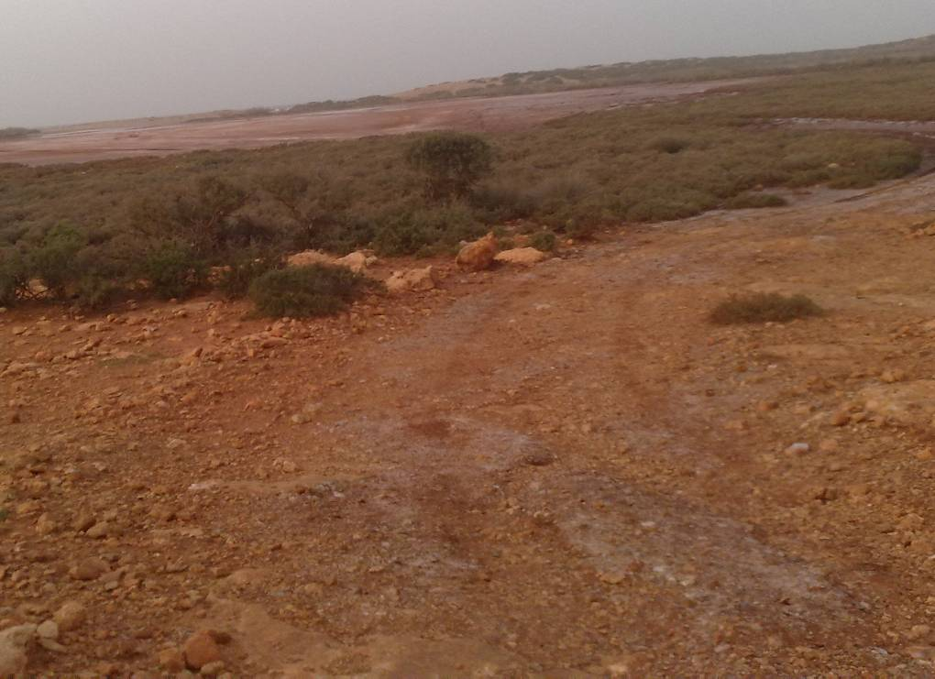
Jarjr-oma Saline habitat winter 2011
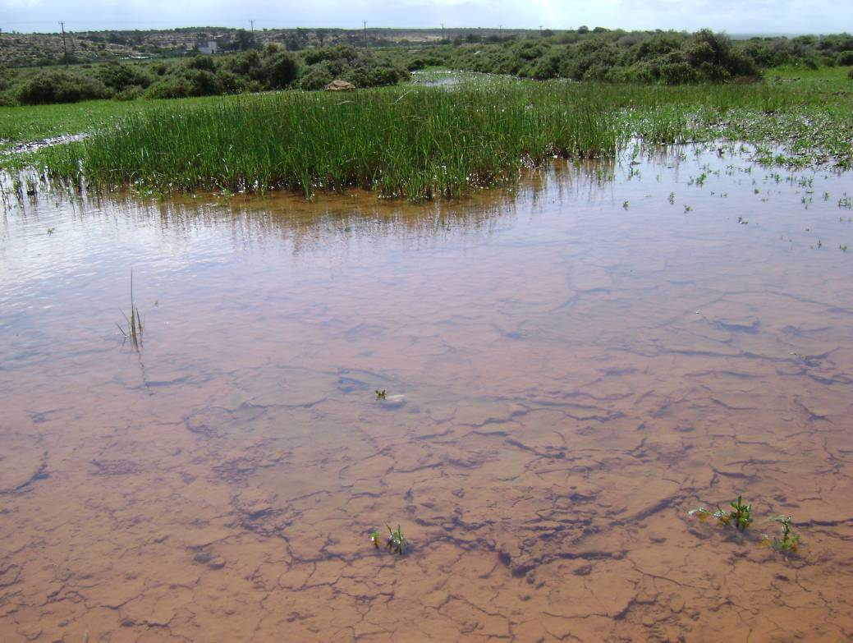
Salt March Winter Jarjr-oma.
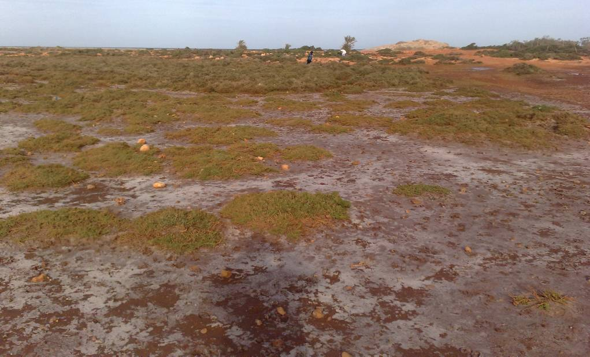
Jarjar oma Autumn 2010
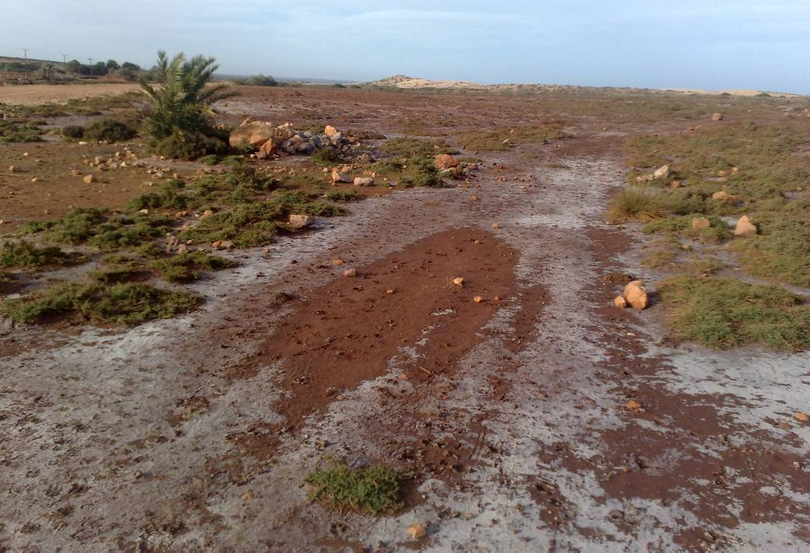
Jarjar oma Autumn 2010
Figs. 9. Pictures of some habitats in Jarjr-oma area of Al- Jabal Al- Akhdar.

4. Discussion
Although poor in species, the vegetation composition of the saltmarshes in is a Jarjr-oma of two plant communities. Succulence is a common phenomenon in the vegetation of Saline habitats (Fahmy, 1986). Suaeda vera, Bellevalia sessiliflora, Drimia maritima, Umbilicus horizontalis, Asphodelus microcarpus, Allium roseum, Cyclamen rohlfsianum, Pancratium maritimum and Zygophyllum album. Succulent perennial shrubs growth form e.g. Tamarix tetragyna, Nitraria retusa and Juncus acutus.
The vegetation distribution pattern in the study areas was mainly related to amount salinity and sand.
The annuals occurring in saline areas could be divided into three categories non-halophilous therophytes, spring halophytic therophytes and late summer annual halophytic chenopods (Akhani and Ghorbanli, 1993). Leaf growth rate per shoot was generally 100% higher in sandy habitats than in rocky areas (Bandeira, 2002). A comparison of the annual precipitation with the distribution of saline soils shows that a majority of the areas have total annual precipitation of less than 250 mm (Akhani and Ghorbanli, 1993). The dominating life forms are chamaephytes in sites of high salinity, and therophytes in sites of low salinity. Spatial and temporal variations in the standing crop biomass were pronounced (Ayyad and El-Ghareeh, 2004). Saline habitat increased number of species of winter and spring seasons of 71 and 65 species, while, Sandy beach increase in spring season to 20 species, in Salt march 11 and 10 of winter and spring, in summer season equal winter and spring the number of species.
In Libya, several thousand hectares of mixed stands of Acacia saligna syn, A.cyanophylla and Atriplex canexens have been established in large fenced areas to provide supplementary grazing in autumn and spring (Choukr-Allah, 1997).

Acknowledgements
We would like to thank Assistant Abd-Al Salam Al-Mogasby (Botany Department of Faculty of Science and Benghazi University), for their help in the diagnosis of plant samples and Mohamed Mahmod Abd-Al-Naby (Soil Department Agriculture University), for their help in the soil analysis.

References
- Akhani', H. and Ghorbanli, M. (1993). A contribution to the halophytic vegetation and flora of Iran. Towards the rational use of high salinity tolerant plants. Vol. I: 35-44.
- Al-Jabal Al-Akhdar south project. (2005). Study and evaluation natural vegetation in Al-Jabal Al-Akhdar area. (In Arabic). Omar Al-Mokhtar Univ., Libya. 12 p.
- Al Hawas, A. A., (2004). The impact of drought on the distribution of vegetation in the basin Al Arda villages "A tributary Valley Touqi" Riyadh. Department of Geography. King Saud Univ. 10 p.
- Ayyad, M. A. and El-Ghareeh, R. E. M. (2004). Salt marsh vegetation of the Western Mediterranean desert of Egypt. Plant Ecology. 3-19.
- Bandeira, S. O. (2002). Leaf production rates of Thalassodendron ciliatum from rocky and sandy habitats. Aquatic Botany, 72(1). 13-24.
- Boulos, L. (1999). Flora of Egypt (Azollaceae-Oxalidaceae). Vol. 1, Al-Hadara Pub., Cairo, Egypt.
- Boulos, L. (2000). Flora of Egypt (Geraiaceae-Boraginaceae). Vol. 2, Al- Hadara Pub., Cairo, Egypt.
- Boulos, L. (2002). Flora of Egypt (Verbenaceae-Compositae). Vol. 3, Al-Hadara Pub., Cairo, Egypt.
- Boulos, L. (2005). Flora of Egypt (Monocotyledons). Vol. 4, Al-Hadara Pub., Cairo, Egypt.
- Fahmy, G.M. (1986). Ecophysiological Studies on some Halophytes in the Mediterranean Zone, Egypt. Ph.D. Thesis, Fac. Sci., Cairo Univ., 283 pp.
- Gad, M. R. M., El-Hadidy, M. E. A. and El-Nabarawy, A. A. A. (2012). Comparative study on the adaptation of some natural plants grown under macronutrients limitation at North Sinai sand dunes (Egypt). Annals of Agricultural Sciences, 57(1), 81-90.
- Choukr-Allah, R. (1997). The potential of salt-tolerant plants for utilization of saline water. Options Mediterranean's. 313-325.
- Hamdy, A. 1995. Saline irrigation: Assessment and management techniques. In Marcel Dekker, Inc. (eds), Halophytes and Biosaline Agriculture
- Henderson, P. A. and Seaby, R. M. H. (1999). Community analysis package, version 1.2. Pisces conservation Ltd, IRC House, Pennington, Lymington, S041 8GN, UK.
- Jafri, S. M. and El-Gadi, A., (Eds). (1977-1993). Flora of Libya. Bot. Department, Faculty of Sci., Tripoli Univ., Libya.
- Le Houérou, H.N. (1991). The role of saltbushes (Atriplex spp.) in arid grazing land rehabilitation in the Mediteranean basin. In: R. Choukr-Allah (ed) Plant Salinity Research New Challenges. IAV Hassan II, Agadir, Morocco, pp 397-433.
- Ludwig, J. A. and Reynolds, J. F. (1988). Statistical ecology: a Primer on Methods and Computing. John Wiley and Sons Inc., New York, U. S. A, 337 p.
- Marcar, N. E., D. F. Crawford and P. M. Leppert. (1993). The potential of trees for utilization and management of salt-affected land. In: N.Davidson and R. Galloway (ed): Productive use of saline land. ACIAR Proceedings 42: 17-22.
- Nie, N., Hadlai Hull, C., Jenkins, J. G., Steinbrenner, K. and Bent, H. D. (1975). SPSS-Statistical Package for the Social Sciences. 2 nd. Ed, McGrraw-Hill, New York, 204 p.
- Schleicher, J., Wiegand, K. and Ward, D. (2011). Changes of woody plant interaction and spatial distribution between rocky and sandy soil areas in a semi-arid savanna, South Africa. Journal of Arid Environments, 75(3). 270-278.
- Town of Scituate Open Space Conservation & Recreation Plan. (1998). Environmental inventory and analysis. Section IV. 44.

4/29/2013

