Modeling Marshall Stability and Flow for Hot Mix Asphalt Using Artificial Intelligence Techniques

Khaled A. Kandil

Associate Professor, Public Works Department, Faculty of Engineering, Ain Shams University, Cairo, Egypt.
K_kandil@hotmail.com

Abstract: Marshall Mix design method is one of the common methods that are used in several countries to design hot mix asphalt. Two of the main design parameters that are considered in this method are Marshall stability and Marshall flow. These parameters depend on several factors including aggregate gradation and asphalt cement content. Mix stability and flow are measured in the laboratory by applying a constant rate of deformation diametrically on a cylindrical specimen of asphalt mix. In recent years, artificial intelligence techniques such as neural networks (ANNs) and Adaptive Neuro-Fuzzy Inference System (ANFIS) have been utilized in many civil engineering tasks as an alternative to traditional prediction approaches and have shown a good degree of success. The main objective of this study is to use Adaptive Neuro-Fuzzy Inference System to develop models that can predict the asphalt mix stability and flow as a function of mix gradation and asphalt cement content. An experimental investigation was carried out to provide the database containing the data required for models development. These data were then used to develop ANFIS models. These models were developed through using the Gaussian membership function. The output results indicated that ANFIS models can be used effectively to predict Marshall stability and flow.

[Khaled A. Kandil. Modeling Marshall Stability and Flow for Hot Mix Asphalt Using Artificial Intelligence Techniques. Nat Sci 2013;11(6):106-112]. (ISSN: 1545-0740). http://www.sciencepub.net/nature. 12

Key words: Asphalt Mix, Marshall Mix design, Stability, Flow, Adaptive Neuro-Fuzzy Inference System, Gaussian membership function.

1.Introduction
Asphalt concrete pavement is the most common pavement type used around the world. The performance of this type of pavement is largely depends on the quality of the asphalt concrete mixture. In order to achieve the proper mix quality, the highway authority establishes a set of design requirements to be achieved by the contractor. Marshall mix design method is one of the common methods that are used in several countries. The main objective of this method is to determine the optimum asphalt content for a particular aggregate blend to satisfy the predefined mix requirements. Mix stability and flow are two of the essential requirements that control the mix design process (AI, 2001).
Stability is considered as an empirical measure for the strength of asphalt concrete mixes. It is defined as the resistance of the mix to deformation (flow) when subjected to traffic loadings under a variety of environmental conditions. Mix stability and flow are measured in the laboratory by applying a constant rate of deformation diametrically on a cylindrical specimen of asphalt mix. The flow increases by increasing the asphalt cement content. On the other hand, the stability increases through increasing asphalt content to a certain limit. After this limit, increasing the asphalt cement creates a too thick asphalt film around the aggregate particles resulting in loss in mix stability. This limit depends mainly on the characteristics of the aggregate blend (Garber and Hoel, 2009).
In recent years, artificial intelligence techniques such as neural networks (ANNs) and Adaptive Neuro-Fuzzy Inference System (ANFIS) have been utilized in many civil engineering tasks as an alternative to traditional prediction approaches and have shown a good degree of success. Xiao and Amirkhanian (2009) estimated the stiffness behavior of rubberized asphalt concrete containing reclaimed asphalt using ANNs. Singh et al. (2013) utilized the ANNs to model the dynamic modulus of hot mix asphalt taking into consideration the aggregate shape properties. Ozgan (2011) applied the ANNs to model the temperature effect on the Marshall stability. Tabatabaei et al. (2013) modeled the deduct value of the pavement condition of asphalt pavement by ANFIS. Morova et al. (2013) developed an ANNs model to predict the present serviceability ratio for rigid pavements.
The main objective of this paper is to use Adaptive Neuro-Fuzzy Inference System (ANFIS) to develop models that can predict the mix stability and flow as functions of the aggregate gradation and the content of the asphalt cement. These models can be used effectively in the quality control process. To achieve the objective of this paper an experimental investigation was carried out to build the database needed for models development. This paper includes four main parts. The first part presents the experimental investigation, the second part gives a brief background about ANFIS, the third part deals with the models development, and the fourth part presents the summary and conclusion.

2. Experimental Investigation
This part deals with preparing the database needed for the models development. Two hundred and twenty eight asphalt mix samples were taken from the site before compaction. In order to get a wide range of aggregate gradation and asphalt content, the samples were obtained from different sites representing three different types of asphalt concrete mixes. Each mix sample was divided into two parts. The extraction test was performed on the first part in order to get the aggregate gradation and asphalt cement content. On the other hand, the second part was used to prepare cylindrical specimens. The specimens were then tested by Marshall Apparatus to get their stabilities and flows. Table 1 summarizes the output data of the experimental investigation which include the minimum and maximum values obtained for the following items:
- Percentage of passing from each sieve size.
- Percentage of asphalt content (aggregate weight base).
- Marshall stability.
- Marshall flow.

Table 1 Experimental Investigation Output Results
Test | Minimum Value | Maximum Value
Extraction Test  - % passing from Sieve 1"  - % passing from Sieve 3/4"  - % passing from Sieve 1/2"  - % passing from Sieve 3/8"  - % passing from Sieve No. 4  - % passing from Sieve No. 8  - % passing from Sieve No. 30  - % passing from Sieve No. 50  - % passing from Sieve No. 100  - % passing from Sieve No. 200  - % of bitumen content  Marshall Test  - Marshall Stability (kg)  - Marshall Flow (0.01") | 100  82.3  50.2  40.1  25.2  18.9  9.9  3.5  1.0  0.4  4.44  736  8.27 | 100  100  100  96.0  76.2  64.8  29.4  21.0  11.0  6.7  5.98  1302  12.86

Adaptive Neuro-Fuzzy Inference System
Adaptive Neuro-Fuzzy Inference System is a multi-layer adaptive neural network-based fuzzy inference system that developed by J.S. Roger Jang (Jang, 1993). This system is mainly an artificial neural network that uses the fuzzy inference system to describe the relationship between a specific set of variables. As shown in Figure 1, a fuzzy inference system consists of five main elements. The first element is a fuzzification interface which converts the crisp input data to linguistic values using membership functions. The second element is the defuzzification interface that converts the output linguistic results to output crisp values. The third element is a rule base that includes a number of fuzzy if-then rules. The fourth element is a database which includes the membership functions that can be used in the fuzzy rules. The fifth element is a decision –making unit that completes the inference operation on the rules. The main function of the rule base and the decision-making unit is to define the most appropriate relationships that link between the input and output parameters.
The main objective of ANFIS is to obtain the most favorable values of the fuzzy interface system parameters through applying a learning algorithm using the input-output data sets. This is carried out through a training process. The inference system parameters are optimized through minimizing the differences (errors) between the predicted and actual output data. The parameters are optimized by hybrid technique which utilizes the least square estimate and gradient descent method.

Models Development
As mentioned earlier, the main objective of this paper is to develop two ANFIS models. The first model is to predict the Marshall stability, while the second model is to predict the Marshall flow as functions of the mix gradation and the percentage of asphalt cement content. Figure 2 illustrates a schematic chart of the developed models. As shown in this figure, the models are based on Sugeno type fuzzy inference system. For the creation of the fuzzy sets, several membership functions can be used such as triangular, trapezoidal, or Gaussian. The Gaussian function is selected to be used in this study. Figure 3, illustrates the shape of this function for sieve 3/4". On the other hand, the output membership function can be either a constant or a linear function. Due to the large number of input parameters associated with this study and to reduce the running time, each input variable was fuzzified using two membership functions and the output membership function was selected to be constant. The number of the fuzzy rules used in this study is 1024.

Database
Rule base
Knowledge base
Decision-making unit
Defuzzification
interface

Fuzzification
interface

Input
(crisp)
Output
(crisp)
Fuzzy
Fuzzy

Figure 1 ANFIS Structure

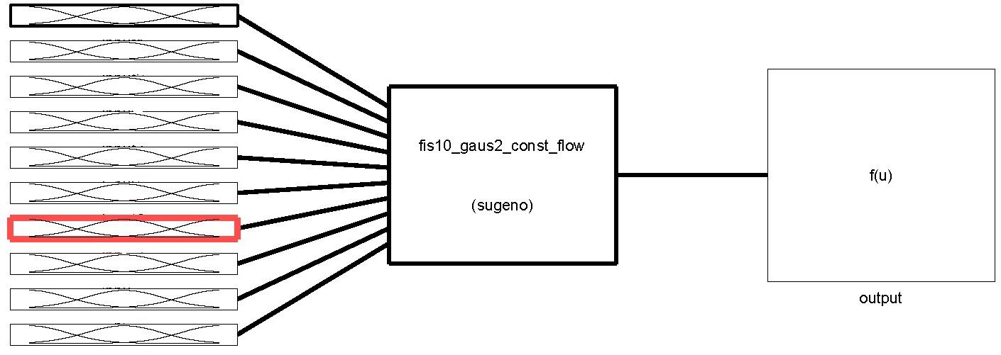
3/4"
1/2"
3/8"
No. 4
No. 8
No. 30
No. 50
No.1004
No. 200
% AC
fis10_gaus2_const_flow
or
fis10_gaus2_const_stability

(sugeno)
Flow
or
Stability
Figure 2 Schematic Chart of ANFIS Models

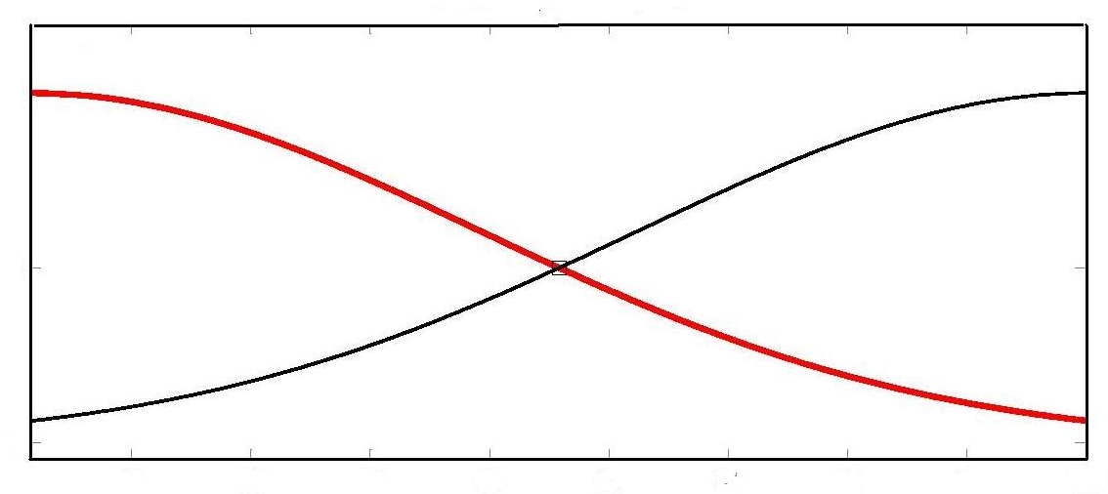
84
88
92
96
100
0
0.5
1

Figure 3. Membership Functions for Sieve 3/4"

Figure 4 illustrates a typical structure of ANFIS. In this model, the input data is fuzzified, the fuzzy rules are then applied, after that the weight is calculated for each corresponding rule, and finally the average weight for all outputs is calculated to obtain the crisp final output. In this study, the input data for the two models consists of ten variables: percent passing from sieves 3/4", 1/2", 3/8", No. 4, No. 8, No. 30, No. 50, No. 100, and No. 200, and percentage of bitumen content. The outputs are the Marshall stability and flow for the first and second models, respectively. The data obtained from the experimental investigation were used to train these models. In the training process, an arbitrary starting set of the fuzzy inference parameters were selected in order to produce initial predicted values of the stability and flow. The predicted values were then compared with the actual values of the stability and flow obtained from the experimental investigation. The differences between the actual and predicted values represent the error. The fuzzy inference parameters were then updated and the process was repeated in an iterative fashion until the error was minimized. The optimization procedure was achieved using hybrid technique.

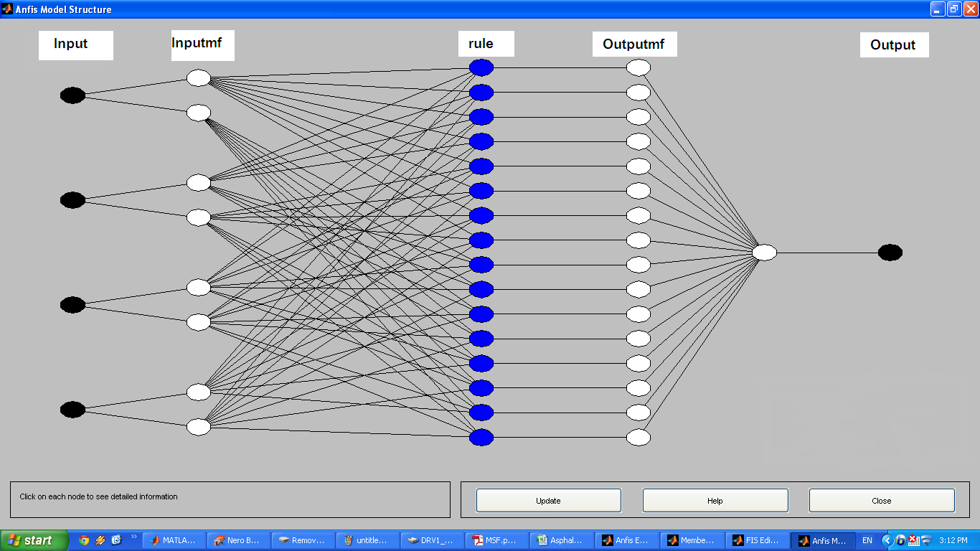
Figure 4 Typical Structure of ANFIS

The training process was carried out using 250 epochs for both stability and flow models. Figures 5 and 6 illustrate the relationship between the epoch number and the root mean square error (RMSE) resulting from the training process of the stability and flow models, respectively. It can be noticed that there is no reduction in the RMSE value after almost 60 epochs for flow model and after 70 epochs for stability model which indicates the sufficiency of using 250 epochs in the training process. As shown in these figures, the RMSE reported during the training process was 13.67 kg and 0.00192" for stability and flow, respectively. After the training process was completed, ANFIS models were tested by comparing the predicted values with the actual values. As shown in Figures 7 and 8, the predicted stability and flow values are very close to the actual values. This indicates that ANFIS can be used as an effective tool for modeling the Marshall stability and flow based on the mix gradation and bitumen content.

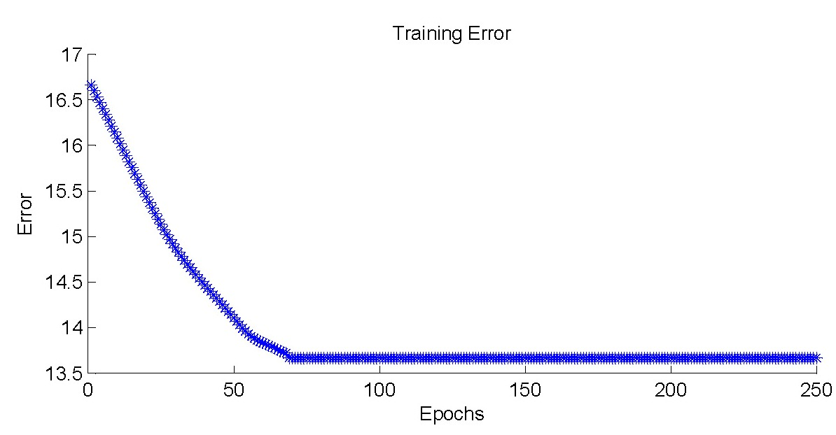
Root Mean Square Error (kg)
Figure 5 Root Mean Square Error versus Epoch Number for Stability Training Process

Root Mean Square Error (0.01")
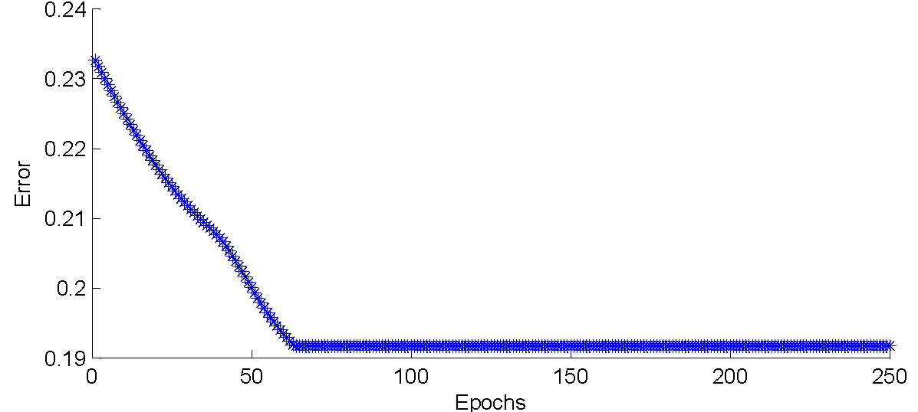

Figure 6 Root Mean Square Error versus Epoch Number for Flow Training Process

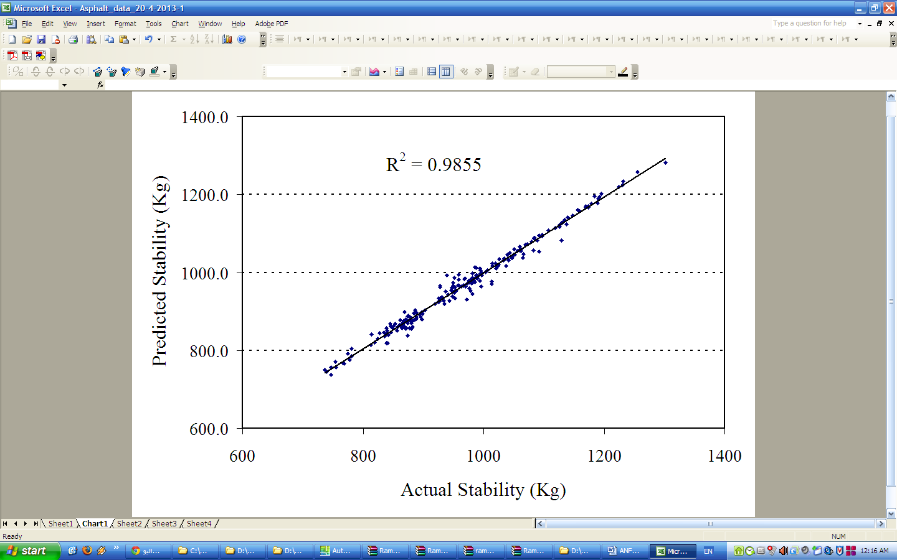
Predicted Stability (kg)
Actual Stability (kg)

Figure 7 Marshall Stability (actual versus predicted)

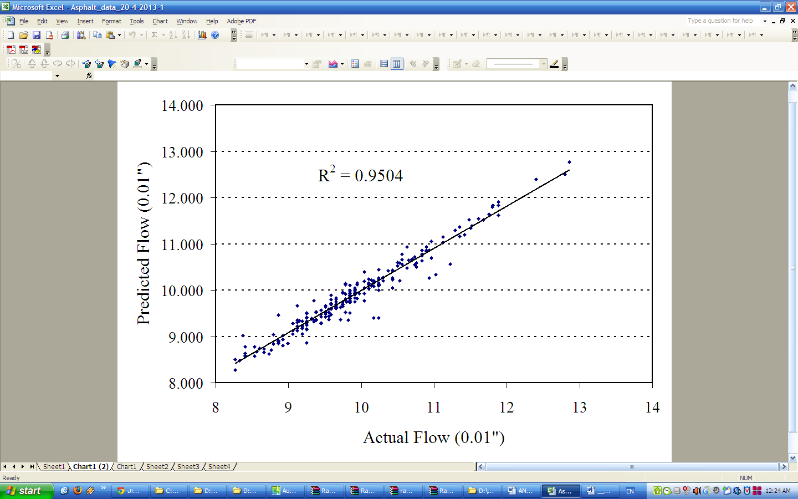
Predicted Flow (0.01")
Actual Flow (0.01")
Figure 8 Marshall Flow (actual versus predicted)

4. Summary and Conclusions
This study investigated the possibility of using ANFIS in modeling the Marshall stability and flow. Two ANFIS models were developed to predict the Marshall stability and flow as functions of the mix gradation and the percentage of asphalt cement content. The developed models were based on Sugeno type fuzzy inference system, Gaussian membership functions, and constant output functions. The input variables include percent passing from sieves 3/4", 1/2", 3/8", No. 4, No. 8, No. 30, No. 50, No. 100, and No. 200, and percentage of bitumen content. The outputs are the Marshall stability and flow. An experimental program was designed to get the data required for the model training process which involved the testing of two hundred and twenty eight asphalt samples. The evaluation process showed that the coefficient of determination and the root mean square error for stability were 0.98 and 13.67 kg, respectively. On the other hand, the coefficient of determination and the root mean square error for flow were 0.95 and 0.00192", respectively. This indicates that ANFIS can be used as an effective tool for modeling the Marshall stability and flow based on the mix gradation and bitumen content. It is recommended for future research to extend this model to include other aggregate characteristics into consideration such as aggregate texture, angularity, and absorption.

5. References
- Asphalt Institute (AI), (2001). “HMA Construction, Construction of Hot Mix Asphalt Pavements”, Manual Series No. 22 (MS-22), Second Edition.
- Garber, N.J., Hoel, L.A. (2009). "Traffic and Highway Engineering" Fourth Edition, Cengage Learning, Canada.
- Morova, N., Serin, S., Terzi, S., and Saltan, M., (2013) “Prediction of the Pavement Serviceability Ratio of Rigid Highway Pavements by Artificial Neural Networks”, Journal of Advanced Technology Sciences, 2(1), 12-25.
- Ozgan., E. (2011) “Artificial Neural Network Based Modelling of the Marshall Stability of Asphalt Concrete”, Journal of Expert Systems with Applications, 38(5), 6025-6030.
- Singh, D., Zaman, M., and Commuri, S. (2013) “Artificial Neural Network Modeling for Dynamic Modulus of Hot Mix Asphalt Using Aggregate Shape Properties”, Journal of Materials in Civil Engineering, 25(1): 54-62.
- Tabatabaei, S., Khaledi, S., and Jahantabi, A., (2013) “Modeling the Deduct Value of the Pavement Condition of Asphalt Pavement by Adaptive Neuro Fuzzy Inference System”, International Journal of Pavement Research and Technology, 6(1): 59-65.
- Xiao, F., and Amirkhanian, S. (2009) “Artificial Neural Network Approach to Estimating Stiffness Behavior of Rubberized Asphalt Concrete Containing Reclaimed Asphalt Pavement”, Journal of Transportation Engineering, 135(8), 580-589.
- Jang, J. S. R., (1993) “ANFIS: Adaptive Network-Based Fuzzy Inference Systems”, IEEE Trans. on Syst. Man Cybern, 23(3), 665-685.

4/12/2013

