Variation in physical and biochemical characteristics of wheat plants treated with sewage water & plant growth regulators

Ram kumar Sagar¹, Chandra Shekhar Kumar¹, Alka Singh² and J.N. Maurya^{1*}

¹Department of Plant Science, M.J.P. Rohilkhand University, Bareilly, U.P., India
²Department of Botany, Bareilly College, Bareilly, U.P., India

ABSTRACT: Plant hormones play a vital role in coordination of many growth and behavioral process in the plant. They regulate the amount, type and direction of plant growth. Organic waste recycling in form of sewage water is an effective organic waste management, turning in to a high quality and in expensive soil amendment. In this study plant growth regulators like Auxin (IAA) and Gibberellin (GA₃) were both applied in 10ppm and 20ppm concentrations in combination with sewage water. The sewage water was collected from Quilla channel (QA channel) of Bareilly city. Result indicated that 20ppm IAA and 20ppm GA₃ with 100% of sewage water increased the physical and bio chemical properties of wheat crop compared to the 100% sewage water with 10ppm IAA & 10ppm GA₃ and control (Tap water). Our findings also proved that exogenous application of PGRs along with sewage water result an increased physical and biochemical parameters as compared to sewage water alone and control.
[Ram kumar Sagar, Chandra Shekhar Kumar, Alka Singh and J.N. Maurya. Variation in physical and biochemical characteristics of wheat plants treated with sewage water & plant growth regulators. Nat Sci 2013;11(6):129-135]. (ISSN: 1545-0740). http://www.sciencepub.net/nature. 15

KEYWORDS: Sewage Water; Indole Acetic Acid; Gibberellin; Wheat.

INTRODUCTION:
Water is an essential component of the environment and it sustains life on the earth, on the other hand, it is also a resource that is adversely affected both quantitavely and qualitatively due to rapid urbanization, industrialization and other human activities. As a consequence, the use of sewage water and other industrial effluents for irrigating agricultural land is on the rise particularly in peri-urban areas of developing countries (Nagajyothi et al., 2009; Singh and Agarwal, 2010). Expansion of urban populations and increased coverage of domestic water supply and sewerage give rise to greater quantities of wastewater. With the current emphasis on environmental health and water pollution issues, there is an increasing awareness of the need to dispose of these wastewaters safely and beneficially. In arid and semi-arid regions, wastewater is considered a valuable source of irrigation water and a fertilizing material (AI-Rashed and Sherif, 2000).
Problem of sewage water or waste water is common both in developed and developing countries (Nath et al., 2009). Nowadays the application of sewage water or sewage sludge created considerable interest in agricultural productivity due to the valuable components such as organic matter, Nitrogen (N), Phosphorus (P) and other plant nutrient (Kanan et al., 2005). Besides nutrients, plant hormones are other organic substances which regulate plant growth and development. Plant hormones are active members of the signal cascade involved in the induction of plant stress responses (Pedranzani et al., 2003). Plant hormones play pivotal roles in the regulation of plant growth and development (Tuna et al., 2008; Wen et al., 2010). Indole acetic acid (IAA) is the most abundant naturally occurring plant hormone, well known for its regulating function in plant growth and development (Rout, 2006). Indole acetic acid is a type of auxin that stimulates growth through cell elongation and lateral root formation which probably support more absorption of minerals (Egamberdieva, 2009). Similarly, Gibberellic acid (GA₃) facilitates cell elongation in different organs and tissues throughout plant growth and development (Karssen et al., 1989).The aim of present investigation was to study the effectiveness of Auxin (IAA) and Gibberellin (GA₃) when irrigated with sewage water for improving growth and yield of wheat crop.
MATERIAL AND METHODS:
Wheat (Triticum aestivum L. cv. PBW 343) was obtained from the National seed corporation, New Delhi. Before use seeds were surface sterilized with 30% sodium hypochlorite for 10 min, thoroughly washed with distilled water and placed on moist filter paper for germination. After 24 h seeds were sown in the field (0.5 cm depth) and irrigated with sewage water collected from Quilla channel (QA Channel), Bareilly, U.P., India. Sewage water (SW) was analyzed for its physical and chemical parameters (Table 1) as per APHA (1998). 50% and 100% concentrations of sewage water (SW) were used along with exogenous application of 10 and 20 ppm Auxin (IAA) and Gibberellin (GA₃) respectively after 25, 50, 75 and 100 days of sowing. All the treatments were conducted in triplicates and tap water was used as control. At physiological maturity physical parameters like plant height (cm), number of tillers, leaf area (cm²) and leaf area index were measured. Ears/plant, grains/head, grain yield (gm/m²), straw yield (gm/m²), 1000grains weight (gm) and harvest index were measured at harvesting stage after irrigation with sewage water alone and in combination with IAA and GA₃.
The harvested plants were properly washed with distilled water and used for estimation of bio chemical parameters like total chlorophyll, protein, in vivo nitrate reductase activity and nitrogen content. Chlorophyll content was determined by extracting fresh leaves (100mg) with 80% chilled acetone and centrifuging at 10000 rpm as per method of Arnon (1949). Protein was estimated by the method of Lowry et al., (1951). Fresh leaves of plant was extracted in 3ml of 10% TCA and centrifuged at 10000 rpm for 10 min. 1 N NaOH was added in pellets after decanting supernatants which was then boiled for 15min. and then cooled. 5ml of Lowry solution was added to the 0.5 ml of final supernatant, and then incubated for 10min. at 30º C. 0.5ml of Folin & Ciocalteu’s phenol reagent was added and absorbance was read at 750nm after 45min using BSA as the standard. In vivo nitrate reductase activity was assayed following Srivastava (1974). Nitrogen content was measured by the method of Lang (1958).

STATISTICAL ANALYSIS:

Data were summarized as Mean ± SD. Treatments were compared by two factor, analysis of variance and the significance of mean difference within and between the treatments was done by Duncan multiple range test (DMRT). A two-sided p <0.05 was considered statistically significant.
RESULTS AND DISCUSSION:
Result showed differential response on growth and productivity parameters of wheat at harvesting stage of wheat (Table 2, 3, 5 & 6). Significant (P<0.001) increase in plant height, no. of tillers, leaf area and leaf area index (Table 2) of wheat was observed in 100% SW followed by 50% SW compared to control. Irrigation of wheat by SW+IAA resulted more plant height, no. of tillers, leaf area and leaf area index compared to SW alone and control. Similarly, Ibrahim et al., (2007) revealed that GA₃ (100 ppm) application led to increase in plant height, average number of leaves, leaf area per plant and dry weight of shoot in Vicia faba. Kalyankar et al., (2008) showed that foliar spray of GA₃ (150 ppm) increased number of leaves and leaf area. NAA (100ppm) was effective in increasing total dry weight. Similar increment was also observed in plant height, no. of tillers, leaf area and leaf area index (Table 5) of wheat irrigated with SW+GA₃ compared to SW alone in both the concentrations and control. Application of N-enriched compost with gibberellic acid (GA₃) also produced statistically similar plant height (Akram et al., 2011; Zahir A. et al., 2007).
Plant height, No. of tillers, leaf area and leaf area index were more in wheat irrigated with 20ppm GA₃ than 10ppm GA₃ in combination with both concentrations of sewage water respectively. Vasudevan et al., (2008) reported that GA₃ (100 ppm) foliar spray at 50 percent flowering resulted in production of significantly higher plant height, number of productive branches (6.68) and seed yield (8.53 q/ha) in fenugreek. Both IAA and GA₃ in combination with SW attributed more or less similar results of plant height, no. of tillers, leaf area and leaf area index compared to SW alone and control. Emongor (2007) revealed that exogenous application of GA₃; 7 days after emergence at 30, 60 and 90 mg/l significantly increased plant height, first nodal height, leaf area and number of leaves per plant without significant effect on plant senescence in cowpea. Thus exogenous application of GA₃ can be used to modify growth and development of some cowpea varieties. Enriched compost treated with GA₃ showed non-significant effect on no. of tillers/m² when compared with N-enriched compost supplemented with 60 kg/ha N fertilizer (Zahir A. et al., 2007).
At physiological maturity, gradual increase in ears/plant, grains/head, grain yield, straw yield, 1000-grains weight and harvest index was noticed significantly (p<0.001) in wheat irrigated with 100% SW+20ppm IAA compared to 100% SW+10ppm IAA followed by 100% sewage water alone and control (Table 3). Maximum straw yield (5.3 t/ha) was recorded in IAA-blended N-enriched compost which was at par with Kinetin-treated N-enriched compost. 1000-grains weight of wheat was significantly influenced by the application of plant growth regulators-blended N-enriched compost and chemical fertilizers (Zahir A. et al., 2007). Similar findings were also observed with 50% SW+IAA compared to 50% SW alone and control.
Ears/plant, grains/head, grain yield, straw yield, 1000-grains weight and harvest index of wheat irrigated with SW+GA₃ were observed more or less similar to findings of SW+IAA compared to SW alone and control (Table 6). Jamil M. et al., (2007) reported that sewage sludge increased the grain yield and straw production of wheat. They mentioned that the maximum yields in both grain and straw were obtained at 40 t ha-1 of sewage sludge application. Results revealed that GA₃-blended N-enriched compost showed non-significant improvement in the growth and yield of wheat. Vasudevan et al., (2008) revealed that interaction effect between apical bud pinching and GA₃ sprays showed a significant influence on growth, seed yield and yield attributes like number of pods per plant, number of seeds per pod etc. 20ppm of both IAA and GA₃ with SW attributed more productivity of wheat compared to 10ppm of IAA and GA₃ in combination with SW compared to respective concentrations of SW and control. Jadhav (2000) stated that the application of increasing concentrations of GA3 and NAA increase the morphological and physiological parameters like CGR, RGR, NAR and LAR in soybean which in turn led to the increased yield and yield attributes.
The addition of IAA to N-enriched compost showed non-significant improvement in most of the growth and yield parameters of wheat (Zahir A. et al., 2007; Zahir ZA et al., 2000). Application of IAA at the rate of 10⁻⁵ M increased grain yield and biological yield in wheat (Arif et al., 2001). With the progressive increase in concentration of IAA and GA₃ i.e. 20ppm accounted significant (p<0.001) increase in total chlorophyll and nitrogen content of wheat leaves compared to 10ppm IAA and GA₃ in combination with respective concentrations of SW compared to SW alone and control (Table 4 & 7). Tagade et al., (1998) studied the influence of PGRs by soaking seeds of soybean in 25-150 ppm IAA and kinetin before sowing and noticed that leaf chlorophyll and nitrogen contents, seed yield and seed protein and oil contents increased with IAA concentration upto 100 ppm then decreased with increasing concentrations. Similar trend of increment was also evident in protein content in grains and NR activity in leaves of wheat irrigated with SW+IAA and SW+ GA₃ compared to SW alone and control (Table 4 & 7). Protein content in grains and NR activity in leaves of wheat irrigated with SW+IAA was significantly (p<0.001) more or less similar to wheat irrigated with SW+ GA₃. Senthil et al., (2005) conducted experiment to study the effect of growth regulators on IAA oxidase, peroxidase and NRA’s activities in groundnut under different salinity levels and indicated that seed treatment with GA₃ and IAA solutions reduced the activity of IAA oxidase and increased the activity of NRA’s enzyme.
CONCLUSION:
Physical and bio chemical properties were observed more in SW+IAA / SW+ GA₃ compared to respective concentrations of SW alone and control. It implies that PGR’s applied in combination with SW can result greater yield and productivity by enhancing biochemical parameters of wheat. Complimentary use of various nutrient sources and Plant growth regulators is advantageous, reducing dependence on chemical fertilizers, helping to maintain both soil health and crop productivity at the same time.
ACKNOWLEDGEMENT:
We thank to The Head, Dept. of Plant Science, M.J.P.R.U, Bareilly, (U.P.), India for the support and assistance provided during research work.

Tables
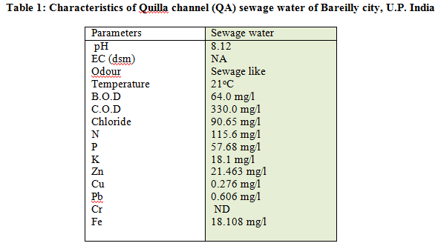

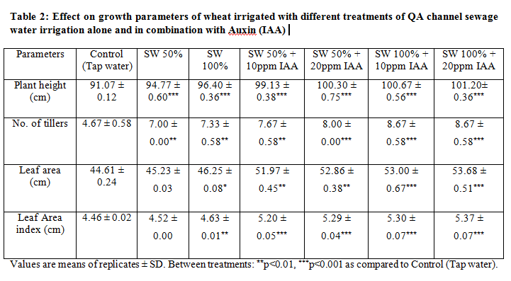

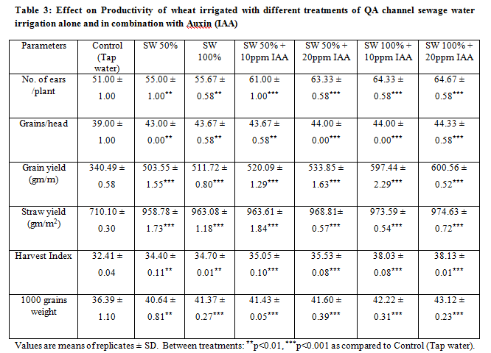

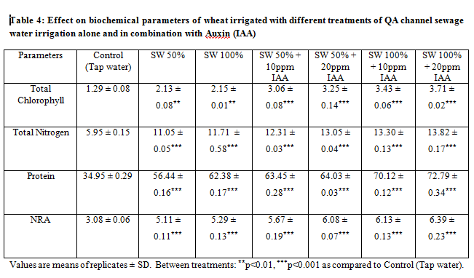

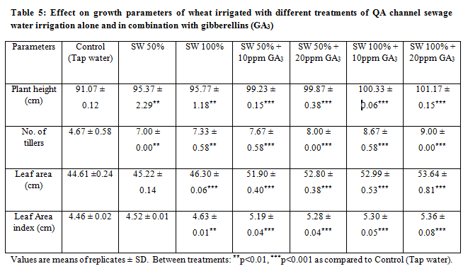

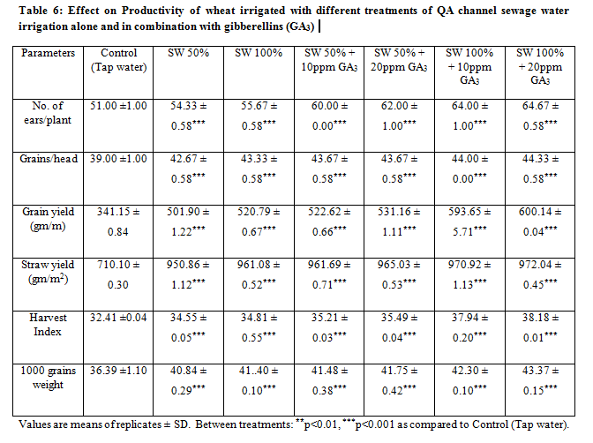
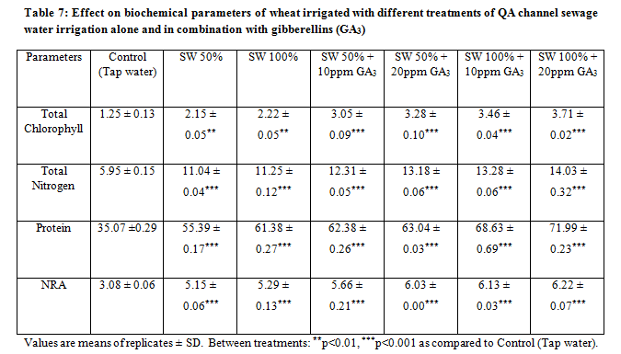

REFERENCES:
- AI-Rashed MF and Sherif MM. Water resources in the GCC countries: an overview. Water Resour. Mgt. 2000; 14(1): 59-73.
- Akram HM, Shahid M and Sattar A. Impact of growth substances applications on yield parameters of wheat under water stress. Iranian Journal of Plant Physiology. 2011; 3: 141–156.
- APHA. Standard methods for the examination of water and wastewater analysis.20th ed. Washington DC 1998.
- Arif M, Shah P, Azam F and Ahmad R. Effect of auxin on different wheat varieties. Sarhad J.Agri. 2001; 17: 33-40.
- Arnon DI. Copper enzymes in isolated chloroplasts Polyphenoloxidase in Beta vulgaris. Plant Physiology.1949; 24: 1-15.
- Egamberdieva D. Alleviation of salt stress by plant growth regulators and IAA producing bacteria in wheat. Acta Physiol. Plant.2009; 31: 861-864.
- Emongor V. Gibberellic acid (GA3) influence on vegetative growth, nodulation and yield of cowpea (Vigna unquiculata (L.) Walp.). J. Agron.2007; 6(4): 509-517.
- Ibrahim ME, Bekheta MA, El-Moursi A and Grafar NA. Improvement of growth and seed yield quality of Vicia faba L. plants as affected by application of some bioregulators. Australian J. Basic Appl. Sci.2007; 1(4): 657-666.
- Jadhav BP. Influence of plant growth regulators on growth and yield of soybean genotypes. M. Sc. (Agri) Thesis (unpub.), MPKV, Rahuri 2000.
- Jamil M and Rha ES. Gibberellic acid (GA₃) enhances seed water uptake, germination and early seedlings growth in sugar beet under salt stress. Pak J Biol Sci. 2007; 10(4): 654-658.
- Kalyankar SV, Kadam GR, Borgaonkar SB, Deshmukh DP and Kadam BP. Effect of foliar application of growth regulators on seed yield and yield components of soybean (Glycine max (L.) Merill). Asian J. Bio-Sci.2008; 3(1): 229-230.
- Kanan V, Ramesh R and Shashikumar C. Study on ground water characteristics and the effects of discharged effluents from textile units at Karur District. J. Environ. Biol.2005; 26: 269-272.
- Karssen CM, Zagorski S, Kepczynski J and Groot SPC. Key role for endogenous gibberellins in the control of seed germination. Anals Bot.1989; 63: 71-80.
- Lang CA. Simple microdetermination of Kjeldahl nitrogen in biological materials. Chem.1958; 30: 1692-1694.
- Lowry OH, Rosenbrough NJ, Farr AL and Randall RJ. Protein measurement with folin phenol reagent. Biochemistry Journal. 1951; 193: 265-275.
- Nagajyothi PC, Dinakar N, Suresh S, Udaykiran Y, Suresh C and Damodharan T. Effect of industrial effluent on the morphological parameters and chlorophyll content of green gram (Phaseolus aureus Roxb.). J. Environ. Biol.2009; 30: 385-388.
- Nath K,Dharam S, Shilpa S and Sharma YK. Phytotoxic effects of chromium and tannery effluent on growth and metabolism of Phaseolus mungo Roxb. J. Environ. Biol.2009; 30: 227-234.
- Pedranzani H, Racogni G, Alemano S, Miersch O, Ramirez I, Pena-Cortes H, Taleisnik E, Machoda-Domenech E and Abdala G. Salt tolerant tomato plants show increased levels of jasmonic acid. Plant Growth Regul.2003; 41: 149-158.
- Rout GR. Effects of Auxins on adventitious root development from single node cutting of Camellia sinensis (L.) Kuntze and associated biochemical changes. Plant Growth Regul.2006; 48: 111-117.
- Senthil A, Djanaguiraman M and Vijayalakshmi C. Influence of seed treatment of growth regulators on some enzyme activity in groundnut under salinity.Agricultura Tropica et Subtropica.2005; 38(2): 88-90.
- Singh RP and Agarwal M. Biochemical and physiological responses of rice (Oryza sativa L.) grown on different sewage sludge amendments rates., Bull. Environ. Cont. Toxicol.2010; 84: 606-612.
- Srivastava HS. Distribution of nitrate reductase in ageing bean seedlings. Plant Cell Physiology. 1974; 16: 995-999.
- Tagade R, Deotale RD, Sable S and Chore C N. Effect of IAA and kinetin on biochemical aspects and yield of soybean. J. Soils Crops.1998; 8(2): 172-175.
- Tuna AL, Kaya C, Dikilitas M and Higgs D. The combined effects of gibberellic acid and salinity on some antioxidant enzyme activities, plant growth parameters and nutritional status in maize plants. Environ. Exp. Bot.2008; 62: 1-9.
- Vasudevan SN, Sudarshan JS, Kurdikeri M P and Dharamatti PR. Influence of pinching of apical bud and chemical sprays on seed yield and quality of fenugreek. Karnatak J. Agric. Sci.2008; 21(1): 26-29.
- Wen F, Zhang Z, Bai T, Xu Q and Pan Y. Proteomics reveals the effects of gibberellic acid on salt-stressed rice (Oryza sativa L.) shoots. Plant Sci. 2010; 178:170-175.
- Zahir A, Iqbal M, Arshad M, Naveed M and Khalid M. Effectiveness of IAA. GA₃ and Kinetin blended with recycled organic waste for improving growth and yield of wheat (Triticum aestivum L.). Pak. J. Bot.2007; 39(3): 761-768.
- Zahir ZA, Malik MAR and Arshad M. Improving crop yield by the application of an auxin precursor L-TRP. Pak. J. Biol. Sci.2000; 3: 133-135.

5/11/2013

