A survey of Traditional medicinal plants of Uttar Pradesh (India) - Used in treatment of infectious diseases

Achuta Nand Shukla ¹, Sharad Srivastava ² and A.K.S. Rawat ²

^{1.} Botanical Survey of India, Northern Regional Centre, 192-Kaulagarh Road, Dehra Dun-248195 (India)
achutbsi@gmail.com
^{2.} Pharmacognosy & Ethnopharmacology Division, National Botanical Research Institute (CSIR), Lucknow – 226 001 (India)

Abstract: The present study was to explore the traditional plant knowledge of Uttar Pradesh, India used in infectious disease. Ethnobotanical information was obtained through open informal interviews. The informants were residents, belonging to families living in the study area since generations, and involved at least partially in agriculture. A total of 184 botanical taxa were recorded along with local name, family, habit and parts used. These 184 plants species which provide the crude drugs pertain to 151 genera and 74 families. These plants used to cure 12 infectious ailments. The most widely sought after plant parts in the preparation of remedies in the area are the leaves (17.74%) and bark (14.51%). Plants used by local people were compared with previous ethnobotanical literature, concerning the neighboring areas of Uttar Pradesh. Our results highlight the role of the traditional use of plants in the maintenance of health and the prevention of infectious diseases.
[Achuta Nand Shukla, Sharad Srivastava and A.K.S. Rawat. A survey of Traditional medicinal plants of Uttar Pradesh (India) - Used in treatment of infectious diseases. Nat Sci 2013;11(9):24-36]. (ISSN: 1545-0740). http://www.sciencepub.net. 5

Keywords: Ethnobotany, Traditional plant, Infectious diseases, Uttar Pradesh, India.

1. Introduction
Traditional medicine is now recognized worldwide as a healthcare resource. The World Health Organization has pointed out the traditional medicine is an important contributor to its health goals (www.wpro.who.int/health). Today, according to the WHO, 80% of the world’s population depends on traditional medicine for their primary health care needs. Infectious diseases are the second leading cause of death worldwide (World Health Report, 2002). Infectious disease is a clinically evident disease resulting from the presence of pathogenic microbial agents, including pathogenic viruses, pathogenic bacteria, fungi, protozoa, multicellular parasites, and aberrant proteins known as prions. These pathogens are able to cause disease in animals and or plants. Infectious pathologies are usually qualified as contagious diseases due to their potential of transmission from one person or species to another Infectious disease. Transmission of an infectious disease may occur through one or more of diverse pathways including physical contact with infected individuals. These infecting agents may also be transmitted through liquids, food, body fluids, contaminated objects, airborne inhalation, or through vector-borne spread (MacGraw-Hill Encyclopedia of Science and Technology 2005). The term infectivity describes the ability of an organism to enter, survive and multiply in the host, while the infectiousness of a disease indicates the comparative ease with which the disease is transmitted to other hosts. An infection however, is not synonymous with an infectious disease, as an infection may not cause important clinical symptoms or impair host function. In the current scenario, the integration of local indigenous knowledge for sustainable management and conservation of natural resources is receiving more and more recognition (Posey, 1989). Moreover, an increased emphasis is being placed on possible economic benefits especially of the medicinal use of tropical forest products instead of pure timber harvesting (Reddy et al., 2008). The present study is to focus on the current status of knowledge of medicinal plants of Uttar Pradesh which are used in infectious disease.

2. Material and Methods
Uttar Pradesh (U.P.) is located between 23º 52' N and 31º 28' N lat and 77º 3' and 84º 39' E long. The altitude varies between 50 -500 m above mean sea level. The state is bounded by Nepal on the north, Uttarakhand on the north-east, Himachal Pradesh on the north-west, Haryana on the west, Rajasthan on the south-west, Madhya Pradesh on the south and south-west and Bihar on the east. The climate of the state is tropical monsoonal with annual rainfall varying between 600-2000 mm. The average maximum and minimum temperatures are 48ºC and 2ºC, respectively. There are three distinct seasons: winter from October to February, summer from March to mid-June, and rainy from June to September.
The field work was carried out from September 2009 to March 2010, by gathering ethnobotanical information regarding the use of wild plants and, in addition, of some cultivated plants. Data were obtained mainly through open informal interviews. All informants were residents, belonging to families living in the study area since generations, and involved, at least partially, in agriculture. Quite often the interviews occurred in the square of village, in the fields, or in the houses of informants. Plant samples were generally collected in the fields upon the indications provided by the informants. Informants were requested to indicate vernacular names, folk uses, parts used, preparation procedures and associations with other plants. Only the plants indicated by at least two informants were considered.
Samples of medicinal plants were collected for scientific identification and herbarium preparation following standard procedures (Jain & Rao, 1977) Citation of author names was given according to Brummitt and Powell (1992). The voucher specimens of plants were deposited in the herbarium of National Botanical Research Institute, Lucknow (LWG). The nomenclature adopted was according to (Uniyal et al., 1994; Uniyal et al., 1997, 1999; Khanna et al., 1999).

3. Results
Through this study, 184 medicinal plant species belonging to 151 genera in 74 families were collected. All the medicinal plants have been written down with their traditional prescriptions. Most ingredients of the prescriptions are plants, of which the local name and the botanical Latin name were written down; some ingredients are things like liquid wax, tallow and muskiness. All the plants have been listed in alphabetical order with the prescriptions (Table 1).
The most cited families of medicinal plants were Caesalpiniaceae, Euphorbiaceae (24.32% each), Fabaceae (21.62%), Malvaceae, Scrophulariaceae, Mimosaceae (8.10% each) and Bignoniaceae, Anacardiaceae, Convolvulaceae and Moraceae (6.75% each) (Fig. 1).

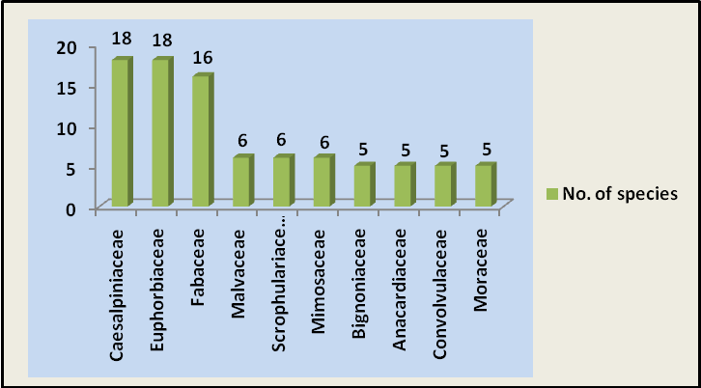
Figure 1. Dominant families of medicinal plants

The results of growth form analysis of medicinal plants showed that herbs made up the highest proportion being represented with (72 spp., 39.13%), followed by trees (61 spp., 33.15%), shrubs (27 spp., 14.67%), climbers (7 spp., 3.84%), twiners (6 spp., 3.26%), undershrubs (3 spp., 1.63%) and lianas (2 spp., 1.08%) (Fig. 2).

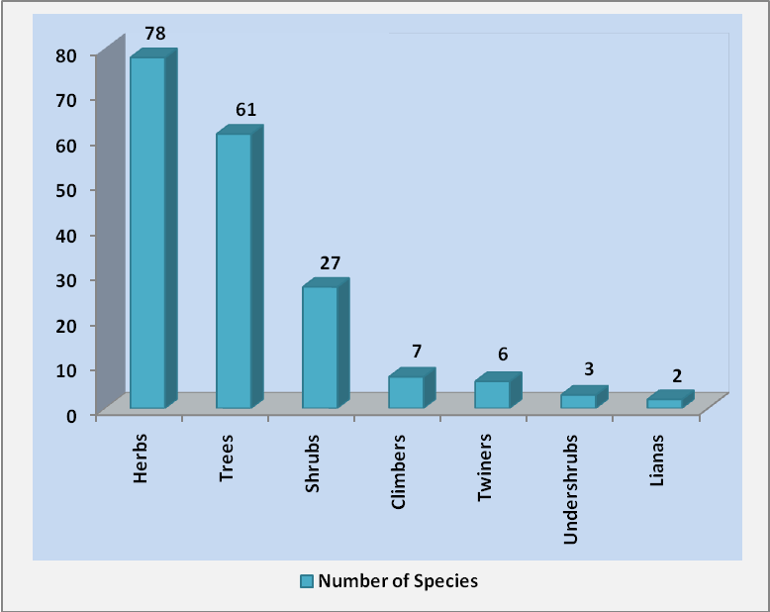
Figure 2. Habit wise distribution of ethnobotanical species

One hundred seventy (93.47%) of the medicinal species are Dicotyledons, twelve are Monocotyledons (6.52%), one is fern and gymnosperm (1.5% each). Different preparations and applications of medicinal plants are shown in Fig. 3. The methods reported for internal use were paste, decoction, powder, juice, oral, extract, infusion, oil and ash. The methods documented for external use included paste, decoction, powder, juice, extract, infusion, oil, ash and direct application of fresh or boiled plant material. Overall, paste was the most cited preparation (31%) followed by decoction (24%), powder (15%), juice (9%), extract, oral (8% each), infusion, oil (2%) and ash (1%).

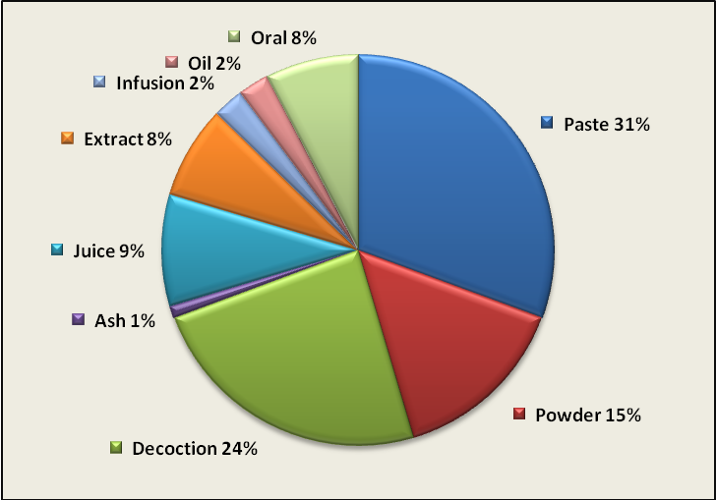
Figure 3. Different preparation methods

The plant parts/product used for medicinal purposes are shown in the Fig. 4, and the and the leaves (17.74%) may be concluded as the most frequently used part followed by bark (14.51%), roots, whole plant (12.90% each), seeds (9.67%), latex (8.06%), rhizome (6.45%), flowers (4.83%), gum, resin (3.22% each) and wood, branch, root bark (1.61% each).

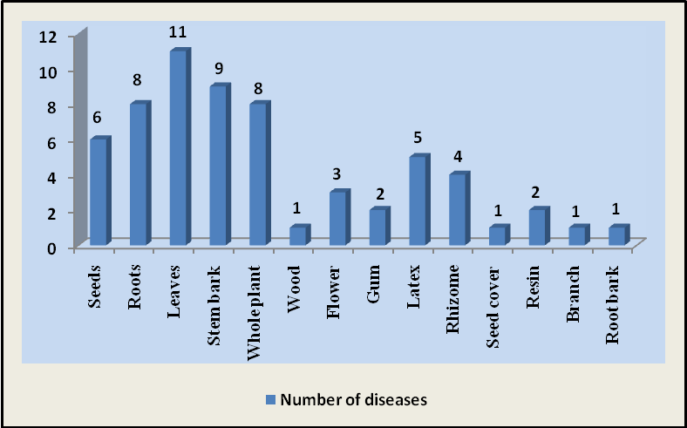
Figure 4. Plant parts used as medicine

The 184 traditional medicinal plants may cure 12 kinds of infectious diseases, among which the dysentery (28.07%) is the most common illness treated followed by Diarrhoea (21.92%), Skin disease (17.69%), Jaundice (9.23%), Ringworm (6.15%), Tuberculosis, Leprosy (4.61% each), Eczema (2.69%), Syphilis, Itches (1.92% each), Cholera (0.76%), Dandruff (0.38%) (Fig. 5).
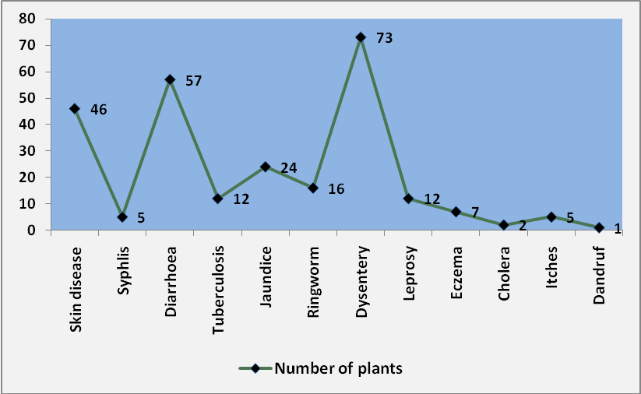
Figure 5. Diseases/symptoms cured by the 184 plants

Appendix Figures
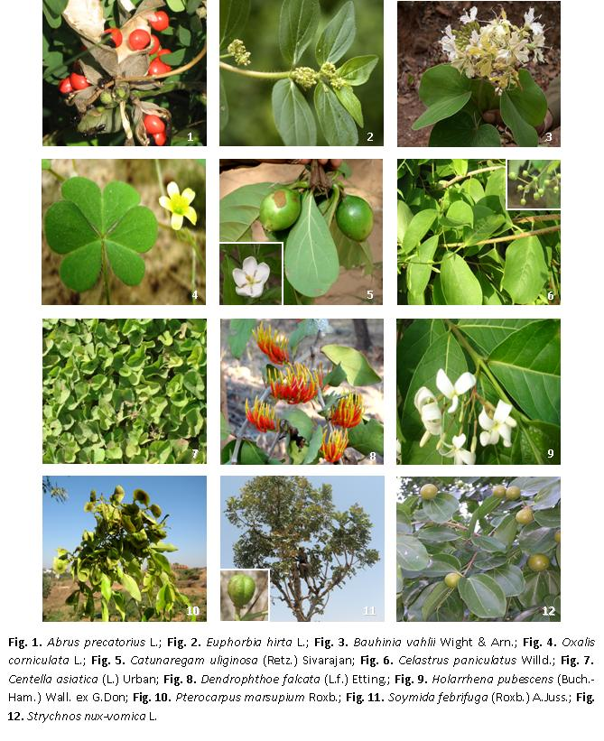
Appendix Figures: Fig. 1. Abrus precatorius L.; Fig. 2. Euphorbia hirta L.; Fig. 3. Bauhinia vahlii Wight & Arn.; Fig. 4. Oxalis corniculata L.; Fig. 5. Catunaregam uliginosa (Retz.) Sivarajan; Fig. 6. Celastrus paniculatus Willd.; Fig. 7. Centella asiatica (L.) Urban; Fig. 8. Dendrophthoe falcata (L.f.) Etting.; Fig. 9. Holarrhena pubescens (Buch.-Ham.) Wall. ex G.Don; Fig. 10. Pterocarpus marsupium Roxb.; Fig. 11. Soymida febrifuga (Roxb.) A.Juss.; Fig. 12. Strychnos nux-vomica L.

The local traditional medicinal knowledge and managing experiences which are practiced, accumulated and passed down from generation to generation may play a significant role in the sustainable use and development of plants resources. Nevertheless, along with the disappearing of biodiversity and negative effects of mainstream culture, the traditional/folk medicinal knowledge of many ethnic groups is facing the danger of losing. Furthermore, the losing of the traditional medicinal knowledge and culture which is the same as the disappearing of biodiversity is not a reversible process. Therefore, it is imperative to carry out the systematic investigation and research on the local traditional medicinal knowledge of Uttar Pradesh.

Table 1. Medicinal plants of Uttar Pradesh used in treatment of infectious diseases
Species Name | Field voucher no. | Local Name | Family | Habit | Parts used | Uses
Abrus precatorius L. | 262601 | Ghumchi, Ratti | Fabaceae | Climber | Seed and  root | Seeds paste in skin diseases; roots paste in dandruff and extract in syphilis.
Abutilon indicum (L.) Sweet | 262602 | Kakai | Malvaceae | Shrub | Leaf and root | Powdered leaves in diarrhoea. Powdered roots in tuberculosis.
Acacia catechu (L.f.) Willd. | 262603 | Khair | Mimosaceae | Tree | Bark | Bark paste in skin diseases.
Acacia leucophloea (Roxb.) Willd. | 262604 | Rewenja, Rayunch | Mimosaceae | Tree | Bark and root | Bark decoction in diarrhoea. Powdered roots in jaundice.
Acacia nilotica (L.) Willd. ex Delile subsp. indica (Benth.) Brenan | 262605 | Babool | Mimosaceae | Tree | Leaf | Pounded leaves in jaundice.
Acalypha indica L. | 262606 | Khokali | Euphorbiaceae | Herb | Leaf | Leaves paste in ringworm.
Acanthospermum hispidum DC. | 262607 | - | Asteraceae | Herb | Leaf | Leaves paste in skin diseases.
Achyranthes aspera L. | 262608 | Chirchiri, Latjira | Amaranthaceae | Herb | Whole plant and root | Plant ash in jaundice. Powdered roots in dysentery.
Adhatoda zeylanica Medik. | 262609 | Adusa | Acanthaceae | Shrub | Leaf | Leaves decoction in tuberculosis and paste in ringworm.
Agave americana L. | 262610 | Patangwar | Agavaceae | Herb | Leaf | Pulp of leaves in skin diseases.
Albizia lebbeck (L.) Benth. | 262611 | Siris | Mimosaceae | Tree | Leaf | Leaves juice in curing white spots on skin.
Albizzia odoratissima (Willd.) Benth. | 262612 | - | Mimosaceae | Tree | Bark | Bark paste in leprosy, and other skin diseases.
Ammannia baccifera L. | 262613 | - | Lythraceae | Herb | Leaf | Leaves paste in skin diseases.
Anagallis arvensis L. | 262614 | Krishna neel | Primulaceae | Herb | Whole plant | Plants paste in leprosy.
Apluda mutica L. | 262615 | Sutara | Poaceae | Herb | Whole plant | Plants juice in dysentery.
Ardisia solanacea Roxb. | 262616 | - | Myrsinaceae | Shrub | Root | Roots decoction in diarrhoea.
Argemone mexicana L. | 262617 | Bharbhanda, Kateli | Papaveraceae | Herb | Whole plant and root | Plants juice in jaundice and skin diseases. Roots extract in itching.
Argyreia nervosa (Burm. f.) Bojer | 262618 | Samandar-ka-pat | Convolvulaceae | Climber | Leaf | Leaves paste in skin diseases.
Asparagus racemosus Willd. | 262619 | Satawar | Liliaceae | Herb | Root | Powdered roots in jaundice.
Azadirachta indica A.Juss. | 262620 | Neem | Meliaceae | Tree | Leaf and seed | Leaves decoction in skin diseases. Seeds oil in leprosy.
Bacopa monnieri (L.) Wettst. | 262621 | Jalneem, Brahmi | Scrophulariaceae | Herb | Whole plant and seed | Plants decoction in epilepsy. Seeds paste in skin disease.
Balanites aegyptiaca (L.) Delile | 262622 | Ingua, Hingot | Simaroubaceae | Small tree | Fruit | Fruits pulp in tuberculosis.
Bambusa arundinacea (Retz.) Willd. | 262623 | Bans | Poaceae | Tree | Wood | Wood oil in eczema.
Bauhinia acuminata L. | 262624 | Sivamalli | Caesalpiniaceae | Shrub | Bark | Bark decoction in leprosy.
Bauhinia racemosa Lam. | 262625 | Kachnal | Fabaceae | Small tree | Bark | Pounded bark powder in dysentery and diarrhoea.
Bauhinia tomentosa L. | 262626 | Kachnar | Caesalpiniaceae | Small tree | Leaf and flower | Dried leaves and flowers in dysentery.
Bauhinia vahlii Wight & Arn. | 262627 | Mohlain | Caesalpiniaceae | Liana | Bark and root | Bark decoction in dysentery and cholera. Roots extract in syphilis.
Bauhinia variegata L. | 262628 | Kachnar | Caesalpiniaceae | Small tree | Bark | Bark decoction in dysentery, leprosy, syphilis and other skin diseases.
Boerhavia diffusa L. | 262629 | Santan, Santh, Gadapurena, Punarnava | Nyctaginaceae | Herb | Leaf | Leaves decoction in jaundice. Cooked leaves in jaundice.
Bombax ceiba L. | 262630 | - | Bombacaceae | Tree | Fruit | Fruits in dysentery.
Bridelia stipularis (L.) Blume | 262631 | Khaji | Euphorbiaceae | Small tree | Leaf | Leaves decoction in jaundice.
Buchanania lanzan Spreng. | 262632 | Chirongi | Anacardiaceae | Tree | Leaf, gum, and seed | Leaves paste in skin diseases. Gum in diarrhoea. Seeds paste in skin diseases.
Buddleja asiatica Lour. | 262633 | Nayari | Loganiaceae | Shrub | Leaf | Leaves paste in eczema.
Bulbostylis barbata (Rottb.) C.B.Clarke | 262634 | - | Cyperaceae | Herb | Whole plant | Plant paste in dysentery.
Butea monosperma (Lam.) Taub. | 262635 | Chihula, Palas | Fabaceae | Small tree | Leaf, flower, bark and gum | Leaves paste in blood dysentery and ringworms. Flowers decoction in skin diseases. Bark decoction in dysentery. Gum in diarrhoea and dysentery.
Butea parviflora Roxb. | 262636 | Vyavhar | Fabaceae | Liana | Flower | Flowers decoction in skin disease.
Cajanus cajan (L.) Millsp. | 262637 | Arhar, Rahar | Fabaceae | Shrub | Leaf and root | Leaves paste in cholera and jaundice. Powdered leaves and roots in dysentery.
Cajanus scarabaeoides (L.) du Petit-Thouars, | 262638 | Bankulthi | Fabaceae | Shrub | Whole plant | Plants decoction in dysentery.
Calotropis gigantea (L.) R.Br. | 262639 | Akaua | Asclepiadaceae | Shrub | Root | Powdered root bark in jaundice.
Calotropis procera (Aiton) R.Br. | 262640 | Madar | Asclepiadaceae | Shrub | Leaf and latex | Leaves paste on skin diseases. Latex in itching, eczema, ringworm, and leprosy.
Capparis spinosa L. | 262641 | Baferu | Capparaceae | Shrub | Root | Roots extract in jaundice.
Capsella bursa-pastoris (L.) Medik. | 262642 | - | Brassicaceae | Herb | Leaf | Leaves juice in dysentery.
Carica papaya L. | 262643 | Papita | Caricaceae | Tree | Latex | Latex in ringworm and jaundice.
Casearia tomentosa Roxb. | 262644 | Chilla | Samydaceae | Small tree | Bark | Bark juice in ringworm.
Cassia absus L. | 262645 | Chaksu | Caesalpiniaceae | Herb | Seed | Seeds paste in skin diseases.
Cassia fistula L. | 262646 | Amaltas | Caesalpiniaceae | Small tree | Leaf,  Fruit and seed | Leaves paste in skin diseases. Fruits in dysentery. Powdered seeds in jaundice.
Cassia obtusifolia L. | 262647 | Panevar | Caesalpiniaceae | Herb | Root | Roots paste in ringworm.
Cassia occidentalis L. | 262648 | Chakwad | Caesalpiniaceae | Undershrub | Leaf | Leaves paste in skin disease.
Cassia tora L. | 262649 | Chakunda | Caesalpiniaceae | Undershrub | Whole plant and seed | Plants paste in skin diseases. Seeds paste on itches, eczema and ringworm.
Cassine glauca (Rottb.) Kuntze | 262650 | Mamar | Celastraceae | Tree | Root | Root bark extract in dysentery.
Casuarina equisetifolia L. | 262651 | Jhau, Jangli saru | Casuarinaceae | Tree | Bark | Bark decoction in diarrhoea and dysentery.
Catunaregam uliginosa (Retz.) Sivarajan | 262652 | Pindalu | Rubiaceae | Small tree | Fruit | Fruits in dysentery.
Celastrus paniculatus Willd. | 262653 | Unjan | Celastraceae | Liana | Fruit | Fruits paste in dysentery and diarrhoea.
Celosia argentea L. | 262654 | Safed murga ka phul | Amaranthaceae | Herb | Seed | Powdered seeds in diarrhoea and dysentery.
Centella asiatica (L.) Urban | 262655 | Brahmi-buti | Apiaceae | Herb | Whole plant | Plants decoction in skin diseases and leprosy.
Chloroxylon swietenia DC. | 262656 | Bharhul, Bharuee | Meliaceae | Tree | Bark | Bark decoction in jaundice.
Cissampelos pareira L. | 262657 | Batulia | Menispermaceae | Climber | Root | Roots extract in dysentery.
Citrus medica L. | 262658 | Neembu | Rutaceae | Shrub | Fruit | Fruits juice in dysentery.
Clerodendrum cordatum D.Don | 262659 | Bhat | Verbenaceae | Shrub | Bark | Powdered bark in skin diseases.
Clitoria ternatea L. | 262660 | Gokari, Aparajita | Fabaceae | Climber | Root | Powdered roots in dysentery.
Cocculus hirsutus (L.) Diels | 262661 | Charenti | Menispermaceae | Herb | Whole plant and Leaf | Plants decoction in dysentery. Leaves paste in eczema.
Commelina diffusa Burm.f. | 262662 | - | Commelinaceae | Herb | Whole plant | Plants paste on itches.
Corchorus aestuans L. | 262663 | Chench | Tiliaceae | Herb | Whole plant | Plants decoction in diarrhoea.
Corchorus capsularis L. | 262664 | Kharenti | Tiliaceae | Herb | Leaf | Leaves decoction in dysentery.
Coriandrum sativum L. | 262665 | Dhania | Apiaceae | Herb | Fruit | Powdered fruits in dysentery.
Croton bonplandianus Baill. | 262666 | - | Euphorbiaceae | Herb | Leaf | Leaves decoction in diarrhoea.
Cuminum cyminum L. | 262667 | Jeera | Apiaceae | Herb | Seed | Powdered seeds in diarrhoea.
Curculigo orchioides Gaertn. | 262668 | Kali-musali | Hypoxidaceae | Herb | Whole plant and root | Plants paste in jaundice and diarrhoea. Roots paste on itching and other skin diseases.
Curcuma longa L. | 262669 | Haldi | Zingiberaceae | Herb | Rhizome | Powdered rhizomes in skin diseases.
Cynodon dactylon (L.) Pers. | 262670 | Dubghas | Poaceae | Herb | Whole plant | Plants paste in leprosy.
Dendrophthoe falcata (L.f.) Etting. | 262670 | Banda | Loranthaceae | Shrub | Whole plant | Plants extract in tuberculosis.
Desmodium triflorum (L.) DC. | 262672 | Throughout years | Fabaceae | Herb | Leaf | Leaves paste in diarrhoea and dysentery.
Diospyros exsculpta Buch-Ham. | 262673 | Tendu or Kundi | Ebenaceae | Shrub | Fruit | Fruits pulp in dysentery and diarrhoea.
Diospyros malabarica (Ders.) Kostel | 262674 | Tendu | Ebenaceae | Tree | Bark | Powdered bark in dysentery.
Emblica officinalis Gaertn. | 262675 | - | Euphorbiaceae | Tree | Bark | Bark decoction in diarrhoea, dysentery and cholera.
Euphorbia hirta L. | 262676 | Dudhi | Euphorbiaceae | Herb | Whole plant | Plants juice in dysentery.
Euphorbia thymifolia L. | 262677 | Lal dudhi | Euphorbiaceae | Herb | Whole plant | Plants decoction in blood dysentery.
Feronia limonia L. | 262678 | Kaith | Rutaceae | Tree | Fruit | Fruits in diarrhoea and dysentery.
Ficus benghalensis L. | 262679 | Bargad | Moraceae | Tree | Bark | Bark infusion in diarrhoea and dysentery.
Ficus glomerata Roxb. | 262680 | Gular | Moraceae | Tree | Fruit | Fruits infusion in diarrhoea and dysentery.
Ficus heterophylla L.f. | 262681 | Traymana | Moraceae | Shrub | Leaf | Leaves juice in dysentery.
Ficus racemosa L. | 262682 | Gular | Moraceae | Tree | Latex and fruit | Latex in dysentery. Fruits in diarrhoea.
Flacourtia indica (Burm.f.) Merr. | 262683 | Rakatsonk, Kateyya | Flacourtiaceae | Small tree | Bark and fruit | Bark decoction in dysentery and eczema. Fruits juice in jaundice.
Flacourtia jangomas (Lour.) Raeusch. | 262684 | Paniyala | Flacourtiaceae | Small tree | Leaf | Leaves paste in diarrhoea.
Hamelia patens Jacq. | 262685 | - | Rubiaceae |  | Fruit | Berries-syrup in dysentery.
Hedychium coronarium Buch.-Ham. | 262686 | Seerh | Zingiberaceae | Shrub | Rhizome | Powdered rhizomes in diarrhoea.
Helicteres isora L. | 262687 | Murerua or Rasbhari or Aithan | Sterculiaceae | Shrub | Fruit, bark and seed | Fruits paste in dysentery. Bark in diarrhoea and dysentery. Seeds paste in dysentery.
Hemidesmus indicus (L.) R.Br. | 262688 | Cherdudhia | Asclepiadaceae | Herb | Leaf and root | Leaves infusion in diarrhoea. Roots extract in eczema and ringworm infection.
Hibiscus rosa-sinensis L. | 262689 | Gurhal | Malvaceae | Shrub | Flower | Flowers extract in tuberculosis.
Holarrhena pubescens (Buch.-Ham.) Wall. ex G.Don | 262690 | Chirol | Apocynaceae | Shrub | Bark | Bark decoction in dysentery; paste in diarrhoea.
Holoptelea integrifolia (Roxb.) Planch. | 262691 | Chilbil | Ulmaceae | Tree | Leaf | Leaves paste in ringworm.
Hyptis suaveolens (L.) Poit. | 262692 | Bantulsi | Lamiaceae | Herb | Seed | Seeds oil in skin diseases.
Indigofera astragalina DC. | 262693 | Hairy Indigo | Fabaceae | Herb | Leaf | Leaves decoction in diarrhoea.
Indigofera linnaei Ali | 262694 | Latahai | Fabaceae | Herb | Leaf | Leaves decoction in diarrhoea.
Ipomoea eriocarpa R.Br. | 262695 | Nakhari | Convolvulaceae | Twiner | Whole plant | Plants paste in leprosy.
Ipomoea nil (L.) Roth | 262696 | Paturia/ Kala dana | Convolvulaceae | Climber | Seed | Pounded seeds in diarrhoea.
Jacaranda mimosaefolia D.Don | 262697 | Nila gulmohar | Bignoniaceae | Tree | Leaf and bark | Leaves in syphilis.
Jasminum humile L. | 262698 | Pili - Chameli | Oleaceae | Shrub | Root | Roots paste in ringworm.
Jatropha curcas L. | 262699 | Rtanjot | Euphorbiaceae | Shrub | Bark | Powdered bark in dysentery and tuberculosis.
Jatropha gossypifolia L. | 262700 | Banren | Euphorbiaceae | Shrub | Leaf | Leaves paste in eczema and itches.
Kigelia africana (Lam.) Benth. | 262701 | Balamkhira | Bignoniaceae | Tree | Fruit | Fruits paste in skin diseases.
Kyllingia brevifolia Rottb. | 262702 | - | Cyperaceae | Herb | Leaf | Powdered leaves in diarrhoea.
Lablab purpureus (L.) Sweet | 262703 | Sem | Fabaceae | Climber | Leaf | Leaves paste on skin diseases.
Lannea coromandelica (Houtt.) Merr. | 262704 | Jingna | Anacardiaceae | Tree | Bark | Bark decoction in skin disease.
Lawsonia inermis L. | 262705 | Mehandi | Lythraceae | Shrub | Leaf | Leaves juice in dysentery.
Leonotis nepetifolia (L.) R.Br. | 262706 | Baraguma, Hejurchei | Lamiaceae | Herb | Flower | Flowers paste in skin infection.
Leucas cephalotes (Koenig ex Roth) Spreng. | 262707 | Gumma | Lamiaceae | Herb | Leaf | Leaves decoction in dysentery and diarrhoea.
Limonia acidissima L. | 262708 | Kaitha/Kait | Rutaceae | Tree | Fruit | Fruits pulp in diarrhoea and dysentery.
Lindenbergia muraria (Roxb. ex D.Don) Bruehl | 262709 | - | Scrophullariaceae | Herb | Leaf | Powdered leaves in tuberculosis.
Lindernia crustacea (L.) F.v.Muell. | 262710 | - | Scrophullariaceae | Herb | Whole plant | Plants in dysentery and ringworm.
Ludwigia adscendens (L.) Hara | 262711 | - | Onagraceae | Herb | Whole plant | Plants paste in skin diseases.
Ludwigia octovalvis (Jacq.) Raven | 262712 | - | Onagraceae | Herb | Whole Plant | Plants extract in diarrhoea.
Luffa acutangula (L.) Roxb. | 262713 | Satputia | Cucurbitaceae | Climber | Leaf | Leaves paste in leprosy.
Mallotus philippensis (Lam.) Muell. Arg. | 262714 | Rohini | Euphorbiaceae | Tree | Leaf, fruit and bark | Leaves paste in skin diseases. Powdered fruits in dysentery. Bark decoction in jaundice.
Malvastrum coromandelianum (L.) Garcke | 262715 | Bariara | Malvaceae | Herb | Seed | Seeds decoction in dysentery.
Mangifera indica L. | 262716 | Aam | Anacardiaceae | Tree | Bark and fruit | Fruits pulp in dysentery. Bark decoction in jaundice.
Martynia annua L. | 262717 | Biswat | Martyniaceae | Shrub | Seed | Seeds oil in eczema and other skin diseases.
Medicago polymorpha L. | 262718 | Jangli ghas | Fabaceae | Herb | Leaf | Leaves decoction in dysentery.
Melilotus indica (L.) All. | 262719 | Senji | Fabaceae | Herb | Seed | Seeds in diarrhoea.
Melochia corchorifolia L. | 262720 | Bilpat | Sterculiaceae | Undershrub | Leaf | Leaves decoction in dysentery.
Mimusops elengi L. | 262721 | Maulsiri | Sapotaceae | Tree | Bark | Bark decoction in dysentery.
Nelumbo nucifera Gaertn. | 262722 | Kamal | Nelumbonaceae | Herb | Rhizome | Powdered rhizomes in diarrhoea and dysentery.
Nymphaea nouchali Burm.f. | 262723 | Kamal | Nympheaceae | Herb | Rhizome | Powdered rhizomes in dysentery and diarrhoea.
Ochna pumila Buch.-Ham. ex D.Don | 262724 | Bhuikusum | Ochnaceae | Undershrub | Root | Roots decoction in dysentery and diarrhoea.
Operculina turpethum (L.) Manso | 262725 | Pipal pant | Convolvulaceae | Climber | Leaf | Leaves sap in itching and ringworm.
Oroxylum indicum (L.) Venten | 262726 | - | Bignoniaceae | Tree | Leaf, bark and root | Leaves decoction in diarrhoea. Bark decoction in jaundice. Roots decoction in dysentery.
Ougeinia oogeinensis (Roxb.) Hochr. | 262727 | Sanan | Fabaceae | Tree | Bark | Bark decoction in dysentery and diarrhoea.
Oxalis corniculata L. | 262728 | Khatibuti, Khatamithi, Teepatiya | Oxalidaceae | Herb | Leaf | Leaves decoction in dysentery.
Peltophorum pterocarpum (DC.) Baker ex K.Heyne | 262729 | Copper pod | Caesalpiniaceae | Tree | Bark | Powdered bark in dysentery.
Phanera integrifolia (Roxb.) Benth. | 262730 | Mohlain | Caesalpiniaceae |  | Root | Roots extract in syphilis.
Phyllanthus virgatus Forst.f. | 262731 | Banaunri | Euphorbiaceae | Herb | Leaf | Leaves juice in dysentery.
Pistia stratiotes L. | 262732 | Pistia, Jalkumbhi | Araceae | Herb | Leaf | Leaves juice in skin diseases.
Plantago ovota Forssk. | 262733 | Isaphgol | Plantaginaceae | Herb | Seed cover | Husk in dysentery and diarrhoea.
Pongamia pinnata (L.) Pierre | 262734 | Karanj | Rhamnaceae | Tree | Seed | Powdered seeds in ringworm.
Premna latifolia Roxb. | 262735 | Bakar | Verbenaceae | Small tree | Bark | Bark extract in ringworm.
Prosopis cineraria (L.) Druce. | 262736 | Chaonka | Mimosaceae | Small tree | Leaf | Leaves paste in ringworm.
Psidium guajava L. | 262737 | Amrood | Myrtaceae | Small tree | Leaf | Leaves extract in cholera, diarrhoea and dysentery.
Pterocarpus marsupium Roxb. | 262738 | Vijasal | Fabaceae | Tree | Leaf | Leaves paste in skin diseases.
Quisqualis indica L. | 262739 | Malti | Combrataceae | Tree | Seed | Seeds in diarrhoea.
Raphanus sativus L. | 262740 | Mooli | Brassicaceae | Herb | Root | Roots juice in jaundice
Ricinus communis L. | 262741 | Rendi | Euphorbiaceae | Small tree | Leaf | Leaves decoction in jaundice.
Rivea hypocrateriformis (Desr.) Choisy | 262742 | Phang | Convolvulaceae | Climber | Leaf and seed | Leaves paste in tuberculosis. Powdered seeds in tuberculosis.
Saccharum officinarum L. | 262743 | Ikh | Poaceae | Herb | Whole plant | Plants juice in jaundice.
Sapindus trifoliatus L. | 262744 | Reetha | Sapindaceae | Tree | Fruit | Fruits paste in leprosy.
Saraca asoca (Roxb.) de Wilde | 262745 | Ashok | Caesalpiniaceae | Tree | Flower | Flowers infusion in blood dysentery.
Scoparia dulcis L. | 262746 | Sweet broom weed | Scrophullariaceae | Herb | Leaf | Powdered leaves in diarrhoea.
Selaginella bryopteris (L.) Bak. | 262747 | Kamraj | Selaginellaceae | Herb | Whole plant | Plants paste in dysentery.
Semecarpus anacardium L.f. | 262748 | Bhela | Anacardiaceae | Tree | Resin | Gum-resin in leprosy and skin diseases.
Shorea robusta Roxb. ex Gaertn.f. | 262749 | Sal, Sakhul | Dipterocarpaceae | Tree | Fruit and gum | Fruits paste in dysentery. Gum in dysentery.
Sida cordata (Burm.f.) Borss. | 262750 | Baharbuta | Malvaceae | Herb | Whole plant | Plants extract in dysentery.
Sida rhombifolia L. | 262751 | Sahadevi | Malvaceae | Herb | Whole plant | Plants powder in tuberculosis.
Solanum nigrum L. | 262752 | Makoi | Solanaceae | Herb | Whole plant and leaf | Plants juice in diarrhoea and decoction in jaundice. Leaves paste in skin diseases and decoction in jaundice.
Solanum surattense Burm.f. | 262753 | Kantakeri | Solanaceae | Herb | Flower | Flowers juice in diarrhoea.
Solanum viarum Dunal | 262754 | - | Solanaceae | Herb | Fruit | Fruits extract in jaundice.
Sonchus wightianus DC. | 262755 | Gobhi | Asteraceae | Herb | Root | Powdered roots in tuberculosis.
Soymida febrifuga (Roxb.) A.Juss. | 262756 | - | Meliaceae | Tree | Bark | Bark decoction in diarrhoea.
Spathodea campanulata P.Beauv. | 262757 | Rugtoora | Bignoniaceae | Tree | Bark | Bark paste in skin diseases and dysentery.
Spergula arvensis L. | 262758 | - | Caryophyllaceae | Herb | Whole plant | Plants in tuberculosis.
Spondias pinnata (L.f.) Kurz | 262759 | Amra, Wild Mango | Anacardiaceae | Tree | Bark | Bark decoction in diarrhoea and dysentery.
Stephania japonica (Thunb.) Miers | 262760 | Vanatikatika | Menispermaceae | Herb | Root | Roots decoction in diarrhoea.
Streblus asper Lour. | 262761 | Sihoor | Moraceae | Tree | Bark | Bark decoction in diarrhoea and dysentery.
Strychnos nux-vomica L. | 262762 | Kuchila | Loganiaceae | Tree | Seed | Seeds paste in eczema and ringworm.
Syzygium cumini (L.) Skeels | 262763 | - | Myrtaceae | Tree | Bark | Bark juice in diarrhoea.
Syzygium heyneanum Wall. ex Duthie | 262764 | Jamati | Myrtaceae | Tree | Bark | Bark paste in dysentery.
Tecomaria capensis (Thunb.) Spach | 262765 | - | Bignoniaceae | Shrub | Leaf | Leaves decoction in diarrhoea.
Tephrosia purpurea (L.) Pers. | 262766 | Sarpokha | Fabaceae | Herb | Leaf | Leaves paste in skin diseases.
Terminalia arjuna (Roxb. ex DC.) Wight & Arn. | 262767 | Arjun | Combrataceae | Tree | Bark | Bark decoction in dysentery, jaundice and cholera.
Terminalia bellirica (Gaertn.) Roxb. | 262768 | Bahera | Combrataceae | Tree | Fruit | Powdered fruits in leprosy and diarrhoea.
Terminalia chebula Retz. | 262769 | Harra | Combrataceae | Tree | Fruit and seed | Fruits paste in dysentery and diarrhoea. Seeds powder in diarrhoea.
Thalictrum foliolosum DC. | 262770 | Supowa | Ranunculaceae | Herb | Root | Roots extract in dysentery and diarrhoea.
Thespesia populnea (L.) Soland. ex Corrêa | 262771 | Parsipu | Malvaceae | Small tree | Bark and seed | Seeds paste in skin troubles. Bark in dysentery.
Thuja orientalis L. | 262772 | Morpankhi | Cupressaceae | Small tree | Leaf | Leaves ash in dysentery.
Toona ciliata M.Roem. | 262773 | Tun, Mahaneem | Meliaceae | Tree | Bark | Bark paste in dysentery.
Trachyspermum ammi (L.) Sprague | 262774 | Ajwain | Apiaceae | Herb | Seed | Seeds paste in diarrhoea.
Urtica dioica L. | 262775 | Bichhughas | Urticaceae |  | Whole plant | Plants decoction in jaundice.
Verbascum chinense (L.) Sant. | 262776 | - | Scrophulariaceae | Herb | Leaf | Leaves juice in skin disorders.
Veronica anagallis-aquatica L. | 262777 | Titlokia | Scrophulariaceae | Herb | Root | Roots decoction in diarrhoea.
Vitis vinifera L. | 262778 | Angur | Vitaceae | Climber | Branch | Sap of young branches in skin infections.
Wahlenbergia marginata (Thunb.) DC. | 262779 | - | Campanulaceae | Herb | Whole plant | Plants paste in skin troubles.
Xanthium indicum Koenig | 262780 | Bichchu, Gokharu, Kaktoni | Asteraceae | Herb | Leaf and seed | Leaves juice in ringworms. Seeds oil in skin diseases.
Zingiber officinale Roscoe | 262781 | Adrak | Zingiberaceae | Herb | Rhizome | Powdered rhizomes in tuberculosis.
Ziziphus mauritiana Lam. | 262782 | Ber | Rhamnaceae | Small tree | Seed | Seeds decoction in diarrhoea.
Ziziphus oenoplia (L.) Mill. | 262783 | Jharberi | Rhamnaceae | Shrub | Fruit | Fruits paste in dysentery.
Ziziphus xylopyra Willd. | 262784 | Guthar | Rhamnaceae | Small tree | Root bark | Roots bark extract in dysentery.

4. Conclusions
The study is of great importance to preserve the knowledge of medicinal plants used by the tribal people and exploit the knowledge in treatment of various diseases. Moreover, further phytochemical and pharmacological studies of little noticed medicinal plants are an urgent need to understand the underlying mechanism of traditional treatment systems. On the other hand, these plants hold tremendous potentials for pharmaceutical products of commercial values. The search for new biologically active compounds from plants usually starts in the field and depends on the specific ethnic and folk information obtained from local practitioners. The conservation of the medicinal plants is an essential requirement for maintaining traditional medicine as a medicinal and cultural resource.

Acknowledgments:
The authors express thanks to the local communities for revealing their traditional medical knowledge for the benefit of everyone. Authors are also thankful to the Director, NBRI, Lucknow for providing facilities to carry out research work and NAIP, ICAR, New Delhi for providing Research Associateship to the first author.

Corresponding Author:
Dr. Achuta Nand Shukla
Botanical Survey of India, Northern Regional Centre,
192-Kaulagarh Road, Dehradun-248195, India
E-mail: achutbsi@gmail.com

References
- World Health Organization (WHO). Deaths by cause, sex and mortality stratum in WHO Regions, estimates for 2001. www.wpro.who.int/health topics/traditional medicine, 2002.
- Infectious disease, MacGraw-Hill Encyclopedia of Science and Technology. The McGraw-Hill Companies, Inc, 2005.
- Posey D. Traditional knowledge, conservation and “The Rain Forest Harvest”. In Sustainable Harvest and Marketing of Rain Forest Products, 1989.
- Reddy CS, Prasad PRC, Raza SH, Dutt CBS. Folklore medicinal plants of North Andaman, India Natl Acad Sci Lett 2008;31(9&10): 269-276.
- Jain SK, Rao RR. Handbook of Field and Herbarium Methods. Goyal Offsets, Delhi, 1977.
- Brummitt RK, Powell CE. Authors of plant names: a list of authors of scientific names of plants, with recommended standard forms of their names, including abbreviations, Kew, Royal Botanic Gardens, 1992.
- Uniyal BP, Balodi B, Nath B. Grasses of Uttar Pradesh-A checklist. Bishen Singh Mahendra Pal Singh, Dehradun, 1994.
- Uniyal SK, Swami A, Uniyal BP. Cyperaceae of Uttar Pradesh-A checklist. Bishen Singh Mahendra Pal Singh, Dehradun, 1997.
- Uniyal SK, Swami A, Uniyal BP. Monocotyledonous plants of Uttar Pradesh-(Excluding Cyperaceae & Poaceae) A-checklist. Bishen Singh Mahendra Pal Singh, Dehradun, 1999.
- Khanna KK, Mudgal V, Uniyal BP, Sharma JR. Dicotyledonous plants of Uttar Pradesh-A checklist. Bishen Singh Mahendra Pal Singh, Dehradun. 1999.

7/1/2013

