Morphology and anatomy of egg and oncomiracidium of the monogenean gill parasite Diplectanum aequanus

Abdel Aziz A. Khidr, Ola A. Abu Samak, Ashraf, E. Said and Marwa, M. Abou Hadied

Zoology Department, Faculty of Science, Damietta University, Egypt
E- mail: rosalina_marwa@yahoo.co.uk

Abstract: Morphology and anatomy of the egg and free swimming oncomiracidia of Diplectanum aequanus infesting the gills of Dicentrarchus labrax were studies. Freshly laid egg of Diplectanum aequanus is yellowish brown in color, operculate, more or less tetrahedral with rounded protuberances at each corner and is provided with non-adhesive single appendage. The findings of the present study indicate that the appendage of the egg may ensure to a suitable anchoring and prevent the egg drift away from areas inhabited by potential host. Embryonation period ranged from 6 to 7 days at (20±2) °C with prominent developmental features is the formation of eyespots, which appeared on day 4 at 20±2°C. Hatching take place at the sixth day after deposition. Hatching process continued for about 10 to 15 minutes in the morning, one to two hours after sunrise. Oncomiracidial behaviour patterns were recorded. The free swimming oncomiracidium possesses four zones of ciliated cells (one anterior; two lateral and one posterior); four pigmented eyes; a prominent pharynx and a groups of gland cells on each side of the pharynx. The opisthaptor of each oncomiracidium has two pairs of well-developed hamuli in the centre of the opisthaptor in addition to usually present of 14 peripherally marginal hooklets. The distribution of the ciliated cells and possible functions of the pigmented eyes; lateral gland cells and haptoral sclerites are discussed.
[Kharkwal G, Mehrotra P, Rawat YS. Morphology and anatomy of egg and oncomiracidium of the monogenean gill parasite Diplectanum aequanus. Nat Sci 2013;11(9):48-54]. (ISSN: 1545-0740). http://www.sciencepub.net/nature. 7

Key words: Diplectanides, Dicentrarchus labrax, Diplectanum aequanus, monogenean life cycle.

INTRODUCTION
Dicentrarchus labrax (Sea bass) is the most important commercial fish species in Egypt and it is commonly used in aquaculture (Holder, 2003). Sea bass is an economically important cultured fish species in the Mediterranean coastal waters. The market demand is great and as a result, the price for fresh Dicentrarchus labrax has increased markedly over the past decade due to the desirable aroma and quality attributes of this fish; consequently, its farming is deemed to be a profitable business. Thus, many fish farms on the Mediterranean coasts have gradually expanded for the last decade (Manera and Dezfuli, 2003; Johnson et al., 2004 and Caruso et al., 2005).
Nevertheless the infections with parasite have assumed an increasingly role among the factors limiting aquaculture productivity, particularly those with direct life cycles, such as Monogeneans (Buchmann and Lindenstrøm 2002; Fioravanti et al., 2006 and Hayward et al., 2007). They are often responsible for economic losses for the activities of fish farming and have acquired an increasing importance as pathogens in marine fish (Poulin and Rohde, 1997).
A monogenean parasite, Diplectanum aequans is a common parasite of D. labrax and has a wide geographic distribution (Dezfuli et al., 2007 and Whittington and Chisholm, 2008). The simple life cycle has sufficient evolutionary plasticity to enable monogeneans to adapt to fishes living in a range of marine and freshwater habitats (Kearn, 1986). Much has been learned about the life cycles of ectoparasitic monogenean in the context of their serving as pathogens of ﬁshes in aquaculture (Whittington and Chisholm, 2008), details of their life histories on associated ﬁshes are understudied. For example, it is generally unknown what transpires i) in the water column as the oncomiracidium seeks its ﬁsh host, ii) on the newly infected host as the post-oncomiracidium seeks an optimal microhabitat, and iii) within the optimal microhabitat as the post-oncomiracidium develops to an adult. Therefore, the present study is plane to give some light on life cycle of Diplectanum aequans. Moreover, this study may give some useful informations which help fisheries during control strategies parasite infections of the life cycle of Diplectanum aequans in order to design prophylactic and therapeutic measures against the parasite in fish cultures.
MATERIAL AND METHODES:
Specimens of the marine water fish Dicentrachus labrax were collected from the Mediterranean coast at Ras El-Bar at Damietta Province, in Egypt. Fishes were dissected to be searched for the monogenean parasites. The living mature monogenean parasite Diplectanum aequanus were carefully removed from excised gills and placed in separate dishes containing marine water where they were allowed to lay eggs at different temperatures (14°C±2 and 20°C). Freshly laid eggs were studied morphologically using light microscopy. Groups of eggs were transferred to small dishes containing filtered marine water and incubated at room temperatures (20±2°C) under natural light. Eggs were observed daily to examine the free swimming oncomiracidium. The behaviour and anatomy of the oncomiracidium were observed using stereo-microscopy. The anatomy of the free swimming oncomiracidia was studied. All measurements are given in µm.
RESULTS:
- The Egg:-
Freshly laid eggs of Diplectanum aequanus are yellowish brown in color, operculate, more or less tetrahedral with rounded protuberances at each corner (Fig. 1). The egg measures 73.6µm by long and measured 105.6µm by width. The filament (appendage) measures about 25.6 µm by long and arises from one pole.
The operculum has not been observed in the freshly laid eggs but begins to observe at the late stages of egg development, on the corner of tetrahedral egg. Numerous vitellaria fill most of the internal space of the egg (Fig. 2).
Embryonation to hatching takes (6-7) days at (20±2) °C. One of the prominent developmental features is the formation of eyespots, which appeared on day 4 at 20±2°C.
- Hatching and the hatching time:-
Hatching take place at the sixth day of incubation at temperature 20±2°C under natural light. A few minutes before hatching, contraction and relaxation of oncomiracidia body started and the secretion from the median head gland cells was discharged towards the suture of the operculum. As a result of the rotation of oncomiracidia head towards the operculum and the continuous secretion produced by the median head glands, two small lateral splits were observed through the operculum suture.
Consequently, the operculum is opened suddenly and most of oncomiracidia liberated from the egg by its anterior and first end the fluid-filled sac was swelled during the emergence of the oncomiracidia and finally was burst. The whole process of hatching continued for about 10 to 15 minutes. In most cases, hatching occurs in the morning, one to two hours after sunrise.
- Behavior of the oncomiracidia:-
Swimming pattern of the oncomiracidia was mainly of two types: vertical swimming in the water column and horizontal swimming close to the bottom. After emerges from the eggshell, it swimmed in the mid water near the side of the dish for a short time, then moved to the upper surface of the water in a wavy movement. After vertical swimming, some oncomiracidia continued swimming in spiral path or showed a horizontal and vertical whirling movement to the bottom of the dish and crept on the bottom with its anterior half of the body for a short time, then swimmed to the middle of the dish again.
- The oncomiracidia:-
Free swimming oncomiracidia of Diplectanum aequanus are fusiform in shape and slightly compressed dorso-ventrally (Figs. 3 and 4). The body measurements of 10 well flattened, living specimens are 112 (100-130) µm in length and 48 (30-60) µm in width.
Each oncomiracidia has 59 ciliated cells (Figs. 3 and 4) arranged in four zones; one anterior, two median and one posterior. The anterior zone posseasss 27 ciliated cells, 10 of them are dorsal while 17 cells are ventro-lateral. Each of two median zones is ventro-laterally located and consists of 10 ciliated while the posterior zone possesses 12 ciliatd cells, 10 of them are dorsal and 2 are ventral.
The head of each oncomiracidium contains four pigmented eyes (Figs. 3 and 4). Each eye consists of a pigmented cell which appears as a cup containing numerous brown to black cylindrical bodies and a single crystalline-like lens (Fig. 3). The lenses of the anterior eyes are directed posterolaterally whereas the lenses of the posterior eyes are directed antero-laterally. The posterior eyes appear to be in close contact with each other while the anterior eyes are widely separated (Fig. 4). The muscular pharynx was observed posterior to the eyes but mouth and rest of gut was not observed (Figs. 3 and 4).
Gland-cells and their ducts were observed in each lateral region of the head just posterior to the pharynx (Fig. 4).
At the posterior end of the oncomiracidium an adhesive opisthaptor was observed in the form of a ventrally-directed disc shape and measured (32µm) long and (38.4µm) wide. The opisthaptor is equipped with seven pairs of marginal hooklets (I_VII). Each hooklet has a domus. The points of the fourteen marginal hooklets are ventrally located and distributed around the edge of the circular haptor; there are no centrally situated hooklets. At the center of the haptor, there are two pairs of well-developed median hamuli. Each hamulus consists of two roots and a shaft with recurved pointed hooked end. The hamuli appear as slender primordial (Figs. 3 and 4).

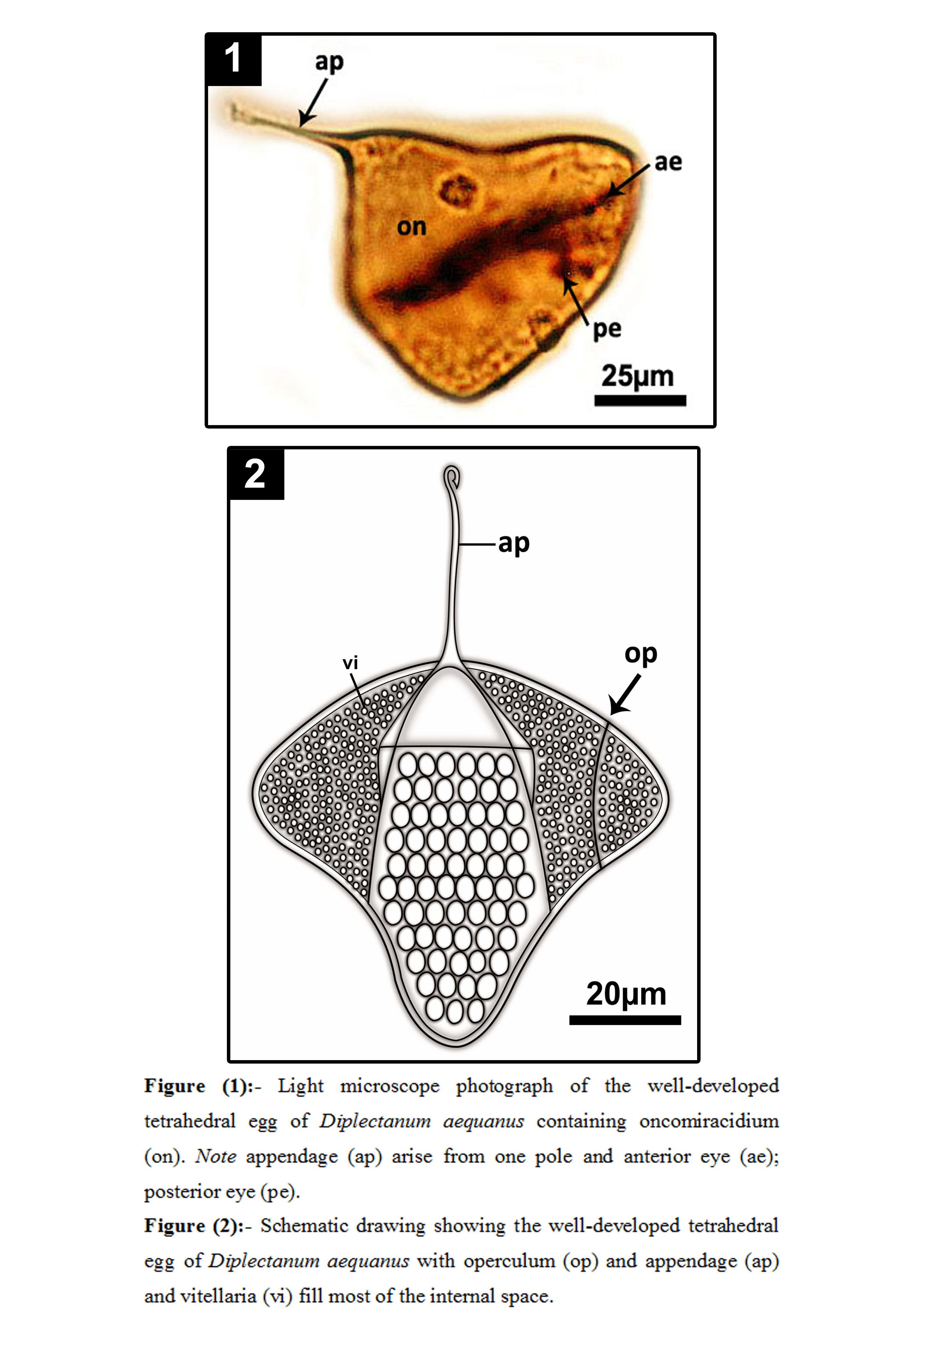
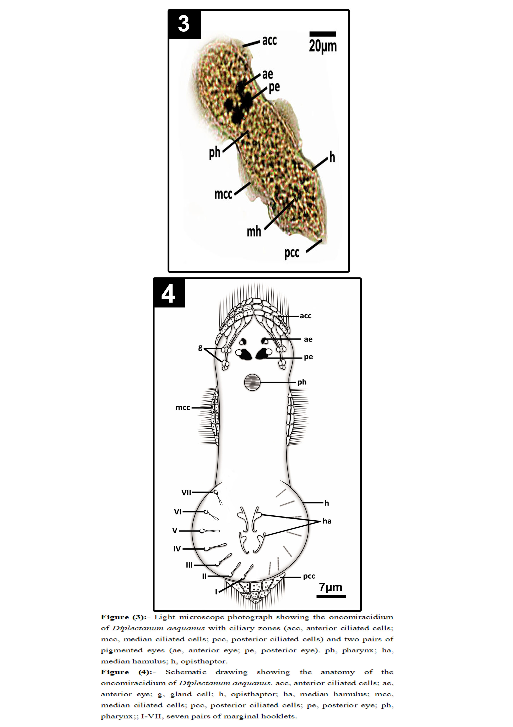
DISCUSSION
The egg morphology of Diplectanum aequanus in the present studyshowed that great similarities of the eggs of Diplectanum aequanus that originally described as triangular and flat by Oliver (1969); and is more or less tetrahedral with prominent protuberances. Each egg has an operculum at one pole and an elongate flexible filament from another pole. Kearn (1986) mentioned that eggs of several species of monogeneans are roughly tetrahedral in shape due to the shape of the ootype chamber in which they are made. Entanglement happens to attach them to the host gills.
Oliver (1969) referred to that rounded appearance of ridges and corners of well-developed eggs of Diplectanum aequanus and to the fact that the egg resumes its tetrahedral shape after hatching, observation that is consistent with an increase in fluid pressure within the egg prior to hatching. The possible functions of the egg appendages are not known. However, Kearn (1986) has reviewed the possible functions of long egg appendages in monogeneanes. He proposed that the long, slender appendages of some mongenean eggs may promote the lifting of eggs off the bottom by water turbulence, in the same way that young spiders are carried aloft by the interaction of air currents with long threads of silk produce by the spiders and may also increase frictional resistance to sinking.
The appendage of the egg is better for ensuring a suitable anchoring as the egg drifts (Kearn et al., 1992) the findings of the present study indicate that the appendage of the egg of Diplectanum aequanus could be the anchoring function. This is an advantage because if the egg failed to become anchored, it may be drift away from areas inhabited by potential host.
However, Kearn (1975) suggested that egg appendage of Entobdella solea serves as anchoring site which assists in egg hatching. Moreover, Egg appendages of Kuhnia scombri and capsalid monogeneans were suggested by Kearn (1986) to increase the surface area of the eggs and serve to reduce sinking rates. Also, he suggested that the egg appendage of Diplozoon paradoxum may serve to attach egg to the substrate if suitable projections, such as plant material or hydroid colonies in the sea, were available to snare the appendages of the egg drifting in the current; or may promote the lifting of eggs off the bottom by water turbulence or may also increase frictional resistance of skinning. However, egg appendages of Diplozoon lucscae resembling grappling hooks, may be adaptations to reduce the chances of the eggs being swept away from areas inhabited by the bottom-dwelling host (Whittington and Kearn, 1988). In contrast, Cone (1979a) reported that short appendages of egg of Urocleidus adspectus have no role in attachment to the sediments or in hatching.
Moreover, Yoon, (1998) has reviewed the possible function of buoy-like structure on the egg appendage of Entobdella hippoglossi seems to be needed for preventing egg from being covered by mud or particles and thus maintaining the eggs in an oxygenated environment.
It seems likely that the behavior of the oncomiracidia observed for Diplectanum aequanus in the present study were very similar to those reported for other monogeneans (Khidr and Abu-Samak, 1998; Whittington et al., 2000 and Albelda, et al., 2012): ﬁrstly a period of vertical swimming, which might lead to contact with hosts in the water column, and then period near the substrate, a “sit and wait” strategy which is less energy consuming. Gannicott and Tinsley (1998) reported that swimming ability, rather than survival, is related to infectivity, as oncomiracidia are able to ﬁnd new hosts mostly while they can swim in the water column. Kearn (1980) highlighted the importance of the vertical swimming in Entobdella. soleae, which was probably related to a search pattern for a bottom-dwelling host. The vertically swimming of Diplectanum aequanus oncomiracidia after emerging are especially infectious while, this in which to ﬁnd a new host.
The coordination between parasite development and ﬁsh habits has been reported in other species as a useful strategy to increase location of hosts by parasites. As swimming speeds of oncomiracidia and hosts differ considerably, coordination between the behavior of host and parasite becomes essential for successful transmission of oncomiracidia (Kearn, 1986). Hatching rhythms in some monogeneans have been related to the behavior of the host. Macdonald (1975) discovered that various species of Diclidophora emerged rhythmically, that the rhythms differed from one species to another and appeared to be adapted to speciﬁc host behavior patterns. In D. sagittata, the egg hatching rhythm is apparently coordinated with the resting habits of the trout host. The present study has revealed that the oncomiracidium swimming near the bottom of the glass dish could aid host ﬁnding and attachment of the larvae.
A striking feature of the larva of Diplectanum aequans in the present study is that possessing four bands of cilia: (one anterior; two symmetrical regions around the median zone of the body and one posterior on the opisthaptor in the form of a ciliated cone). This manner resembles the majority of monopisthocotyleans, monocotylid oncomiracidia have four bands of cilia and two pairs of eyes have been regarded as a distinctive feature of the most monopisthocotylinean oncomiracidia (Whittington et al., 2000).
The oncomiracidia of Diplectanum aequanus possess two pairs of eyes with crystalline-like lens. This conﬁguration suggests that the worms may be capable of detecting the direction of a light source. Assuming that oncomiracidia of Diplectanum aequanus are photopositive and that the eyespot is phototactic and allows orientation to a light source, oncomiracidia with eyespots could position themselves at appropriate levels in the water column in order to maximize the probability of an encounter with a fast moving host. Pigment-shielded eyes probably endow the free swimming larva (oncomiracidia) in most monogeneas with a directional response to light (Whittington and Kearn, 1989, 1990), oncomiracidia that lack pigment-shielded eyes fail to respond in a directional sense to light, e.g. Diclidophora spp. (Frankland, 1955). Kearn and Whittington (1992) demonstrated that the presence of four eyes in the oncomiracidia is one of two synapomorphies used previously to support the monophyly of the Monogenea. They reported that pigment-shielded eyes were absent in the oncomiracidia, although juvenile and adult specimens are known to possess them. Furthermore, adult specimens of E. caballeroi are known to display a strong response to light on the pharyngeal tooth pads of their fish hosts.
The distribution of gland-cells in the oncomiracidia of Diplectanum aequanus appears to be consistent throughout the family, with the majority of monocotylid larvae having gland-cells in the antero-lateral region, posterior to the pharynx. The function of these glands in the oncomiracidia is unknown, although they probably have an adhesive role (Chisholm and Whittington, 1996b). Kearn (1975) speculated that the anteromedian gland-cells may aid hatching by producing a secretion which digests the opercular cement of the egg or that they may facilitate attachment to the host after hatching. Furthermore, (Chisholm and Whittington, 1996a, b) suggested that the anteromedian gland-cells probably have an adhesive role. The present study supports Chisholm and Whittington, 1996a, b hypothesis, in that some of the oncomiracidia of Diplectanum aequanus in the present study was observed to attach themselves by the anterior end to the bottom of the glass egg-dishes. Since the lateral gland-cells that open anteriorly, it seems likely that some or all of these secretions have adhesive properties.
The morphological features of the opisthaptor of Diplectanum aequanus oncomiracidia are seven pairs of marginal hooklets and two pairs of well-developed hamuli. These features were similar to other diplectanids described previously by Lambert (1980) Kearn (1980) and Khidr and Abu-Samak, (1998).
The contribution of the marginal hooklets in the process of attachment of monogenean parasites seems to be minor if compared with that of the relatively massive hamuli and it is difficult to understand why they persist. Llewellyn (1963) and Kearn (1998) suggested that the marginal hooklets of most monogeneans play an important role in attachment in the larval stage.
Finally it can concluded that simple life cycle of monogenean gill parasite of Diplectanum aequanus masks many wonderful adaptations to parasitism, especially egg and regarding the time of larval emergence (rhythmical hatching, or hatching stimulated by host-generated cues. Furthermore, larval behaviours in response to environmental and host factors and the pigmented eyes; lateral gland cells and haptoral sclerites can direct oncomiracidia to the habitat of their speciﬁc host ﬁsh species.

REFRENCES
- Albelda AR Holzer AS Raga JA Montero FE. Oncomiracidial development survival and swimming behaviour of the monogenean Sparicotyle chrysophrii (Van Beneden and Hesse 1863). Aquaculture 2012; 338(341) 47-55.
- Buchmann K Lindenstrøm T. Interactions between monogenean parasites and their fish hosts. International Journal for Parasitology 2002; 32(3): 309-319
- Caruso G Genovese L Maricchiolo G Modica A. Haematological biochemical and immunological parameters as stress indicators in Dicentrachus labrax and Sparus aurata farmed in off-shore cages. Aquaculture International 2005; 13:67-73.
- Chisholm LA Whittington ID. Descriptions of the larvae of six species of monocotylid monogeneans from Himantura fai (Dasyatididae) and Rhinobatos typus (Rhinobatidae) from Heron Island Great Barrier Reef Australia. Systematic Parasitology 1996a; 35:145-156.
- Chisholm LA, Whittington ID. A revision of Heterocotyle (Monogenea Monocotylidae) with a description of Heterocotyle capricornensis n. sp. from Himantura fai (Dasyatididae) from Heron Island Great Barrier Reef Australia. International Journal for Parasitology 1996b; 26:1169-1190.
- Cone DK. Hatching of Urocleidus adspectus Mueller 1936 (Monogenea: Dawes B. Ancyrocephalinae). Canadian Journal of Zoology 1979; 57:833-837.
- Dezfuli BS Giari L Simoni E Menegatti R Shinn AP Manera M. Gill histopathology of cultured European sea bass. Dicentrarchus labrax (L.) infected with Diplectanum aequans (Wagener 1857) Diesing 1958 (Diplectanidae: Monogenea). Parasitol Res 2007; 100:707-713.
- Fioravanti ML Caffara M Florio D, Gustinelli A, Marcer F, Quaglio F. Parasitic diseases of marine fish: epidemiological and sanitary considerations. Parasitologia 2006; 48(1-2):15-18.
- Frankland HT. The life history and bionomics of Diclidophora denticulata (Trematoda: Monogenea). Parasitology1955; 45:313-351.
- Gannicott AM Tinsley RC. Larval survival characteristics and behaviour of the gill monogenean Discocotyle sagittata. Parasitology 1998b; 117:491-498.
- Hayward CJ, Aiken HM, Nowak BF. Metazoan parasites on gills of Southern Bluefin Tuna (Thunnus maccoyii) do not rapidly proliferate after transfer to sea cages. Aquaculture 2007; 262(1)10-16.
- Holder J. Aquaculture in the Egyptian desert. Hatchery 2003.
- Johnson SC, Treasurer JW, Bravo S, Nagasawa K, Kabata Z. A review of the impacts of parasitic Copepods on marine aquaculture. Zoological Studies 2004; 43(2): 229-243.
- Kearn GC. The mode of hatching of the monogenean Entobdella soleae a skin parasite of the common sole (Solea solea). Parasitology 1975; 71:419-431.
- Kearn GC. Light and gravity responses of the oncomiracidium of Entobdella soleae and their role in host location. Parasitology 1980; 81 71-89.
- Kearn GC. The Eggs of Monogeneans. Advances in Parasitology 1986; 25:175-273.
- Kearn GC. Parasitism and the platyhelminths. (Londonand Chapman) 1998.
- Kearn GC, Whittington ID. A response to light in an adult encotyllabine (capsalid) monogenean from the pharyngeal tooth pads of some marine teleost fishes. International Journal for Parasitology 1992; 22:119-121.
- Khidr AA, Abu-Samak OA. Observations on the egg and the oncomiracidium of the monogenean gill parasite Diplectanum lacustris Thurston and Paperna 1969 from the Nile Perch Lates niloticus in Egypt. J Egypt Ger Soc Zool 1998; 26(D) 239-254.
- Lambert A. Oncomiracidiums et phylogenbe des Monogenea (Plathel-minthes). Deuxieme partie: Structures argyrophiles des oncomiracidiums et phylogknese des Monogenea. Annales de Parasitologie Humaine et ComparPe 1980; 55:281-325.
- Llewellyn J. Larvae and larval development of monogeneans. Adv. Parasitol 1963; 1:287-326.
- Macdonald S. Hatching rhythms in three species of Diclidophora (Monogenea) with observations on host behaviour. Parasitology 1975; 71: 211-228.
- Manera M, Dezfuli BS. Lernanthropus kroweri infections in farmed sea bass Dicentrachus labrax: Pathological features. Disease of Aquatic Organisms 2003; 57:177-180.
- Oliver G. Recherches sur les Diplectanidae (Monogenea) parasites de téléostéens du Golfe du Lyon. 111.-Biologie. Vie et Milieu SCrie A: Biologie Marine 1969; 20:397-419.
- Poulin R, Rohde K. Comparing the richness of metazoan ectoparasite communities of marine fishes: controlling for host phylogeny. Oecologia 1997; 110 (2) 278-283.
- Whittington ID, Chisholm LA. Diseases caused by Monogenea. In: Eiras J.C. Wahlii H. S. T. Kapoor B.G. (Eds.) Fish Diseases. Science Publishers New Hampshire 2008; USA pp. 683-816.
- Whittington ID, Kearn GC. Rapid hatching of mechanically-disturbed eggs of the monogenean gill parasite Diclidophora luscae with observations on sedimentation of egg bundles. International Journal of Parasitology 1988; 18:847-852.
- Whittington ID. Kearn GC. Rapid hatching induced by light intensity reduction in the polyopisthocotylean monogenean Plectanocotyle gurnardi from the gills of gurnards (Triglidae) with observations on the anatomy and behaviour of the oncomiracidium. Journal of the Marine Biological Association of the United Kingdom 1989; (69):609-624.
- Whittington ID, Kearn GC. A comparative study of the anatomy and behaviour of the oncomiracidia of the related monogenean gill parasites Kuhnia scombri, K. sprostonae and Grubea cochlear from mackerel Scomber scombrus. Journal of the Marine Biological Association of the United Kingdom 1990; 70:21-32.
- Whittington ID, Chisholm LA, Rohde K. The larvae of Monogenea (Platyhelminthes). Adv. Parasit 2000; 44:139-232.
- Yoon GH. Scanning electron microscopy examination for the egg of skin parasite Entobdella hippoglossi on the commercially important culture fish of Atlantic Halibut Hippoglossus hipoglosi. J. Fish. Sci. Tech 1998; 1(1):68-71.

7/20/2013

