Ecological and Immunological Studies on Rhinoestrus purpureus infecting Donkeys in Egypt and Its Control with Doramectin and Ivermectin

Mohamed Y. Ramadan ¹, Abla D. Abd El mageid ² and Mohamed G. Abdelwahab ³

^{1.}Department of Parasitology, Faculty of Veterinary Medicine, Benha University.

^{2.}Department of Entomology, Faculty of Science, Benha University

³Department of Animal Medicine, Faculty of Veterinary Medicine, Benha University

mgahassan@yahoo.com

Abstract: The objectives of this study was to determine the prevalence, habitat and control of parasitic larvae of Rhinoestrous purpureus in donkeys. Forty donkeys were necropsied to search larvae in their nasal cavities. The results indicated that 26 out of 40 examined donkeys were infected by R. purpureus larvae and the percentage of infection was 65%. Female donkeys showed higher infection rate (77.78%) compared to (54.55%) in males. 263 R. purpureus larvae were collected from all investigated donkeys; 143 from females and 120 from males. The mean burden was 10 in male and 10.1 in females. L3 were more common than L2 (149 L3 compared to 114 L2 ). Most of L2 larvae (86.84%) attack labrynith of ethmoidal bones., moderate number infect sphenopalatine communications and only 2.63% were collected from pharyngeal cavity. On the other hand 53.59 % of L3 was collected from labrynith of ethmoid bones and other half was collected from sphenopalatine communication (23.49%), pharyngeal cavity (8.75%) and common nasal meatus (5.32%). An increase in serum globulin level (6.30 mg/dl) in R. purpures infected animals compared to (4.8 mg/dl) in control was recorded. Gamma globulins in infected animals was (2.97 mg/dl) while it was in (2.53mg/dl) in control. IgM was higher in infected animals (59.20 ng/dl) compared to (23.90 ng/dl) in control. Also IgA showed an increase in its value in infected animals compared to control (191.75, 87.11ng/dl). Concerning control of R. purpureus larvae, the results indicated that both doramectin and ivermectin had a larvicidal effect against R. purpureus larvae with superiority of doramectin as it caused 100% larval mortalities in vitro within 8 hrs. It was concluded that, R. purpureus larvae affect high number of donkeys specially females and the doramectin was selected to be the drug of choice for control in donkeys.
[Mohamed Y. Ramadan, Abla D. Abd El mageid and Mohamed G. Abdelwahab. Ecological And Immunological Studies on Rhinoestrus purpureus infecting Donkeys In Egypt And Its Control With Doramectin And Ivermectin. Nat Sci 2013;11(9):96-102]. (ISSN: 1545-0740). http://www.sciencepub.net/nature. 14

Key words: Rhinoestrous purpures, equine, ivermectin and nitroxynil

1.Introduction
Equines still receive more interest and care in many countries as draft animals, source of leather and other related products. Donkeys have a prominent position in the agricultural systems in many developing countries (Pearson, 1999). The myiasis caused by larvae of Rhinoestrus purpureus has important factor in the equine medicine since it causes severe respiratory diseases, impair animals welfare and cause severe economic losses. The larvae localize in nasal cavities, sinuses and pharynx of equids (Zumpt, 1965), inducing inflammation, dyspnea, sneezing and cough. Moreover, lesions of the upper respiratory tract and lungs, damage the olfactory nerves and encephalomyelitis were reported (Kaboret et al., 1997, Angulo- Valadeza et al., 2010). Adult flies may also eject larvae into human eyes inducing opthalmomyiasis or into nasal cavities or mouth (Rhichard Wall, 2007). Knowledge about ecology, biology, immunology and control of R.purpureus is limited in Egypt ( Zayed, 1992; Zayed and Helali 1993; Zayed et al., 1993). Therefore, the objectives of this study was to determine these parameters in donkeys.

2. Material and Method

1- Collection of Rhinoestrus purpureus larvae:
The animals examined for the larvae of Rhinoestrus purpureus were from north Cairo (Kalubyia Governorate) and southern Cairo (Giza Governorate). The study was carried out on a total of 40 donkeys. The animals were necropsied at Zoo slaughter house to search larvae in their nasal cavities. The entire nasal cavities of killed animals were opened and examined for the larvae. The larvae obtained from donkeys were placed in a jar containing 70 % alcohol and brought to the laboratory for identification according to (Dorchiesa et al., 2003). The site of parasitism, larvae burden, number and type of larvae per animal, animal sex were investigated.

2- Blood samples:
Blood samples were taken from the investigated animals before killing from jugular vein, kept without anticoagulant to separate serum which was used for determination protein fractionation, immunoglobulin M (Ig M) and immunoglobulin A (IgA)..

II-Experimental study to detect the Larvicidal efficacy of ivermectin and doramectin against Rhinoestrous purpureus larvae:

Chemicals:
  - Ivermectin
  - Doramectin
  - Physiological saline

2- R. purpureus larvae: 45 active L2 R. purpureus larvae were chosen to carry out the insecticidal efficacy of ivermectin.

3- Steps of the experiment

Studying the larvicidal efficacy was done according to (Pamo et al., 2005). One dose of ivremectin and another from doramectine with three replications for each were used in vitro. Five larvae per replicate were placed in a clean dry plastic cups with a filter paper, Disc of Whatman No.1 filter paper measuring 62.63 cm2 surface areas, impregnated uniformly with the used concentration of ivermctin and doramectin on the bottom. The drug was dissolved in physiological saline. Bioassays were done at 27±2ºC and 75±5% RH. Larvae were considered alive if they exhibited normal behavior when breathed upon or physically stimulated with a wooden dowels. If larvae were incapable of movement, maintaining normal posture, leg coordination, ability to right themselves, they were considered moribund or dead (Panella et al., 2005). The mortality was initially assessed 30 min. after being subjected to the examined drugs followed by mortality assessment at one hour, 2, 4, 8, 10 and 12 hrs. The used concentrations were 0.1% for each medicaments (Drummond, 1984).

3. Results
Results in Tables (1, 2) indicated that 26 out of 40 examined donkeys were infected by Rhinoestrus purpureus larvae. The over all percentage of infection was 65%. Female donkeys showed higher infection rate (77.78%) compared to (54.55%) in males. The table showed also that 263 Rhinoestrus purpureus larvae were collected from all investigated donkeys; 143 from she donkeys and 120 from males. The mean burden was 10 in male and 10.1 in females. L3 were more common than L2 (149 L3 compared to114 L2). Most of L2 larvae 86.84% attack labrynith of ethmoidlal bones, moderate number infect sphenopalatine communications and only 2.63% were collected from pharyngeal cavity. The common nasal meatus was free from L2. About one half number of L3 53.59 % was collected from labrynith of ethmoid bones and other half was collected from sphenopalatine communication (23.49%), pharyngeal cavity (8.75% ) and common nasal meatus (5.32%).
Results in Table (3) and plates (1, 2) revealed an increase in serum globulin level (6.30 mg/dl) in R. purpures infected animals compared to control (4.8 mg/dl ). Gamma globulins in infected animals was ( 2.97 mg/dl) which was also higher than in control (2.53mg/dl). IgM was higher in infected animals (59.20 ng/dl) compared to control (23.90 ng/dl). Also IgA showed an increase in its value in infected animals compared to control (191.75, 87.11ng/dl) in infected and control animals respectively.

Results in table (4) indicated that, both ivermectin and doramectin had a larvicidal effect against R. purpureus larvae compared to control. Larval mortalities started after one hr of exposure to doramectin and increased gradually with time and reach maximum (100%) after 8 hrs. On the other hand ivermectin started to kill larvae after 2hrs and the mortality rate reached 100% after 10 hrs of exposure. All tested larvae remain alive and very active during all time of the experiment in control group.

Table ( 1): Incidence of Rhinoestrus purpureus in male and female donkeys
Sex | No. of ex. Animals | No. of positive animals | Mean burden | No of collected larvae | No. of L2 | No. of L3
Males | 22 | 12 (54.55%) | 10 | 120  (5.5/animal) | 54 | 66
Females | 18 | 14 (77.78%) | 10.2 | 143  (7.9/animal) | 60 | 83
Total | 40 | 26 (65%) | 10.1 | 263 | 114 | 149

.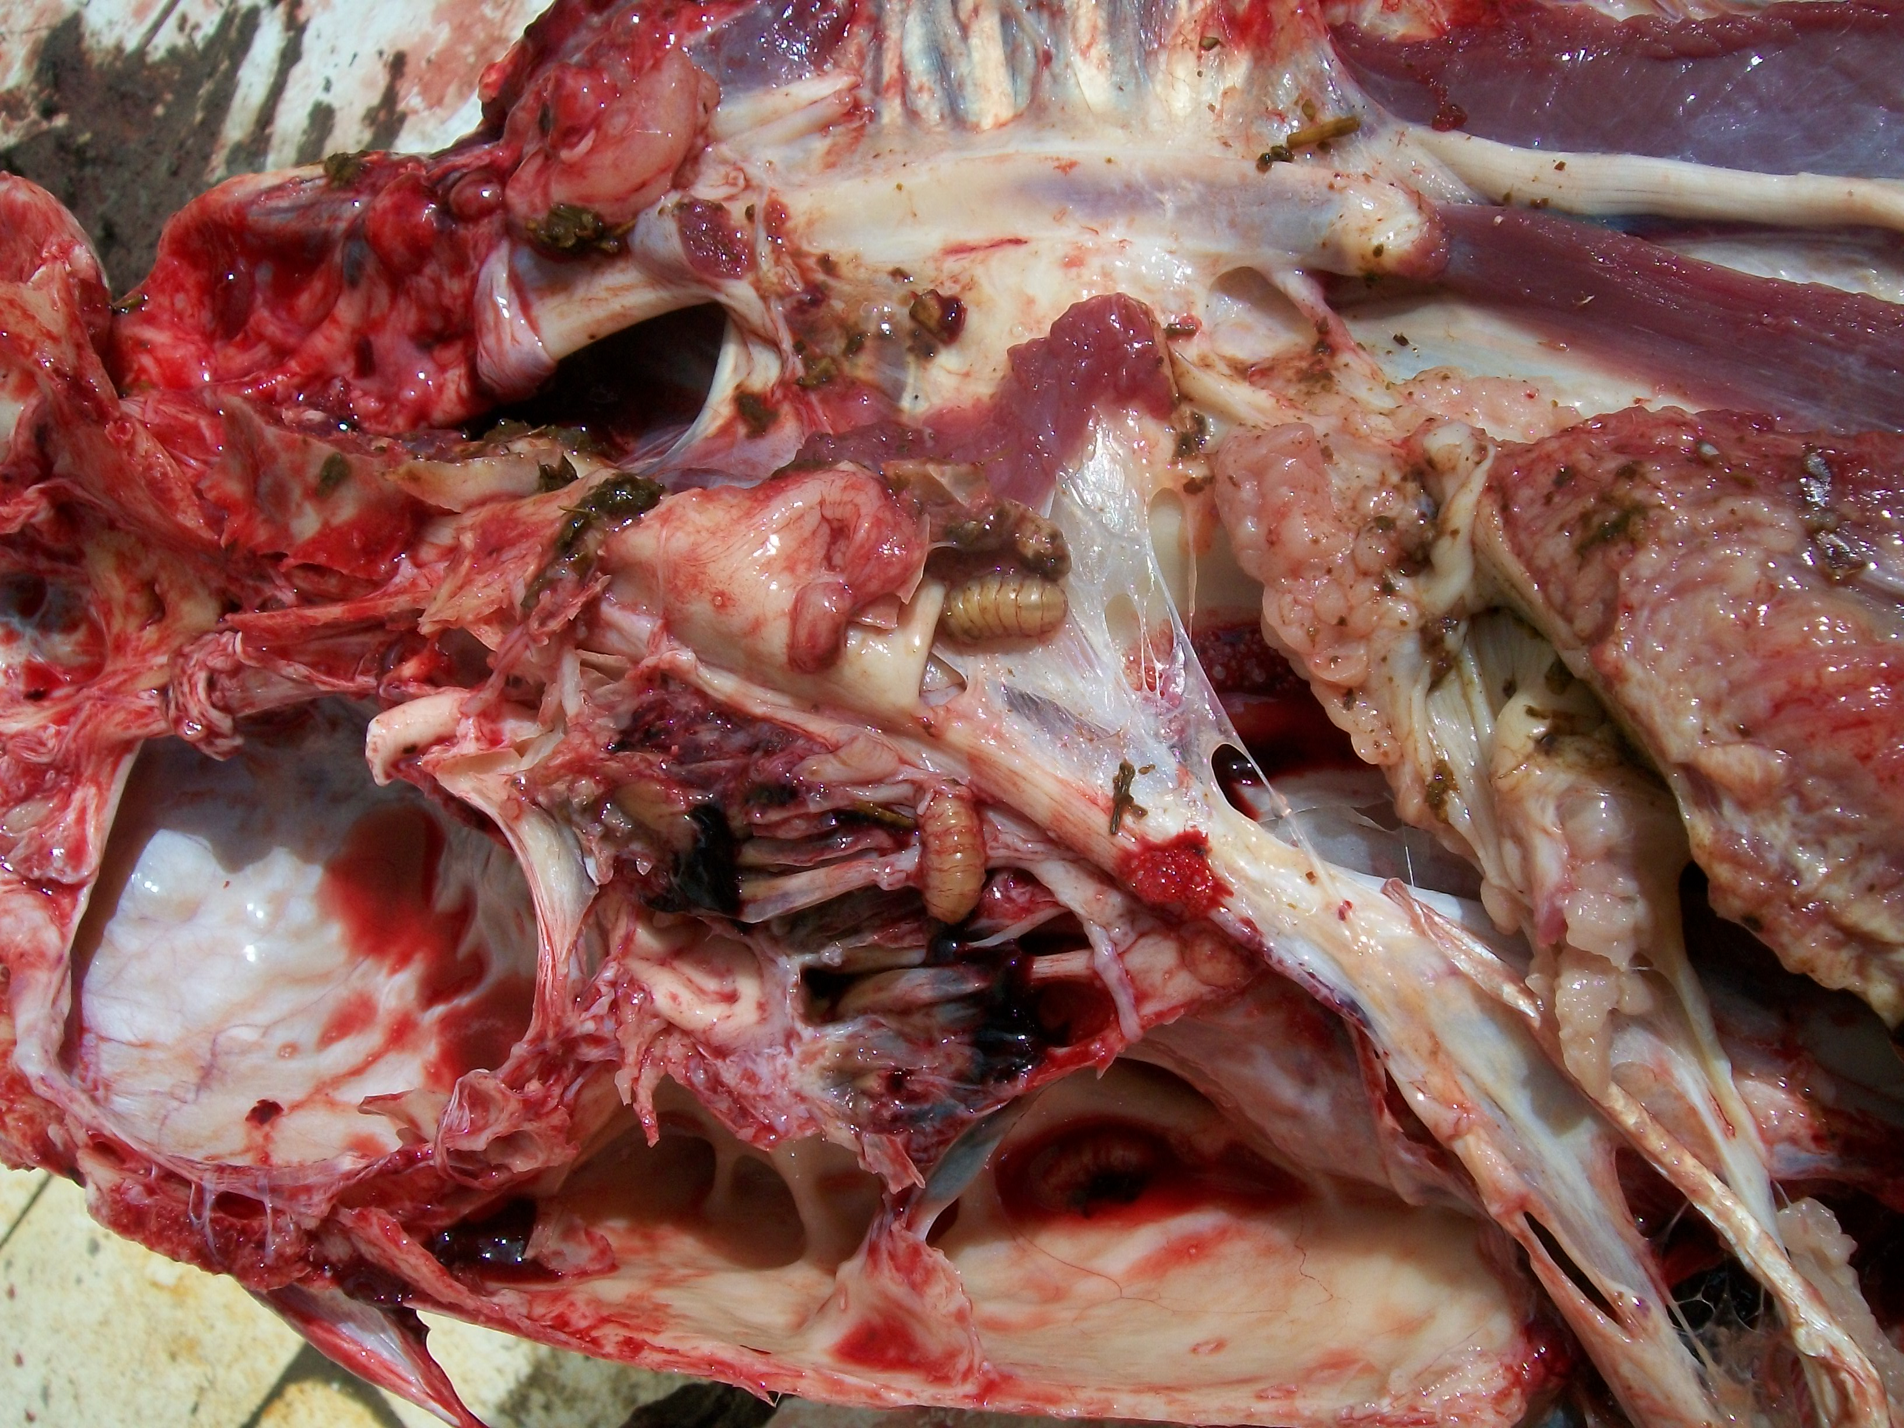
Figure (1): Showing 3rd larval stage of R. purpureus inhibit the area of the ethmoid bones.

Table (2): Distribution of Rhinoestrus purpureus in air passages of donkeys
Larvae | Total | Labrynith of ethmoid | Sphenopalatine communication, | Pharyngeal cavity | common nasal meatus
L2 | 114 | 99 (86.84%) | 12 (10.53%) | 3 (2.63%) | ---
L3 | 149 | 80 (53.59% | 35 (23.49%) | 20 (13.42%) | 14 ( 12.28%)
Total | 263 | 179 (68.06) | 47 (17.87%) | 23 (8.75%) | 14 (5.32%)

Table (3): Serum protein electrophoresis, IgM and IgA in Rhinoestrus infected donkeys
 | Infected | Control
Albumin (gm/dl) | 2.3 | 3.1
Globulin (gm/dl) | 6.30 | 4.8
Alpha1 globulin (gm/dl) | 0.24 | 0.29
Alpha 2 globulin (gm/dl) | 0.99 | 0.96
Beta Globulin (gm/dl) | 2.1 | 1.02
Gamma globulin (gm/dl) | 2.97 | 2.53
IgM (µg/dl ) | 59.20 | 23.90
IgA (µg/dl ) | 191.75 | 87.11
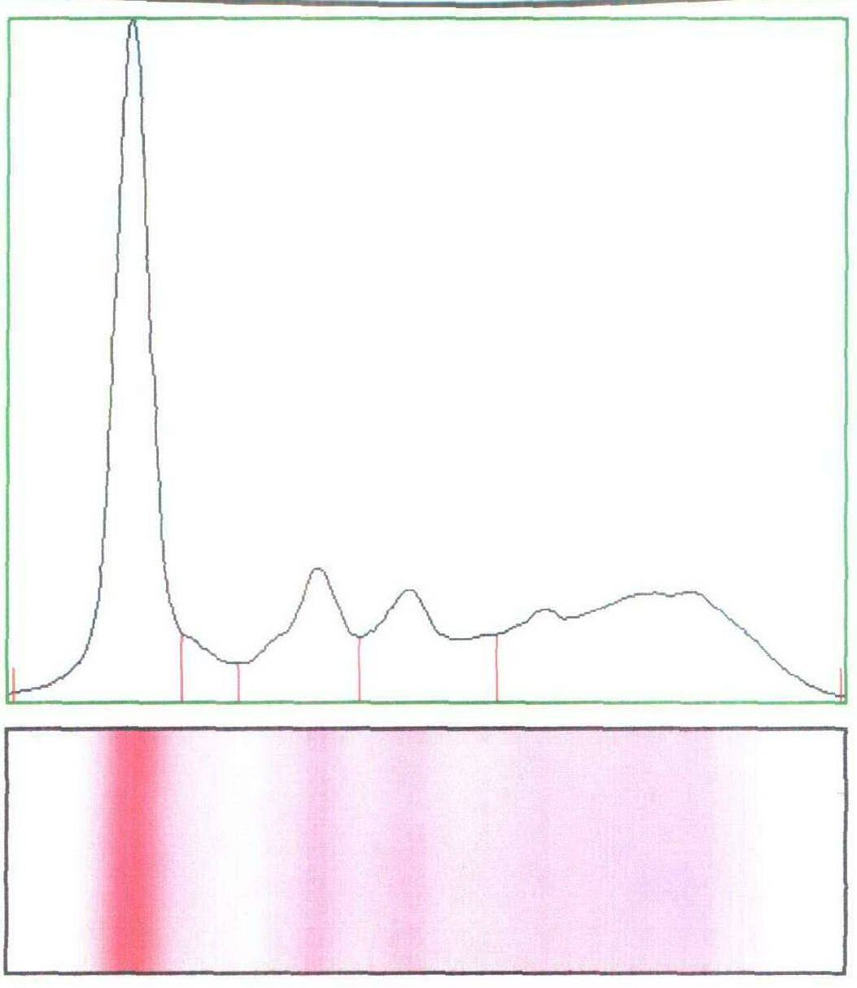
Plate (1): Protein electrophorsis in non infected donkeys

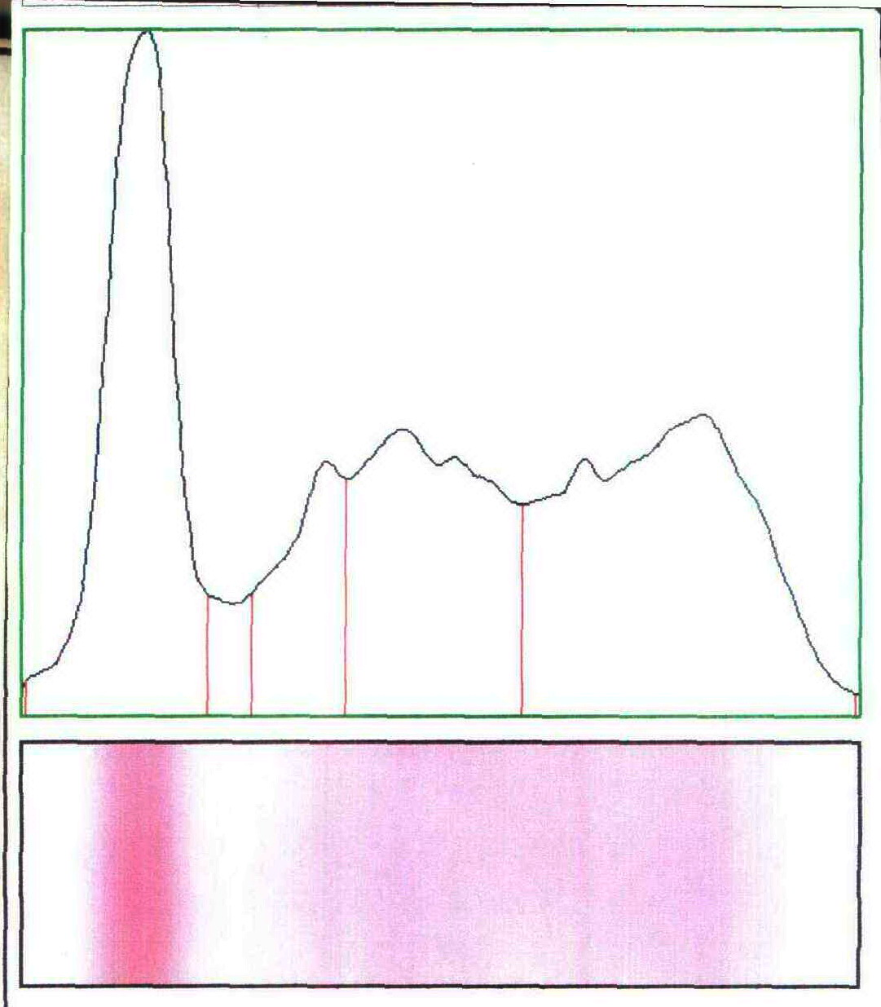

Plate (2): Protein electrophoresis in infected donkeys

Table (3): Mortalities of Rhinoestrous purpureus after treatment with ivermectin and nitroxynil
Drug | 30min | 1hr | 2hrs | 4hrs | 8hrs | 10hrs | 12hrs
Ivermectin  L  D | 5(100%)  0 ( 0.0%) | 5 (100%)  0(0.0%) | 4 (80%)  2 (20%) | 2 (40%)  3 (60%) | 2( 40%)  3 ( 60%) | 0( 0.0%)  5(100%) | 0(0.0%)  5(100%
Doramectin  L  D | 5 (100%)  0(0.0) | 4 ( 80%)  1(20%) | 2 (40%)  3 (60%) | 1(20%)  4 (80%) | 0 (0.0%)  5 (100%) | 0 (0.0%)  5 (100%) | 0 (0.0%)  5(100%)
Control  L  D | 5(100%  0(0.0%) | 5(100%  0(0.0%) | 5(100%  0(0.0%) | 5(100% )  0(0.0%) | 5(100%)  0(0.0%) | 5(100%  0(0.0%) | 5(100%  0(0.0%)

L= alive larvae; D= dead larvae

4. Discussion
Rhinoestrus purpureus larvae infestation has great importance in the horse medicine since it causes severe respiratory diseases. Therefore, an accurate diagnosis of rhinoestrosis is essential to study its epidemiology and control so, it is crucial to understand the actual incidence and epidemiology of this myiasis in live animals (Traversa and Otranto, 2006).
Our results indicated that, the percentage of infection was 65%. This result agreed with the previous study in Egypt which was carried out by (Zayed et al., 1993) who examined heads of 144 donkeys at the postmortem during the period from September 1989 to the end of August 1990 and revealed that (61.11%) donkeys were infested with Rhinoestrus purpureus. (Dorchiesa et al., 2003) recorded 3 species of nasal bots of equids namely; Rhinoestrus purpureus and R. latifrons in horses and donkeys (paleartic region) and R. usbekistanikus in horses, donkeys (palearctic region) and Burchell’s zebra (Equus burchellii) in Africa south of Sahara (Ethiopian region). Also, (Otranto et al., 2004) & Otranto and Colwell, 2008) noted myiasis caused by Rhinoestrus larvae recently in Europe, specifically in southern Italy, with a prevalence rate up to 6%. The recorded lower incidence in Italy may attributed to changes in environmental conditions
Higher infection rate (77.78%) was recorded in she-donkeys showed compared to (54.55%) in males. Such higher incidence in females may be attributed either to calm habit of she-donkeys that enable Rhinoestrous females to larviposit in their nasal cavities or to hormonal differences between male and female donkeys.
In the present study, L3 predominate L2. Such finding confirmed the previous results of (Zayed et al., 1993) in Egypt who recorded an increase in larviposition activity of Rhinoestrous females from mid-January to mid-April and highest mean larval number during June.
Concerning habitat of R purpureus larvae, it was noticed that, most of L2 larvae inhibit labrynith of ethmoidal bones., moderate number infect sphenopaltine sinus and the lowest number were collected from pharyngeal cavity. These results agreed with (Zayed and Hilali, 1993) in Egypt, who studied the localization and migratory route of Rhinoestrus purpureus larvae and recorded 93.9%, of 2nd instar larvae, were found in the labrynith of ethmoid bone, 5.8% in the sphenopalatine sinus, and only 0.3% in the pharyngeal cavity. Such observation suggested that, moulting of the 1st instar larvae occurred only in the labrynith of ethmoid bone. On the other hand, (53.59 %) of L3 was collected from labrynith of ethmoid bones and others were collected from sphenopalatine sinus (23.49%), pharyngeal cavity (8.75%) and common nasal meatus. Our results confirmed the suggestion of (Zayed and Hilali, 1993) who reported that, the 2nd instar larvae moulted in the labrynith of ethmoid bone, sphenopalatine sinus and pharyngeal cavity.
The mean larval burden was 10 in male and 10.1 in females. Indeed (Biggs et al., 1998) suggested that any number of larvae above 10 is potentially harmful to the hosts
Absence of first larval instars together with predomination of L3 indicated that there is no larvipostion activity of adult females during the period of the study (summer months). This may be attributed to higher environmental temperature during Summer months which either kill pupae or resulted in deformities in emerged females. In this respect, (Zayed,1992) in Egypt studied the pupal duration of R. purpureus under variable degrees of temperature and relative humidity (RH) and found that, at 37°C, the pupated larvae failed to pupate and died and their was a deformities in emerged flies. Some necropsy surveys showed that, kinetics of 1st instar larvae is related to adult mating activity (Tabouret et al., 2001a,b). An extended pupariation outside has been observed for O. ovis by (Biggs et al., 1998) allowing adults flies to wait for the best time for emergence, mating and larviposition. Choosing the right place for burrowing and pupariation is of high importance in this species and extreme temperatures into the soil (for example above 40 ◦C for long periods) being lethal to pupae or leading to low adult weight with high post-emergence mortality rates (Cepeda Palacios et al., 1998). For all species of oestrids, mating and seeking activities occur optimal on warm days, sunny and not windy days at temperatures between 20 and 30 ◦C (Anderson, 2006).
The present data revealed an increase in serum globulin specially gamma globulin levels in R. purpures infected animals compared to control. This is probably caused by a permanent antigenic stimulation during infection as antigenic and some inflammatory products produced by larvae induce inflammatory and hypersensitive reactions in a trail by the host to expel or destruct the larvae. (Dorchies et al., 2006) reported that mesoparasites, oestrids display complex host/parasite relationships. Indeed, the hosts develop numerous but often ineffective strategies of expelling them. Frequently there is interstitial pneumonia associated to emphysema and bronchiolitis with many eosinophils. This lesion is firstly related to the effect of parasitic antigens and proinflammatory products liberated by mast cells and eosinophils from nasal cavities inhaled in the lungs. Secondly, it appears that oestrids antigens have an immunosuppressive effect, allowing the actualization of pathogenic effect of virus inducing interstitial pneumonia.
IgM is the first isotype in response to infection, secreted from mucosal surfaces, good agglutinator and fixes complement. IgA is the major isotype at mucosal surfaces, secreted across the epithelial cells, bind to eosinophils, can activate complement by alternative path way and its total % in serum is twice IgM, (Wakelin, 1996; Scala et al., 2006). The higher levels of IgM and IgA in infected animals in the present study was in accordance with previous results of (Suarez et al., 2005; Angulo-Valadez et al., 2009) who recorded that Oestrus ovis infection elicits an IgM and IgG systemic antibody response in both sheep and goats. Innocenti et al.(1995) demonstrated that salivary glands proteins are the most antigenic O. ovis larvae proteins compared to digestive tube contents or cuticular antigens.. Many serological tests have been developed using a crude L2 somatic extract. Sensitivity, specificity, positive and negative predictive values were improved compared to the previous tests but detection of infected animals remains difficult in winter when L1 arrest their development inside the host. Negative correlations among larval establishment and/or larval development as well as intensity of local and systemic IgG responses were found in naturally infected ewes (Angulo-Valadez et al., 2008).
With respect to control of R.purpureus in vitro, our experiment is the first preliminary trial in this aspect, it showed that both doramectin and ivermecitin had a strong larvicidal effect against its larvae as it cause 100% mortalities. From the middle of the last century control of oestrids myiasis in livestock, relied on the use of the organophosphate products (OPs) which, however, have produced some unsatisfactory results in terms of animal and human safety ( Charbon & Pfister, 1993). In the past few years OPs have been superseded by macrocyclic lactones such as doramectin and ivermectin (Sutherland, 1990), As ivermectin has proved to be highly effective against Hypoderma sp. larvae even at dosages as low as 0.2 μg/kg, which is 1/1000th of the recommended dose (Drummond, 1984) so both drugs was suspected to do the same effect against R. purpureus larvae in equine.

Conclusion
It was concluded that R. purpureus infection in donkeys at 65 % in Egypt with higher incidence in females. The parasitic larvae of R. purpureus stimulate immune system. Both of doramectin and Ivermectin had a strong larvicidal effect against R. purpureus larvae in vitro with superiority of doramectin. Further studies are necessary to determine R. purpureus prevalence in the other equine sp. in Egypt as well as studying the effect of ivermectin and doramecin against it in large number of infested equines
It is hoped that this research will help veterinarians, equine owners and others who interested in providing health and welfare to equine to protect equine from such dangerous larvae.

Acknowledgment
We deeply thankful to Prof. Dr / Hatem, B. Hussein Prof. of vet. Anatomy Facculty of Veterinary Medicine Benha University for his help during the preparation of this research

References
- Angulo-Valadeza, C.E., Philip J. Schollb, Ramَn Cepeda-Palaciosc, Philippe Jacquietd, Philippe Dorchiesd,(2010): Nasal bots. a fascinating world! Veterinary Parasitology 174 (2010) 19–25
- Angulo-Valadez, C.E., Cepeda-Palacios, R., Ascencio, F., Jacquiet, P.,Dorchies, P., Romero, M.J., Khelifa, R.M.,(2007): Proteolytic activity in salivary gland products of sheep bot fly (Oestrus ovis) larvae. Vet. Parasitol. 149, 117.
- Angulo-Valadez, C.E., Scala, A., Grisez, C., Prevot, F., Bergeaud, J.P., Carta, A., Cepeda-Palacios, R., Ascencio, F., Terefe, G., Dorchies, Ph., Jacquiet, Ph.(2008): Specific IgG antibody responses in Oestrus ovis L. (Diptera: Oestridae) infected sheep: associations with intensity of infection and larval development. Vet. Parasitol. 155, 257–263.
- Angulo-Valadez, C.E., Cepeda-Palacios, R., Ascencio, F., Jacquiet, Ph., Dorchies, Ph., Ramirez-Orduna, J.M., Lopez, M.A.(2009): IgG antibody response against salivary gland antigens from Oestrus ovis (Diptera: Oestridae) in experimentally and naturally infected goats. Vet. Parasitol. 161, 356–359.
- Anderson, J.R.,(2006): Adult biology. In: Colwell, D.D., Hall, M.J.R., Scholl, P.J. (Eds.), The Oestrid Flies. CABI Publishing, p. 359. C.E. Angulo-Valadez et al. / Veterinary Parasitology 174 (2010) 19–25 25
- Bergeaud, J.P., Duranton, C., Dorchies, Ph. (1994): L’oestrose ovine en Aveyron
- :Résultat d’une enquête sur 1036 têtes à l’abattoir de Rodez. Revue de Médecine Vétérinaire 145 (11), 863–866.
- Biggs, H.C., Mcclain, E., Muller, G.L., Anthonissen, M., Hare, K.M.,(1998): A prediction model for strike in the sheep nasal fly, Oestrus ovis, in Namibia. Prev. Vet. Med. 33, 267–282.
- Cepeda Palacios, R., Jiménez, M.L., Armenta, J.A. (1998): Viabilidad del gusano del cuerno Oestrus ovis l. (Diptera: Oestridae)”. durante los periodos de prepupa y pupa. In: Mem. Del XXXIII Congr. Nac. De Entomol., Soc. Mex. De Entomol. Acapulco, Gro, pp. 516–520.
- Charbon, J. and Pfister, K. (1993): A comparison of a systematic treatment of hypodermosis using metrifonate (Neguvon®) or microdoses of ivermectin (Ivomec®): efficacy and residues in the milk, in: Improvements in control methods for warble-fly. Losson B., Lonneux J.F. & Pithan K. (eds). Luxembourg, Luxembourg, Commission of the European Communities, 55-58.
- Dorchies, P., Tabouret, G., Hoste, H., Jacquiet, P., 2006. Oestrinae host–parasite interactions. In: Colwell, D.D., Hall, M.J.R., Scholl, P.J. (Eds.), The Oestrid Flies. CABI Publishing, p. 359.
- Dorchiesa Ph., F. Gebreabb, F. and. Panguic, L.J., (2003):Rhinoestrus usbekistanikus (Gan 1947): its prevalence and pathological effect in donkeys. Proceedings of the 19th International Conference of the World Association for the Advancement of Veterinary Parasitology August 10th – 14th, Sheraton New Orleans Hotel, New Orleans, Louisiana USA.
- Drummond, R.O. (1984): Control of larvae of the common cattle grub (Diptera: Oestridae) with animal systemic insecticides. Journal of Economic Entomology, 77, 402-406.
- Innocenti, L., Masetti, M., Macchioni, G., Giorgi, F., (1995): Larval salivary gland proteins of the sheep nasal bot fly (Oestrus ovis L.), are major immunogens in infested sheep. Vet. Parasitol. 60, 273–282.
- Kaboret, Y., Deconinck, P., Panguy, L.J., Akakpo, J., Dorchies, Ph.,(1997): Lésions de la rhinoestrose spontanée à Rhinoestrus usbekistanicus (Gan1947) chez l’âne (Equus asinus) au Sénégal. Rev. de Méd. Vét. 148, 123–126.
- Otranto, D.D. and Colwell D.D. ( 2008): Biodiversity and extinction versus control of Oestrid causing myiasis in Mediterranean area xth EMOP, Parasite, 2008, 15, 257-260
- Otranto, D., Colwell, D.D., Milillo, P., Di Marco, V., Paradies, P., Napoli, C., Giannetto, S., (2004): Report in Europe of nasal myiasis by Rhinoestrus spp. in horses and donkeys: seasonal patterns and taxonomical considerations. Vet. Parasitol. 122, 79–88.
- Pamo E.T., Tendonkeng F., Kana J.R., Payne V.K., Boukila B., Lemoufouet J., Miegoue E. & Nanda A.S. 2005. A study of the acaricidal properties of an essential oil extracted from the leaves of Ageratum houstonianum. Veterinary Parasitology. 128: 319-323.
- Panella N.A., Dolan M.C., Karchesy J.J, Xiong Y., Peralta-Cruz J., Khasawneh M., Mont-enieri J.A. & Maupin G.O. 2005. Use of Novel Compounds for Pest Control, Insecticidal and Acaricidal Activity of Essential Oil Components from Heartw-ood of Alaska Yellow Cedar. Journal of Medical Entomology. 42: 352-358.
- Pearson R. A.; Nengomasha E. and Krecek R. C. (1999): The challenges in using donkeys for work in Africa. In: Starkey PH, Kaumbutho P (editors). Meeting the Challenges of Animal Traction. A resource book of the Animal Traction Network for Eastern and Southern Africa (ATNESA), pp. 190-198, Harare, Zimbabwe. Intermediate Technology Publications, London.
- Richard Wall (2007): Ectoparasites: Future challenges in a changing world Veterinary Parasitology 148 62–74
- Scala A., Pedreira J., Ramirez M., Suarez J.L., Diaz P., Arias M.,Paz-Silva A., Lomba C., Diez-Bafiosp., Morrondo P., Sanchez-Andrade R. (2006): Haemogram in sheep with antibodies against Oestrus ovis Parassitologia 48, 314
- Suarez, J.L., Scala, A., Romero, J.A., Paz-Silva, A., Pedreira, J., Arias, M., Diaz,
- P., Morrondo, P., Diez-Banos, P., Sanchez-Andrade, R., (2005): Analysis of the humoral immune response to Oestrus ovis in ovine.Vet. Parasitol.134,153–158.
- Sutherland I. H. 1990 Veterinary use of ivermectin. Acta Leiden,, 59, 211-216.
- Tabouret, G., Jacquiet, Ph., Scholl, Ph., Dorchies, Ph.,( 2001a). Oestrus ovis in sheep: improvement in control through knowledge of relative thirdinstar populations. Vet. Res. 32, 525–531.
- Tabouret, G., Prevot, F., Bergeaud, J.P., Dorchies, P., Jacquiet, Ph.,(2001b): Oestrus ovis (Diptera: Oestridae): sheep humoral immune response to purified excreted/secreted salivary gland 28 kDa antigen complex from second and third instar larvae. Vet. Parasitol. 101, 53–66.
- Traversa, D., Otranto,D. (2006): A new approach for the diagnosis of myiasis of animals: The example of horse nasal myiasis. Vet. Parasito.141:186 -190
- Wakelin, D. (1996): Immunity to parasites. second edition. Cambridge univ. press. Pp25.
- Zayed, A.A. (1992): Studies on Rhinoestrus purpureus (Diptera: Oestridae) larvae infesting donkeys (Equus asinus) in Egypt. III. Pupal duration under controlled conditionsVeterinary Parasitology Volume 44, Issues 3-4, October, Pages 285-290
- Zayed A.A and Hilali, M. (1993): Studies on Rhinoestrus purpureus larvae infesting donkeys in Egypt Localization and migratory Route. Journal of Equine Veterinary Science Volume 13, Issue 2,, 92- 95
- Zayed, A.A, Hilali,M. and El Metenawy,T.M. (1993): Studies on Rhinoestrus purpureus (Diptera: oestridae) larvae infesting donkeys (Equus asinus) in Egypt: Incidence and seasonal variations Journal of Equine Veterinary Science Volume 13, Issue 1,, 46-49
- Zumpt, F., (1965): Myiasis in Man and Animals in the Old World. Butterworths, London.

8/2/2013

