Isopaches decolorans (Limpr.) H. Buch. (Marchantiophyta: Lophoziaceae) in India, A Noteworthy Rare and Disjunct Liverwort

Krishna Kumar Rawat*, Praveen Kumar Verma**

*CSIR - National Botanical Research Institute, Rana Pratap Marg, Lucknow – 226001, India; **Rain Forest Research Institute Deovan Sotai Ali, Post Box # 136, Jorhat -785001, Assam, India
drkkrawat@rediffmail.com, **e-mail of corresponding author: pkverma_bryo@yahoo.co.in

Abstract: Isopaches decolorans (Limpr.) H. Buch., a rare and disjunct species is being reported from Arunachal Pradesh, India along with a note on its distribution and affinities with plants from other localities. The discovery of male plant also has been clearly authenticating the sexuality of the species (dioecious).
[Rawat K.K., and Verma, P.K. Isopaches decolorans (Limpr.) H. Buch. (Marchantiophyta: Lophoziaceae) in India, A Noteworthy Rare and Disjunct Liverwort. Nat Sci 2013;11(9):119-122]. (ISSN: 1545-0740). http://www.sciencepub.net/nature. 19

Keywords: Arunachal Pradesh, Tawang, Marchantiophyta, Cephaloziaceae, Isopaches, I. decolorans.

1. Introduction
Eastern Himalayas, despite of being the adobe of enormous diversity of bryophytes, has been remained underexplored, and consistently provides opportunity to the workers to find some unique information. While working on some plants from Arunachal Pradesh (India), we came across with some beautiful plants of Isopaches decolorans (Limpr.) H. Buch., a rare species, and poorly known among Indian bryoflora.
Genus Isopaches H. Buch., sometimes being treated as a subgenus of genus Lophozia (Dumort.) Dumort. (Schuster, 1995), is represented by four species around the world viz. Isopaches bicrenatus (Schmid. ex Hoffm.) H. Buch, I. pumicicola (Berggr.) Bakalin, I. alboviridis (R.M. Schust.) Schljakov and I. decolorans (Limpr.) H. Buch (Zhang et al., 2013). Out of these, Isopaches decolorans (earlier known as Lophozia decolorans (Limpr.) Steph.) is being considered a rare and highly disjunct species (Schuster, 1995, Long, 2005, Zhang et al., 2013). The species is distributed mainly in Europe, however also sporadically reported from British Colombia, equatorial Africa, Siberian Arctic, Far-east Russia, Europian Russia, China and Himalayan sector. In India, its first report came through Long (2005), who have reported its presence in Sikkim, however, he did not provide any details of the Indian plants of this rare and poorly known species. Hence it felt necessary to provide the details of Indian plants, which may help future workers to understand this rare species and its phytogeographical details along with the rarity status.

2. Materials and Methods
The specimens were collected from rocks at Tawang town of Arunachal Pradesh and air dried initially then kept in brown paper envelope and preserved in Lucknow University Bryyophyte Herbarium (LWU). Slides of whole mount as well as plants parts and sections were mounted in aqueous glycerin, labeled and stored for further studies, wherever found necessary.
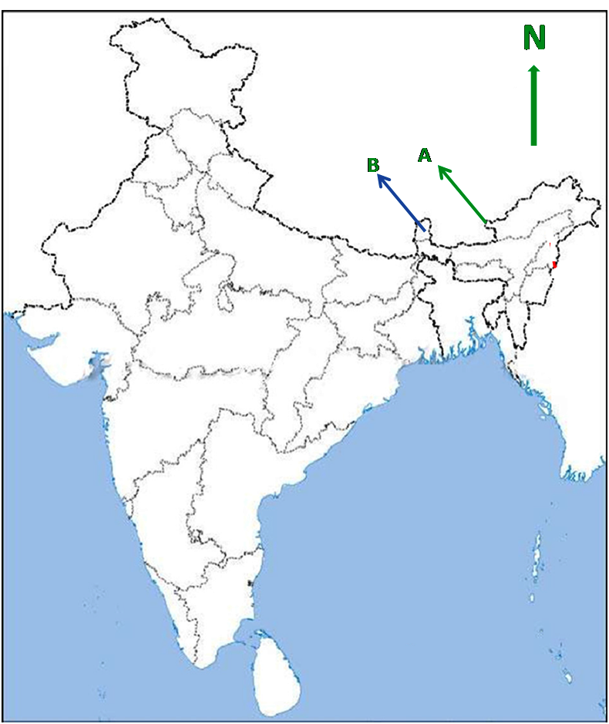
Fig. 1. Map of India showing the distribution of Isopaches decolorans (Limpr.) H. Buch.. in Tawang (A) district of Arunachal Pradesh and Sikkim (B).

3. Taxonomic observation
Isopaches decolorans (Limpr.) H. Buch., Mem. Soc. F. Fl. Fenn. 8: 288 (1932) – Jungermannia decolorans Limpr., Jahresb. Schles. Gesell. Vsterl. Kult. 57: 116 (1880) – Lophozia decolorans (Limpr.) Steph., Sp. Hepat. 2: 147 (1902).
Plants small, 2.0-4.5 mm in size, robust, succulent, brittle when dry, growing in dense patch, creeping, closely appressed to substratum with numerous rhizoids, except at apices; clear, pale green to bright green when fresh, whitish to yellowish brown when dry; occasionally branched, ‘Frullania-type’; Stem elliptical in cross-section, 147-212 µm across, fleshy, up to 10 cells wide; cells undifferentiated, 16-23 × 13-26 µm in size, thin walled, atrigonous. Rhizoids numerous, scattered along the ventral surface except the shoot apices. Leaves succubous, obliquely inserted, closely imbricate producing somewhat julaceous habit, concave, ventral insertion oblique, dorsal insertion transverse, broader than long, 0.68-1.1 × 0.49-0.85 mm in size, unistratose, apical half and margins hyaline, decolourate, mid basal and middle part bright green due to presence of numerous chloroplasts, bilobed, lobes unequal, dorsal lobe smaller than ventral lobe, rarely with a third small to large lobe, margin almost entire, occasionally with a few one-celled projections appearing as small tooth near subapical margin, usually straight to rarely undulate, rarely with a large 4-6 cells high and 3-4 cells broad tooth or lobe at the antical base of leaf, leaf lobes acute, terminating in a single elongated apical cell, 19-22 × 13-16 µm in size, subapical cells 13-26 × (9.7) 13-16 µm, median cells (13) 19-23 × (13)16-23 µm in size, basal cells 16-29 × 13-16 µm in size; cells somewhat thick-walled in contrast to reportedly thin-walled cells; trigones indistinct except at apices; cuticle smooth. Underleaves variable in shape and size, rounded lobed to elongate. Rhizoids numerous. Gemmae not seen.
Dioecious. Male and female plants are same in size. Male plants very rare in population. Androecia terminal; bracts similar to leaves, with one antheridium per bract; antheridia spherical to elliptical, stalk biseriate, short. Gynoecia terminal on main as well as lateral shoots; bracts larger than leaves, bilobed to trilobed and with or without the antical tooth at distal base; bracteoles smaller, bi-tri lobed. Perianth green, elongate, 5-plicate, mouth lobulate, lobes denticulate, teeth 1-2 celled. Mature sporophytes were not observed.

3.a. Habitat
The plants were growing on partially shady road side slopes with Solenostoma sp. and Diplophyllum nanum. The locality is a high altitude site in Himalayas near the juncture of borders of India, Bhutan and China and receives heavy snowfall during the winters.

3.b. Specimens examined
INDIA: Arunachal Pradesh – Tawang town; C. 2950 mts.; 27 April 2002; KK Rawat and MS Azeem; 15598/2002, 15607/2002 (LWU).

3.c. Range
France, Switzerland, Austria, Norway (Müller, 1954), Italy (Aleffi et al., 2008), Scandinavia (Arnell, 1956), Siberian arctic, Europian Russia and Russian Far-east (Ladyzhenskaya and Zhukova, 1971; Schljakov, 1974; Potempkin 1990, 1993; Schuster and Konstantinova, 1996; Bakalin, 2005; Oyesiku, 2008; Potempkin and Sofronova, 2009), Canada (Schuster, 1995) Camerron, Tanzania (Vana, 1982; Bizot et al., 1985; Mwasaga, 1991), Uganda (O’Shea et al, 2003), Congo (Müller, 1995), Equatorial Guinea (Müller, 2006), Bhutan (Long, 1979), Nepal, India (Long, 2005), China (Long, 2005, 2011; Zhang et al., 2013).

3.d. Distribution in India
Sikkim (Long, 2005), Arunachal Pradesh – Tawang (present study).

4. Discussion and Conclusion
The plants are unique in having decolored leaf margins, a characteristic which gave its name. Till now, this plant has been reported mainly from some localities in Europe, Russia and tropical Africa, and only once from Northern America. Due to its rare occurrence, Schuster (1995) considered I. decolorans as “one of the periglacial and/or alpine taxa which survived the ice age in local ice free niches” and discussed the link between European plants and Canadian plants. He also added that its presence in western Siberia could be a “post-Pleistocene invasion”. However, recent reports of its occurrence in Asian and African elements, particularly in Himalayan sector, suggest a possible disjunct distribution of the species, with some scattered populations. The reports from Nepal, Sikkim, Bhutan and Arunachal Pradesh (present study) clearly indicate that the species is distributed throughout the Himalayan sector, however, in very small pockets. It also indicates possible un-noticed presence of this species in other Himalayan localities, particularly western Himalayan sector, which is having a good representation of other Lophoziaceae elements. Its presence in Chinese territory also suggests its most likely route of dispersal from Siberia to Himalayan region.
The Indian plants were completely lacking gemmae as in Chinese plants (Zhang et al, 2013), in contrast to European and American reports where gemmae are well reported. Schuster (1995) and Zhang et al (2013), speculated it to be dioecious in contrast to the view of Potempkin (1993) who stated paroecious sexuality. However, presence of male plants in Indian population clearly puts an end to this controversy. The male plants look alike vegetative plants, as the male bracts are similar to normal leaves with only one antheridia per bract, hence may remain unnoticed.

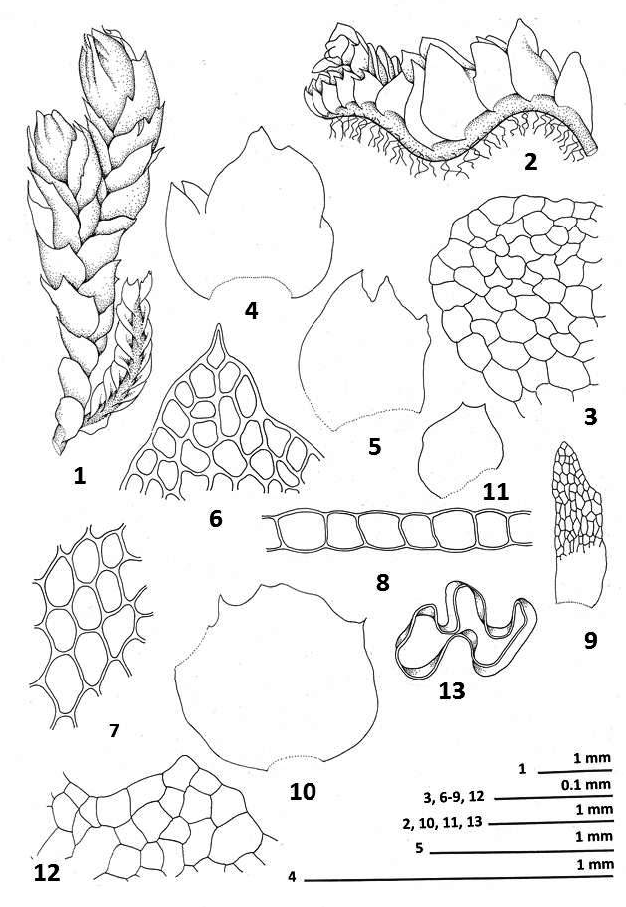

Fig. 2. Plant with perianth, dorsal view, 2. Plant, lateral view, 3. Stem T.S., 4,5. Leaves, 6. Apical and sub-apical cells of leaf, 7. Mid-basal cells of leaf, 8. Leaf T.S., 9. Underleaf, 10. Bract, 11. Bracteole, 12. Cells of perianth mouth, 13. T.S. of perianth (all figures drawn by K. K. Rawat from LWU 15598/2002).

5. Acknowledgements
We are extremely thankful to our mentor Prof. S.C. Srivastava for his critical comments and suggestions. Thanks is also due to Dr. Denilson F. Peralta, Núcleo de Pesquisa em Briologia Instituto de Botânica, Brasil for providing literature. We are also thankful to Drs A. K. Asthana and Vinay Sahu, CSIR-National Botanical Research Institute, and Dr Geeta Asthana, University of Lucknow, for their help during the investigation.

Correspondence to:
Dr. Praveen Kumar Verma
Rain Forest Research Institute Deovan Sotai Ali, Post Box # 136, Jorhat -785001, Assam, India
Cellular phone: +919435153557
E-mail: pkverma_bryo@yahoo.co.in

References
- Aleffi M, Tacchi R, Cortini Pedrotti C. Check list of the hornworts, liverworts and mosses of Italy. Bocconea 2008; 22: 1-255.
- Arnell S. Illustrated moss flora of Fennoscandia. I. Hepaticae. 1-Gleerup, Lund 1956; pp. 308.
- Bakalin V. New data on distribution of liverworts on Kamchatka Peninsula (North-West pacific, Russia). Arctoa 2005; 14: 155-162.
- Bizot M, Pocs T, Sharp J. Results of a bryogeographical expedition to east Africa in 1968, III. The Bryologist 1985; 88: 135-142.
- Ladyzhenskaya KI, Zhukova AL. De species Isopaches decolorans (Limpr.) Buch (Hepaticae) pro flora URSS nova notula. Novosti Sist. Nizsh. Rast. 1971; 8: 310-314.
- Long DG. Hepaticae from Bhutan, East Himalaya. Lindbergia 1979; 5: 54-62.
- Long DG. Notes on Himalayan Hepaticae 2: New records and extensions of range for some Himalayan leafy liverworts. Cryptog. Bryol. 2005; 26: 97-107.
- Müller F. Neue und bemerkenswerte Moosfunde aus Zaire. Trop. Bryol. 1995; 10: 81-90.
- Müller F. Bryophytes of Bioko (Equatorial Guinea), results of an excursion in 2002. Trop. Bryol. 2006; 27: 9-17.
- Müller K. Die Lebermoose Europas. In: L. Rabenhorst’s Kryptogamen-Flora von Deutschland, Oesterreich und der Schweiz. Akademische Verlagsgesellschft, Leipzig 1951-1958. Ed. 3rd 6: 1-1365.
- Mwasaga BC. The natural forest of Mount Kilimanjaro In: Conservation of Natural Resources. (ed. Newmark WD) IUCN, Gland Switzerland and Cambridge, UK 1991; pp 17-20.
- O’shea BJ, Wigginton MJ, Bruggman-Nannega MA, Hedens L, Matcham HW, Frahm JP, Porley RD, Ellis LT, Watling MC, Bates JE, Vana J. Bryophytes of Uganda, 6. New and additional records, 3 Trop. Bryol. 2003; 24: 161-168.
- Oyesiku O. Additions to the hepatic flora of the Russian part of the Caucasus J. Bryol. 2008; 30: 306-308.
- Potempkin AD. The Hepaticae of the Yamal Peninsula, West Siberian Arctic. Arctoa 1993; 2:57-101.
- Potempkin AD, Sofronova EV. Liverworts and hornworts of Russia.Saint Petersburg, Yakutsk 2009; pp. 367.
- Potempkin AD. Lophozia alboviridis and L. decolorans (Hepaticae) on the Yamal Peninsula. Bot. Zhurn. (Moscow and Leningrad) 1990; 75: 1086-1092.
- Schljakov RN. Aditamenta ad Bryofloram URSS. Novosti Sist. Nizsh. Rast. 1974;11: 354-360.
- Schuster RM, Konstantinova NA. Studies on the distribution of critical arctic/subarctic Hepaticae with special reference to taxa found in Russia. Lindbergia 1996; 21: 26-48.
- Schuster RM. Notes on Nearctic Hepaticae, XVII. Lophozia decolorans, new to North America and the subgenus Isopaches. The Bryologist 1995; 98: 246-250.
- Vana J. Notes on some African hepatic genera 1-5. Folia Geobot. Phytotax. 1982; 17: 63-87.
- Zhang LN, Cheng XF, Zhu RL. First record of Isopaches decolorans (Marchantiophyta, Lophoziaceae) from Xizang, China. Polish Botanical Journal 2013; 58: 205-210.

8/8/2013

