Epidemiological studies of abomasal nematodes of sheep of Kashmir Valley with particular reference to Haemonchus contortus.

Irfan-ur-Rauf Tak¹, M. Z. Chishti¹ and Fayaz Ahmad²

¹ Centre of Research for Development, University of Kashmir, Srinagar – 190 006
² Department of Zoology, University of Kashmir, Srinagar-190 006, Kashmir
irfanrauftak@yahoo.in

Abstract: The valley of Kashmir owes its great excellence not only to the charming scenic beauty but is bestowed with rich flora and fauna present in wide variety and diversity. Sheep are among those animals which were first tamed by man. Sheep being a close grazer is regarded as museum of parasites especially for helminths. Haemonchus contortus is a blood sucking intestinal helminth that lives in the abomasum of small ruminants worldwide. This parasite can be devastating to producers as it causes decreased production levels due to clinical signs such as anaemia, edema and death. The abomasae of sheep in which this parasite resides were collected from abattoirs of various districts during the study of one year from November, 2011 to December, 2012 and were then carried to laboratory for screening. In case of collection sites falling in far areas, the organs were screened on spot. The parasites were placed in petridish containing 0.05M PBS (pH 7.4) for initial washing to remove host material and allow regurgitation of gut contents. The length and width of each parasite was measured and segregated into Haemonchus contortus based on standard body lengths: Haemonchus contortus: female (18 to 30 mm), male (10 to 20 mm). The regular record of the entire process was properly maintained. During the study period, a total of 310 sheep abomasum were examined, out of which 198 (63.87%) were found to be infected. Of these, 191 (61.61%) were found to be infected with H. contortus and 112 (36.12%) were found to possess mixed infection. The infection was found highest in summer (80.80%) and lowest in winter (37.5%) (P<0.05). The prevalence of the parasite was highest in lower age groups (78.35%) and lowest in higher age groups (39.65%) (P<0.05). The males (63.03%) showed significantly higher prevalence as compared to females (60.00%) (P>0.05). The study indicates the prevalence of Haemonchus contortus varies in different seasons and in different age groups.
[Irfan-ur-Rauf Tak, M. Z. Chishti and Fayaz Ahmad. Epidemiological studies of abomasal nematodes of sheep of Kashmir Valley with particular reference to Haemonchus contortus. Nat Sci 2013;11(10):34-39]. (ISSN: 1545-0740). http://www.sciencepub.net/nature. 7

Keywords: Haemonchus contortus; Helminths; Abomasum; PBS.

- Introduction
The state of Jammu and Kashmir is strategically located on the northern most part of India. It is geographically located between 32º 17′ and 36º 58′ northern latitude and 37º 26′ and 80º 30′ eastern longitudes. In Jammu and Kashmir, livestock activity has a contribution of about 11% in the Gross Domestic Product of the state as per Integrated Sample Survey (ISS) report 2007-08. The total livestock population as per census 2003 was 98.993 lakhs out of which sheep were 34.107 lakhs and goats were 20.549 lakhs together constituting almost 50% of the total livestock (17th Indian Livestock Census, Jammu and Kashmir, 2003). The sheep plays a significant role in national economy and rural socioeconomic conditions in the country. The overall development of the rural hilly areas could not be achieved by neglecting the development of the agricultural commodities like sheep and goats. Helminths play an important role in decreasing the sheep production in the world. Sheep have numerous gastrointestinal helminth parasites. The prevalence of gastrointestinal nematode infection is very high in Kashmir valley.
Haemonchus contortus (Rudolphi, 1803) Cobb, 1898 is a blood sucking intestinal helminth that lives in the abomasum of small ruminants worldwide. This parasite can be devastating to producers as it causes decreased production levels due to clinical signs such as anaemia, edema and death. Economic losses are especially increased in tropical and subtropical regions where H. contortus thrives and consumption of goat meat is higher than other food animals. Control programmes in the past included pasture management strategies combined with intensive anthelmintic treatment and prophylaxis which were effective in reducing losses of meat and wool in sheep and goats. There are anthelmentics still available but multiple drug resistant H. contortus strains have quickly developed and producers and veterinarians are now faced with seeking alternative methods of treatment and prevention (Sangster, 1999; Miller et al., 1987 and 1994; Jackson et al., 2001; Terrill et al., 2001). The principal aim of the present study was to investigate the prevalence of Haemonchus contortus and to identify its diversity in sheep of Kashmir Valley.

- Material and Methods
Naturally infected guts were obtained from slaughtered sheep on the day of slaughter from local slaughterhouses in particularly three districts namely Anantnag, Pulwama and Srinagar of Jammu and Kashmir. Guts were examined thoroughly especially the abomasum part and nematode particularly Haemonchus contortus was collected and placed in petridish containing 0.05M PBS (pH 7.4) for initial washing to remove host material and allow regurgitation of gut contents. The length and width of each nematode was measured and segregated into Haemonchus contortus based on standard body lengths of adult nematode: Haemonchus contortus: female (18 to 30 mm), male (10 to 20 mm) and general morphology (Soulsby).
  - Determination of prevalence
During the collection period, the season of the collection, age of the host as well as the gender of the host was noted down. After the collection was complete, the prevalence of was calculated as given here under:
    - Prevalence
The prevalence of infection of any parasite indicates the percentage of the hosts infected by the parasite among the ones observed for the infection. The prevalence can be recorded in different ways depending upon the season, age and gender of the host.
Prevalence = Number of infected specimens ×100
Number of observed specimens
Prevalence is the percentile representation of infected hosts divided by hosts examined multiplied by 100.
2.1.2. Seasonal prevalence
The season has a marked influence on the prevalence of infection caused by any parasite. The components of the season like temperature, humidity etc. determine the abundance of the parasites in the host. The seasonal prevalence was calculated by the formula as:
Number of infected hosts in a particular season ×100 Number of hosts observed in that season
2.1.3. Age-wise prevalence
The age has also been reported to influence the prevalence of the parasites in the host because of the resistance/immunity present in some age group or the preference of the parasite to a particular age group over the other. The age wise prevalence was calculated by the formula as:
Number of infected hosts of a particular age group served number of hosts of that age group×100
2.1.4. Gender-wise prevalence
The gender of the host may also sometimes affect the abundance of the parasites present in the host. This probably may be due to the different types of hormones secreted by the male and female individuals. The gender wise prevalence was calculated as per the given formula:
Number of infected hosts of a particular genderObserved number of hosts of that gender×100

- Results and Discussion
  - Epidemiology of H. contortus in sheep
During the present study of one year from November, 2011 to December, 2012, abattoirs of different districts were surveyed and regular record of the entire process was properly maintained.
3.1.1. Overall prevalence
A total of 310 sheep abomasum were examined of which 198 (63.87%) were found to be infected. Out of these, 191 were found to be infected with Haemonchus contortus and 112 (36.12%) were found to have the mixed infection. The number of individuals of the parasite found varied from individual to individual. Thus the overall prevalence of Haemonchus contortus in sheep was found out to be 61.61% (Figure 1).
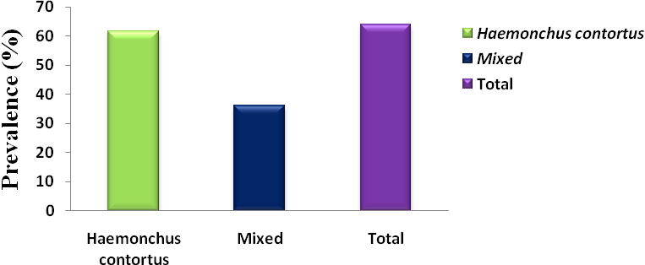
Figure 1. Showing overall prevalence of H. contortus in sheep of Kashmir Valley

Raza et al. (2009) recorded 37.18% prevalence of H. contortus in sheep and 31.10% prevelence in goats; Durrani and Hayat (1964) recorded prevalence percentage of haemonchosis as 32.40% in sheep and goats; Vercruysse (1985) reported 78% prevalence of H. contortus in sheep; Tariq et al. (2008) recorded 38.0% prevalence of O. circumcincta and 59.6% prevalence of H. contortus; Pal and Qayuum (1992) found H. contortus to be the most prevalent among the helminthes recovered and recorded 90.43% prevalence; Maqsood et al. (1996) reported 65.2 % and 47.1% prevalence of haemonchosis in sheep and goats, respectively; Jabeen et al. (2000) recorded overall infection of H. contortus as 54.77% in sheep; Tariq et al. (2003) reported 38% prevalence for haemonchosis; Lone et al. (2012) reported nematodes of which prevalent were Haemonchus (82%), Trichuris (74%), Nematodirus (60%), Trichostrongylus (58%), Chabertia (52%), Strongyloides (42%), Oesophagostomum (46%).
The present results are in accordance with Vercruysse (1985), Tariq et al. (2008), Maqsood et al. (1996), Lone et al. (2012), Jabeen et al. (2000), who observed almost similar prevalence percentages of the two parasites as recorded in the present study. The differences in the prevalence percentages between the present study and many of the above mentioned workers may probably be due to the environmental conditions present at the collection places, overall climate of the valley, different hosts or different breeds of same host and also to the low frequency of intermediate hosts.

3.1.2. Seasonal prevalence of H. contortus
The study revealed seasonality of infection showing highest prevalence of infection in summer and lowest in winter. The prevalence in spring and autumn was found to be falling in between summer and winter seasons. During winter months, 27 sheep were found infected out of 72 examined giving the prevalence of 37.5%. During the spring season, a total of 87 sheep were examined and out of these 62 were infected showing prevalence of 71.26%. During the summer season, a total of 99 sheep were examined and 80 were infected showing prevalence of 80.80%. In autumn season, 29 sheep were found to be infected out of 52 examined, giving prevalence of 55.76%. Thus the prevalence was recorded highest (80.80%) in summer followed by spring (71.26%) then by autumn (55.76%) and lowest (37.5%) in winter. (Figure 2 and Table 1). By using Chi Square test, (P=0.03), which means data is statistically significant (P<0.05). The highest incidence of infection during summer and spring may be correlated with the seasonal/climatic pattern and conditions. These seasons provide optimum conditions for the herbage growth and the necessary moisture for the optimum development of the parasites. The rainy season that starts in spring and early summer in valley makes the environmental conditions more favourable for the development and survival of pre-parasitic stages and causes increased availability of infective larvae in the rainy and post rainy season. The hot and humid weather provides favourable condition for the development and survival of exogenous stages of H. contortus (Kates, 1950). Lower prevalence percentages in the winter may be because in winter, the temperature is low and atmosphere is dry which might have inhibited the development of eggs and larvae. Besides weather conditions, self cure phenomenon may also be the reason for the decrease in infection during colder months.

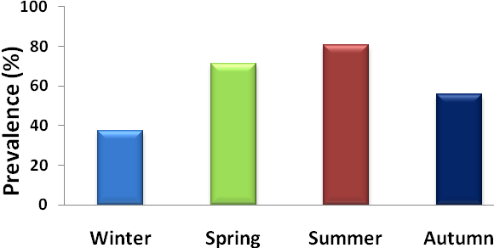
Figure 2. Showing prevalence of H. contortus in sheep in different seasons of Kashmir Valley

Makhdoomi et al. (1995) observed highest infection of H. contortus during summer (82.27%) and lowest (44.23%) during winter season; Jabeen et al. (2000) recorded highest prevalence during summer (89.55%) and lowest during winter (20.02%); Nasreen et al. (2005) also observed the highest infection (33.18%) in summer and lowest (15.25%) in winter in case of H. contortus; Lone et al. (2012) reported 40% of Helminth infections in spring followed by 74% in summer, 51% in autumn and 18% in winter in sheep; Tariq et al. (2008) recorded highest infection in summer and lowest in winter; Similar results were obtained by Mbuh et al. (2008) and Rahman et al. (2012), who observed highest prevalence in summer. The present results are in accordance with Makhdoomi et al. (1995), Jabeen et al. (2000), Tariq et al. (2008), Lone et al. (2012), who reported almost similar prevalence percentages as recorded in the present study.

3.1.3. Age-wise prevalence of H. contortus
Table-1. Showing prevalence of H. contortus in sheep in different seasons of Kashmir Valley
Seasons | Number Examined | Positive | Prevalence (%)
Winter | 72 | 27 | 37.5%
Spring | 87 | 62 | 71.26%
Summer | 99 | 80 | 80.80%
Autumn | 52 | 29 | 55.76%
Total | 310 | 198 | 63.87%
P<0.05

The 310 abomasae were collected for parasite screenings from animals of different age groups. The age groups selected were - <1 year, 1-2 years, 2-3 and >4 years. 97 lambs having age less than 1 year were examined out of which 76 were found to be infected with H. contortus showing prevalence of 78.35% and 61 were found to have mixed infection showing prevalence of 62.88%. In age group of 1-2 years, 83 were examined out of which 55 were found to be infected with H. contortus showing the prevalence of 66.26% and 42 were having mixed infection showing prevalence of 50.60%. Similarly in age group of 2-3 years, 72 abomasae were examined out of which 37 were found to be infected with H. contortus and 18 were found to have mixed infection showing prevalence of 51.38% and 25.00% respectively. At last in age group of >4 years, 58 abomasae were examined, out of which 23 were found to be infected with H. contortus showing prevalence of 39.65% and 7 were found to have mixed infection showing prevalence of 12.06%. Thus, the prevalence was found highest in age group <1 year followed by age group 1-2 years and then by age group of 2-3 years and least prevalence was found in age group >4 years (Figure 3 and Table 2). By using Chi Square test, (P=0.001), which means data is statistically significant (P<0.05).
P<0.05
Table-2. Showing prevalence of H. contortus in sheep of different age groups of Kashmir Valley
Age Group | Number Examined | Infected
Age Group | Number Examined | H. contortus (%) | Mixed (%)
<1 | 97 | 76(78.35%) | 61(62.88%)
1-2 | 83 | 55(66.26%) | 42(50.60%)
2-3 | 72 | 37(51.38%) | 18(25.00%)
>4 | 58 | 23(39.65%) | 7(12.06%)
Total | 310 | 191 (61.61%) | 128 (41.29%)
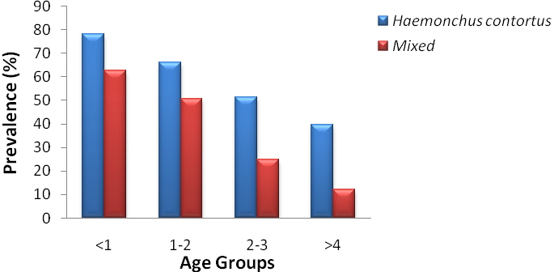
Figure 3. Showing prevalence of H. contortus in sheep of different age groups of Kashmir Valley

The lower age groups of animals found to be more infected is because of the high susceptibility and low resistance found in them. The lower levels of infection reported in adult sheep is because of the development of significant immune capability, which increases with the duration of exposure to infection (Ahmad et al., 2007).
Biu et al. (2009) reported 35% GI parasite infection in younger ones (Age 1-2.5) and 19% prevalence in older ones (3-4); The high rate of infection with H. contortus in young lambs has also been observed by Maqsood et al. (1996) who reported it as 67.1% in lambs of less than two years age and 40.4% in sheep of more than two years age; Qamar et al. (2009) also reported in case of haemonchosis that the infection in sheep was higher below 9 months (46.43%) than above 9 months (34.48%) and similarly in goats the rate of prevalence was higher below 9 months (44.44%) than above 9 months (31.84%); Lone et al. (2011) also reported 49% prevalence of nematodes in 2-4 month goats followed by 58% in 5-12 months and 34% in >1 year of age; Lone et al. (2012) also reported 94.73% and 97.77% prevalence of helminth parasites in 0-1 year age group in sheep and goats respectively and 29.41% and 51.28% in older age group in sheep and goats respectively; Thus the present results are in conformity with the studies carried out by earlier workers.
3.1.4. Gender-wise prevalence of H. contortus
The total 310 examined organs were taken from both the genders. 165 organs were taken from male specimens of which 104 were found to be infected with H. contortus showing a prevalence of 63.03% and 69 were found to have mixed infection showing a prevalence of 41.81%. In case of females, 145 organs were taken out of which 87 were found to be infected with H. contortus and 59 were having mixed infection showing prevalence of 60.00% and 40.68% respectively. Thus the infection was found little higher in males as compared to the females (Figure 4 and Table 3). By using Chi Square test, (P=0.9), which means data is statistically insignificant.
Table-3. Showing prevalence of H. contortus in male and female sheep of Kashmir Valley
Gender | Number Examined | Infected
Gender | Number Examined | H. contortus (%) | Mixed (%)
Male | 165 | 104(63.03%) | 69(41.81%)
Female | 145 | 87(60.00%) | 59 (40.68%)
Total | 310 | 191(61.61% | 128(41.29%)
P>0.05
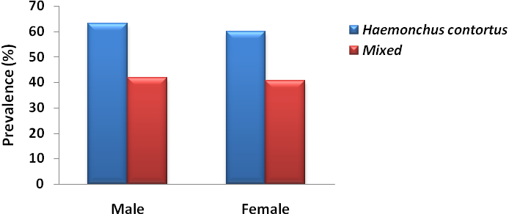
Figure 4. Showing prevalence of H. contortus in male and female sheep of Kashmir Valley

The influence of gender on the susceptibility of animals to parasitic infections could be attributed to genetic predisposition and differential susceptibility owing to hormonal control. Management and climatic conditions also have a greater role to play in the onset of infections.
Gorski et al. (2004) reported that males were more infected with nematode species than females; Tariq et al. (2010) reported 57.8% prevalence of nematodes in males as compared to 52.7% in females; Gulland and Fox (1992); Gauly et al. (2006); Ahmad et al. (2007) and Tariq et al. (2008) also observed a little higher percentage prevalence of H. contortus in males than female sheep. Tariq et al. (2003); Qamar et al. (2009) recorded no significant difference in infection percentage between males and females. Lone et al. (2011) also reported 42.5% prevalence of nematodes in males and 57.2% in females in case of goats; Raza et al. (2009) also recorded 34.11% prevalence of H. contortus in males and 39.22% in case of females in sheep while 29.91% in males and 31.90% in females in case of goats; Javed et al. (1992); Maqsood et al. (1996) and Khan et al. (2010) observed more infection in females than males. Therefore, it seems that both sexes are equally susceptible to nematode infection and the differences reported could be the effect of management conditions of the host animals and also may be due to differences in sample size.

Acknowledgement
First of all I want to thank Almighty Allah alone, the compassionate and merciful, who has always blessed me and guided me on the path of righteousness and then to my parents who have supported me through every walk of my life. At last I would like to apologize to authors whose work was not cited owing to space restrictions.

Corresponding author: Irfan-ur-Rauf Tak
Research Scholar
Parasitology Research Lab
Centre of Research for Development,
University of Kashmir-190006
Email: irfanrauftak@yahoo.in

References
- Ahmad F, Tariq KA, Chishti, MZ. Epidemiological studies on haemonchosis of sheep in Kashmir Valley. Oriental Science 2007;12:43-47.
- Biu AA, Maimunatu A, Salamatu AF, Agbadu ET. A faecal survey of gastrointestinal parasites of ruminants on the University of Maiduguri Research Farm. International Journal of Biomedical and Health Sciences 2009;5:175-179.
- Durrani MZ, Hayat CS. Gastrointestinal parasitism in sheep and goats in Lyallpur district. Pak .Vet. J 1964;1:164-165.
- Gauly M, Schackert M, Hoffmann B, Erhardt G. Influence of sex on the resistance of sheep lambs to an experimental Haemonchus contortus infection. Dtsch. Tierarztl. Wochenschr 2006;113: 78-181.
- Gorski P, Niznikowski R, Strzelec E, Popielarczyk D, Gajewska A, Wedrychowicz, H. Prevalence of protozoan and helminth internal parasite infections in goat and sheep flocks in Poland. Arch. Tierz. Dummerstorf 2004;47:43-49.
- Gulland FMD, Fox M. Epidemiology of nematode infections of Soay sheep (Ovis aries L.) on St. Kilda. Parasitology 1992;105:481-492.
- Jabeen F, Ahmad N, Ahmad KM, Chaudhry MA, Ali S. Studies on the epidemiology and chemotherapy of haemonchosis in sheep in the Punjab. Pak. Vet. J 2000;20:90-92.
- Javed MS, Iqbal Z, Hayat B. Prevalence and economics of haemonchosis in sheep and goats. Pak. Vet. J 1992;12:36-38.
- Jackson F, Coop RL. The development of anthelmintic resistance in sheep nematodes. Parasitology 2001;120:95-107.
- Khan MN, Sajid MS, Khan MK, Iqbal Z, Hussain A. Gastrointestinal helminthiasis: prevalence and associated determinants in domestic ruminants of district Toba Tek Singh, Punjab, Pakistan. Parasitol Res 2010;107:787-794.
- Lone BA, Chishti MZ, Ahmad F. Prevalence of Coccidia and gastrointestinal nematode infection in Goats of Baramullah District of Kashmir Valley. Global Veterenaria 2011;7:27-30.
- Lone BA, Chishti MZ, Ahmad F, Tak, H.. A Survey of Gastrointestinal Helminth Parasites of Slaughtered Sheep and Goats in Ganderbal, Kashmir. Global Veterinaria 2012;8:338-341.
- Makhdoomi DM, Nasreen S, Banday SD, Moulvi BA. Incidence of different bovine gastrointestinal parasites in Kashmir. Indian Veterinary Journal 1995;72:898-900.
- Maqsood M, Iqbal Z, Chaudhary AH. Prevalence and intensity of Haemonchosis with reference to breed, sex and age of sheep and goats. Pak. Vet. J 1996;16:41-43.
- Mbuh JV, Ndamukong KJN, Ntonifor N, Nforlem GF. Parasites of sheep and goats and their prevalence in Bokova, a rural area of Buea Sub Division, Cameroon. Vet. Parasitol 2008;156:350-352.
- Miller JE, Barras SR. Ivermectin resistant Haemonchus contortus in Louisiana lambs. Veterinary Parasitology 1994;55:343-346.
- Miller JE, Hembry FG, Kearney MT, Williams JC, Stagg LC, Sims D. Efficacy of levamisole and netobimin against Haemonchus contortus in lambs in Louisiana. American Journal of Veterinary Research 1987;48:1403-1406.
- Nasreen S, Jeelani SJ, Munir H. Incidence of nematodes in sheep in Kashmir valley. J. of Vet. Parasitology 2005;19:27-29.
- Pal RA, Qayuum M. Distribution of gastro-intestinal helminths of goats in Sood Valley (NWFP), Pakistan. Pak. J. of Zoology 1992;24:359-360.
- Qamar MF, Maqbool A, Khan MS, Ahmad N, Muneer MA. Epidemiology of Haemonchosis in sheep and Goats under different managemental conditions. Veterinary World 2009;2:413-417.
- Rahman H, Pal P, Bandyopadhyay S, Chatlod LR. Epidemiology of gastrointestinal parasitism in goats in Sikkim. Indian Journal of Animal Sciences 2012;82:355–358.
- Raza MA, Murtaza S, Bachaya HA, Dastager G, Hussain A. Point Prevalence of Haemonchosis in Sheep and Goats slaughtered at Multan abattoir. The Journal of Animal & Plant Sciences 2009;19:158-159.
- Rudolphi GA. Fortesetzing der Beobachtingenuber die Eingeweldewurmer. Arch. F. zool. U. Zoot. Bd 1803;2:23-25.
- Sangster NC. Anthelmintic resistance: past, present and future. International Journal for Parasitology 1999;29:115-124.
- Soulsby EJL. Helminths, Arthropods and Protozoa of Domesticated Animals. 1982;7th edition, Bailliere-Tindall, London.
- Tariq F, Maqbool A, Tanveer A, Muhammad F. . Prevalence of haemonchosis in jaba sheep Farm and efficacy of some indeginous medicinal Plants against haemonchosis. Iranian J.Vet. Res 2003;4: 223-227.

Tariq KA, Chishti MZ, Ahmad F. Gastro-intestinal nematode infections in goats relative to season, host sex and age from the Kashmir valley, India. Journal of Helminthology 2010;84:93-97.
- Tariq KA, Chishti MZ, Ahmad F, Shawl AS.. Epidemiology of gastrointestinal nematodes of sheep managed under traditional husbandry system in Kashmir valley. Veterinary Parasitology 2008;158:138–143.
- Terrill TH, Kaplan RM, Larsen M, Samples OM, Miller JE, Gelaye S. Anthelmintic resistance on goat farms in Georgia: efficacy of anthelmintics against gastrointestinal nematodes in two selected goat herds. Veterinary Parasitology 2001;97:261-268.
- Vercruysse J. The seasonal prevalence of inhibited development of Haemonchus contortus in sheep in Senegal. Veterinary Parasitology 1985; 17:159-163.
- 17th Indian Livestock Census Jammu and Kashmir, Livestock, Poultry, Agricultural Machinary and Implements and Fishery Statistics 2003. Government of India, Ministry of Agriculture Department of Animal Husbandry and Dairying Krishi Bhavan, New Delhi.

7/25/2013

